(i) Cover Page

(ii) Table of Contents

(iii) Executive Summary

(iv) Product and/or Services Plan

(v) Marketing Plan

(vi) Operations Plan

(vii) Management Plan or structure

(viii) Financial Plan plus

(ix) Appendices



Lesedi Software Innovation (PTY) LTD .

*We provide mobile and web application solutions for the complete software development life cycle services .*

**Business Plan**

4 May 2020 .

**Phillip Mandla Mtombeni .**

pmtombeni@gmail.com .

2776-568-5999 .

bulldog-pumpkin-f2wy.squarespace.com .

4 Midrand Ridge, George Road, Noordwyk Ext 1, Midrand 1687 .

Contents

Executive Summary 7

Company and Market Overview 7

Target Customer 8

Management Team 8

Board / Advisors 8

Market Problem & Solution 8

Significant Recent Company Milestone 8

Product Image 8

Management Team Overview 9

Management Team 9

FINAL_BP_MANAGEMENT_TEAM_OVERVIEW_YOUR_TITLE_AND_YOUR_NAME 9

FINAL_BP_MANAGEMENT_TEAM_OVERVIEW_EMP1_TITLE_AND_EMP1_NAME 9

FINAL_BP_MANAGEMENT_TEAM_OVERVIEW_EMP2_TITLE_AND_EMP2_NAME 10

FINAL_BP_MANAGEMENT_TEAM_OVERVIEW_EMP3_TITLE_AND_EMP3_NAME 10

FINAL_BP_MANAGEMENT_TEAM_OVERVIEW_EMP4_TITLE_AND_EMP4_NAME 10

FINAL_BP_MANAGEMENT_TEAM_OVERVIEW_EMP5_TITLE_AND_EMP5_NAME 11

FINAL_BP_MANAGEMENT_TEAM_OVERVIEW_EMP6_TITLE_AND_EMP6_NAME 11

FINAL_BP_MANAGEMENT_TEAM_OVERVIEW_EMP7_TITLE_AND_EMP7_NAME 11

FINAL_BP_MANAGEMENT_TEAM_OVERVIEW_EMP8_TITLE_AND_EMP8_NAME 12

FINAL_BP_MANAGEMENT_TEAM_OVERVIEW_EMP9_TITLE_AND_EMP9_NAME 12

FINAL_BP_MANAGEMENT_TEAM_OVERVIEW_EMP10_TITLE_AND_EMP10_NAME 12

Board/Advisors 13

FINAL_BP_MANAGEMENT_TEAM_OVERVIEW_BRD1_TITLE_AND_BRD1_NAME 13

FINAL_BP_MANAGEMENT_TEAM_OVERVIEW_BRD2_TITLE_AND_BRD2_NAME 13

FINAL_BP_MANAGEMENT_TEAM_OVERVIEW_BRD3_TITLE_AND_BRD3_NAME 13

Outsourced Partners 14

FINAL_BP_MANAGEMENT_TEAM_OVERVIEW_PARTNER1_TITLE_AND_PARTNER1_NAME 14

FINAL_BP_MANAGEMENT_TEAM_OVERVIEW_PARTNER2_TITLE_AND_PARTNER2_NAME 14

FINAL_BP_MANAGEMENT_TEAM_OVERVIEW_PARTNER3_TITLE_AND_PARTNER3_NAME 14

FINAL_BP_MANAGEMENT_TEAM_OVERVIEW_PARTNER4_TITLE_AND_PARTNER4_NAME 14

FINAL_BP_MANAGEMENT_TEAM_OVERVIEW_PARTNER5_TITLE_AND_PARTNER5_NAME 14

Employee Recruiting Strategy 14

Employee Incentivizing, Motivation and Retention Strategy 14

Additional Resources to Hire 15

Product/Service 16

Product/Service Overview 16

Quality Control 16

Packaging 16

Production 16

Current Price Strategy 16

Future Price Strategy 16

Bundle Price Strategy 17

Volume Discounts 17

Financing 17

Freemium or Premium Pricing Strategy 17

Input Prices 17

Distribution Strategy 17

Return Policy 17

Who is the Customer? 19

Customer Concentration 19

Customer Attainment Strategy 19

Customer Survey Research 19

Customer Service 19

Customer Response Time 19

Customer Loyalty Program 19

Customer Profile Documentation 20

General Industry Trends / Drivers 20

Industry Risks 20

Warranty Policy 20

Industry Search Trends 20

Barriers to Entry 20

Total Addressable Market (T.A.M.) 20

Percent of the T.A.M. We Plan on Capturing in 5 Years 21

Seasonality 21

Competition 22

Largest Competitor Description 22

Strengths of Largest Competitor 22

Weaknesses of Largest Competitor 22

2nd Largest Competitor Description 22

Strengths of 2nd Largest Competitor 22

Weaknesses of 2nd Largest Competitor 22

3rd Largest Competitor Description 22

Strengths of 3rd Largest Competitor 22

Weaknesses of 3rd Largest Competitor 23

4th Largest Competitor Description 23

Strengths of 4th Largest Competitor 23

Weaknesses of 4th Largest Competitor 23

5th Largest Competitor Description 23

Strengths of 5th Largest Competitor: 23

Weaknesses of 5th Largest Competitor 23

Discussion of Our Strengths Compared to the Competition's Strengths 24

Discussion of Our Weaknesses Compared to the Competition's Weaknesses 24

Discussion of Our Management Compared to the Competition's Management 24

Discussion of Our Price Strategy Compared to the Competition's Price Strategy 24

Go-to Market Strategy 25

Online Distribution Strategy 25

Offline Distribution Strategy 25

Direct Distribution Strategy 25

Indirect Distribution Strategy 25

Cost of Distribution 25

Sales and Marketing Strategy 26

Sales Strategy 26

Sales Force Structure 26

Sales Force Incentives 26

Sales Force Registration / License Certification 26

Marketing Strategy 26

Online Marketing (Social Media) Strategy 26

Lead Generation Strategy 26

Offline Media Strategy 26

Operations 27

Milestones 27

Future Milestones 27

Future Products or Services Milestones 27

Future Revenue Milestones 27

Future Break-Even Milestone 27

Units Sales Milestones 27

TAM Milestones 27

Profit Margins Milestones 27

Geographic Milestones 27

Other Future Milestones 28

Future Exit Strategy Milestones 28

Past Milestones Achieved 29

Revenue Milestones Achieved 29

Units Sales Milestones Achieved 29

TAM Milestones Achieved 29

Break Even Milestone Achieved 29

Profit Margins Milestones Achieved 29

Products or Services Milestones Achieved 29

Geographic Milestones Achieved 29

Other Milestones Achieved 30

Other / Miscellaneous (i.e., Risks) 31

Future Technology Development Risks that Can Impact Our Business Model 31

Future Competition Risks 31

Macroeconomic Developments Risks 31

Disaster Recovery Strategy 31

Other Potential Risks 31

What is the Most Misunderstood Aspect of Our Business Model? 31

Financials 32

Revenue and Net Income Forecast Highlights 32

Financial Ratios 33

Monthly Revenue Forecast 35

Quarterly Revenue Forecast 36

Annual Revenue Forecast 37

Monthly Operating Income Expenses Forecast 38

Annual Operating Income Expenses Forecast 39

Quarterly Income Statement 40

Annual Income Statement 41

Quarterly Balance Sheet 42

Annual Balance Sheet 43

Quarterly Cash Flow Statement 44

Annual Cash Flow Statement 45

Appendix 46

Employee #1 Resume 46

Employee #2 Resume 47

Employee #3 Resume 48

Employee #4 Resume 49

Employee #5 Resume 50

Employee #6 Resume 51

Employee #7 Resume 52

Employee #8 Resume 53

Employee #9 Resume 54

Employee #10 Resume 55

Outsourced Partners #1 Resume 56

Outsourced Partners #2 Resume 57

Outsourced Partners #3 Resume 58

Outsourced Partners #4 Resume 59

Outsourced Partners #1 Resume 60

Marketing Materials (Brochures) 61

Customer Testimonials/References 62

Additional Appendix Items 63

# 

**EXECUTIVE SUMMARY**

**PRODUCT DESCRIPTION:** Lesedi Software Innovation (PTY) LTD offers mobile, web applications and programming training. Each application is designed to fill a specific skill gap. Software applications and training will be done at Lesedi Software Innovation (PTY) LTD head office. Once an software application is completed a client can be able to download software application from Lesedi Software Innovation website, a link will be sent to the client , over the phone, or via email and a link to our training material can also be sent to our clients. Our initial set of applications offerings (existing and planned) are:

• **Mobile Applications** are designed to improve client’s abilities to sell their products , prioritize their efforts, gain support for their ideas and communicate their results clearly, compellingly and succinctly.

• **Web Application** will allow basic business strategy frameworks and methods for assessing and capturing market opportunities.

• **Websites** this a static website which contains about us page and contact details of the clients.

• Programming training. We offer software development or programming training.

• **Training** also offer online training our clients can get software development courses by registering on our website . We offer software development or programming training.

In addition to these applications we also have course offerings, we train clients to develop and create their own mobile and web applications services (both hourly-based and fee-based services) focused on specific client and participant needs.

Some of our clients are startup companies the owners of these startup companies are using public transport for example taxis, buses, uber and trains.

**DEVELOPMENT:** Although Lesedi Software Innovation (PTY) LTD is in the early stages of growth, our offerings have been proven in the marketplace for several years. The majority of our initial focus will be on software development, client development, and course content creation.

Lesedi Software Innovation (PTY) LTD is a development-stage company. It does not currently have a client base nor is there an existing revenue stream at this time. Our current products consist of mobile application web application and one classroom instruction courses and related consulting services. We are in the process of refining our content, defining and documenting new content and courses and identifying both additional instructors for the courses and target clients.

**FINANCIAL SUMMARY?????:** Based on our current assumptions, we expect Lesedi Software Innovation will generate between R5000 000to R7000000 in revenues by Year 5. Net Income After Tax (NIAT) corresponding to those Year 5 revenues is expected to be between $X to $Y. To launch this business we estimate we will require approximately R9000000 in new capital. Those funds will be used for initial salary/administrative costs, benefits costs, professional fees, software development costs, business development and creation/procurement of our initial set of classroom materials.

Our preferred exit strategy is to operate and grow the business or to sell our stake in the company to new management or an external organization if the new owners find our offerings to be complementary to their offerings. If the business does not develop as planned and we find the model is not viable after a substantial period of trying to grow, we will cease operations, liquidate our assets and return any residual funds to our investors in an equitable distribution.

**OFFERING??:** Due to the non-capital intensive nature of our business we require minimal investment to launch the company. Total investment required at start-up is approximately R9000000. The timing of this initial investment will be over the course of our first 3-12 months of existence. Using an NPV methodology to discount future NIAT earnings, Lesedi Software Innovation (PTY) LTD is worth between R1000000 (worst case) and R2000000 (aggressive case). Our offering consists of a debt and equity structure whereby we would pay a fixed return on a portion of our funding and offer a portion of the company’s equity for the remaining funding.

Given a 40% equity stake for a R1000 000 investment, equity holder ROI will be in the range of -20% (worst case) to >80% (aggressive case). The exit strategies for equity investors range from selling their stake back to Lesedi Software Innovation (PTY) LTD owners at a future predetermined point (using the valuation of the company at that point in time) to selling their stake to outside investors to selling their equity to a new owner in the event of a buyout.

??????????????????????????? exit

**1.1 Objectives**

Lesedi Software Innovation (PTY) LTD has identified the following goals and objectives to be achieved :

• Conducting regularly research into the IT industry so that we do not only have a comprehensive understanding of the local and global market developments but also the industry

Challenges and composition, existing statistics and future trends.

• Provide and identify a good working environment for employees of Lesedi Software Innovation (PTY) LTD and also create relationships with the organization’s potential clients by having a meeting with their decision makers and plotting a mutual plan for success.

• Implementing suitable management control systems for the different business elements.

• Offer enough training for our employees and ensure transfer of skill from top down.

• Launching new site sight by September 2020.

• Start office renovations in August 2020.

• Securing proposed funding amount by end July 2020.

• Formalizing organization’s funding arrangements with the targeted funders, involving formalization of amount of funding and exit strategies.

## 

## Company and Market Overview

Lesedi Software Innovation (PTY) LTD (Pty) is an independent, 100% Black owned and managed

organization established to take advantage and identify commercial opportunities specifically in the

IT sector. Lesedi Software Innovation (PTY) LTD is a new business,it is a South African based

Limited Liability Corporation which makes we provide mobile and web application solutions for the

complete software development life cycle services. We also offer software development training.

The size and growth of the total addressable market is $50 billion for the IT industry and $150 billion

for the Software Development industry for a combined total of $200 billion respectively. Lesedi

Software Innovation (PTY) LTD plans on capturing 1% of the market in 5 years. Lesedi Software

Innovation (PTY) LTD is intending s to become a dominant force in the region in terms of the

software development industry, currently it is a small company, we want to grow it into an

international giant. Lesedi Software Innovation (PTY) LTD a  close corporation .

Lesedi Software Innovation (PTY) LTD ’’ mission is to design mobile, web applications and offer software development training for different clients. We will do so by offering high-quality software applications and training . The company will offer services to startup companies and big companies.

“To celebrate Africa United Together” – Nowadays people are living different lives and stand by various principles but information technology is one thing that can always bring individuals together regardless of Political, Social Status, Race, Religion and Affiliation which is a Tranquil Environment, Good Customer Service and Good Quality Product.

Impact of Economic Development and Empowerment

• Employment opportunities is going to be at least 85% historically disadvantages individuals

• Lesedi Software Innovation (PTY) LTD is a hundred percent (100%) black owned company.

• Business established in the IT sector specifically mobile and web application industry.

Safety and Health

• Treat each minor incident of safety negligence at work in a very serious light.

• Public and worker safety is of utmost importance to us and we value quality.

**Business Description:**

Lesedi Software Innovation (PTY) LTD is an independent and 100% Black owned private company, by Mr Phillip Mandla Mtombeni, venturing into the Information Technology industry it is located in

Johannesburg. The financing requires also includes working capital which will be required for the initial 6 months of operations post funding.

• The mission, and the company's long and short term objectives in terms of business growth and development, as well possible exit strategies (for example: buy out investors, sell to larger company, go public, etc) ???????

**2. The product or service**

• describe in full the product or services offered by the business and the innovative features of these products and services and the competitive edge they afford the business over rivals in the market.

• the expected product life cycle where applicable

• include descriptions of key technologies employed and current and future research and development

**3. Describe the location, premises and — where applicable — production facilities**

**4. Production and technology**

• describe production processes and capacity, identifying any existing constraints and possible problem areas

• include a detailed analysis of the process of installing and commissioning any new technologies and production processes

• include information on quality assurance systems and procedures, and certification

• details of suppliers and sub-contractors, and any contractual arrangements governing the supply of key inputs

**5. Elaborate on the business's past achievements and strengths and past problems and weaknesses, and critical success factors**

• **Business Description**

This is a general description of your business. State your business name,

when you plan to open, or if you are an existing business, where you are (or

will be) located, what your products and services are, what your target

market is, etc. This is not detailed. It is just a brief overview.

## Target Customer

The company's initial target market is websites, mobile and web application fans located in South Africa. In 5 years, the target market will be customers located in Africa, The United States, Canada, India, United Kingdom, Australia and New Zealand.

Lesedi’s target market includes:

• International IT Market

• Local IT Market

• Local Residents Market

• Corporate Market

• Family Market

•Adults who own small companies

•Young adults, age 16-22 who want who needs training on software development

•Parents who needs websites for their companies

•Big corporates compnies

????????????????????????????????????????????advetise marketing

Nanny Online has recognised its target market as lone parent families, parents who work a lot as well as parents who just need alone time. For this reason, our marketing campaign relies heavily upon advertising in areas with high family traffic levels. We intend to promote our company in a number of newspapers, family magazines in conjunction with distributing leaflets in schools and displaying billboards in family areas.

//////////////

Overall approach to the target market

///////////

* Target Market: Parents in the Ile-de-France and Paris regions, particularly those with two or more children.

//////////////

when you plan to open, or if you are an existing business, where you are (or

will be) located, what your products and services are, what your target

market is, etc. This is not detailed. It is just a brief overview.

////

Define your target market. You may have more than one. If so, give a

description of each target market. Example: Young adults, age 16-22,

and elderly, age 75+. Include a detailed description with each of these

stated segments.

- Include a demographic analysis. Age, gender, income, education, race,

etc.

- Where do your customers currently shop? Why will they shop at your

store or business?

- Make sure you do not say, “EVERYONE will come to my business.” No

matter how much you think your store will be for all age groups,

genders, income levels, etc. there is a target market for every

business. Figure it out and define it.

//////

In one or two paragraphs, answer the following questions: What market(s) needs will our company address? Who are our target customer's? What products and services will our company sell? What are our current sales and current products (if any)? What are the boundaries of our business?

Identify your *direct competitors* (competitors that sell similar products or services to your potential customers). Carefully define the attributes and characteristics of these competitors and their products/services. For direct competitors, identify size, location, target market, and other important characteristics. For their products or services, identify price, quality, features, distribution, and other important attributes.

/////////

**Customers**

Identify your targeted customers, their characteristics, and their geographic locations, otherwise known as their demographics.

The description will be completely different depending on whether you plan to sell to other businesses or directly to consumers. If you sell a consumer product, but sell it through a channel of distributors, wholesalers, and retailers, you must carefully analyze both the end consumer and the middleman businesses to which you sell.

You may have more than one customer group. Identify the most important groups. Then, for each customer group, construct what is called a demographic profile:

• Age

• Gender

• Location

Page 10 of 31

• Income level

• Social class and occupation

• Education

• Other (specific to your industry)

• Other (specific to your industry)

For business customers, the demographic factors might be:

• Industry (or portion of an industry)

• Location

• Size of firm

• Quality, technology, and price preferences

• Other (specific to your industry)

• Other (specific to your industry)

//////////mmmmmm

• Current demand in target market.

• Trends in target market—growth trends, trends in consumer preferences, and trends in product development.

• And of course, how will you overcome the barriers?

Page 9 of 31

///// mmmmmmmmmmmm

The quality of our instructors and our instruction materials are the strongest elements of our marketing plan. These referrals and manager mandates will drive demand for our initial courses and the quality of instructors and instruction will create ongoing demand for new course offerings as well as consulting services focused on applying the concepts of the course. Our target market consists of managers and leaders of organizations who are in roles that require them to create ideas/recommendations, support those initiatives and communicate their rationale in a clear and compelling manner (primarily junior executives, middle managers and individual team members in analytical or managerial roles). Additional requirements of their roles include leading and managing employees and/or managing projects. Each tthhoouugghhttLLEEAADDEERRSS course offering is targeted at filling one or more of these critical skill gaps.

mmmmmmmmmm

Current demand in target market.

• Trends in target market—growth trends, trends in consumer preferences, and trends in product development.

## Management Team

Phillip Mandla Mtombeni founded Lesedi Software Innovation (PTY) LTD in 2020. Mandla Mtombeni has previous work experience in the software development division of Wesbank, where he created the content platform software distribution business model. Relevant skills and experience that employees of the firm have, includes experience at Wesbank, former Software Developer of Exponant software company and engineering experience at University of Johannesburg.

## Market Problem & Solution

The problem with Information Technology is that software development growth is low and expensive. Lesedi Software Innovation (PTY) LTD solves this problem through a brand new, high-margin distribution channel for different companies. The other issue is that the recent *Hay Global Skills Index* notes that the growing skills mismatch remains one of the key problems of the global job markets. Consequently the main tasks of educational institutions will be the development of new curricula that better match the demands of digital era job market. The lack of appropriate education has produced graduates who cannot find commensurate jobs primarily because our education system has failed them. They simply lack the necessary skills and competencies of the digital era job market. As a result a large percentage of our graduates have become an integrated statistic (63 percent) of the largest youth unemployment drama in the world. To meet the challenges of the skills needs for the digital era, Lesedi Software Innovtion(Pty) Ltd offers software development training which is transformed in ways that allows students to acquire the creative thinking, flexible problem solving, collaboration and innovative skills. The 21st Century has introduced an increasingly complex, competitive and fast-paced labour market which has evolved with new types of jobs, professions and occupations that require a new set of skills for agile and collaborative work teams.

In one or two paragraphs, answer the following questions: What market(s) needs will our company address? Who are our target customer's? What products and services will our company sell? What are our current sales and current products (if any)? What are the boundaries of our business?

**Market research - Why?**

**V. Marketing Plan**

No matter how good your product and your service, the venture cannot succeed

without effective marketing. And this begins with careful, systematic research. It is very dangerous to assume that you already know about your intended market. You need to do market research to make sure you’re on track. Use the business planning process as your opportunity to uncover data and to question your marketing efforts. Your time

will be well spent.

**Market research - How?**

There are two kinds of market research: primary and secondary.

Secondary research means using published information such as industry profiles, trade journals, newspapers, magazines, census data, and demographic profiles. This type of information is available in public libraries, industry associations, chambers of commerce, from vendors who sell to your industry, and from government agencies.

Start with your local library. Most librarians are pleased to guide you through their business data collection. You will be amazed at what is there. There are more online sources than you could possibly use. Your chamber of commerce has good information on the local area. Trade associations and trade publications often have excellent industry‐specific data.

Primary research means gathering your own data. For example, you could do your own traffic count at a proposed location, use the yellow pages to identify competitors, and

do surveys or focus‐group interviews to learn about consumer preferences. Professional market research can be very costly, but there are many books that show small business owners how to do effective research themselves.

In your marketing plan, be as specific as possible; give statistics, numbers, and sources. The marketing plan will be the basis, later on, of the all‐important sales projection.

**Economics**

Facts about your industry:

• What is the total size of your market?

Page 8 of 31

• What percent share of the market will you have? (This is important only if you think you will be a major factor in the market.)

• Current demand in target market.

• Trends in target market—growth trends, trends in consumer preferences, and trends in product development.

• Growth potential and opportunity for a business of your size.

• What barriers to entry do you face in entering this market with your new company? Some typical barriers are:

o High capital costs

o High production costs

o High marketing costs

o Consumer acceptance and brand recognition

o Training and skills

o Unique technology and patents

o Unions

o Shipping costs

o Tariff barriers and quotas

• And of course, how will you overcome the barriers?

• How could the following affect your company?

o Change in technology

o Change in government regulations

o Change in the economy

o Change in your industry

Page 9 of 31

//////////////////

## Significant Recent Company Milestone

A recent milestone achieved by Lesedi Software Innovation (PTY) LTD is exclusive contract signing with Bryston company. Lesedi Software Innovation (PTY) LTD intends on raising $9,000,000 ; the use of proceeds is to hire 2 software engineers and to open an office in Sandton The intended exit strategy is through an Initial Public Offering and/or selling the company. The management team members currently have three major sets of responsibilities: running the organization and creating/delivering our mobile, web application, and offer training as instructors. Organizationally, members of the management team will also be software developers, instructors and course creators. The growth of the team will be contingent upon Lesedi Software Innovation (PTY) LTD achieving sufficient scale to support a larger organization or upon the need to add a specific area of expertise to our product offerings.

## Product Image

THIS TOPIC IS OPTIONAL (IF YOU WANT, DELETE THE TITLE ABOVE THIS TEXT AND DELETE THE LINE BELOW THIS TEXT)



# Management Team Overview

## Management Team

|  |  |
| --- | --- |
| CEO and Founder: Phillip Mandla Mtombeni | |
|  |  |
|  | Phillip Mandla Mtombeni is a very experienced with over 14 years working as software engineer, with significant software engineering work experience at Department of Education, University Of Johannesburg, Standard Bank, and Wesbank where he led the Development Team. He also started a software company . Mandla Mtombeni has an MBA from Regent Business School , Honors in Computer Science from UNISA, and postgraduate diploma in business management from Regenesys Business School, and an undergraduate degree from University Of Free State, where he graduated 2nd in his class. |
|  |

## Outsourced Partners

BELOW IS OPTIONAL AS IT CONTAINS THE DETAILS OF YOUR 5 OUTSOURCED PARTNERS, WHICH ARE LABELED AS PARTNER1, PARTNER2, PARTNER3, PARTNER4 AND PARTNER5 (IF YOU WANT, DELETE THE INFORMATION BELOW THIS TEXT AS WELL AS THE TITLE ABOVE THIS TEXT IF IT IS NOT APPLICABLE)

### FINAL_BP_MANAGEMENT_TEAM_OVERVIEW_PARTNER1_TITLE_AND_PARTNER1_NAME

FINAL_BP_MANAGEMENT_TEAM_OVERVIEW_PARTNER1_BIO

### FINAL_BP_MANAGEMENT_TEAM_OVERVIEW_PARTNER2_TITLE_AND_PARTNER2_NAME

FINAL_BP_MANAGEMENT_TEAM_OVERVIEW_PARTNER2_BIO

### FINAL_BP_MANAGEMENT_TEAM_OVERVIEW_PARTNER3_TITLE_AND_PARTNER3_NAME

FINAL_BP_MANAGEMENT_TEAM_OVERVIEW_PARTNER3_BIO

### FINAL_BP_MANAGEMENT_TEAM_OVERVIEW_PARTNER4_TITLE_AND_PARTNER4_NAME

FINAL_BP_MANAGEMENT_TEAM_OVERVIEW_PARTNER4_BIO

### FINAL_BP_MANAGEMENT_TEAM_OVERVIEW_PARTNER5_TITLE_AND_PARTNER5_NAME

FINAL_BP_MANAGEMENT_TEAM_OVERVIEW_PARTNER5_BIO

## Employee Recruiting Strategy

We recruit employees that have significant software development practical experience, including engineers that have worked at large IT companies, founders of IT companies and advanced research and development computer science PHDs from top universities. The common element that all of our employees have is a passion for disrupting the entire IT industry using next generation software technologies. Everyone at Lesedi Software Innovation is a team player, affable, hungry and ethical. The aim is to design an employee recruitment strategy that is innovative, relevant, people-focused and driven by business needs. In an ecosystem where the conversation between the organization and the candidate is changing quickly by becoming more transparent, strategic and individualized, recruitment strategies must evolve. This is a structured action plan to effectively and efficiently identify talent pools, attract candidates and get the best-fit talent onboard. Our aim is to build inroads into quality talent pools, encourage applications and to reduce the cost and time to hire, having the right hiring strategy in place is a prerequisite

## Employee Incentivizing, Motivation and Retention Strategy

We believe in a solid work or life balance. As such, we allow all employees to work from home, which keeps our costs lower and morale very high. We offer generous stock options as well, with a vesting period of 4 years for each annual stock option grant.

## Additional Resources to Hire

We are looking to hire a full-time engineer with back end a.i. experience in foreign markets. We are also looking to hire a part-time data entry employee.

# Product/Service

## Product/Service Overview

We offer boutique mobile and web solutions for the complete software development life cycle services and software development training.

## Quality Control

Our quality control process is superb as we test each pair of our software 3 times post manufacturing. In addition, content that we deliver to customers over mobile and web application Platform is upscaled to 4K quality (if available and if the broadband connection is high speed) and downscaled to 720 resolution (if the broadband connection is not high speed)??????.

## Packaging

????????

The dowloading of the mobile application is a minimalist process, where the consumer clicks on Apple App store types the application name and then click on the search button then he clicks on get button to download the mobile application on his phone ,once downloaded he can click on open button to open the application. The process is low cost . In addition, the apllication can also be downloaded from th microsoft app store and follows the same steps.   
  
Please see the financial section of this document for details on the cost of packaging?????.

## Production

In order to ensure that we do not have material inventory issues, mobile and web is created by a contract manufacturing company called ST-Software. Once the consumer places the order. The software product is then produced and delivered to customers in 1-2 weeks. In the future, we plan on allowing customers to customize the product with their own colors and higher priced options.

## Current Price Strategy

Customers purchase mobile and web application, we charger R650 per hour plus a R300 monthly subscription fee, which provides consumers with system download per month. Customers have the option to pay annual subscription fee at a lower price of R1200. We also charge customer maintenance fee of R650 per hour. For example if the client wants to add more functionality or add enhancement on the existing mobile and web application

## Future Price Strategy

In the future, we plan on upselling live streaming content for R200 + prices for static website, mobile application, web application, database maintenance , etc. We also plan on cross-selling content for R75 per update.

## Bundle Price Strategy

We are currently in late stage discussions with Microsoft on potentially bundling our product with ultra high end . ?????????????

## Volume Discounts

We also offer training to students who want to learn about software development. We provide educational discounts of R200 for our students if educational institutions purchase lots of training courses. ?????

## Financing

We plan on offering financing options for the training courses. We are currently discussing this strategy with the 3 largest financing companies. ????

## Freemium or Premium Pricing Strategy

THIS TOPIC IS OPTIONAL (IF YOU WANT, DELETE THE TITLE ABOVE THIS TEXT AND DELETE THE LINE BELOW THIS TEXT.)

We are currently in late stage discussions with Clients about creating an ultra high end R90000 version of our product with future acoustic capabilities. We are not sure though about this strategy as it is unclear if this will jeopardize our ability to eventually sell our product through the Apple store. ????

## Input Prices

THIS TOPIC IS OPTIONAL (IF YOU WANT, DELETE THE TITLE ABOVE THIS TEXT AND DELETE THE LINE BELOW THIS TEXT.)

Part of our patent pending production process involves several commodity inputs, service pack and other materials. We have a hedging strategy in place in case the price of our inputs spike. ?????????

## Distribution Strategy

"The mobile and web application are sold on app store,google store , training courses are currently sold online via facebook. We plan on also selling the training courses on our website and through Best Buy's retail stores. We are optimistic that social media company will help us sell our products through the Apple Store and google play in the future.

Our media content is sold online through our monthly subscription service; customers can download our product to their iphone,windows phones, Windows or Mac computers using . Once the software applcation is dowloaded to the customer's phone or computer. The application are also registered to our customer when downloaded to their phones and computers for the first time (we ask for the customer's email address so we can upsell or cross sell future content). The customer also enters in their credit card number before software application is downloaded to their phones or computer, then they can download application once we have confirmed that the payment has been processed. "

## Return Policy

We offer a 15 day 100% refund policy to all our Prime customers and a 20% restocking fee charged to other customers of our mobile and web product. FOR FREE??????

**Customer and Market Commentary**

## Who is the Customer?

"Based on our extensive customer research*, our ideal customer is a mobile and web application lover, an early adopter when it comes to new technology products, over 18 years old, lives in large cities, has an undergraduate university degree, is interested in computer programming and loves music. For the next two years, we are targeting consumers in South Africa. In five years, we will also target consumers in Unite State, India, The United Kingdom, Australia and New Zealand.

* Please see the Appendix for the completed Survey Monkey customer data analysis report. Also, please see Step 9 in order to view the Facebook advertising campaign we are using to target customers with the aforementioned characteristics." ?????????

## Customer Concentration

We do not have customer concentration issues as no customer comprises more than 1% of total revenue.

## Customer Attainment Strategy

Given how revolutionary our product is, we have received a material amount of free media publicity. As a result, we have not spent much on customer attainment. Going forward, we plan on using Twitter, Instagram, Facebook advertising, which we discuss in detail in the Sales and Marketing part of this business plan. We also plan on using Google ads and YouTube, as it is now the second largest search engine.

The mission is going to be obtained by adopting these strategic objectives:

• Good governance, sound financial discipline and legal compliance.

• Grow the business in the region, maximize profits and increase revenue

• Provide the best service

• Provide the best product

• Become the dominant force with-in the region in the IT Industry

• Uniting each and every nation, create social networking , business, and safe environment as LESEDI offers a broad variety of software applications catering for most of South Africans and other African and international clients . Hence “Celebrate Africa United Together”

• Become the preferred service provider.

## Customer Survey Research

We included the results of our comprehensive SurveyMonkey.com survey in the Appendix (the back of the Business Plan). Please refer to the Appendix to review the results of the survey. ??????

## Customer Service

In addition to having a detailed FAQ section on our website, the Apple and Android app downloadable versions of our product contain a step by step guide on how to use our product, configure our product and troubleshoot the use of our product. We will offer additional email support initially and Bruce Banner will offer telephone support. Based on the volume of inbound calls we receive, we will quickly hire offshore telephone support personnel or outsource the job function.

## Customer Response Time

In most cases, customers only contact us if they cannot find the answers to their questions on our FAQ webpage. The customer education video that our customers watch is incredibly well-made that we are pleasantly surprised by the small number of customer questions that we receive. In addition, our customers are incredibly loyal and they often create their own YouTube videos and Quora.com content to help our other customers. Takes 1 day

## Customer Loyalty Program

## Customer Profile Documentation

When customers register their purchased products, they enter their email address and they can opt in to receiving updates on new mobile and web applications, new 1-time higher priced special events media purchases and software upgrades for the products. Given the fact that we provide the value of offering free platform (operating system) upgrades for the products, we do note expect many customers to opt out of the email distribution list. We document and track all customer details using ActiveCampaign.com (discussed in more detail in the Sales and Marketing part of our business plan). ???

## General Industry Trends / Drivers

The problem with the IT market is that the growth of the market is anemic and large media companies are looking for ways to reignite revenue and profitability growth. We believe that our company solves the problem that large media companies are having with anemic growth, as our company offers a very high margin and scalable revenue model with high visibility given the nature of our subscription offering; we are confident that software programming is the key future growth driver for the IT market.

## Industry Risks

A material risk with the media industry is the threat of piracy. All of our content is streamed to consumers with embedded digital signatures that are specifically encoded to only allow the content to be streamed on a unique registered products. We filed a patent on this process. Please see the Appendix for a copy of the patent that we filed. ??????????

## Warranty Policy

We offer a 1 year warranty on the sales of our software product. Please see the Appendix of this business plan to see what our warranty looks like. ???

## Industry Search Trends

Based on our analysis of the industry trends using Trends.Google.Com., we have noticed that search volume based interest in our industry has seen accelerated growth over the past 12 months. Please see the Appendix in this business plan for more details. ?????????

## Barriers to Entry

We believe that a material barrier to entry in our industry is the complex technical nature of our patented IT product, our patented streaming technology and our patent pending anti-piracy technology. Please see the Appendix for details on our patents. ??????

## Total Addressable Market (T.A.M.)

The Total Addressable Market (T.A.M.) size of the market that we compete in is $5.2 trillion for the current size of the entire market that I am targeting(also called the Total Addressable Market: TAM). The growth rate of the T.A.M. is 3.2% for the IT industry. [Source: IBIS World for the IT industry data ,total for the IT industry, and reportlinker: https://www.reportlinker.com/market-report/ICT/597055/Information-Technology?gclid=Cj0KCQjwhZr1BRCLARIsALjRVQNq5-FAJTJivPnT4GRXRzGWh5S3IiXaFwkQ2bfBfabW1pvCJyYpn6gaAi4cEALw_wcB https://www.toptal.com/finance/market-sizing/total-addressable-market-example https://www.ibisworld.com/united-states/market-research-reports/it-consulting-industry/]

## Percent of the T.A.M. We Plan on Capturing in 5 Years

The percent of the T.A.M. market share that we are planning on attaining in 5 years is 1%. Please see the Income Statement portion of this business plan to see our revenue projections.

## Seasonality

Our product's best selling month is January, given holiday Black Friday shopping trends. July and August are the lowest selling months given vacation schedules. The subscription revenue is much less seasonal, which helps us achieve high revenue visibility trends.

# Competition

## Largest Competitor Description

Microsoft higher reality product called Visual Studio (which has materially high quality than Lesedi Software Innovation), costs R19000* and is targeted at PC programmers . The Visual Studio runs on Windows 10 platform product. Visual Studio was first released in 2004 (Microsoft was founded in 1975 in United State and generates more than $4bn USD annually in revenue).

## Strengths of Largest Competitor

Microsoft is a big company, they have many customers and they are operating world wide.

## Weaknesses of Largest Competitor

They do not know some of the potential clients, startups or small companies in the country

## 2nd Largest Competitor Description

EOH consulting company

## Strengths of 2nd Largest Competitor

They know banks procurement people or department

## Weaknesses of 2nd Largest Competitor

They were involved in the corruption scandal involving Gupta family

## 3rd Largest Competitor Description

Exponant offer software products using java, they were founded in 1998, it is a small company , they are based in Centurion

## Strengths of 3rd Largest Competitor

Read newspapers looking for government , they also check government gazette

## Weaknesses of 3rd Largest Competitor

Top management is only white people , they often lose government tenders because of their BEE status.

## 4th Largest Competitor Description

Zande

## Strengths of 4th Largest Competitor

They look at government gazette to find tenders offered by government

## Weaknesses of 4th Largest Competitor

Not well known

## Discussion of Our Strengths Compared to the Competition's Strengths

I can target small companies or startups with lower budget and also target medium to big corporates and convince them to become my clients plus with experience that I have I managed to build good relationship with some of the companies that I worked when I was still a consulted, I managed to network and build strong relationship.

## Discussion of Our Weaknesses Compared to the Competition's Weaknesses

Weakness includes lack of funding and taking the initiative to know the banks procurement people, plus lack of marketing and advertising.

## Discussion of Our Management Compared to the Competition's Management

Our company's management team has highly qualified managers from the best institutions including UNISA, Regenesys Business School and Regent Business School.

## Discussion of Our Price Strategy Compared to the Competition's Price Strategy

My prices are affordable because I want to attract new customers and startup normally customers prefer cheaper prices

# Go-to Market Strategy

## Online Distribution Strategy

Our marketing strategy concentrates on identifying unmet software application needs in organizations and designing our software application offerings on filling critical skill gaps. Each software application offering is designed to **help participants concepts and skills to meet specific needs**. Because we also offer software development training we will create trial courses for our clients, meanwhile trial courses will generate initial interest and demand for our training, manager mandate, incorporation into formal client training programs. The quality of our mobile ,web application, instructors and our instruction materials are the strongest elements of our marketing plan. We will use online distribution by visiting government websites and apply for tenders, google companies and banks procurement contact details. Use our facebook page and instagram page to sell our products, advertise our products on linkedin and on gumtree, our company managed to get a client before via gumtree. Use yahoo, youtube and google ads to sell our products and services. These referrals will drive demand for our mobile ,web application applications, initial courses and the quality of instructors and instruction will create ongoing demand for new course offerings as well as consulting services focused on applying the concepts of the course. Our target market consists of startups, and big corporates who are in roles that require them to create ideas/recommendations, support those initiatives and communicate their rationale in a clear and compelling manner (primarily junior executives, middle managers and individual team members in analytical or managerial roles). Each software application and course offering is targeted at filling one or more of these critical skill gaps.

## Offline Distribution Strategy

Sales calls will be performed by our Managing Director . Not only will they be able to represent the products and services that we offer and negotiate pricing and contracts, they are also the course facilitators and do software development. This sales model will enable our clients to understand the value proposition of our offerings as well as enable them to get a sense for how our products differ dramatically from our competitors and word of mouth/referrals will drive expanded demand for our services.

## Direct Distribution Strategy

Handout pamphlets at supermarkets, salon, barbershops, shops and at the robots. Print T-shirt and print big notice boards and large banners, put them on the streets. Put the logo outside the door of my car and also at the back of my window's car so that people can notice it. Read Sunday newspapers and apply for tenders. Handout pamphlets to everyone even at the taxi rank, ask uber drivers to hand out pamphlets to their passengers. Hand out pamphlets at Gautrain station and also at metro rail park station.

## Indirect Distribution Strategy

Pay an advertising agent to advertise on billboards so that when people pass on the highway they see billboards and also advertise on radio station for example 5FM,702,Y-FM and MetroFM

## Cost of Distribution

My budget for cost of distribution is R90 000

# Sales and Marketing Strategy

## Sales Strategy

### Sales Force Structure

THIS TOPIC IS OPTIONAL (IF YOU WANT, DELETE THE TITLE ABOVE THIS TEXT AND DELETE THE LINE BELOW THIS TEXT.)

Sales force structure the way our sales team is structured we will hire new staff members who will handle sales . These staff members will be in charge for selling to certain geographies or industry verticals or large accounts or telesales etc. As a side note, the best way to get customers is to network network , and network; as such, the sales team can download 200+ page book for free on how to network and get customers (or anything they want) at this address: www.harounventures.com. Side note: sales team can visit this site and get the easiest way to meet ANY CEO in the world (goldmine for finding customers): https://www.youtube.com/watch?v=uSRfqlpphAo . Or check this video out on how too get free publicity (goldmine for getting customers): https://www.youtube.com/watch?v=Fc3F4nnLQlY

### Sales Force Registration / License Certification

Employees of Lesedi Software Innovation (PTY) LTD are not certified to sell any products, each employee can be trained to do salesforce.

## Marketing Strategy

### Online Marketing (Social Media) Strategy

Lesedi software Innovation(PTY) LTD we continue advertising on gumtree to get target the clients, this is the website that we used to get our first client we will also use social media strategy to target my clients the platforms that I will use Hootsuite.com as a way to distribute all my social media content through one platform, when I say all my social media content I am referring facebook, twitter, whatsapp, instagram, youtube, google ads. I will ensure that my Linkedin profile is superb and all your employees' LinkedIn profiles are great too. I will use Google Alerts on my brand or my competitor's brand in order to better understand how the market perceives what my brand is. If I find out that all this social media stuff is complicated, then I will hire a younger intern as they get it better than I do . If I have to make professional looking brochures to give to potential customers, I will consider outsourcing the creative process at www.fiverr.com. If I want to set up a Vlog or create YouTube videos, It is explained here how to create one : https://www.youtube.com/watch?v=hHYAjypBQLE

### Lead Generation Strategy

Our company will use lead generation strategy . We will use our email marketing campaign or lead generation campaign to get customers from online sources. For example if users visit our website for the first time we will have Register option where users can enter their name and surname plus their contact details for example email address. We will do the following to get email leads the right way  
Identify your target audience.  
The first step in getting leads for your email marketing campaign is to identify your target audience. Our target audience is made up of ideal client. This also means that we will have to develop a buyer persona to help us better understand their pain points. Create an irresistible offer.  
Once we understand our target audience and know what their pain points are, we will have enough data to help us create a resource they will find useful. The offer, also known as a lead magnet, has to be a solution to a particular problem our prospect has.  
Leverage social media.  
There are 3.196 billion active social media users in the world. Use social media to get email leads by promoting our offer or running some paid posts. This strategy is especially profitable, as it will help us not only generate email leads, but also gain followers on social media.  
Keep subscribers engaged with valuable content.  
Once our prospect has signed up to receive emails from us, they are officially a lead, but this is only the beginning of their customer journey with our company.  
To nurture them into a paying client, we will have to keep them engaged with valuable content.  
Use personalization to reel them in. Email marketing software has brought marketers a convenient tool they can use to improve their results: data. With a good email marketing tool, like Campaign Monitor, for instance, we can gather enough data about our prospects to create personalized emails.  
These will endear them to us, as it gives our brand a human touch.  
Use catch and interesting email subject lines. If we want to refer back, here's a handy checklist of my email lead generation best practices:  
Segment our email list.  
Use email drip campaigns.  
Send the right message to the right people.  
Perform lead scoring.  
Nurture your email list with amazing content.  
Use catch and interesting email subject lines.

### Offline Media Strategy

Offline media strategy this refers to my non-internet based marketing campaigns. To ensure that my potential customers consume this offline media format, i.e., radio, TV, newspapers, tradeshows, etc. Owner will put a big sticker on the door of the car outside. We will print T-Shirt with my company logo and state the service and products that we offer. We will also create a big banner with my details on it. Lesedi software Innovation will advertise on radio we will approach radio stations like 5FM,MetroFM,YFM,702 and other advertise during pick ours from example between 6 and 9 when radio listeners go to work they can hear out advert on their favorite radio station, and also in the afternoon from 3pm to 6pm when to go back to their homes we aim to target large audience hence we prefer to advertise on radios during pick ours. We will talk to Gautrain station managers so that we can put our banners in their stations so that when people use the train they can see our adverts. Some of our target clients are startup companies the , some of these owners are still using public transport for example taxis, uber, buses and metro rail we aim to target them as well.

DDDDDDDDDDD

Use word of month

# Operations

Lesedi Software Innovation (PTY) LTD operational model consists of software development, scheduling courses, delivering those courses and revising or creating course content based on client feedback. Many of these functions will be performed by Lesedi Software Innovation (PTY) LTD employees given the skill requirements for developing mobile, web application, and training. These functions that are a competitive advantage for us (e.g., printing materials or building websites and surveys) will outsource HR function to vendors who can provide distinctive offerings in that areas.

# Milestones

## Future Milestones

### Future Products or Services Milestones

Looking to do partnership with other entrepreneurs including ST-SOFTWARE, who are passionate about Software Development

### Future Revenue Milestones

Future revenue milestone, next year well increase our prices by R50, currently we charge R650 per hour ,it means that next we will charge our clients R700 per hour for service, we will consider offering discount to our clients.

### Future Break-Even Milestone

Future break even milestone, 2022 is the year we plan on breaking even (meaning reaching profitability)

### Units Sales Milestones

Future unit sales milestone, we charge per hour, this means our prices will increase accordingly , we do not want to chase away our clients hence we prefer charging our clients affordable price.

### TAM Milestones

Future tam milestone, the percentage of the total addressable market we plan on capturing in 1st year = 1%, 3rd year = 2%, 5th year = 4% and in 10 years = 7%.

### Profit Margins Milestones

Future revenue milestone, next year well increase our prices by R50, currently we charge R650 per hour ,it means that next we will charge our clients R700 per hour for service, we will consider offering discount to our clients.

### Geographic Milestones

Future break even milestone, 2022 is the year we plan on breaking even (meaning reaching profitability)

### Other Future Milestones

Other future milestones: we plan to open new offices in our neighboring countries such as Lesotho, Botswana and Namibia. Our plans is to open new offices overseas for example in New York city and in the UK.

### Future Exit Strategy Milestones

Exit strategy this refers to future exit strategy milestones The plan is doing an IPO (initial public offering) in order to put my company on the stock market.

## Past Milestones Achieved

### Revenue Milestones Achieved

Sample past revenue milestone, our company is a startup company so far managed to get one client which capital legacy, we charged R7000 for doing database management and removing redundancy on the database our past revenue milestones achieved is R7000.

### Units Sales Milestones Achieved

Sample past unit sales milestone: We charge per hour, what we did is that we charged the clients R650 per hour to do the work for about a week or so.

### Profit Margins Milestones Achieved

The past profit margin milestone that we achieved is about R6500 because R500 was spent on transport for going to the client and working on the client site.

### Products or Services Milestones Achieved

Past products or services milestone achieved is that we managed to clean the database of the client and normalize the database , the client was very happy with services that we provided to him.

### Geographic Milestones Achieved

Geographic milestone: Johannesburg is regarded as our significant geographic based milestones we have already achieved.

# Other / Miscellaneous (i.e., Risks)

## Future Technology Development Risks that Can Impact Our Business Model

The risk is that future technology developments might have is that technology changes rapidly , we will be forced to keep up with the pace by doing research and development about new technology, subscribing to learning websites such as youtube, linkedin learning, linda.com, udemy.

CCCCCCCC

CORONA VIRUS, work remotely

## Future Competition Risks

Competition is everywhere especially when it comes to technology , we have to use company's strength as competitive advantage by keeping the prices low, delivering services and on products on time and keeping the client happy. Competitive risk is the chance that competitive forces will prevent our from achieving a goal. This means that the company must know the competition. Find out who our competitors are, what they are offering, and what their strengths and weaknesses are. This will identify the areas we need to compete in, and give us a platform for differentiating our company . Know our customers. Customer expectations can change dramatically. Find out what matters to our customers now - is it lower price, more flexible or premium service, or the latest products? Differentiate. It is essential to give our customers good reasons to comeback instead of a rival. Develop a unique selling point (USP) that taps into what customers want. It should be clear and obvious - no-one should have ask what makes us different. Step up our marketing. Make more effort to tell people who we are , what we sell and why they should buy from us. It doesn't have to be expensive - promotional ideas can range from posters in my window and leaflet drops to campaigns on social media.

## Macroeconomic Developments Risks

Macroeconomic development risk simply refers to the risk of a slowing economy that could result in generally poor investment performance to my business model due to reduced aggregate demand, profit margins, earnings growth, etc. These can have a negative impact to my business model. The companys must constantly engage with the future investors and all the stakeholders about the future macro economic developments.

The greatest financial risk we face is that we will be unable to generate enough client demand for our services to create a sustainable stream of net income. To mitigate that risk we will devote a substantial amount of our initial time and efforts toward business development since our efforts will not yet be required in classroom instruction.

GGGGGGGGGGGGGGGGGGGGGGGGGGGG

## Disaster Recovery Strategy

Create a backup on cloud environment, many IT companies are using cloud technology as disaster recovery. We are discussion with company that deals with disaster recovery, so that we can store some of our application on their servers the we can monthly fee.

## Other Potential Risks

A product development strategy provides a framework for creating new products or improving the performance, cost or quality of existing products. The strategy helps a company achieve business goals, such as entering new markets, selling more to existing customers or winning business from competitors. A successful product development strategy can also increase revenue and profitability, but careful planning is essential to minimize the risk of costly mistakes. Product development is a high-risk process with many new product programs failing. To minimize risk and ensure the program delivers its planned benefits, set measurable goals and review progress at each stage of development, from generating ideas, through technical and commercial assessment to detailed development and launch. A key to success is to focus on developments that meet genuine customer needs, rather than developing exciting technical features that customers do not need. By improving the performance of existing products, you can help your sales team win business from competitors that cannot match the new level of performance. Improved performance also enables you to increase revenue or profit by charging higher prices for a superior product. By carrying out research or consulting customers or sales representatives, you can identify the performance factors that are most important to the market and set measurable targets for improvement.

## What is the Most Misunderstood Aspect of Our Business Model?

THIS TOPIC IS OPTIONAL (IF YOU WANT, DELETE THE TITLE ABOVE THIS TEXT The most misunderstood aspect of my business plan is that it is broad it is not limited to one industry for example banking industry, education, transportation, video games and agriculture. It caters for all the industries ,we develop software application according the client's requirements and needs, maybe in the future we must focus on one industry instead of all the industries.

?????

It is essential that one understands business models and pricing. As cash is the lifeblood of any business and profitable businesses can fail and go bankrupt if they run out of cash and can't pay their suppliers or their employees (Pride et al., 2008: 178).

# Financials

## Revenue and Net Income Forecast Highlights

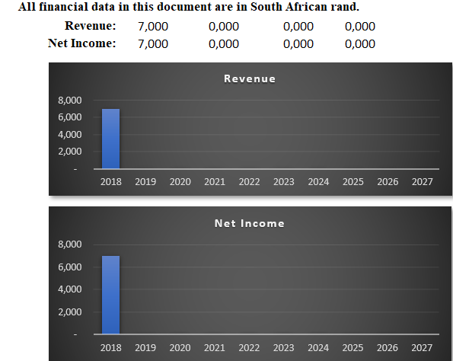

## Financial Ratios

|  |  |  |  |  |  |  |
| --- | --- | --- | --- | --- | --- | --- |
| **Financial Ratios** | | | | | | |
|  | | | | | | |
|  |  | 2018 | 2019 | 2022 | 2027 | |
| **Gross Margins:** | | 100% | N/A | N/A | N/A | |
| **Operating Margins** | | 100% | N/A | N/A | N/A | |
| **Net Profit Margins** | | 100% | N/A | N/A | N/A | |
| **Return on Assets** | | N/A | N/A | N/A | N/A | |
| **Return on Equity** | | N/A | N/A | N/A | N/A | |
|  | |  |  |  |  | |
|  |  |  |  |  |  |  |
|  |  |  |  |  |  |  |
|  |  |  |  |  |  |  |
|  |  |  |  |  |  |  |
|  |  |  |  |  |  |  |
| |  | | --- | |  | |  |  |  |  |  |  |
|  |  |  |  |  |  |  |
|  |  |  |  |  |  |  |
|  | | | | | | |
|  |  |  |  |  |  |  |
|  |  |  |  |  |  |  |
|  |  |  |  |  |  |  |
|  |  |  |  |  |  |  |
|  |  |  |  |  |  |  |
|  |  |  |  |  |  |  |
|  |  |  |  |  |  |  |
|  |  |  |  |  |  |  |
|  | | | | | | |
|  |  |  |  |  |  |  |
|  |  |  |  |  |  |  |
|  |  |  |  |  |  |  |
|  |  |  |  |  |  |  |
|  |  |  |  |  |  |  |

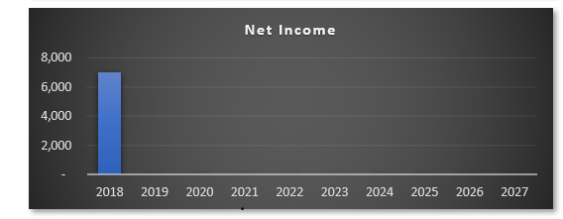

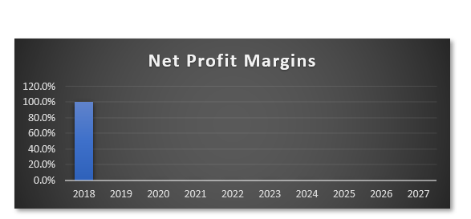

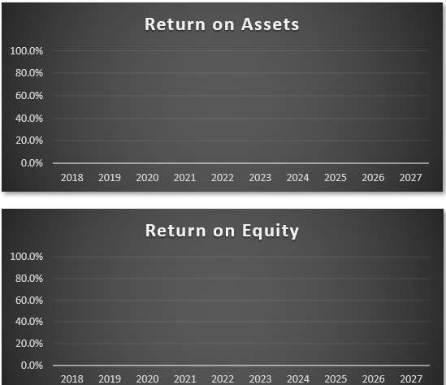

## Monthly Revenue Forecast

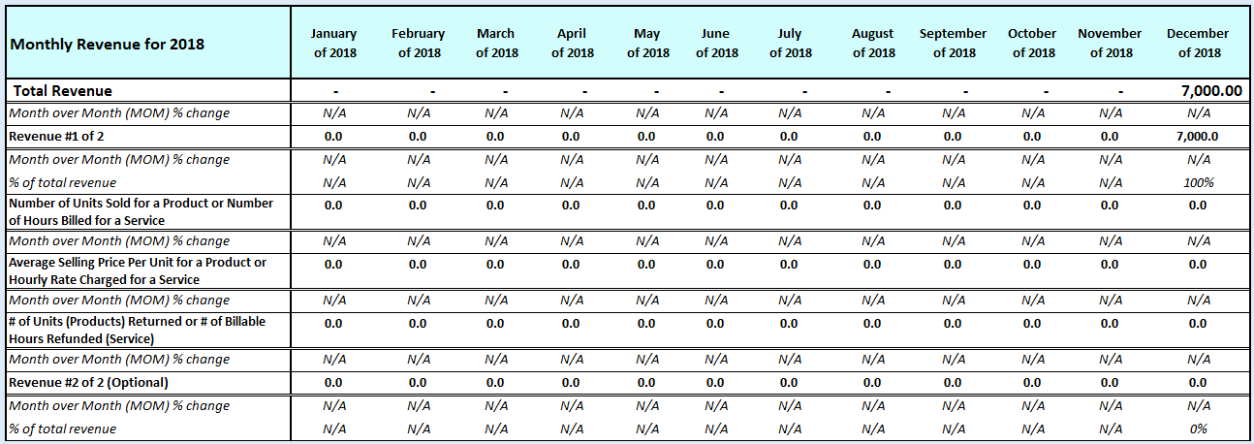

## Quarterly Revenue Forecast

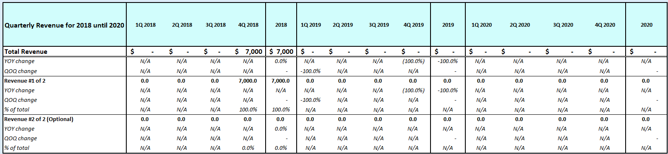

## Annual Revenue Forecast

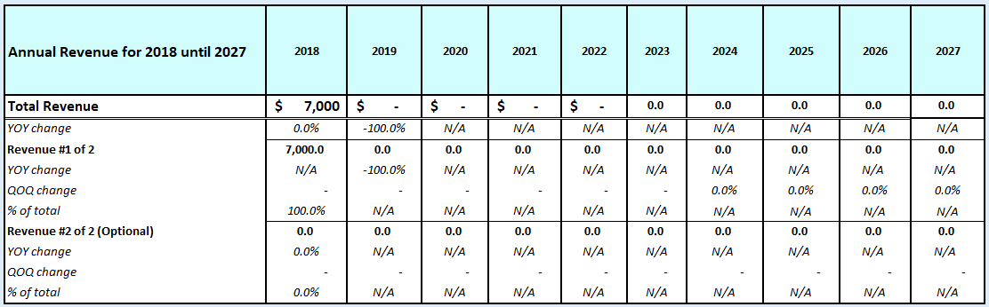

## Monthly Operating Income Expenses Forecast

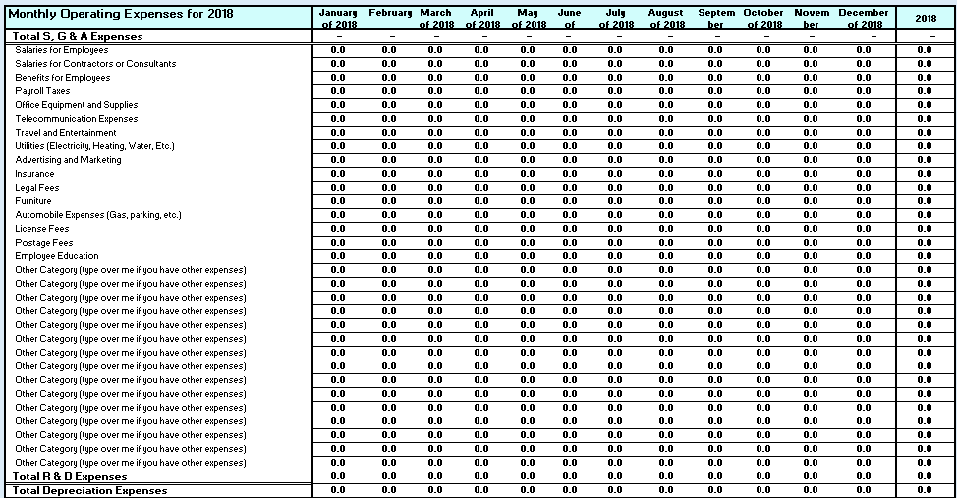

## Annual Operating Income Expenses Forecast

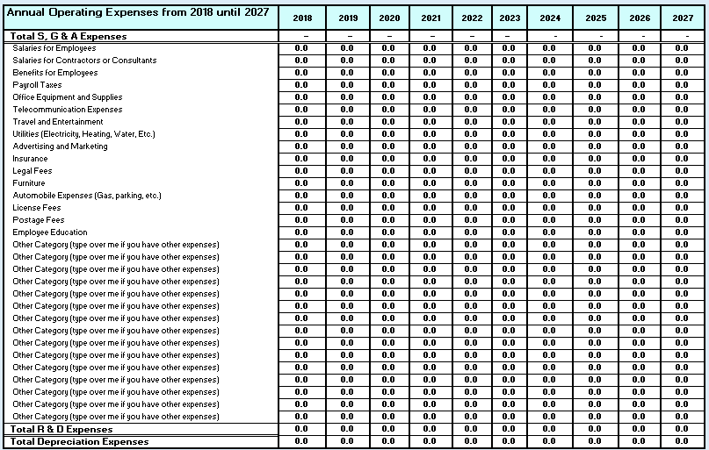

## Quarterly Income Statement

## 

## Annual Income Statement

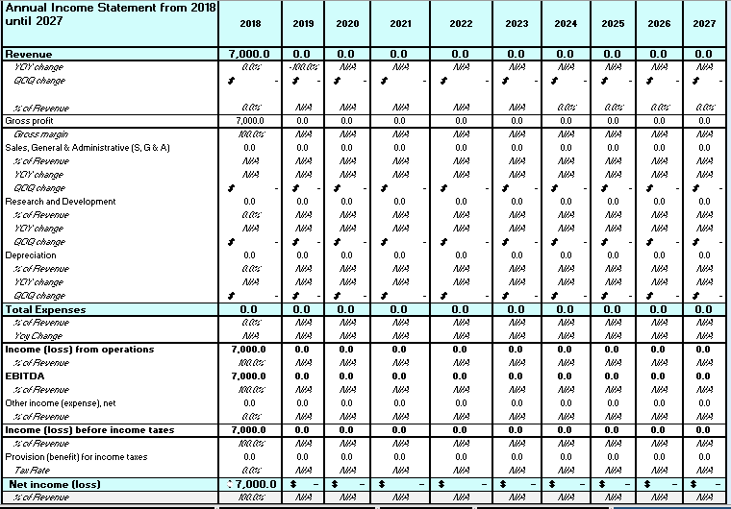

## Quarterly Balance Sheet

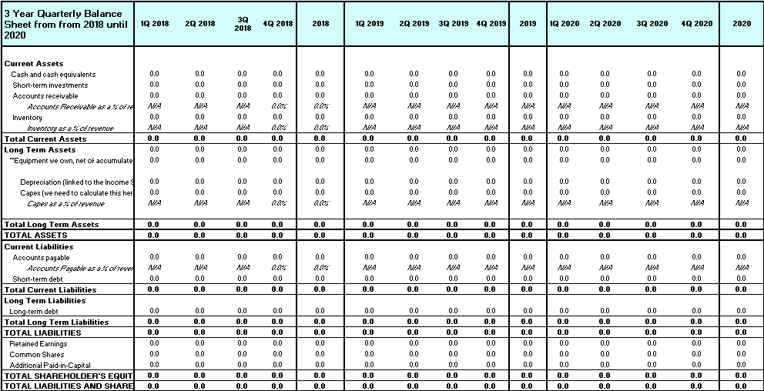

## Annual Balance Sheet

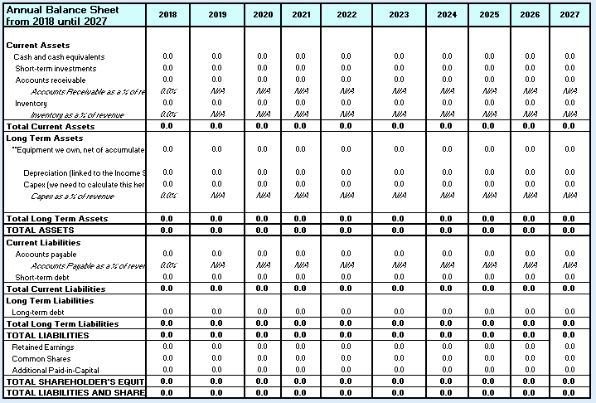

## Quarterly Cash Flow Statement

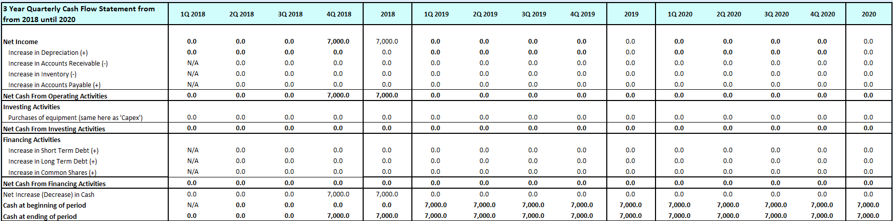

## Annual Cash Flow Statement

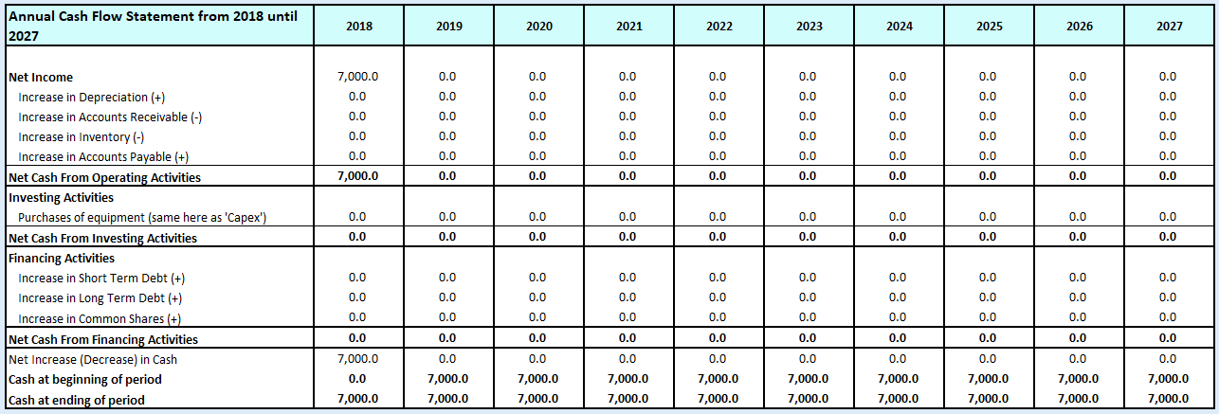

# Appendix

## Employee #1 Resume

I recommend pasting special as an image as many of your appendix items as you can, while ensuring that the size of this document does not get too large (if you intend to email your document).

## Employee #2 Resume

## Employee #3 Resume

## Employee #4 Resume

## Employee #5 Resume

## Employee #6 Resume

## Employee #7 Resume

## Employee #8 Resume

## Employee #9 Resume

## Employee #10 Resume

## Outsourced Partners #1 Resume

## Outsourced Partners #2 Resume

## Outsourced Partners #3 Resume

## Outsourced Partners #4 Resume

## Outsourced Partners #1 Resume

## Marketing Materials (Brochures)

## Customer Testimonials/References

## Additional Appendix Items

(i) Cover Page

(ii) Table of Contents

(iii) Executive Summary

(iv) Product and/or Services Plan

(v) Marketing Plan

(vi) Operations Plan

(vii) Management Plan or structure

(viii) Financial Plan plus

(ix) Appendices

9-4

[Optional] Suggestions (not a question) that might help you to write your marketing / social media portion of your business plan:

Check out how your more established competitors use social media (Instagram, YouTube, Facebook, Twitter, LinkedIn, etc.)

Repurpose content often (meaning if you write an article in LinkedIn, use a quote from the article and send over Twitter or Instagram, etc.)

Create content online daily (yes - and please be a thought leader in your industry) as it gets indexed in search engines and it costs you nothing (please see my Twitter account or LinkedIn account or Instagram account or YouTube account, etc). If you want to learn how to write like a journalist does, please watch this video: https://www.youtube.com/watch?v=rg24V2YmFms

Make sure that you are collecting email addresses on your website (yes email is old school, but no other distribution channel is more profitable). You can use MailChimp.com or ActiveCampaign.com

Consider writing a book and giving it away to your potential customers or partners. It is easy to do and I want to help. As such, please download my how to write a book template for free here: http://harouneducationventures.com/write-book

Use Google Analytics or the analytics on the website platform that you are using (i.e., Squarespace.com has decent analytics so you can see who your customer is).

Give give give to customers to add value and I promise you, that in the long run, you will establish brand loyalty (it always takes time when marketing...but please stick with it).

Make sure you have links in your emails or in your online newsletter or on your website to all social media links (Twitter, Facebook, LinkedIn, Instagram, etc.)

/////////////

9-5

[Optional] More Suggestions (not a question) that might help you to write your marketing / social media portion of your business plan:

If social media is overwhelming for you, check out Hootsuite.com as a way to distribute all your social media content through one platform.

Make sure that your LinkedIn profile is superb (and all your employees' LinkedIn profiles are great too). For help on how, please watch this video: https://www.youtube.com/watch?v=BilffCxJOa4

I will use Google Alerts on my brand or my competitor's brand in order to better understand how the market perceives what my brand is!

If I find out that all this social media stuff is complicated, then I will hire a younger intern as they get it better than I do

If I have to make professional looking brochures to give to potential customers, I will consider outsourcing the creative process at www.fiverr.com

If I want to set up a Vlog or create YouTube videos, It is explained here how to create one : https://www.youtube.com/watch?v=hHYAjypBQLE

If you don't have a website, I recommend SquareSpace.com as it is easy to set up and maintain (or WordPress.com).

////////////////

9-2

For instance, under the new system, a portion of compensation was based on customer satisfaction surveys, the number of prospective accounts visited (even if they didn’t buy), and the retention of existing accounts.

Although there are fewer academics studying sales force compensation and management than researching trendy marketing subjects, such as the use of social media or digital advertising, in the past decade it’s become a fast-moving field.

///////

The world’s #1 enterprise cloud platform, with all the tools and services you need to build apps. Building apps is critical for business success today. But how can you keep up with customer and employee demand for apps? You need an all-encompassing, blazing-fast platform that can connect, integrate, and give anyone from developers to business users all the tools they need to build apps fast.

**/////////**

**6. Key Success Factors**

**Strategy and Key Success factors**

The mission will be achieved by adopting the following strategic objectives: -

• Become the dominant force with-in the region in the food Industry

• Provide the best Quality food

• Provide the best Service and give a relaxing tranquil environment

• Increase revenue and maximise profits and grow the business in the region

• Unite all nations and create Business and social networking safe Environment as MOYO provides

a wide variety of food offering catering for most of South African Cuisine and Other African and

international Cuisine. Hence “Celebrating Africa Together United”

• Become the preferred service provider.

• Good governance, legal compliance and sound financial discipline

//////////////////

**Public Relations**

Public Relations efforts in this regard will include:

1. Contacting and article submissions to newspapers, magazines, trade publications on industry issues to

provide them with new and fresh content through the featuring of local and regional information, service

information etc. that are available at Moyo. Bontal will choose relevant publications, editorials, local

newspapers and online blogs where it can submit industry relevant articles.

2. Such published articles may then be included in the pre-defined communications to provide third party

endorsements and boost credibility. Contact information links will ensure that such enquirers’ contact

details are captured for inclusion in the marketing campaigns.

3. Develop a sustained public relations effort, with on-going contact between key editors and top-level

personnel across the relevant industries in South Africa.

4. Develop a regular and consistent package update programmed for the major target media keeping key

editors and industry stakeholders abreast of all new developments at Moyo.

Bontal plans to reach its target market through conventional marketing methods, which have been proven

to be effective. They are:

1. Lead Generation Program.

Bontal will do a direct and regular online mailing to potential customers.

2. Databases

Register on all databases of registered companies that require our services in order to be included in all new

contract and service opportunities.

3. Print media.

26

This includes newspapers, brochures, flyers and other special promotional items to market the company.

4. Referrals.

Referrals will form a considerable portion of the company’s business.

5. Radio.

Bontal will engage different radio stations for marketing and brand awareness purposes.

6. Business Development.

Including cold canvassing, business development, networking; this will be managed by the Director.

7. Strategic Partnerships

WE intend to put MOYO as the centre of attention with in Durban. Our plan is to Affiliate the store with

Travel, Agency, Hotels B&Bs we will offer them packages that will benefit them as well as the store. Some

will receive incentives and some commission depending on the agreed Packages

We will partner with Events companies and Event Organisers, Music markers and Fashion designers to

Host some of their launches Music shows or any other high profile events at MOYO. We can cater for the

premium events in the lounge and others in the main Restaurant

We will also partner will local business and corporate business we will offer them packages for

companies to Host Meetings, After Parties, Seminars, business Breakfast/lunch meetings.

We will also partner with local Government, Tourism Department, offer them packages that will be

competitively priced. We plan to become affiliated with most of the Tourism events that will be held in

Durban such as the Durban July, J&B MET and many more. We plan to be the preferred Pre-launch and

After Launch venue.

We will also partner with sporting agencies and fraternities e.g. Amazulu and other Celebrity Agencies.

The reason for this is that our society hangs around where the celebrities are, if we can get the approval of

the rich and the famous, the rest will follow.

Marketing Programs

1. Procure and establish industry databases nationally that are split into industry sectors and segments,

designations, addresses, e-mails and contact numbers.

2. Use databases to create mailing lists for service launches and niche e-campaigns.

3. Conduct client satisfaction surveys, industry needs analysis, develop and manage several on-going

rewards and recognition/ customer loyalty programmers, etc.

4. Use above and below the line tactics, e.g. brochures and flyers, newsletters (print and online),

publications and editorial adverts/ banners in relevant magazines, online surveys and competitions, etc.

**Revenue Model**

27

Bontal’s revenue model is based the standard restaurant franchise revenue model. This model is centred on

the provision on high end African cuisine to the local and tourist market in the Durban Beach area. Revenue

is generated from sale of food and beverages. Bontal’s revenue model is strengthen by the fact that it is a

franchise model spearheaded by the Fournews development company which is an established franchise

player. Below is a diagrammatic outline of the business model.

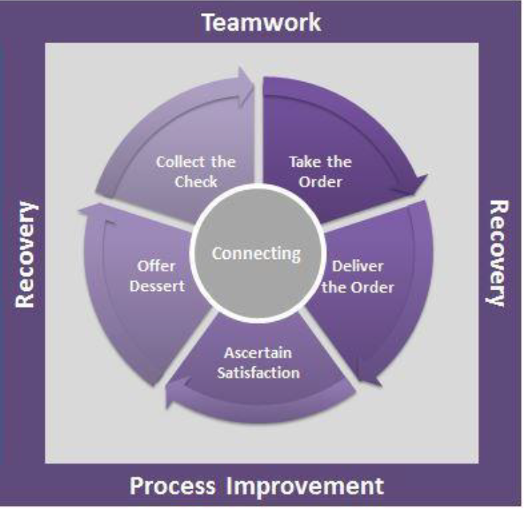

NBNBNB

**Management & Employee Organogram**

///////