

Lesedi Software Innovation (PTY) LTD .

*We provide mobile and web application solutions for the complete software development life cycle services and offer software development training.*

**Business Plan**

4 May 2020 .

**Phillip Mandla Mtombeni .**

pmtombeni@gmail.com .

2776-568-5999 .

bulldog-pumpkin-f2wy.squarespace.com .

4 Midrand Ridge, George Road, Noordwyk Ext 1, Midrand 1687 .

Contents

Description of Organisation 7

Organisational mission 7

Long term objectives 7

Industry description 8

Competitive Analysis 8

Key success factors 8

SWOT Analysis 9

Largest Competitor Description 9

Strengths of Largest Competitor 9

Weaknesses of Largest Competitor 9

2nd Largest Competitor Description 9

Strengths of 2nd Largest Competitor 9

Weaknesses of 2nd Largest Competitor 10

3rd Largest Competitor Description 10

Strengths of 3rd Largest Competitor 10

Weaknesses of 3rd Largest Competitor 10

4th Largest Competitor Description 10

Strengths of 4th Largest Competitor 10

Weaknesses of 4th Largest Competitor 10

Discussion of Our Strengths Compared to the Competition's Strengths 11

Discussion of Our Weaknesses Compared to the Competition's Weaknesses 11

Discussion of Our Management Compared to the Competition's Management 11

Discussion of Our Price Strategy Compared to the Competition's Price Strategy 11

Growth Potential Strategies 11

Executive Summary 12

Company and Market Overview 12

Target Customer 13

Market Problem & Solution 13

Significant Recent Company Milestone 14

Management Team Overview 15

Management Team 15

Board/Advisors 15

Employee Recruiting Strategy 16

Employee Incentivizing, Motivation and Retention Strategy 16

Additional Resources to Hire 16

Product/Service 17

Product/Service Overview 18

Quality Control 18

Packaging 18

Production 18

Current Price Strategy 18

Future Price Strategy 19

Bundle Price Strategy 19

Volume Discounts 19

Financing 19

Distribution Strategy 19

Return Policy 20

Who is the Customer? 21

Customer Analysis 21

Customer Concentration 21

Customer Attainment Strategy 22

Customer Service 22

Customer Response Time 22

Customer Loyalty Program 22

Customer Profile Documentation 22

General Industry Trends / Drivers 23

Industry Risks 23

Warranty Policy 23

Industry Search Trends 23

Barriers to Entry 24

Total Addressable Market (T.A.M.) 24

Percent of the T.A.M. We Plan on Capturing in 5 Years 24

Seasonality 24

Go-to Market Strategy 25

Online Distribution Strategy 25

Offline Distribution Strategy 26

Direct Distribution Strategy 26

Indirect Distribution Strategy 26

Cost of Distribution 26

Sales and Marketing Strategy 27

Sales Strategy 27

Sales Force Structure 27

Marketing Strategy 27

Online Marketing (Social Media) Strategy 27

Lead Generation Strategy 28

Offline Media Strategy 29

Operations 30

Milestones 30

Future Milestones 30

Future Products or Services Milestones 30

Future Revenue Milestones 30

Future Break-Even Milestone 30

Units Sales Milestones 31

TAM Milestones 31

Profit Margins Milestones 31

Geographic Milestones 31

Other Future Milestones 31

Future Exit Strategy Milestones 31

Past Milestones Achieved 32

Revenue Milestones Achieved 32

Units Sales Milestones Achieved 32

Profit Margins Milestones Achieved 32

Products or Services Milestones Achieved 32

Geographic Milestones Achieved 32

Other / Miscellaneous (i.e., Risks) 33

Future Technology Development Risks that Can Impact Our Business Model 33

Future Competition Risks 33

Macroeconomic Developments Risks 34

Disaster Recovery Strategy 34

Other Potential Risks 34

What is the Most Misunderstood Aspect of Our Business Model? 35

Financials 36

Revenue and Net Income Forecast Highlights 36

Financial Ratios 37

Monthly Revenue Forecast 40

Quarterly Revenue Forecast 41

Annual Revenue Forecast 42

Monthly Operating Income Expenses Forecast 43

Annual Operating Income Expenses Forecast 44

Quarterly Income Statement 45

Annual Income Statement 46

Quarterly Balance Sheet 47

Annual Balance Sheet 48

Quarterly Cash Flow Statement 49

Annual Cash Flow Statement 50

Appendix 52

Employee #1 Resume 51

Bibliography 61

Description of Organisation

Lesedi Software Innovation (PTY) LTD (Pty) is an independent, 100% Black owned and

managed organization established to take advantage and identify commercial opportunities specifically in the IT sector. Lesedi Software Innovation (PTY) LTD is an existing business, it is a South African based Limited Liability Corporation which provides mobile and web application solutions for the complete software development life cycle services a. We also offer software development training. It is owned by Mr Phillip Mandla Mtombeni, the company is venturing into the Information Technology industry it is located in Johannesburg.

**Organisational mission**

Lesedi Software Innovation (PTY) LTD a  close corporation . Our ’’ mission is to design mobile, web applications and offer software development training for different clients. We will do so by offering high-quality software applications and training . The company will offer services to startup companies and big companies. “To celebrate Africa United Together” – Nowadays people are living different lives and stand by various principles but information technology is one thing that can always bring individuals together regardless of Political, Social Status, Race, Religion and Affiliation which is a Tranquil Environment, Good Customer Service and Good Quality Product.

**Long term objectives**

Lesedi Software Innovation (PTY) LTD has identified the following goals and objectives to be achieved :

• Conducting regularly research into the IT industry so that we do not only have a

comprehensive understanding of the local and global market developments but also the industry challenges and composition, existing statistics and future trends.

• Provide and identify a good working environment for employees of Lesedi Software Innovation (PTY) LTD and also create relationships with the organization’s potential clients by having a meeting with their decision makers and plotting a mutual plan for success.

• Implementing suitable management control systems for the different business elements.

• Offer enough training for our employees and ensure transfer of skill from top down.

• Launching new site sight by September 2020.

• Start office renovations in August 2020.

• Securing proposed funding amount by end July 2020.

• Formalizing organization’s funding arrangements with the targeted funders, involving formalization of amount of funding and exit strategies.

**Industry description**

Although Lesedi Software Innovation (PTY) LTD is in the early stages of growth, our offerings have been proven in the marketplace for several years. The majority of our initial focus will be on software development, client development, and course content creation. Lesedi Software Innovation (PTY) LTD is a development-stage company. It does not currently have a client base nor is there an existing revenue stream at this time. Our current products consist of mobile application web application and one classroom instruction courses and related consulting services. We are in the process of refining our content, defining and documenting new content and courses and identifying both additional instructors for the courses and target clients. We operate in the IT industry we develop websites, mobile and web application, in addition we provide software development training.

**Competitive analysis**

Competitive analysis can be defined as categorizing competitors and evaluating their strategies to determine their strengths and weaknesses comparative to those of Moyo Franchise products or services. Competitive analysis is seen as an essential part of the marking plan for a business (Fleisher and Bensoussan, 2015).

**Key success factors**

The mission is going to be obtained by adopting these strategic objectives:

• Good governance, sound financial discipline and legal compliance.

• Grow the business in the region, maximize profits and increase revenue

• Provide the best service

• Provide the best product

• Become the dominant force with-in the region in the IT Industry

• Uniting each and every nation, create social networking , business, and safe environment as LESEDI offers a broad variety of software applications catering for most of South Africans and other African and international clients . Hence “ To Celebrate Africa United Together”

• Become the preferred service provider.

**SWOT Analysis**

## **Largest Competitor Description**

Microsoft higher reality product called Visual Studio (which has materially high quality than Lesedi Software Innovation), costs R19000* and is targeted at PC programmers . The Visual Studio runs on Windows 10 platform product. Visual Studio was first released in 2004 (Microsoft was founded in 1975 in United State and generates more than $4bn USD annually in revenue).

## **Strengths of Largest Competitor**

Microsoft is a big company; they have many customers and they are operating worldwide.

## **Weaknesses of Largest Competitor**

They do not know some of the potential clients, startups or small companies in the country.

## **2nd Largest Competitor Description**

EOH consulting company

## **Strengths of 2nd Largest Competitor**

They know banks procurement people or department

## **Weaknesses of 2nd Largest Competitor**

They were involved in the corruption scandal involving Gupta family

## **3rd Largest Competitor Description**

Exponant offer software products using java, they were founded in 1998, it is a small company , they are based in Centurion.

## **Strengths of 3rd Largest Competitor**

Read newspapers looking for government , they also check government gazette

## **Weaknesses of 3rd Largest Competitor**

Top management is only white people , they often lose government tenders because of their BEE status.

## **4th Largest Competitor Description**

Zande

## **Strengths of 4th Largest Competitor**

They look at government gazette to find tenders offered by government

## **Weaknesses of 4th Largest Competitor**

Not well known

## **Discussion of Our Strengths Compared to the Competition's Strengths**

We can target small companies or startups with lower budget and also target medium to big corporates and convince them to become my clients plus with experience that I have we managed to build good relationship with some of the companies that I worked when I was still a consulted, I managed to network and build strong relationship.

## **Discussion of Our Weaknesses Compared to the Competition's Weaknesses**

Weakness includes lack of funding and taking the initiative to know the banks procurement people, plus lack of marketing and advertising.

## **Discussion of Our Management Compared to the Competition's Management**

Our company's management team has highly qualified managers from the best institutions including UNISA, Regenesys Business School and Regent Business School.

## **Discussion of Our Price Strategy Compared to the Competition's Price Strategy**

My prices are affordable because I want to attract new customers and startup normally customers prefer cheaper prices

**Growth Potential Strategies**

Growth strategies are common methods a company or organisation can use to expand its business (McDonald and Wilson ,2016). The business expansion is mostly due to a company’s financial situation, the competition or even due to government regulation. The Ansoff’s Product-market matrix suggests that an organisation’s attempts to grow its business depend on whether it markets new or existing products in a new or existing market. From the Ansoff’s Product-Market matrix a series of suggested growth strategies that set the direction for business strategy are discussed as follows:

•Market penetration – selling more of the same product or services to the same type of customers. For the market penetration strategy, the business focuses on the market or products it knows well.

• Diversification – selling new products to new customers. For the diversification strategy, the

business focuses on marketing new products in the new market.

• Product development – selling new products or services to existing customers. For the Product

development strategy, business focuses on introducing or developing new products into an existing

market.

• Market development – selling the existing products to new type of customer. For the market

development strategy, the business focuses on a new geographical market or new distribution

channels to create a new market segment.

**Executive Summary**

## **Company and Market Overview**

The size and growth of the total addressable market is $50 billion for the IT industry and $150 billion for the Software Development industry for a combined total of $200 billion respectively. Lesedi Software Innovation (PTY) LTD plans on capturing 1% of the market in 5 years. Lesedi Software Innovation (PTY) LTD is intending s to become a dominant force in the region in terms of the software development industry, currently it is a small company, we want to grow it into an international giant.

**Impact of Economic Development and Empowerment**

• Employment opportunities is going to be at least 85% historically disadvantages individuals

• Lesedi Software Innovation (PTY) LTD is a hundred percent (100%) black owned company.

• Business established in the IT sector specifically mobile and web application industry.

**Safety and Health**

• Treat each minor incident of safety negligence at work in a very serious light.

• Public and worker safety is of utmost importance to us and we value quality.

**Target Customer**

The company's initial target market is websites, mobile and web application fans located in South Africa. In 5 years, the target market will be customers located in other parts of Africa, The United States, Canada, India, United Kingdom, Australia and New Zealand.

Lesedi’s target market includes:

•Government department

• International IT Market

• Local IT Market

• Local Residents Market

• Corporate Market

• Family Market

•Adults who own small companies

•Young adults, age 16-22 who want who needs training on software development

•Startup owners who need websites for their companies

•Big corporates companies

**Market Problem & Solution**

The problem with Information Technology is that software development growth is low and expensive. Lesedi Software Innovation (PTY) LTD solves this problem through a brand new, high-margin distribution channel for different companies. The other issue is that the recent *Hay Global Skills Index* notes that the growing skills mismatch remains one of the key problems of the global job markets. Consequently, the main tasks of educational institutions will be the development of new curricula that better match the demands of digital era job market.

The lack of appropriate education has produced graduates who cannot find commensurate jobs primarily because our education system has failed them. They simply lack the necessary skills and competencies of the digital era job market. As a result, a large percentage of our graduates have become an integrated statistic (63 percent) of the largest youth unemployment drama in the world. To meet the challenges of the skills needs for the digital era, Lesedi Software Innovation(Pty) Ltd offers software development training which is transformed in ways that allows students to acquire the creative thinking, flexible problem solving, collaboration and innovative skills. The 21st Century has introduced an increasingly complex, competitive and fast-paced labor market which has evolved with new types of jobs, professions and occupations that require a new set of skills for agile and collaborative work teams.

## 

## **Significant Recent Company Milestone**

A recent milestone achieved by Lesedi Software Innovation (PTY) LTD is exclusive contract signing with Bryston company. The company intends on raising R9,000,000 ; the use of proceeds is to hire 2 software engineers and to open an office in Sandton . The intended exit strategy is through an Initial Public Offering and/or selling the company. The management team members currently have three major sets of responsibilities: running the organization and creating/delivering our mobile, web application, and offer training as instructors. Organizationally, members of the management team will also be software developers, instructors and course creators. The growth of the team will be contingent upon Lesedi Software Innovation (PTY) LTD achieving sufficient scale to support a larger organization or upon the need to add a specific area of expertise to our product offerings.

**Management Team Overview**

## 

## **Management Team**

|  |  |
| --- | --- |
| CEO and Founder: Phillip Mandla Mtombeni | |
|  |  |
|  | Phillip Mandla Mtombeni founded Lesedi Software Innovation (PTY) LTD in 2016. He is a very experienced with over 14 years working as software engineer, with significant software engineering work experience at Department of Education, University of Johannesburg, Standard Bank, and Exponant he led the Development Team. Mandla Mtombeni has previous work experience in the software development division of Wesbank, where he created the content platform software distribution business model. He also started a software company . Mandla Mtombeni has an MBA from Regent Business School , Honors in Computer Science from UNISA, and postgraduate diploma in business management from Regenesys Business School, and an undergraduate degree from University of Free State, where he graduated 2nd in his class. |
|  |

**Board/Advisors**

People formally elected with legal responsibilities, typically not needed until a business receives outside investment and has shareholders. Serves as experts on special topics and responsible for holding management accountable to shareholders. Currently Lesedi software Innovation does not have the board.

## **Employee Recruiting Strategy**

We recruit employees that have significant software development practical experience, including engineers that have worked at large IT companies, founders of IT companies and advanced research and development computer science PHDs from top universities. The common element that all of our employees have is a passion for disrupting the entire IT industry using next generation software technologies. Everyone at Lesedi Software Innovation is a team player, affable, hungry and ethical.

The aim is to design an employee recruitment strategy that is innovative, relevant, people-focused and driven by business needs. In an ecosystem where the conversation between the organization and the candidate is changing quickly by becoming more transparent, strategic and individualized, recruitment strategies must evolve. This is a structured action plan to effectively and efficiently identify talent pools, attract candidates and get the best-fit talent onboard. Our aim is to build inroads into quality talent pools, encourage applications and to reduce the cost and time to hire, having the right hiring strategy in place is a prerequisite

## **Employee Incentivizing, Motivation and Retention Strategy**

We believe in a solid work or life balance. As such, we allow all employees to work from home, which keeps our costs lower and morale very high. We offer generous stock options as well, with a vesting period of 4 years for each annual stock option grant.

## **Additional Resources to Hire**

We are looking to hire a full-time engineer with back end i.e. experience in foreign markets. We are also looking to hire a part-time data entry employee.

**Product/Service**

## **Product/Service Overview**

We offer boutique mobile and web solutions for the complete software development life cycle services and software development training. Each application is designed to fill a specific skill gap. Software applications and training will be done at Lesedi Software Innovation (PTY) LTD head office. Once a software application is completed a client can be able to download software application from Lesedi Software Innovation website, a link will be sent to the client , over the phone, or via email and a link to our training material can also be sent to our clients. Our initial set of applications offerings (existing and planned) are:

**Mobile Applications** are designed to improve client’s abilities to sell their products , prioritize their efforts, gain support for their ideas and communicate their results clearly, compellingly and succinctly.

**Web Application** will allow basic business strategy frameworks and methods for assessing and capturing market opportunities.

**Websites** this a static website which contains about us page and contact details of the clients.

**Training** also offer online software development training to our clients can get software development courses by registering on our website . We offer software development or programming training.

In addition to these applications we also have course offerings, we train clients to develop and create their own mobile and web applications services (both hourly-based and fee-based services) focused on specific client and participant needs. Some of our clients are startup companies the owners of these startup companies are using public transport for example taxis, buses, uber and trains.

**Quality Control**

Our quality control process is superb as we test our software application 3 times post manufacturing. In addition, content that we deliver to customers over mobile and web application Platform is upscaled to 4K quality (if available and if the broadband connection is high speed) and downscaled to 720 resolution (if the broadband connection is not high speed).

We offer a certified service which means that our products are utilized having passed different quality control tests.

## **Packaging**

The downloading of the mobile application is a minimalist process, where the consumer clicks on Apple App store types the application name and then click on the search button then he clicks on get button to download the mobile application on his phone ,once downloaded he can click on open button to open the application. The process is low cost . In addition, the application can also be downloaded from the Microsoft app store and the user must follow the same steps mentioned above.

## **Production**

In order to ensure that we do not have material inventory issues, mobile and web is created and deployed to production by the company owner . Once the consumer places the order. The software final product is then produced, deployed and delivered to customers in 1-2 weeks. In the future, we plan on allowing customers to customize the product with their own colors and higher priced options.

## **Current Price Strategy**

Customers purchase mobile and web application, we charger R650 per hour plus a R300 monthly subscription fee, which provides consumers with system download per month. Customers have the option to pay annual subscription fee at a lower price of R1200. We also charge customer maintenance fee of R650 per hour. For example, if the client wants to add more functionality or add enhancement on the existing mobile and web application

## **Future Price Strategy**

In the future, we plan on upselling live streaming content for R200 + prices for static website, mobile application, web application, database maintenance , etc. We also plan on cross-selling content for R75 per update.

## **Bundle Price Strategy**

We are currently in late stage discussions with Microsoft on potentially bundling our product with ultra-high end.

## 

## **Volume Discounts**

We offer 10% discount for our first-time users who require website, mobile and web application. We also offer training discount to students who want to learn about software development. We provide educational discounts of R200 for our students if educational institutions purchase lots of training courses.

## **Financing**

We plan on offering financing options for the training courses. We are currently discussing this strategy with the 3 largest financing companies.

## 

## **Distribution Strategy**

The mobile and web application are sold on app store, google store , training courses are currently sold online via Facebook . We plan on also selling the training courses on our website and through Best Buy's retail stores. Our customers will be obliged to register as a member on our website the first time they visit. Once registered, they will be required to sign-in on each future visit. When signed-in, our clients will have access to the wide availability of software applications and training courses.

Through the use of the internet our clients will be able to choose software application that they prefer ,they can also choose training course that they are interested in . We are optimistic that social media company will help us sell our products through the Apple Store and google play in the future. Software applications are sold online through our monthly subscription service; customers can download our product to their iPhone, windows phones, Windows or Mac computers.

Once the software application is downloaded to the customer's phone or computer. The application is also registered to our customer when downloaded to their phones and computers for the first time (we ask for the customer's email address so we can upsell or cross sell future content). The customer also enters in their credit card number before software application is downloaded to their phones or computer, then they can download application once we have confirmed that the payment has been processed. We use direct (mail order, Web, catalog). In the future we plan on using agents and independent representatives so that we can increase our sales.

## **Return Policy**

We offer a 15-day 100% refund policy to all our Prime customers and a 20% restocking fee charged to other customers of our mobile and web product.

**Customer and Market Commentary**

## 

## **Who is the Customer?**

Customer Analysis

"Based on our extensive customer research*, our ideal customer is a mobile and web application lover, an early adopter when it comes to new technology products, over 16 years old, lives in large cities, has an undergraduate university degree, is interested in computer programming and loves music. For the next two years, we are targeting consumers in South Africa. In five years, we will also target consumers in Unite State, India, The United Kingdom, Australia and New Zealand. There are major customer segments in our market: government departments, employees, managers/executives and training directors. Each segment requires our services for different reasons. Employees will demand and purchase our services because they will improve their own skills thereby improving their job performance and enhancing their careers. Managers/executives will require and purchase our services to improve their business unit productivity and profitability/performance. Training directors are typically required to seek out and deliver high quality training to their organizations. They will purchase our services to meet their goals of delivering great content to their business partners in a cost-effective manner.

## 

## **Customer Concentration**

We do not have customer concentration issues as no customer comprises more than 1% of total revenue.

## **Customer Attainment Strategy**

Given how revolutionary our products are. Going forward, we plan on using Twitter, Instagram, Facebook advertising, which we discuss in detail in the Sales and Marketing part of this business plan. We also plan on using Google ads and YouTube, as it is now the second largest search engine.

## **Customer Service**

In addition to having a detailed FAQ section on our website, the Apple and Android app downloadable versions of our product contain a step by step guide on how to use our product, configure our product and troubleshoot the use of our product. We will offer additional email support initially and Bruce Banner will offer telephone support. Based on the volume of inbound calls we receive; we will quickly hire offshore telephone support personnel or outsource the job function.

## **Customer Response Time**

In most cases, customers only contact us if they cannot find the answers to their questions on our FAQ webpage. The customer education video that our customers watch is incredibly well-made that we are pleasantly surprised by the small number of customer questions that we receive. In addition, our customers are incredibly loyal, and they often create their own YouTube videos and Quora.com content to help our other customers. Takes 1 day

## **Customer Loyalty Program**

## **Customer Profile Documentation**

When customers register their purchased products, they enter their email address and they can opt in to receiving updates on new mobile and web applications, new 1-time higher priced special events media purchases and software upgrades for the products. Given the fact that we provide the value of offering free platform (operating system) upgrades for the products, we do not expect many customers to opt out of the email distribution list. We document and track all customer details using ActiveCampaign.com (discussed in more detail in the Sales and Marketing part of our business plan).

## 

## **General Industry Trends / Drivers**

The problem with the IT market is that the growth of the market is anemic and large media companies are looking for ways to reignite revenue and profitability growth. We believe that our company solves the problem that large media companies are having with anemic growth, as our company offers a very high margin and scalable revenue model with high visibility given the nature of our subscription offering; we are confident that software programming is the key future growth driver for the IT market.

## **Industry Risks**

A material risk with the media industry is the threat of piracy. All of our content is streamed to consumers with embedded digital signatures that are specifically encoded to only allow the content to be streamed on a unique registered product. We filed a patent on this process.

## **Warranty Policy**

We offer a 1-year warranty on the sales of our software product.

## **Industry Search Trends**

Based on our analysis of the industry trends using Trends.Google.Com., we have noticed that search volume-based interest in our industry has seen accelerated growth over the past 12 months.

## 

## **Barriers to Entry**

We believe that a material barrier to entry in our industry is the complex technical nature of our patented IT product, our patented streaming technology and our patent pending anti-piracy technology.

## **Total Addressable Market (T.A.M.)**

The Total Addressable Market (T.A.M.) size of the market that we compete in is $5.2 trillion for the current size of the entire market that I am targeting(also called the Total Addressable Market: TAM). The growth rate of the T.A.M. is 3.2% for the IT industry. [Source: IBIS World for the IT industry data ,total for the IT industry, and report linker: https://www.reportlinker.com/market-report/ICT/597055/Information-Technology?gclid=Cj0KCQjwhZr1BRCLARIsALjRVQNq5-FAJTJivPnT4GRXRzGWh5S3IiXaFwkQ2bfBfabW1pvCJyYpn6gaAi4cEALw_wcB https://www.toptal.com/finance/market-sizing/total-addressable-market-example https://www.ibisworld.com/united-states/market-research-reports/it-consulting-industry/]

## **Percent of the T.A.M. We Plan on Capturing in 5 Years**

The percent of the T.A.M. market share that we are planning on attaining in 5 years is 1%. Please see the Income Statement portion of this business plan to see our revenue projections.

## **Seasonality**

Our product's bestselling month is January, given holiday Black Friday shopping trends. July and August are the lowest selling months given vacation schedules. The subscription revenue is much less seasonal, which helps us achieve high revenue visibility trends.

# 

# Go-to Market Strategy

## **Online Distribution Strategy**

Our marketing strategy concentrates on identifying unmet software application needs in organizations and designing our software application offerings on filling critical skill gaps. Each software application offering is designed to help participants concepts and skills to meet specific needs. Because we also offer software development training, we will create trial courses for our clients, meanwhile trial courses will generate initial interest and demand for our training, manager mandate, incorporation into formal client training programs.

The quality of our mobile ,web application, instructors and our instruction materials are the strongest elements of our marketing plan. We will use online distribution by visiting government websites and apply for tenders, google companies and banks procurement contact details. Use our Facebook page and Instagram page to sell our products, advertise our products on LinkedIn and on gumtree, our company managed to get a client before via gumtree. Use yahoo, YouTube and google ads to sell our products and services.

These referrals will drive demand for our mobile ,web application applications, initial courses and the quality of instructors and instruction will create ongoing demand for new course offerings as well as consulting services focused on applying the concepts of the course. Our target market consists of startups, and big corporates who are in roles that require them to create ideas/recommendations, support those initiatives and communicate their rationale in a clear and compelling manner (primarily junior executives, middle managers and individual team members in analytical or managerial roles). Each software application and course offering are targeted at filling one or more of these critical skill gaps.

## **Offline Distribution Strategy**

Sales calls will be performed by our Managing Director . Not only will they be able to represent the products and services that we offer and negotiate pricing and contracts, they are also the course facilitators and do software development. This sales model will enable our clients to understand the value proposition of our offerings as well as enable them to get a sense for how our products differ dramatically from our competitors and word of mouth/referrals will drive expanded demand for our services.

## **Direct Distribution Strategy**

Direct distribution utilizes diverse apparatus to increase customer consideration. The billboards, Kiosks, and occasions or events are a compelling approach to pass on the organization's message. The billboards will be available in selected places around the city but we will ensure that the substance of the message ought to be such that it draws on the customers' consideration. The kiosks serve as information outlets for the general population as well. As such, as an organization, we strongly believe that outdoor advertising is a compelling advertising instrument.

**Indirect Distribution Strategy**

Pay an advertising agent to advertise on billboards so that when people pass on the highway, they see billboards and also advertise on radio station for example 5FM,702,Y-FM and Metro FM.

## **Cost of Distribution**

My budget for cost of distribution is R90 000.

# Sales and Marketing Strategy

## **Sales Strategy**

### **Sales Force Structure**

Sales force structure the way our sales team is structured we will hire new staff members who will handle sales . These staff members will be in charge for selling to certain geographies or industry verticals or large accounts or telesales etc. As a side note, the best way to get customers is to network network , and network; as such, the sales team can download 200+ page book for free on how to network and get customers (or anything they want) at this address: www.harounventures.com. Side note: sales team can visit this site and get the easiest way to meet ANY CEO in the world (goldmine for finding customers): https://www.youtube.com/watch?v=uSRfqlpphAo . Or check this video out on how to get free publicity (goldmine for getting customers): https://www.youtube.com/watch?v=Fc3F4nnLQlY

## **Marketing Strategy**

### **Online Marketing (Social Media) Strategy**

Lesedi software Innovation(PTY) LTD we continue advertising on gumtree to get target the clients, this is the website that we used to get our first client we will also use social media strategy to target my clients the platforms that I will use Hootsuite.com as a way to distribute all my social media content through one platform, when I say all my social media content I am referring Facebook, twitter, WhatsApp, Instagram, YouTube, google ads. I will ensure that my LinkedIn profile is superb, and all your employees' LinkedIn profiles are great too. I will use Google Alerts on my brand or my competitor's brand in order to better understand how the market perceives what my brand is. If I find out that all this social media stuff is complicated, then I will hire a younger intern as they get it better than I do . If I have to make professional looking brochures to give to potential customers, I will consider outsourcing the creative process at www.fiverr.com. If I want to set up a Vlog or create YouTube videos, it is explained here how to create one : https://www.youtube.com/watch?v=hHYAjypBQLE

### **Lead Generation Strategy**

Our company will use lead generation strategy . We will use our email marketing campaign or lead generation campaign to get customers from online sources. For example, if users visit our website for the first time, we will have Register option where users can enter their name and surname plus their contact details for example email address. We will do the following to get email leads the right way  
Identify your target audience.  
The first step in getting leads for your email marketing campaign is to identify your target audience. Our target audience is made up of ideal client. This also means that we will have to develop a buyer persona to help us better understand their pain points. Create an irresistible offer. Once we understand our target audience and know what their pain points are, we will have enough data to help us create a resource they will find useful. The offer, also known as a lead magnet, has to be a solution to a particular problem our prospect has.  
Leverage social media.  
There are 3.196 billion active social media users in the world. Use social media to get email leads by promoting our offer or running some paid posts. This strategy is especially profitable, as it will help us not only generate email leads, but also gain followers on social media.  
Keep subscribers engaged with valuable content.  
Once our prospect has signed up to receive emails from us, they are officially a lead, but this is only the beginning of their customer journey with our company.  
To nurture them into a paying client, we will have to keep them engaged with valuable content.  
Use personalization to reel them in. Email marketing software has brought marketers a convenient tool they can use to improve their results: data. With a good email marketing tool, like Campaign Monitor, for instance, we can gather enough data about our prospects to create personalized emails.  
These will endear them to us, as it gives our brand a human touch.  
Use catch and interesting email subject lines. If we want to refer back, here's a handy checklist of my email lead generation best practices:  
Segment our email list.  
Use email drip campaigns.  
Send the right message to the right people.  
Perform lead scoring.  
Nurture your email list with amazing content.  
Use catch and interesting email subject lines.

### **Offline Media Strategy**

Offline media strategy this refers to my non-internet-based marketing campaigns. To ensure that my potential customers consume this offline media format, i.e., radio, TV, newspapers, tradeshows, etc. Owner will put a big sticker on the door of the car outside. We will print T-Shirt with my company logo and state the service and products that we offer. We will also create a big banner with my details on it. Lesedi software Innovation will advertise on radio we will approach radio stations like 5FM,MetroFM,YFM,702 and other advertise during pick ours from example between 6 and 9 when radio listeners go to work they can hear out advert on their favorite radio station, and also in the afternoon from 3pm to 6pm when to go back to their homes we aim to target large audience hence we prefer to advertise on radios during pick ours. We will talk to Gautrain station managers so that we can put our banners in their stations so that when people use the train, they can see our adverts. Some of our target clients are startup companies the , some of these owners are still using public transport for example taxis, uber, buses and metro rail we aim to target them as well. Handout leaflets at supermarkets, salon, barbershops, shops and at the robots. Print T-shirt and print big notice boards and large banners, put them on the streets. Read Sunday newspapers and apply for tenders. Handout leaflets to everyone even at the taxi rank, ask uber drivers to hand out leaflets to their passengers. Hand out leaflets at bus station and also at metro rail park station.

# Operations

Lesedi Software Innovation (PTY) LTD operational model consists of software development, scheduling courses, delivering those courses and revising or creating course content based on client feedback. Many of these functions will be performed by Lesedi Software Innovation (PTY) LTD employees given the skill requirements for developing mobile, web application, and training. These functions that are a competitive advantage for us (e.g., printing materials or building websites and surveys) will outsource HR function to vendors who can provide distinctive offerings in that areas.

# Milestones

## **Future Milestones**

### **Future Products or Services Milestones**

Looking to do partnership with other entrepreneurs including ST-SOFTWARE, who are passionate about Software Development

### 

### **Future Revenue Milestones**

Future revenue milestone next year well increases our prices by R50, currently we charge R650 per hour ,it means that next we will charge our clients R700 per hour for service, we will consider offering discount to our clients.

### **Future Break-Even Milestone**

Future break-even milestone, 2022 is the year we plan on breaking even (meaning reaching profitability)

### **Units Sales Milestones**

Future unit sales milestone, we charge per hour, this means our prices will increase accordingly , we do not want to chase away our clients hence we prefer charging our clients affordable price.

### **TAM Milestones**

Future tam milestone, the percentage of the total addressable market we plan on capturing in 1st year = 1%, 3rd year = 2%, 5th year = 4% and in 10 years = 7%.

### **Profit Margins Milestones**

Future revenue milestone next year well increases our prices by R50, currently we charge R650 per hour ,it means that next we will charge our clients R700 per hour for service, we will consider offering discount to our clients.

### 

### **Geographic Milestones**

Future break-even milestone, 2022 is the year we plan on breaking even (meaning reaching profitability)

### **Other Future Milestones**

Other future milestones: we plan to open new offices in our neighboring countries such as Lesotho, Botswana and Namibia. Our plan is to open new offices overseas for example in New York city and in the UK.

### **Future Exit Strategy Milestones**

Exit strategy this refers to future exit strategy milestones the plan is doing an IPO (initial public offering) in order to put my company on the stock market.

## 

## **Past Milestones Achieved**

### **Revenue Milestones Achieved**

Sample past revenue milestone, our company is a startup company so far managed to get one client which capital legacy, we charged R7000 for doing database management and removing redundancy on the database our past revenue milestones achieved is R7000.

### **Units Sales Milestones Achieved**

Sample past unit sales milestone: We charge per hour, what we did is that we charged the clients R650 per hour to do the work for about a week or so.

### **Profit Margins Milestones Achieved**

The past profit margin milestone that we achieved is about R6500 because R500 was spent on transport for going to the client and working on the client site.

### **Products or Services Milestones Achieved**

Past products or services milestone achieved is that we managed to clean the database of the client and normalize the database , the client was very happy with services that we provided to him.

### **Geographic Milestones Achieved**

Geographic milestone: Johannesburg is regarded as our significant geographic based milestones we have already achieved.

# Other / Miscellaneous (i.e., Risks)

## **Future Technology Development Risks that Can Impact Our Business Model**

The risk is that future technology developments might have is that technology changes rapidly , we will be forced to keep up with the pace by doing research and development about new technology, subscribing to learning websites such as YouTube, LinkedIn learning, linda.com, Udemy.

## **Future Competition Risks**

Competition is everywhere especially when it comes to technology , we have to use company's strength as competitive advantage by keeping the prices low, delivering services and on products on time and keeping the client happy. Competitive risk is the chance that competitive forces will prevent us from achieving a goal. This means that the company must know the competition. Find out who our competitors are, what they are offering, and what their strengths and weaknesses are. This will identify the areas we need to compete in and give us a platform for differentiating our company .

Know our customers. Customer expectations can change dramatically. Find out what matters to our customers now - is its lower price, more flexible or premium service, or the latest products? Differentiate. It is essential to give our customers good reasons to comeback instead of a rival. Develop a unique selling point (USP) that taps into what customers want. It should be clear and obvious - no-one should have ask what makes us different. Step up our marketing. Make more effort to tell people who we are , what we sell and why they should buy from us. It doesn't have to be expensive - promotional ideas can range from posters in my window and leaflet drops to campaigns on social media.

## **Macroeconomic Developments Risks**

Macroeconomic development risk simply refers to the risk of a slowing economy that could result in generally poor investment performance to my business model due to reduced aggregate demand, profit margins, earnings growth, etc. These can have a negative impact to my business model. The company’s must constantly engages with the future investors and all the stakeholders about the future macro economic developments.

The greatest financial risk we face is that we will be unable to generate enough client demand for our services to create a sustainable stream of net income. To mitigate that risk, we will devote a substantial amount of our initial time and efforts toward business development since our efforts will not yet be required in classroom instruction.

## 

## **Disaster Recovery Strategy**

Create a backup on cloud environment, many IT companies are using cloud technology as disaster recovery. We are discussion with company that deals with disaster recovery, so that we can store some of our application on their servers the we can monthly fee.

## **Other Potential Risks**

A product development strategy provides a framework for creating new products or improving the performance, cost or quality of existing products. The strategy helps a company achieve business goals, such as entering new markets, selling more to existing customers or winning business from competitors. A successful product development strategy can also increase revenue and profitability, but careful planning is essential to minimize the risk of costly mistakes. Product development is a high-risk process with many new product programs failing. To minimize risk and ensure the program delivers its planned benefits, set measurable goals and review progress at each stage of development, from generating ideas, through technical and commercial assessment to detailed development and launch. A key to success is to focus on developments that meet genuine customer needs, rather than developing exciting technical features that customers do not need. By improving the performance of existing products, you can help your sales team win business from competitors that cannot match the new level of performance. Improved performance also enables you to increase revenue or profit by charging higher prices for a superior product. By carrying out research or consulting customers or sales representatives, you can identify the performance factors that are most important to the market and set measurable targets for improvement.

## **What is the Most Misunderstood Aspect of Our Business Model?**

The most misunderstood aspect of my business plan is that it is broad it is not limited to one industry for example banking industry, education, transportation, video games and agriculture. It caters for all the industries ,we develop software application according the client's requirements and needs, maybe in the future we must focus on one industry instead of all the industries.

It is essential that one understands business models and pricing. As cash is the lifeblood of any business and profitable businesses can fail and go bankrupt if they run out of cash and can't pay their suppliers or their employees.

**Financials**

## **Revenue and Net Income Forecast Highlights**

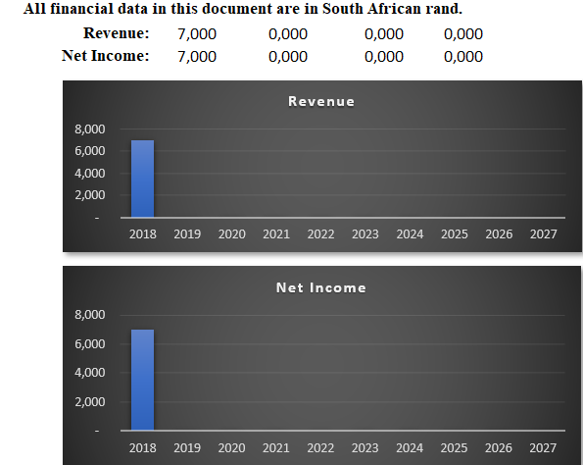

## **Financial Ratios**

|  |  |  |  |  |  |  |
| --- | --- | --- | --- | --- | --- | --- |
| **Financial Ratios** | | | | | | |
|  | | | | | | |
|  |  | 2018 | 2019 | 2022 | 2027 | |
| **Gross Margins:** | | 100% | N/A | N/A | N/A | |
| **Operating Margins** | | 100% | N/A | N/A | N/A | |
| **Net Profit Margins** | | 100% | N/A | N/A | N/A | |
| **Return on Assets** | | N/A | N/A | N/A | N/A | |
| **Return on Equity** | | N/A | N/A | N/A | N/A | |
|  | |  |  |  |  | |
|  |  |  |  |  |  |  |
|  |  |  |  |  |  |  |
|  |  |  |  |  |  |  |
|  |  |  |  |  |  |  |
|  |  |  |  |  |  |  |
| |  | | --- | |  | |  |  |  |  |  |  |
|  |  |  |  |  |  |  |
|  |  |  |  |  |  |  |
|  | | | | | | |
|  |  |  |  |  |  |  |
|  |  |  |  |  |  |  |
|  |  |  |  |  |  |  |
|  |  |  |  |  |  |  |
|  |  |  |  |  |  |  |
|  |  |  |  |  |  |  |
|  |  |  |  |  |  |  |
|  |  |  |  |  |  |  |
|  | | | | | | |
|  |  |  |  |  |  |  |
|  |  |  |  |  |  |  |
|  |  |  |  |  |  |  |
|  |  |  |  |  |  |  |
|  |  |  |  |  |  |  |

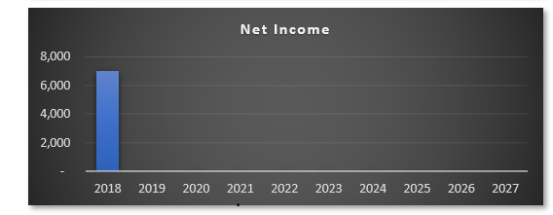

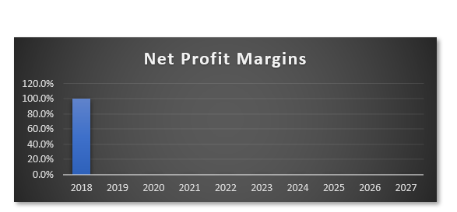

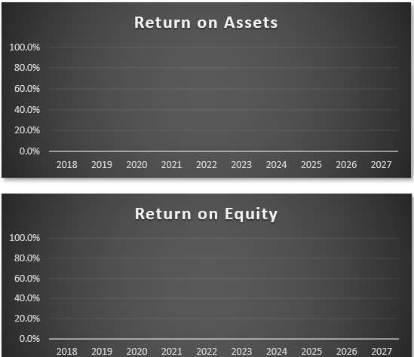

**Monthly Revenue Forecast**

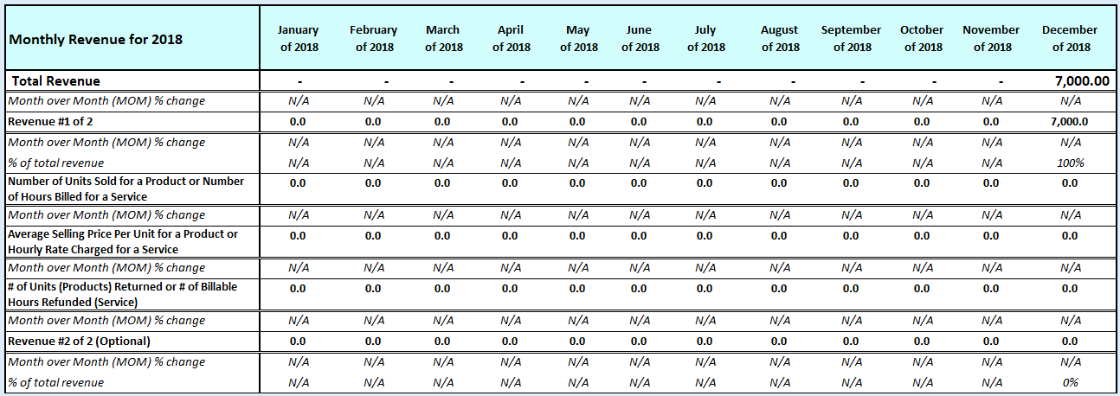

## **Quarterly Revenue Forecast**

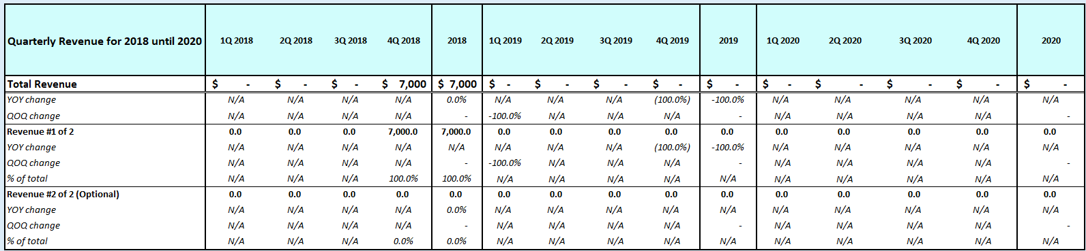

## **Annual Revenue Forecast**

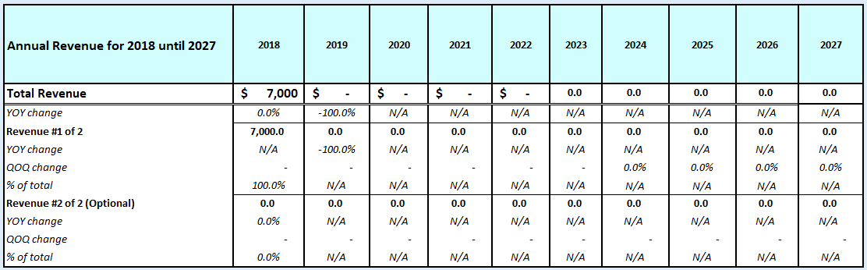

## **Monthly Operating Income Expenses Forecast**

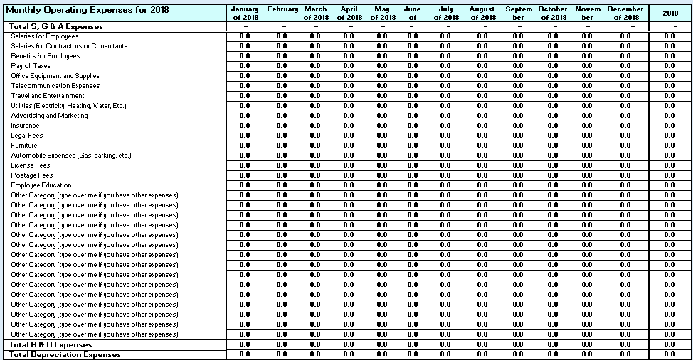

## **Annual Operating Income Expenses Forecast**

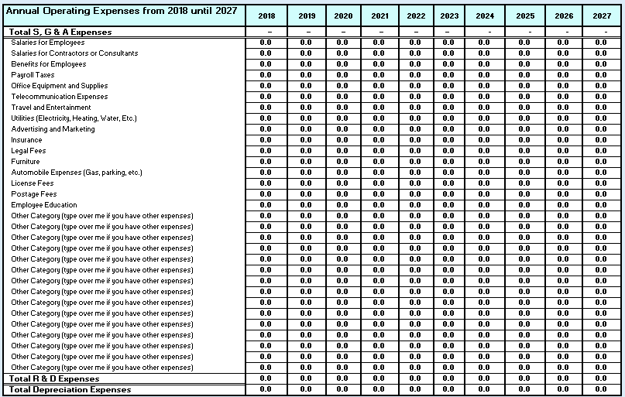

## **Quarterly Income Statement**

## 

## **Annual Income Statement**

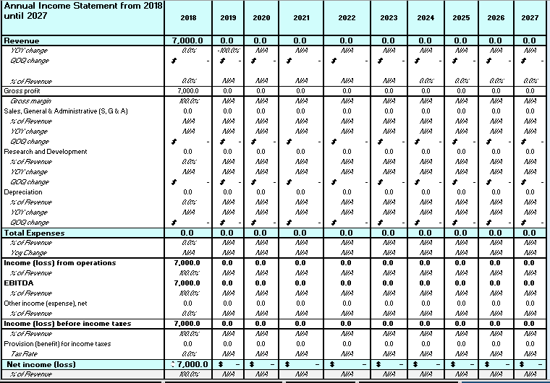

## **Quarterly Balance Sheet**

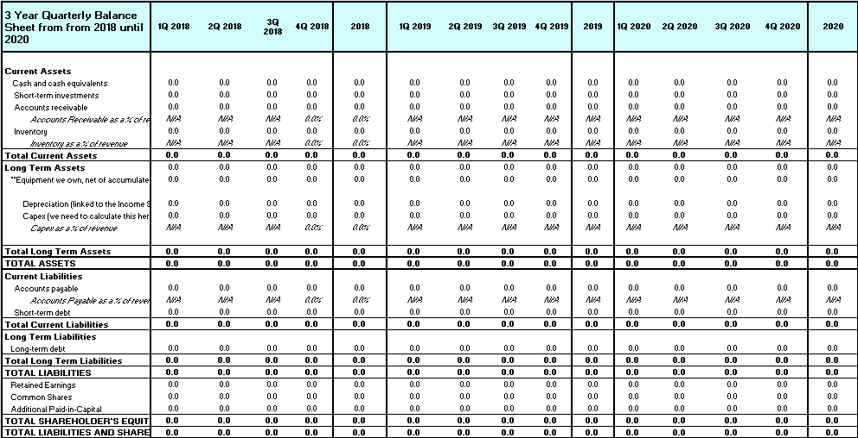

## **Annual Balance Sheet**

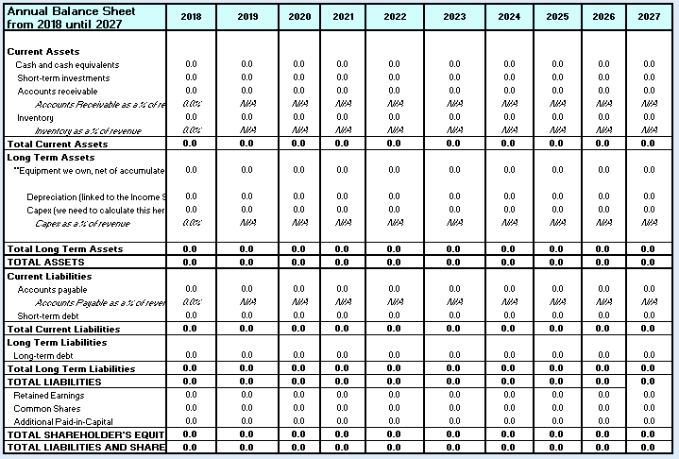

## **Quarterly Cash Flow Statement**

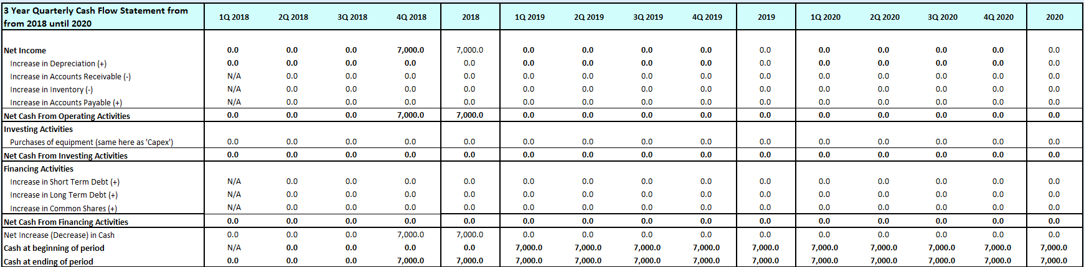

## **Annual Cash Flow Statement**

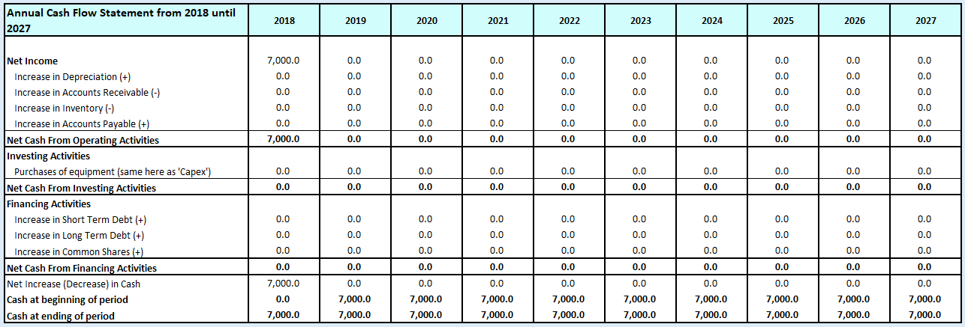

# Appendix

## Employee #1 Resume



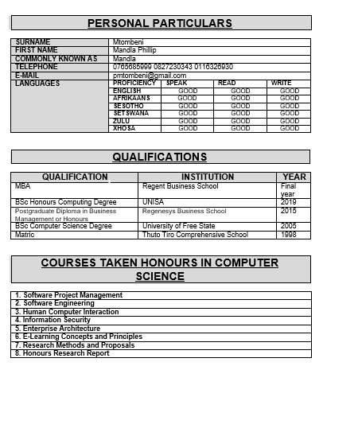

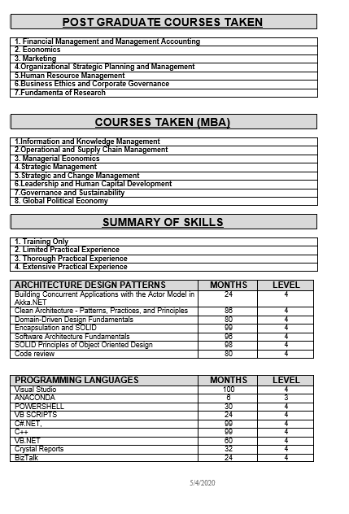

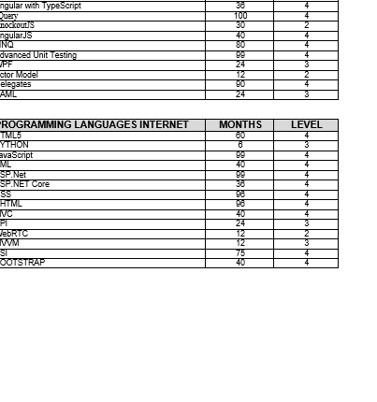

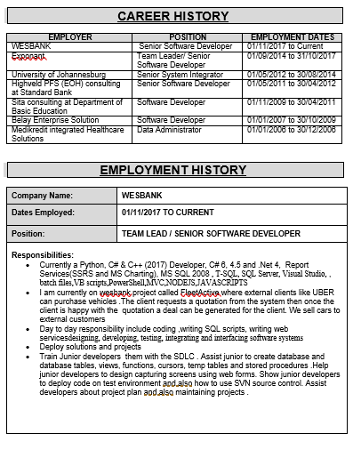

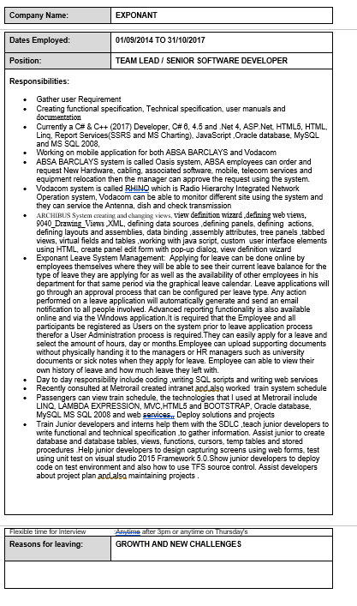

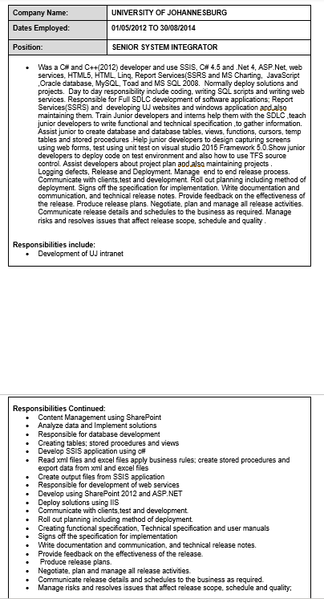

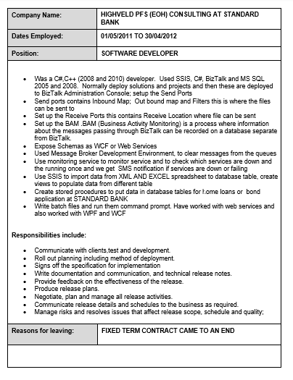

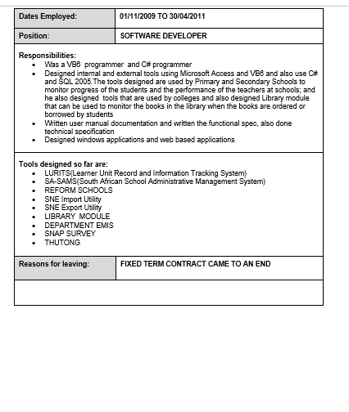

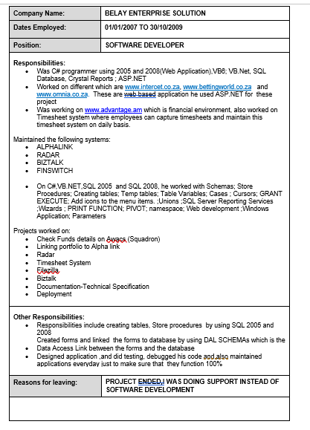

**Bibliography**

Fleisher, C.S. and Bensoussan, B.E., 2015. *Business and competitive analysis: effective application of*

*new and classic methods*. FT Press.

Haines, S., 2016. *The systems thinking approach to strategic planning and management*. CRC Press.

Hollensen, S., 2015. *Marketing management: A relationship approach*. Pearson Education.

McDonald, M. and Wilson, H., 2016. Planning: Yes, it Really Works! Experiences from the Real World.

*Marketing Plans 8e: How to Prepare Them, How to Profit from Them*, pp.603-614.

(South Africa HRI Sector Report 2014)

|  |  |
| --- | --- |
| **ASSIGNMENT COVER SHEET** | |
| ***Programme*** | **MBA (NQF9)** |
| ***Module Name*** | Entrepreneurship |
| ***Assignment Number*** | 1 |
| ***Surname*** | Mtombeni |
| ***First Name/S*** | Phillip Mandla |
| ***Student Number*** | 5160031 |
| ***Date Submitted*** | 4 May 2020 |
| ***Postal Address*** | 4 Midrand Ridge, George road , Noordwyk ext1 , Midrand 1865 |
|  |
| ***E-MAIL***  ***myregent email address*** | **51600131@regent.ac.za** |
| ***E-Mail***  ***(alternate email address)*** | **pmmtombeni@gmail.com** |
| ***Contact Numbers*** | **0765685999 07654444098** |
|  |
|  |
| ***Alternate contact:***  ***Name:***  ***Relationship:***  ***Contact number:*** |  |
| Tsholofelo |
| Wife |
| 0827230343 |
|  | |
| |  |  |  |  |  |  |  |  |  |  |  | | --- | --- | --- | --- | --- | --- | --- | --- | --- | --- | --- | | ***FOR OFFICE USE ONLY***  ***Marks per question (Q)*** | | | | | | | | | | | | **Q1** | **Q2** | **Q3** | **Q4** | **Q5** | **Q6** | **Q7** | **Q8** | **Q9** | **Q10** | **TOTAL** | |  |  |  |  |  |  |  |  |  |  |  | | |