SUPPLEMENTARY MATERIAL

Antibiotic residues in final effluents of European wastewater treatment plants and their impact on the aquatic environment
Sara Rodriguez-Mozaz^{1,2*}, Ivone Vaz-Moreira³, Saulo Varela Della Giustina^{1,2}, Marta Llorca^{1,2,4}, Damià Barceló^{1,2,4}, Sara Schubert⁵, Thomas U. Berendonk⁵, Irene Michael-Kordatou⁶, Despo Fatta-Kassinos^{6,7}, Jose Luis Martinez⁸, Christian Elpers⁹, Isabel Henriques¹⁰, Thomas Jaeger¹¹, Thomas Schwartz¹¹, Erik Paulshus¹², Kristin O’Sullivan¹², Katariina M. M. Pärnänen¹³, Marko Virta¹³, Thi Thuy Do¹⁴, Fiona Walsh¹⁴, Célia M. Manaia³

Affiliations:
¹ Catalan Institute for Water Research (ICRA), Emili Grahit 101, 17003 Girona, Spain.
² Universitat de Girona, Girona, Spain
³ Universidade Católica Portuguesa, CBQF - Centro de Biotecnologia e Química Fina – Laboratório Associado, Escola Superior de Biotecnologia, Rua Diogo Botelho 1327,
4169-005 Porto, Portugal.
⁴ Water and Soil Quality Research Group, Department of Environmental Chemistry, (IDAEA-CSIC), Jordi Girona 18-26, 08034, Barcelona, Spain,
⁵ Technische Universität Dresden, Institute of Hydrobiology, Dresden, Germany.
⁶ Nireas-International Water Research Centre, University of Cyprus, P.O. Box 20537, CY-1678, Nicosia, Cyprus.
⁷ Department of Civil and Environmental Engineering, University of Cyprus, P.O. Box 20537, CY-1678, Nicosia, Cyprus.
⁸ Centro Nacional de Biotecnología. CSIC. Darwin 3. 20049-Madrid. Spain.
⁹ Aquantec GmbH, Am Zwinger 5, 76227 Karlsruhe, Germany
¹⁰ Centre for Environmental and Marine Studies (CESAM; University of Aveiro) and Department of Life Sciences, Faculty of Sciences and Technology, University of Coimbra, Calçada Martin de Freitas, 3000-456, Coimbra, Portugal.
¹¹ Karlsruhe Institute of Technology (KIT) - Campus North, Institute of Functional Interfaces (IFG), P.O. Box 3640, 76021 Karlsruhe, Germany.
¹² Norwegian University of Life Sciences, Faculty of Veterinary Medicine, Department of Food Safety and Infection Biology, Section of Microbiology, Immunology and Parasitology, Post Box 8146 Dep., 0033 Oslo, Norway.
¹³ Department of Microbiology, University of Helsinki, Viikinkaari 9, 00014 University of Helsinki, Finland.
¹⁴ Department of Biology, Maynooth University, Maynooth, Co. Kildare, Ireland.
.

Table S1. Sampling campaigns (in brackets the number of sampling days)
WWTP location | Acronym | Spring  2015 | Autumn  2015 | Spring  2016 | Autumn  2016
Portugal (PT)  (North Portugal) | PT1 | (3d) | (3d) | n.s.* | (3d)
Portugal (PT)  (North Portugal) | PT2 | (3d) | (3d) | (3d) | (3d)
Portugal (PT)  (North Portugal) | PT3 | n.s. | n.s. | (3d) | n.s.
Spain (ES)  (Catalonia) | ES1 | (3d) | (3d) | (2d) | (3d)
Cyprus (CYP)  (Limassol and Nicosia) | CYP1 | (3d) | (3d) | (3d) | (3d)
Cyprus (CYP)  (Limassol and Nicosia) | CYP2 | (3d) | (3d) | (3d) | (3d)
Ireland (IL) **  (location information not available) | IL1 | (3d) | (3d) | (3d) | (3d)
Ireland (IL) **  (location information not available) | IL2 | (3d) | (3d) | (3d) | (3d)
Germany (DE)  (Baden-Württemberg and Saxony) | DE1 | (3d) | (3d) | (3d) | (3d)
Germany (DE)  (Baden-Württemberg and Saxony) | DE2 | (3d) | (3d) | (3d) | (3d)
Finland (FI)  (Uusimaa) | FI1 | (3d) | (3d) | (3d) | (3d)
Finland (FI)  (Uusimaa) | FI2 | (3d) | (3d) | (3d) | (3d)
Norway (NO)  (Eastern Norway) | NO1 | (3d) | (3d) | (3d) | (3d)
* PT1 suffered an overflow and was not operating in March 2016. Samples were collected in another WWTP in the same region (PT3). n.s. not sampled on these dates
** The IL1 and IL2 WWTPs samples were pooled for the three days and analyzed as a single sample.

Table S2. Characterization of the WWTPs used in this study. Adapted from Pärnänen et al. (2019).
WWTP | Treatment | Population equivalent | N.º of hospitals/hospital beds in the area | Sewer system | BOD5  (Effluent) | COD  (Effluent) | DWF  (m³/day) | CAS HRT  (hours) | CAS SRT  (days) | Tertiary Treatment Specifications | Tertiary Treatment HRT (sec)
PT1 | CAS | 160 000 | n.a./n.a. | combined | 15−25 | 78−107 | 21 241-21 884 | 11 | 2.8-5.3
PT2 | CAS | 150 094 | n.a./n.a. | combined | 5.0−11 | 34−50 | 32 060-34 005 | n.a. | n.a.
PT3 | CAS + UV | 173 839 | n.a./n.a. | combined | 8.0 | 29 | n.a.- 23 793 | n.a. | 12 | Open channel (Trojan, UV3000HO), with 38×8 150W 29.7mJ/cm² | 11.44
ES1 | CAS | 200 000 | 3/400 | combined | 1.4−7.9 | n.a. | 43 000 | 24 | 18
CYP1 | CAS + Cl | 151 000 | n.a./n.a. | separated | 4.0−12 | 23−33 | 18 000-21 480 | 25 | 8.9 | Cl₂=5-10 mg/L at the inlet and 0.5-1 mg/L at the outlet | 1800-3600 (30-60 min)
CYP2 | MBR | 30 000 | n.a./n.a. | separated | 2.0−26 | 18−42 | 4 000 | 18 | 30
IL1 | n.a. | 2 000-100 000 | n.a. | combined | n.a. | n.a. | 1 000-30 000 | n.a. | n.a.
IL2 | n.a. | 2 000-100 000 | n.a. | combined | n.a. | n.a. | 1 000-30 000 | n.a. | n.a.
DE1 | CAS + O₃ | 440 000 | 3/2162 | combined | 2.0 | 12-17 | 114 221-126 317 | 12 | 12 | 1g O₃/g DOC  Ozone Generator: OCS-GSO30, Wedeco 480L | 250 (c.a. 4 min)
DE2 | CAS | 650 000 | 8/5048 | combined | <3.0−5.0 | 20−34 | 137 000-140 600 | 29 | 14
FI1 | CAS + BAF | 800 000 | 11/2492 | combined | 3.9−4.4 | 41−52 | 270 684-278 082 | n.a. | n.a. | BIOSTYR ® denitrification filter, methanol consumption 8000 kg/d | 1-500
FI2 | CAS | 310 000 | 2/812 | separated | 3.7−5.4 | 26−40 | 100 273-102 191 | n.a. | n.a.
NO1 | CAS | 739 000 | 4/2650 | combined | 6.0−18 | 41−54 | 250 959-272 877 | 3.5 | 25-37

Types of treatment: CAS, conventional activated sludge; MBR, membrane bioreactor; Cl, chlorination; O₃, ozone; BAF, biologically active filter.
Combined: combined sewer system for wastewater and rain waters; separated: sewer system only for wastewater
BOD5, 5 day biochemical oxygen demand; COD, chemical oxygen demand; HRT, hydraulic retention time; SRT, sludge retention time; DWF, daily water flow; n.a. – information not available

Table S3: Average air temperature (ºC) and cumulative rainfall (mm) collected in the 3 days of sampling and the day before, assuming that the hydraulic residence time in the treatment plants is between 24 and 48 h.

WWTP location | Acronym | Average. air temp (ºC) | Cumulative precipitation (mm)
WWTP location | Acronym | Average. air temp (ºC) | Spring  2015 | Autumn  2015 | Spring  2016 | Autumn  2016
Portugal (PT)  (North Portugal) | PT1 | 15 | 0 | 14 | 3 | 0
Portugal (PT)  (North Portugal) | PT2 | 15 | 0 | 14 | 3 | 0
Portugal (PT)  (North Portugal) | PT3 | 15 | 0 | 14 | 3 | 0
Spain (ES)  (Catalonia) | ES1 | 20 | 0 | 3 | 0 | 0
Cyprus (CYP)  (Limassol and Nicosia) | CYP1 | 20 | 30 | 0 | 2 | 0
Cyprus (CYP)  (Limassol and Nicosia) | CYP2 | 20 | 30 | 3 | 0 | 0
Ireland (IL)  (location information not available) | IL1 | 10 | 11 | 14 | 15 | 5
Ireland (IL)  (location information not available) | IL2 | 10 | 11 | 14 | 15 | 5
Germany (DE)  (Baden-Württemberg and Saxony) | DE1 | 9 | 2 | 5 | 8 | 3
Germany (DE)  (Baden-Württemberg and Saxony) | DE2 | 11 | 4 | 43 | 9 | 0
Finland (FI)  (Uusimaa) | FI1 | 6 | 0 | 0 | 0 | 18
Finland (FI)  (Uusimaa) | FI2 | 6 | 0 | 0 | 0 | 18
Norway (NO)  (Eastern Norway) | NO1 | 7 | 1 | 0 | 18 | 11

Avg. temp., yearly average temperature for the region according to the timeanddate.com (www. timeanddate.com).
Cumulative precipitation collected in the 3 days of sampling and the day before from www.wetteronline.de

Table S4. List of antibiotics analyzed in effluent wastewater using the methodology described by Gros et al. (2013) and the respective analytical method quality parameters: Method detection limit (MDL), method quantification limit (MQL) and recovery values (%) of the extraction method. The values of MDL, MQL and recovery are average values of the four sampling campaigns analyses. Quality parameters for each sampling campaign can be found in table S5
Chemical group | Antibiotic | Use | MDL (ng/L) | MQL (ng/L) | Rec (%)
Fluoroquinolones | Cinoxacin | Human & Veterinary | 8.56 | 28.53 | 105
Fluoroquinolones | Ciprofloxacin | Human & Veterinary | 9.80 | 32.66 | 92
Fluoroquinolones | Danofloxacin | Veterinary | 7.32 | 31.18 | 119
Fluoroquinolones | Enrofloxacin | Veterinary | 10.10 | 33.67 | 73
Fluoroquinolones | Marbofloxacin | Veterinary | 5.63 | 18.76 | 92
Fluoroquinolones | Norfloxacin | Human | 9.30 | 37.24 | 109
Fluoroquinolones | Ofloxacin | Human | 10.29 | 34.32 | 73
Fluoroquinolones | Orbifloxacin | Veterinary | 7.40 | 24.66 | 100
Quinolones | Flumequine | Human & Veterinary | 6.79 | 22.63 | 117
Quinolones | Nalidixic Acid | Human | 15.59 | 35.43 | 84
Quinolones | Oxolinic Acid | Veterinary | 18.83 | 46.91 | 82
Quinolones | Pipemidic Acid | Human | 9.12 | 30.40 | 120
Penicillins | Amoxicillin | Human & Veterinary | 11.69 | 38.96 | 105
Penicillins | Ampicillin | Human & Veterinary | 7.92 | 26.39 | 87
Penicillins | Penicillin G | Veterinary | 9.10 | 30.33 | 96
Penicillins | Penicillin V | Human | 11.49 | 38.31 | 81
Penicillins | Oxacillin | Human & Veterinary | 18.09 | 48.92 | 116
Cephalosporins | Cefalexin | Human | 7.69 | 25.64 | 83
Cephalosporins | Cefapirin | Human & Veterinary | 12.73 | 35.96 | 89
Cephalosporins | Cefazolin | Human & Veterinary | 13.49 | 39.99 | 114
Cephalosporins | Cefotaxime | Human | 10.20 | 34.00 | 72
Cephalosporins | Ceftiofur | Veterinary | 9.21 | 30.69 | 70
Cephalosporins | Cefuroxime | Human | 12.25 | 39.34 | 115
Macrolides | Azithromycin | Human | 6.34 | 21.14 | 81
Macrolides | Clarithromycin | Human | 9.02 | 28.75 | 86
Macrolides | Roxythromycin | Human | 10.73 | 35.76 | 72
Macrolides | Spiramycin | Veterinary | 13.33 | 36.73 | 85
Macrolides | Tilmicosin | Veterinary | 11.26 | 40.86 | 59
Macrolides | Tylosin | Veterinary | 12.77 | 44.98 | 82
Tetracyclines | Chlortetracycline | Human & Veterinary | 13.45 | 34.47 | 101
Tetracyclines | Doxycycline | Human & Veterinary | 12.44 | 38.86 | 115
Tetracyclines | Oxytetracycline | Human & Veterinary | 9.82 | 32.72 | 94
Tetracyclines | Tetracycline | Human & Veterinary | 12.16 | 32.27 | 108
Lincosamides | Clindamycin | Human | 7.68 | 25.59 | 75
Lincosamides | Lincomycin | Human | 19.21 | 37.05 | 82
Sulfonamides | N-Acetylsulfadiazine | Human | 9.68 | 33.74 | 84
Sulfonamides | N-Acetylsulfamerazine | Human | 10.63 | 35.45 | 85
Sulfonamides | N-Acetylsulfamethazine | Veterinary | 11.32 | 37.93 | 98
Sulfonamides | Sulfabenzamide | Human | 6.44 | 21.47 | 77
Sulfonamides | Sulfadiazine | Human | 11.44 | 33.29 | 81
Sulfonamides | Sulfadimethoxine | Veterinary | 11.23 | 34.43 | 82
Sulfonamides | Sulfamerazine | Human | 9.56 | 29.43 | 81
Sulfonamides | Sulfamethizole | Human & Veterinary | 8.67 | 28.89 | 61
Sulfonamides | Sulfamethoxazole | Human | 8.37 | 27.90 | 95
Sulfonamides | Sulfamethoxypiridazine | Veterinary | 9.84 | 32.81 | 97
Sulfonamides | Sulfanitran | Veterinary | 13.23 | 34.23 | 76
Sulfonamides | Sulfapyridine | Veterinary | 7.61 | 25.38 | 80
Sulfonamides | Sulfathiazole | Human & Veterinary | 11.18 | 37.26 | 79
Sulfonamides | Sulfisomidin | Human | 8.12 | 27.08 | 70
Sulfonamides | Sulfisoxazole | Human | 7.51 | 25.04 | 65
Dihydrofolate reductase inhibitors | Trimethoprim | Human & Veterinary | 10.06 | 41.87 | 98
Nitroimidazole antibiotics | Metronidazole | Human & Veterinary | 5.31 | 17.72 | 90
Nitroimidazole antibiotics | Metronidazole-OH | Human & Veterinary | 11.06 | 36.86 | 96

Table S5. Data on the occurrence (ng/L) of the 53 target antibiotics in the 13 WWTPs in the 4 sampling campaigns. <MDL: below method detection limit. <MQL: below method quantification limit. Analytical quality parameters specific for each sampling campaign are reported. Excel file available in the supplementary materials.
Table S6. Dilution Factors for the 7 countries considered in this study. Compiled from Keller et al. 2014
Country | Acronym | Dilution Factor (DF)
Norway | NO | 2453.29
Finland | FI | 1702.28
Ireland | IL | 229.76
Portugal | PT | 61.23
Germany | DE | 32.30
Spain | ES | 25.92
Cyprus * | CYP | 5.86
* Dilution factor (DF) not provided by Keller et al. (2014) due to the small size of the country (not fitting the spatial resolution necessary for accurate calculations) and the absence of rivers. Following authors’ recommendation the dilution factor of Morocco was assigned (country with the lowest DF (authors’ recommendation)

Table S7. Environmental Predicted No Effect Concentration (PNEC-ENV) and Minimum Inhibitory Concentration based (PNEC-MICs) for the 17 antibiotics found in this study. Compiled from Tell et al. 2019 except for orbifloxacin, oxolinic acid, pipemidic acid and sulfapyridine, which were extracted from literature sources and ecotoxicology modelling software.
Chemical group | Antibiotic | PNEC-ENV (µg/L) | PNEC-MIC (µg/L) | Lowest PNEC Value (µg/L)
Cephalosporins | Cefalexin | 0.08 | 4 | 0.08
Dihydrofolate reductase inhibitors | Trimethoprim | 100 | 0.5 | 0.5
Fluoroquinolones | Ciprofloxacin | 0.45 | 0.06 | 0.06
Fluoroquinolones | Enrofloxacin | 1.9 | 0.06 | 0.06
Fluoroquinolones | Ofloxacin | 10 | 0.5 | 0.5
Fluoroquinolones | Orbifloxacin * | 259.2 | n.a. | 259.2
Lincosamides | Clindamycin | 0.1 | 1 | 0.1
Macrolides | Azithromycin | 0.02 | 0.25 | 0.02
Macrolides | Clarithromycin | 0.08 | 0.25 | 0.08
Nitroimidazole antibiotics | Metronidazole | n.a. | 0.13 | 0.13
Penicillins | Ampicillin | 0.87 | 0.25 | 0.25
Quinolones | Nalidixic Acid | n.a. | 16 | 16
Quinolones | Oxolinic Acid ** | 0.0073 | n.a. | 0.0073
Quinolones | Pipemidic Acid ** | 447 | n.a. | 447
Sulfonamides | Sulfamethoxazole | 0.6 | 16 | 0.6
Sulfonamides | Sulfapyridine * | 6.2 | n.a. | 6.2
Tetracyclines | Tetracycline | 3.2 | 1 | 1
* ECOSAR
** Orias and Perrodin 2013
n.a.: values not available

Table S8. Risk Quotients (RQs) in freshwater calculated for the maximum value found in any of the 4 sampling campaigns for the 17 selected antibiotics detected in the samples from the 13 WWTPs. RQ are calculated using the equation 1 and II (see section 2.4). Environmental Risk: RQ ≤ 0.1: Low; 0.1 < RQ ≤1: Moderate; RQ > 1: High. Values in bold correspond to RQ >0.1 moderate or high risk. Portugal (PT), Spain (ES), Cyprus (CYP), Ireland (IL), Germany (DE), Finland (FI), Norway (NO).
Chemical groups |  | PT1 | PT2 | PT3 | ES1 | CYP1 | CYP2 | IL1 | IL2 | DE1 | DE2 | FI1 | FI2 | NO1
Cephalosporins | Cefalexin | 0.02 | 0.03 | 0.00 | 0.10 | 0.31 | 0.38 | 0.01 | 0.01 | 0.00 | 0.00 | 0.00 | 0.01 | 0.00
Dihydrofolate reductase inhibitors | Trimethoprim | 0.01 | 0.01 | 0.01 | 0.01 | 0.05 | 0.04 | 0.00 | 0.00 | 0.00 | 0.01 | 0.00 | 0.00 | 0.00
Fluoroquinolones | Ciprofloxacin | 0.20 | 0.32 | 0.09 | 0.22 | 2.02 | 1.03 | 0.04 | 0.03 | 0.05 | 0.30 | 0.00 | 0.00 | 0.00
Fluoroquinolones | Enrofloxacin | 0.00 | 0.00 | 0.00 | 0.10 | 0.00 | 0.00 | 0.00 | 0.00 | 0.00 | 0.00 | 0.00 | 0.00 | 0.00
Fluoroquinolones | Ofloxacin | 0.00 | 0.01 | 0.01 | 0.02 | 0.18 | 0.15 | 0.00 | 0.00 | 0.00 | 0.01 | 0.00 | 0.00 | 0.00
Fluoroquinolones | Orbifloxacin | 0.00 | 0.00 | 0.00 | 0.00 | 0.00 | 0.00 | 0.00 | 0.00 | 0.00 | 0.00 | 0.00 | 0.00 | 0.00
Lincosamides | Clindamycin | 0.01 | 0.02 | 0.01 | 0.07 | 0.02 | 0.07 | 0.01 | 0.01 | 0.00 | 0.05 | 0.00 | 0.00 | 0.00
Macrolides | Azithromycin | 0.48 | 0.93 | 0.13 | 1.37 | 0.72 | 0.61 | 0.14 | 0.12 | 0.72 | 0.95 | 0.01 | 0.01 | 0.00
Macrolides | Clarithromycin | 0.06 | 0.03 | 0.04 | 0.09 | 0.00 | 0.10 | 0.02 | 0.01 | 0.06 | 0.07 | 0.00 | 0.00 | 0.00
Nitroimidazole antibiotics | Metronidazole | 0.00 | 0.00 | 0.00 | 0.04 | 0.10 | 0.00 | 0.01 | 0.01 | 0.01 | 0.02 | 0.00 | 0.00 | 0.00
Penicillins | Ampicillin | 0.00 | 0.00 | 0.00 | 0.00 | 0.00 | 0.00 | 0.00 | 0.00 | 0.00 | 0.00 | 0.00 | 0.00 | 0.00
Quinolones | Nalidixic Acid | 0.00 | 0.00 | 0.00 | 0.00 | 0.00 | 0.00 | 0.00 | 0.00 | 0.00 | 0.00 | 0.00 | 0.00 | 0.00
Quinolones | Oxolinic Acid | 0.00 | 0.00 | 0.00 | 0.00 | 0.00 | 0.00 | 0.00 | 0.01 | 0.00 | 0.00 | 0.00 | 0.00 | 0.00
Quinolones | Pipemidic Acid | 0.00 | 0.00 | 0.00 | 0.00 | 0.00 | 0.00 | 0.00 | 0.00 | 0.00 | 0.00 | 0.00 | 0.00 | 0.00
Sulfonamides | Sulfamethoxazole | 0.00 | 0.00 | 0.00 | 0.01 | 0.01 | 0.06 | 0.00 | 0.00 | 0.00 | 0.01 | 0.00 | 0.00 | 0.00
Sulfonamides | Sulfapyridine | 0.00 | 0.00 | 0.00 | 0.00 | 0.00 | 0.00 | 0.00 | 0.00 | 0.00 | 0.00 | 0.00 | 0.00 | 0.00
Tetracyclines | Tetracycline | 0.01 | 0.01 | 0.00 | 0.00 | 0.03 | 0.02 | 0.00 | 0.00 | 0.00 | 0.00 | 0.00 | 0.00 | 0.00

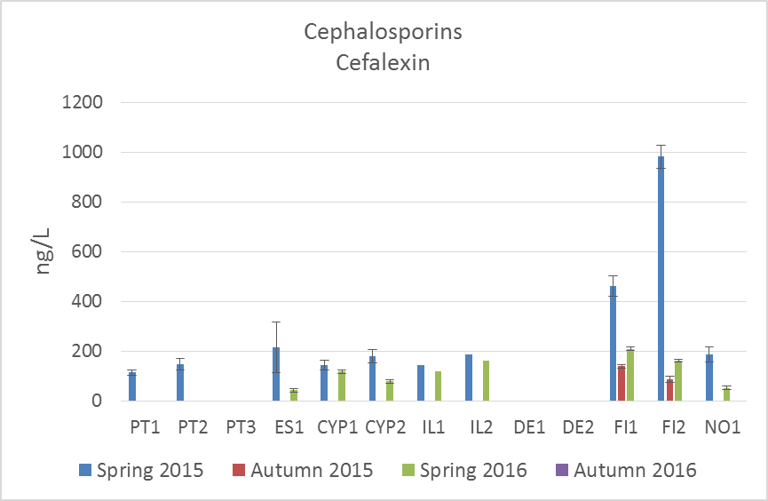 | 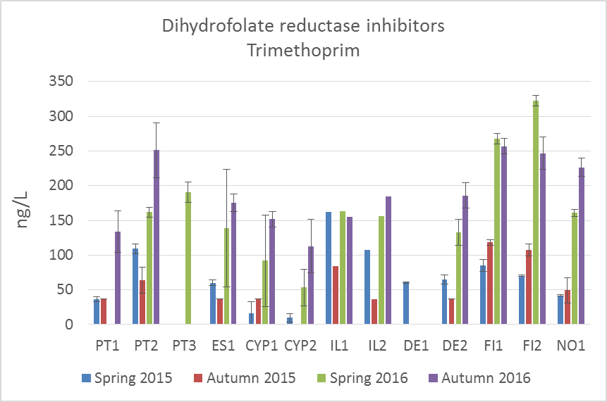
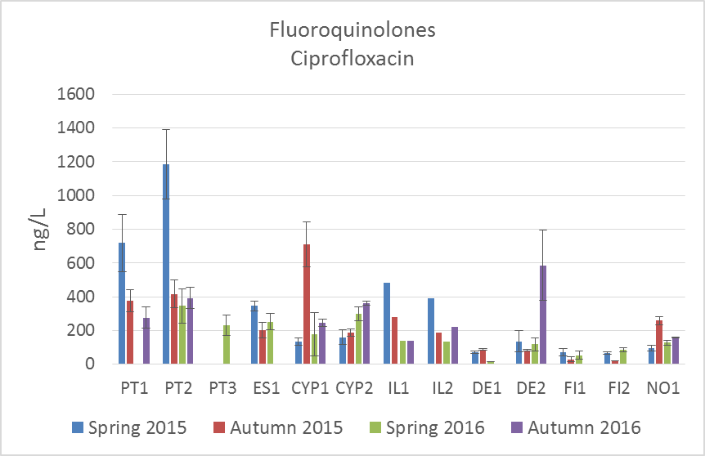 | 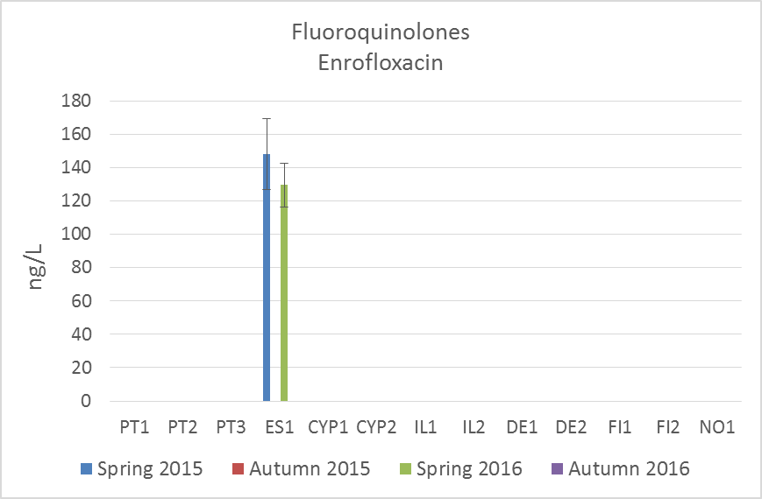
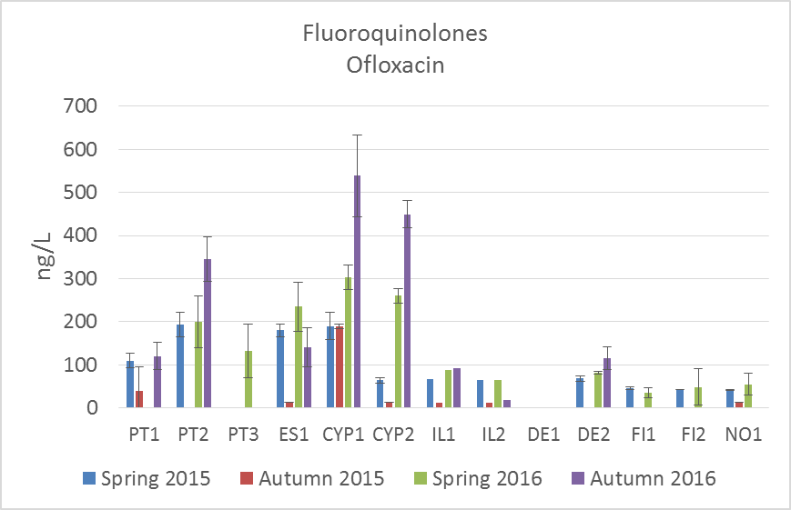 | 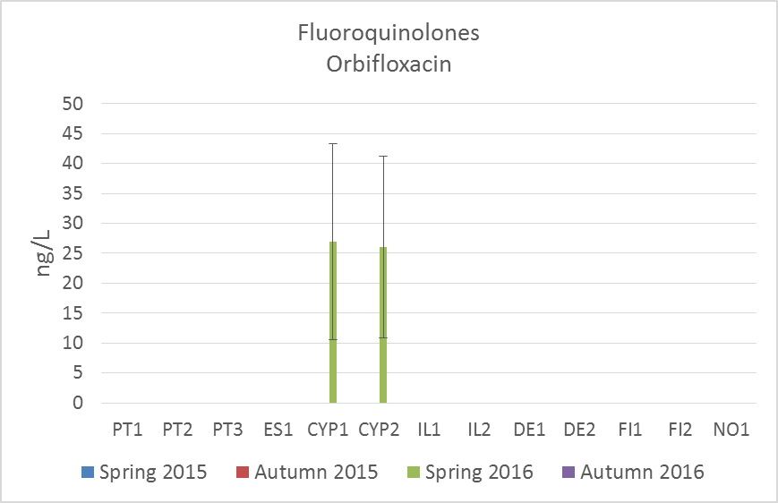
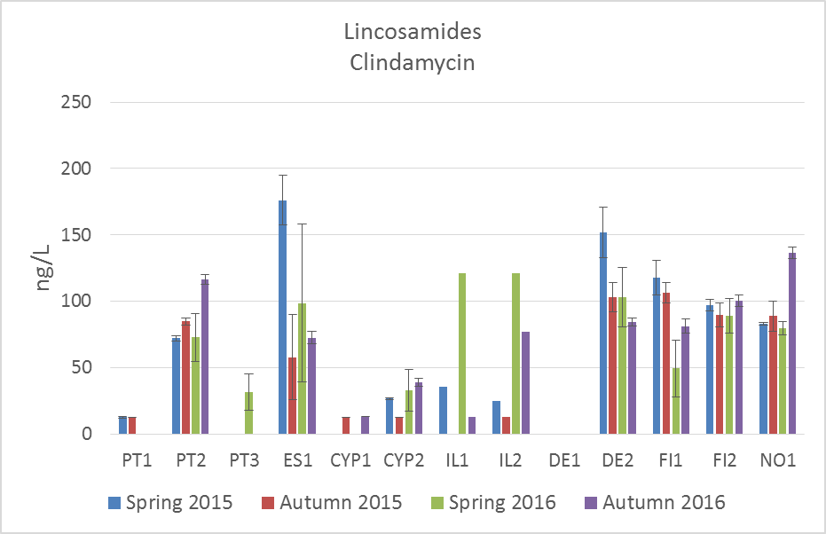 | 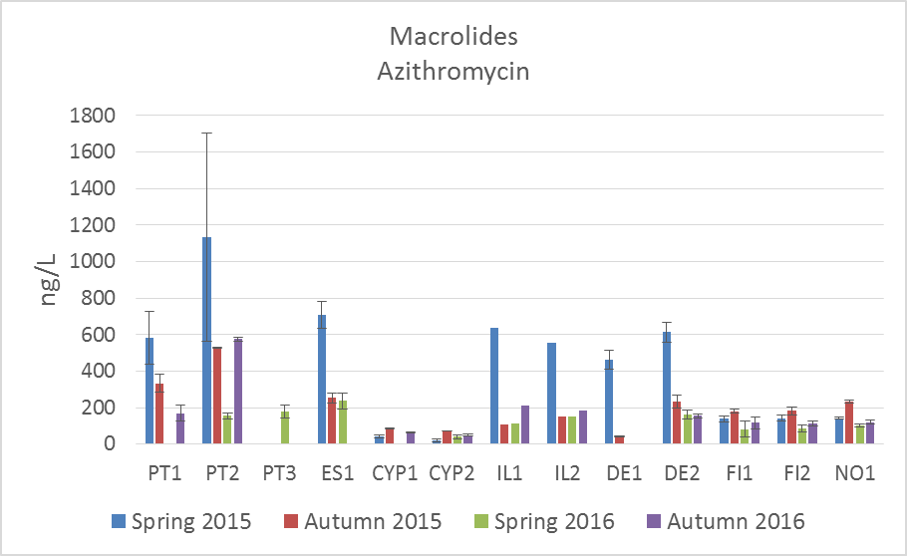
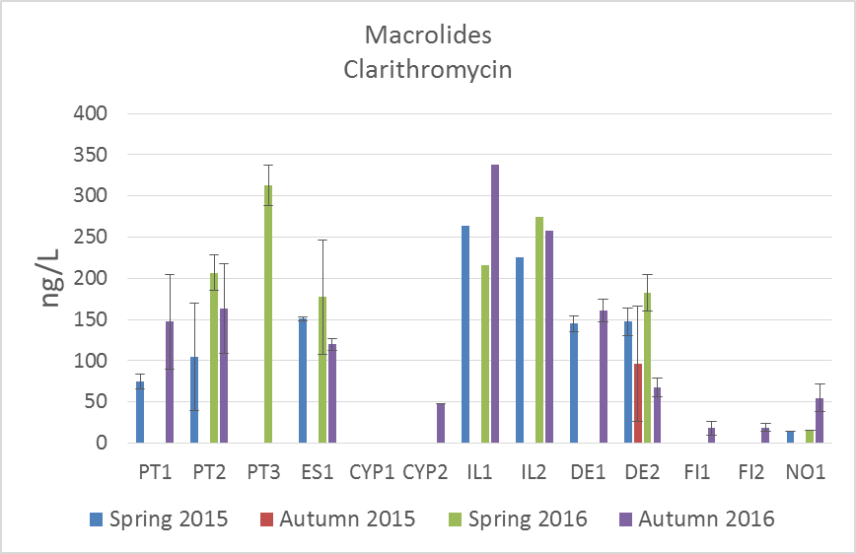 | 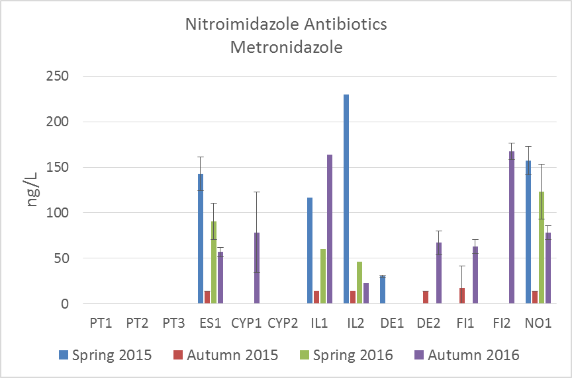
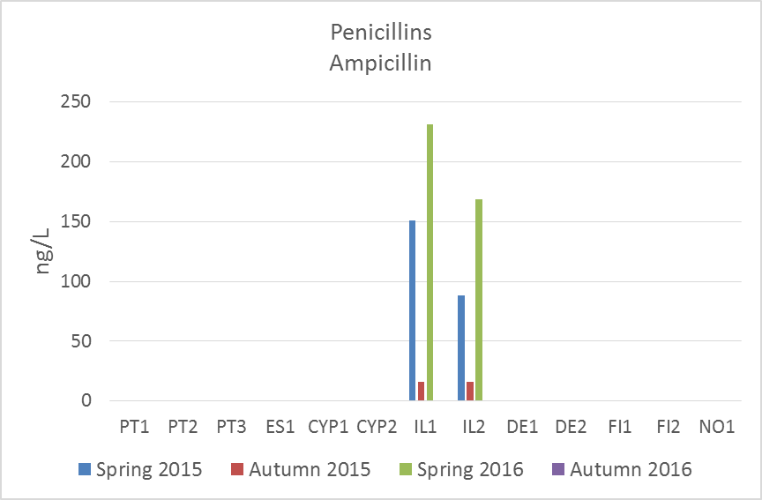 | 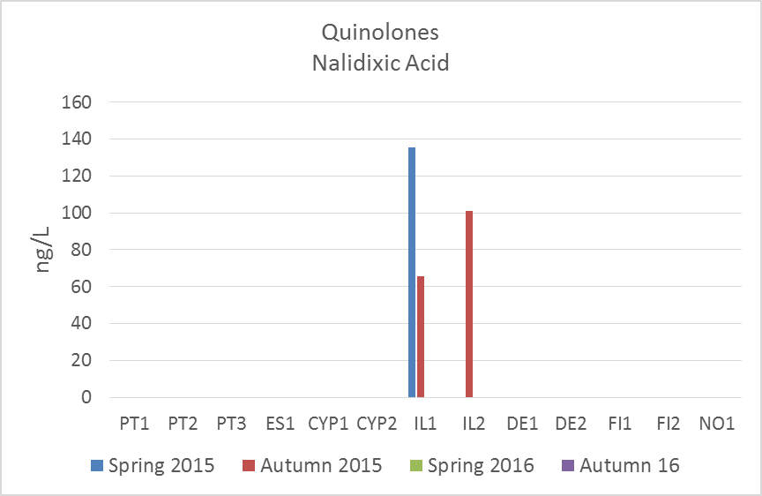
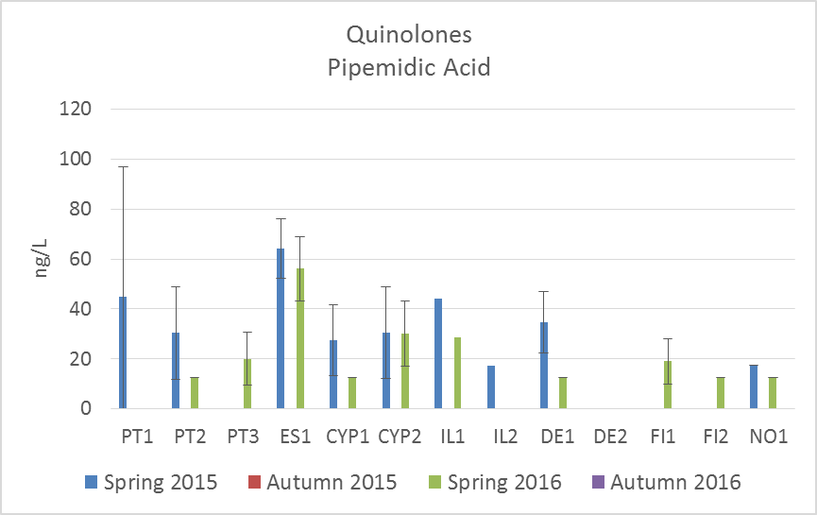 | 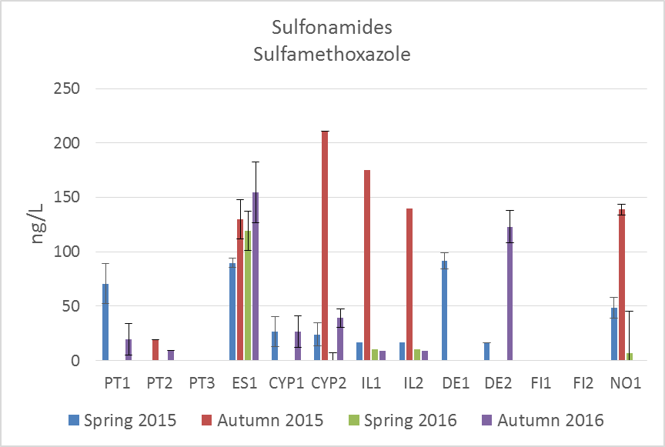
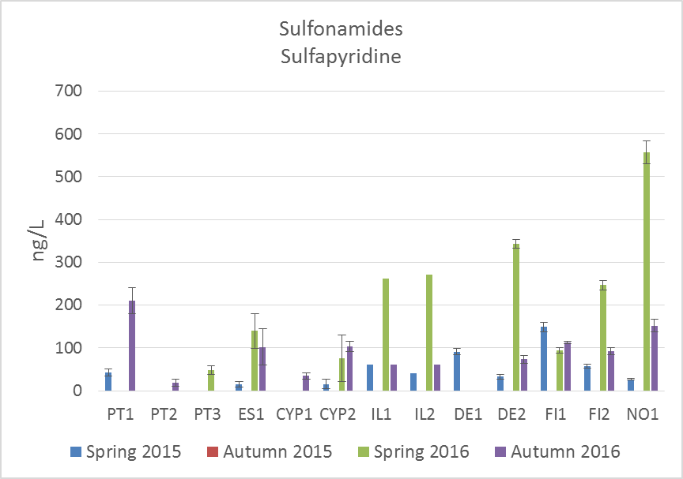 | 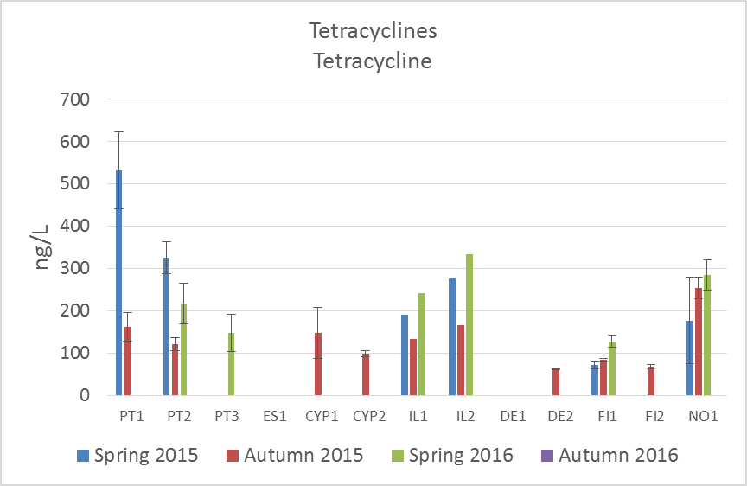

Figure S1. Antibiotic average concentration (ng/L) of 3 consecutive days in each WWTP along the 4 sampling campaigns in March 2015, October 2015, March 2016, and September 2016. Oxolinic acid was only detected in IL2, sampling campaign of Spring 2015 and is not represented.
a) | b)
c) | d)
Figure S2. Cumulative concentrations of antibiotics for human use (excluding veterinary antibiotics enrofloxacin and orbifloxacin) measured in the effluents of each country (ng/L) and grouped based on the “Anatomical Therapeutic Chemical” (ATC) classification system (https://www.whocc.no/atc_ddd_index/?code=J01); (a) 2015 and (c) 2016. Values for each year calculated as the average of antibiotic concentrations in early Spring and early Autumn sampling campaigns. Defined daily dose values (DDD) per 1000 inhabitants per day per country for antibiotics consumed by the community (primary sector) in (b) 2015 and (d) 2016. Values extracted from the “Annual Epidemiological Report for 2016” from the European Centre for Disease Prevention and Control (ECDC) (https://ecdc.europa.eu/en/publications-data/antimicrobial-consumption-annual-epidemiological-report-2016). Countries: PT. Portugal; ES. Spain; CYP. Cyprus; IL. Ireland; DE. Germany; FI. Finland; and NO. Norway. *For Cyprus data on consumption in hospital sector is also included.

Bibliography
ECOSAR Ecological Structure Activity Relationships (ECOSAR) Predictive Model. American Environmental Protection Agency (EPA). https://www.epa.gov/tsca-screening-tools/ecological-structure-activity-relationships-ecosar-predictive-model
Keller VDJ. Williams RJ. Lofthouse C. Johnson AC. 2014. Worldwide estimation of river concentrations of any chemical originating from sewage treatment plants using dilution factors. Environmental Toxicology and Chemistry 33(2): 447–452..
Orias F and Perrodin Y. 2013 Characterisation of the ecotoxicity of hospital effluents: A review. Science of the Total Environment 454–455: 250–276
Pärnänen KMM et al.. 2019. Antibiotic resistance in European wastewater treatment plants mirrors the pattern of clinical antibiotic resistance prevalence. Science Advances 5
Tell J. Caldwell DJ. Häner A. Hellstern J. Hoeger B. Journel R. et al. 2019. Science-based Targets for Antibiotics in Receiving Waters from Pharmaceutical Manufacturing Operations. Integrated Environmental Assessment and Management 15(3): 312-319.
ECDC (European Centre for Disease Prevention and Control). Surveillance of antimicrobial resistance in Europe 2016. Annual report of the European Antimicrobial Resistance Surveillance Network (EARS-Net). Stockholm (2017). [accessed 2019 Jun 16] https://ecdc.europa.eu/en/publications-data/antimicrobial-consumption-annual-epidemiological-report-2016.

