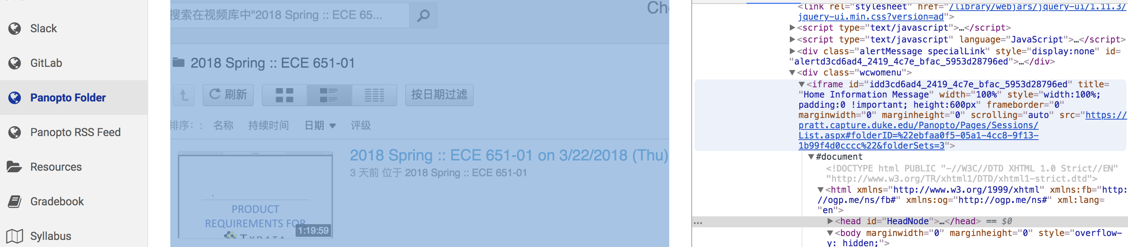

Figure

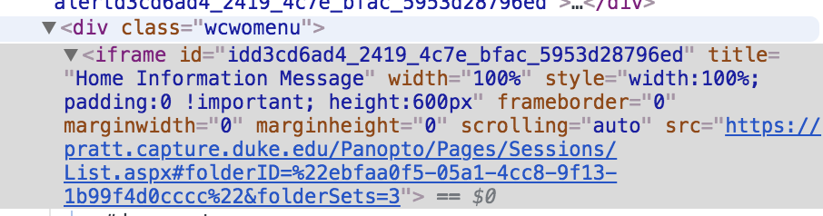

Figure

From figure 1 and figure 2, we found that after <div class=” wcwomenu”> all html code is the same as origin Panotop. The only thing we have to figure out is the content after “<iframe”, specifically is the iframe id.

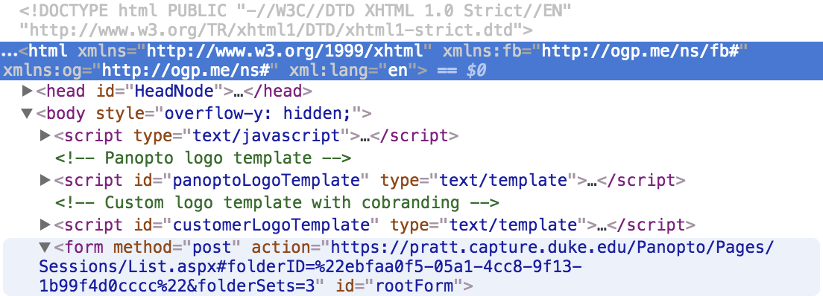

Figure

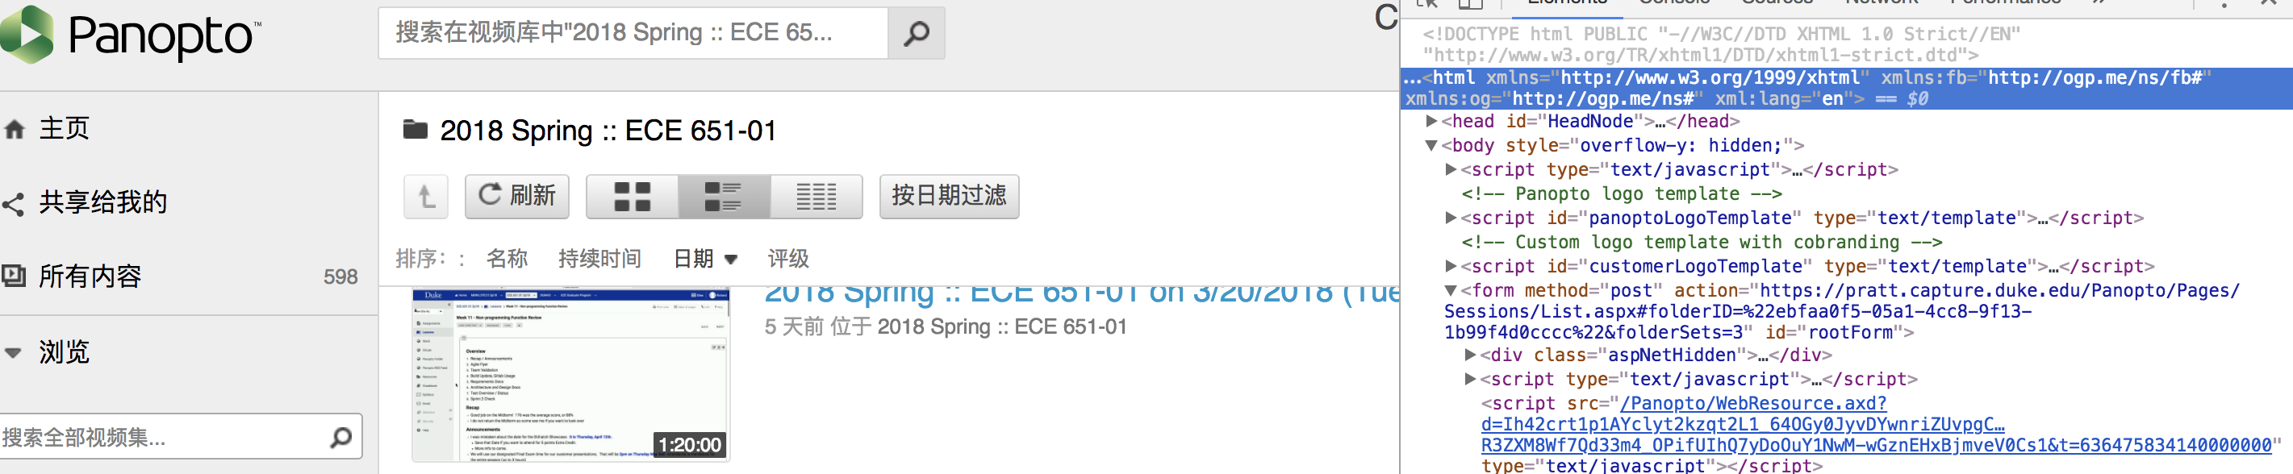

Figure