WEEK 2 TASK
Advanced Data Visualization and Storytelling with Python

Domain: Public-health / scientific data exploration
Dataset: Scikit-learn Diabetes Dataset
Prepared by: ______________________________
Institution: ______________________________
Submission date: _________________________

Executive Summary
This report uses the publicly documented Diabetes dataset distributed with scikit-learn to demonstrate data storytelling for a non-technical audience. The dataset contains 442 observations and 10 baseline features, with a quantitative measure of disease progression one year after baseline. Six visualizations move from the overall outcome distribution to feature associations, then examine BMI and age patterns in more detail. The strongest positive single-feature linear association in this dataset is with bmi (r = 0.59); BMI is also positively associated with progression (r = 0.59). These are associations, not proof of causation. The report emphasizes careful chart selection, readable labels, context, uncertainty, and limitations so the visuals support informed interpretation rather than overclaiming.

1. Introduction and Question
Data visualization is more than drawing charts: it is the process of choosing a visual form that makes a question easier to understand. A good data story has a logical sequence, gives the audience context, highlights the most important patterns, and explains what can and cannot be concluded. This report asks: What does the one-year progression outcome look like, and which baseline measurements show the clearest simple associations with it?
The audience is assumed to be non-technical. Therefore, chart titles state the takeaway, axes use plain-language labels, and each chart is followed by an interpretation and a caution. The goal is exploratory communication, not clinical diagnosis or a causal claim.

2. Dataset and Methods
Dataset source: the Diabetes dataset packaged with scikit-learn (sklearn.datasets.load_diabetes). It is a commonly used research/teaching dataset based on baseline measurements from 442 participants. The target is a quantitative measure of disease progression one year after baseline. The dataset includes age, sex, body mass index (BMI), blood pressure, and six serum measurements. The feature values are standardized by the dataset provider; they are not raw units, so a feature value of 0 does not mean a literal BMI or blood-pressure value of zero.
The analysis was performed with Python, Pandas, NumPy, Matplotlib, and scikit-learn. Visualizations include a distribution histogram, ranked correlation bar chart, scatterplot with a fitted linear trend, quartile comparison with standard-deviation bars, a correlation heatmap, and an age-quartile comparison. Pearson correlation is used as a descriptive measure of linear association. It can miss nonlinear relationships and is sensitive to outliers.
from sklearn.datasets import load_diabetes
import pandas as pd
import matplotlib.pyplot as plt
dataset = load_diabetes(as_frame=True, scaled=True)
X = dataset.data
y = dataset.target
df = X.copy()
df["disease_progression_1y"] = y
print(df.shape) # observations and columns
print(df.describe().T) # descriptive statistics
print(df.corr(numeric_only=True)["disease_progression_1y"].sort_values())

3. Visual Analysis and Story

3.1 Start with the outcome: how varied is progression?
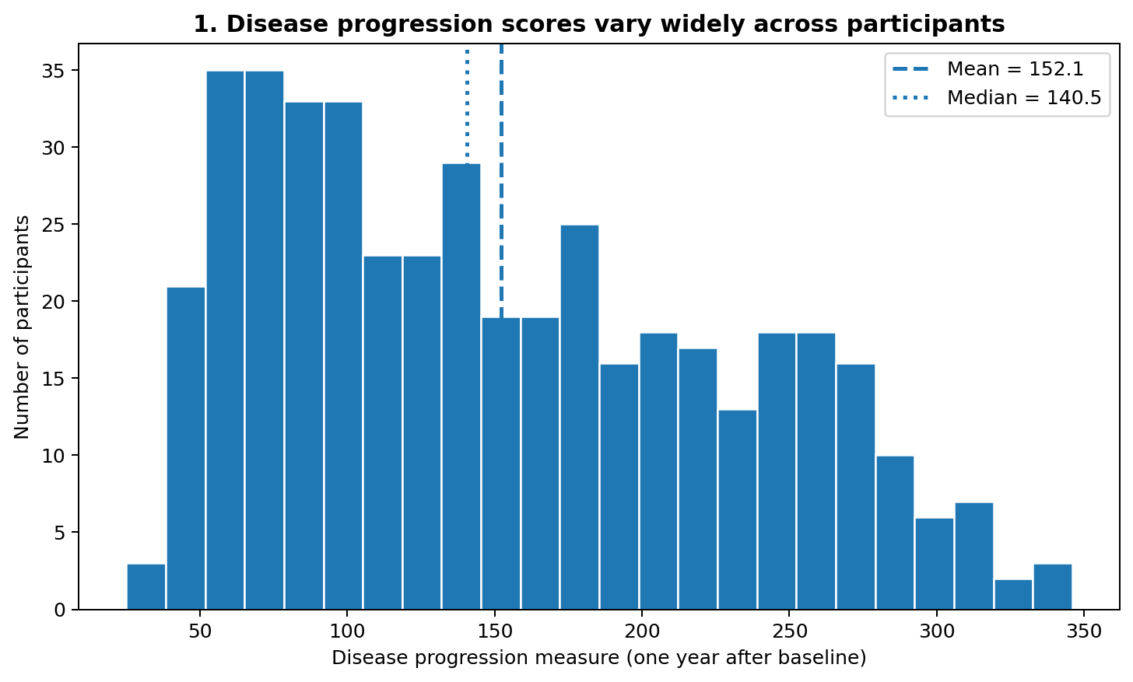
Figure 1. The distribution shows the spread of the one-year progression measure; dashed and dotted lines mark the mean and median.
The distribution spans a broad range of values (mean 152.1, median 140.5, standard deviation 77.1). This indicates that participants did not share one uniform outcome. The histogram is the right first chart because it establishes scale, spread, and whether the data appear symmetric or skewed before comparing individual features.
Story contribution: start with the outcome itself before asking which baseline features relate to it. This prevents the audience from interpreting a feature relationship without knowing how variable the outcome is.

3.2 Compare features: which have the clearest linear associations?
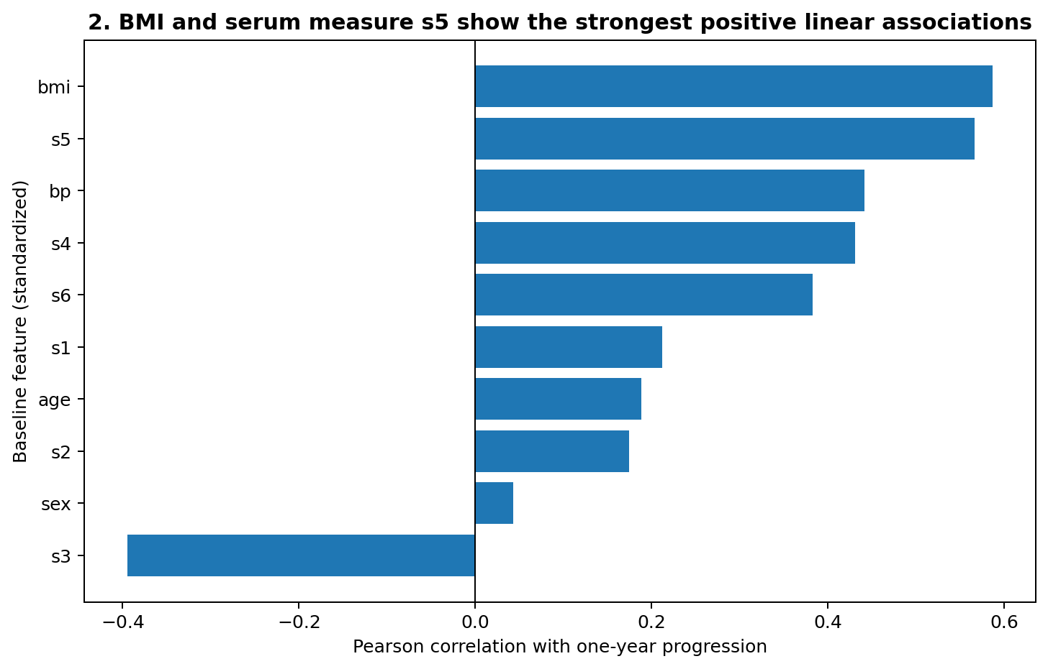
Figure 2. Pearson correlations ranked from negative to positive; bmi has the largest positive correlation in this dataset.
The strongest positive correlation is bmi (r = 0.59), followed by other positive associations; s3 has the most negative association (r = -0.39). BMI has a positive correlation of 0.59. Correlation describes the direction and strength of a linear relationship, not the effect of changing a feature. Correlated features may also overlap in the information they contain.
Story contribution: the ranked bar chart is more direct than a table of coefficients because the audience can immediately compare direction and magnitude. It identifies candidates for closer inspection, not a list of proven causes.

3.3 Explore BMI in more detail
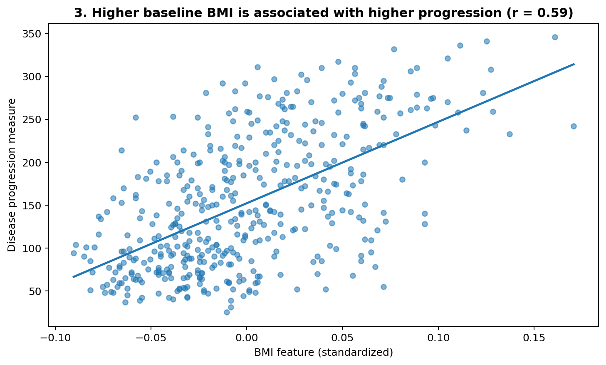
Figure 3. Each point represents a participant; the line summarizes the positive linear trend (Pearson r = 0.59).
The scatterplot shows a positive overall relationship between the standardized BMI feature and the progression measure, but individual points are widely dispersed around the trend. This dispersion matters: BMI alone does not precisely determine the outcome. The fitted line is a descriptive summary and should not be interpreted as a causal effect.
Story contribution: the scatterplot complements the correlation bar chart by revealing spread, clustering, and potential influential observations that a single coefficient hides.

3.4 Compare lower-to-higher BMI groups
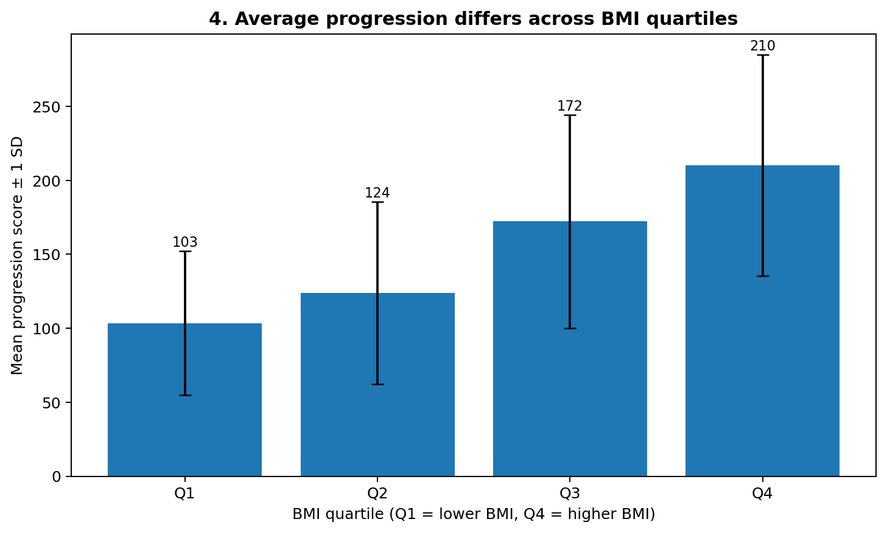
Figure 4. Mean progression across BMI quartiles; error bars show one standard deviation within each group.
Mean progression by BMI quartile is Q1: 103.4; Q2: 123.9; Q3: 172.3; Q4: 210.1. The group means generally provide a simple way to compare lower and higher BMI ranges. The error bars show substantial within-group variation, reminding readers that groups overlap and that group averages do not predict an individual's outcome.
Story contribution: quartile grouping is accessible to audiences who find standardized scatterplot axes difficult. The trade-off is that grouping discards detail and results depend partly on the chosen cut points.

3.5 Consider the wider pattern among features
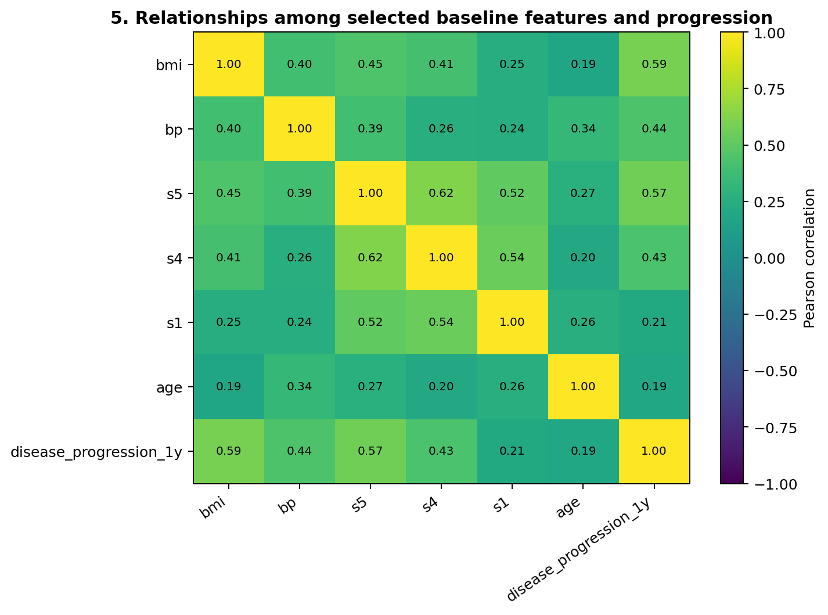
Figure 5. Correlation heatmap for selected features and the target; colors and values encode direction and strength.
The heatmap shows that baseline measurements can be related to one another as well as to the target. This is important because a feature that correlates with progression may share information with another feature. A multivariable model can help examine joint predictive value, but correlated predictors complicate interpretation of individual coefficients.
Story contribution: the heatmap moves from a one-feature view to a system view. It helps the audience see why health outcomes are unlikely to be explained by a single measurement.

3.6 Check whether age tells a similar story
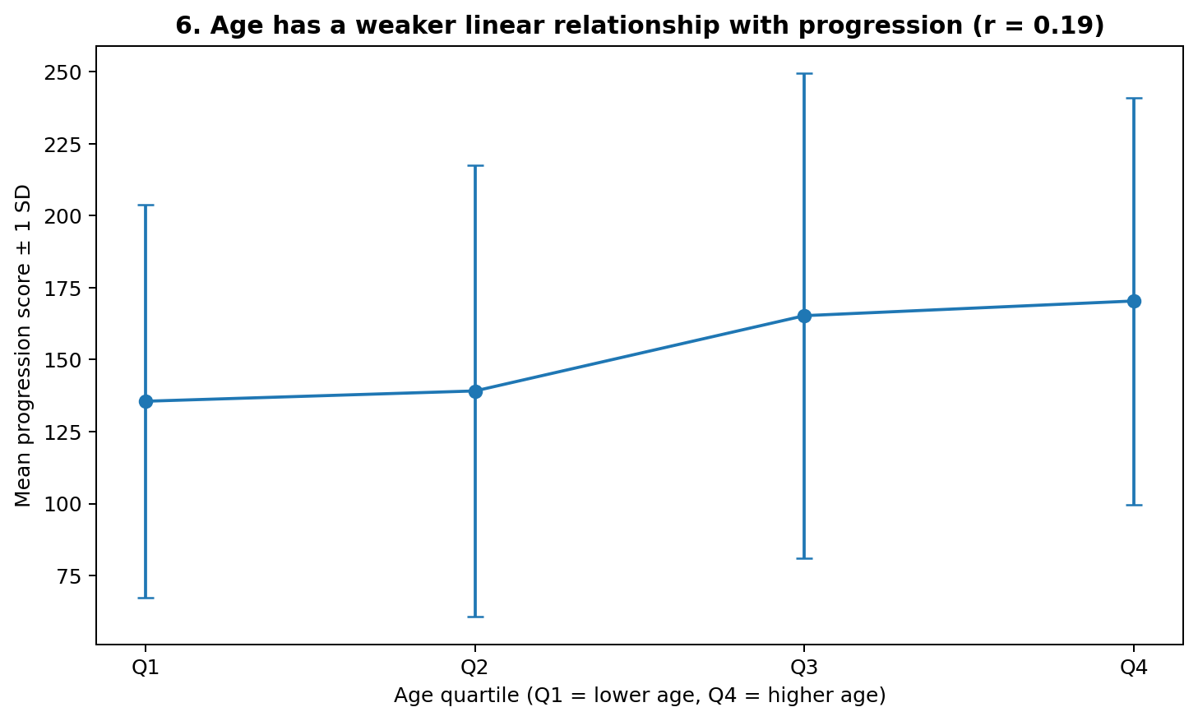
Figure 6. Mean progression across age quartiles; the overall linear correlation between age and progression is 0.19.
Age has a weaker linear correlation with progression in this dataset (r = 0.19) than BMI and bmi. The age-quartile plot provides a grouped view, but the means and standard deviations should be interpreted cautiously. A weak linear correlation does not prove that age is irrelevant; the relationship could be nonlinear or affected by other variables.
Story contribution: this chart prevents the narrative from focusing only on the strongest association. It shows that a plausible variable may have a weaker simple relationship in this particular sample.

4. Summary of the Data Story
- The outcome varies considerably across the 442 observations (mean 152.1; median 140.5).
- The strongest positive single-feature linear association with progression is bmi (r = 0.59); BMI is also positively associated (r = 0.59).
- The BMI scatterplot has substantial dispersion, so a positive trend should not be used to predict an individual's outcome by itself.
- The heatmap demonstrates interrelationships among baseline measurements, reinforcing that outcomes are multifactorial.
- Age's linear correlation is comparatively weak (r = 0.19), but this does not establish that age has no relationship.

5. Potential Scientific and Practical Implications
For scientific exploration, these charts can help prioritize questions for further study, such as whether BMI-related patterns remain after accounting for other baseline measurements and whether relationships differ across subgroups. For health analytics teams, the report demonstrates how to communicate a dataset's variability and associations without overstating evidence. For a general audience, the main message is that baseline features can be associated with later progression, but no single chart establishes cause, treatment effectiveness, or an individual's prognosis.
Any real clinical or policy decision would require domain expertise, appropriate study design, external validation, privacy safeguards, and careful consideration of confounding variables. This dataset is suitable for demonstrating visualization methods, not for making medical recommendations or diagnosing individuals.

6. Limitations and Responsible Interpretation
- The dataset is small compared with many modern health datasets and may not represent every population.
- Predictor values are standardized, limiting direct interpretation in original clinical units.
- Correlation is not causation and does not adjust for confounders.
- Quartile charts depend on grouping choices and hide within-group detail.
- The analysis is exploratory; the visuals do not establish clinical thresholds or validated prediction rules.
- A few unusual observations may influence correlations and fitted lines.

7. Conclusion
The visual sequence creates a coherent narrative: understand the outcome distribution, compare feature associations, examine BMI at individual and grouped levels, inspect relationships among predictors, and check a weaker association for contrast. Six chart types were selected because each answers a different question rather than repeating the same message. The main findings are descriptive: the outcome varies widely, BMI and serum measure s5 show positive linear associations, and substantial individual variation remains. The most important storytelling principle is to make the chart's message clear while also showing uncertainty and limitations. A good visualization informs the next question; it does not replace evidence or domain judgment.

Appendix A. Reproducibility
Suggested environment: Python 3.10+, scikit-learn, pandas, NumPy, and Matplotlib. The dataset is loaded from scikit-learn, so no separate CSV download is needed.
pip install scikit-learn pandas numpy matplotlib
python create_visual_story.py
For context only, a simple linear regression using all ten features was evaluated on a held-out 20% split (random_state=42): R² = 0.45, MAE = 42.8. This is an illustrative baseline, not a tuned or clinically validated model. The main assignment is about visualization and storytelling, not model optimization.

References
- Scikit-learn documentation, Diabetes dataset: https://scikit-learn.org/stable/datasets/toy_dataset.html#diabetes-dataset
- Scikit-learn API, load_diabetes: https://scikit-learn.org/stable/modules/generated/sklearn.datasets.load_diabetes.html
- Matplotlib documentation: https://matplotlib.org/stable/
- Pandas documentation: https://pandas.pydata.org/docs/

