PRECISION AGRICULTURE USING MACHINE LEARNING

& IOT

Softwares Used:
- Programming Language
Python3
- Front-End
HTML, CSS, JavaScript, Bootstrap, Python-Flask
- Back-End
MySQL

- Python-Libraries
Seaborn, Pandas, NumPy, SciKit-Learn, Pytorch, ResNet-9, SQLAlchemy, Pickle

Algorithms used & their accuracy:
Algorithm | Accuracy (%)
Decision Tree | 90%
SVM | 97%
Logistic Regression | 95%
Random Forest | 99%

User Interface Snap:
Home Page 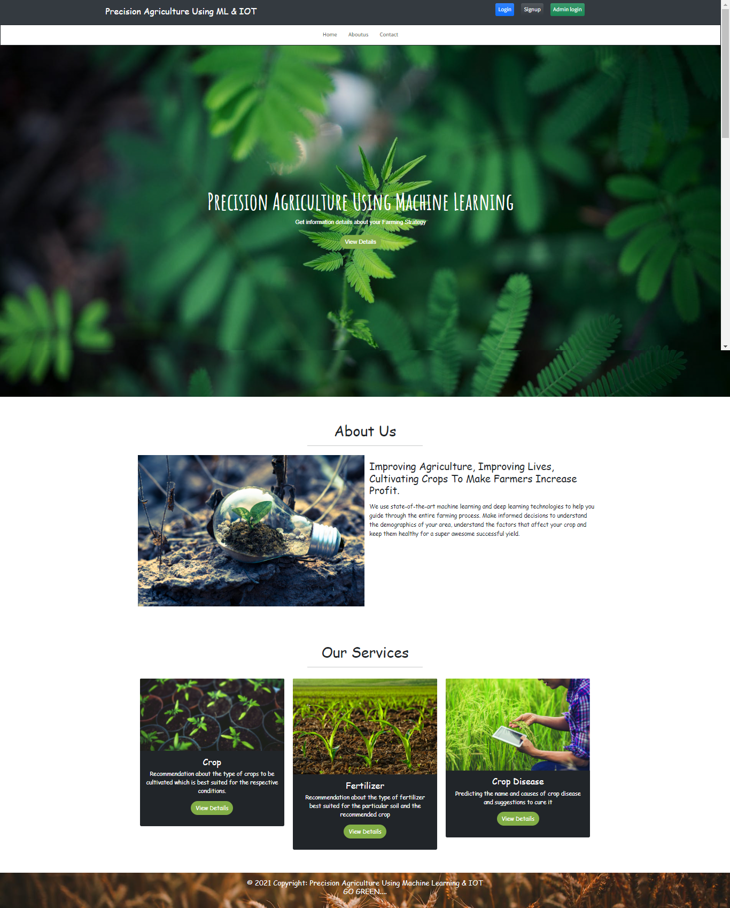
Crop Recommendation & Result Page 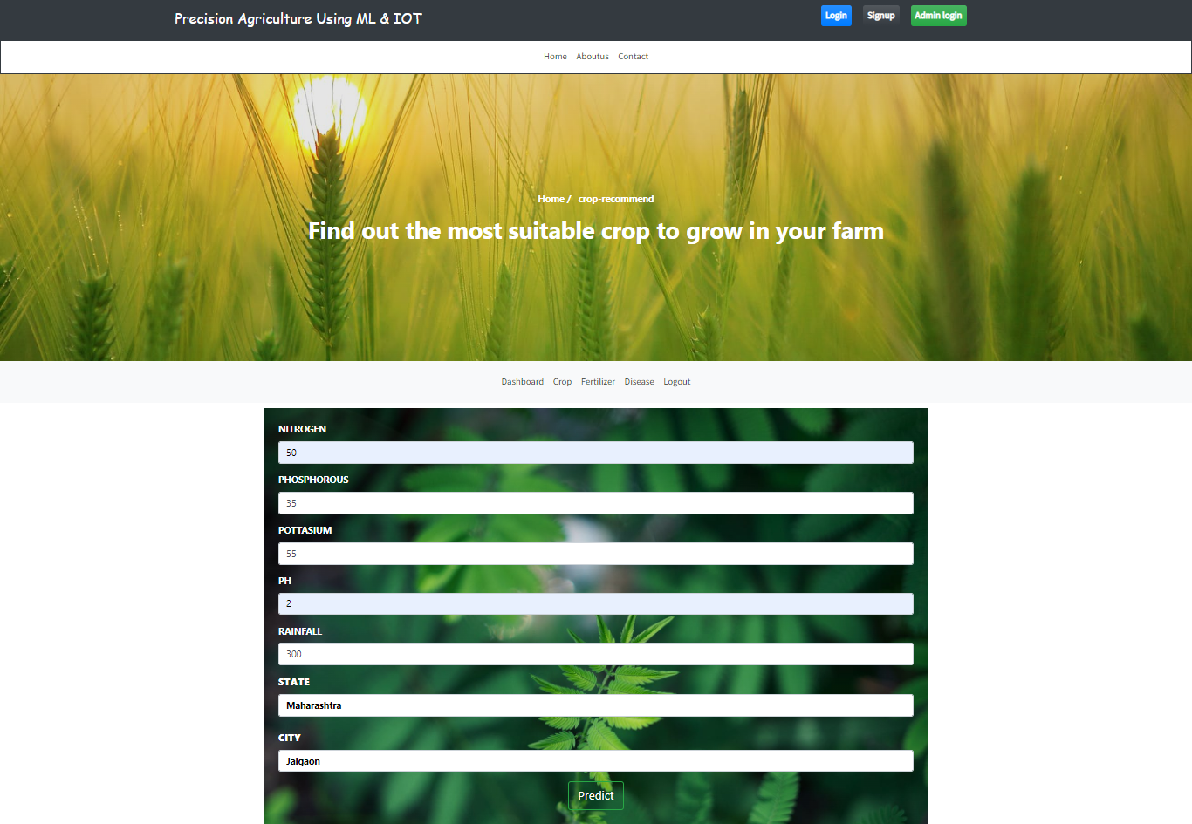
Result 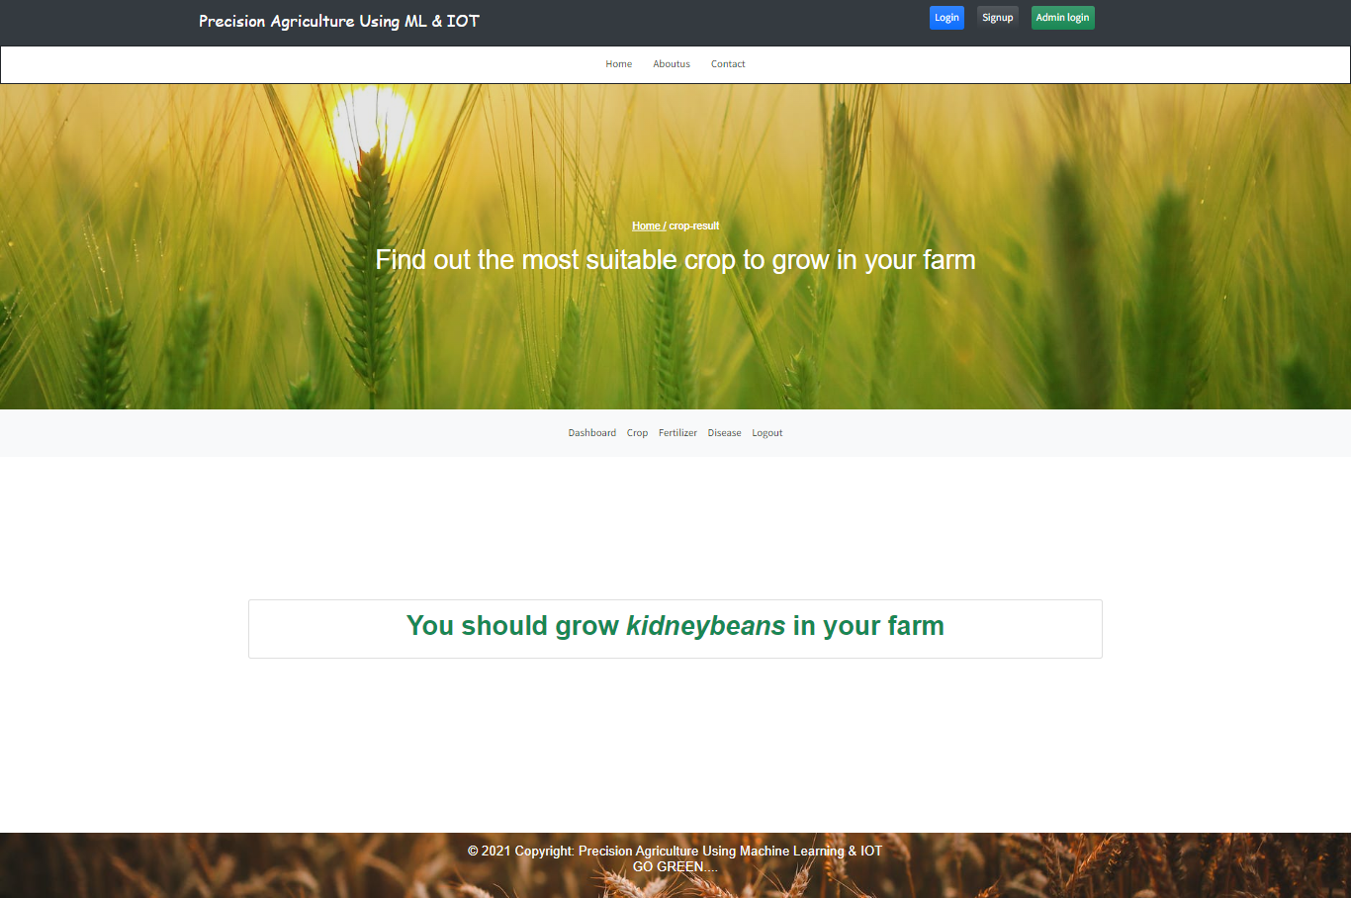
Fertilizer-Suggestion & Result PageCrop 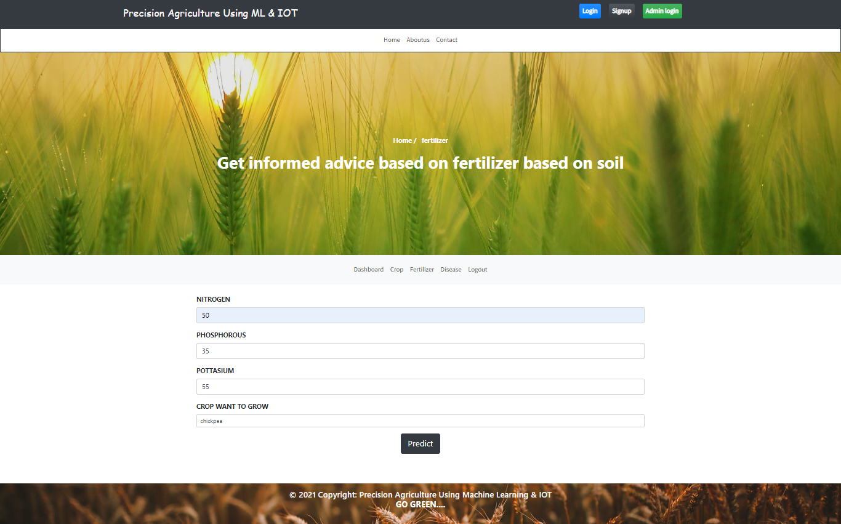
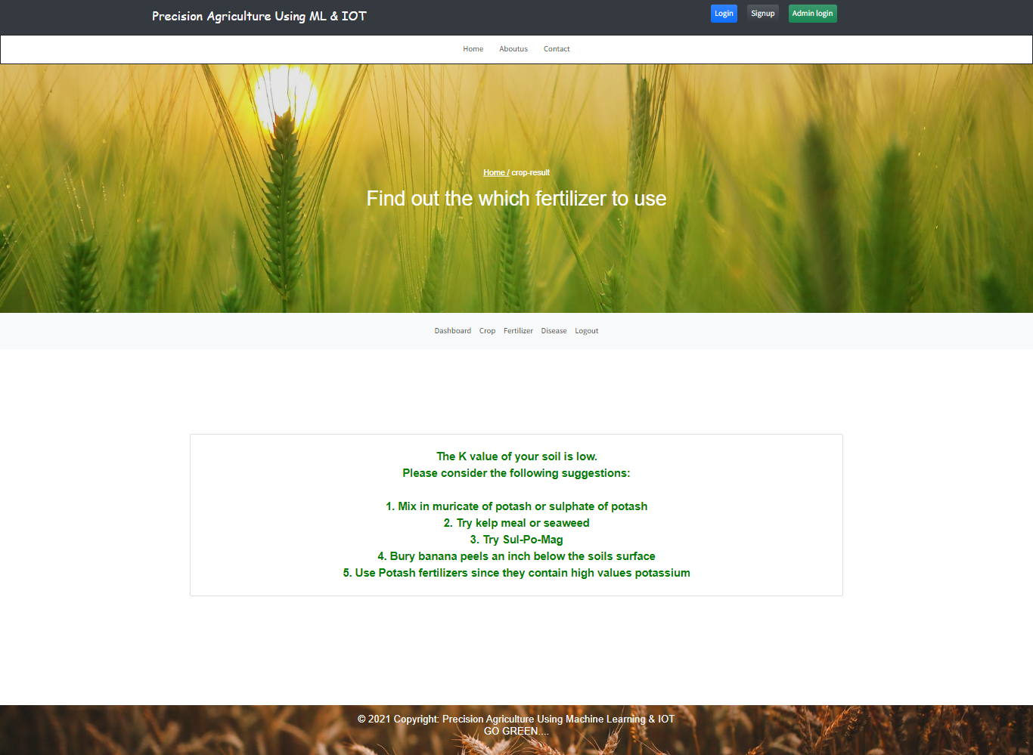

Crop Disease Prediction & Result PageCrop 