**NOISE POLLUTION MANAGEMENT USING INTERNET OF THINGS**

**(Phase 1)**

**Abstract**

Recently, the World Environment Day was celebrated globally, which reminds that to take proper control action for saving and maintaining the environment. Rapid Industrialization is the main reason for each type of pollution. The major sources of environment degradation are: - Industrial emission, Vehicle emission, Fossil fuel burning and fire, Agricultural activities, Population etc. Toxic gas emission, waste water discharge, noise from industries are responsible for the degradation of the environment. Sources of emission in industries have been identified and presented in this study. To reduce the noise pollution from industrial area the use of IoT technique is presented in this paper. Using the noise sensors, the noise intensity is determined at that area and processed this signal and transferred it to the microcontroller. WiFi module is used for transmitting the level of noise to the server and further it is shared with that authority.

**Keywords***:* IoT (Internet of Things), Microcontroller, Wi-Fi module, sensors.

1. **Introduction:**

Every year in Europe alone, the noise causes 16,600 premature deaths and 72,000 hospital admissions. It is detrimental to both humans and animals. Noise pollution harms wildlife and has a significant negative influence on the ecosystem. According to experts, noise pollution can affect mating and rearing processes and potentially expedite the extinction of some species. The harm that contamination causes to the world's inhabitants is not limited to atmospheric pollution. It is one of the most harmful environmental risks to health, according to the World Health Organization (WHO). Unwanted sounds (environmental noise) in urban settings are mostly produced by road-based mobility, but rail-based, airport-based, and industrial noise are also significant contributors. Noise pollution does not apply to all sounds. Noise pollution is defined by the World Health Organization (WHO) as noise that is louder than 65 decibels (dB). More specifically, noise becomes unpleasant over 120 decibels (dB) and hazardous above 75 dB. Since peaceful sleep cannot be achieved with ambient noise levels above 30 dB at night, it is advised that noise levels be kept below 65 dB during the day.

Industrial noise is the environmental component that has raised the most questions about how it affects workers' productivity and health. Processes that cause impact, vibration or reciprocation movements, friction, and turbulence in air or gas streams are the main sources of noise in industry. Noise emission regulations only have a slight influence on how loud a machine emits noise. The maximum allowable noise levels crossing industrial and construction site boundaries, as well as acceptable daytime and night-time noise levels in residential, commercial, and industrial sectors, are all stated in these regulations. The maximum volume that can be heard at a worker's ears and the amount of time they are exposed to it are not directly related to the noise made by any particular machine; instead, they are affected by the overall amount of noise in the space, the workers' proximity to the machine, and other variables. Because of this, product-oriented noise emission rules must be the exclusive focus of noise emission standards or their objective. According to reports, the characteristics that irritate workers are loud noises, high frequencies, and their intermittent nature. In addition to creating bodily and psychological harm, such a circumstance reduces worker efficiency, which results in low output and discontent. Because of the diversity and complexity of the various components involved, it is challenging to properly determine how the community will react to industrial noise and, as a result, the establishment of permissible limits for community areas. Industrial noise pollution is mostly caused by the loud noises that machines in various factories, mills, and industries make. Noise pollution is heavily produced by engineering firms, printing presses, textile mills, and metal enterprises. Noise pollution is heavily produced by engineering firms, printing presses, textile mills, and metal enterprises. Public annoyance is caused by the machine's mechanical pneumatic drills, saws, and revolving belts, which make insufferable noises. Residents who live close to manufacturing or industrial operations report loud noise levels that can harm hearing. Industrial towns near to residential areas have long caused annoyance and discomfort to the locals. Workers in these fields are required to protect themselves from loud noise by donning earplugs. Due to the variety of activities involved, industrial noises that infiltrate residential areas can be very diverse. In order to reduce industrial noise, noisy gear or equipment are typically replaced with quieter alternatives. For instance, one can get the same amount of airflow while reducing the rotational speed and increasing the number of blades or their pitch on an air fan. By blocking the path of industrial noise, such as by insulating a noisy motor, noise levels can also be reduced.

1. **Review of Literature:**

In this paper the author presented the sound pollution monitoring system, Choosing the number and locations of stations while considering the goals, costs, and available resources is fundamental to designing the network for monitoring air and sound quality. An expert system should be created to fix the precise quantity and distribution of monitoring locations for a sensor in order to aid an industrialist. The energy-efficient continuous air and sound pollution monitoring sensor network must have some direction from the expert system.

In this paper the author represented a system using a smartphone application, the air and sound pollution monitoring system tracks both air and noise pollution. The user can utilise a graph that is provided to analyse the digital value of air and sound pollution. It becomes quite simple for us to make changes to the levels of noise and air pollution around and to plan for a healthy lifestyle. The air and sound monitoring technology resolves a significant issue with extremely contaminated locations. People can use this system's capabilities and an app to check the level of pollution on their mobile phones.

The author presented the air and sound pollution monitoring system. The air and noise sensors give the microcontroller the information so it may get notifications from the Blynk app. The output is displayed in analogue form, so if the air pollution increases, it will be shown on the output and the buzzer will also increase at the same time. Similarly, if the sound pollution exceeds the set limit, the buzzer will also buzz, and the user will also receive a notification on their phone via the Blynk app at the same time.

For monitoring the environmental pollution, the author represented the system which monitors the pollution level. to place sensor equipment in the environment for the purpose of gathering and analysing data It can communicate with other items via the network by placing sensor devices in the environment. The user will then have access to the gathered data and the analysis' findings over Wi-Fi. In this research, various models for the intelligent environmental monitoring and an effective, low-cost embedded system are described. Different modules' functions were covered in the suggested architecture. Two metrics were experimentally monitored using the noise and air pollution monitoring system with Internet of Things (IoT) concept. Additionally, it uploaded the sensor's parameters to the cloud (Google Spread Sheets). This information can be easily shared with other end users and will be useful for upcoming analyses.

In this system the author developed a system which monitors the air and sound pollution by using internet of things. Air and sound sensors are used to sense the level of pollution in that particular area. Arduino Uno is used for processing the data and by using Wi-Fi module the data is sent to the cloud for monitoring purpose. By utilising the technology, every deviation can be analysed and surrounding people can be informed promptly.

In this system the author proposed a system which monitors the pollution level. When the pollution levels change, this technology will also provide notifications to the authorities. To enable the authorities to take the necessary measures, the system will also consider pollution levels. The app will display the levels as well as the mobile device's GPS location, and depending on the location, it will display all pertinent local information. The system will be installed in the most crowded area of the region and made up of Arduino and sensors that measure the levels of sound and noise pollution. The system will constantly be in operation and taking the necessary readings. These readings will be delivered to the administrator. The full database will be accessible to the Administrator.

**3. Methodology:**

As depicted in Figure.1, the system's primary controller is an Arduino. MQ135 gas sensor is used in the system to detect or sense gases, and sound sensor LM393 module is utilised to detect noise pollution. The analogue pin of the Arduino receives the sensor data, and the digital output pins are connected to the LCD and buzzer. Buzzer will begin beeping if noise and air pollution levels there exceed the threshold level. All pollution levels are shown on an

LCD, and prior data may be analysed using Things peak’s graphical interface. An opensource prototype is Arduino. Applications will run in the Arduino IDE. It is possible to write and

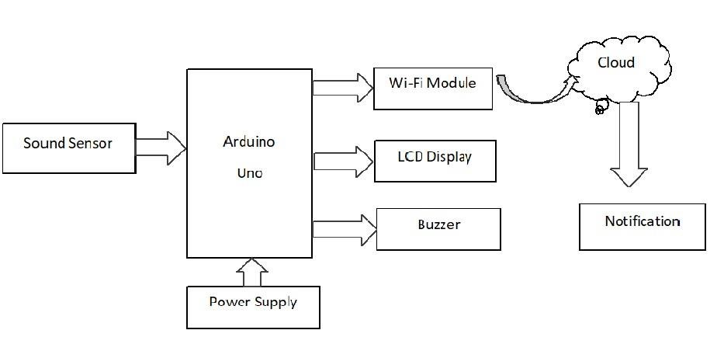

**Figure 1.** Block diagram of the system

upload computer code to the actual board. Applications will run in the Arduino IDE. It is possible to write and upload computer code to the actual board. The programming language Embedded C is used for Arduino. This IoT-based sound pollution monitoring device is economical and environmentally benign. Both the relevant authorities and the general public are able to use this system. Once deployed, this autonomous equipment can continuously monitor the level of pollution and analyse the data collected. The Internet of Things (IoT) concept for monitoring noise through an experimental noise pollution monitoring system. This approach offers a successful and affordable method for ongoing environmental monitoring in order to safeguard public health from pollution and other diseases induced by pollution.

1. **Conclusion:**

In this research, an effective, low-cost embedded system is described together with a clever technique to monitor the surroundings. A positive step toward addressing the greatest threat is the Automatic Sound control system. The major issue of extremely polluted places is solved by the sound monitoring system. It effectively promotes the concept of a healthy living while also supporting modern technology. With the help of the application, users of this system can use features to track the level of pollution on their mobile devices. As a result, monitoring the environment by the relevant agencies and the general public becomes very dependable and effective. This method gains more importance if civilians are allowed to participate in it. This idea of IOT is advantageous for the wellbeing of society as citizens are now equally aware of and curious about their environment. And the most recent technology is used in its implementation.

**Thank you**