NOISE POLLUTION MONITORING
USING
INTERNET OF THINGS

(Phase-2)

Submitted by:
B.Manobala
INNOVATIONS:
- Smartphone Apps with Noise Mapping:
Develop a smartphone app that allows users to measure noise levels and contribute data to a centralized noise map. This crowd sourced data can be valuable for both individuals and urban planners.
- AI-Powered Noise Recognition:
Implement artificial intelligence algorithms to recognize and classify different types of noise sources. This can help in identifying specific sources of noise pollution and potential violators.
- Wearable Noise Monitoring Devices:
Create wearable devices (like smartwatches or badges) that monitor noise levels around the user in real-time. Users can receive alerts and track their exposure to noise pollution.
- Drone-Based Noise Surveillance:
Use drones equipped with noise sensors to conduct aerial surveys of noise pollution in urban areas, transportation routes, and construction sites. This can help in identifying hotspots and sources.
- Noise Monitoring IOT Devices:
Develop a network of IOT (Internet of Things) devices that can be deployed across cities and connected through a central system. These devices should provide real-time data on noise levels, helping cities to make data-driven decisions for noise control.
- Noise Pollution Prediction Models:
Use machine learning models to predict future noise pollution levels based on historical data and events. This can be useful for proactively managing noise in sensitive areas.
- Noise Pollution Score for Properties:
Introduce a scoring system for properties based on their noise pollution levels. This score could be made public, encouraging property owners to take measures to reduce noise emissions.
8. Noise Pollution Education Apps:
Develop educational apps for schools and communities to raise awareness about the execution noise pollution and how individuals can contribute to its reduction.
DESIGN:
Air and sound pollution is a growing issue these days. It is necessary to monitor air quality and keep it under control for a better future and healthy living for all. Here we propose an air quality as well as sound pollution monitoring system that allows us to monitor and check live air quality as well as sound pollution in a particular areas through IOT. System uses air sensors to sense presence of harmful gases/compounds in the air and constantly transmit this data to microcontroller. Also system keeps measuring sound level and reports it to the online server over IOT. The sensors interact with microcontroller which processes this data and transmits it over internet.

BLOCK DIAGRAM:

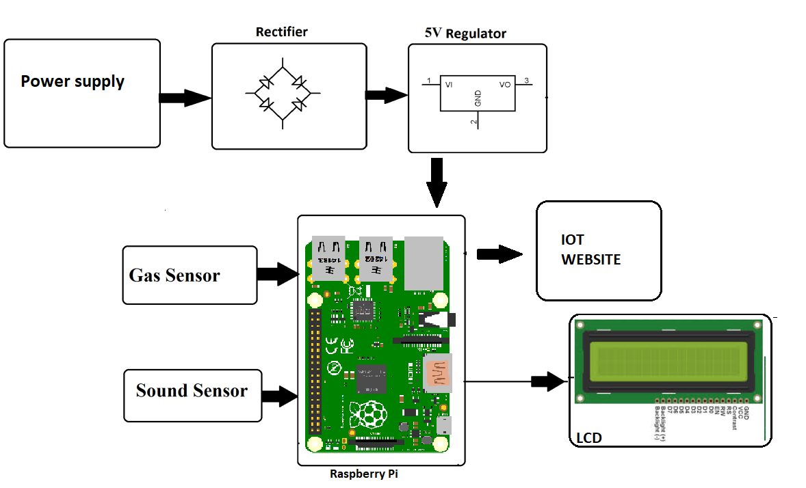

Hardware Specifications:
- Air Pollution Sensors
- Sound Sensors
- Atmega 328 Microcontroller
- Wifi Modem
- LCD Display
- LED’s
- Transformer
- Resistors
- Capacitors
- Diodes
Software Specifications:
- Arduino Compiler
- MC Programming Language: C

THANK YOU

