**screen shot**

**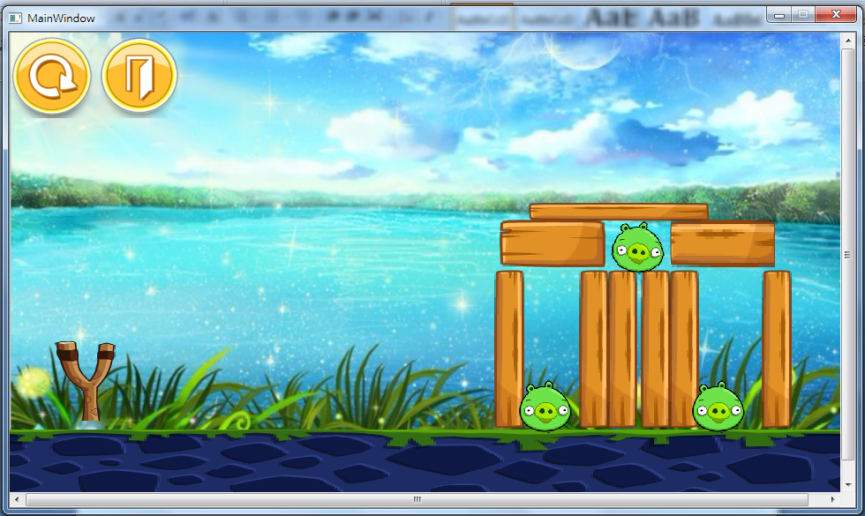**

**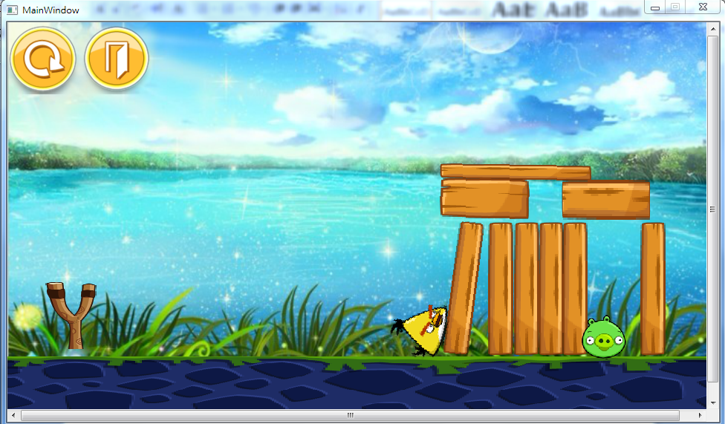**

**How to play** 

按滑鼠左鍵一下可生成一隻鳥，並按以下順序產生

Normal_Bird_1.png ：普通版

yellow.png：過重版:

：加速版→案下”A”鍵垂直往下掉

blue.png：影分身之術版→案下”S”鍵會分成三隻

**program architecture**

首先出現遊戲畫面，上面有兩個按鈕restart和quit，按下restart之後回復為一開始的狀態，在遊戲畫面按下滑鼠左鍵就會出現鳥，若打擊到豬或豬被障礙物壓倒，豬就會消失。

**UML class diagram**

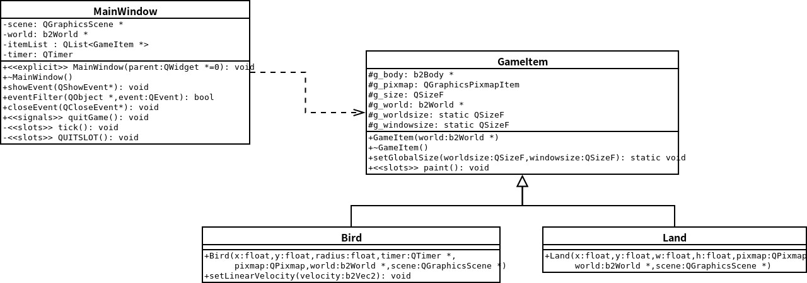

Button

+<<constructor>>Button(QGraphicsItem\* parent=NULL);

+<<signals>>clicked():void

*+mousePressEvent*(QGraphicsSceneMouseEvent \* event): void

Obstacle

+Obstacle(float x, float y, float w, float h, QTimer \*timer, QPixmap pixmap, b2World \*world, QGraphicsScene \*scene);

Target

+Target(float x, float y, float radius, QTimer \*timer, QPixmap pixmap, b2World \*world, QGraphicsScene \*scene);

Bird3

+Bird1(float x, float y, float radius, QTimer \*timer, QPixmap pixmap, b2World \*world, QGraphicsScene \*scene);

+ setLinearVelocity(b2Vec2 velocity):void

Bird2

+Bird1(float x, float y, float radius, QTimer \*timer, QPixmap pixmap, b2World \*world, QGraphicsScene \*scene);

+ setLinearVelocity(b2Vec2 velocity):void

Bird1

+Bird1(float x, float y, float radius, QTimer \*timer, QPixmap pixmap, b2World \*world, QGraphicsScene \*scene);

+ setLinearVelocity(b2Vec2 velocity):void

-birdie: Bird \* - target1:Target\*

-birdie1:Bird1 \* - target2:Target\*

-birdie2:Bird2 \* - target3:Target\*

-birdie3:Bird3 \* -score:int

Target\*target1;

Target\*target2;

Target\*target3;

+<<slots>>start():void

+<<slots>>getpoint() : void

+game():void