1. UML class diagram (slot:+’ signal:+.)

|  |
| --- |
| Button |
| -text:QString |
| <<constructor>>+Button(name:QString,parent=NULL:QGraphicsItem*)  +mousePressEvent(event:QGraphicsSceneMouseEvent*) void  + hoverEnterEvent(event:QGraphicsSceneHoverEvent*) void  + hoverLeaveEvent(event:QGraphicsSceneHoverEvent*) void  +.clicked():void |

QObject,QGraphicsRectItem

|  |
| --- |
| Bullet_1 |
| -getscoresound:QMediaPlayer*  +score:Score* |
| <<constructor>>+Bullet_1(parent=0:QGraphicsItem*)  +keyPressEvent(event:QKeyEvent*):void  +’move():void |

QObject,QGraphicsPixmapItem

|  |
| --- |
| MyRect |
|  |
| +’spawn_1():void |

QObject,

QGraphicsRectItem

|  |
| --- |
| GamePlay |
|  |
| +create():void |

|  |
| --- |
| Bullet_2 |
| -getscoresound:QMediaPlayer*  +score:Score* |
| <<constructor>>+Bullet_2(parent=0:QGraphicsItem*)  +keyPressEvent(event:QKeyEvent*):void  +’move():void |

QGraphicsRectItem

QObject,QGraphicsPixmapItem

QGraphicsTextItem

|  |
| --- |
| Score |
| +score:int |
| <<constructor>>+Score(parent=0:QGraphicsTextItem*)  +increase():void  +getscore():int |

|  |
| --- |
| Game |
| +score:Score*  +time:Time*  +scene:QGraphicsScene* |
| <<constructor>>+Game(parent=0:QWidget*)  +displayMainMenu():void  +’start():void  +’timecount():void  +’endwindow(parent=NULL:QWidget*):void |

|  |
| --- |
| Time |
| +time:int  +score:Score* |
| <<constructor>>+Time(parent=0:QGraphicsTextItem*)  +decrease():int  +getTime(); |

QGraphicsView

QGraphicsTextItem

2.screen shot

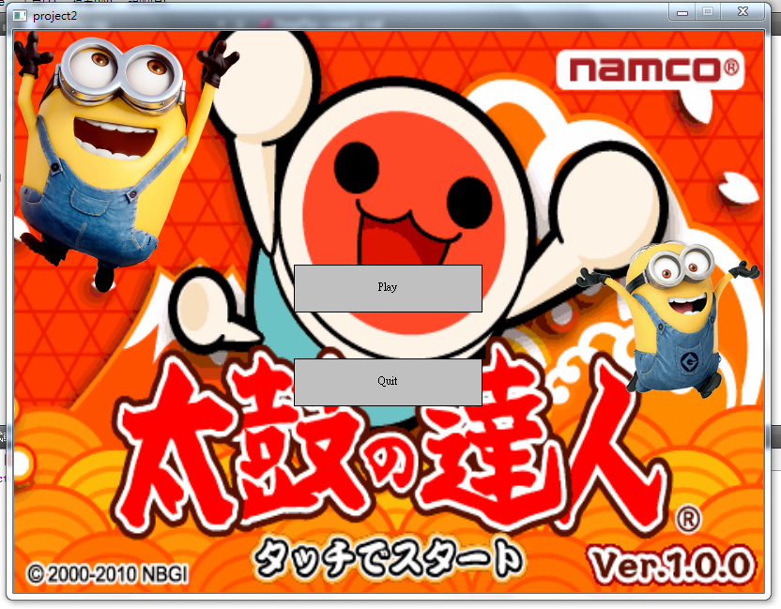

開始畫面

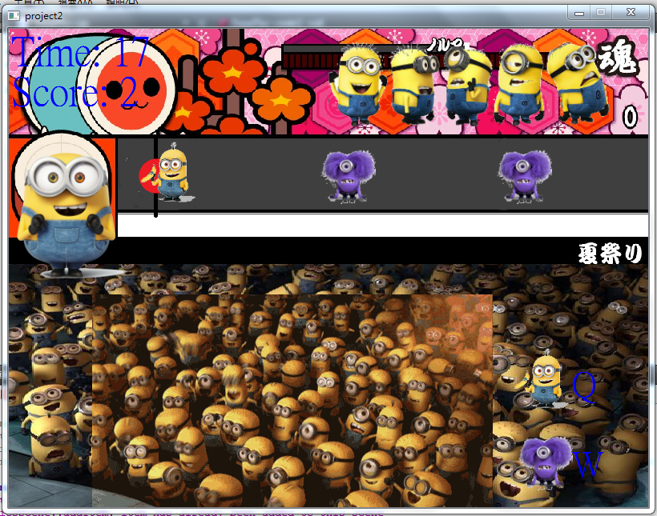

遊戲畫面

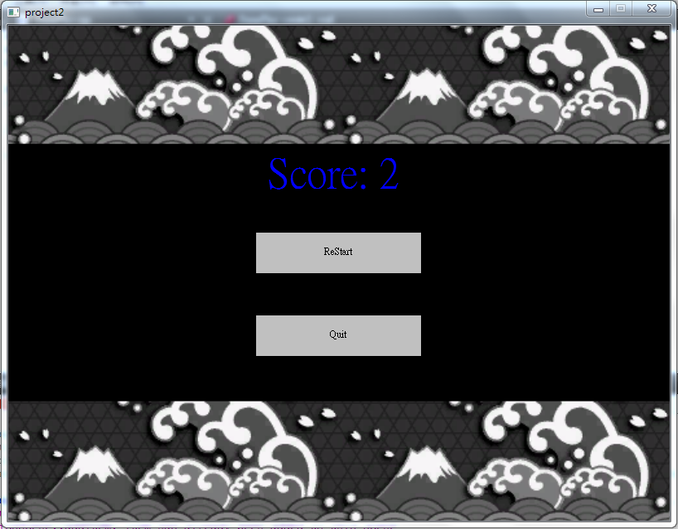

結束畫面

3.how to play

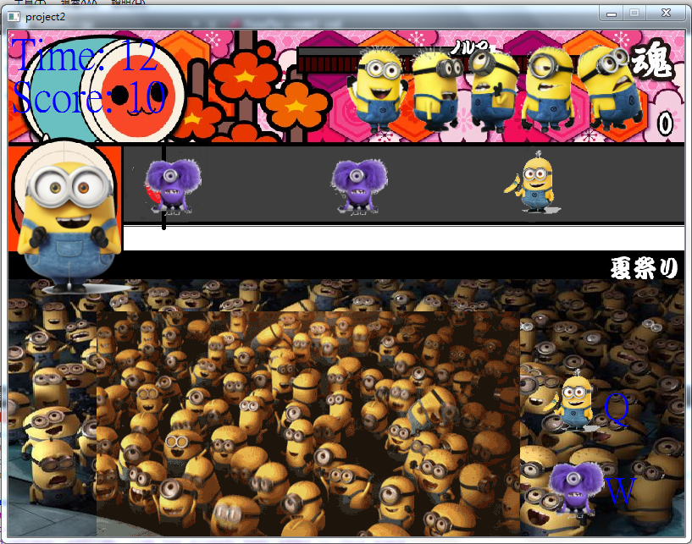

當小小兵到達此位置按下指定按鍵即可消去

按W可消去

紫色小小兵

按Q可消去

黃色小小兵

4.program architecture

首先出現遊戲開始畫面，按下play鍵後會clear視窗、出現分數、出現時間並開始倒數同時連接GamePlay class出現遊戲畫面，同時開始每秒隨機產生兩種小小兵且移動，當時間為零時關掉視窗，重新開啟一個結束畫面視窗，上面有兩個按鈕restart和quit，按下restart之後的動作皆與一開始按下play鍵一樣。