Which Economies Come Under Stress When Oil Prices Spike?
ISOM3360 Data Mining progress report | [Group number and member names] | November 5, 2026

1. Project recap
When oil prices spike, some economies absorb the shock and others fall into high inflation. We ask which countries are likely to come under economic stress, and whether we can flag them a year in advance. We will then apply the best model to the 2026 Iran-related oil shock, when Brent rose from about $63 in December 2025 to $117 in April 2026, to rank vulnerable countries.
The answer matters to multinationals managing market and supply-chain exposure, to banks and investors pricing sovereign and currency risk, and to governments and aid agencies deciding where to prepare support.
Our data is the Kaggle dataset "Iran Oil Shock 2026: Global Economy | ML Ready" (kaggle.com/datasets/tejal5kunjir/iran-oil-shock-2026-global-economic-exposure), compiled from the EIA, World Bank, UN Comtrade and Our World in Data / Energy Institute.

2. Problem formulation
Item | Decision and reason
Unit of analysis | Country-year: 150 countries over 2010-2025, giving 2,400 rows.
Target | stress_next = 1 if next-year inflation is above 10%. This makes the task a binary classification predicting one year ahead.
Second technique | K-means clustering of countries by oil-exposure profile, with the cluster label tested as a feature.
Evaluation | Train on 2010-2021 and test on 2022-2024, with no random shuffling, because a real forecast can only learn from the past. Tuning will use time-ordered folds inside the training years.
Metrics | ROC-AUC, recall, precision and F1. Accuracy alone misleads because only 12.4% of labelled rows are stress years.

3. Data preparation completed
Merging. A reproducible script joins seven of the eight source files into one panel of 2,400 rows and 30 columns; the eighth is a latest-year snapshot and is not used for modelling. Monthly oil production and prices are averaged to annual values. We derived exposure features such as crude import burden (% of GDP), export dependence (% of GDP), oil intensity and exchange-rate change. Of the 2,400 rows, 2,105 have a target, including 262 stress cases. The other 295 are the 150 rows for 2025, whose outcome is not yet observed, and 145 rows where next-year inflation is missing.
Missing values. Crude imports are 28% missing and crude exports 41%, while most macro columns are under 10%. We found that these gaps are not random, which shapes how we handle them:
- Gaps concentrate in poorer countries. Crude imports are 13% missing for high-income countries and 62% for low-income ones, so dropping incomplete rows would remove many of the countries most prone to stress.
- Missing does not mean zero. Large producers such as Venezuela, Iran, Libya and Russia have missing exports in periods of sanctions or conflict, so we will never fill trade gaps with 0.
- Missingness carries signal. Rows with missing crude imports have a 21% stress rate, against 10% when reported. This supports testing 0/1 missing-value flags as features.
- Gaps grow over time. Crude imports reach 52% missing in 2025, so the 2026 ranking will rely on filled-in values more than any earlier year.
Outliers. Most extreme values are real crises, such as 359% inflation in Sudan in 2021, so we keep them for now. A few look like data problems and will be reviewed in the next phase, including an 11,668% exchange-rate change in Myanmar in 2012, which may reflect a change of exchange-rate regime, and small negative oil-production values for 10 countries.

4. Exploratory findings
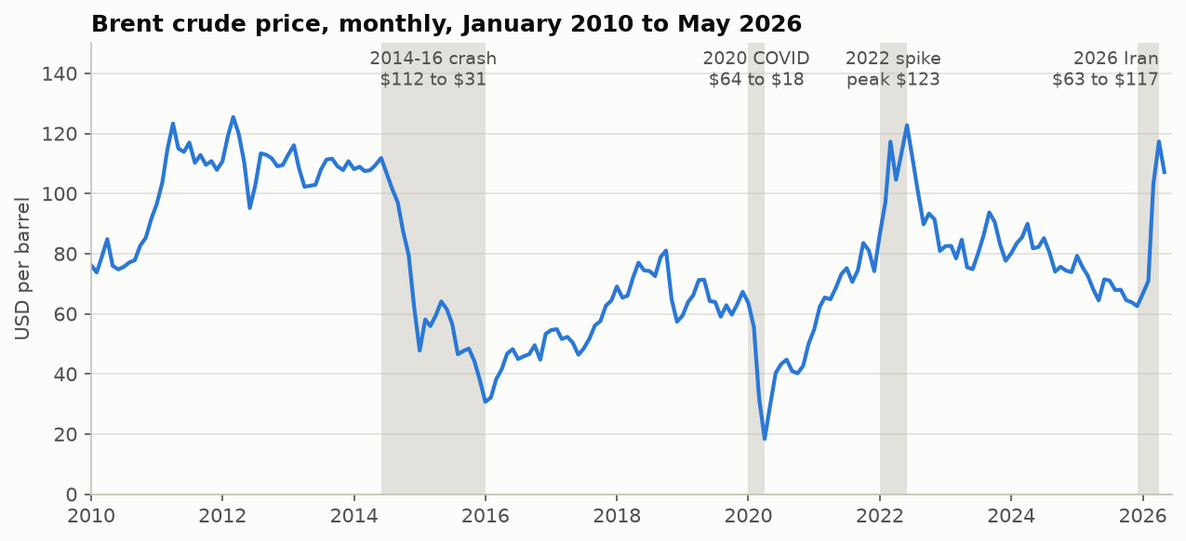
Figure 1. Brent price with the four oil episodes in our sample.
The sample holds several oil episodes, but only a few. Brent is the same for every country in a given year, so it provides only 14 distinct values across the labelled rows. Country-level exposure has to supply most of the variation.
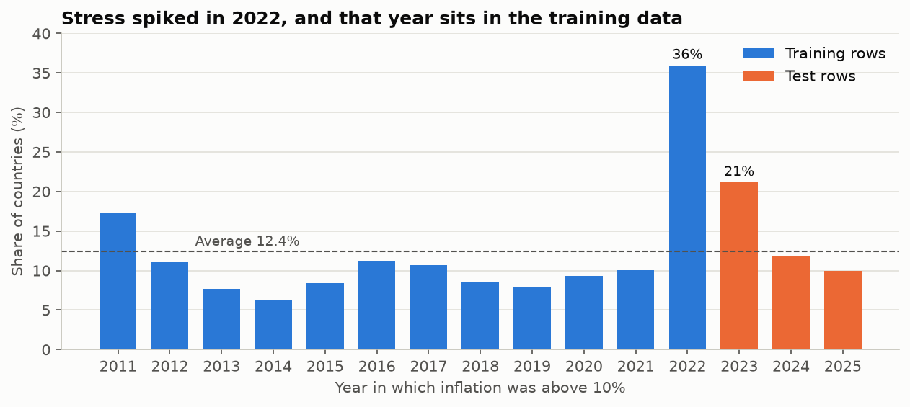
Figure 2. Share of countries with inflation above 10%, by the year the stress occurred.
Stress is usually rare at 6-12% of countries, but reached 36% in 2022. A Brent rise alone does not guarantee stress: Brent rose 40% in 2011 and 25-31% in 2017-18 with no surge the following year, and 2022 also reflects post-COVID supply problems. Our main test labels cover 2023-2025, so that test never covers the start of a shock.
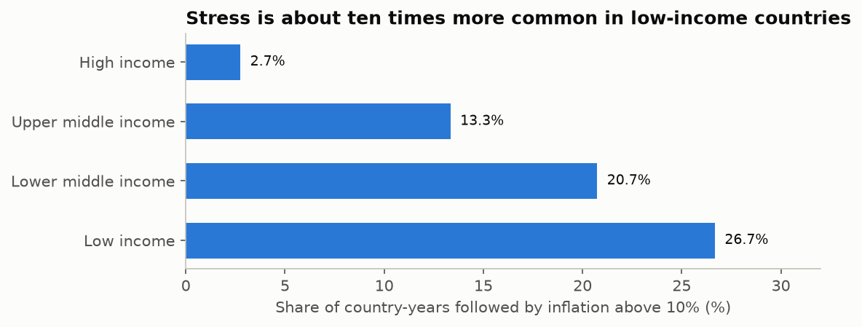
Figure 3. Stress rate by World Bank income group, 2010-2024 rows.
Income is a strong factor and a likely confounder of any oil relationship. In the training years, stress falls overall as crude import burden rises (12.6% in the lowest quartile, 5.4% in the highest), which contradicts the simple story. Within low-income and upper-middle-income countries, however, the higher-burden half has about twice the stress rate of the lower-burden half (41% vs 21%, and 10% vs 5%), although the low-income group is small at 68 rows. Big crude importers tend to be richer countries with refineries, and our crude-only trade data cannot see refined-fuel imports.
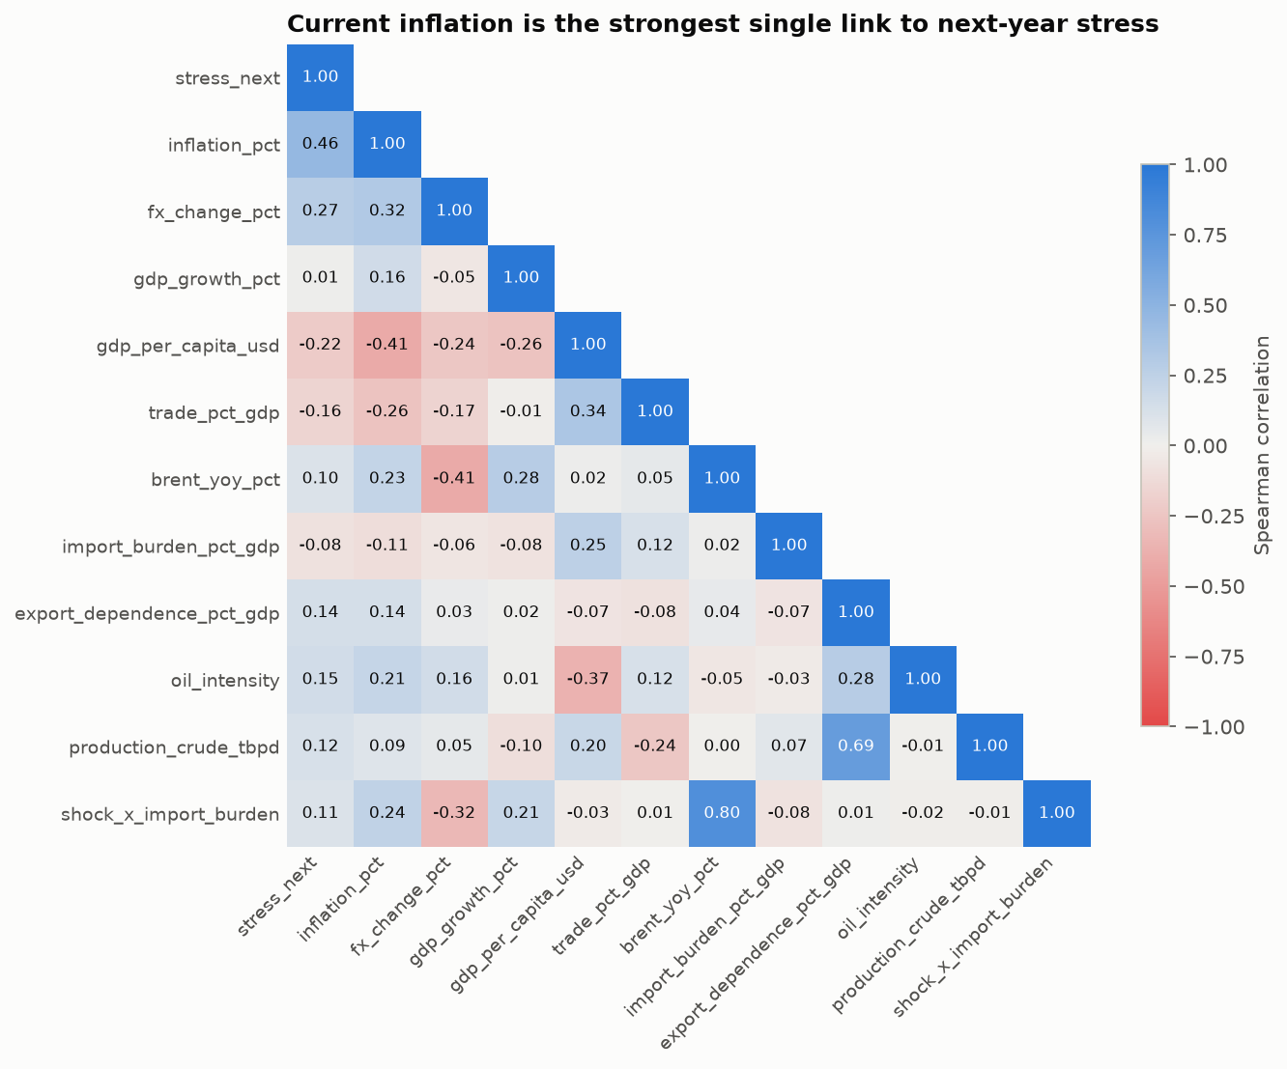
Figure 4. Spearman rank correlations, training years only.
Current inflation has the strongest link to next-year stress (+0.46), ahead of exchange-rate change (+0.27) and every oil feature. When inflation is already above 10%, stress follows 67% of the time, against 2% when it is 5% or less. This persistence effect is the central challenge for the project.

5. Preliminary results
We began with the simplest possible models. All results use the same 404 test rows, which contain 58 stress cases, and every experiment is recorded in our model log.
Model | Accuracy | Precision | Recall | F1 | ROC-AUC | Caught | False alarms | Missed
Always predict "no stress" | 0.856 | 0.000 | 0.000 | 0.000 | n/a | 0 | 0 | 58
Persistence rule: flag if inflation is above 10% now | 0.884 | 0.559 | 0.897 | 0.689 | 0.951 | 52 | 41 | 6
Logistic regression: 6 features, median imputation, scaling | 0.921 | 0.686 | 0.828 | 0.750 | 0.948 | 48 | 22 | 10
Table 1. Baseline results on the test set (2022-2024 rows).
Logistic regression is the best model so far, but with an important caveat. It leads on F1 because it raises about half as many false alarms as the one-line rule, while the two rank countries almost equally well on ROC-AUC. Its largest weight by far is on current inflation (4.16, against 0.45 for Brent, the next largest).
Neither model yet flags new trouble. We call a stress case new-onset when inflation is at or below 10% in the current year. Only 6 of the 58 test stress cases are new-onset, and neither model catches any of them. In contrast, 36 of the 50 stress cases in the 2021 rows, which lead into the 2022 shock, are new-onset. High scores on the current test therefore mostly reflect predicting that high inflation will continue.

6. Challenges and questions for the professor
Our main challenges are the persistence effect, class imbalance, non-random missing data, and having few distinct oil episodes. We would welcome your view on the following:
- Target definition. Next-year inflation above 10% is simple, but is dominated by countries already above 10%. Should we keep it and report new-onset results separately, or also build a model that targets new-onset stress only?
- Evaluation design. Alongside the main test, we plan to train on rows up to 2020 and test on the 2021 rows, the only period that covers the start of a shock. It removes about a quarter of the training stress cases (50 of 204). Is one shock episode acceptable as a second test?
- Choosing the final model. We plan to select the model and classification threshold using cross-validation within the training years, and to use the test set only to report the result. If another model then scores slightly higher on the test set, is it acceptable to keep our cross-validated choice as the final model?
- Scoring the 2026 shock. The 2025 rows record a 14% fall in average Brent, not the 2026 spike. Would it be reasonable to replace the Brent feature with the observed 2026 price change as a scenario, and label the ranking as a scenario-based forecast that cannot yet be validated?
- Crude-only trade data. The data covers crude oil (HS 2709) but not refined fuels, which may understate exposure in countries without refineries. Is it worthwhile to add outside data, or should we state this as a limitation?

7. Next steps
Dates | Work
Nov 6-17 | Modelling, in this order: missing-value strategies; feature engineering (log transforms, lags, year-on-year changes, a Brent and import-burden interaction); clustering; macro-only vs macro + oil features; training end-year 2020 vs 2021; algorithm comparison (logistic regression, decision tree, k-NN, random forest, gradient boosting); hyperparameter tuning; classification threshold tuning.
Nov 18-21 | Final results: freeze data and features on Nov 18, compare all models, interpret the best model in business terms, and rank countries under the 2026 shock.
Nov 22-26 | Final report: draft all sections, check every number against our results files, confirm the full pipeline reruns from scratch, and submit by Nov 26.

The macro-only vs macro + oil comparison is the core test of the project: it shows whether oil exposure adds predictive value beyond current inflation and growth. We will report the result whichever way it goes.

8. Division of labour
Role | Member | Responsibilities
A | [Name] | Data lead: panel build, missing-value analysis, feature preparation
B | [Name] | EDA and clustering: descriptive analysis, charts, country exposure clusters
C | [Name] | Baselines and evaluation: baseline models, evaluation scheme, comparison tables
D | [Name] | Advanced models and coordination: ensembles, tuning, 2026 scoring, project coordination

