TT284 Web Technologies - TMA01

Solution Document

Author: Anthony W.Wootton
ID: B5362275

Part 1
Part 1(a) | Standards compliant Marks 40
Answer:

The standardisation of Extensible Hypertext Markup Language (XHTML) and of Cascading Style Sheets (CSS) is vested in the World Wide Web Consortium (W3C). XHTML 1.0 Strict and CSS 2.1 are published versions of those standards which define the content and syntax of language features permitting the definition of web pages. The value of compliance lies in the fact that a user should be able to use any browser written to meet those standards to display any website that also satisfies them. The complexity of browser software is such that there may be minor exceptions to that general rule, but without standards, there could be no free choice of browser to display any given site and browsing as it is presently understood would be impossible.

The relevant validator was first used to scan the textual contents of the draft files comprising the prototype site. Errors and warnings were then dealt with using the indications that that process yielded, as well as a comparison with other htm and css files known to be compliant. Each of the changes then made were preceded by comments starting “@@@MOD” (to facilitate searching for individual changes) followed by an index number and brief description of the problem to be corrected.

The first three problems were common to both the index_ourc (Home page) and data_ourc (data table page) pages. Of these, the first was caused by an omission of the DOCTYPE clause which is required to identify the standard with which coding in the file should be compliant and, in this case, that the language is English. The second indicates that HTML in the file will be in the form of XHTML (for which the DOCTYPE provided the compliance standard). The third problem was the missing clause3 which includes the specification of an appropriate character set.

The final problem preventing validation was an “alt” clause (like alt="Participants running in the monthly club handicap") missing from an img statement; in at least XHTML 1.0 Strict, an “alt” clause is required with “img” statements to improve accessability by providing a textual alternative to the pictorial element with which it is associated.

Finally, the validator indicated three minor problems in the styles_ourc CSS, all of which were syntax errors; two were missing semi-colons that needed to be added (for statements where they are required as terminations), the third being an unnecessary right brace that had to be deleted.

At this point, although the HTM files validated correctly as “XHTML 1.0 Strict” and the CSS file also validated correctly, the prototype site was obviously not operational. Investigation showed that the cause of this was incorrect spelling of the CSS filename; it was decided to correct this (see @@@MOD 5) so as to show that the CSS file was effective, as well as validating.

462 words

Part 1 (continued)

Part 1(b) | Usability Marks 25

Answer:

Unfortunately, “usability” is an essentially subjective term, so that although there may be general agreement with Nielsen that factors affecting usability include Learnability, Efficiency, Memorability, Errors and Satisfaction (Ref: http://www.nngroup.com/articles/usability-101-introduction-to-usability/ considered on12th November, 2014), there is unlikely to be agreement on the extent to which each contribute to usability and some may contend that other factors should be considered, such as the influence a site might have on the tiredness of a major user of it.

In my opinion, an evident failure of links (viz. the appearance of an error page headed “This page can’t be displayed”) constitutes a lack of usability. For that reason, although fixing links was not of itself a requirement, links in the home page to itself (<a href="index_ourc.htm">) and to the data page (<a href="data_ourc.htm">) were corrected, and a dummy page (referenced by <a href="dummy.htm">) created.

Given the expressed importance of look and feel, the table definition in the data_ourc.htm file was bracketed by the following 2 html fragments copied from the index_ourc.htm file:

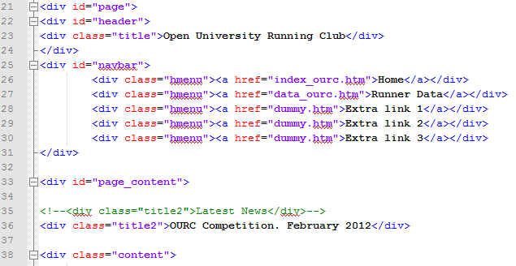
.
.
.
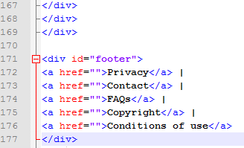

Part 1 (continued)

Part 1(b) | Usability Marks 25

After using <div class="title2">OURC Competition. February 2012</div> to change the displayed title (from “Latest News”) and a similar approach to creating the dummy.htm file, this had the advantage of minimising change to the home page, at the same time as providing identical navigation facilities and a consistent “look and feel” for all site pages.

Although only one table of data is presently available, the requirements plainly indicate that there will be more. Possibly the simplest way of approaching this future need would be to use the existing data page as a template, perhaps adding a “Back” button to appear at the bottom right of and table data. A new set of data could then be displayed by first copying the template and changing the content heading and data. The existing data page would then be replaced by a series of links to each data table page. Although probably not applicable, given future plans for a new website, the existing page could be replaced by a database mechanism using a combo box to select the desired data table and suitable code to reconstruct what is presently displayed.

358 words

Part 2

Part 2 | Marks 35

Answer:

The degree of web accessibility for any given website is defined by the extent to which any disabled user, irrespective of their disability, can utilize that website, by comparison with a user that has no relevant disability.

In coming to deal with this part of the TMA, I rapidly came to realise that Block 1 in general and Part 4 in particular places a great deal of emphasis on defining and expanding on various aspects of accessibility and certainly considers some of the ways in which features of HTML (such as “alt” and “longdesc”). Unfortunately, however, it may not provide complete information on how to ensure that those features work and I also realised that it is not possible to assume that they will work unless there is explicit testing.

Making the presumption that the location of the “Sponsored links” on the prototype home page might confuse technologies like screenreaders, I moved it to just above the footer. I also added a “longdesc” clause to the “img” tag for the home page image and a corresponding page file named “testlongdesc.htm” (so named pending verification that the mechanism worked). In attempting to test the latter, I eventually found that the test page was reached by right-clicking on the image and selecting “View Description”, although I was unable to set the image itself as a link.

I then decided to focus on the blindness disability (as it would not be practical to generalise) and to install the Thunder screen reader (without considering alternatives, given the impossibility of completing a proper evaluation) so as to gain practical experience of the technology and to have a means of testing the prototype OURC website and changes to it.

In attempting to use the screen reader, I found that it will fairly efficiently read any link texts that receive focus. However, even using the mouse, I could not set focus to any of the content text or cause the screen reader to read it.

328 words

