Part 1(a) – 631 words {within the 10% allowance}

Standards Compliance in Terms of XHTML and CSS

The W3C recommend that XHTML (extensible hypertext markup language) used for writing web pages should be compliant with the XHTML 1.0 ‘strict’ standard. Use of syntax rules defined therein (eg. closing of tags, variable naming conventions) makes for ‘well-formed’ code to resolve issues of browsers rendering XHTML differently. XHTML can be checked for conformance to ‘legal’ standards through the validator at http://validatorw3.org/; code can be labelled W3C-compliant if at least 2 of the standards are adhered to.

The specification of XHTML 1.0 ‘strict’ at www.w3.org/TR/xhtml1/ defines 2 key aims of the standards to be extensibility and interoperability. Extensibility means ease of growth to ensure that new and/or modified code functionality has minimal effect on existing systems, making changes less complex. Standards for interoperability of XHTML mean that the code should be usable by and compatible with any platform, including mobile and tablet devices.

For presentation (eg. layout, colours, fonts, etc) of documents written in markup languages such as XHTML, the W3C recommend use of CSS (cascading style sheets) compliant with CSS 2.1. The standards specify separation of styling from the content of documents, which simplifies the writing and maintenance of websites, particularly in achieving consistency of presentation.

The preferred method of using CSS is as an external style sheet linked to XHTML which reduces repetition and complexity. CSS uses selectors (eg. h1{color:red}) to determine the styling of output. Selectors can be defined as id selectors unique to the document, or as class selectors which can be used for the class. The specification of CSS 2.1 at www.w3.org/TR/CSS21 highlights the benefits of external style sheets: they can be amended without changing the XHTML document; they can be shared by many XHTML documents so that presentation of web pages looks consistent.

CSS 2.1 can also improve accessibility since the same markup language page can be used for different methods of rendering (eg. speech-based or Braille-based browsers). Checking XHTML for conformance to CSS 2.1 through the validator at http://jigsaw.w3.org/css-validator/ ensures compliance with the standards.

The Web Pages Should Be Syntactically Error-Free and Should Validate as XHTML 1.0 Strict

FILE: ourc_data

The validated code gave the following errors:-

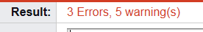

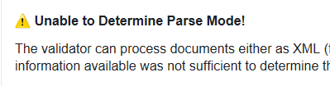

The following declaration was added to indicate an HTML document for elements and attributes, excluding elements for presentation:-

<!DOCTYPE html PUBLIC "-//W3C//DTD XHTML 1.0 Strict//EN"
"http://www.w3.org/TR/xhtml1/DTD/xhtml1-strict.dtd">
<html xmlns="http://www.w3.org/1999/xhtml">

The revised validated code gave the following warnings:-

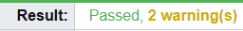

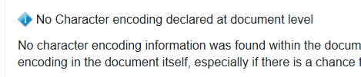

The following code was added after the <head> tag to define the character encoding for the document:-

<meta http-equiv="Content-Type" content="text/html; charset=utf-8" />

The revised validated code gave the following warning which was ok:-

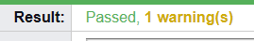

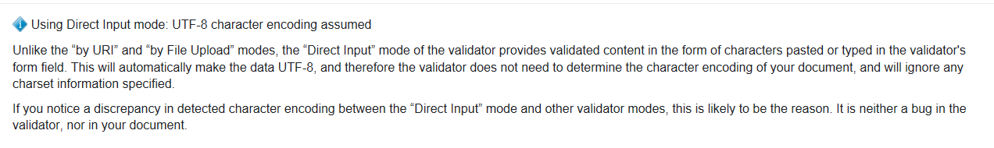

FILE: ourc_index

The following validation code errors were resolved as for ourc_data above:-

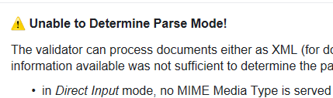

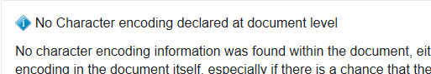

The revised validated code gave the following errors:-

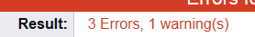

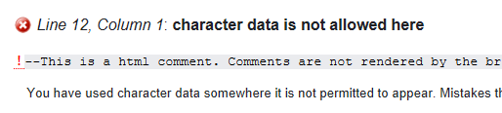

The HTML comment syntax was corrected:-

<!--This is a html comment. Comments are not rendered by the browser-->

The revised validated code gave the following errors:-

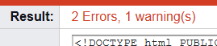

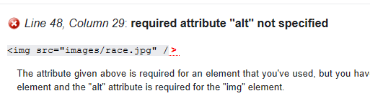

The alt was added as a required attribute for alternative text information if the image cannot be displayed by the user (eg. a screen reader is used).

<img src="images/race.jpg" alt="race image" />

The revised validated code gave the following error:-

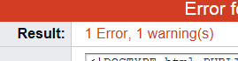

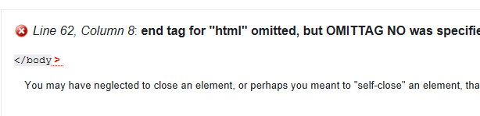

The closing html tag was added at the end of the document.

</html>

The revised validated code gave a warning as for ourc_data above which was ok:-

The Style File Should Validate as CSS (level 2.1)

ourc_global

The validated code gave the following errors:-

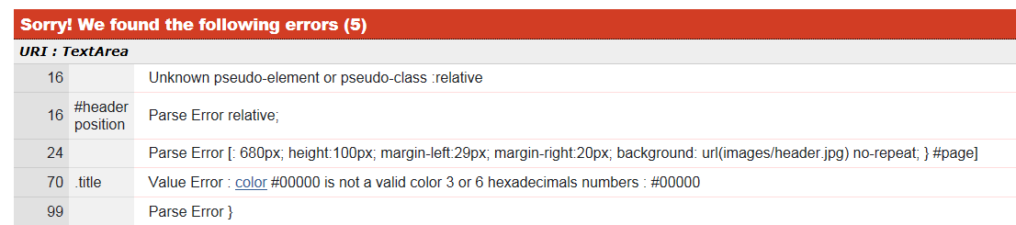

The opening bracket for attributes in the header id selector definition was added.

#header
{
position:relative;
width: 680px;
height:100px;
margin-left:29px;
margin-right:20px;
background: url(images/header.jpg) no-repeat;
}

The hexadecimal colour definition was corrected to include all RGB elements.

.title
{
position:relative;
left:25px;
top:20px;
text-align:left;
font-family:"Century Gothic", Verdana, sans-serif;
font-size:32px;
font-weight:bold;
color:#000000;
}

The closing bracket for attributes in the sponsors class selector definition was added.

.sponsors
{
width: 124px;
font-size:11px;
font-weight:bold;
line-height:20px;
height:auto;
margin-left:2px;
margin-right:-2px;
background-repeat:no-repeat;
text-align:left;
float:right;
}

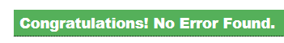

Part 1(b) – 437 words including code comments {within the 10% allowance}

Usability in Terms of Websites

Usability in terms of websites is defined by Jakob Neilsen’s five usability goals.

- Learnability refers to the users’ ability to use a website on the first visit to the site. My changes include the following learnability aspects, particularly relating to navigation:-
- Links to other pages on a navigation bar;
- Sponsored links positioned away from the main panel so they stand out;
- Both the navigation bar and hyperlinks change colour when activated which are intuitive features to users of the internet that would enable a user to use the functionality on first visit to the website.

- Efficiency refers to the speed at which users’ are able to use the website. My changes include the following features:-
- Consistent positioning of the navigation bar and hyperlinks on both pages which would enable a user to navigate the website quickly as they will become familiar with the layout, being the same on both pages.

- Memorability refers to users’ ability to remember how to use the website after a period of non-use. My changes include the following memorability aspects:-
- The layout is the same for the header, navigation and content on both web pages;
- The colour scheme and fonts are consistent giving a memorable identity to the user whenever they visit the site.

- Errors refer to errors by users in terms of number, seriousness and recoverability. My changes consider errors that could occur:-
- A user could attempt to click on the picture as a link, but the lack of cursor change would indicate it was not a link and no error would result from the action.

- Satisfaction refers to the user experience of the website overall. My changes include the following satisfaction features:-
- The components of the web page are lined up and tidy;
- A further enhancement would be for the header image file to be wider so the text could be spread across the page meaning the user would not have to scroll down on the Home page.

The screenshots below show the web pages after my changes when viewed in the Firefox browser:-

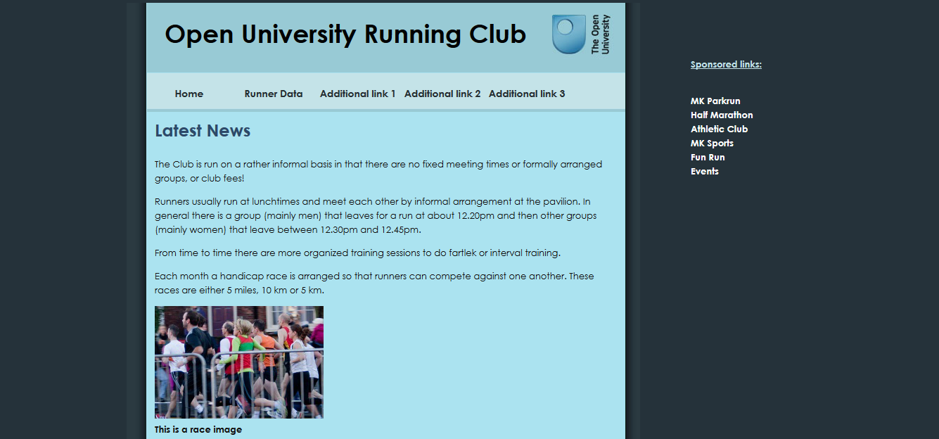

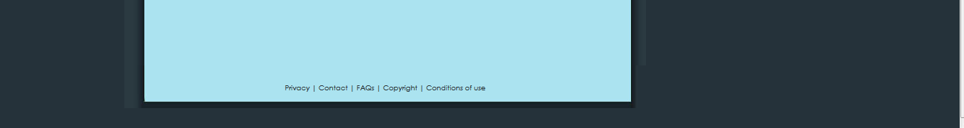

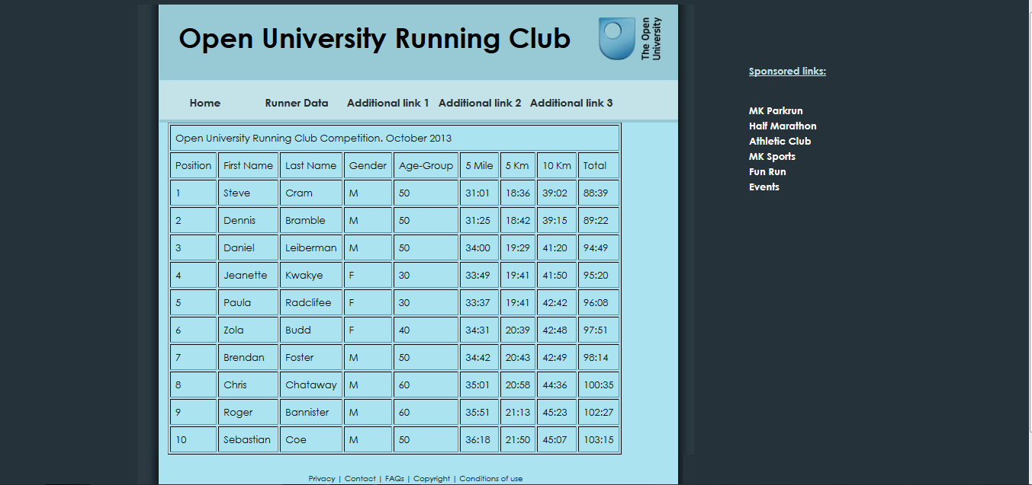

The screenshots below show the commented code changes for usability:-

ourc_index

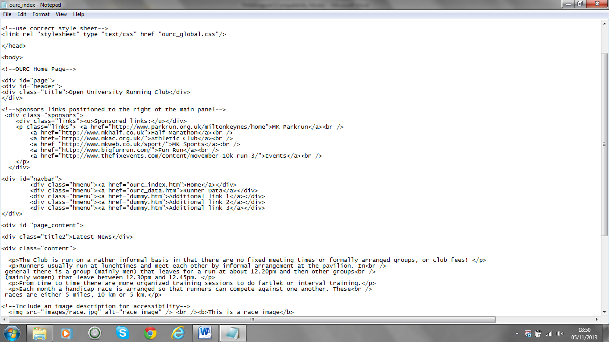

ourc_data

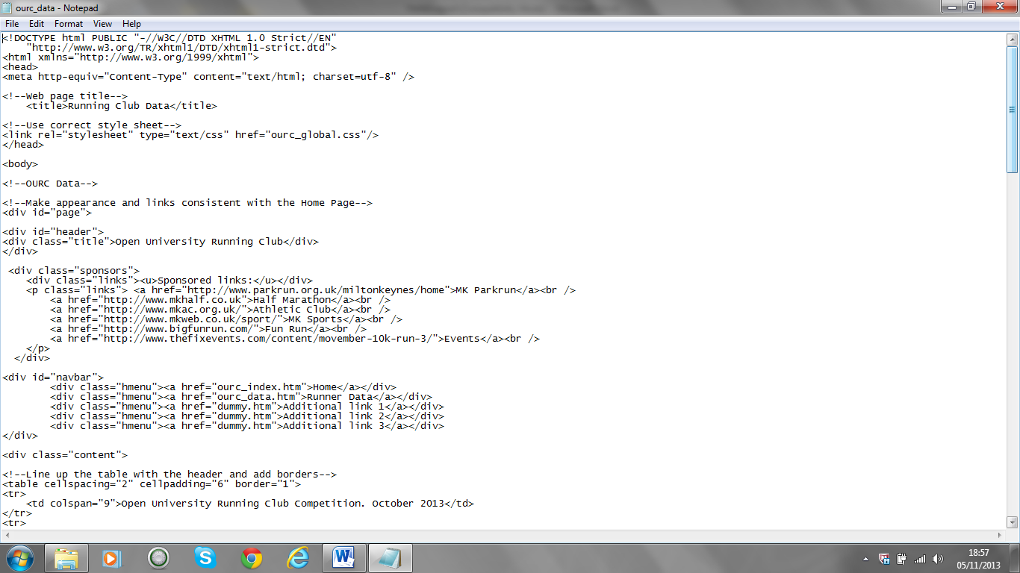

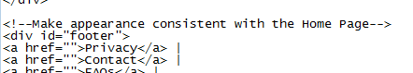

ourc_global

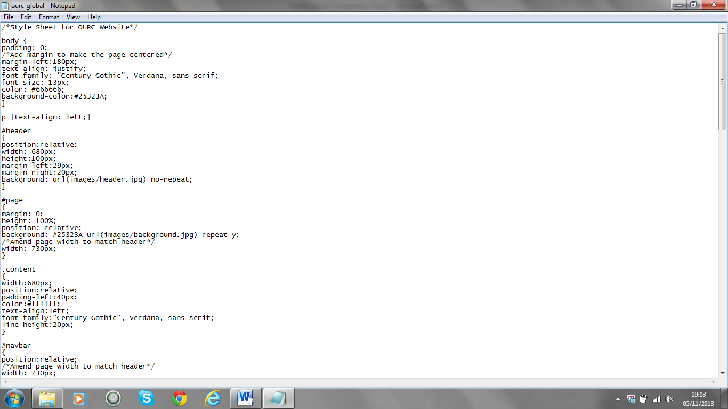

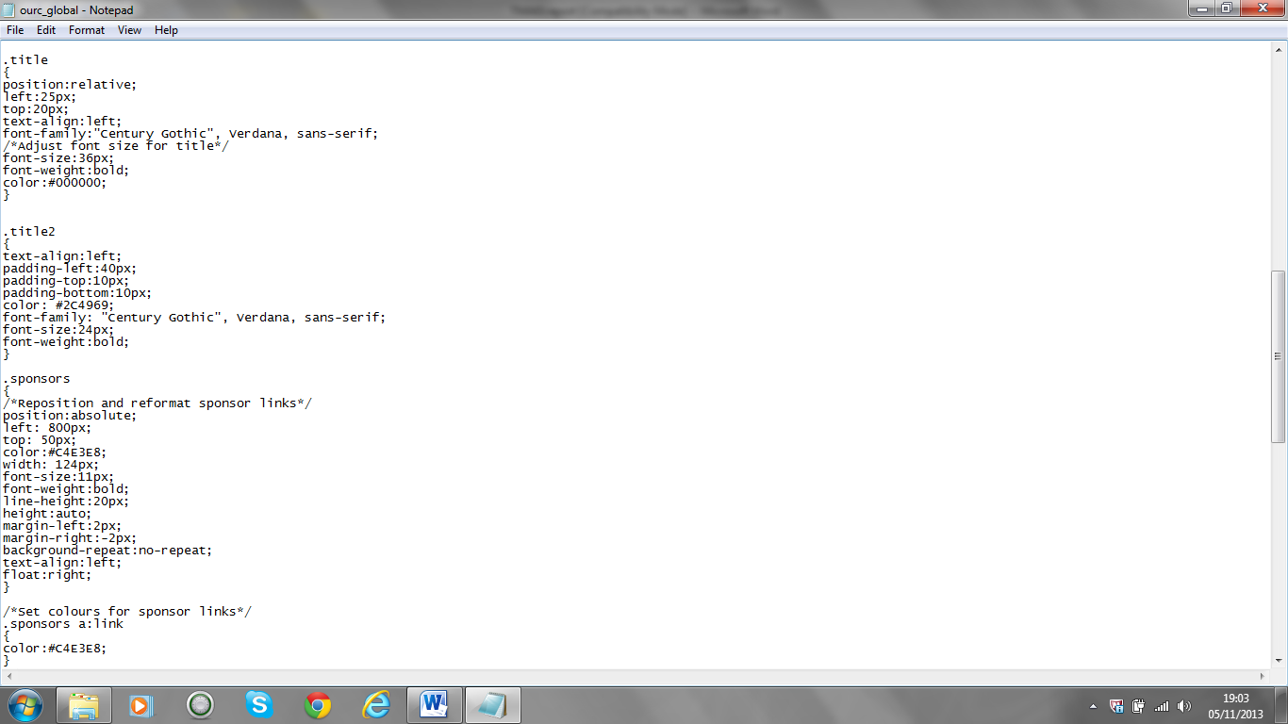

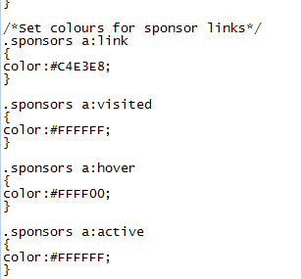

Part 2(a) – 352 words including code comments

The Web Pages Must Be Accessible

The web pages adhere to the W3C’s Web Content Accessibility Guideline principles:-

- Perceivable refers to the ability of users’ to identify information using any of their senses. My changes include the following features:-
  - An image caption has been added so the information is visible and could be used by a Braille browser where the user could not see the image.

- Operable refers to the ability of users’ to interact with the website interface for navigation and operation. My changes include:-
  - Navigation of the web site by standard methods being a navigation bar and hyperlinks.
  - Navigation using a scroll bar to read down the Home page.

- Understandable refers to the ability of users’ to understand the content and operation of the website. My changes include:-
- An attempt was made to translate the Latin text (see screenshot below) on the index page to ensure the readable content would not be beyond the understanding of users, but the translation did not make sense, so the text was removed in adherence with the principle of understandable information.

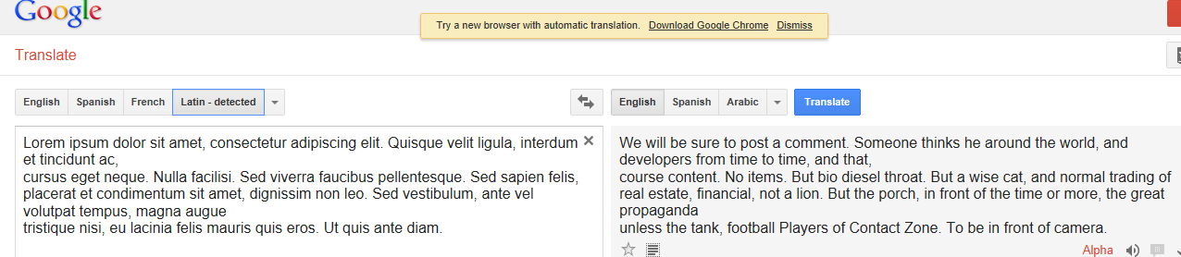

- Robust refers to the ability of users’ to use a wide range of technologies to aid use pf websites. My changes include:-
  - The code was made XHTML 1.0 Strict compliant and CSS (Level 2.1) compliant which are indicators that the code will be accessible using a variety of technologies, browsers and platforms which to provide accessibility for disabled users.

The screenshots below show the OURC data page after my changes when viewed in the Firefox browser:-

Enhancements for improved accessibility are:-
- Consistent appearance with the index page in respect of the title, navigation bar and sponsored links.
- Larger font sizes used for easier vision.
- Borders included on the table to provide clarity viewing rows and columns.

The screenshots below show commented code changes for accessibility:-

ourc_index

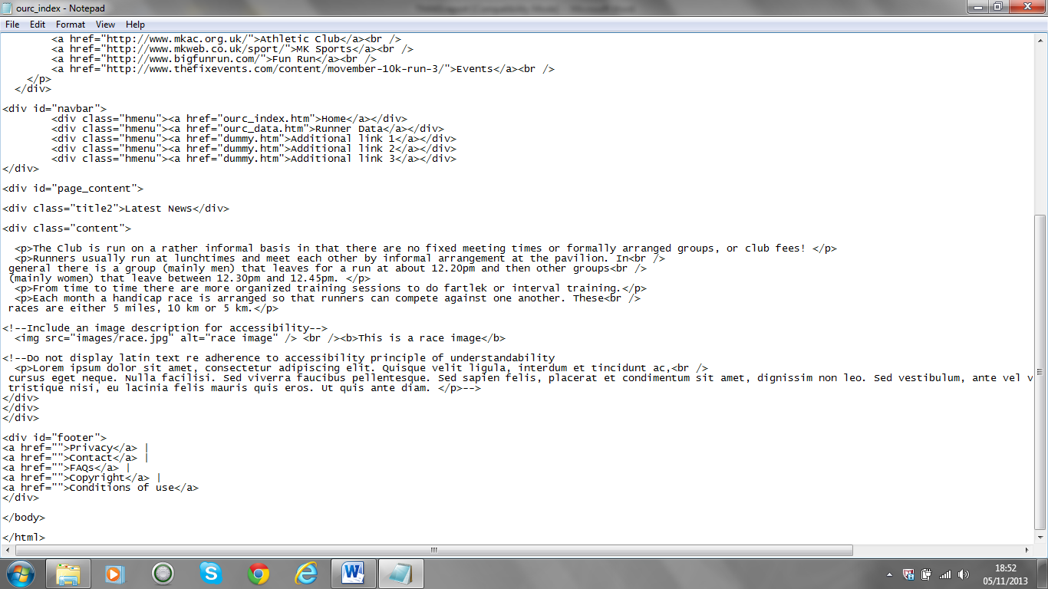

Proposals for further improvements to site accessibility:-
- Audio for listening to the text.
- Screen setting options for larger text.
- Alternative screen colour options to cater for dyslexia.
- Voice recognition options for navigation.

Total Report Word Count – 1420 words including code comments

