TT284 – TMA 01

Contents Page
Question 1a 3
Question 1b 4
Question 2 5 - 6

Usability definition.
Usability can be defined as a measurement of how easy a task can be accomplished without specialised training. In the case of a web site it should be easy to use, friendly, allow new users to quickly learn how to use the site without training. Once the users are familiar with the site they should be able to perform tasks efficiently without errors. If they do make mistakes it should be easy to recover from them. The design should satisfy the users requirements making it a pleasant experience to visit the site. Returning users should be able to use the site easily even if they haven’t used it for some time, thus demonstrating that the previous visit had been memorable.
In summary if you have to think too much to use a web site then its not usable.
Running club usability improvements
To create familiarity with the site and to provide consistency across the pages, aiding navigation between them, a layout was developed for the running club based on the home page and the corrected stylesheet (which is now linked to both pages). This standard page design is utilised across the running club pages to create a site where the pages fit together logically and feel connected through their similarity. This was achieved through the use of a header, footer and navigation bar on each page along with the Open University logo in the top right hand corner of each page. The font-type, colour palette and general styling was made consistent throughout with the use of the stylesheet.
A number of syntax errors (see section 1b) were corrected to enable the correct layout of the page, this prevented the sections from overlapping and making the page difficult to read. Web standards were followed with the navigation bar and footer links being consistent with other web pages and peoples’ general experience of how websites work and where to find things making the site quicker and easier to use.
Another issue was identified for the hover colour of the sponsored links which virtually disappeared on hover over. The hover style has been changed to a colour with greater contrast with the background colour to prevent this behaviour which reduced visual feedback of the link you were hovering over.
Greater detail has been added to the page titles to make it clearer where you are in the site aiding navigation.
(Word count 400)
1b In order to be confident that your web pages display as expected it is important that you files conform to the appropriate standards. Valid XHTML 1.0 strict and valid CSS 2.1 are the standards that have been identified for this project.
Computer programmes are written in many different languages, XHTML and CSS being two of them. Each language has its own syntax (outlined in a specification) which it needs to follow. Software tools are available to compare your XHTML and CSS files against the defined standards. After the tool has parsed your file it will generate a report listing any errors or warnings. If there are no errors then the file is said to be valid.
It is important to use valid syntax as typically browsers will make assumptions and attempt to display illegal files by making educated guesses regarding the originators intentions. In some cases the browser will make the right guess and the page displays without errors but it could also end up displaying a mess or worse it could crash the browser.
Using the W3C validation tools the following errors were identified in the files:
ourc_global.css file.
- The opening brace for the navigation bar was missing, this caused formatting errors on the home page. A brace was added to correct this problem.
- The footer color was coded as a four digit number it should be six. Although this did not cause a problem with the Firefox browser other browsers may display the wrong colour. The value updated to six digits.
- There was an extra closing brace at the end of the file; again this did not cause a problem when tested. The bracket was deleted to so that the file could be declared valid.
ourc_index.htm file
- The document type definition was missing at the start of the file, this cause formatting error on the home page. Definition line added to correct this fault.
- There was no namespace at the start of the file, new line added which defined the language to be used.
- The opening comment ‘<’ was missing, the comment was displayed on the screen. Added chevron to close the comment box.
- There was a reference to dummy.htm file but this file did not exist. A copy of the new template was named dummy.htm fixing this issue.
ourc_data1.htm file
- No namespace at the start of the file. Using the new template correct this fault.
The css is now valid to level 2.1, all of the xhtml files are valid to 1.0 strict.
(Word count 424)
2.
This short report discusses web accessibility and how it affects the design of the Open University (OU) running club website.
Definition.
Accessibility is making the web available for disable people to surf websites with ease, enabling them to navigate through sites and contribute to them using a range of assistive technology aids.
The design changes will require assistive technologies such as screen readers or braille displays to be used to take advantage of the improvements.
The UK Disability Discrimination Act 1995 (now the Equlities Act 2010) outlines the minimum requirement for web accessibility.
Changes made to improve accessibility.
The following changes (which will not be visible to the user) have been made to improve the accessibility of the site: Titles are used to describe the content of the pages; an alternative description has been added which is displayed when the cursor hovers over the picture. The table mark-up has been corrected to distinguish the header and header row from the data, this will improve the screen readers navigation and improve the screen reader output. A summary of the table has also been added to describe the table.
Who will benefit?
The site aims to accommodate people of all abilities to be able to use it to obtain the latest news and also review the competition results. The common navigation bar and the changes listed above will benefit anyone who visits the website.
Browser usage
The website should work on all the popular browsers and should be consistent between browsers. Ideally the website should be tested across the major browsers; the main five used in the UK are shown in the graph.
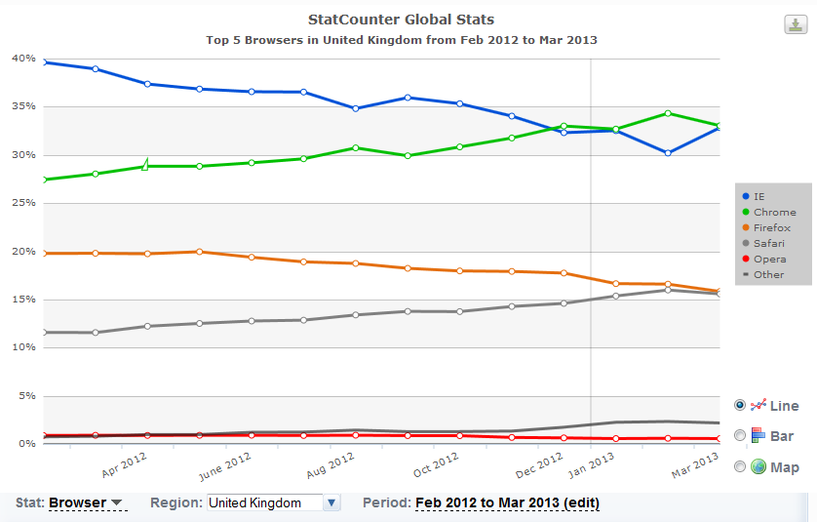
StatCounter (n.d.) GlobalStats [Online], Available at http://gs.statcounter.com/#browser-ww-monthly-201202-201302 (Accessed 21 March 2013).

No changes have been made for displaying the site on mobile devices (phones, ipads etc.) since this would require major changes to the site. However, media queries could be utilised to manipulate the layout to make the running data easier to read on small screens.

Conclusion
The website has been changed as per the initial brief, the main page and runner data now work together and validate to the correct standards. Mobile devices may need a different view, however further work would be required to understand the requirements and implement the changes.
(Word count 363)

