Mandy Honeyman
M3160730
TT381 ECA Report

Guide to implementing the Shopping Cart application
for A&B Pots & Pans

- Shopping Cart Application Software
  - Introduction
Three elements critical to running the application are:
    - Web Server software
    - Scripting software
    - Database software
There is one important choice to make from which many of the others will follow; will the company use open source software (OSS) or rely on commercial software?
OSS can be explained in terms of a business model, and will be here, rather than engaging in discussions about “free” software and licences. OSS is developed and maintained by developers on the basis that that software is available free of charge to users who can contribute back modifications to the software in order to improve it. However, many OSS applications are also supported and maintained by commercial organisations that package the original source with manuals, support contracts and training. For example NuSphere bundle the three components above and provide support, consultation and training. Arguably this is not so different from what Microsoft or Sun do, except that Microsoft’s products are closed-source, but in effect, this should, now, make little difference to a company wishing to use these products but uninvolved in software development. Furthermore, these developments make some older arguments against OSS obsolete, namely less support, training and documentation.

So why choose OSS?
    - Free choice of which software to integrate with which.
    - The majority of sites on the Internet use OSS for web, scripting and database software.
    - Reliability: The three recommended products below all fall within “…software [that] runs most of the Internet’s key infrastructure functions”. This makes it imperative to a large number of users that the software is maintained, continues to develop and remains as bug-free as possible.

Why choose commercial products?
    - Just because OSS is free to download and use, does not necessarily mean that it is cheaper in the long run.
    - Maintaining the software in terms of upgrading. Companies like Microsoft have a necessary warning system for patches and upgrades.
    - Commercial companies should have highly developed user interfaces that can make their software somewhat easier to configure and run.
  - Alternatives to the recommendations below:
There are many commercial web server applications available. The most popular are IIS, Sun (various) and Zeus (see Appendix 1 for detailed comparison charts): Main reasons for and/or against these:
    - IIS: Must use ASP.Net for scripting. This requires programmers to learn a non-transportable programming language. However, it is a Microsoft product and therefore guarantees familiar GUI’s. Additional cost: The development team will need an additional license for IIS. All Microsoft products continue to be a target for security attacks, therefore keeping up with security patches can take up much time.
    - Sun (Java Web Server): Encouraged to use Java programming language. Confusing GUI configuration.
    - Zeus: Can use any language. Complete package. However, extra cost for a development copy.
  - Recommendation: Apache Server Software
The most popular server software on the market. Proviso being that, at least for the first year of operation, a support contract is purchased to help with configuration, tuning and set-up.
    - Disadvantages: Version 1.3.x may be nearing end of life-cycle replaced by version 2.0.x which does not have as wide a user-base.
  - Recommendation: PHP Scripting Language
    - Introduction: There are five scripting languages to choose from:
      - PHP, “…is the most popular dynamic Web content technology for use with Apache servers.”, and fairly simple for programmers to pick up. It was specifically designed for the web.
      - ASP/ASP.Net requires VBScript knowledge, only recently able to use with Apache.
      - JSP requires Java knowledge. “Entrance to this world is a cultural conversion, not a choice of one simple programming language over another.” However, it appears that it delivers dynamic content faster. The authors of Performance Benchmarking of Dynamic Web Technologies conclude, “In general, our results indicate that Java server technologies outperform both PHP and Perl.” although notably, not for static page delivery. Only available on Java through TomCat.
      - Coldfusion, simple to learn if programmers are used to HTML. Coldfusion support needs to be explicitly loaded in Apache configuration.
      - Perl, the granddaddy of Internet scripting languages but can be difficult to master.
    - Disadvantages: If your “novice” programmers have had no experience of Unix, or Perl or C, the learning curve will be long on all languages except Coldfusion and, arguably, PHP.
One of the overwhelming reasons for recommending using PHP is that it is so popular and therefore, a huge user network which can be supportive to programmers. It ranks 4th in overall programming usage (this survey includes non-web programming).
  - Recommendation: MySQL Database Software
    - Introduction: There are two main OSS RDBMS’s, MySQL and PostgreSQL competing against Oracle, DB2 and MS-SQL (Windows platform only) in the commercial sector. More tweaking is required with PostgreSQL than MySQL, particularly in relation to full indexes. If the company’s database is currently on Access the data can be migrated to MySQL. Below 100Gb databases both perform as well as commercial RDBMS’s.
    - A disadvantage with both OSS RDBMS’s is that back-up procedures have minimal functionality and are handled primarily via table text dumps.
MySQL version 5.x, currently in development, should provide enterprise level functionality particularly in terms of stored procedures.

- Development Environment
A number of useful applications that could be considered critical to development are outlined below (on the basis that the above recommendations are followed):
  - phpmysqladmin
This is an OSS application that enables developers to maintain the database(s) used in online applications. It has some annoying limitations, like a file size limit for source uploads, but nevertheless provides a useful front-end for viewing database tables and general maintenance.
  - Code-writing tools
There are an enormous selection of tools available - OSS and commercial.
Recommended: Zend Studio: Specifically for PHP development, from the original developers of PHP, this application includes a CVS (see below) and syntax debugging support.
  - Selection of different browser applications
    - All code should be tested before deployment on the various browsers.
  - SSH Tectia Client/Server
    - Enables command line interface for developers and secure FTP transfers.
  - Blogging
    - Blogging tools like MoveableType and Blogger have become useful tools for maintaining documentation during software development.
  - Relationship between Development & Production
    - Requirements for Production:
      - A stable environment that responds reliably to user requests.
      - A secure environment for financial transactions.
    - Requirements for Development:
      - Replicated databases from the production environment. In order to give the development team an up-to-date view of the database and so that any testing does not affect “live” data.
      - A separate environment should be on another server (ideally using the same set-up as 1.a). This would allow team to start/stop the server if required without affecting production.
  - Integration with stock and transactions applications
The demonstration stock and transaction tables are inaccurate representations of the data the company’s stock and financial applications produce. It would be possible to integrate these at a far more enhanced level, for example:
    - Warning emails for low stock levels triggered by purchases.
    - Ordered output in transaction data according to date.

- Organising the Development Team
A&B’s new development team needs to have a clearly defined development map and “a clear well thought out architecture” for the application before they start coding.

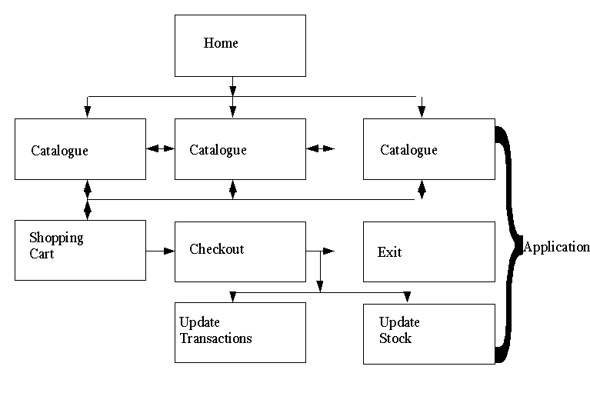
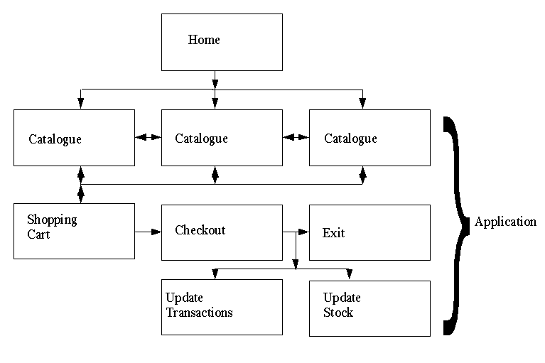
Table 1: Site map of demonstration pages.

The demonstration application doesn’t take into account the existing site structure and one of the first steps might be to work out how the old might be integrated with the new. For example, A&B might wish for the shopping cart to be available from all pages, and for the entire site to be personalised for the visitor. (This would go some way in handling the issue of 3.h below.)
  - Management of development process
These are the typical stages of development:
    - Identification of required software: A&B commissioned this report.
    - Analysis of the software requirements: Parts 1 & 2 of this report and demonstration application.
    - Detailed specification of the software requirements: This should take the form of, probably, several diagrams, which will include: naming conventions, relationships between modules, dependencies.
    - Software design: there are two system development models that might be appropriate here, prototyping in conjunction with “synchronise and stabilise”. The team already has a prototype, which they can, most definitely, improve. Synchronise and stabilise means that the programmers work on the same module until it is complete and stable before moving on to the next. The documentation process begins here, not after scripting is complete.
    - Programming. The main problem at this stage will be the need for programmers to have access to the same suite of files at the same time. Occasionally that they are likely to make concurrent changes. This can be handled using CVS software (see below).
    - Testing
    - [Implementation]
    - Maintenance
  - Typical development problems
There are two stages where this arises: the initial pre-implementation stage and maintenance. We are only looking at pre-implementation. David B. Stewart believes that even only addressing one of the common problems (he lists thirty detailed programming issues, despite the title of his article) will save many hours during development. These problems can be summarised in three parts, inadequate planning, bad coding style and haphazard testing.
  - Organisation of code
    - The programmers should use a pre-defined directory structure in which to store the scripts. This should be detailed in one of the diagrams mentioned above.
    - Maintain portions of html as separate files that can in included in scripts, i.e. header.inc and footer.inc. (This will also help with 3.h.)
    - Continue to separate structure from content by using CSS as much as possible. XHTML is very suited to working with modular script design and it’s possible that all the HTML used on the site should be updated to reflect this.
    - Re-use code where possible, and relevant, as functions.
  - How to avoid typical problems
    - Keep up with documentation.
    - If the design is modified, ensure that the diagrams are updated.
  - Concurrent Versions[Versioning] System (CVS)
There are a number of CVS applications available for all different platforms. This demonstration application was developed with the help of TortoiseCVS; an example log file is included as Appendix 2.
CVS enables programmers to work concurrently on files; they first take a complete copy from the repository and then update from, or commit files back to, it. This enables them to check whether changes have been made while they’ve been working and incorporate those changes into their own scripts.
Most Integrated Development Environments (IDEs), like Zend Studio recommended above, will include some form of CVS.
Using a CVS means that coders can restore earlier working versions if necessary.
  - Developing code for pages
An excellent place for the team to start would be on the catalogue pages. The code used in the demonstration pages is far from optimal (because the products have been hard-coded). These pages should dynamically load pictures, descriptions and prices from the real stock database.
  - Handling Staff turnover, training and development
    - Training and staff development: There are a number of training programs for PHP, it might be of interest to A&B that Zend promote a PHP Certification Scheme with a 19 hour online training preparation course provided by PHP Architect Magazine.
    - Turnover: If necessary new staff could be put through one of these courses, however, if they were already proficient in PHP, maintaining the documentation trail, as discussed above, should help enormously with integrating them quickly into the development team.
  - Keeping the site fresh
    - Personalising the site for the user is one way that online retailers, like Amazon, maintain a fresh feel.
    - Updating the look can easily be achieved using a combination of dynamic data, included html snippets and CSS.
    - Dynamic catalogue content would reflect new products, which could be highlighted on the index page.

Bibliography

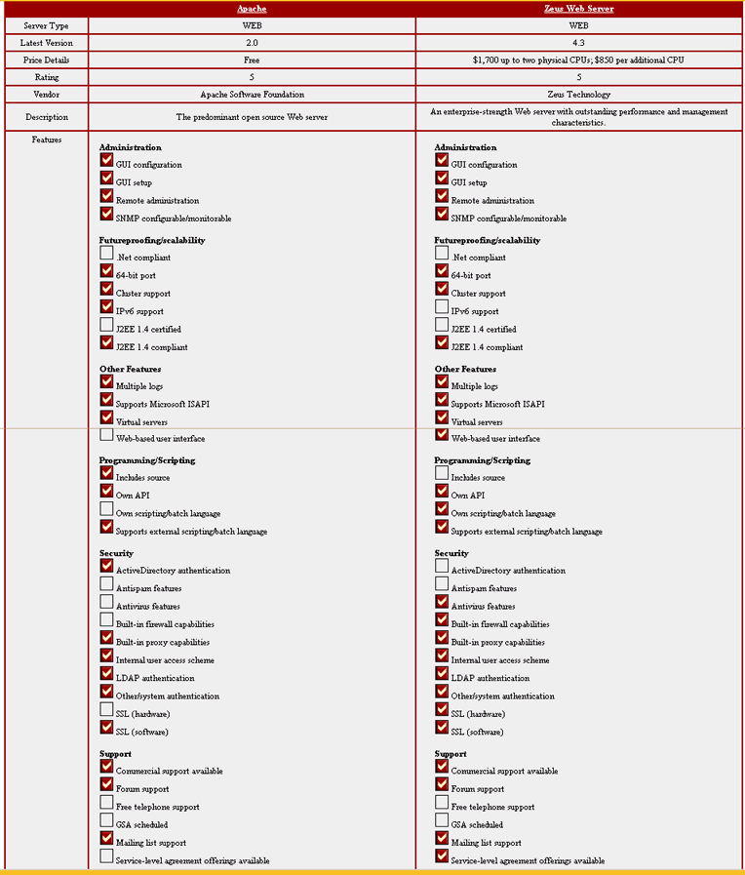
Appendix 1:

Comparison between Apace and Zeus Web Servers

Comparison between Apace and Microsoft IIS Web Servers

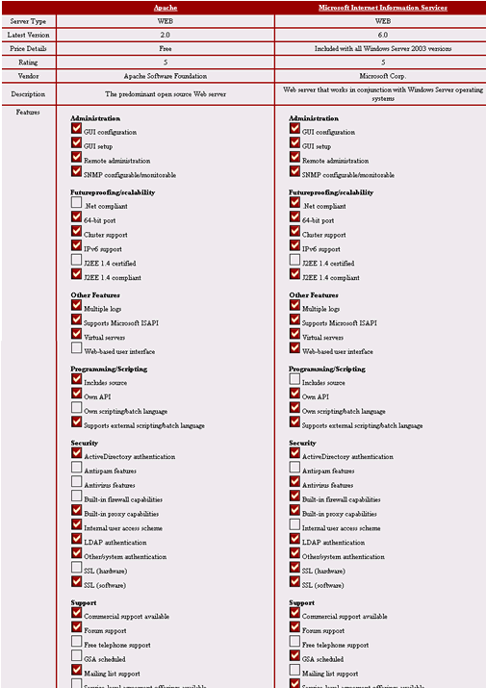

Comparison between Apace and Sun Web Servers

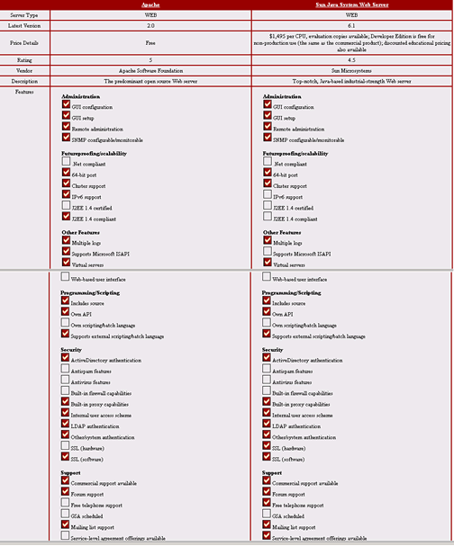
<!DOCTYPE HTML PUBLIC "-//W3C//DTD HTML 4.01 Transitional//EN">Appendix 2:

CVS Log listing example from A&B Pots & Pans Demonstration
For two files: cartaction.php and mh4468includes.php only.
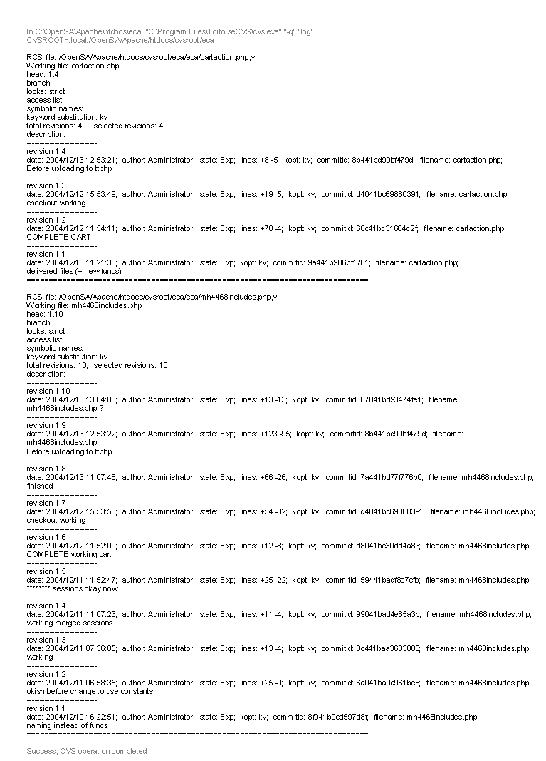

Available at http://www.nusphere.com/index.htm
According to: Netcraft Survey published 1st Dec 2004 available from http://news.netcraft.com/archives/web_server_survey.html. And Security Space survey published 1st Dec 2004 available from http://www.securityspace.com/s_survey/data/200411/index.html.
Software.Global The Hard News on Software published by Merrill Lynch 24 October 2001 edition (I cannot find the site I originally downloaded this from.)
Ibid.
See “Kicking the Windows habit: Apache vs. IIS” by Margie Semilof 18.06.2002 available from http://searchwin2000.techtarget.com/originalContent/0,289142,sid1_gci833798,00.html accessed December 2004
As mentioned in iPlanet Web Server review, published 01.15.02 available from http://www.pcmag.com/article2/0,1759,11534,00.asp
NB: Unnecessary if hosting via hosting service. See message and response “Who Hosts A&B Pots & Pans website” in FirstClass TT381 ECA conference.
“Performance Benchmarking of Dynamic Web Technologies” by Lance Titchkosky, Martin Arlitt, Carey Williamson published May 8, 2003 available from http://pages.cpsc.ucalgary.ca/~carey/papers/DynamicContent.pdf accessed October 2004
“Active Web Sites and Comparison of Scripting Languages” available from http://training.gbdirect.co.uk/courses/php/comparison_php_versus_perl_vs_asp_jsp_vs_vbscript_web_scripting.html#jsp accessed October 2004.
Ibid.
Information available from http://jakarta.apache.org/tomcat/ accessed December 2004.
“Server-side Scripting Shootout” 21 May 2001 available from http://webmonkey.wired.com/webmonkey/99/46/index1a_page3.html?tw=programming accessed October 2004.
Information available from http://www.cfdev.com/apache/index.cfm accessed December 2004 NB may only be applicable for RedHat Linux operating system.
Survey available from http://www.tiobe.com/tpci.htm
Article “PostgreSQL vs. MySQL vs. Commercial Databases:” by Tim Conrad 12 April 2004 available from http://www.devx.com/dbzone/Article/20743 accessed December 2004
See tutorial available from http://www.webmasterstop.com/tutorials/access2mysql.shtml accessed December 2004.
“New Features Planned for 5.0” available from http://dev.mysql.com/doc/mysql/en/TODO_MySQL_5.0.html accessed December 2004.
Available from www.zend.com
available from www.ssh.com
Again depends on who is hosting the site.
Available from www.moveabletype.com
Available from www.blogger.com
P2, Study Guide - Week 4 TT381, authors Neil Simpkins and Nick Heap, published 2004 Open University.
LearnIT: Software Development available from http://searchwin2000.techtarget.com/sDefinition/0,,sid1_gci936454,00.html accessed December 2004
“Twenty-Five Most Common Mistakes with Real-Time Software Development” by David B Stewart published September 1999 available from http://www.ee.umd.edu/serts/education/esc/paper304.pdf accessed December 2004
available from www.tortoisecvs.org
available from http://www.zend.com/store/education/online-training/zend-online-training-courses.php#Certification
Available from http://www.phparch.com/cert/training.php
Bibliography: (many of these sources were first accessed as research for a TMA on M360, specifically on Open Source Operating systems.) Online: - at http://www.opensource.org/docs/definition.php accessed 11 Mar. 04 - at http://www.stallman.org/#serious accessed 11 Mar. 04 - at http://www.fsf.org/philosophy/free-software-for-freedom.html accessed 14 Mar 04. - Raymond, Eric S. “The Cathedral and the Bazaar” available at http://www.firstmonday.dk/issues/issue3_3/raymond/#d1 [accessed 11 Mar. 04] - Online Sourcefire “The Strengths and Weaknesses of Open Source Software – And Its Role in the Security Model” available at www.itsecurity.com accessed 11 Mar. 04 - Online Mundie, Craig “The Commercial Software Model and Sustainable Innovation” available from - “http://www.microsoft.com/resources/sharedsource/Initiative/speeches/mundie_model.mspx accessed 14 Mar 04. - “The Great NT v. Linux Debate” available from http://www.linux-tutorial.info/Linux-NT_Debate/An_Editorial_on_LINUX.html [accessed 14 Mar 04] - “Open Source Software, use within UK Government” available from http://www.e-envoy.gov.uk/assetRoot/04/00/28/41/04002841.pdf [accessed 14 Mar 04] - “Samba 3 extends lead over Win 2003” http://www.itweek.co.uk/News/1144312 [accessed 14 Mar 04] - “Linux hosting v. Windows hosting” available from http://www.interspeed.co.nz/linuxvswinnt.htm [accessed 14 Mar 04] - “Setting up Shop” available from http://www.hecker.org/writings/setting-up-shop.html [accessed 14 Mar 04] - “Comparison between Windows and Unix operating system” available from http://www.harrysufehmi.com/hs/achievements/paper-winnt-vs-unix.htm [accessed 14 Mar 04] - “Comparing Linux to Windows” available from http://www.biznix.org/whylinux/windows/ [accessed 14 Mar 04] - “The Open Source Movement” available from http://www.infotoday.com/it/oct01/poynder.htm [accessed 11 Mar 04] - “Whatdya mean, free software” by Robin Bloor http://www.theregister.co.uk/2004/11/02/issues_with_open_source/ accessed October 04 - “Open Sources: Voices from the Open Source Revolution” various published Jan 1999 available from http://www.oreilly.com/catalog/opensources/book/toc.html accessed Oct-Dec 04.
Available from http://www.serverwatch.com/stypes/compare/ accessed 16 December 2004
Ibid.
Ibid.

