Mastermind
Author: Amanda Scott
SID: 0246104
Date: 11.11.2002

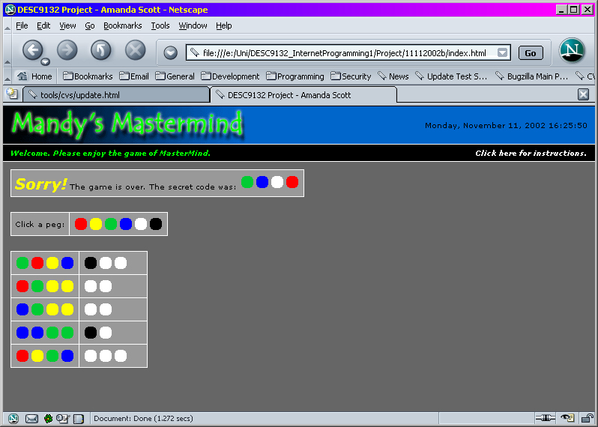

Note on Javascript employed for this Mastermind project

An object oriented approach has been used to re-create the classic game of Mastermind.
There are four objects -
* a peg
* a code (made up of 4 pegs)
* a game - contains functions to test for who's turn it is, etc
* controls - the user interface to the game
Javascript works nicely for this particular game as Object-Oriented modules are possible, because Javascript is capable of emulating encapsulation, so that each object has access to it's own variables, and no other objects can directly get to those variables, except via special functions designed to modify those variables.

