## ABSTRACT

Corona virus disease (covid-19) is a global pandemic, and every country is actively fighting against the virus. It is an effective way to prevent the spread of the virus in finding the person with abnormal temperature promptly to perform further medical observation. However, the traditional method of temperature measurement has low efficiency and accuracy. Body temperature acting an important role in medicine, several diseases is characterized by a change in human body temperature. Monitoring body temperature also allows the doctor to track the effectiveness of treatments. But current continuous body temperature measurement system is mainly limited by reaction time, movement noise, and labor requirement. In addition, the traditional contact body temperature measurement has the problem of wasting consumables and causing discomfort. To address above issues, we present a noncontact, automatic system using a single thermal non-contact sensor. The Proposed Covid prevention method scans their body temperature. We have built a detects the presence of face detection in people from a pi camera running in a Tensor Flow background, OpenCV, and Raspberry pi model 3+ architecture. We have used MLX90614 Contactless Temperature Sensor to measure the body temperature at the entrance. The MLX90614 is connected to the raspberry pi and temperature is displayed in a monitor.

## TABLE OF CONTENTS

[CERTIFICATE ii](#_bookmark0)

[DECLARATION iii](#_bookmark1)

[ACKNOWLEDGEMENTS iv](#_bookmark2)

[ABSTRACT v](#_bookmark3)

[LIST OF FIGURES viii](#_bookmark4)

[LIST OF TABLES x](#_bookmark5)

1. [INTRODUCTION 1](#_bookmark6)

[PROBLEM STATEMENT](#_bookmark7) 1

[APPLICATIONS](#_bookmark8) 1

ORGANIZATION OF REPORT 2

1. [LITERATURE SURVEY](#_bookmark9) 3

[PAPER 1](#_bookmark10) 3

[PAPER 2](#_bookmark11) 7

[PAPER 3](#_bookmark12) 10

[PAPER 4](#_bookmark13) 13

[PAPER 5](#_bookmark14) 16

1. [SYSTEM REQUIREMENT SPECIFICATION 1](#_bookmark15)9

[FUNCTIONAL REQUIREMENTS](#_bookmark16) 19

[NON-FUNCTIONAL REQUIREMENTS](#_bookmark17) 21

[SOFTWARE REQUIREMENTS 22](#_bookmark18)

[THONNY](#_bookmark19) 22

[HARDWARE REQUIREMENTS](#_bookmark20) 25

1. [METHODOLOGY](#_bookmark21) 26

FLOWCHART 34

[ARCHITECTURE](#_bookmark22) 35

1. [IMPLEMENTATION](#_bookmark23) 36
2. [RESULTS](#_bookmark24) 41
3. [CONCLUSION AND FUTURE SCOPE](#_bookmark25) 44

[BIBLIOGRAPHY](#_bookmark26) 45

## LIST OF FIGURES

**Figure 2.1.1:** Automatic selected frame **Figure 2.1.2:** Manually selected frame. **Figure 2.2.1:** Standard thermal camera **Figure 2.2.2:** Using telephoto lens.

**Figure 2.2.3:** Standard camera lens **Figure 2.2.4:** telephoto lens **Figure 2.3.1:** First-order scheme **Figure 2.3.2**: Second-order scheme

**Figure 2.3.3:** prediction diagrammatic sketch of body temperature

**Figure 2.4.1:** The proposed thermal camera-based continuous body temperature measurement framework.

**Figure 2.4.2:** The illustration diagram of ROI assignment.

**Figure 2.5.1:** Simulations of the core temperature

**Figure 2.5.2:** Comparison of predictive performance of different modeling techniques.

**Figure 3.1:** Thonny python ide in pi

**Figure 4.1:** Raspberry PI

**Figure 4.2**: MLX90615 Contactless IR Digital Temperature Sensor

**Figure 4.3:** Connections **Figure 4.4:** flow chart **Figure 4.5:** architecture

**Figure 5.1:** Go to I2C option and enable it

**Figure 5.2:** packages

**Figure 5.3:** Connect Sensor to Raspberry Pi 3

**Figure 5.4**: connect the camera.

**Figure 6.1**: Body temperature

**Figure 6.2**: Body Temperature Result with image

**Figure 6.3**: Body Temperature Result with hot mug image

## LIST OF TABLES

**Table 2.1.1:** Frame Difference between videos of FLIR& IR camera

**Table 2.4.1:** The results of the proposed CBTM system.

**Table 3.1:** Software required

**Table 3.2:** PC/Laptop hardware specifications

**Table 4.1:** Pin Configuration of MLX90614 Temperature Sensor

## INTRODUCTION

### OVERVIEW

The motivation behind this project is that if we can take help of IOT to measure the skin temperature in a contactless manner based on the pi camera input, it would be helpful to increase our safety. If deployed correctly, the temperature detector could potentially be used to help ensure our safety. The model can be applied to the camera in densely populated areas, essential districts, large-scale industries to scan the people face to ensure whether they have temperature on their face. It can be applying for communities, business buildings, schools, hotels, scenic spots, transportation hubs and other public service places. Coronavirus disease (covid-19) is a global pandemic, and every country is actively fighting against the virus. It is an effective way to prevent the spread of the virus in finding the person with abnormal temperature promptly to perform further medical observation. However, the traditional method of temperature measurement has low efficiency and accuracy. Body temperature acting an important role in medicine, several diseases are characterized by a change in human body temperature.

### APPLICATIONS

* Body Temperature system can be used in many ways as follows.
* It can be used in hospitals monitor if their staff and people during their shift.
* This model can be applied to the camera in densely populated areas, residential districts, large-scale industries, Hospital, School, Railway, Airport, and Government offices, Company Factory to scan the people face and detected the temperature.

### PROBLEM DEFINITION

Covid-19 is the major pandemic, we are facing these days, finding the person with abnormal temperature plays a major role in maintaining safety and to avoid the spread of Covid. So to overcome this issue we need a device to find the body temperature of a person, increasing accuracy up to 75 % to 80 %.

**AIM OF THE PROJECT**

The solution enables the user to identify individuals with an elevated skin temperature efficiently and effectively. An elevated skin temperature is an indicating symptom of an infectious disease. It is non-contact based which prevents the chances of cross infection.

### ORGANIZATION OF THE REPORT

**Chapter 1** deals with the introduction of the project and explains the purpose of the project.

**Chapter 2** deals with the literature survey.

**Chapter 3** deals with the requirements that are needed in order to execute the project.

**Chapter 4** deals with the methodology, system design and features of the project.

**Chapter 5** deals with the implementation of the project.

**Chapter 6** involves the results of the project.

**Chapter 7** involves conclusion and future scope of the project.

## 2. LITERATURE SURVEY

Based on the problem statement and the project requirements the following research papers have been referred:

### PAPER 1:

**Title:** Image processing Based Body temperature estimation using thermal video sequence**. Authors**: Arpita Sharma Scholar, Arvind R. Yadav

**Source**: IEEE

### Description:

Temperature is most significant vital sign in human body regulation system if this increases at certain level it may be dangerous because temperature support whole immune system, also supporting the healing process. However, high temperature causes serious reimbursements to the human body. Therefore, in this paper, authors propose a non-contact temperature algorithm based on thermograph analysis.

The purpose of developing this system is to provide body temperature estimation without any discomfort. In the proposed approach viola Jones algorithm has been used for face detection in a video stream. Further, as a temperature is not going to change within few seconds, thus rather than measuring the temperature of the face in each of the frame, authors have incorporated a algorithm which selects best frame that contains all the features of the face and then the temperature for the same as been measured.

At the end temperature is of the face is exhibited. Simulation results of this established algorithm shows the human face detection & temperature estimation of the FLIR and IR camera videos. Results have been validated against standard temperature measuring device. The result was achieved by processing different set of IR video sequences as an input to the measurement algorithm. However, video sequences are from "one FLIR camera and IR camera videos. The testing was done on one FLIR camera & six R cameras different video sequences. In each video sequences different frame selection methods have been used.

After implementation of temperature measurement algorithm, the results have been calculated and it is presented in tabulated form which is shown in table 2.1.1.The security surveillance system is expected to alarm any unauthorized movement (sneaking, running, etc.) in the area of the protected facilities and the state border by day and night and all weather conditions. Our project aims to define a machine learning model for the detection and recognition of people on

the thermal images that could be implemented in the surveillance system to assist the protection of people, facilities, and areas. To learn a model, necessary is to choose an adequate learning dataset.

A learning dataset to be of high quality and reliability must contain a large number of images where objects are displayed in different ways, on different lighting conditions, recording angles, different distances from the camera, etc. When a dataset satisfies these conditions, it is more likely that a learned model will generalize better for various situations that may occur in real life, or in our case, in the surveillance area. A data set can be created by using and combining images from existing data sets, capturing new images according to the defined scenarios that best fit the needs and research goals, and combining images from existing data sets and own recordings. In our case, we have created a dataset by recording our images, which is perhaps the hardest and most demanding approach.

On the other hand, in such a way, we had the opportunity to create a dataset that best suits the needs of our research and the goal of detecting people in harsh weather conditions. We recorded people in clear, rainy and foggy weather at different distances from the camera and in different body positions, as well as different motion speeds, maximizing the simulated conditions for detecting people in the surveillance and monitoring areas. The face detection algorithm perceives the face part in the single frame of the one FLIR & IR video sequence. The perceived face section is exposed to detection of corner point in the detected face section and the computation of bounding box points in the first frame is carried out.

In the manual frame extraction, user randomly select a frame from the video (frame number is displayed in the command window) and process it with Matlab for face temperature estimation. In the implementation of automatic frame extraction algorithm (as shown in Fig 3) after face detection, if face is detected in the frame then the bounding box is obtained having row, column, height, width, so the face area is detected in a particular region. For the best frame (i.e. frame having whole details of human face) selection it was found that a frame having straight face fulfil criteria, which show full symmetry of face. In each frame we calculate bounding box with respect to the [x,y,h,w] four element in that top left corner and bottom right corner has to be found and extracting that part only. Index of R & C shows square of box will make in that insertion area having face and calculation is carried out. The Sobel edge detection was performed on that insertion area. After edge detection in all corner points in the face are segmented, then image (frame) is divided into two parts i.e. no. of pixels lying at the left &

right side of the frame. The algorithm is completed by taking sum pixels of the left & right side of an image because after edge detection we have only zero and one in the image then taking difference of sum of pixels. Here difference is compared with thresholding value.

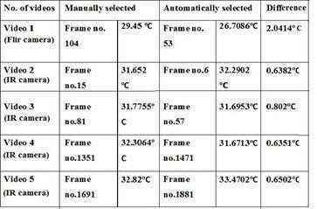

**Table 2.1.1: Frame Difference between videos of FLIR& IR camera**

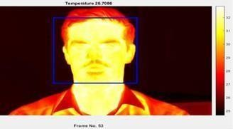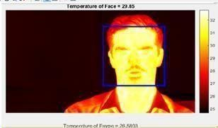However, video sequences are from "one FLIR camera and IR camera videos. The testing was done on one FLIR camera & six R cameras different video sequences. In each video sequences different frame selection methods have been used. After implementation of temperature measurement algorithm, the results have been calculated and it is presented in tabulated form which is shown in table 2.1.1.Frame difference have been done to measure temperature variation in the different frames of FLIR and IR camera videos selected by two different frame extraction methods and these results have been used for further analysis in the result section. The result of manual & automatically frame extraction method of both FLIRE63900 thermal camera video and CP- USC TA10L2-360–Infrared camera videos were performed.

**Figure 2.1.1 Automatic selected frame Figure 2.1.2: Manually selected frame.**

#### PAPER 2:

**Title:** Thermal Image Dataset For Person Detection

**Authors:** M. Krišto, M. Ivašić-Kos

### Source: IEEE Description:

In this paper will be presented an original thermal dataset designed for training machine learning models for person detection. The dataset contains 7412 thermal images of humans captured in various scenarios while walking, running, or sneaking. The recordings are captured in the LWIR segment of the electromagnetic (EM) in various weather condition- clear, fog and rain at different distances from the camera, different body positions (upright, Hunched) and movement speeds (regular walking, running). In addition to the standard lens of the camera, we used a telephoto lens for recording, and we compared the image quality at different weather conditions and at different distances in both cases to set parameters that provide the level of detail that is enough to detect the person. Comparison of images taken at the clear weather and the distance of 165 m:

The basic scenarios that should be met: Clear weather:

* + It is used to estimate the maximum (reference) distance of the camera on which the person on the record can be detected with a naked eye.
  + The reference distance of 110 m is selected, and the recording with the standard lens is carried out at a distance of 165 m, Fig 2.2.1

1. Primarily used for training the person detection model.
2. Record people while walking, running, sneaking (hunched walking).

The main goal was to create a dataset for learning a deep learning model for person detection in realistic conditions that can happen during surveillance and monitoring protected area. All scenarios are recorded with thermal cameras in night conditions and during the winter period. Recordings were done in clear weather, fog, and heavy rain. Recorded people had to mimic people who intentionally but unauthorized enter the monitored area, therefore should move at the different distance from the camera, with different movement speeds and body positions, from crawling on all fours, hiding, hunched walking to running.

### Dense fog weather:

* 1. Evaluation of the camera’s ability to record in fog and conditions with low visibility – reference distances of 30 and 50 m
  2. It is used to prepare a test set to examine the robustness of a model for person detection: the objective is to learn a model for person detection at clear weather footage and observe its ability to be used in conditions that simulate realistic conditions in protected areas such as fog or rain.
  3. Record people while walking, running, sneaking (hunched walking).

### Heavy rain weather:

1. Estimate the camera’s ability to record in rainy weather and weather with high humidity - distances from 30 to 215 m. It is used during the test phase to test the robustness of the model for person detection trained on clear weather images and to examine the ability to be used under real- world surveillance conditions.
2. Record people while walking, running, sneaking (hunched walking).

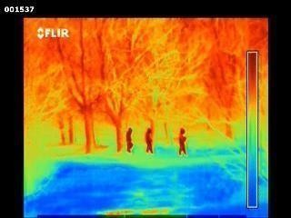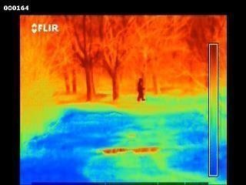

**Figure 2.2.1: Standard thermal camera Figure 2.2.2: Using telephoto lens**

For supervised learning of a model for person detection in thermal images, there should be valuable annotated frames with tagged persons in the learning set as well as in the test set hat will serve as ground truth. That is why the next phase was the process of frame notation and tagging of all persons present on each image. As the manual annotation and objects tagging is long lasting and tedious work, we tried to choose representative images that will be manually annotated.

Considering that human walking or running is a repetitive activity, we have selected the frames at different distances and angles from the camera that would maximally show the differences in body positions. Therefore, several scenarios for choosing candidate images have been applied. The first step was the visual inspection of all the frames, and then the corresponding frames were selected according to the defined criterion (maximum difference in the motion and position of the body, as well as visibility of the recorded persons). After this phase, the initial set selected for manual annotation and person tagging was reduced to a total of 7,412 frames. In a formed set, 3,174 frames were obtained for clear weather, 1,460 images for fog, and 2,778 images for rain.

Also, we recorded a person in clear weather at a distance of 110 meters with changed body positions - from normal to walk on all fours, crawling and lying on the ground (Fig. 2.2.4). Comparison of images taken at the clear weather and the distance of 165 m using standard lenses – one person– changing positions: Comparison of images taken at the clear weather and the distance of 110 m:

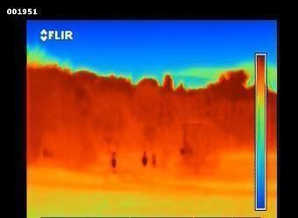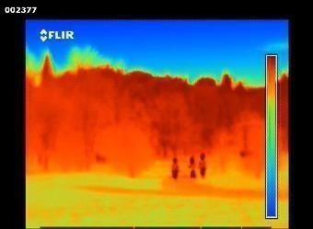

**Figure 2.2.3: Standard camera lens Figure 2.2.4: telephoto lens**

Due to the high density of water particles in the air in fog conditions, LWIR radiation is highly dispersed, so the visibility for the thermo-visual camera is significantly reduced compared to other atmospheric conditions. This fog condition was the most demanding scenario as it is stated in the reviewed literature [29, 30]. Although it was primarily intended to repeat shooting scenarios as well as at clear weather, the same was not possible. Concerning available equipment and extremely dense fog, people at distances of over 50 meters were not visible at all. After the initial visual inspection of the recorded images, we selected a distance of 0 to 30 m and at 50 m, using only the telephoto lens, Fig. 2.2.4.After recording and video pre-processing, we got about 20 minutes of videos recorded on the clear weather, about 13 minutes on fog and about 15 minutes on rainy weather. The resulting video material needed additional processing to be prepared for training, so we cut all the videos into smaller parts that best fit the pre-defined scenarios. At this stage, we used the VSDC Video Editor’s free software tool to cut video materials [31]. After cutting the videos into smaller parts, it was necessary to extract frames from all the videos we have got. We performed the image extraction using MATLAB and corresponding scripts for extracting video frames. The result was a total of 11,900 frames in 1280x960 resolution (for clear weather at all distances, all body positions, and motion speeds). For fog, we obtained a total of 4,905 images for both recording distances and all body positions. For rainy weather, there are 7,030 frames for all distances and all body positions.

### PAPER 3:

**Title:** Dynamic Prediction of Body Temperature Monitoring Equipment.

**Authors:** Guo-jun Li, Xiao Jiang

**Source**: IEEE

### Description:

Body temperature is an important physiological indicator reflecting the health status of human beings. It plays an irreplaceable role in human production and life. Observing changes in body temperature can provide an important basis for the prevention, diagnosis and treatment of diseases [1]-[3]. Mercury thermometer is the most common body temperature measurement tool in China because of its accurate measurement results [4]. However, with the signing of the Minamata Convention, China will no longer produce or import mercury containing products from 2020 [5]- [7]. The elimination of mercury thermometers has become an irreversible trend.

Therefore, looking for the substitute of mercury thermometer is extremely urgent. Stable Since the SARS period in China, the infrared electronic thermometer has been widely used because of its obvious advantage —short measuring time. However, comparing with mercury thermometer, it also has some shortcomings. For instance, infrared forehead thermometer is susceptible to environmental impact, and infrared ear thermometer is not suitable for infants or people with otitis media. A large number of studies and experiments shows that the results of mercury thermometer are stable and reliable, which can be used as the standard for comparative study in fever diagnosis. But the infrared thermometer should be further improved in performance and optimized design, so as to be more conducive to its long-term development [8]-[9]. Meanwhile, with the development of Internet technology and sensor technology, the real wearable technology has been developed rapidly, and consumer wearable equipment has emerged [10]-[12]. Recent years, along with the phasing out of mercury thermometers, wearable sensors have become very popular in many applications such as medical, entertainment, security, and commercial fields [13]-[17].

It's also worth mentioning that there are some problems to be solved. As we know, the process of measuring body temperature by a thermometer belongs to the first order inertia link, and its dynamic response characteristics depend on equipment’s time constant. The larger time constant is, the longer time is required for the temperature measurement process. For this reason, many global famous scholars have done a lot of research about it. In 2012, Mr. Brambilla and Mr. Ding et al. demonstrated a compact temperature sensor with a response time of tens of milliseconds, which based on a broadband microfiber coupler tip [18]-[19]. In 2013, Liu proposed an improved

recursive least squares method. Gradient descent method was used to generate the initial value of the filter parameters, then the recursive least squares method (RLS) algorithm was used to optimize the parameters. Engineering experiments showed that the compensation filter designed by the improved recursive least squares algorithm could improve the dynamic characteristics of the sensor system [20]. In 2017, based on the step response characteristics of the first-order resistor-capacitor (RC) system, Wang designed a high precision measuring circuit which is proportional to the resistance value, and proposed a fast charging and discharging method, which effectively eliminated the invalid waiting time for temperature measurement and greatly improved the response speed of NTC thermostat [21] .

From an objective point of view, that research mentioned above contributed a lot for improving the dynamic characteristics of the thermometer from the aspects of circuit design, materials, structure, etc. But at the same time, those technological improvements will also increase production costs. As far as electronic thermometers are concerned on the market at present, the principal contradiction is that the thermometer with small time constant has good performance but the price is high, while the thermometer with large time constant is suitable but the performance cannot meet the actual demand.

DATA ANALYSIS UNDER DIFFERENT INITIAL TEMPERATURE CONDITIONS

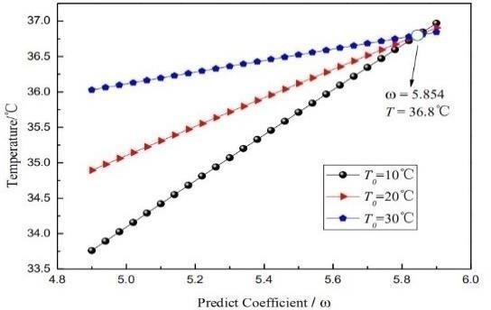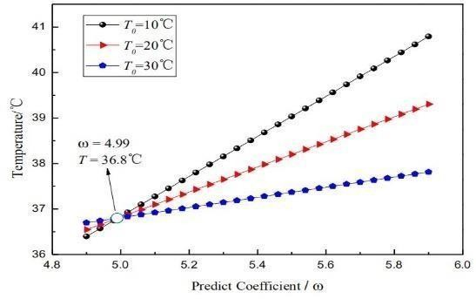

**Figure 2.3.1: First-order scheme Figure 2.3.2: Second-order sch****eme**

A new dynamic predict method for solving the problem of a wearable body temperature measuring equipment’s poor dynamic response characteristics and a data fitting method of body temperature under experimental conditions are proposed in this paper. The method is based on the law of conservation of energy, Taylor expansion in respect of time and the idea of finite difference. The predictive equations of predict temperature with respect to predict coefficient and known time nodes’ temperature are established, the body temperature can be quickly obtained by measuring the

first few minutes’ temperature. The predicted results are well verified by experimental data. And the possible influencing factors for prediction are analyzed, which include difference scheme, initial temperature, body temperature, time constant and temperature difference. This method allows the body temperature measurement equipment with lower price get higher performance, which greatly improved the practicability of temperature sensors that measurement process satisfies the first order inertia link.

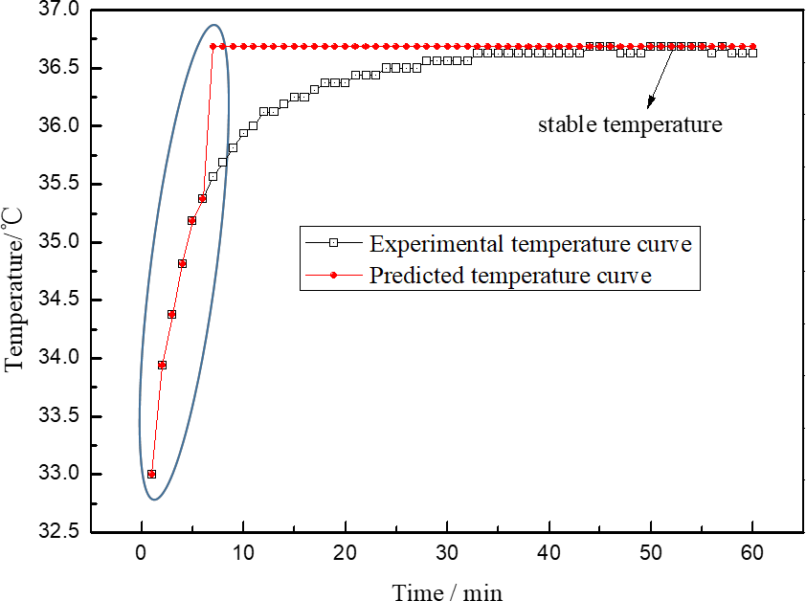This equipment continuously monitors body temperature even during sleep. Users can set temperature thresholds, and be notified on mobile devices when the temperature reaches a certain point. Parents and caregivers can also monitor remotely from another device. However, its disadvantages are also very prominent. It takes even more than 30 minutes to obtain the body temperature. In order to solve the problem of poor dynamic response characteristics, a new dynamic prediction method that greatly reduces the time required for temperature measurement is proposed in this paper.

**Fig.2.3.3 Prediction diagrammatic sketch of body temperature**

The prediction process is shown in Fig.2. The stable temperature can be predicted by measuring a limited number of time nodes’ temperature. The stable temperature in Fig.2 is the body temperature at monitoring point. This is a connected thermometer, and you can wear it like a bandage. Based on the principle of thermostat temperature sensor, the temperature change can be sensed by the temperature sensing element, and the temperature signal is converted into an electrical signal and transmitted to the mobile phone via Bluetooth.

### PAPER 4:

**Title:** A Thermal Camera based Continuous Body Temperature Measurement System

**Authors:** Jia-Wei Lin

**Source**: IEEE

### Description:

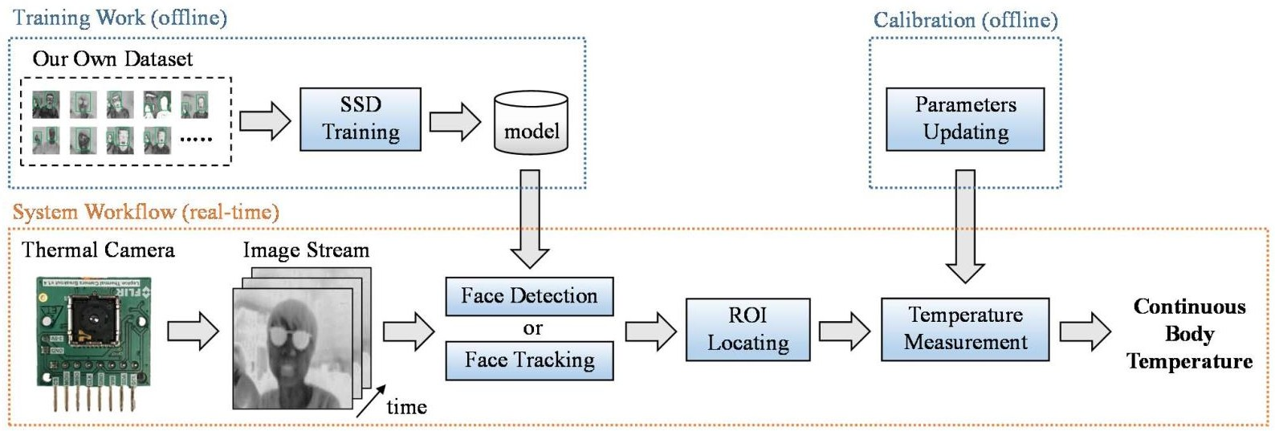Body temperature acting an important role in medicine, a number of diseases is characterized by a change in human body temperature. Monitoring body temperature also allows the doctor to track the effectiveness of treatments. But current continuous body temperature measurement (CBTM) system is mainly limited by reaction time, movement noise, and labor requirement. In addition, the traditional contact body temperature measurement has the problem of wasting consumables and causing discomfort. To address above issues, we present a non contact, automatic CBTM system using a single thermal camera. By applying deep learning based face detection, objects tracking, andcalibrated conversion equation, we can successfully extract subject’s forehead temperature in real- time. The experimental results show that the overall mean absolute error (MAE) and root-mean- squared-error (RMSE) of our proposed framework compared with industrial instrument are 0.375°C and 0.439 °C, respectively.

**Figure 2.4.1:The proposed thermal camera-based continuous body temperature measurement framework.**

Face detection is a very popular research topic in image processing, which has also been developed very maturely in the field of general full-color RGB cameras. On the other hand, to the best of our knowledge, there are currently three main methods for face detection in thermal images:

* 1. Image Projection method firstly convert thermal image to gray-scale image, and binarize the image by using the Ostu’s method. After that, the vertical and horizontal projection of the binarized image is calculated, facial part can be defined from projection curve finally. In [5][6], this method has achieved good results and short processing time. However, it can only detect one face at a time.
  2. Haar-Cascade method also known as Viola-Jones (VJ) method [7]. It can detect objects based on Haar-like features, Integral image, Adaptive Boosting (AdaBoost), and Cascade Classifier. This method has been successfully applied in several object detection applications such as face, animal, and vehicle detection. Authors of [8][9] used this algorithm to detect thermal face; however, the presented results indicated that the method was sensitive to the subject’s head movement.
  3. Machine Learning-based method was proposed in [10][11], the authors introduced a high- resolution thermal facial image database, which can be used to adapt methods from the visual domain for IR images. But unfortunately, the training images data of this database is too different from our camera specifications (our image has a poorresolution while their database were recorded with 1024x768 pixel-sized). The application way is also dissimilar, so it is not suitable for this paper.

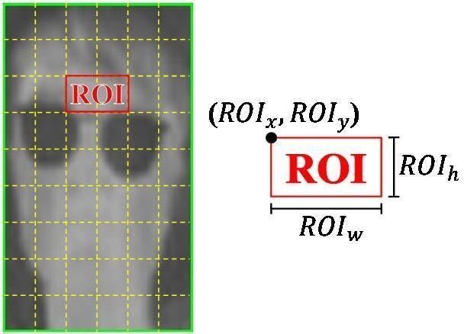

**Figure 2.4.2: The illustration diagram of ROI assignment.**

Although our deep learning-based face detection can accurately determine the location of the face in each frame, there is a disadvantage that the processing time is too long, ending to a decrease in frames per second (FPS). Therefore, we have added face tracking algorithm to improve the FPS in this system. Once the face is d1e4tected, kernel correlation filter (KCF)

tracker[15] will be used to track the face region across each image.

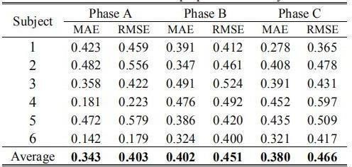

**Table 2.4.3: The results of the proposed CBTM system.**

In this paper, we adopted mean absolute error (MAE) and root- mean- squared-error (RMSE) metrics to express the difference between the proposed framework and the verified device. The operations are shown in(9) and (10). Table 1 shows the evaluation results provided by each subject. where is the average temperature of all pixel points in ROI௡ denotes the average temperature of similar area acquired from the GT device. These values are compared every 10 second. refers to the number of obtained temperatures within 10 second. Finally, Figure 9 presents an example of the temperature estimated from our methods as well as the temperature corresponding to the GT. These representative signals arefrom subject 6.In this work, a good face detection is an important step for further processing. To achieve this goal, we decided to train a new model basedon deep-learning method. Our method adopted the Single-Shot-Multibox Detector (SSD) with MobileNet. The MobileNet-SSD architecture is shown in Figure 2. One issue with deep learning is the heavy demand for training data. To tackle this problem, we transferred the learned weights from pre- trained model and fine-tuned it to our thermal images. Thistransferred learning process helped our detection model capture the features of thermal face with only a small dataset. The data used in our work came from a series of real-time execution, the overview of detection network architecture. Here, classes indicate the number of classes, which is 2 (thermal face and background) in this paper.

#### PAPER 5:

**Title:** Regularization of body core temperature prediction during physical activity.

**Authors:** Andrei Gribok, Thomas McKenna, and Jaques Reifman

**Source**: IEEE

### Description:

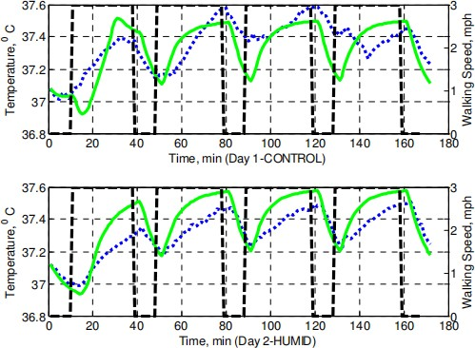This paper deals with the prediction of body core temperature during physical activity in different environmental conditions using first-principles models and data-driven models. We argue that prediction of physiological variables through other correlated physiological variables using data-driven techniques is an ill-posed problem. To make predictions produced by data driven models accurate and stable they need to be regularized. We demonstrate on data collected during laboratory study that data driven models, if regularized properly, can outperform first principlesmodels in terms of accuracy of core temperature predictions. We also show that data- driven models can be made “portable” from one subject to another, thus, making them a valuable, practical tool when data from only one subject is available to “train” the model. Applying ARMAX to time series predictions involves three steps: selection of model type (AR, MA, ARX, etc.), selection of the order of the polynomials A, B and C, and finally estimation of the coefficients of those polynomials.

**Fig 2.5.1 Simulations of the core temperature**

The model type is normally selected empirically based on prior knowledge of the modeled time series and experiments. The model’s order is selected more rigorously by using analytical criteria, such as the Akaike Information Criteria [8], the Minimum Description Length approach [9], or cross-validation. The estimation of ARMAX coefficients is the final step, however, many physiological variables are inherently correlated among each other making this estimation problem an ill-posed one requiring special consideration. There are different ways in which data-driven models can be applied to physiological data. We consider

three approaches arranged in the order of practical usefulness.

* + 1. Subject Specific —each subject has an individually tuned model, which is based on tuning the model’s type, order and parameters to that individual’s data and the model is then applied to that individual only.
    2. Fixed Order—the model’s type and order is fixed beforehand, and only the parameters are tuned to an individual’s data and the model is applied to that individual only.
    3. Portable—the model’s type, order and parameters are selected and tuned to one individual’s data and the model is applied to other individuals.

The most important finding, however, is that RMSEs for the Portable models are smaller than SCENARIO’s RMSEs. This fact shows that data- driven models can be effectively applied then data from only one subject are available for training. This is a very valuable result for practical applications, as it may obviate the need to customize models for each subject, while facilitating the incorporation of individualized models as part of the WPSM system. It should be stressed, however, that there is a fundamental difference in which the data are used in the two approaches. The data-driven models use the currently available measurements to make further predictions while SCENARIO does not make use of such information.

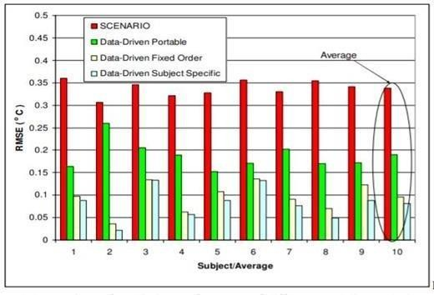

**Figure 2.5.2: Comparison of predictive performance of different modeling techniques.**

The first-principles SCENARIO model [4], a computer based simulator developed by the

U.S. Army Research Institute of Environmental Medicine (USARIEM), predicts and estimates core temperature, heart rate, and other physiological variables. The underlying model for SCENARIO simulates the time course of core temperature, while taking into account different clothing ensembles, workloads, anthropometric

Characteristics, such as body weight, stature, body fat, fitness, and effects of progressive dehydration. Temperature distribution in the human body is represented by a lump parameter model consisting of six concentric cylindrical compartments. Heat flow is then modeled by a set of macroscopic energy conservation equations, which are based on heat convection between the central blood compartment and the adjacent core, muscle, fat and vascular skin compartments; radial heat conduction between every pair of adjacent Compartments; and air convection, radiation and sweat evaporation between the superficial a vascular skin layer and the environment and transition through the clothing [4]. These relationships are represented by a set of six ordinary differential equations, which can be expressed as follows:

Where T(t)∈ R6x1 is a vector representing the temperatures in each of the six modeled compartments of the body, A(t)∈ R6x6 is a time varying matrix determined by parameters, such as the conductance between two adjacent compartments and blood flow between the compartments. The vector B(t)∈ R6x1 may be viewed as representing the secondary inputs to the system, and is primarily governed by the metabolic rate in each compartment as well as the respiration rate. Since the data are collected at discrete points in time, in SCENARIO, equation (1) is represented by approximating the temperature gradient by a difference equation. The need to represent between- subject variability can be addressed by developing data-driven models that utilize historic and real- time data that are specific to the individual. For example, the benefits of a hybrid approach to core temperature modeling have recently been explored where SCENARIO was augmented with a data- driven model [5], [6].

## SYSTEM REQUIREMENT SPECIFICATION

### FUNCTIONAL REQUIREMENTS

A Functional Requirement (FR) is a description of the service that the software must offer. It describes a software system or its component. A functions nothing but inputs to the software system, its behavior, and outputs. It can be a calculation, data manipulation, business process, user interaction, or any other specific functionality which defines what function a system is likely to perform. My project Ai Device Fever Screening operates as described below:

1. Raspberry pi install.
   * Raspberry Pi have developed a graphical SD card writing tool that works on Mac OS, Ubuntu 18.04 and Windows, and is the easiest option for most users as it will download the image and install it automatically to the SD card.
   * Download the latest version of [Raspberry Pi Imager](https://www.raspberrypi.org/downloads/) and install it.
   * If you want to use Raspberry Pi Imager on the Raspberry Pi itself, you can install it from a terminal using sudo apt install rpi-imager.
   * Connect an SD card reader with the SD card inside.
   * Open Raspberry Pi Imager and choose the required OS from the list presented.
   * Choose the SD card you wish to write your image to.
   * Review your selections and click 'WRITE' to begin writing data to the SD card.
2. Pi camera setup
   * Type "sudo raspi-config" in the terminal.
   * Select Interfacing Options.
   * Turn off your Raspberry Pi camera using the text-based menu. You can also do this graphically by clicking on the raspberry icon, selecting Preferences, and Raspberry Pi Configuration.
   * Under the Interfaces tab, click on "Enabled" for the camera, then hit OK.
   * The graphical interface will ask if you want to restart to allow the changes to take effect, which is a good opportunity to shut down and plug in the camera if you haven't done so already.
   * Once you shut down, pop open the camera ribbon connector on the Pi, slide the ribbon in with the blue tape facing the black top piece, then push down to connect. Restart and the Pi camera will be ready to go.
3. Open cv, Tensor Flow, Dlib, for detect the face and temperature.
   * **OpenCV** is the huge open-source library for the computer vision, machine learning, and image processing and now it plays a major role in real-time operation which is very important in today's systems. By using it, one can process images and videos to identify objects, faces, or even handwriting of a human.
   * **TensorFlow** is an open-source library developed by Google primarily for deep learning applications. It also supports traditional machine learning. **Tensor Flow** was originally developed for large numerical computations without keeping deep learning in mind.
   * **Dlib** is a modern C++ toolkit containing machine learning algorithms and tools for creating complex software in C++ to solve real world problems. It is used in both industry and academia in a wide range of domains including robotics, embedded devices, mobile phones, and large high performance computing environments. Dlib's [open source](http://dlib.net/license.html)  [licensing](http://dlib.net/license.html) allows you to use it in any application, free of charge.To follow or participate in the development of dlib subscribe to [dlib on github.](https://github.com/davisking/dlib) Also be sure to read the [how to contribute](http://dlib.net/howto_contribute.html) page if you intend to submit code to the project. Dlib is also capable of using any optimized BLAS or LAPACK libraries that are installed on your system. Linking to these libraries will make many things run faster. To do this you define the DLIB\_USE\_BLAS and/or DLIB\_USE\_LAPACK preprocessor directives and then link your program with whatever BLAS or LAPACK libraries you have. If you use CMake it will set this up automatically.

:

4. **MLX90614:**

The MLX90614 is an infrared thermometer for non-contact temperature measurements. Both the IR sensitive thermopile detector chip and the signal conditioning ASIC are integrated in the same TO-39 can. Integrated into the MLX90614 are a low noise amplifier, 17-bit ADC and powerful DSP unit thus achieving high accuracy and resolution of the thermometer. The thermometer comes factory calibrated with a digital SMBus output giving full access to the measured temperature in the complete temperature range(s) with a resolution of 0.02°C.The user can configure the digital output to be pulse width modulation (PWM). As a standard, the 10-bit PWM is configured to continuously transmit the measured temperature in range of -20 to 120°C, with an output resolution of 0.14°C.

* Small size and low cost
* Easy to integrate
* Factory calibrated in wide temperature range: -40 to 125°C for sensor temperature and -70 to 380°C for object temperature

### NON-FUNCTIONAL REQUIREMENTS

Non-functional requirements are the requirements which specify criteria that can be used to judge the operation pf a system, rather than specific behaviors. This should be contrasted with functional requirements that specify behavior or functions. Typical non-functional requirements responsiveness, scalability, security, usability.

**Scalability**: The system should be scalable and must be capable of handling many detection temperatures at a time.

**Usability:** The system should be easy to use so that the users do not face any kind of difficulty while operating it.

### SOFTWARE REQUIREMENTS

The following software as shown in Table 3.1 are required to run the project:

|  |  |  |
| --- | --- | --- |
| **S no.** | **Software** | **Description** |
| 1. | Operating System | Microsoft Windows 10, Linux |
| 2. | Integrated Development Environment | Python ide, Thonny ide |
| 3. | Programming language | Python |

### Table 3.1: Software required

**3.3.1Thonny**

Thonny is another great, easy-to-use IDE that comes pre-loaded on Raspbian. It focuses on Python and has an interactive environment when you load the program. Start Thonny by clicking on the Raspberry Pi icon followed by Programming > Thonny Python IDE.Thonny is an [integrated development environment](https://en.wikipedia.org/wiki/Integrated_development_environment) for [Python](https://en.wikipedia.org/wiki/Python_(programming_language)) that is designed for beginners. It supports different ways of stepping through the code, step-by-step expression evaluation, detailed visualization of the call stack and a mode for explaining the concepts of references and heap.

* [Line numbers](https://en.wikipedia.org/wiki/Line_numbers)
* Statement stepping without breakpoints
* Live variables during debugging
* Stepping through evaluation of the expressions (expressions get replaced by their values)
* Separate windows for executing function calls (for explaining local variables and call stack)
* Variables and memory can be explained either by using simplified model (name → value) or by using more realistic model (name → address/id → value)
* Simple [pip](https://en.wikipedia.org/wiki/Pip_(package_manager)) GUI

**Install:**

The latest version:

Binary bundle for PC (Thonny+Python):

bash <(wget -O - https://thonny.org/installer-for-linux)

**With pip:**

pip3 install thonny

**Distro packages (may not be the latest version):**

Debian, Raspbian, Ubuntu, Mint and others: sudo apt install thonny

**Fedora:**

sudo dnf install thonny

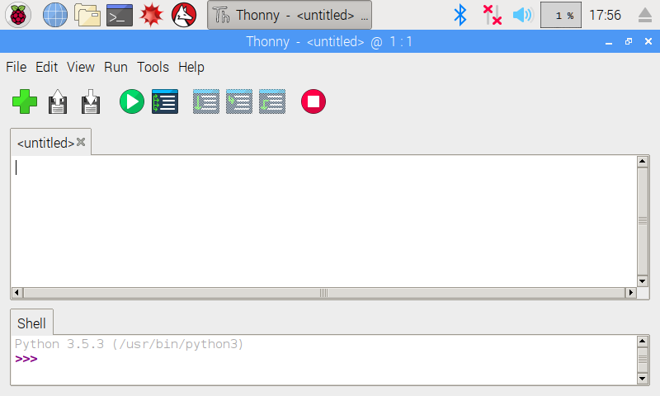

**Figure 3.1: Thonny python ide in pi**

**Python:**

Python is an interpreter, high-level, and general-purpose programming language. The project’s body temperature detection program was done using this program. Python is a general-purpose interpreted, interactive, object-oriented, and high-level programming language. It was created by Guido van Rossum during 1985- 1990. Like Perl, Python source code is also available under the GNU General Public License (GPL). This tutorial gives enough understanding on Python programming language.

Characteristics of Python

* + It supports functional and structured programming methods as well as OOP.
  + It can be used as a scripting language or can be compiled to byte-code for building large applications.
  + It provides very high-level dynamic data types and supports dynamic type checking.
  + It supports automatic garbage collection.
  + It can be easily integrated with C, C++, COM, ActiveX, CORBA, and Java. Applications:
  + Easy-to-learn − Python has few keywords, simple structure, and a clearly defined syntax. This allows the student to pick up the language quickly.
  + Easy-to-read − Python code is more clearly defined and visible to the eyes.
  + Easy-to-maintain − Python's source code is fairly easy-to-maintain.
  + A broad standard library − Python's bulk of the library is very portable and cross-platform compatible on UNIX, Windows, and Macintosh.

Python is [becoming increasingly popular](https://blog.hackerrank.com/emerging-languages-still-overshadowed-by-incumbents-java-python-in-coding-interviews/) for its potential applications in the fintech realm. The reason for this popularity is Python’s usefulness in applications like data regulation, analytics, risk management, and quantitative rate problems. Further, there are tons of Python tools that make it the perfect language for fintech and other finance applications. Here are just a few examples:

* + NumPy
  + SciPy
  + Pandas
  + Scikit-learn
  + Cython
  + PyTables

As fintech continues to grow, you can expect Python to feature prominently. Indeed, there are already scores of fintech companies that include Python in their stack. Here are just a few examples of the most prominent fintech companies that have adopted Python:

* + Zopa
  + Vyze
  + Venmo
  + Bank of America

### HARDWARE REQUIREMENTS

* Pc/Laptop with minimum specification is required as shown in Table 3.2

|  |  |  |
| --- | --- | --- |
| **S no.** | **Hardware** | **Description** |
| 1 | Processor | Intel 5th generation processor |
| 2 | RAM | 6GB |
| 3 | Raspberry pi | model 3+ |
| 4 | Mlx90614 | Non-contact temperature measurements. |
| 5 | Camera | Pi camera |
| 3. | Hard Disk space | 200GB and 16 SD card |

**Table 3.1: Laptop/PC hardware specifications**

## 4. METHODOLOGY

In our approach we try to build a model which takes input from the live web camera image and detect the face and screen the body temperature. The accuracy to which the body temperature is predicted mainly depends on the sensor.

### Raspberry Pi:

The Raspberry Pi is a low cost, credit-card sized computer capable of computing, and uses Graze and Python languages. It can be plugged into a computer monitor or TV and uses a keyboard and mouse as input devices. It is capable of replacing a desktop computer, from browsing the internet, CAD modelling, frolicking high- definition video and games, and word-processing, To use a raspberry pi forvarious application an SD Card, display and connectivity cables, keyboard and mouse, power supply and internet connection are required. The features of Raspberry pi[5] includes-The Broadcom BCM2835 ARM11 700Mhz ‘System on Chip’ Processor, Integrated Video core 4 Graphics Processing Constituent (GPU) capable of frolicking Maximum 1080p Elevated The Real Time Temperature Sensing using Raspberry PI (IJIRST/ Volume 1 / Issue 12 / 039) All rights reserved by [www.ijirst.org](http://www.ijirst.org/) 233 Meaning Blu-Ray Quality Video,512Mb SDRAM, The free, flexible, and exceedingly builder approachable Debian GNU/Linux Working System,2 x USB Ports, HDMI Video Output, RCA Video Output,3.5mm Audio Output Jack,10/100Mb Ethernet Port for Internet Access,5V Micro USB Domination Input Jack, SD, MMC, SDIO Flash Recollection Card Slot,40-pin 2.54mm Header Progress Slot .

### Plugging into Raspberry Pi:

For plugging in to raspberry pi the following steps must be followed.

* + To start slot the SD card into the SD card slot on the Raspberry Pi.
  + Plug in the USB keyboard and Mouse into the USB slots on the Raspberry Pi.
  + Make sure that the monitor or TV is coiled on, and the right input is selected (e.g. HDMI, DVI,etc.)
  + Link the HDMI cable from the Raspberry Pi to the monitor.
  + If the Raspberry Pi must be linked to the internet, plug in an Ethernet cable into the Ethernet seaport consecutive to the USB seaports.

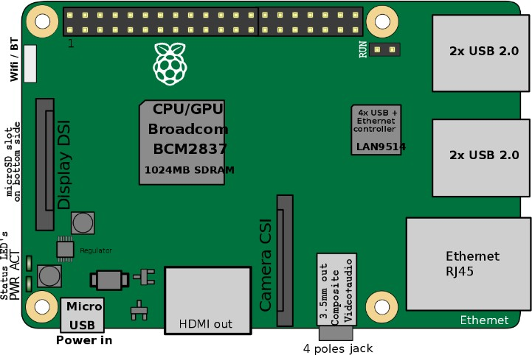

### Figure 4.1: Raspberry PI

Raspberry Pi have developed a graphical SD card writing tool that works on Mac OS, Ubuntu

18.04 and Windows, and is the easiest option for most users as it will download the image and install it automatically to the SD card.

* Download the latest version of [Raspberry Pi Imager](https://www.raspberrypi.org/downloads/) and install it.
* If you want to use Raspberry Pi Imager on the Raspberry Pi itself, you can install it from a terminal using sudo apt install rpi-imager.
* Connect an SD card reader with the SD card inside.
* Open Raspberry Pi Imager and choose the required OS from the list presented. Choose the SD card you wish to write your image to.
* Review your selections and click 'WRITE' to begin writing data to the SD card.

There are all kinds of Raspberry Pi accessories available in the market. But the ones you can’t do without are:

* Power Adapter: A 2.5A 5V power adapter is needed to power up the microcomputer.
* MicroSD Card: Use a microSD card with at least 8 GB capacity, class 10. The microSD card acts like the hard drive of your micro-computer. All your data, even the operating system itself, is stored on the microSD card. While setting up your Raspberry Pi microcomputer, you can either buy a microSD card preloaded with the operating system or you can install the operating system yourself.

These two accessories are the absolute essentials to get started with Raspberry Pi. But you can also use other accessories such as an HDMI cable to connect your TV or monitor with the Raspberry Pi chip and a case to protect it.

The Three Raspeteers

* Raspberry Pi Model A: This model was released in 2013 and a second version of this, called A+, was released in 2014. The model A is now discontinued but the A+ version is available for purchase.
* Raspberry Pi Model B: Model B was the original Raspberry Pi that was released in 2012. Many successors to this model were launched including “+” model, Pi 2, v1.2 Pi 2 and finally the Pi 3. These models use the Raspberry Pi B board, which is bigger than the A board used in A models
* Raspberry Pi Model Zero: Raspberry Pi Model Zero took compact computing to a whole new level. It further reduced the size of Raspberry Pi Model A to produce a microcomputer CPU available for just 5 dollars. Many successors to this Model Zero came later. They include a Zero 1.3 board, Zero W and the Zero WH that was released in the beginning of 2018.
* CanaKit Raspberry Pi 3 B+ Starter Kit 32GB EVO+ Edition Premium Black Case:The CanaKit Raspberry Pi 3 B+ offers everything you need to get started with the Raspberry Pi microcomputer. It contains the Pi 3 B+ computer board, a microSD card preloaded with NOOBS, a case, power supply and cables to connect everything together. Apart from these supplies, you need to have a keyboard, mouse and monitor of your own.

As reported by customers, this Pi model is much faster than the previous B generations. This isn’t a minor performance tweak. Performance has significantly increased as the processor has gone from 1.2GHz to 1.4GHz. The previous Pi generation made it a sub-desktop machine, as more than two tabs on the browser would freeze the system and playing videos on YouTube even in a small window was a painful experience. But with the Raspberry Pi 3 B+, you can watch YouTube videos in full screen at 1920×1080 pixels. In short, the Raspberry Pi 3 B+ can be used as a proper desktop machine capable of performing multiple tasks from word processing and coding to watching videos and playing games.

It is safe to say that this small machine is much more capable than you would probably imagine. It has a built-in dual band AC WiFi which further adds to its performance and makes it great. This is remarkable because it would have worked well, even with the 2.4 GHz WiFi, but the company chose to go one step further.

Setting up the operating system to a separately purchased microSD card is as easy as it gets. As a user reports, the best part about using this small but mean machine is that it works well as a media

player using OSMC. You can enjoy watching YouTube videos, stream remote content and play local video or music content on your USB drive.

* Pro Tip: Use a fast memory card for the best performance improvement. Use a 32GB U3 Class 10 card and you will see snappy performance.
* In short, the Pi 3 B+ is a major performance improvement over the previous version. The 200 MHz increase is great but the real performance gem is the significant increase in networking speed.

### Contactless Temperature Sensor (MLX90614)

The MLX90614 is a Contactless Infrared (IR) Digital Temperature Sensor as shown in Figure

* + 1. that can be used to measure the temperature of a particular object ranging from -70° C to 382.2°C. The sensor uses IR rays to measure the temperature of the object without any physical contact and communicates to the microcontroller using the I2C protocol. The pin configuration of the sensor is shown in Table 2.

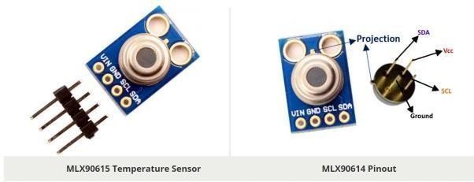

**Figure 4.2 MLX90615 Contactless IR Digital Temperature Sensors**

The working principle of infrared sensor MLX90614 is to transform the infrared radiation signal collected from objects and bodies into electrical signals, send the electrical signal into converter after noise amplification processing by amplifier, then the electrical signal is converted to digital signals and store the processed signals into the internal memory, finally send the signals into the SCM control system for further processing [5]. MLX90614 infrared temperature sensor uses the SPI bus, when connected to the microcontroller, SCL

termination microcontroller serial input port RXD, serial output pulse signals of sensor are provided by the microcontroller, it is used to transmit temperature information, SDA serial output port TXD is used to provide temperature information for the microcontroller, in the specific operation, the microcontroller transfer data through the serial port mode 0. Infrared temperature measurement circuit is shown in Fig. 4.2.

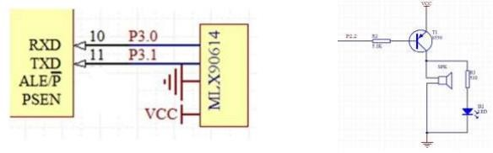

### Fig 4.3: Infrared temperature measurement circuit Figure and Alarm circuit

MLX90614 Pin out Configuration

|  |  |  |
| --- | --- | --- |
| Pin No. | Pin Name | Description |
| 1 | Vdd  (Po  wer supply) | Vdd can be used to power the sensor, typically using 5V |
| 2 | Ground | The metal can also act as ground |
| 3 | SDA – Serial Data | Serial data pin used for I2C Communication |
| 4 | SCL – Serial Clock | Serial Clock Pin used for I2C Communication |

**Table 4.1:** Pin Configuration of MLX90614 Temperature Sensor

MLX90614 Temperature Sensor Specifications

* Operating Voltage: 3.6V to 5V (available in 3V and 5V version)
* Supply Current: 1.5mA
* Object Temperature Range: -70° C to 382.2°C
* Ambient Temperature Range: -40° C to 125°C
* Accuracy: 0.02°C
* Field of View: 80°
* Distance between object and sensor: 2cm-5cm (approx.) Connect mlx90614 to raspberry pi:
  + - 1. Vin power supply pin to vcc 5v pin 4/2
      2. Ground pin to GND 6 pin
      3. SDA pin to SDA 3 pin
      4. SCL pin to SCL 5 pin

The **MLX90614** offers a standard **accuracy** of ±0.5˚C around room temperatures. A special version for medical applications exists offering an **accuracy** of ±0.2˚C in a limited temperature range around the human body temperature. Body temperature is the most basic and vital indicator of life. Measuring body temperature plays an important role in daily care. However, in the face of people's pursuit of a fast and safe lifestyle nowadays, the traditional mercury thermometer needs to measure about 5 minutes under the armpits and needs to be read by human eyes. Therefore, there are many drawbacks. With the development of infrared technology, infrared thermometers have also been recognized by the public due to their safety and rapidity. Infrared thermometer is mainly based on the principles of black body radiation to measure the human body's infrared radiation wavelength, followed by the measurement of body temperature, infrared sensors used by it only to absorb the infrared radiation of human body without any emission, which uses a passive non-contact measurement methods and can effectively prevent cross-infection of the human body, it is safe and convenient, so the infrared thermometer does not cause harm to the human body [1,2]. Compared with the traditional thermometer, the infrared thermometer is safe to use and has convenient measurement and short measuring time. Therefore, the research on infrared thermometer design has important theoretical and practical significance.

### Connect pi camera.

Connect your camera module to the CSI port on your Raspberry Pi; this is the long thin port adjacent to the HDMI socket. Gently lift the collar on top of the CSI port (if it comes off, don’t worry, you can push it back in but try to be more gentle in future!). Slide the ribbon cable of the camera module into the port with the blue side facing the Ethernet port (or where the Ethernet port would be if you’ve got a model A/A+).

Once the cable is seated in the port, press the collar back down to lock the cable in place. If done properly you should be able to easily lift the Pi by the camera’s cable without it falling out.

The following illustrations show a well-seated camera cable with the correct orientation:

* + To attach a camera module to a Pi Zero:
  + Remove the existing camera module’s cable by gently lifting the collar on the camera module and pulling the cable out.

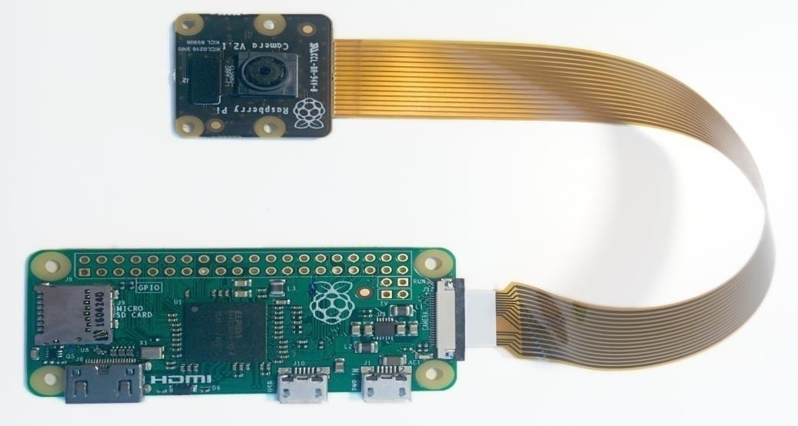

**Fig: 4.4 connections**

* + Next, insert the wider end of the adapter cable with the conductors facing in the same direction as the camera’s lens.
  + Finally, attach the adapter to the Pi Zero by gently lifting the collar at the edge of the board (be careful with this as they are more delicate than the collars on the regular CSI ports) and inserting the smaller end of the adapter with the conductors facing the back of the Pi Zero.

Upon construction, this class initializes the camera. The *camera\_num* parameter (which defaults to 0) selects the camera module that the instance will represent. Only the Raspberry Pi compute module currently supports more than one camera, and this class has not yet been tested

with more than one module.The *resolution* and *framerate* parameters can be used to specify an

initial and framerate. If they are not specified, the *framerate* will default to 30fps, and

resolution

the *resolution* will default to the connected display’s resolution or 1280x720 if no display can be detected (e.g. if the display has been disabled with tvservice -o ). If specified, resolution must be a tuple of *(width, height)*, and framerate must be a rational value (integer, float, fraction,

[sensor\_mode](https://picamera.readthedocs.io/en/release-1.10/api_camera.html" \l "picamera.camera.PiCamera.sensor_mode)

etc).The *sensor\_mode* parameter can be used to force the camera’s initial to a

particular value. This defaults to 0 indicating that the sensor mode should be selected automatically based on the requested *resolution* and *framerate*. The possible values for this parameter, along with a description of the heuristic used with the default can be found in the [Camera](https://picamera.readthedocs.io/en/release-1.10/fov.html" \l "camera-modes) [Modes](https://picamera.readthedocs.io/en/release-1.10/fov.html" \l "camera-modes) section.The *stereo\_mode* and *stereo\_decimate* parameters configure dual cameras on a compute module for sterescopic mode. These parameters can only be set at construction time; they

cannot be altered later without closing the instance and recreating it.

[PiCamera](https://picamera.readthedocs.io/en/release-1.10/api_camera.html" \l "picamera.camera.PiCamera)

The *stereo\_mode* parameter defaults to (no stereoscopic mode) but can be set to

'side-by-

'none'

or to activate a stereoscopic mode. If the *stereo\_decimate* parameter is True, the

'top-bottom'

side'

resolution of the two cameras will be halved so that the resulting image has the same dimensions as if stereoscopic mode were not being used.

FLOWCHART:

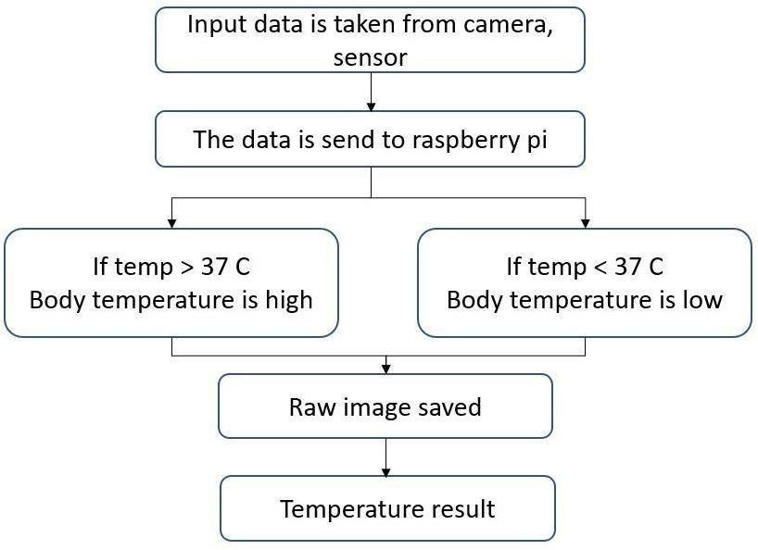

**Figure 4.5: flow chart**

### Flow chart processing:

* We have built a model that detects body temperature is measured using the contactless temperature sensor and displayed in monitor.
* First input has taken from camera which identifies the person’s faces.
* Then sensor gets output from camera with the human image. Sensor used from detecting the temperature.
* The data has sent to raspberry pi this is shows the temperature of the body we have taken two scenario.

1. If the person is body temperature value is less than 37 C, then it is normal.
2. If body temperature value is great than 37 C, then it captures image and store in file with date and time in raw data.

### ARCHITECTURE

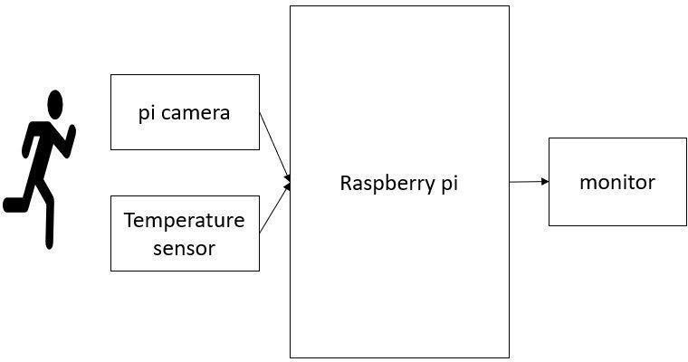

**Figure 4.6: architecture**

* If a person pass through the PI camera input has been taken and sends to the Raspberry pi.
* The temperature sensor used from detecting the temperature of the person and send to the Raspberry PI.
* Raspberry pi data that shows the temperature of the body and displays on the monitor that has been taken two scenarios.

1. If the person is body temperature value is less than 37 C, then it is normal.
2. If body temperature value is great than 37 C, then it captures image and store in file with date and time.

## 5 IMPLEMENTATIONS

**Components Required**

Here we are using Raspberry Pi 3 Raspbian OS**.** All the basic Hardware and Software requirements are previously discussed, you can look it up in the [Raspberry Pi](http://circuitdigest.com/microcontroller-projects/getting-started-with-raspberry-pi) [Introduction](http://circuitdigest.com/microcontroller-projects/getting-started-with-raspberry-pi) and [Raspberry PI LED Blinking](http://circuitdigest.com/microcontroller-projects/raspberry-pi-led-blinking) for getting started, other than that we need:

* + Raspberry Pi 3 (any version would be fine).
  + Pi Camera.
  + MLX90614 - IR temperature sensor.
  + Connecting wires.
  + Breadboard.
  + Power Supply (5V,2A/3A)

This project is simple if we divide the project into parts.

1. Understanding & Interfacing MLX90614 with Raspberry pi.
2. Getting started with Pi Camera.
3. Setting up laptop with Raspberry pi.
4. Final code developing and understanding.

### Raspberry Pi:

Raspberry Pi is a credit card size computer that was designed for educational purposes. Due to its price and amazing specifications like onboard wifi, Bluetooth, and programmable GPIO header, and the number of possible options to create an application, it was adopted by developers and electronics hobbyists. You can look it up in the Raspberry Pi Introduction and Raspberry PI LED Blinking for getting started with the booting process.

Raspberry Pi is an ARM cortex-based board designed for Electronic Engineers and Hobbyists. It’s a single board computer working on low power. With the processing speed and memory, Raspberry Pi can be used for performing different functions at a time, like a normal PC, and hence it is called Mini Computer in your palm.

Because it has an ARMv7 processor, it can run the full range of ARM GNU/Linux distributions as well as Microsoft Windows 10, we will discuss about that later. ARM architecture is very influential in modern electronics. We are using the ARM architecture-based processors and controllers everywhere. For example we are using ARM CORTEX processors in our mobiles, iPods and computers etc.

Raspberry Pi is a pocked sized computer which also has GPIO pins for connecting it to other sensors and peripherals which makes it a good platform for embedded engineers. It has an ARM architecture processor based board designed for electronic engineers and hobbyists. The PI is one of most trusted project development platforms out there now. With higher processor speed and high RAM, the Raspberry Pi can be used for many high profile projects like [Image](https://circuitdigest.com/tags/image-processing) [processing](https://circuitdigest.com/tags/image-processing) and [Internet of Things.](http://circuitdigest.com/ten-examples-of-internet-of-things-iot) Raspberry Pi 4 with 8GB RAM is the high end version available for sale now. It also has other lower version with 4GB and 2GB RAM.

### MLX90614 IR Temperature Sensor:

There are many sensors available in the market which can give us temperature and humidity. What makes this sensor different from all other sensors is that it can give us object temperature and other sensors give ambient temperature. We have used DHT11 Sensor and LM35 extensively for many applications where atmospheric humidity or temperature must be measured.

But here for making a temperature gun which does not need physical contact and can measure the object temperature instead of ambient temperature, we use IR based MLX90614 sensor is manufactured by Melexis Microelectronics Integrated systems, it works on the principle of InfraRed thermopile sensor for temperature measurement. These sensors consist of two units embedded internally to give the temperature output. The first unit is the sensing unit which has an infrared detector which is followed by the second unit which performs the computation of the data with Digital signal processing (DSP). This sensor works on Stefan- Boltzmann law which explains power radiated by a black body in terms of its temperature. In simple terms, any object emits IR energy and the intensity of that will be directly proportional to the temperature of that object.MLX90614 sensor converts the computational value into 17- bit ADC and that can be accessed using the I2C communication protocol. These sensors measure the ambient temperature as well as object temperature with the resolution calibration of 0.02°C. To know more about the features of the MLX90614 sensor, refer to the MLX90614 Datasheet. This sensor works on Stefan-Boltzmann law which explains power radiated by a black body in terms of its temperature. In simple terms, any object emits IR energy and the intensity of that will be directly proportional to the temperature of that object.MLX90614 sensor converts the computational value into 17-bit ADC and that can be accessed using the

I2C communication protocol.

Features of MLX90614:

* + Operating Voltage: 3.6V to 5V
  + Ambient Temperature Range: -40°C to 125°C Object Temperature Range: -70°C to - 382.2°C Resolution/Calibration: 0.02°C
  + 17-bit ADC.
  + I2C communication.

### Interfacing MLX90614 with Raspberry Pi:

First, we will download the library and packages required to successfully interface the MLX90614.

**Step1:** Enabling the I2C from Raspberry Pi setting.

Type *sudo raspi-config* and then go to interfacing options.

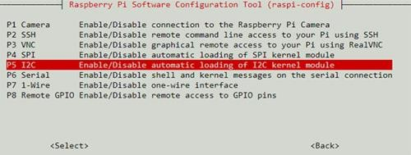

**Fig 5.1Go to I2C option and enable it.**

**Step2:** Download the package/library of MLX90614 by going to [https://pypi.org/project/PyMLX](https://pypi.org/project/PyMLX%2090614/) [90614/#](https://pypi.org/project/PyMLX%2090614/) Files, then right click and copy the link address.

Go to RPI terminal and type wget and paste the link copied like below.

Wget [https://files.pythonhosted.org/packages/67/8a/443af31ff99cca1e30304dba28a60d3f07d247c8](https://files.pythonhosted.org/packages/67/8a/443af31ff99cca1e30304dba28a60d3f07d247c8d410822411054e170c9c/PyMLX90614-0.0.3.tar.gz) [d410822411054e170c9c/PyMLX90614-0.0.3.tar.gz](https://files.pythonhosted.org/packages/67/8a/443af31ff99cca1e30304dba28a60d3f07d247c8d410822411054e170c9c/PyMLX90614-0.0.3.tar.gz)

It will download the library in the zip file name *‘PyMLX90614-0.0.3.tar.gz’*. then extract the folder with the extension of *tar -xf* file name or use the below command to do the same.

**tar -xf PyMLX90614-0.0.3.tar.gz**

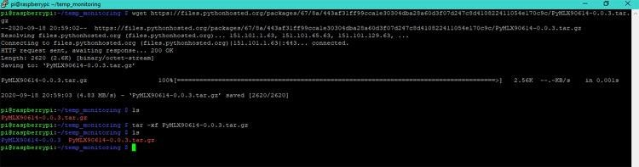

**Fig5.2:packages**

Then we need to install some required packages using the below commands.

**sudo apt-get install python-setuptools**

**sudo apt-get install -y i2c-tools**

Then go to the extracted folder using ***cd PyMLX90614-0.0.3/*** and run the command.

**sudo python setup.py install**

Once you are done following the steps, just interface the MLX90614 sensor with Raspberry pi using the circuit given below. The below Raspberry Pi MLX90614 circuit was designed using fritzing.

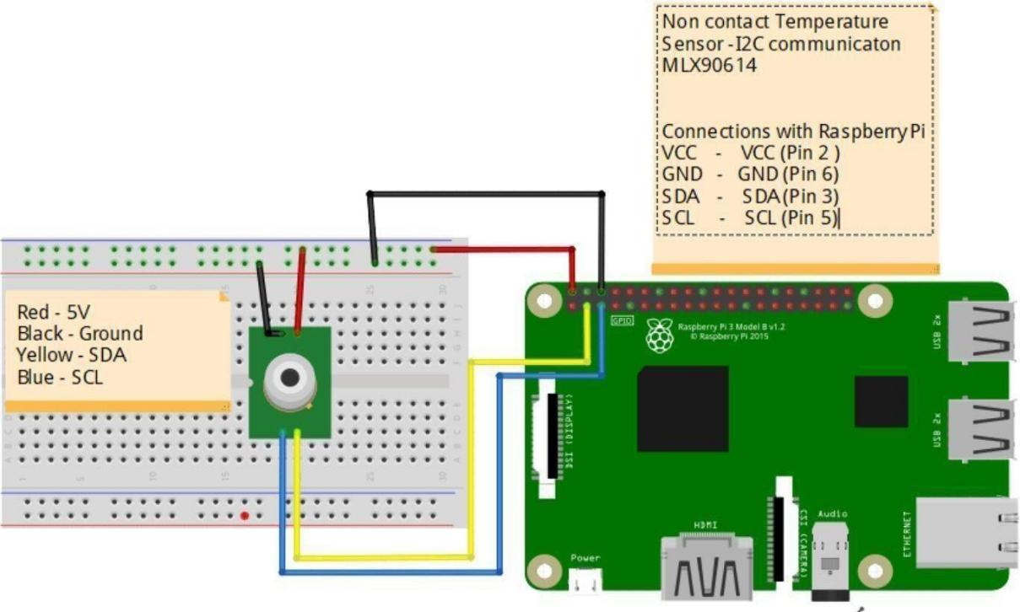

**Figure 5.3 Connect Sensor to Raspberry Pi 3**

If the connections and the installation is done properly, we can check if we get the sensor address value on the I2C bus using the command i2cdetect -y 1.

If everything works as expected, we can see the below output on our terminal. 0x5A represents the address of the sensor as mentioned by the datasheet. The datasheet snippet showing the same is given below.

Now, we will run make a new file name mlxread.py and write a sample program to check the data from the sensor.

Once the file is created, we will run it with python extension python mlxread.py.

The output I received is shown below. I ran the program multiple times to check if the values change as I move my hand over it.

we have successfully interfaced MLX90614 with our Raspberry Pi.

### Pi Camera Interfacing with Raspberry Pi

Step1: Enabling the Camera from Raspberry Pi setting.

Type sudo raspi-config and then go to interfacing options. Go to Camera and enable the camera.

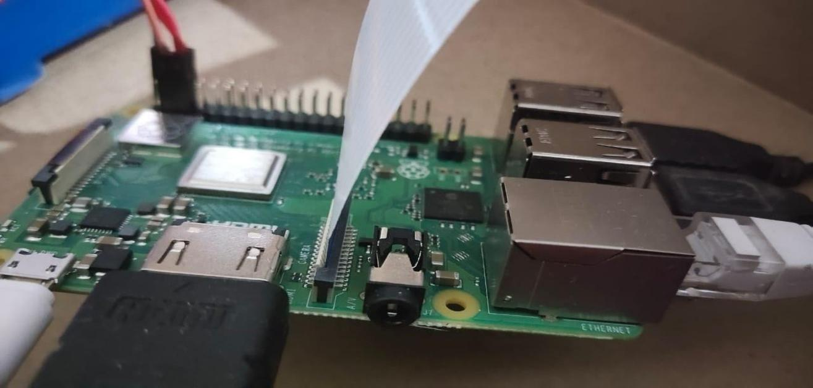

**Figure 5.4: connect the camera.**

Step2: To check if the camera is connected properly, we take a test image and save that in our Desktop (we are using Full GUI Raspbian OS version)

raspistill -o Desktop/image.jpg

This will enable your camera to click a picture with the name image and store that on your Desktop.

### Python Code for Pi to Read Temperature from MLX90614 and store Picture in file with date and time:

The python program does all the necessary operations to read the sensor data, compare it with the threshold value, authorize the data, and then store the imagewith the date and time when temperature is high. At first, we will require libraries.

Then, we create a function to capture the image which is sent data and stores the image with data and time. Then, we make some settings with PiCamera. And at last, we have a while (1) loop which will run infinitely. It will read the data from the MLX90614 temperature sensor and if the temperature exceeds the set value, then the capture\_image() function is called to store the image capture.

## 6 RESULTS

When the hardware and software are ready, just run the python code on your pi. It will print the value of temperature read from the sensor as shown below.

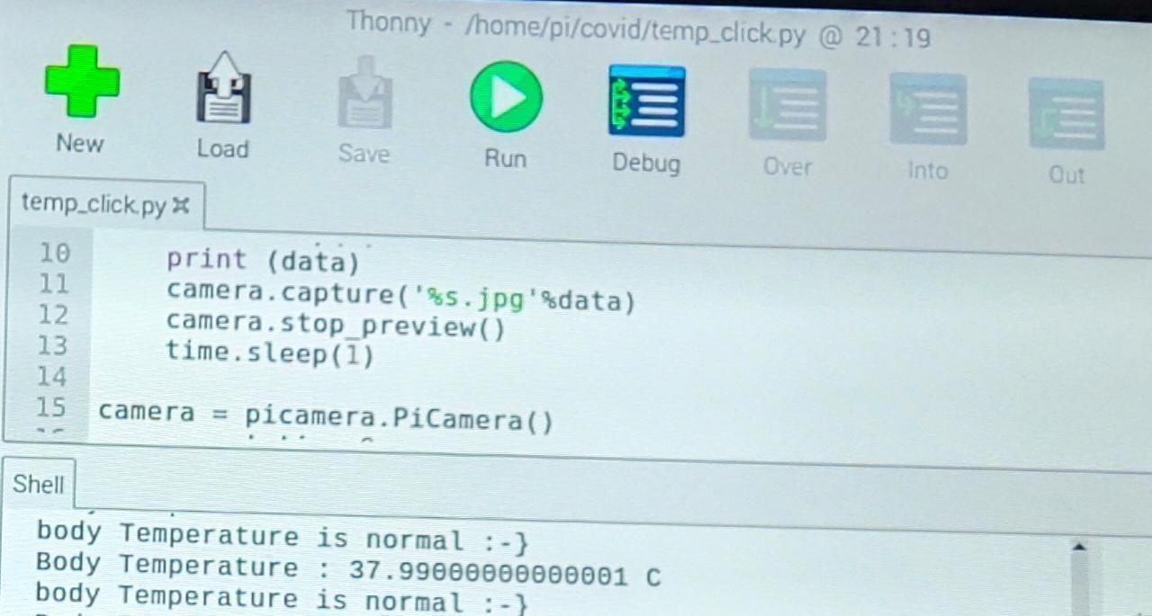

**Figure 6.1: Body temperature**

If the body temperature exceeds the threshold temperature, then our python program will take an image from the camera, save it on raspberry pi with date and time , display body temperature.

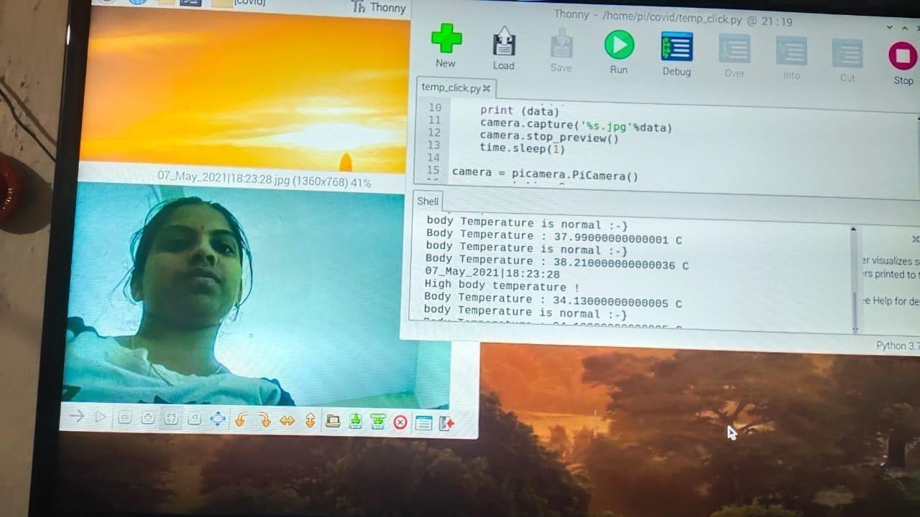

**Figure 6.2: Body Temperature Result with image**

****

**Figure 6.3: Body Temperature Result with hot mug image**

# 7 CONCLUSION AND FUTURE SCOPE

Fever Screening system can be used in real time applications which are meant for safety in this covid pandemic time. This can be integrated with the embedded systems for applications in airports, railway stations, school, public places to ensure our safety and to find people with abnormal temperature. The accuracy to which the screening works depends on the sensor methods used to screen the temperature.

Future scope is addition of automatic face mask to our proposed model. Developing face mask detection mobile application. Developing a model that recognizes social distance. Detecting temperature using thermal imaging techniques.

# BIBLIOGRAPHY

1. Gribok is with the Bioinformatics Cell, Telemedicine and Advanced Technology Research Center, U.S. Army Medical Research and Materiel Command, Frederick, MD 21702 and also with the Nuclear Engineering Department of the University of Tennessee, Knoxville.
2. McKenna is the Deputy Director of Bioinformatics Cell, Telemedicine and Advanced Technology Research Center, U.S. Army Medical Research and Materiel Command, Fort Detrick, MD 21702.
3. Gate - 2019,Thomas Mckenna, Andrei Gribok. Thermal Imaging Dataset for Person Detection, IEEE-2020,Marina Ivasic-Kos.
4. Reifman is a Senior Research Scientist and Director of the Biotechnology HPC Institute, U.S. Army Medical Research and Materiel Command, Fort Detrick, MD 21702.
5. AP. Welles et al. Estimation of core body temperature from skin temperature, heat flux, and heart rate using a kalman filter. Computers in Biology and Medicine, 99:1-6, 2018.
6. X. Xu, AJ. Karis, MJ. Buller, and WR. Santee. Relationship between core temperature, skin temperature, and heat flux during exercise in heat. Eur J Appl Physiol, 113:2381-2389, 2013.
7. AG. Howard et al. MobileNets: efficient convolutional neural networks for mobile vision applications. arXiv: 1704.04861, 2017.
8. J. F. Henriques, R. Caseiro, P. Martins, and J. Batista. High speed tracking with kernelized correlation filters. arXiv: 1404.7584, 2014.
9. NA. Livanos et al. Design and interdisciplinary simulations of a hand-held device for internal-body temperature Regularization of body core temperature prediction during physical activity,Research sensing using microwave radiometry. IEEE Sensors Journal, 18(6):2421-2433, 2018.
10. Kessler, "The Minamata Convention on Mercury: A First Step toward Protecting Future Generations." Environ. Health. Persp., vol. 121, no. 10, pp. A304-A309, 2013.
11. E. Chiappini, S. Sollai, R. Longhi, “Performance of non-contact infrared thermometer for detecting febrile children in hospital and ambulatory settings.” J. Clin. Nurs., vol. 20, no. 9-10, pp. 1311–1318, 2011
12. G. C. Teran, J. Torrez-Llanos, E. T. Teran-Miranda, “Clinical accuracy of a non-contact infrared skin thermometer in paediatric practice.” Child Care Hlth. Dev., vol. 38, no. 4, pp. 471- 476, 2012.
13. T. K. Mackey, J. T. Contreras, B. A. Liang, "The Minamata Convention on Mercury: attempting to address the global controversy of dental amalgam use and mercury waste disposal."

Sci. Total. Env., vol. 472, no. 472, pp. 125-129, 2014

1. T. Y. Zeng, X. Huang. "Development, challenges, and future trends of wearable sensors." Sci. & Technol. Rev., 2017
2. S. C. Mukhopadhyay, "Wearable sensors for human activity monitoring: A review", IEEE Sensors J., vol. 15, no. 3, pp. 1321-1330, Mar. 2015