**Configuration of Mobile App Service**

1. Go to folder : **mobile-svc**
2. Open **appsettings.json** file and change the following parameters based on key:

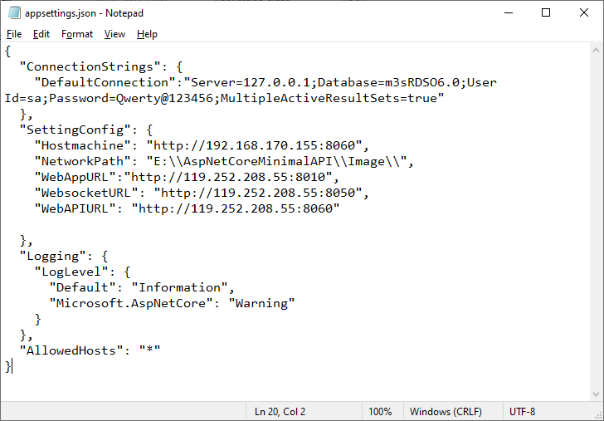

**DefaultConnection**: Enter your SQL Server details like: server, database, user id, password

**Hostmachine**: IP of machine where this service is running. Port number is fixed: **8060**

**NetworkPath**: This parameter is under-development. Leave it as it is.

**WebAppURL**: Web application url

**WebsocketURL:** Websocket url mentioned in mmc.ini file which loads wbscSrv.dll

**WebAPIURL:** URL of Web API. It means this mobile service. Usually, it will be the same as   
 Hostmachine, mentioned above. This will be different when we the service is

running on public/Internet machine.

1. How to run the application as Service

* Open CMD prompt as an Administrator. Go to the folder of mobile-svc
* Find file: **mobile-svc.bat**
* It will create a window service name: **mobile-svc** ( Go to point 4, in case of any errors)
* Initially this service is not running. You have to manually start the service.
* Open **service.msc** as an Administrator. Find service **mobile-svc** and start it.

1. If you are not able to create a service, please go inside the folder **mobile-svc** and run **VmsMobileApi.exe** in command prompt.

Check for the errors present.

**Configuration for streaming in Mobile application by HLS**

Streaming in mobile application is done by HLS. It creates a playlist file which contains location of small chunks of files created. All this is handled by wbscSrv.dll present in MMC server.

* + Open mmc.ini file where wbscSrv.dll is added. Go to this location.
  + [WBSC_SRV]  
    WBSC_PORT=8050  
    **HLS_PATH=E:\Railtel-Service-Configuration\M3s-WebApp\wwwroot\hls**
  + Add HLS_PATH value here. Path is the location of Web application folder.  
    Make sure Web application is running.   
    Go to the path from web application is running. Go inside ‘wwwroot’ folder.   
    Inside this create a folder ‘hls’.  
    Kindly copy the full path till ‘hls’ folder and paste it inside mmc.ini file HLS_PATH.
  + Note: Assumption is that Web application and mobile backend service is running in same machine.