Regulation of Water Resources using Fuzzy Logic

FUZZY LOGIC

**PROJECT**

S Maneesha PES1201700024

V Sathvika PES1201701460

**INTRODUCTION**

Regulation of a water resource system is one of the challenging tasks due to uncertainty involved in demand and supply. It may be due to changes in the climatic conditions, living standards of people, land-use patterns and even because of changes in technology. The problem becomes even more complicated if the objectives pertaining to demand and supply are multiple and conflicting in nature. We use “if–then” fuzzy logic-based rules which interlinks concepts of interpolative reasoning, logical implications and certain inference tools to infer knowledge about a water resource system using linguistic descriptions.

The notion of fuzzy set is the formation of conceptual framework for representation of a set of data at convenient point in many real-life applications. In general, a water resources system has a large set of data which require careful analysis for taking appropriate decisions pertaining to water allocation, quality and quantity management. These data should be reliable enough so that they can not only be used in optimal and justifiable manner but also should be communicated and processed effectively to all concerned stakeholders including end-users in a user-friendly manner.

Regulation policies of a water resources system has been formulated using concepts of fuzzy logic to incorporate uncertainty due to vagueness. The vagueness can be defined by deriving appropriate membership functions. The nature of uncertainty decides the fuzzy set to be used for representing the vagueness or uncertainty of the system. Multiple degrees of membership can prove to be key in decision-making process where infinite number of values between two extreme points exists.

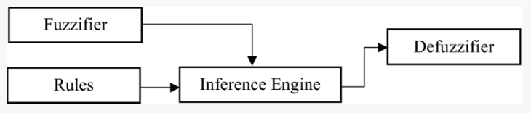

**FUZZY SETS**

**Universe of Discourse -> Inflow**

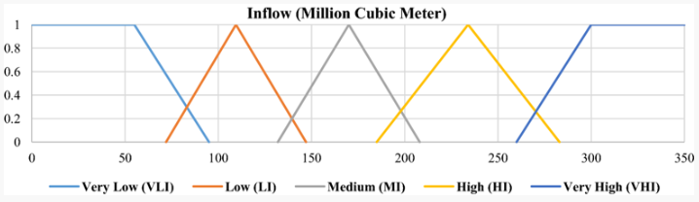

**()=** {}

**() =** {}

**() =** {}

**() =** {}

**() =** {}

**Universe of Discourse -> Storage**

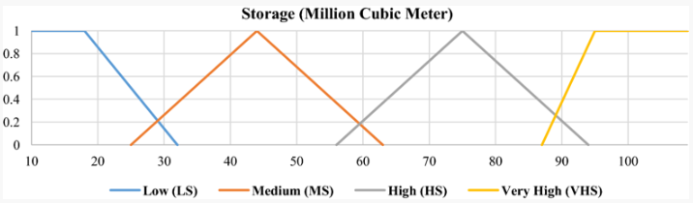

**() =** {}

**() =** {}

**() =** {}

**() =** {}

**Universe of Discourse -> Outflow**

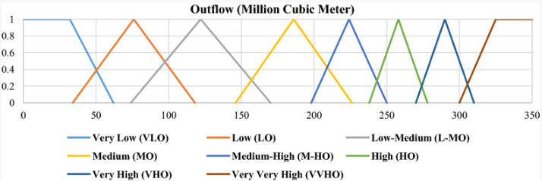

**() =** {}

**() =** {}

**() =** {}

**() =** {}

**() =** {}

**() =** {}

**() =** {}

**() =** {}

**Properties:**

**De-Morgan’s Laws:**

* **=**

**=** }

**=** }

**=** }

**=** }

**=** }

**=** }

**=** }

* **=**

**=** }

**=** }

**=** }

**=** }

**=** }

**=** }

**=** }

**Law of Contradiction:**

* **≠ O**

**=** }

**=** }

**=** } **≠ O**

**Law of Excluded Middle:**

* **≠ E**

**=** {}

**=** {}

**=** {} **≠ E**

**Alpha Cut:**

α = 0.5

* **= {**285,294,300,315,320,335,350}

**Operations:**

**Union:**

**=** {}

**=** {}

**=** {}

**Intersection:**

**=** {}

**=** {}

**=** {}

**Complement:**

**=** {}

**=** {}

**Difference:**

**=** {}

**=** {}

**=** {}

**- =**

**=** {}  **-**

**Set Difference:**

**- =** {}

**=** {}

**=** {}

**- =**

**=** {} =  **-**

* **= - -**

**=** {}

**FUZZY RELATIONS**

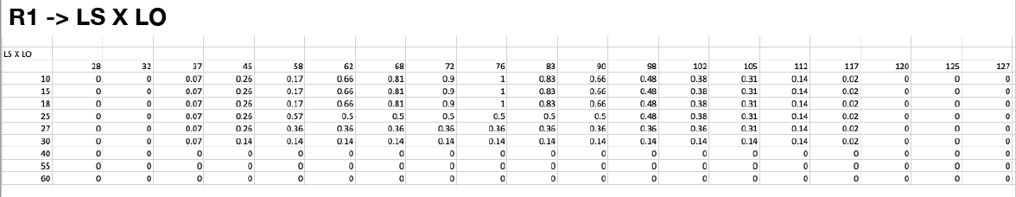

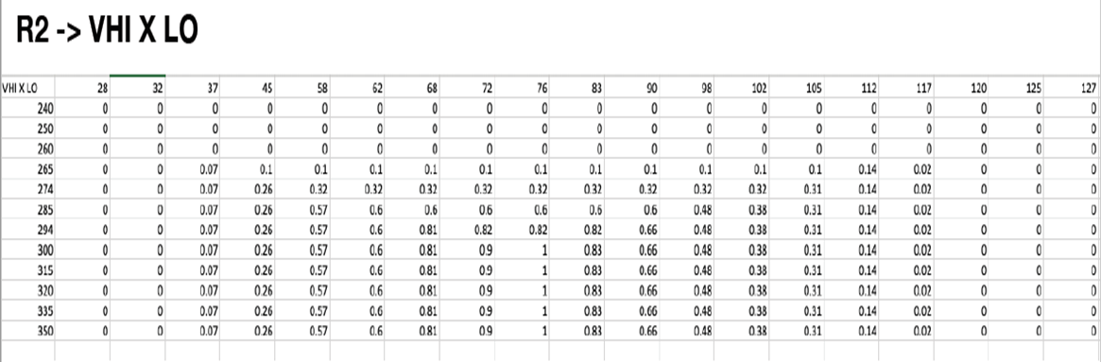

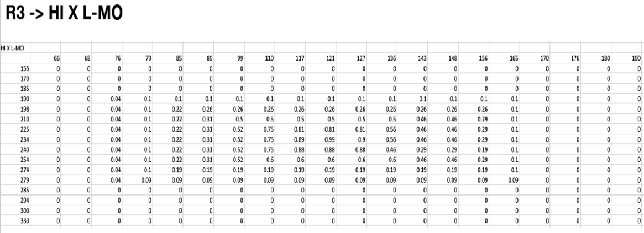

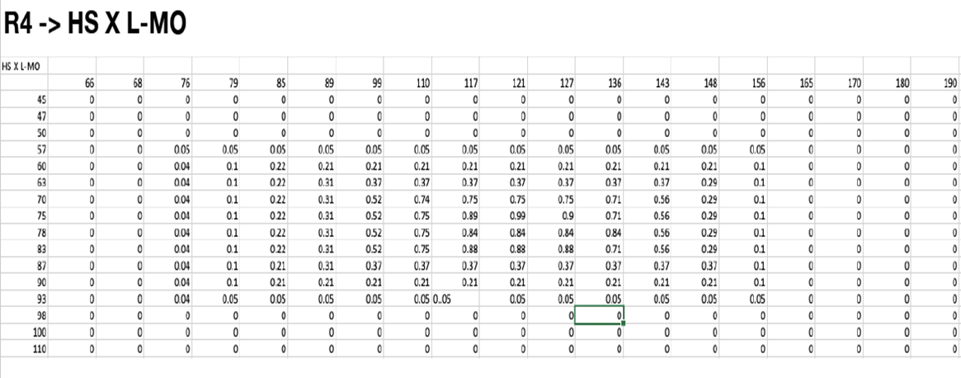

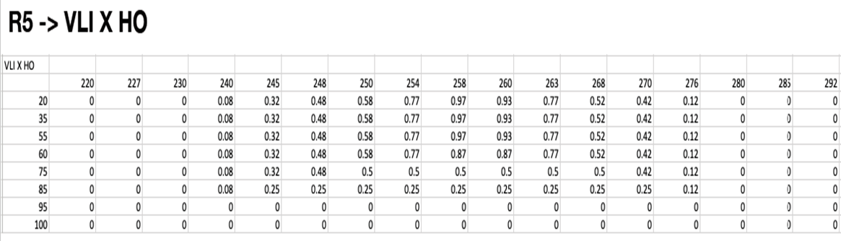

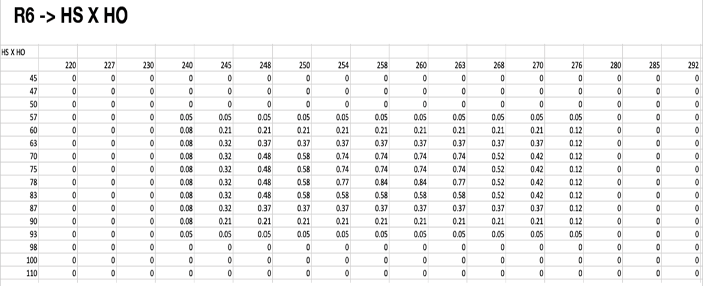

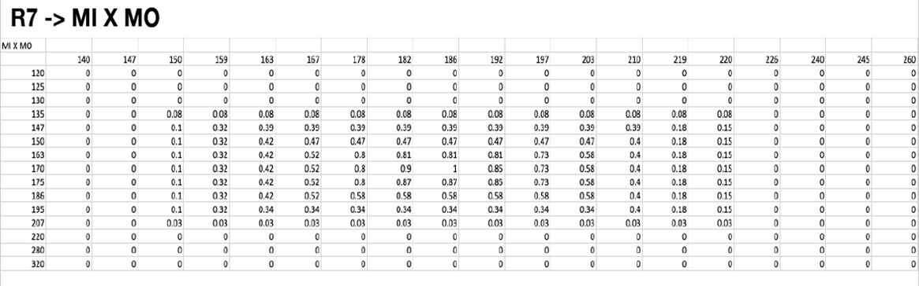

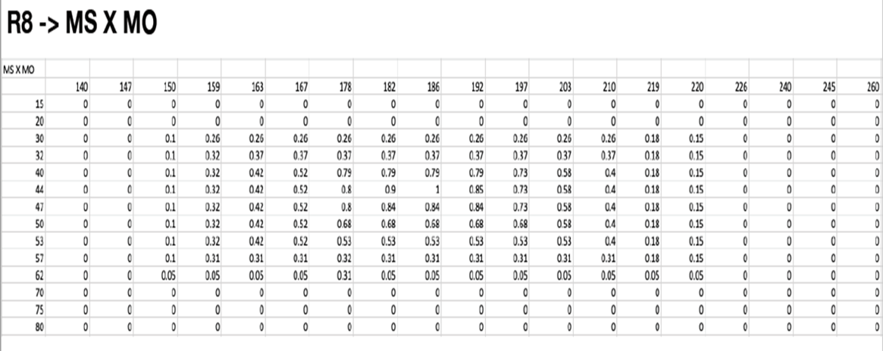

**PROPERTIES:**

R1,R2,R3,R4,R5,R6,R7,R8,R9,R10,R11 relations do not satisfy Reflexive, Symmetric, Transitive properties as they do not meet the following conditions:

* REFLEXIVE -> Relation is reflexive if (a,a) belongs to R for every a belongs to A. All diagonal elements are not 1.
* SYMMETRIC -> Relation is symmetric if (a,b) belongs to R and (b,a) also belongs to R. xRy => yRx for all (xi,yj).
* TRANSITIVE -> Relation is transitive if (a,b) belongs to R and (b,c) belongs to R, then (a,c) belongs to R.

The relation matrices (R1 TO R11) are not NULL RELATION MATRICES as all values in those matrices are not equal to 0.

* The relation matrices (R1 to R11) are not COMPLETE RELATION MATRICES as all values in those matrices are not equal to 1.
* R1 TO R11 relation matrices are not TOLERANCE RELATIONS as they do not satisfy Reflexive, Symmetric and not Transitive properties.
* R1 TO R11 relation matrices are not EQUIVALENCE RELATIONS as they do not satisfy Reflexive, Symmetric and Transitive properties.

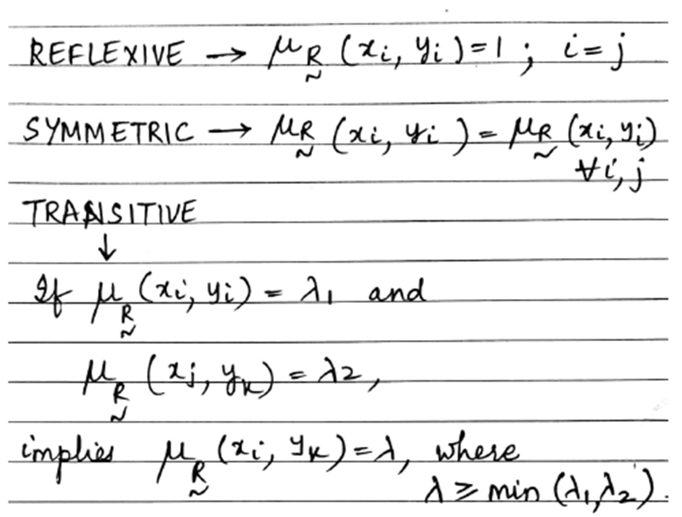

**OPERATIONS:**

* An intersection operator is used for minimization of flow and storage.
* VHI X LS -> LO // RULE
* (VHI X LO) ∩ (LS X LO) // RELATION-> R9



* HI X HS -> L-MO // RULE
* (HI X L-MO) ∩ (L-MO X HS) // RELATION -> R10



* MI X MS -> MO // RULE
* (MI X MO) ∩ (MO X MS)// RELATION-> R11



**MEMBERSHIP and MEMBERSHIP**

**FUNCTIONS**

**FEATURES OF MEMBERSHIP FUNCTION**:

Fuzzy set = { 1/10 + 1/15 + 1/18 + 0.5/25 + 0.36/27 +0.14/30 + 0/40 + 0/55 + 0/60}

1. Core = Core () = {10,15,18}

2. Support() = { 10,15,18,25,27,30}

3. Height = Hgt() = 1

4.Crossover = {25}

5. α – cut of membership function 0.14 = (0.14) = {10,15,18,25,27,30}

6. Boundaries = {0.5,0.36,0.14}

1. Normal fuzzy set = A fuzzy set is said to be normal if height value is 1.

Hgt() =1 . So, LS is a normal fuzzy set.

8.Convex fuzzy set : A fuzzy set is said to be convex if it is strictly decreasing or strictly increasing or strictly increasing and then decreasing.

LS is not a convex fuzzy set.

**SPECIAL PROPERTIES OF -CUT:**

1. = U

= {1/10 + 1/15 + 1/18 + 0.5/25 + 0.36/27 + 0.14/30 + 0/40 + 0/55 + 0/60}

= {0/80 + 0/83 + 0/87 + 0.37/90 + 0.87/94 + 1/97 + 1/100 + 1/108}

= {10,15,18,94,97,100,108}

= {10,15,18}

= {94,97,100,108}

U = {10,15,18,94,97,100,108}

=

= { }

= {10}

= { 94,97,100,108}

= { }

3. (A’) = A (LS) = {25,10,15,18} (LS’) = { 25,10,15,18}

4. For any<= , where 0<= alpha <= 1, it is true that A () is a subset of A ()

**FUZZY ARITHMETIC**

**OPERATIONS:**

**Addition:**

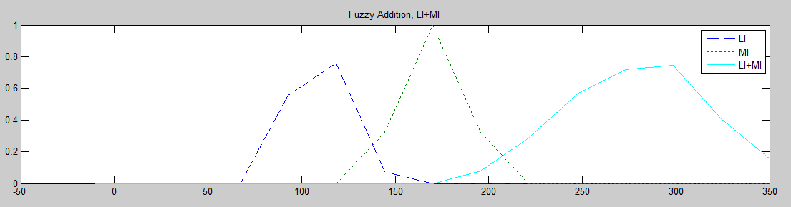

**Subtraction:**

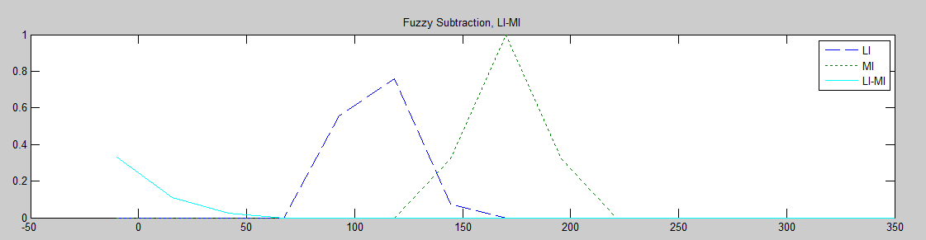

**Multiplication:**

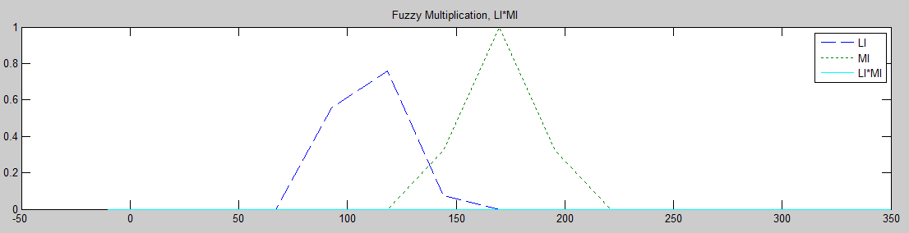

**Division:**

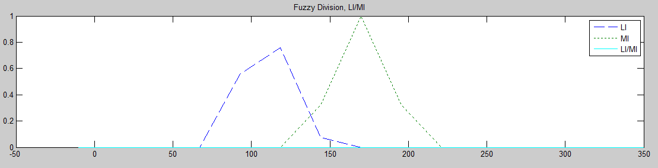

**LINGUISTIC**

**HEDGES**

**Linguistic hedges**: Hedges are adjectives or adverbs; it can also be regarded as a form of euphemism. Hedges signal a level of caution to speakers and writers in making an assertion.

**COMPOSITE TERM:**

**Very Low Storage OR Slightly High Storage**

**() =** {}

**:**

**() =** {}

VERY OR SLIGHTLY VERY OR SLIGHTLY :

Very = {}

Slightly = {}

VERY OR SLIGHTLY  = { }

**FUZZY SET INTERVALS**

* Intervals can be defined from a fuzzy set using λ-cut.
* For the Fuzzy set Medium Storage:

**() =** {}

* = [15 ,80] =A
* = [37 ,53] =B
* = [44] =C

**OPERATIONS:**

**Addition:**

A+B = [a1, a2] + [b1, b2]

= [a1+b1, a2+b2]

A+B = [15,80] + [37,43]

= [15+37,80+43]

= [52,123]

**Subtraction:**

A-B = [a1, a2] - [b1, b2]

= [a1-b2, a2-b1]

A-B = [15, 80] - [37, 43]

= [15-43, 80-37]

= [-28,42]

**Multiplication:**

A*B = [a1, a2] * [b1, b2]

= [min{(a1*b1),(a1*b2),(a2*b1),(a2*b2)}, max{(a1*b1),(a1*b2),(a2*b1),(a2*b2)}]

A*B = [15, 80] *[37, 43] = [min{(15*37),(15*43),(80*37),(80*43)}, max{(15*37),(15*43),(80*37),(80*43)}] = [555,3440]

**Division:**

A/B = [a1, a2] / [b1, b2]

= [min{(a1/b1),(a1/b2),(a2/b1),(a2/b2)}, max{(a1/b1),(a1/b2),(a2/b1),(a2/b2)}]

A/B = [15, 80] /[37, 43]

= [min{(15/37),(15/43),(80/37),(80/43)}, max{(15/37),(15/43),(80/37),(80/43)}]

=[0.3488,2.162]

**GRAPHICAL TECHNIQUES OF INFERENCE**

Rules defined are:



Inference obtained:

View 1:

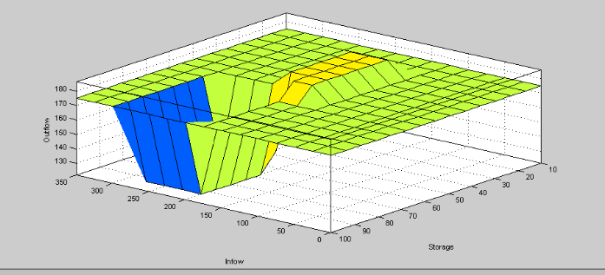

From this graph we infer that the Blue region indicates the least Outflow obtained, that’s when Inflow is high and Storage is high.

When the Inflow is medium and Storage is in any range preferably medium, the Outflow is medium indicated by Green. Inflow is lo

The maximum Outflow is obtained when Inflow is low and Storage is medium, indicated by Yellow.

View 2:

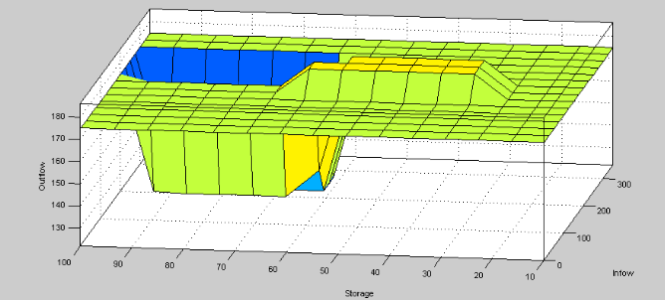

**MAMDANI METHOD:**

MAX-MIN METHOD:

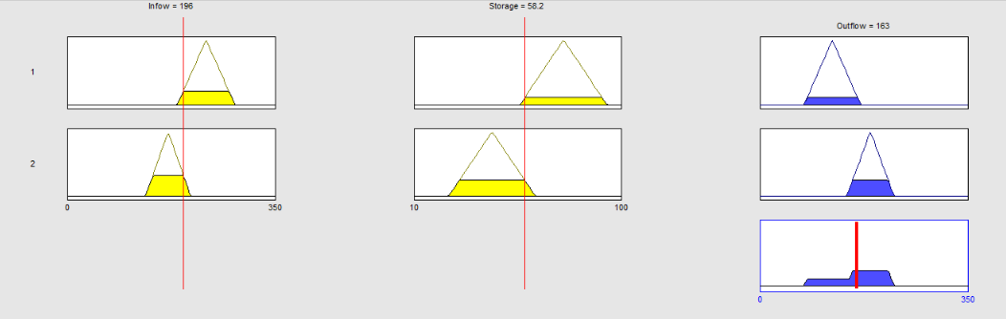

MAX-PRODUCT METHOD:

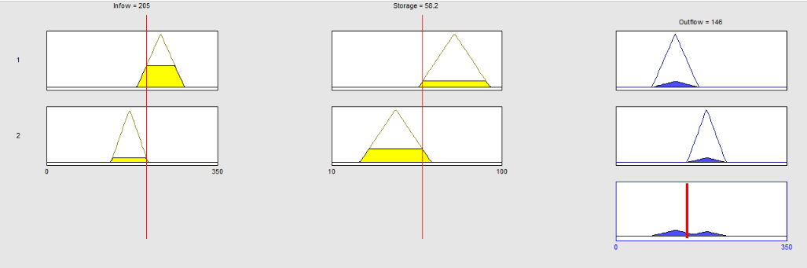

**THE END**