FarmVendor

A Role- Based Digital Platform for Farmer-Vendor Coordination
And Demand Forecasting and vendor optimization

Student Name : Maneesha Eeshwara
Student ID : 300392759
Course : CSIS 4495 Applied Research Project
Section : 03
GitHub Repository : https://github.com/maneeshaprs- rgb/W26_4495_S3_ManeeshaE.git

Contents
1. Introduction 4
1.1 Background and Domain Context 4
1.2 Problem Definition 5
1.3 Research Questions 5
1.4 Literature Overview and Research Gap 5
Literature Overview 5
Research Gap 6
1.5 Hypotheses and Expected Benefits 7
2. Summary Of Research Project 7
Architecture Diagram 9
Database Structure 9
3. Changes to the Proposal 10
4. Project Completion Timeline 12
Description of timeline 13
Milestones and Deliverables 15
Team Responsibilities 15
5. Implemented Feature 16
Feature 1: Demand Forecasting using ML.NET SSA 16
App 18
Frontend 20
Backend 26
Feature 2: Vendor Recommendation, Relationship Score, and Distance-Based Matching 41
Backend 49
Feature 3: Realtime chatmodule 57
Feature 3: Forecast Export Functionality 75
Feature 4: Role-Based Authentication (Registration & Login) 79
Feature 5: Farmer Inventory Management 91
Feature 6: Vendor Demand Request System 113
Feature 6: Dispatch Management Module 121
Feature 7: Dashboard Analytics and Status Badge System 131
Evaluation Technique 133
Forecasting model evaluation 133
Recommendation Logic Evaluation 134
Functional and Integration Testing 134
Usability Evaluation 135
Reflections/Discussions 136
Challenges Faced 136
Comparison between ML.NET SSA model and Moving Average model 136
Lessons Learned 136
Most Satisfying Parts 137
Future Improvements 137

Introduction

Background and Domain Context

Local and small-scale agricultural supply chains continue to struggle with challenges such as demand uncertainty, inventory mismatch, food waste, overproduction, under-supply, communication gap between producer and vendor. These challenges are basically visible in British Columbia as many farmers and buyers still depend on informal communication like phone calls, text messages or word of mouth to coordinate with their business partners. This lack of communication may result in delays, inefficient dispatch planning, and poor visibility of demand and supply status.
With increasing interest in digital transformation, there is a clear opportunity to develop a lightweight web-based platform that supports farmers and vendors through structured workflows, shared information, and decision-support features. Many currently available systems are either too enterprise-focused, too expensive, or not designed for the needs of small and medium-scale agricultural stakeholders. This project addresses that gap by designing and implementing FarmVendor, a role-based digital platform that supports farmer–vendor coordination, demand forecasting, vendor recommendation, and real-time messaging.

Problem Definition
This research addresses the lack of a structured, secure, and intelligent coordination platform for small agricultural stakeholders. The problem includes the following limitations:
- farmers do not have a clear way to view vendor demand in one place
- vendors do not have a structured method to submit requests and track deliveries
- dispatch planning is not supported by demand forecasting
- decision-making for farmers lacks data-driven vendor recommendations
- communication between farmers and vendors is often informal and fragmented

Research Questions
Following research questions are supposed to addressed by the project:
- How can a role-based digital platform improve coordination between farmers and vendors?
- How can simulated and user-generated data support early-stage demand forecasting?
- How can machine-learning-based forecasting improve dispatch planning?
- How can farmers be supported with vendor recommendations based on predicted demand and available inventory?
- Can a real-time chat feature improve coordination and usability within the supply chain workflow?

Literature Overview and Research Gap

Literature Overview
Research in agriculture supply chain management highlights the importance of demand forecasting, inventory visibility, and coordination between farmers and vendors. Prior studies show that even basic forecasting techniques prioritised with time and structured communication should reduce food waste, improve supply planning and increase efficiency in agricultural operations. Digital platforms are increasingly used to support these goals by enabling data sharing, record keeping and making decisions on data.
There are several farm management tools and other platforms that partially support those challenges. Here is background research and limitations on existing applications.
- AgriWebb: Farm management mobile application that focus on helping farmers manage production records, operational planning and inventory. offer limited direct coordination with vendors such as grocery stores and restaurants
- FarmLogs: largely farmer-centric mobile application with good internal visibility. limited vendor supportive.
- Cropln: web based Agri-intelligence and AI driven platform for enterprises across the agriculture value chain. Designed only for enterprise level Agri businesses
- AgriDigital: Provide cloud-based grain supply chain and management platform. Use blockchain technology to secure settlement while digitize grain storage, trading, logistics and financing. Less suitable for small and medium scale farmers where developed models need extensive historical data and long-term adoption.

A key limitation across both academic literature and existing mobile applications and platforms is the high dependability on large historic datasets. While many optimization and forecasting models assume the availability of long-term, real world transactional data newly deployed systems and small – scale agricultural networks face a cold-start problem, where little or no historical data exists.

Most of systems ignore human decision making while fully automated recommendations prioritized where agriculture grow with trust, long-term relationships and farmer experience is vital in decision making and planning.

Research Gap
Below gap remains based on existing research and platforms,
- Limited availability of lightweight, role-based platforms designed specifically for local farmers and vendors.
- Insufficient support for incremental data collection, where forecasting improves gradually over time.
- Lack of optimization models that combines distance, requested quantity and historical relationships.
- Minimal focus on human-in-the-loop decision support rather than full automation.
- Overdependence on real-world, large-scale datasets that are impractical for early-stage systems.

1.5 Hypotheses and Expected Benefits

The project is based on the following assumptions:
- structured demand communication reduces uncertainty for farmers
- forecasting can improve dispatch planning
- recommendation logic can support better vendor selection
- real-time communication can reduce coordination friction
- simulated and user-generated data can support meaningful early-stage research and evaluation
Expected benefits include:
- better visibility of demand and supply
- improved dispatch planning
- reduced communication barriers
- better farmer decision support

Summary Of Research Project

The FarmVendor project is a full-stack, role-based web application designed to enhance coordination between farmers and vendors by integrating demand management, forecasting, and intelligent decision support into a unified platform. The system enables farmers to manage inventory, monitor product availability, and make dispatch decisions, while vendors can submit demand requests specifying required quantities and delivery timelines.
A central feature of the project is the integration of machine learning–based demand forecasting using the ML.NET Singular Spectrum Analysis (SSA) algorithm. This forecasting component analyzes historical demand request data to generate future demand predictions for specific vendor–product combinations. These predictions support proactive planning by helping farmers anticipate demand, reduce produce waste, and optimize inventory and dispatch strategies.
Building on the forecasting capability, the system incorporates an intelligent vendor recommendation module that identifies the most suitable vendors for dispatching. This module evaluates multiple factors, including forecasted demand, available farmer inventory, geographical distance between farmers and vendors, and historical relationship scores derived from past interactions. A weighted scoring mechanism is applied to rank vendors, allowing farmers to make informed, data-driven decisions when selecting vendors for fulfillment.
To enhance collaboration and operational efficiency, the platform also includes a real-time communication module implemented using SignalR, enabling direct and instant messaging between farmers and vendors. This feature supports timely coordination, negotiation, and clarification during the dispatch process.
The application is developed using a modern and scalable technology stack, with React (Vite) for the frontend, ASP.NET Core (.NET 8) for backend services, and SQL Server for data persistence. The system follows a layered architectural approach, clearly separating the presentation layer, business logic, and data access components to improve modularity, maintainability, and scalability.
Overall, the FarmVendor project transforms a traditional transactional system into an intelligent, data-driven agricultural supply chain platform by integrating forecasting, recommendation algorithms, and real-time communication. The project demonstrates how emerging technologies can be applied to improve efficiency, reduce uncertainty, and support informed decision-making in agricultural supply chain management.
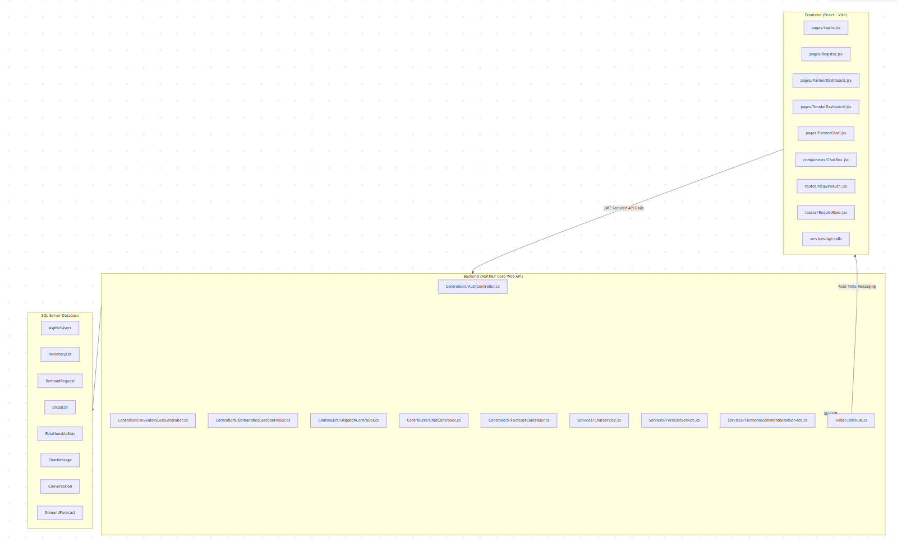

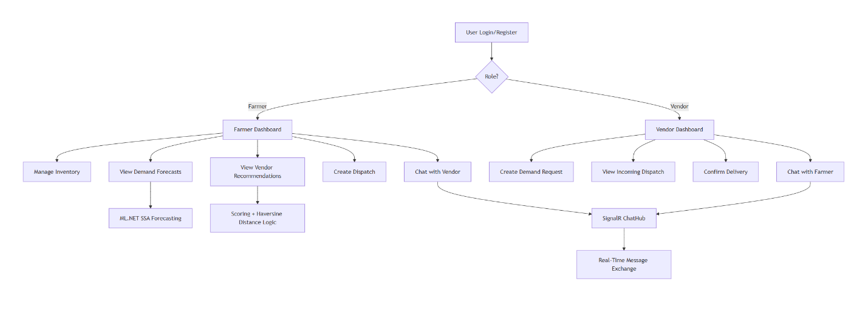
Architecture Diagram

Database Structure
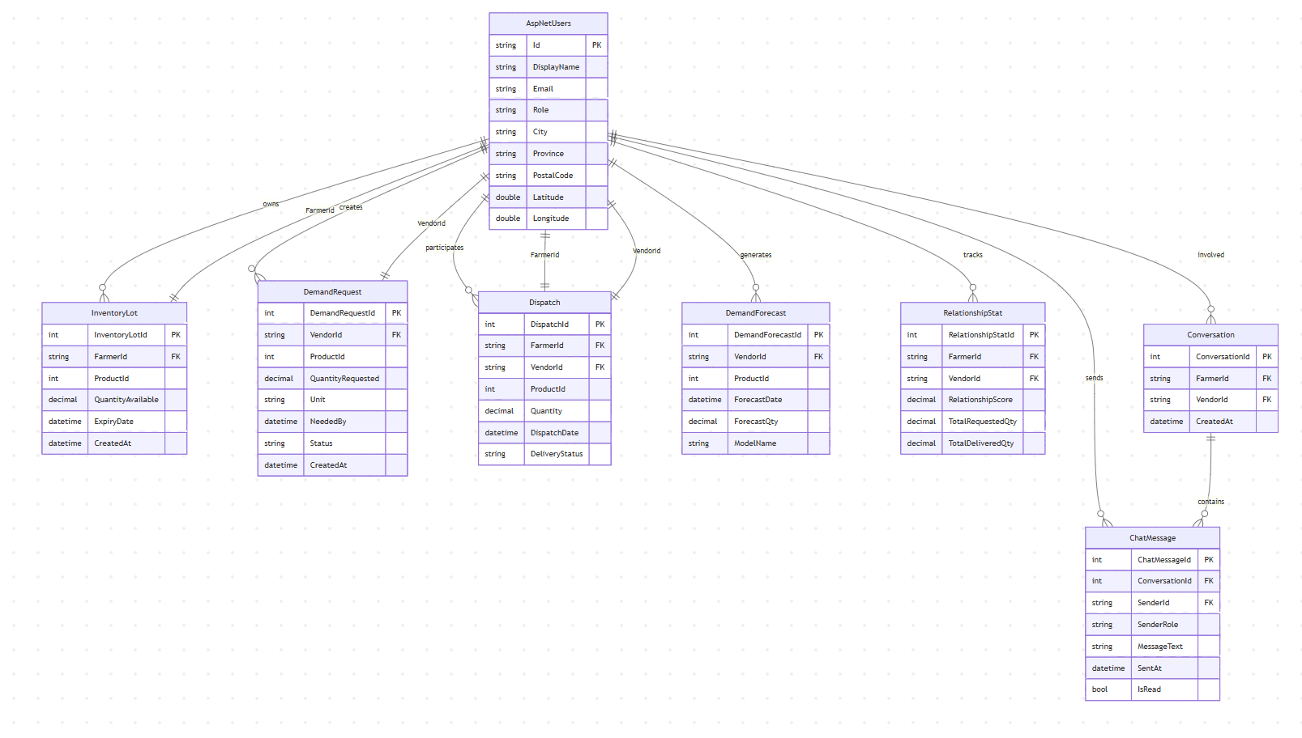

Changes to the Proposal

During the implementation phase of the FarmVendor project, several modifications were introduced to enhance system functionality, usability, and alignment with real-world agricultural requirements. These changes were informed by iterative testing, technical feasibility analysis, and the need to support intelligent decision-making for non-technical users. Overall, the refinements strengthened the original proposal by improving scalability, interpretability, and practical applicability.

Change Area | Description | Justification
Forecast Model | The initially proposed simple logic-based demand estimation and Moving Average algorithm was replaced with a machine learning-based forecasting model using ML.NET Singular Spectrum Analysis (SSA). | The SSA model provides more accurate, data-driven, and scalable demand forecasts by analyzing historical time-series data, enabling better production planning and dispatch decisions.
Forecasting Integration (New Addition) | ML-based demand forecasting was fully embedded into the operational workflow and used as a core input for vendor recommendations. | Integrating forecasting directly into decision support improved system intelligence and ensured that recommendations were driven by future demand rather than static historical data.
Dashboard Architecture | The dashboard was upgraded from a static UI design to a fully dynamic, API-driven architecture supporting real-time data updates. | This change improved system responsiveness and enabled real-time visibility of inventory, requests, forecasts, and recommendations, enhancing user decision-making.
Authentication and Security | Role-based authentication was implemented using ASP.NET Identity with JWT-based authorization. | Secure role separation was required to protect sensitive data and enforce access control between farmer and vendor functionalities.
Recommendation Logic | The original optimization-based approach was simplified into a weighted scoring-based recommendation system. | The scoring approach improved interpretability and usability, making recommendation logic easier for non-technical agricultural users to understand and trust by prioritizing demand match, distance and relationship score which calculated score by weighted formula
Relationship Tracking Enhancement | A new relationship-tracking entity was introduced to record historical farmer–vendor interactions and compute a relationship score. | Including relationship history improved recommendation accuracy by accounting for prior collaboration performance and trust which mainly focused on Total Requested Quantity, Total Delivered Quantity, Relationship Score and finally calculating relationship Stats using EF Core aggregation queries
Location Feature | Latitude and longitude fields were added to user profiles to support geospatial calculations. | Geolocation data is required to compute distances between farmers and vendors, which is essential for distance-based ranking and logistics optimization. Here I used Haversine formula with fields Longitude and Latitude
Data Generation Strategy | The initial simulated dataset approach was enhanced to include multi-period historical demand, inventory, and dispatch data. | More realistic historical data was necessary to support reliable machine learning forecasting and to reflect real-world agricultural scenarios. Here I used SQL scripts to generate multi-week historical data. Data seeded into DemandRequest, InventoryLot, Dispatch tables
User Experience Improvements | Searchable dropdowns, improved navigation through a shared sidebar layout, hover-based details, and enhanced input validation were introduced. | These changes significantly improved usability, reduced user errors, and enhanced overall interaction efficiency for both farmer and vendor roles.
Chat Module | A real-time communication module was added using SignalR. | Real-time messaging was required to support timely coordination, negotiations, and clarification during dispatch and fulfillment processes. Here Implementation use SignalR Hub with WebSocket transport. Client uses @microsoft/signalr to establish connection
Image Integration | Product images were integrated using the Unsplash API to dynamically display images in dropdowns and dashboards. | This enhancement improves visual clarity, user engagement, and usability. It eliminates the need for manual image uploads while providing high-quality, scalable visual content. Integrated via Unsplash REST API

Project Completion Timeline

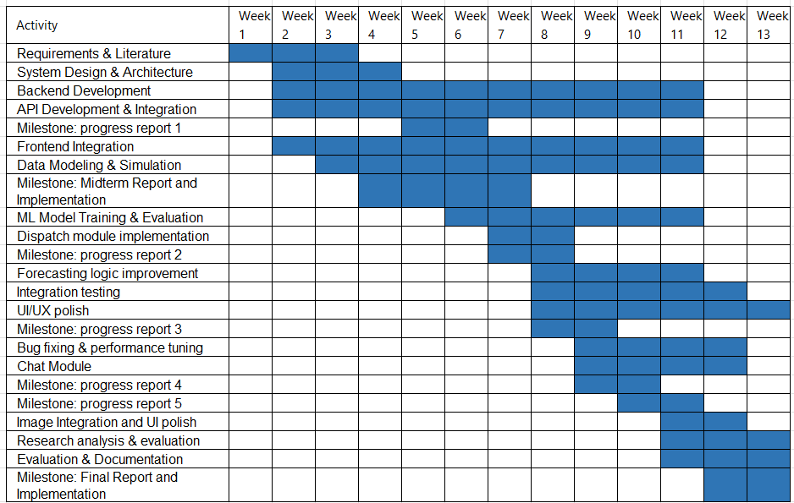

Description of timeline
The project was executed over a 13-week period, following a structured and incremental development approach that combined research, system design, implementation, testing, and evaluation.
The development process began with requirements gathering and literature review (Weeks 1–2), where the problem domain, research objectives, and system requirements were defined. This was followed by system design and architecture planning (Weeks 2–3), where the overall system structure, database schema, and API design were finalized.
The backend development and API integration phase (Weeks 2–10) formed the core of the system implementation. During this phase, key modules such as authentication, demand request management, inventory tracking, dispatch handling, and forecasting services were developed using ASP.NET Core and Entity Framework.
Parallel to backend work, frontend integration (Weeks 2–10) was carried out using React, enabling dynamic interaction with backend APIs and real-time data visualization.
The data modeling and simulation phase (Weeks 3–9) focused on generating realistic historical datasets for demand, inventory, and dispatch operations. This was essential to support machine learning forecasting.
The machine learning phase (Weeks 6–10) involved implementing and evaluating forecasting models. Initially, a Moving Average approach was used, which was later enhanced by integrating the ML.NET SSA model to improve prediction accuracy.
Several key milestones were achieved during the project:
- Progress Report 1 (Week 4) – Initial design and backend setup
- Midterm Report & Implementation (Week 5–7) – Core system functionality completed
- Progress Report 2 (Week 7–8) – Forecasting and dispatch modules
- Progress Report 3 (Week 9) – UI/UX and integration progress
- Progress Report 4 (Week 10) – Chat module and performance improvements
- Progress Report 5 (Week 11) – Final system enhancements
Advanced features such as the chat module using SignalR (Weeks 9–11) and image integration using the Unsplash API (Weeks 11–12) were implemented in later stages to enhance usability and system interaction.
The final stages of the project included:
- Integration testing (Weeks 9–12)
- UI/UX improvements (Weeks 9–13)
- Bug fixing and performance tuning (Weeks 9–12)
- Research analysis and evaluation (Weeks 11–13)
- Final documentation and report preparation (Weeks 12–13)

Milestone | Deliverable
Progress Report 1 | Requirements, system design, initial backend setup
Midterm Report | Functional backend + partial frontend
Progress Report 2 | Dispatch + forecasting modules
Progress Report 3 | UI improvements + integration
Progress Report 4 | Chat module + performance optimization
Progress Report 5 | Final system features completed
Final Report | Full system + evaluation + documentation

Milestones and Deliverables

Team Responsibilities
This project was completed individually by Maneesha Eeshwara, who was responsible for all aspects of the system, including:
- Backend development using ASP.NET Core
- Database design and Entity Framework integration
- Machine learning model implementation (ML.NET SSA)
- Frontend development using React
- API integration and authentication (JWT)
- Real-time chat implementation using SignalR
- UI/UX design improvements
- Testing, debugging, and performance optimization
- Final report preparation and documentation

Implemented Feature

Feature 1: Demand Forecasting using ML.NET SSA

This is one of the most significant features of the final system. It predicts future vendor demand using historical demand data and supports proactive dispatch planning.
This feature includes:
Forecast generation using Moving Average
Forecast generation using ML.NET SSA
Forecast results table
Forecast line charts
Multi-vendor comparison chart
Filtered vendor/product selection

The design consists of:
- Auto-loaded chart view
- Product and vendor filters
- Forecast generation controls
- CSV export
- Top vendor comparison visualization

Implementation
Frontend
- FarmerForecast.jsx
- ForecastLineChart.jsx
- MultiVendorForecastLineChart.jsx
- forecastApi.js
Backend
- DemandForecastController.cs
- DemandForecastService.cs
- MLDemandForecastingEngine.cs
- filtered vendor/product API endpoints for the logged-in farmer
Database
- DemandForecast table storing:
  - VendorId
  - ProductId
  - ForecastDate
  - ForecastQty
  - ModelName
  - LookbackPeriods
  - CreatedAt
Technical Methods
- Moving Average based on recent demand history
- ML.NET SSA time-series forecasting
- historical demand grouped by VendorId + ProductId
- chart comparison using shared time axis

App

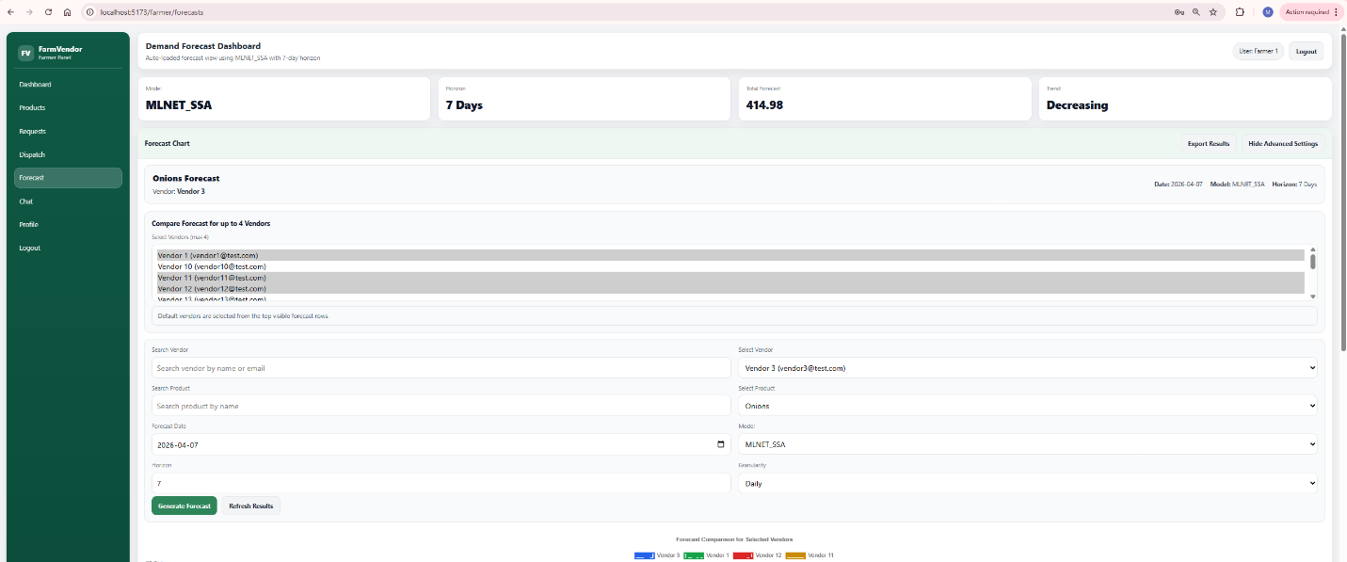

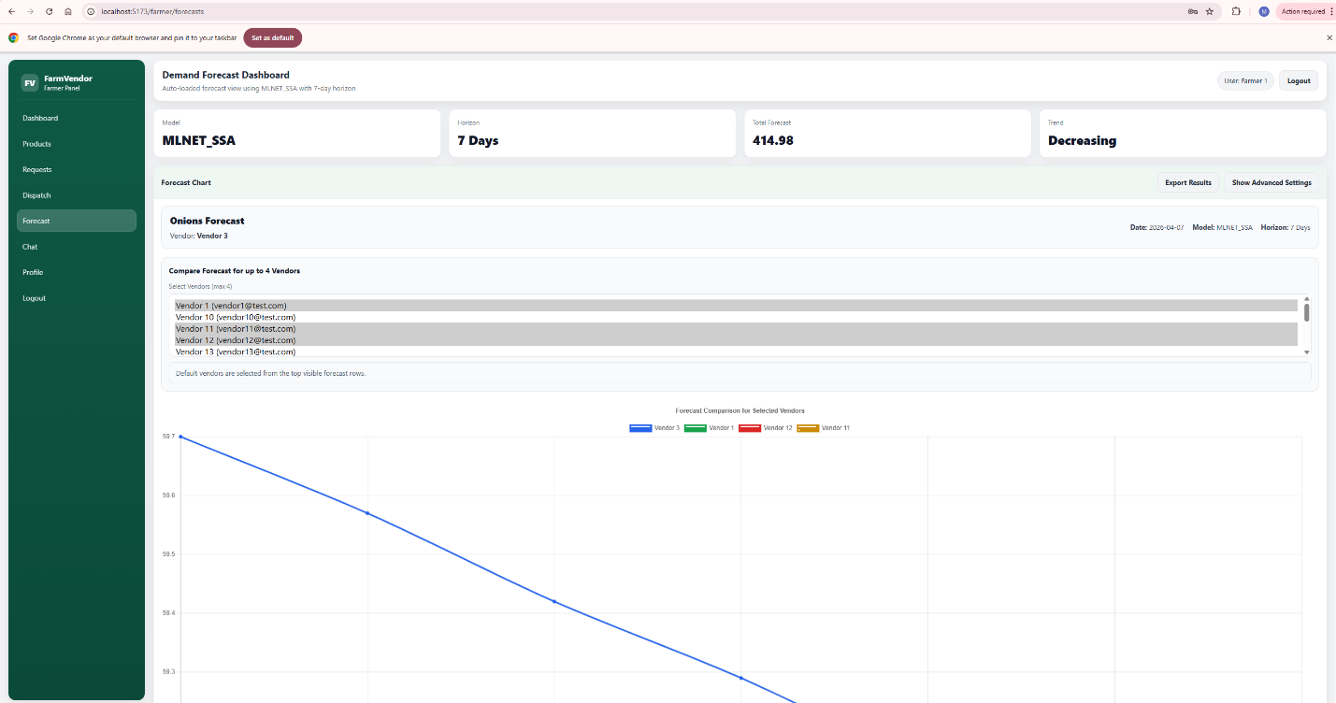

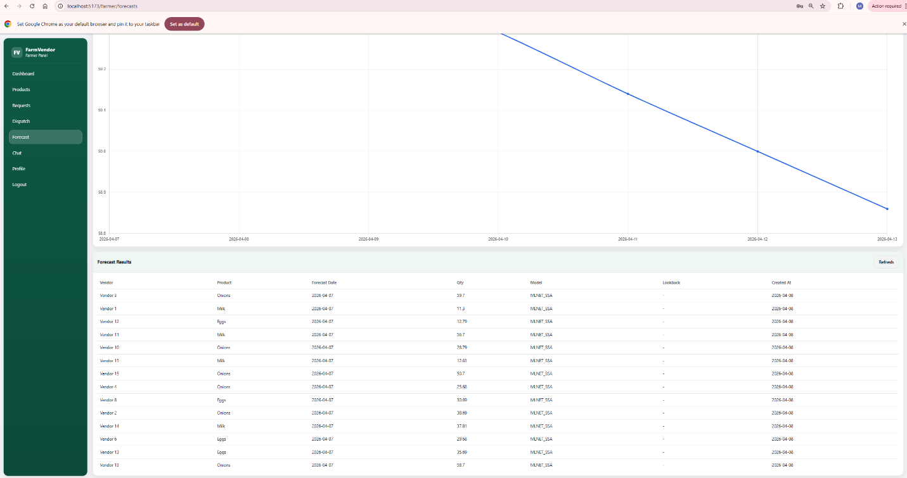

Frontend

FarmerForecast.jsx
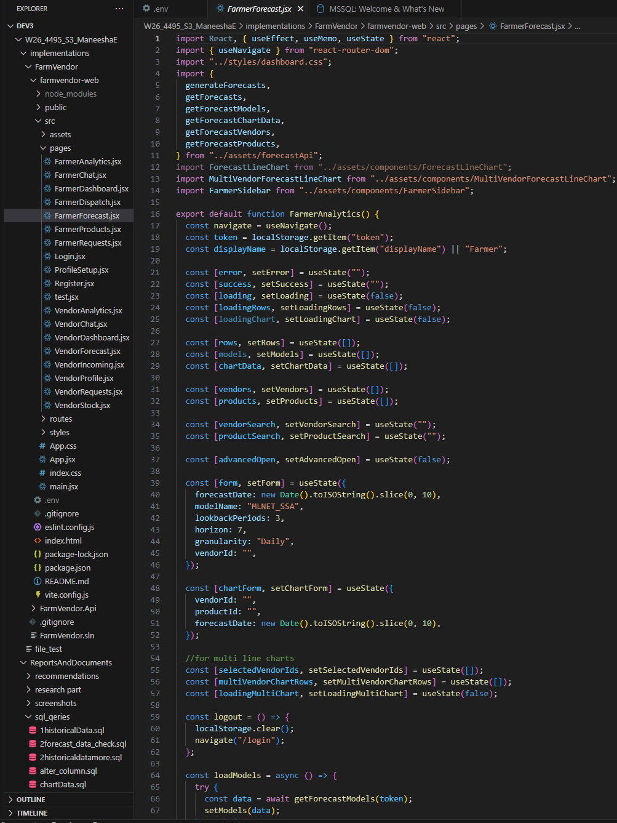

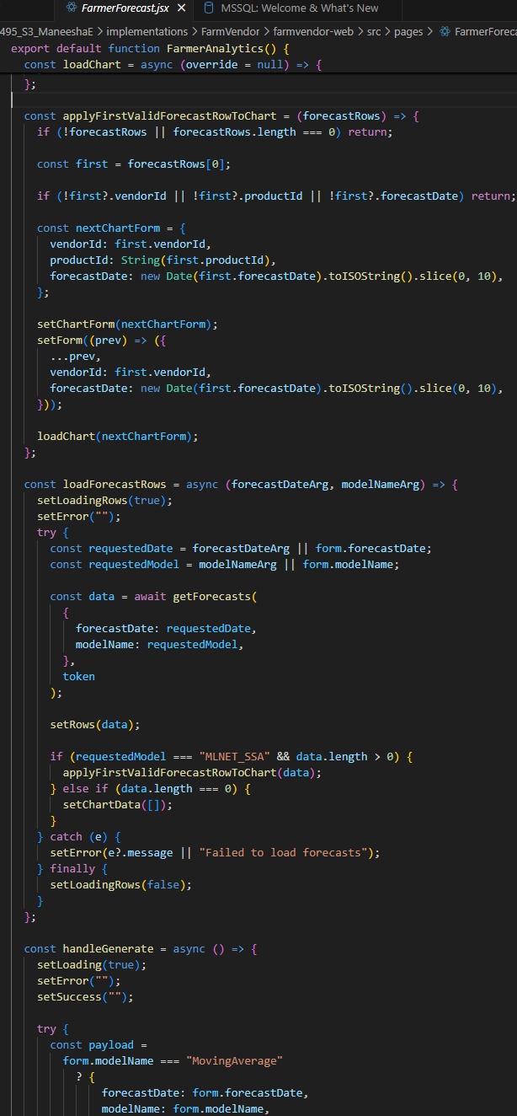
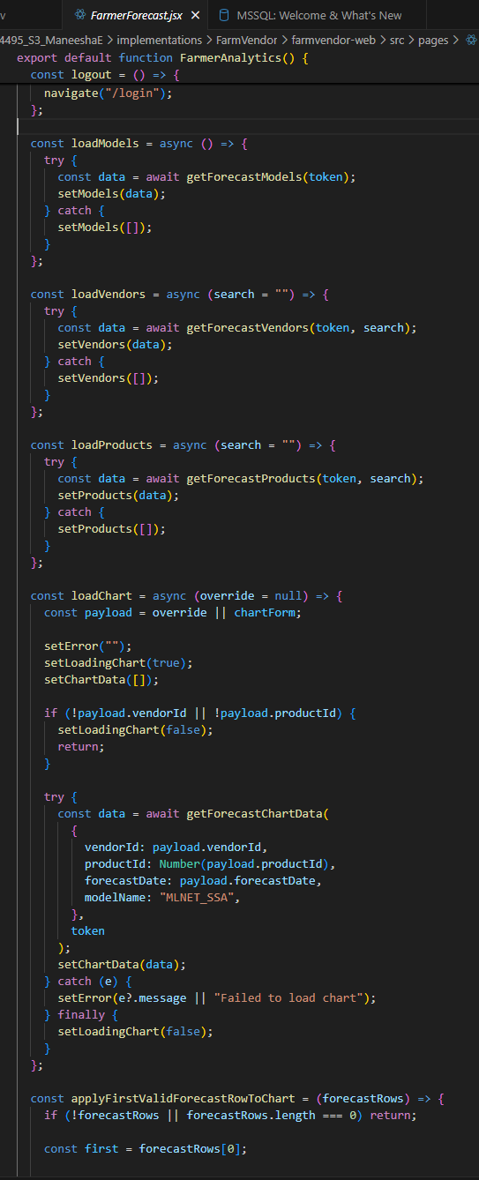

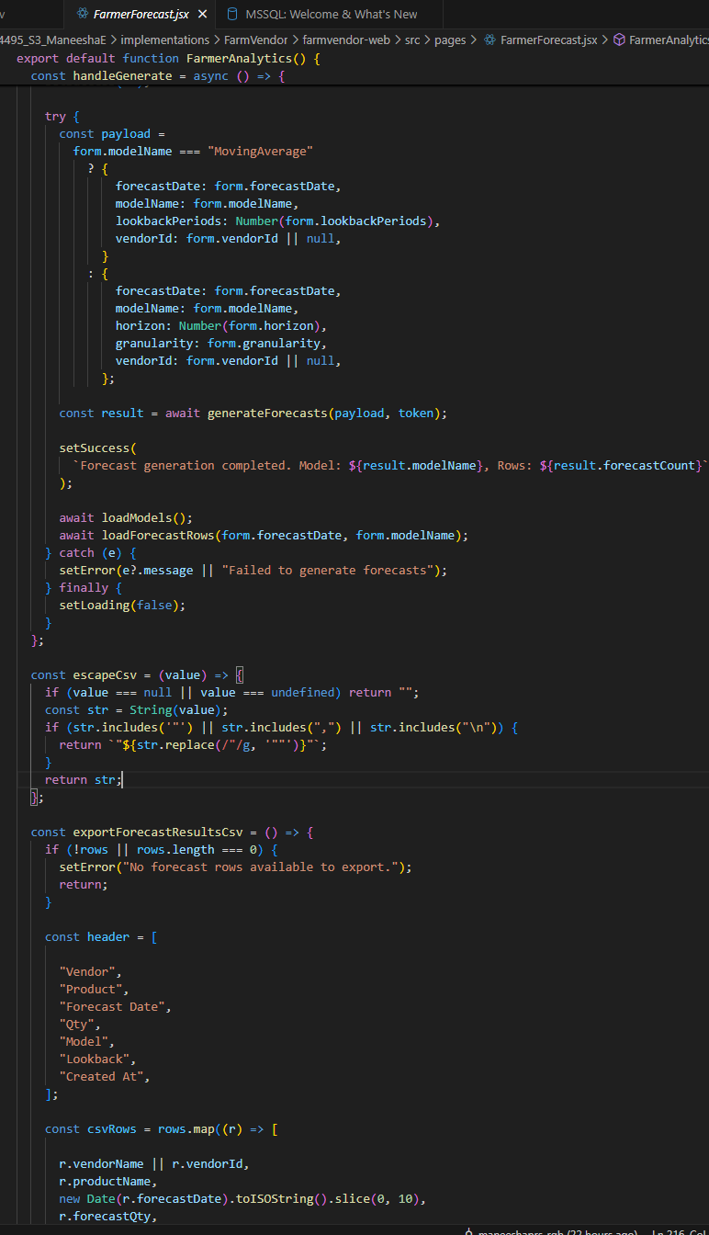

ForecastLineChart.jsx

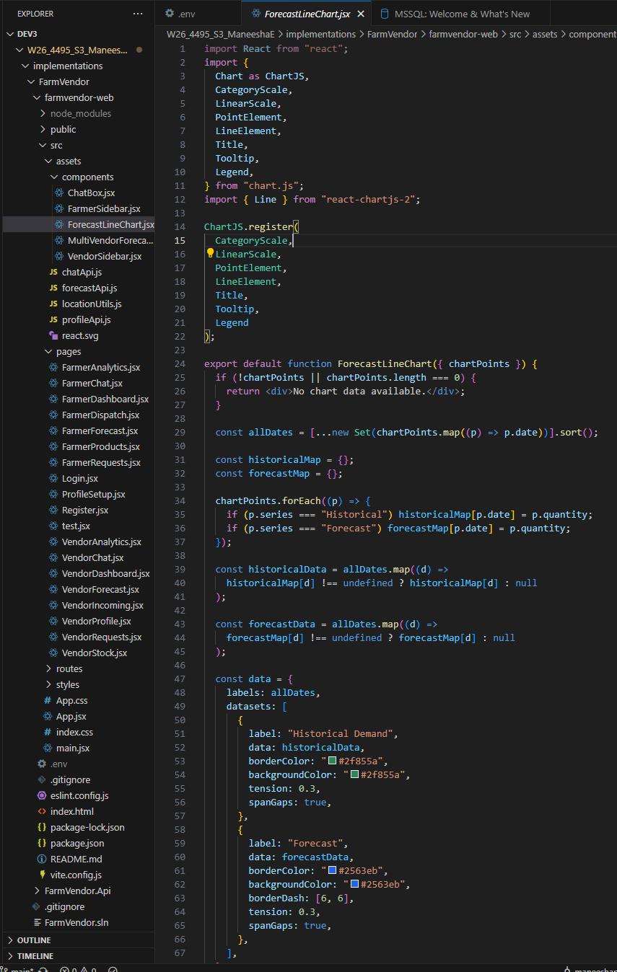

MultiVendorForecastLineChart.jsx
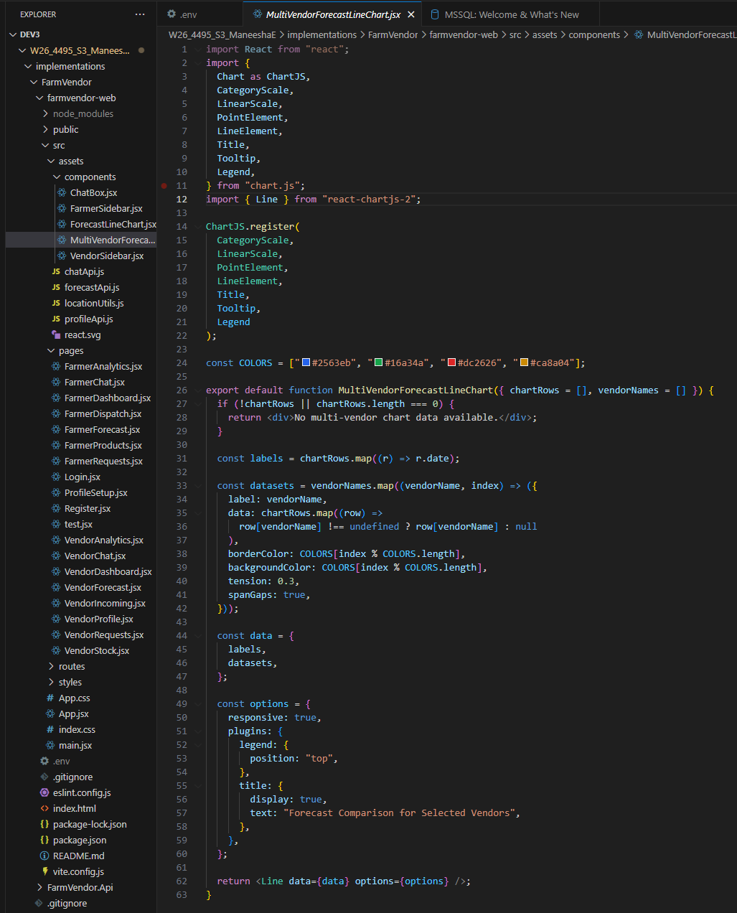

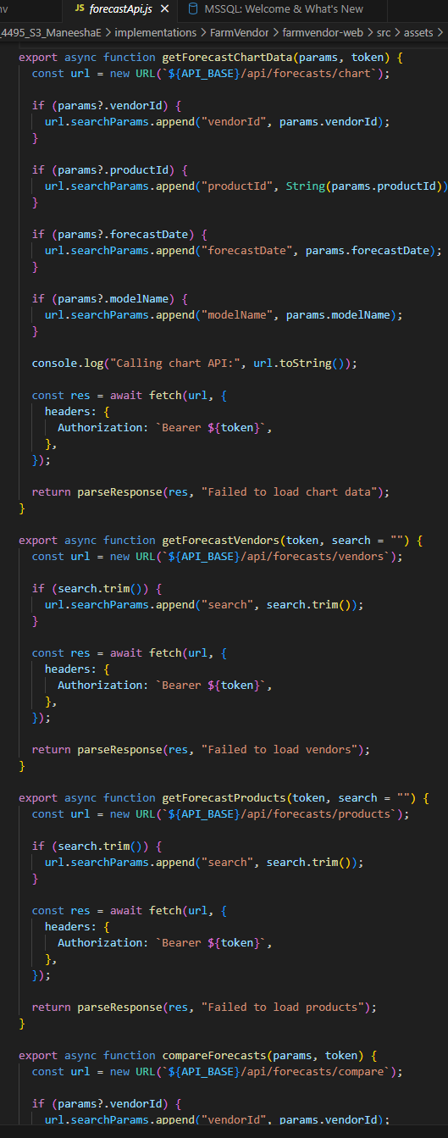
ForecastApi.js

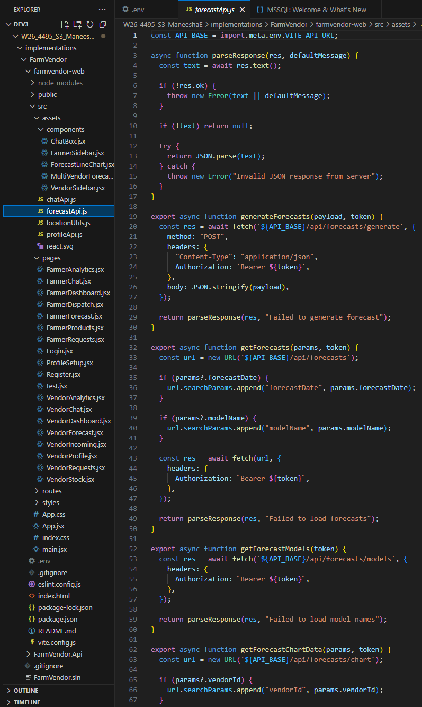

Backend

DemandForecastController

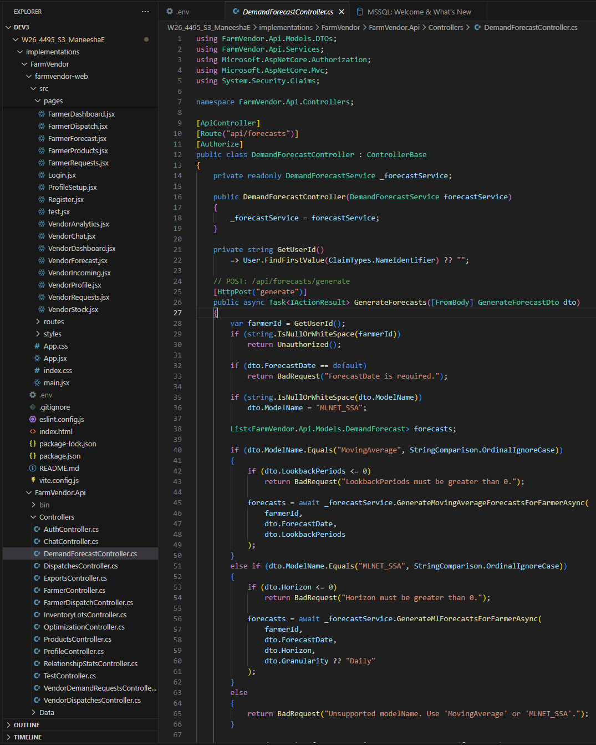

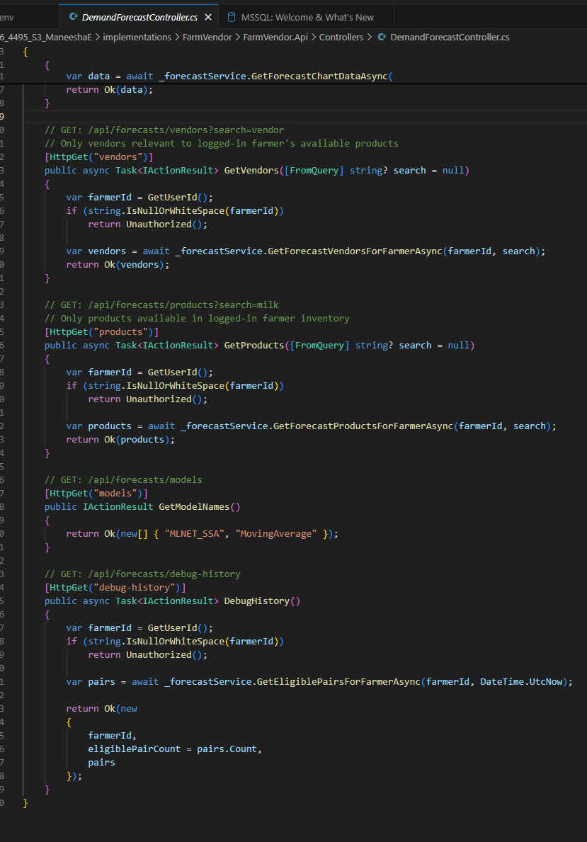
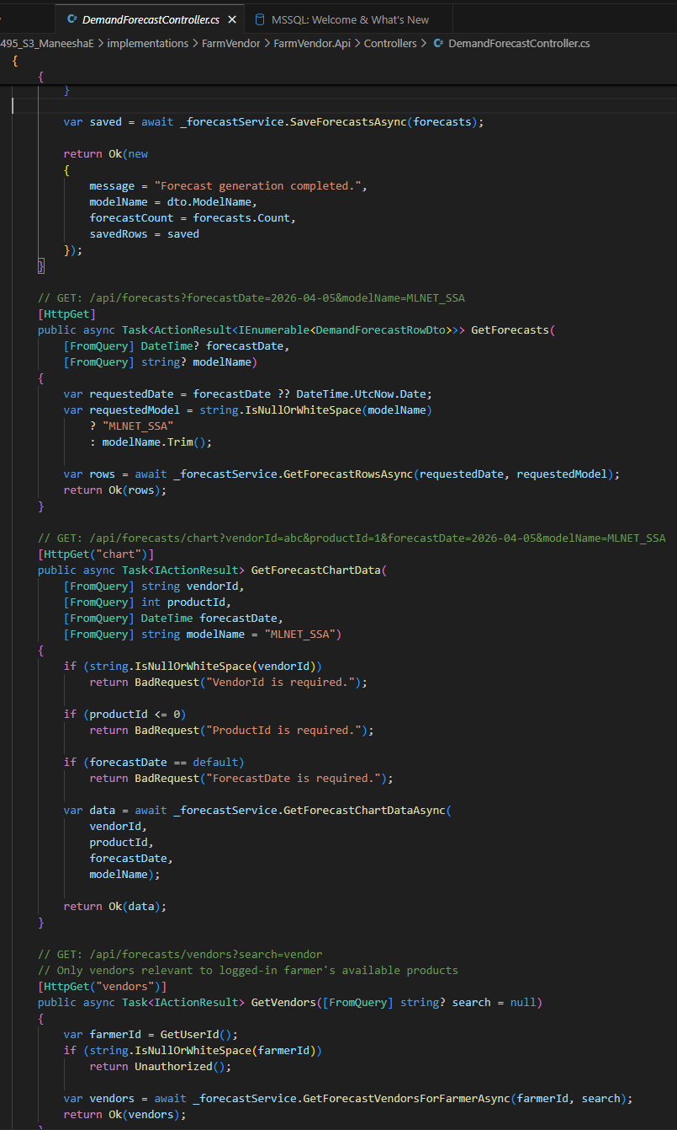

DemandForecastService.cs

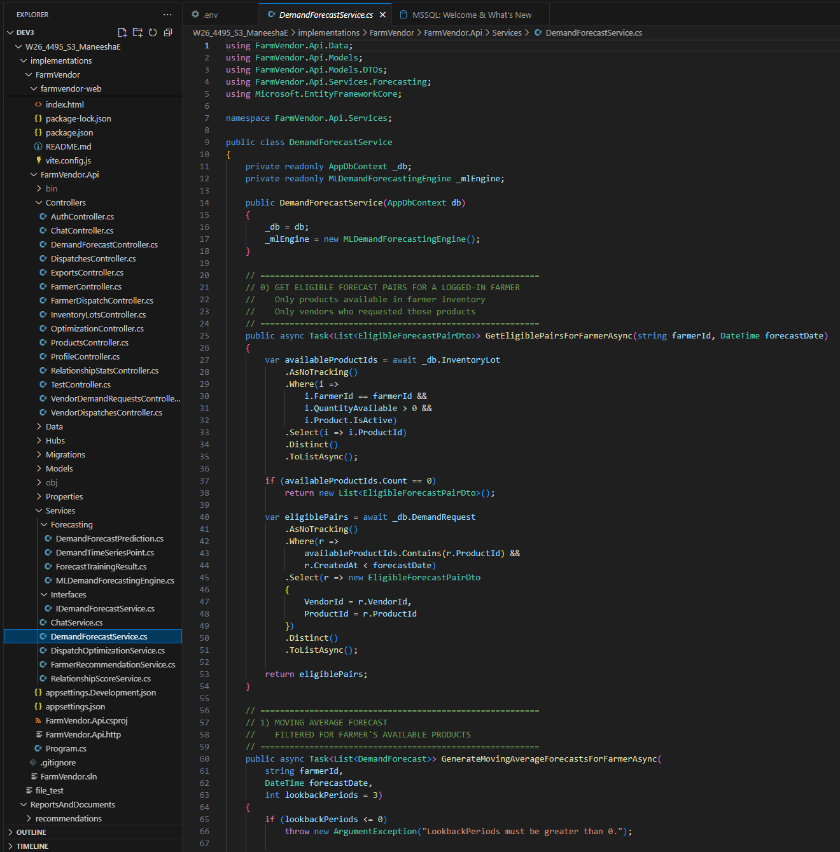

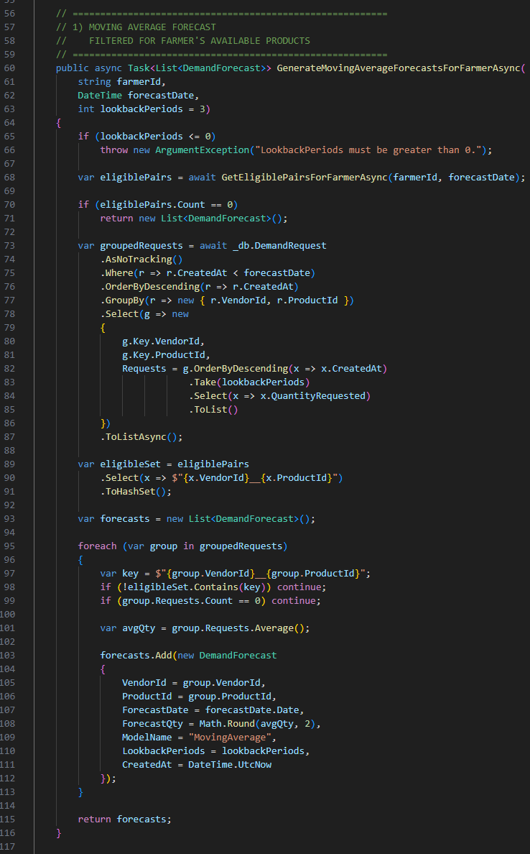

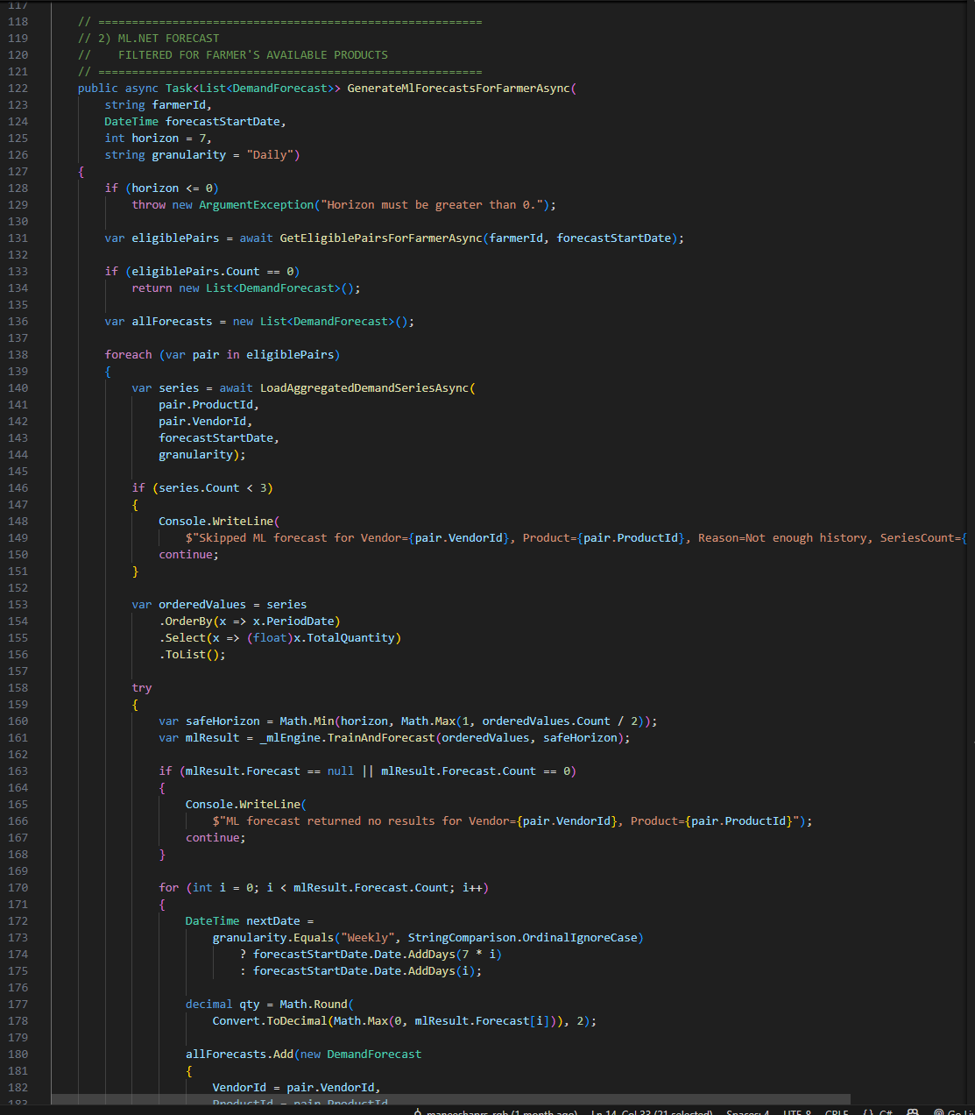

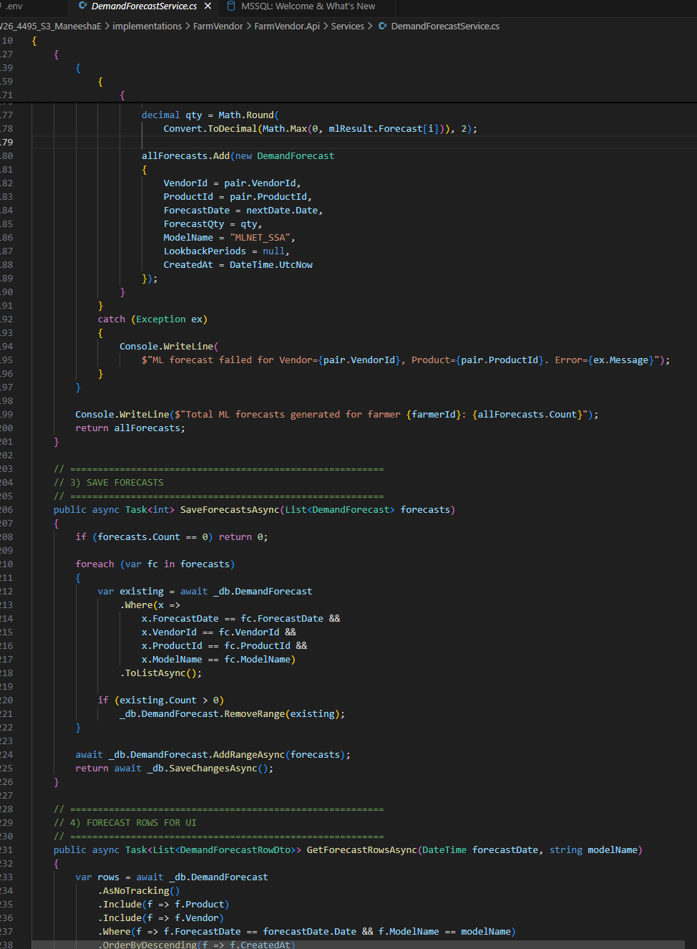

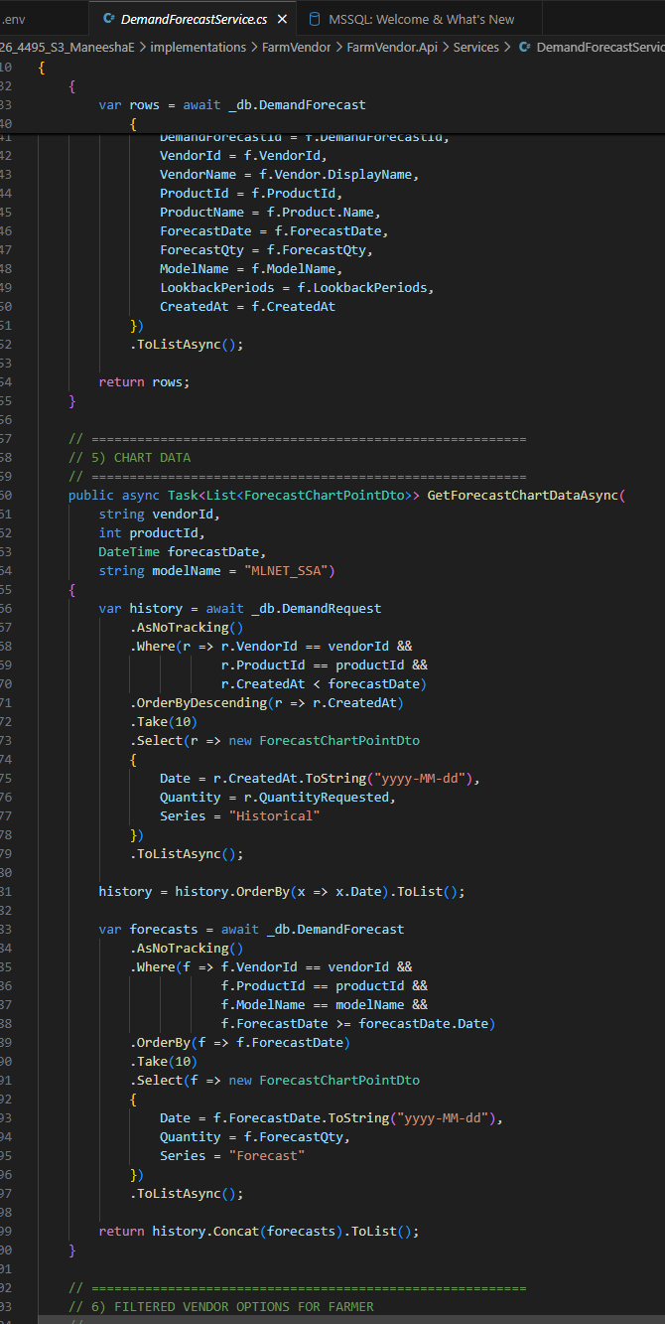

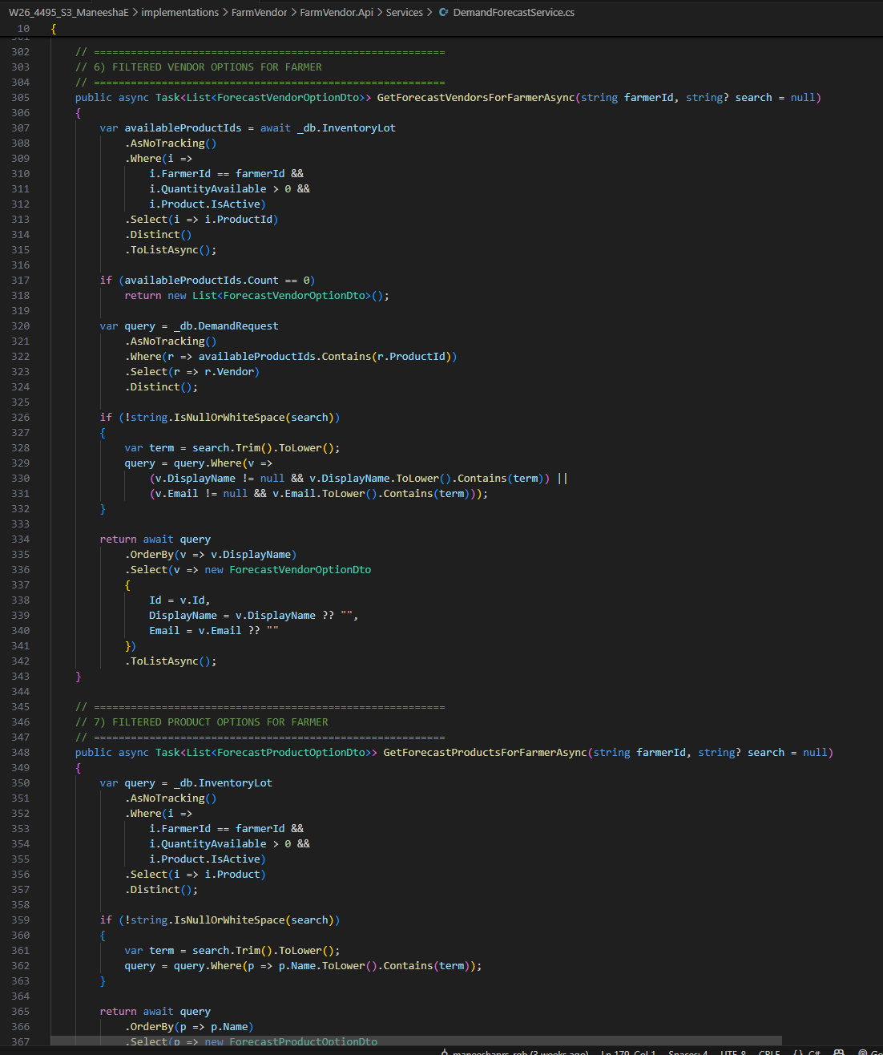

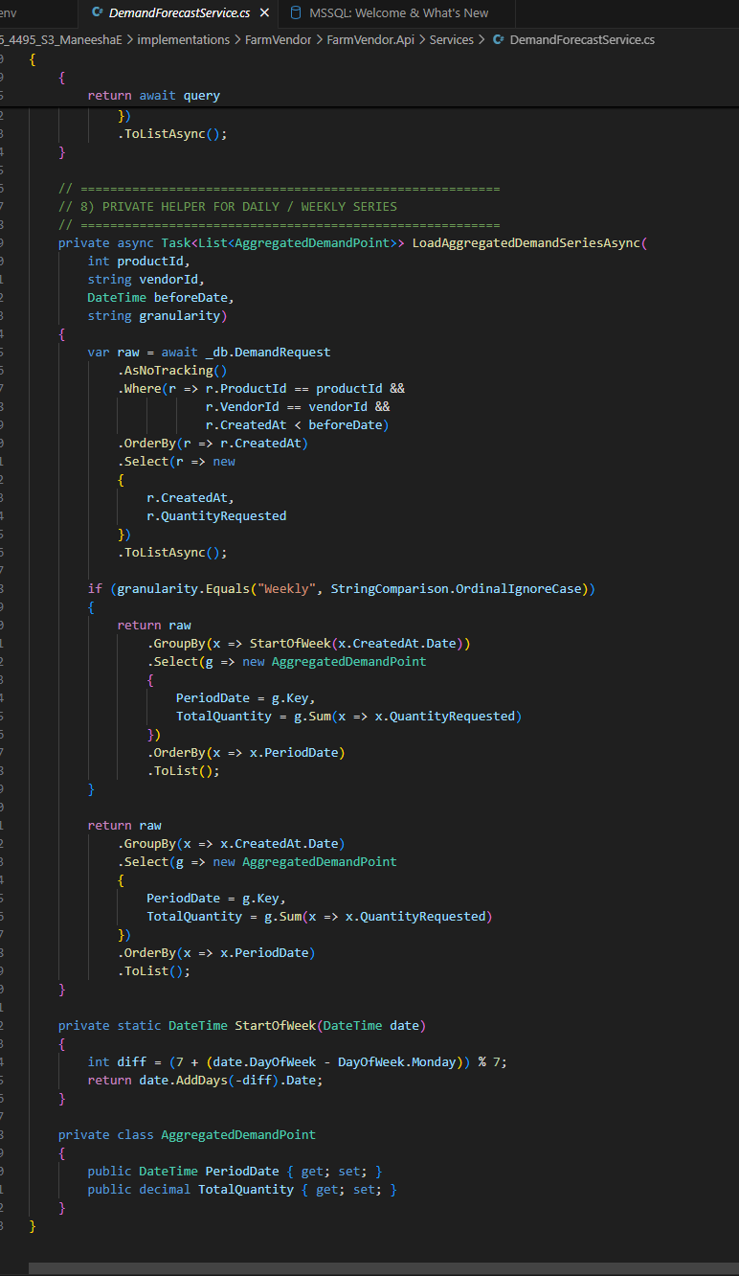

MLDemandForecastingEngine.cs
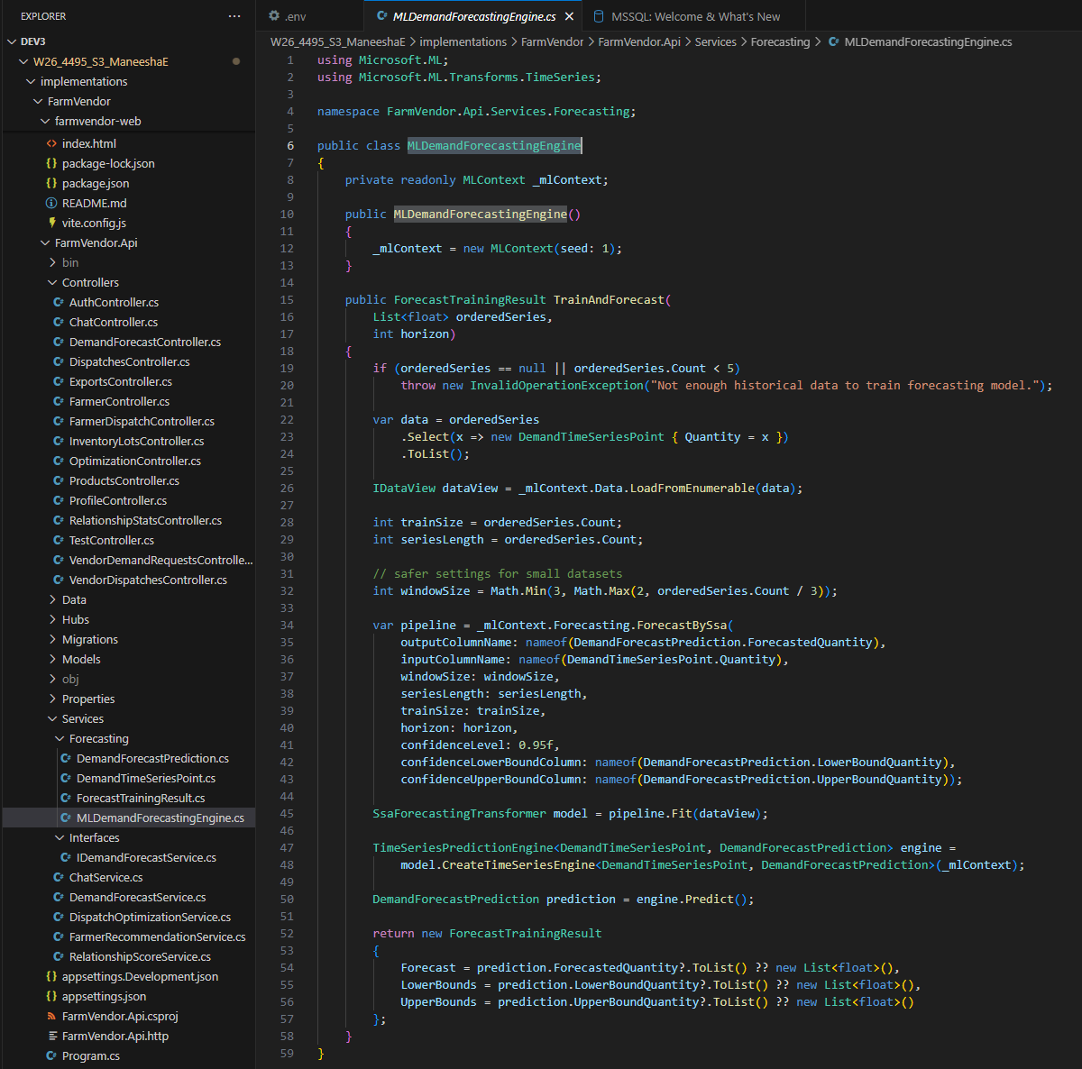

Postman Testing

- Moving Average request : POST : http://localhost:5136/api/forecasts/generate
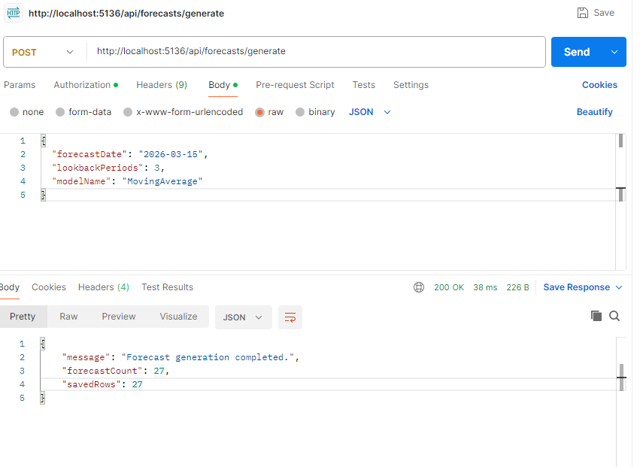
{
"forecastDate": "2026-03-15",
"lookbackPeriods": 3,
"modelName": "MovingAverage"
}

- ML.NET request : POST : http://localhost:5136/api/forecasts/generate
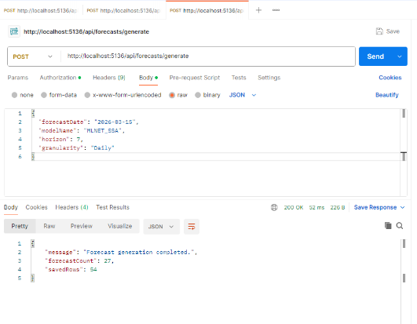
{
"forecastDate": "2026-03-15",
"modelName": "MLNET_SSA",
"horizon": 7,
"granularity": "Daily"
}

- GET /api/forecasts?modelName=MovingAverage : http://localhost:5136/api/forecasts?modelName=MovingAverage

- GET /api/forecasts?modelName=MLNET _SSA : http://localhost:5136/api/forecasts?modelName=MLNET_SSA

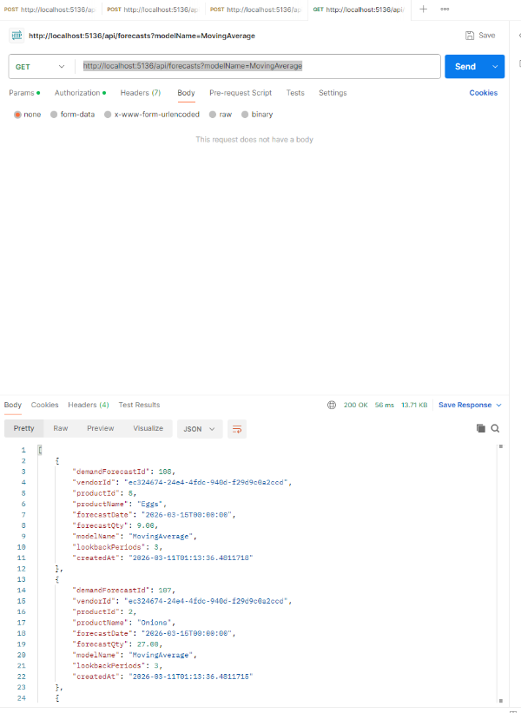
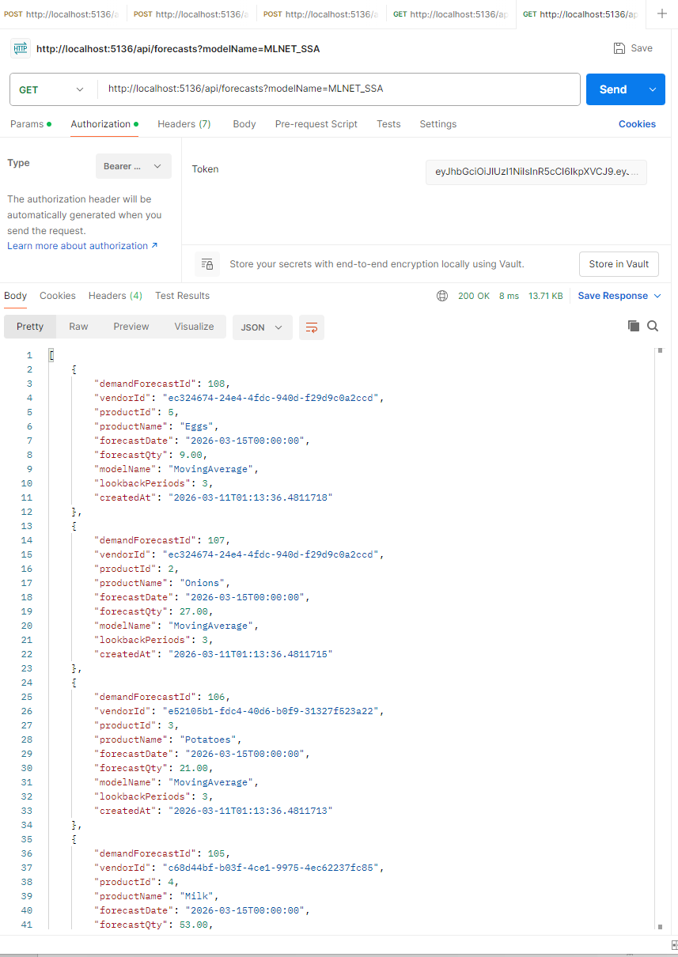

Database queries

- Forecast dates exists
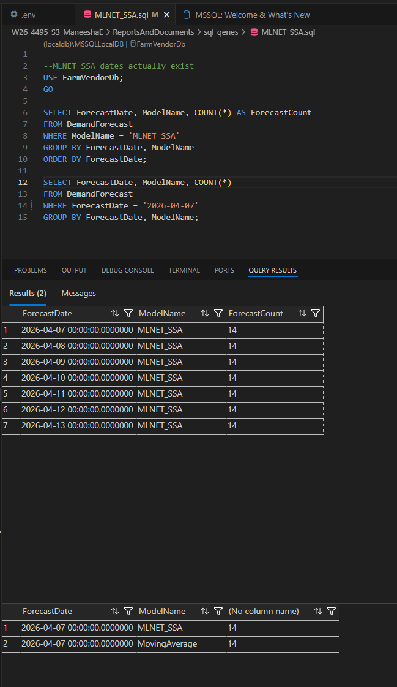

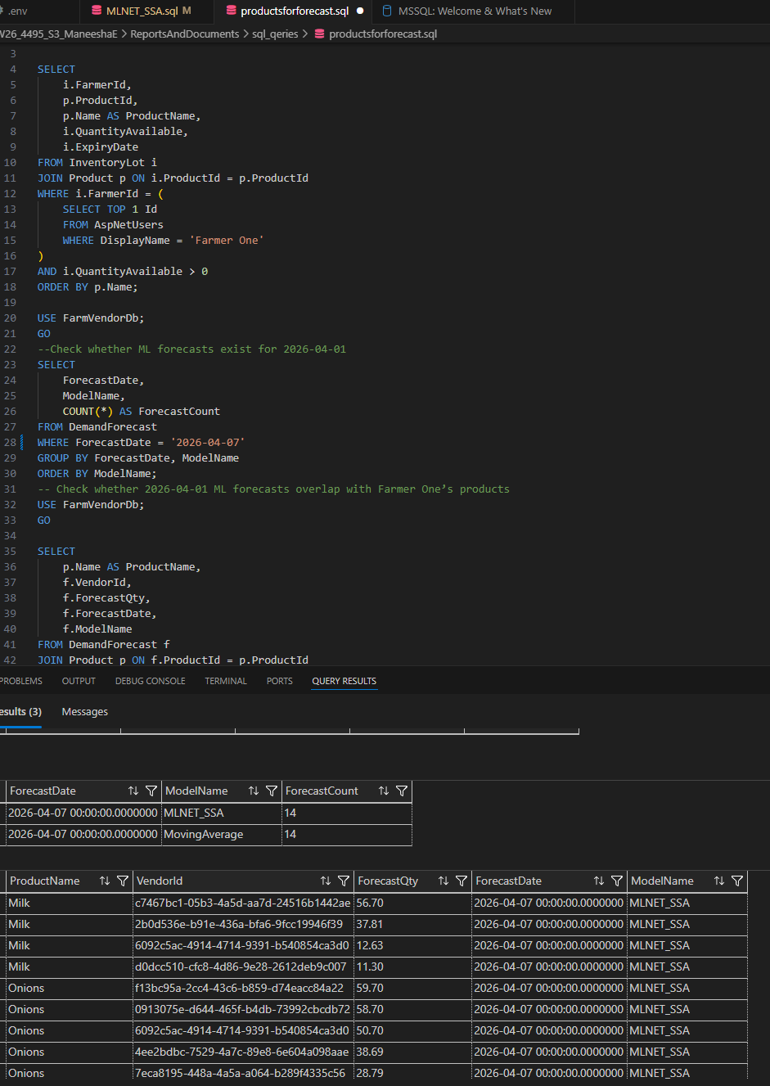
- MLNET_SSA forecast data existence check

- Forecast data check

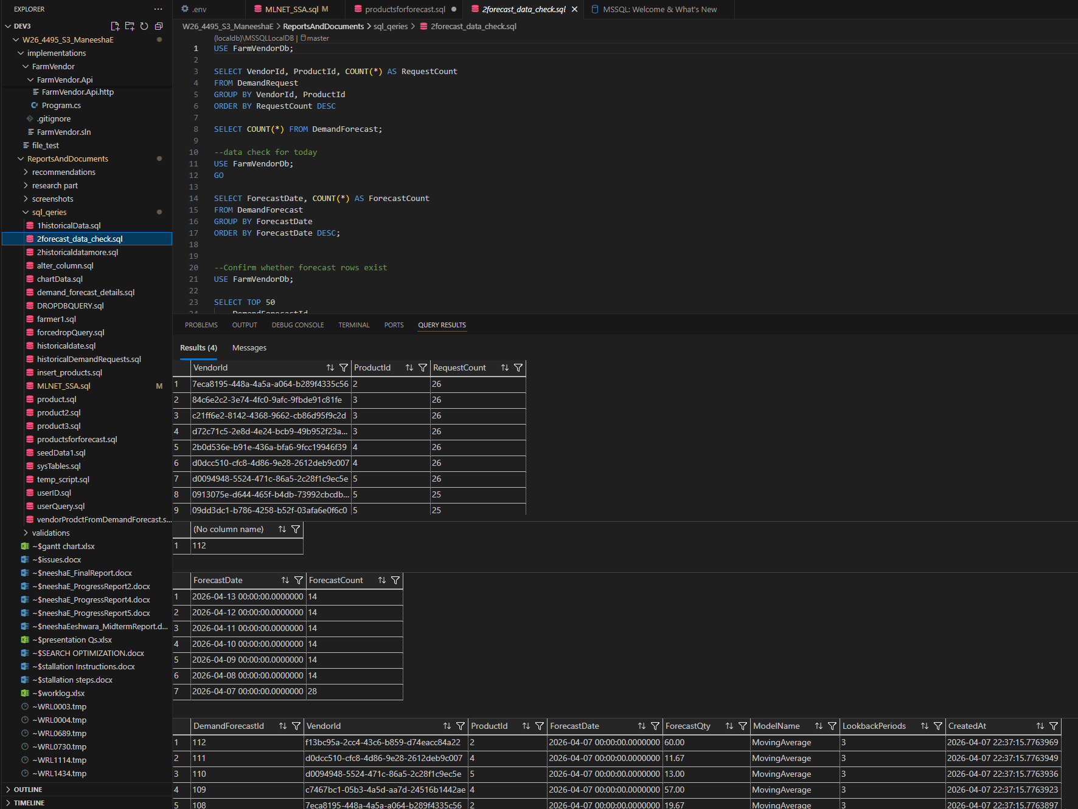

Feature 2: Vendor Recommendation, Relationship Score, and Distance-Based Matching

This feature supports dispatch decision-making by identifying suitable vendors based on demand relevance, past interactions, and physical distance.
This feature includes:
- Recommended vendors section
- Distance calculation between farmer and vendor
- Relationship score logic
- Hover popup for vendor details
- Request-specific vendor information
The design consists of:
- Score-based ranking
- Location-aware prioritization
- Historical relationship analysis
Implementation
Frontend
- FarmerDashboard.jsx
- vendor hover popup UI
- recommendation table rendering
Backend
- FarmerRecommendationService.cs
- FarmerController.cs
- RelationshipScoreService.cs
- Haversine distance calculation logic
Database
RelationshipStat table storing:
- FarmerId
- VendorId
- TotalRequestedQty
- TotalDeliveredQty
- RelationshipScore
Technical Methods
- weighted score formula using demand, distance, and relationship
- geospatial calculation using latitude/longitude
- ranking through EF Core + LINQ queries

App

FarmerDashboard

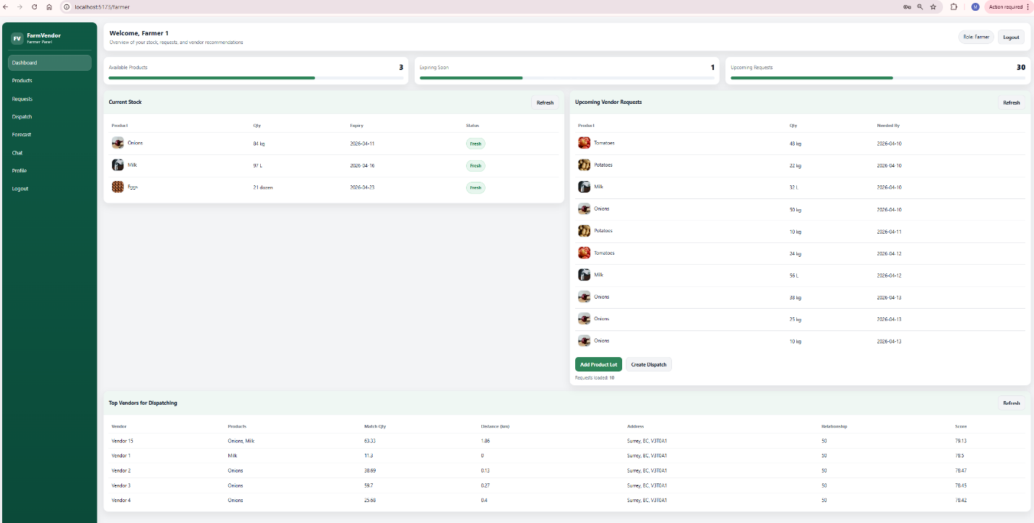

- Top Vendors for Dispatching section
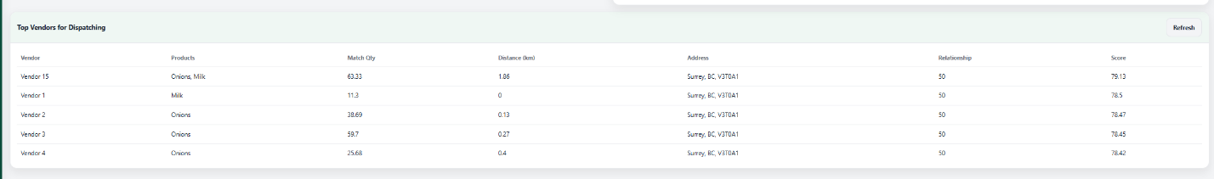

- Vendor specific hover popup

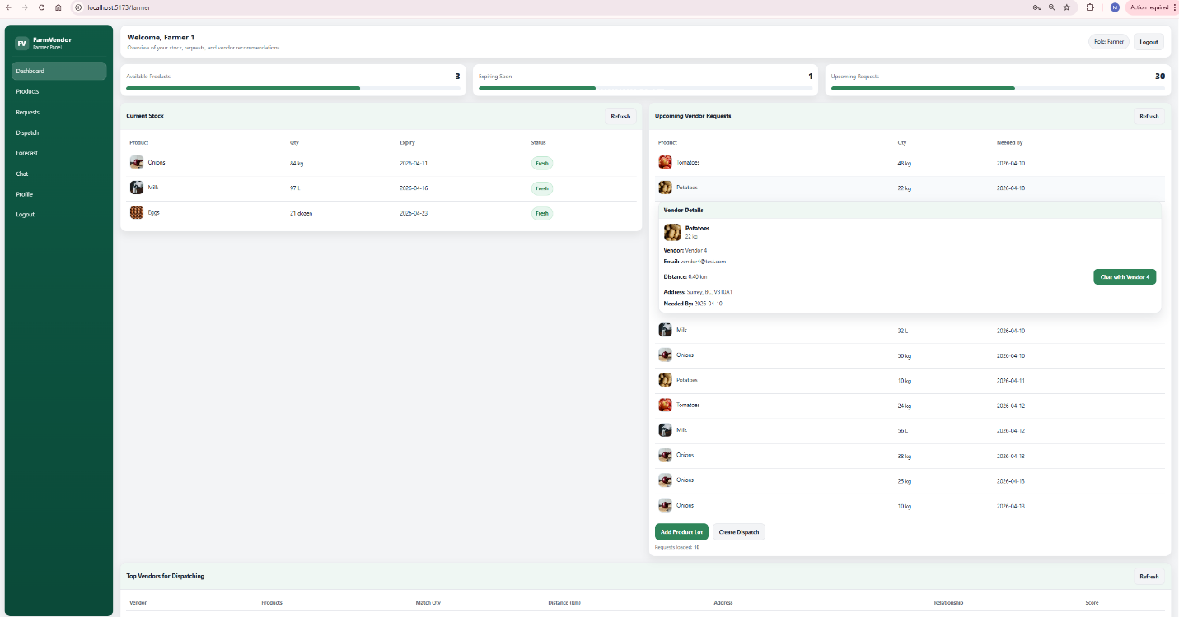

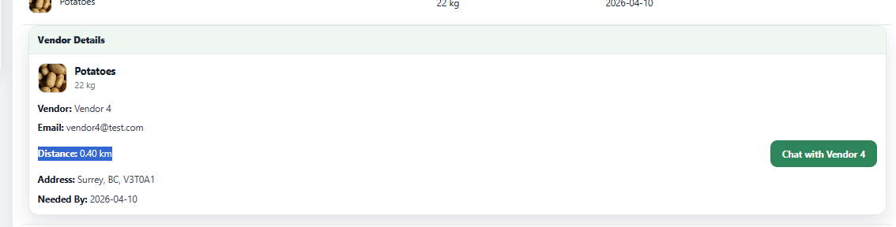

- Distance shown in request details

Frontend

FarmerDashboard.jsx

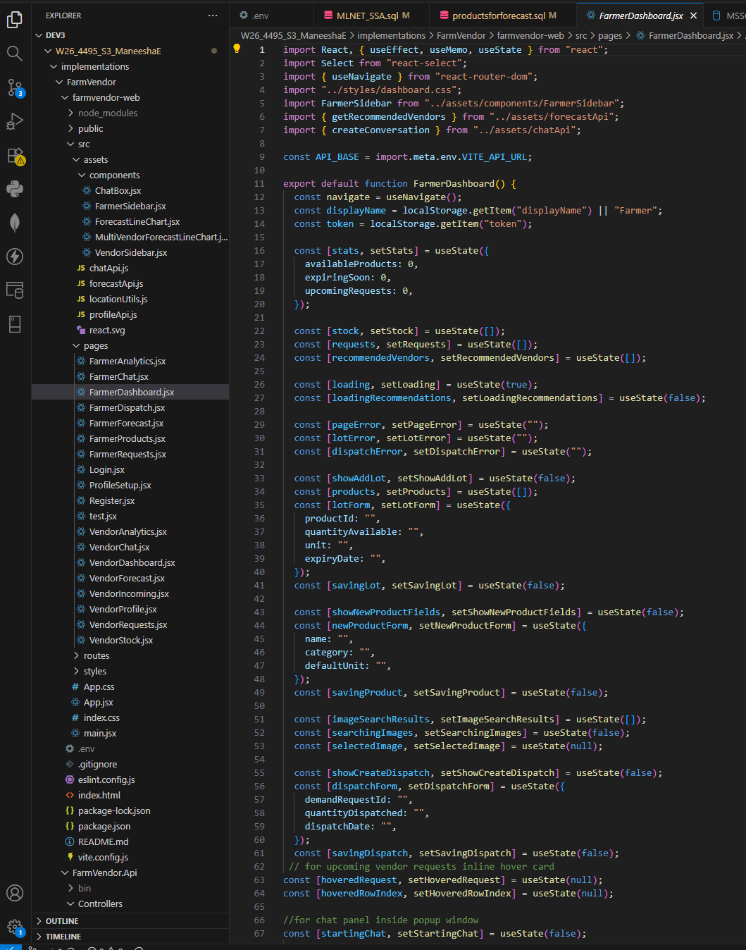

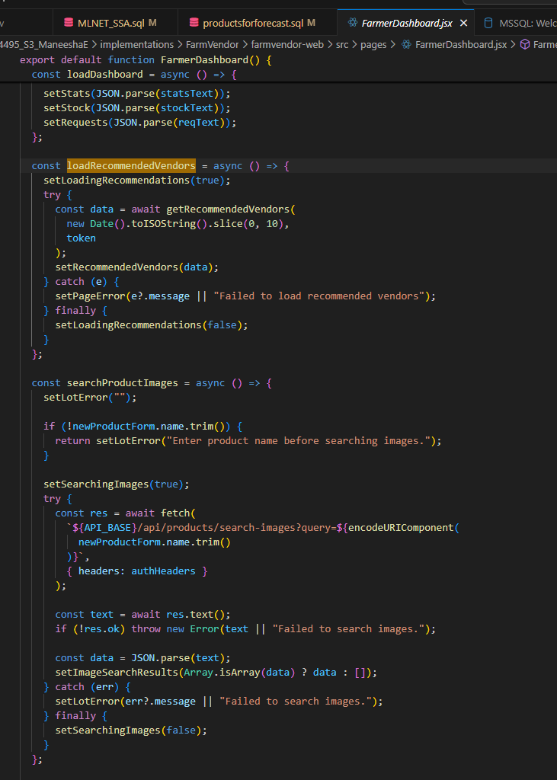

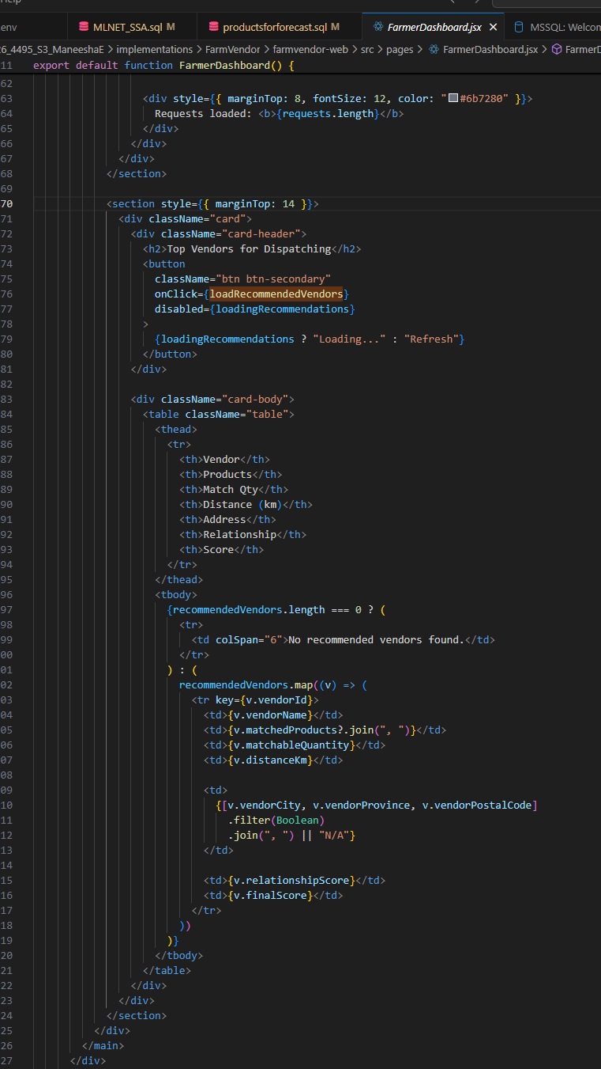

- upcoming vendor requests inline hover card
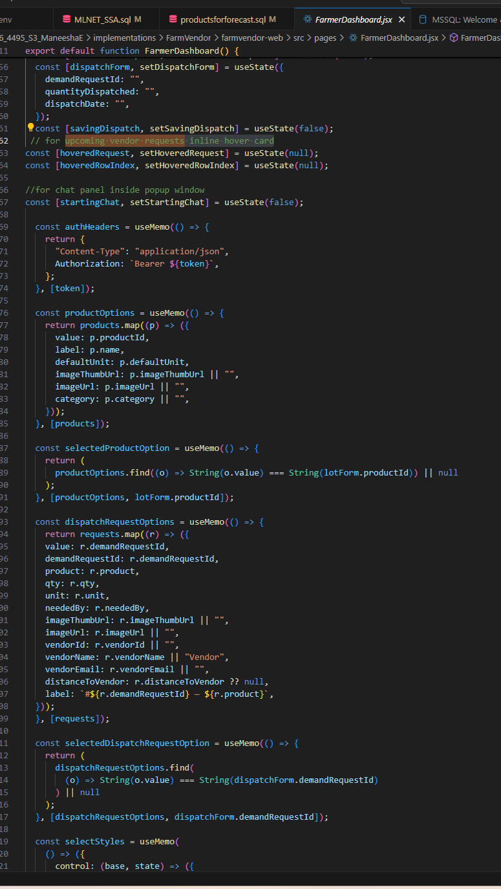

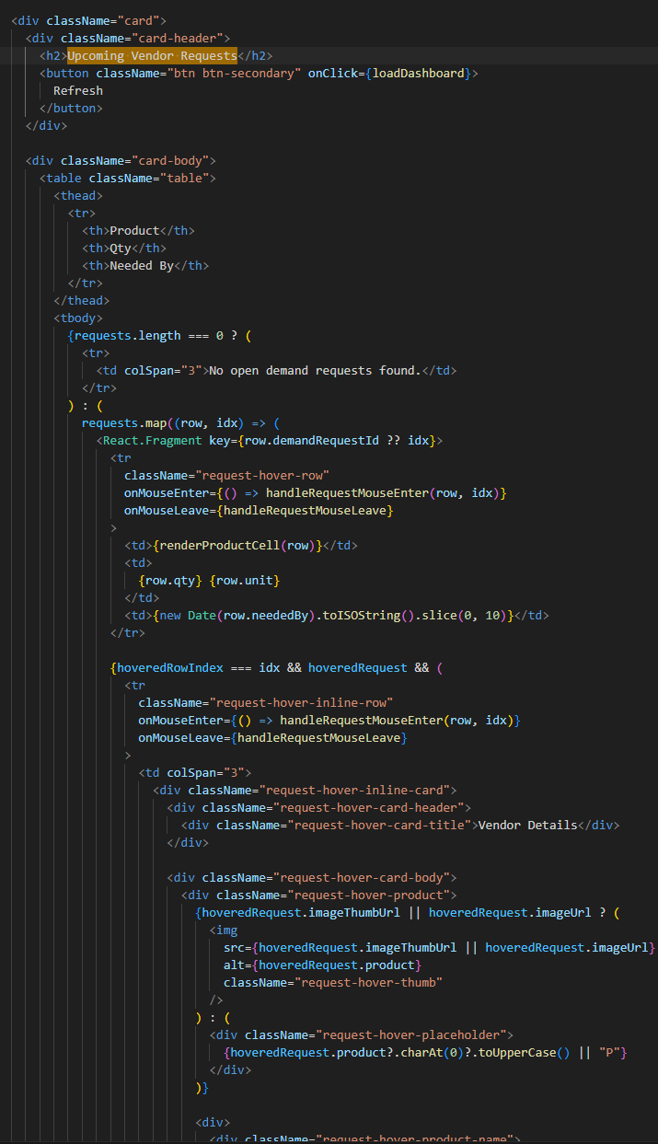

Backend

FarmerRecommendationService.cs

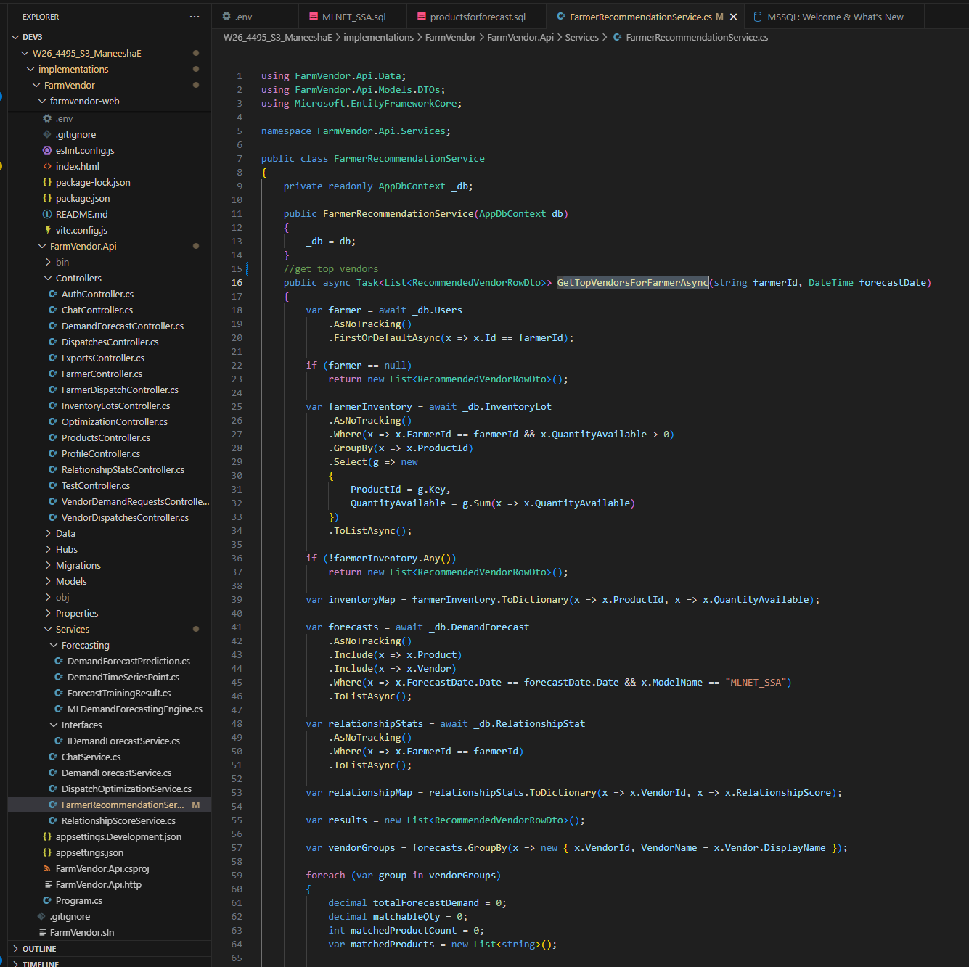

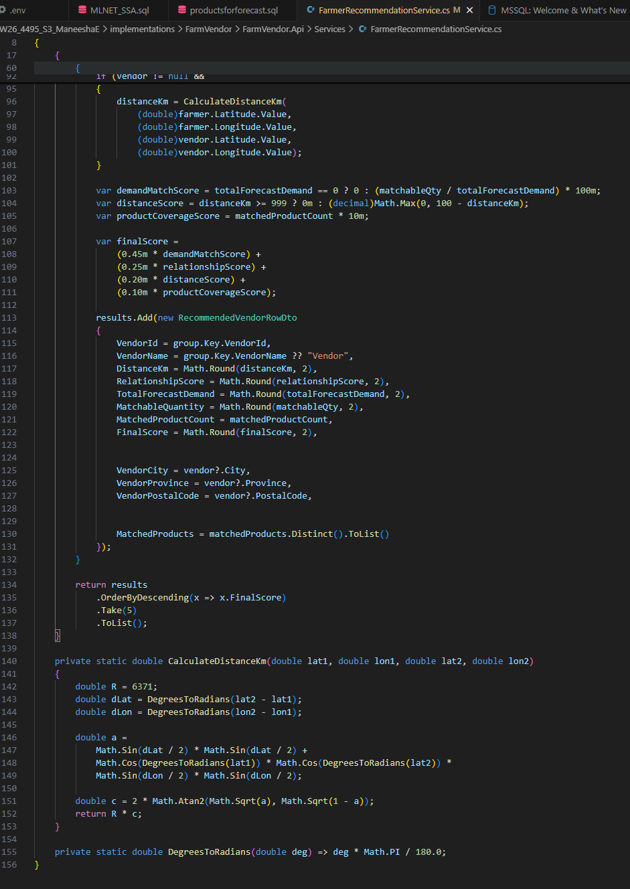

FarmerController.cs

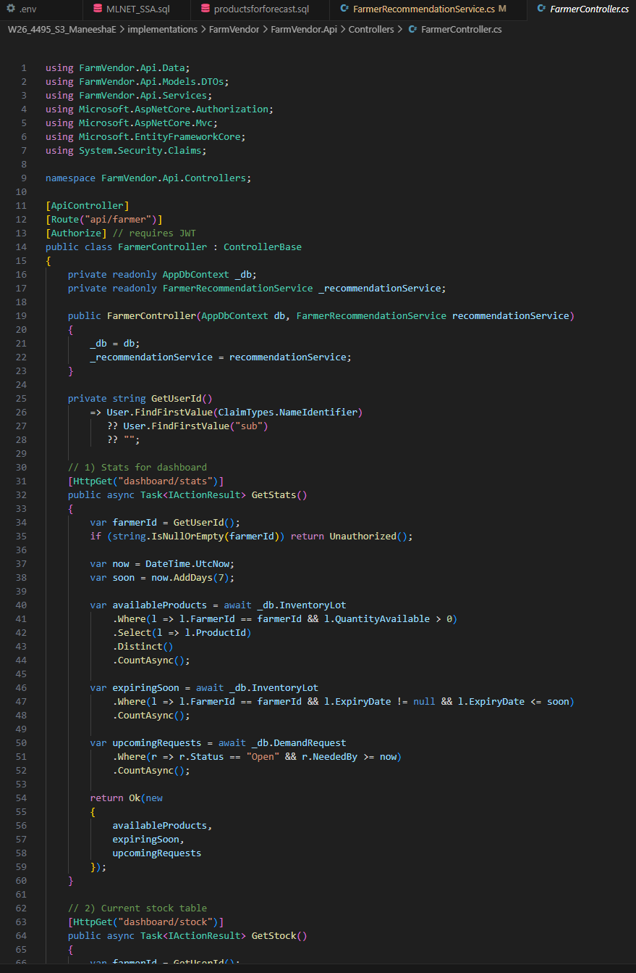

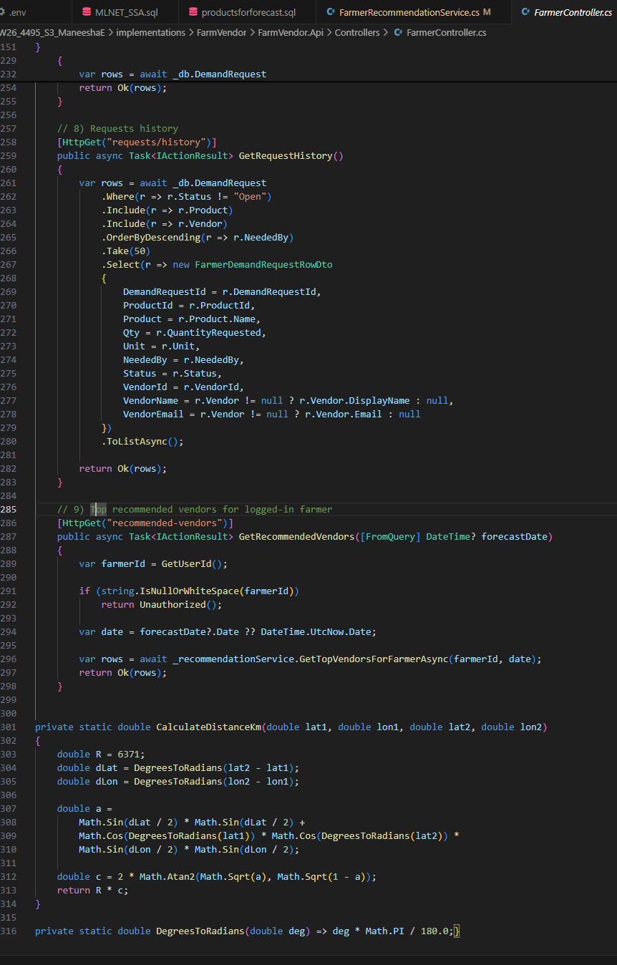

- Haversine formula applied in FarmerController.cs

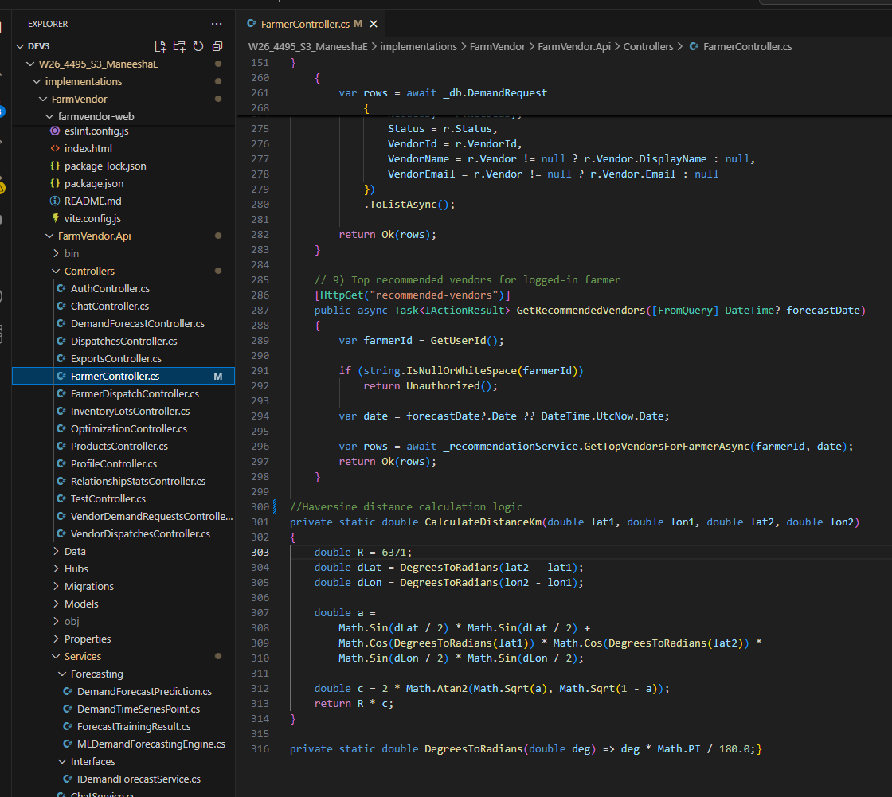

RelationshipScoreService.cs

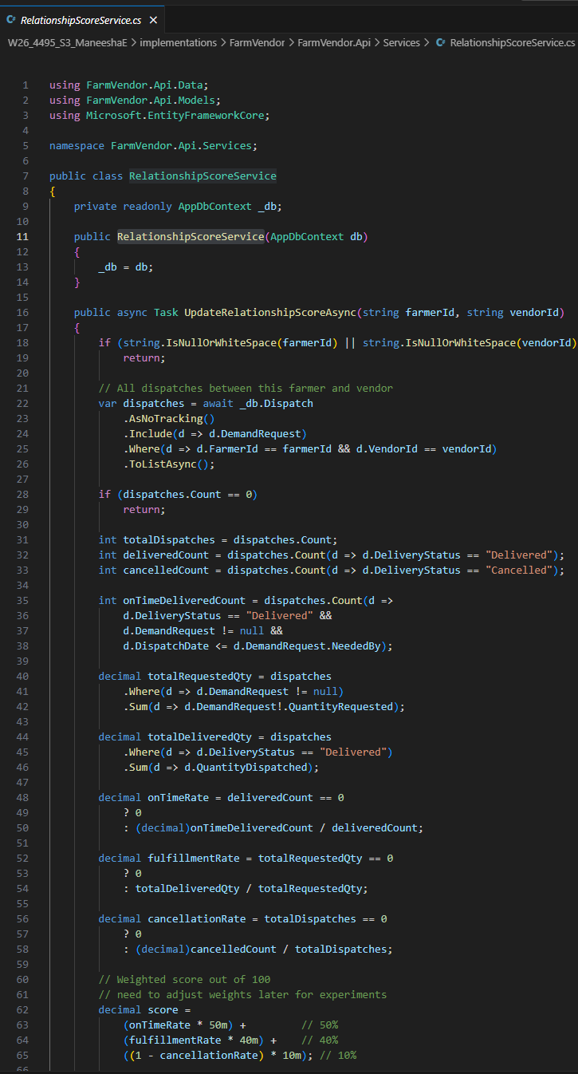

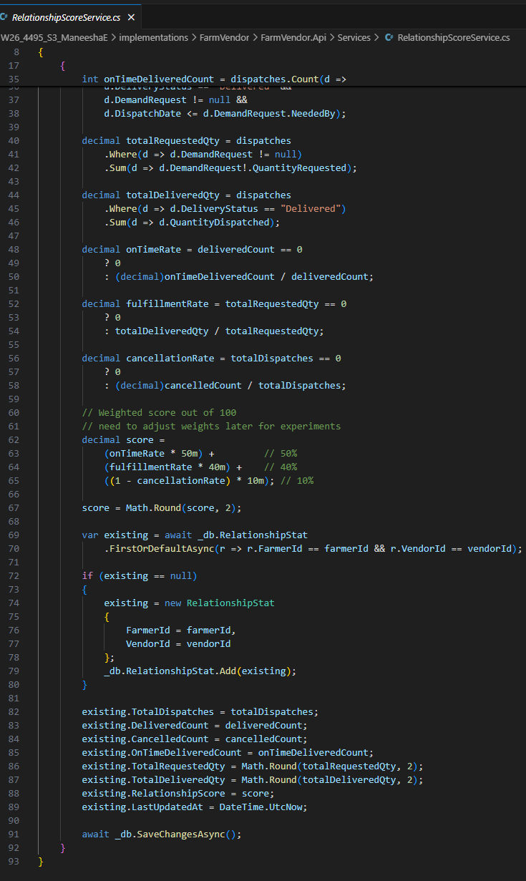

Database queries
- RelationshipStat table

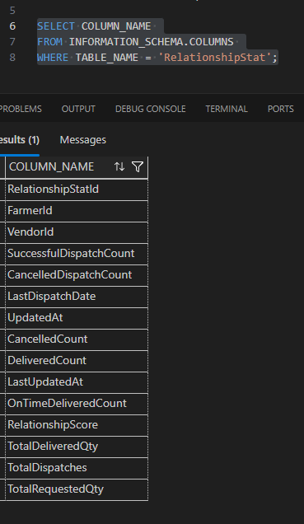

Feature 3: Realtime chatmodule

This feature enables real-time communication between farmers and vendors, supporting quick coordination, clarification, and negotiation during dispatch and fulfillment.
This feature includes:
- Create conversation
- Conversation list
- Real-time message sending
- Persistent message history
- Farmer and Vendor chat pages
The design consists of:
- SignalR-based live communication
- conversation-based organization
- stored message history
- authenticated hub connection
Implementation
Frontend
- FarmerDashboard.jsx
- VendorChat.jsx
- FarmerChat.jsx
- ChatBox.jsx
- chatApi.js
Backend
- ChatController.cs
- ChatHub.cs
- ChatService.cs
Database
- Conversation table storing:
  - FarmerId
  - VendorId
  - CreatedAt
- ChatMessage table storing:
  - ConversationId
  - SenderId
  - SenderRole
  - MessageText
  - SentAt
  - IsRead
Technical Methods
- SignalR WebSocket / fallback transport
- JWT-secured hub authentication
- real-time broadcast using conversation groups

App
- farmerDashboard
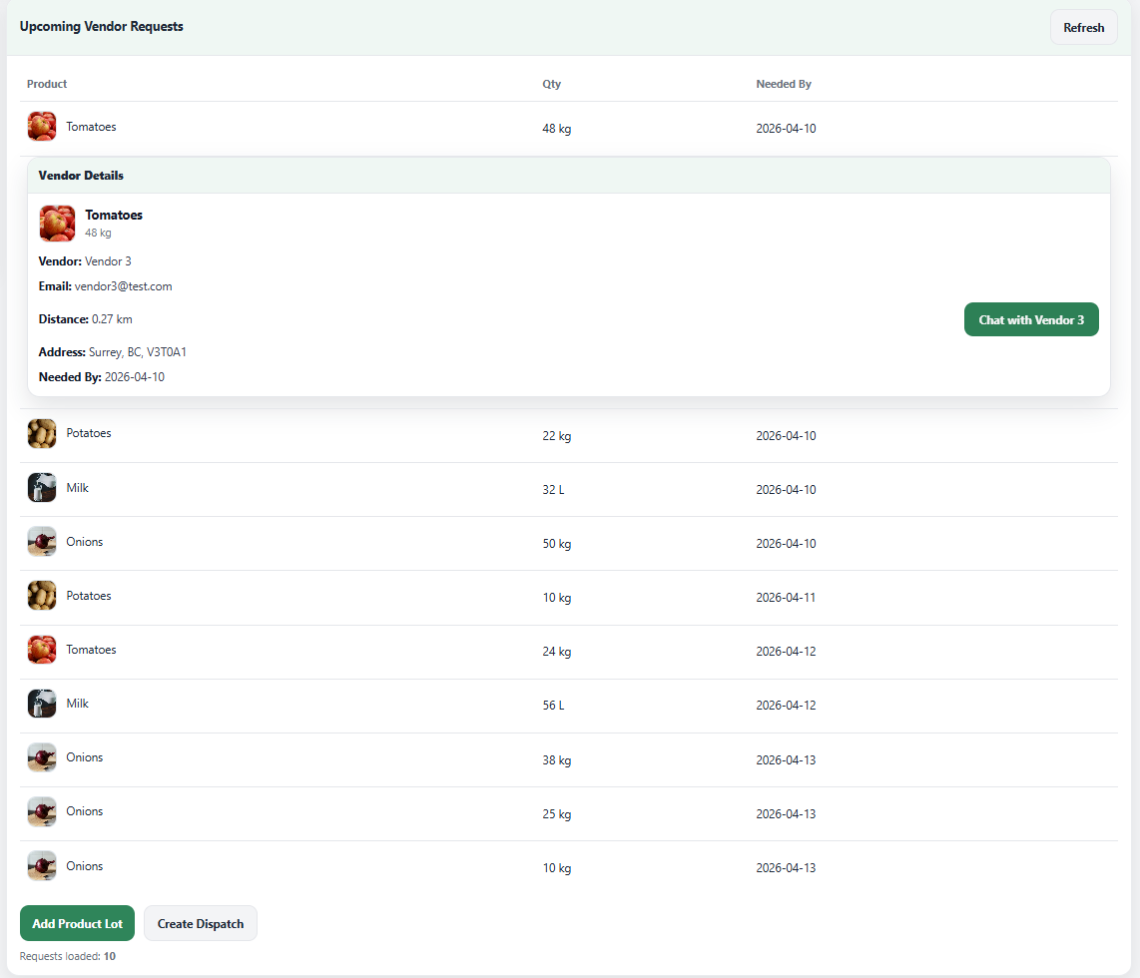

- Farmer chat panel
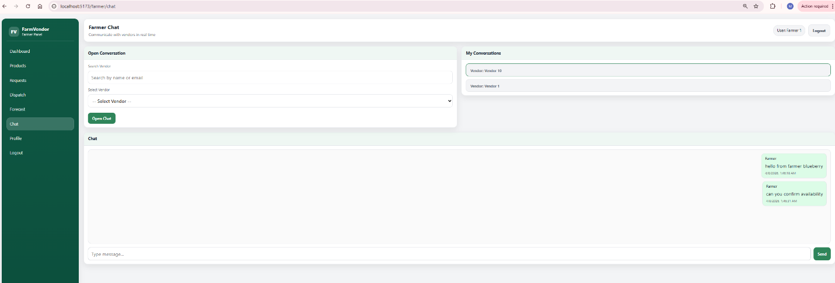

- Vendor chat panel
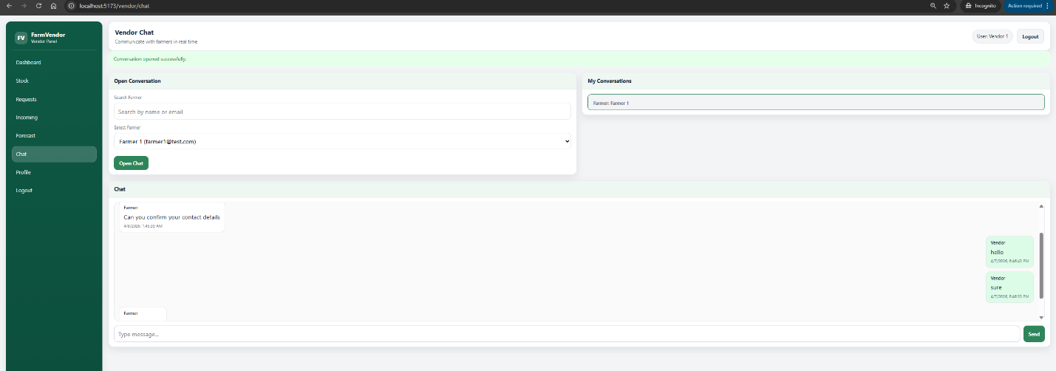

Frontend
- FarmerDashboard.jsx

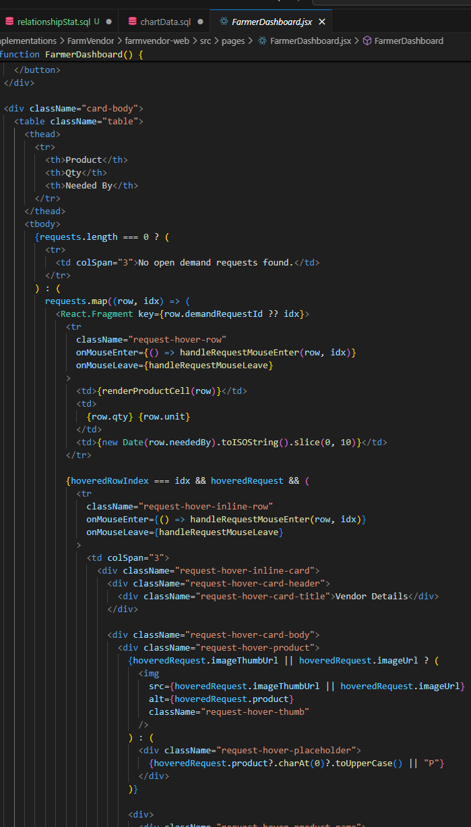

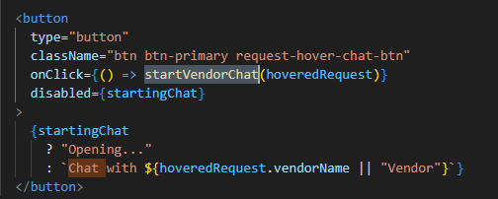

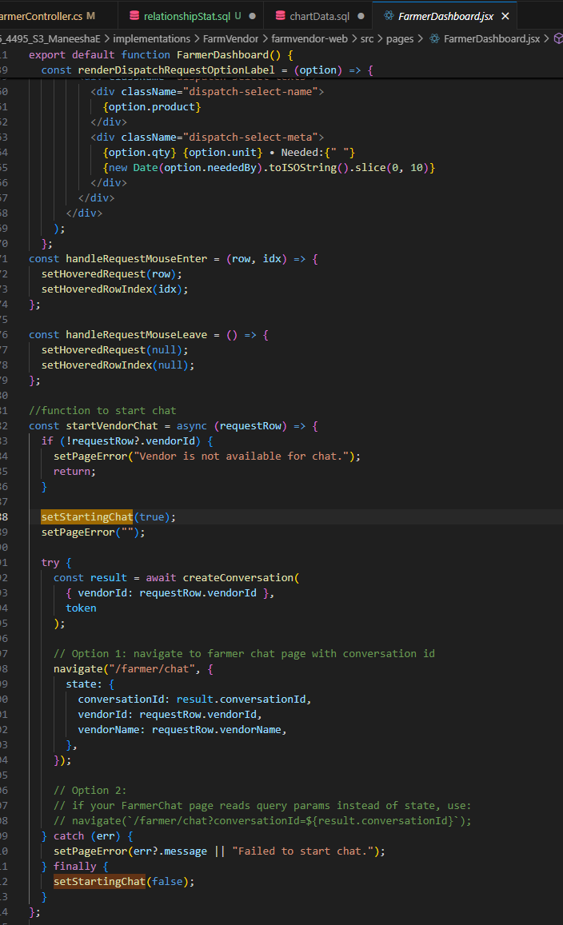

- FarmerChat.jsx
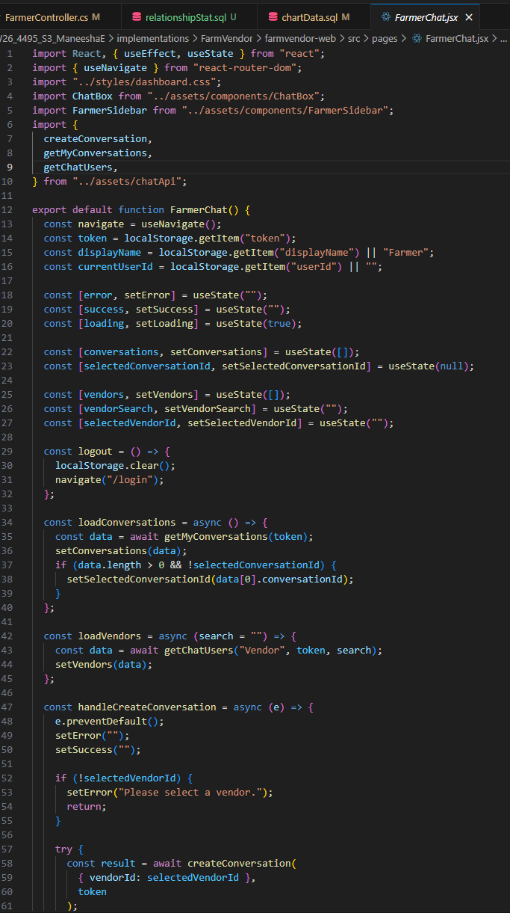

- VendorChat.jsx
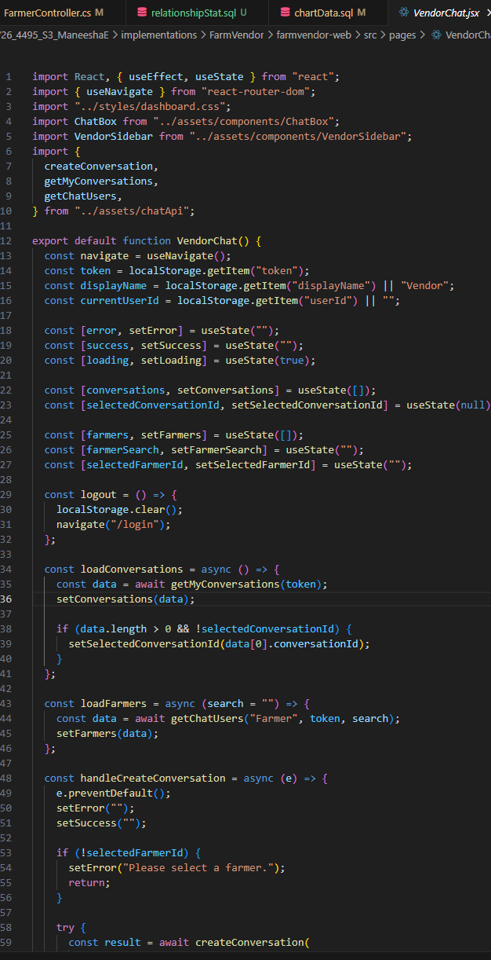

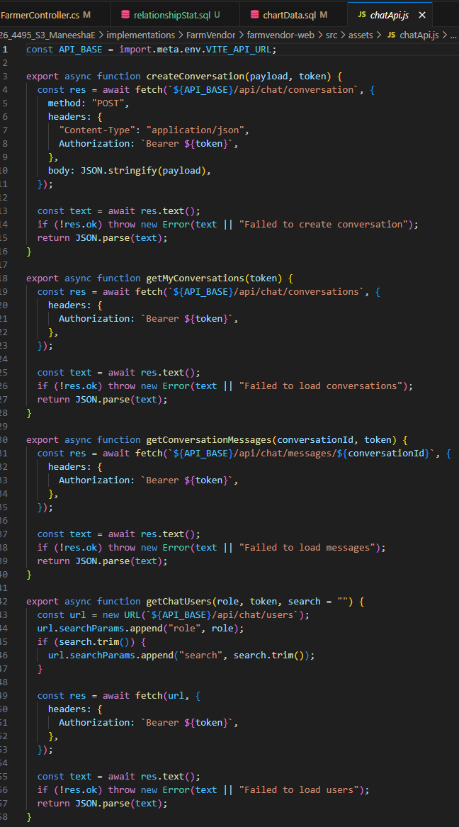
- ChatApi.js

- ChatBox.jsx
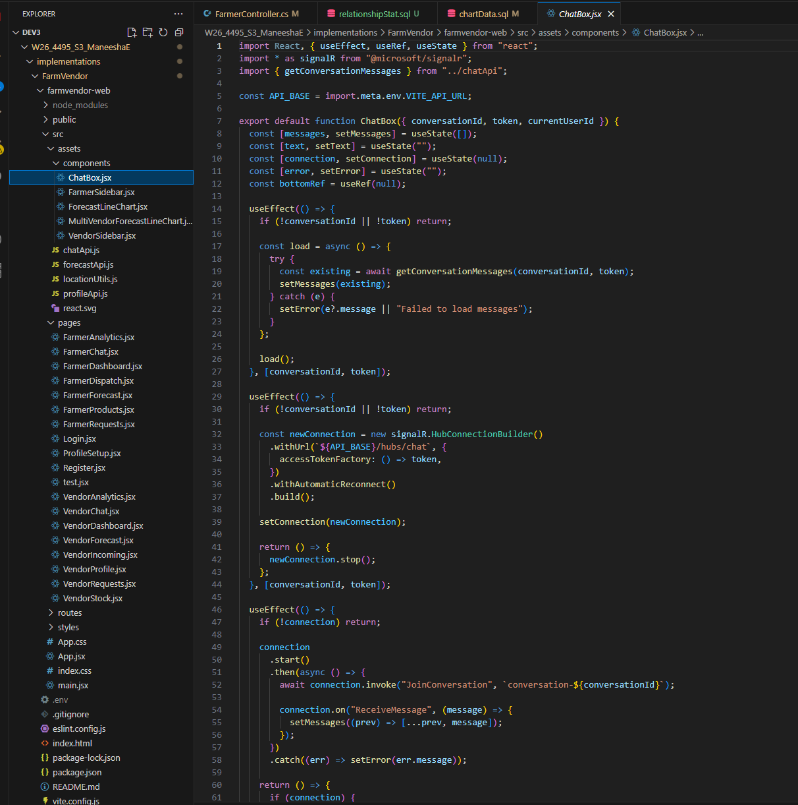

Backend

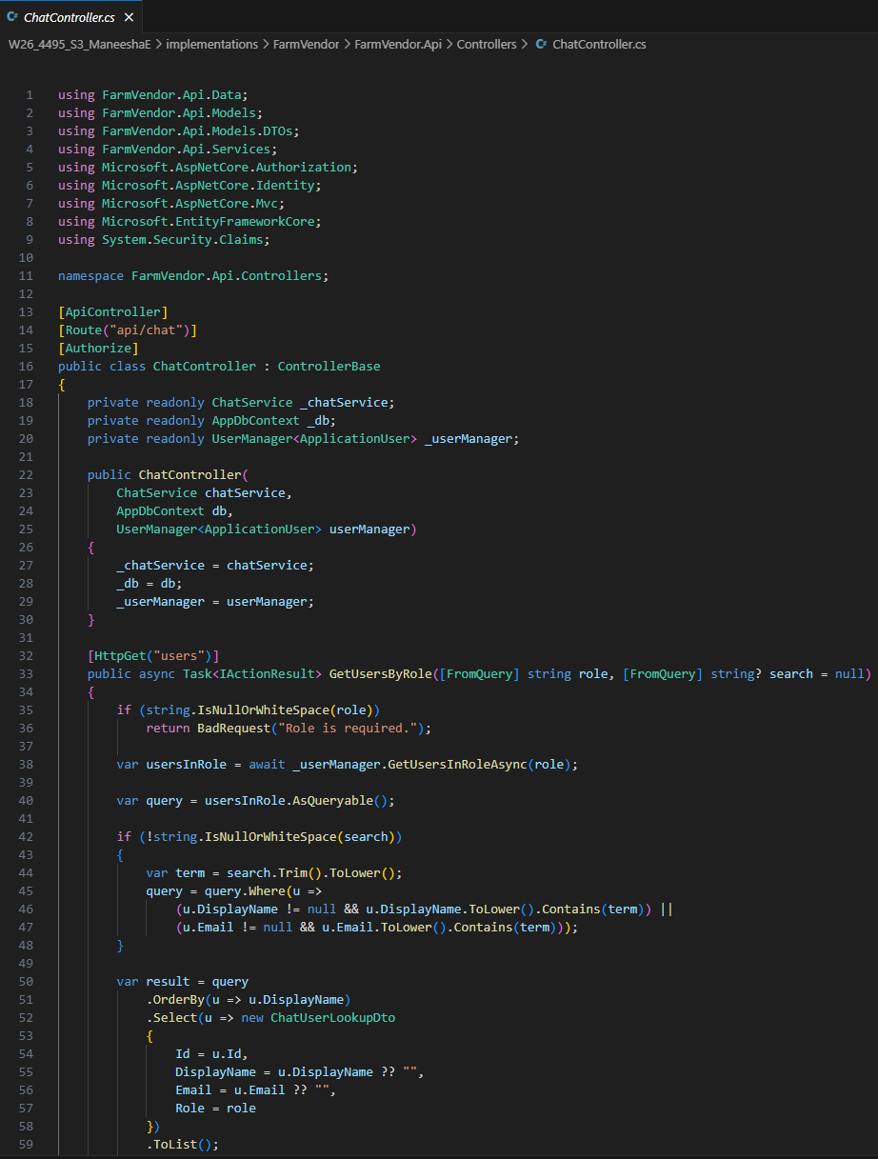
- ChatController.cs

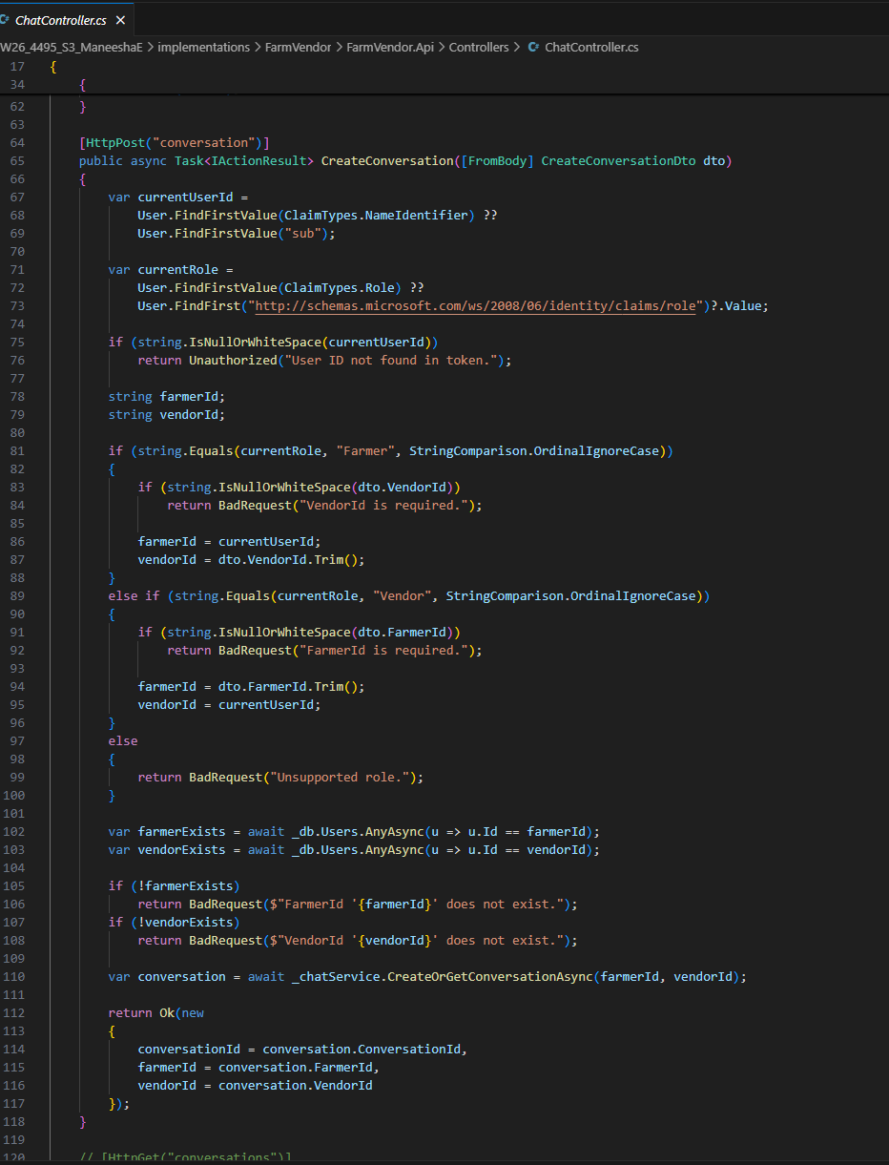

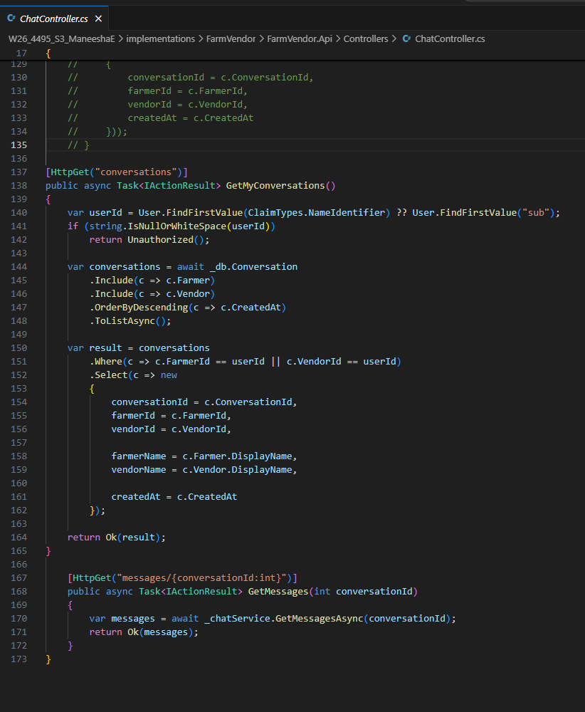

- ChatHub.cs
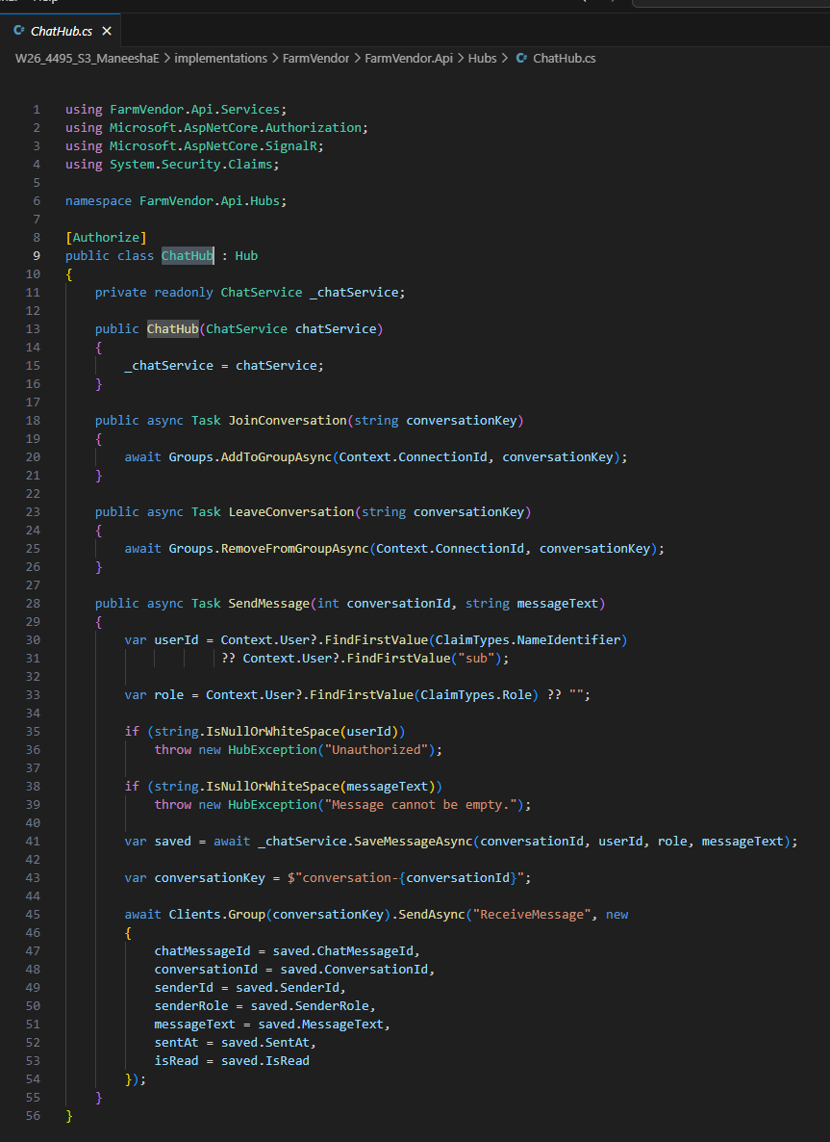

- ChatService.cs
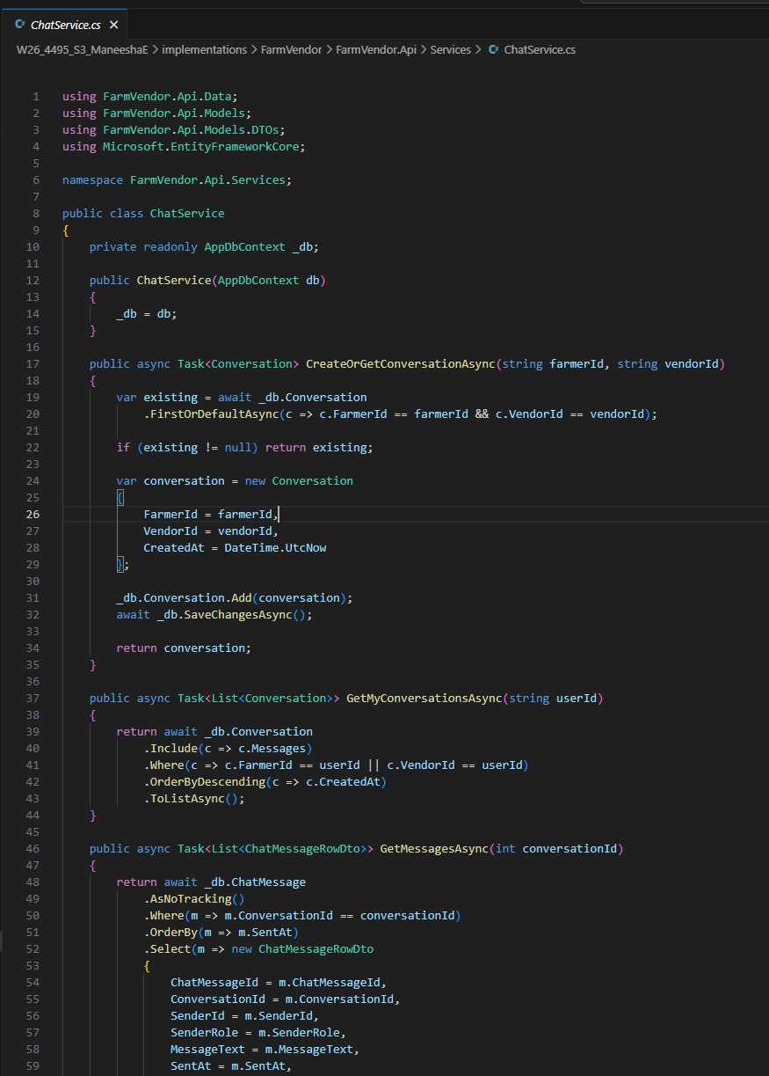

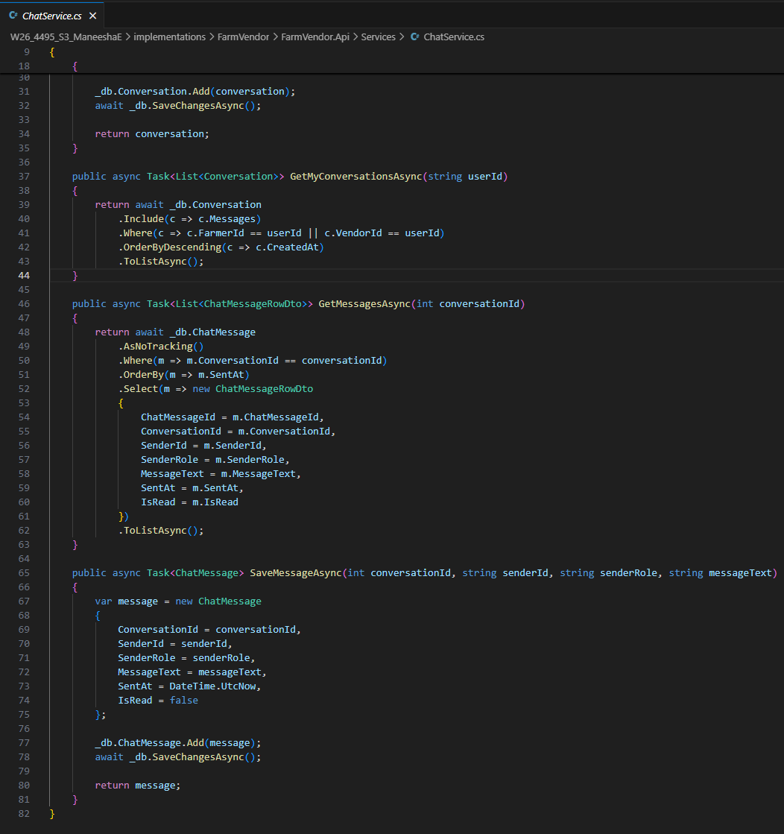

Database

- ChatMessage table
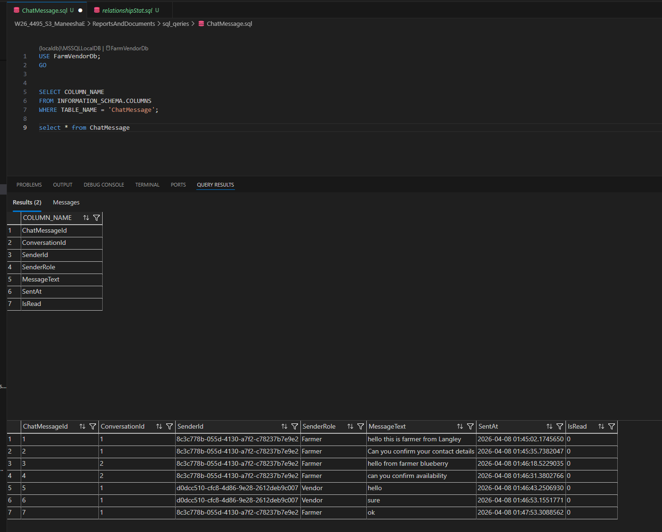

- Conversation Table
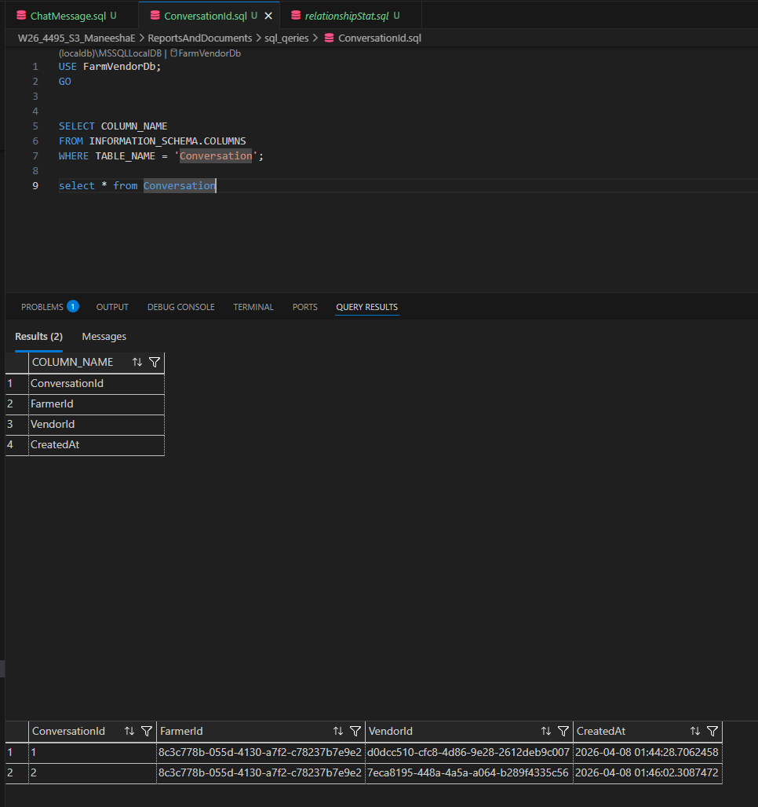

Feature 3: Forecast Export Functionality

This feature allows users to export forecast results in CSV format for external analysis, reporting, and presentation.
This feature includes:
- Export Results button
- CSV generation from forecast table
- Downloadable file with forecast details
Implementation
Frontend
- FarmerForecast.jsx
- CSV blob generation using JavaScript
- dynamic file download handling
Backend
- No dedicated backend export endpoint required for current version
- data taken from forecast rows already loaded through API
Exported Fields
- Vendor Name
- Product
- Forecast Date
- Quantity
- Model
- Lookback
- Created At

App

- Farmer forecast dashboard

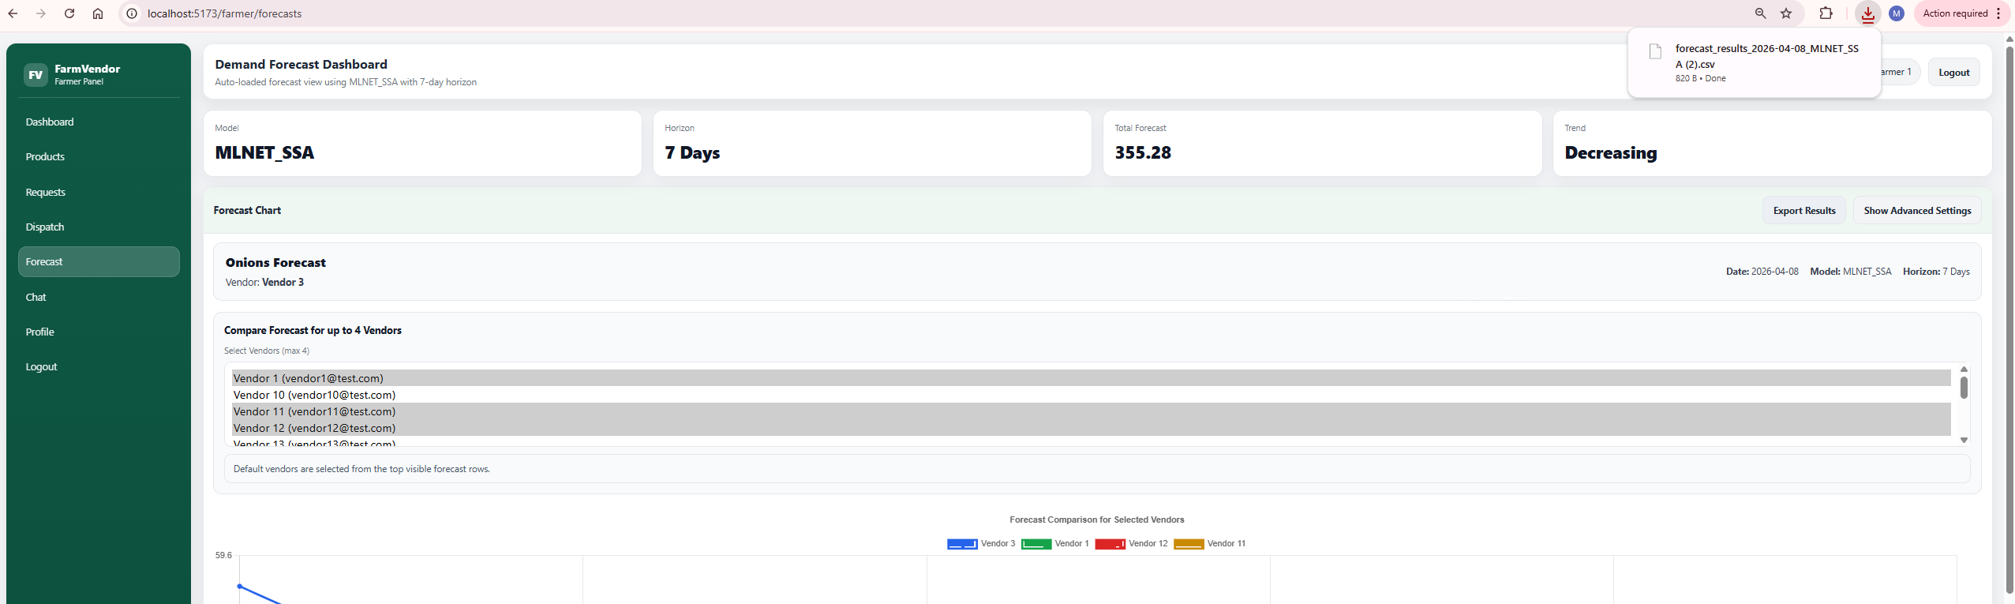
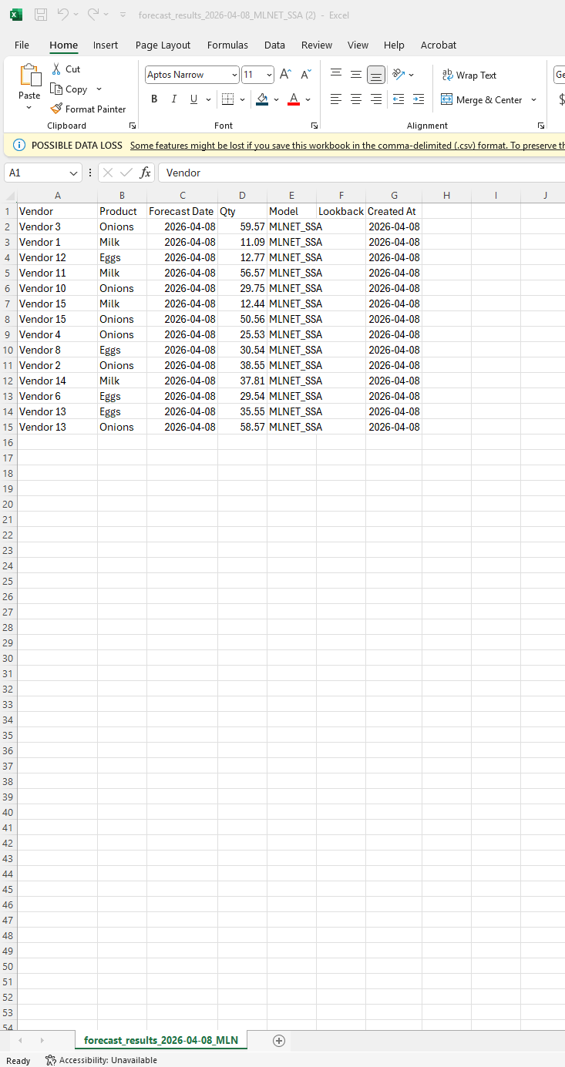

Frontend

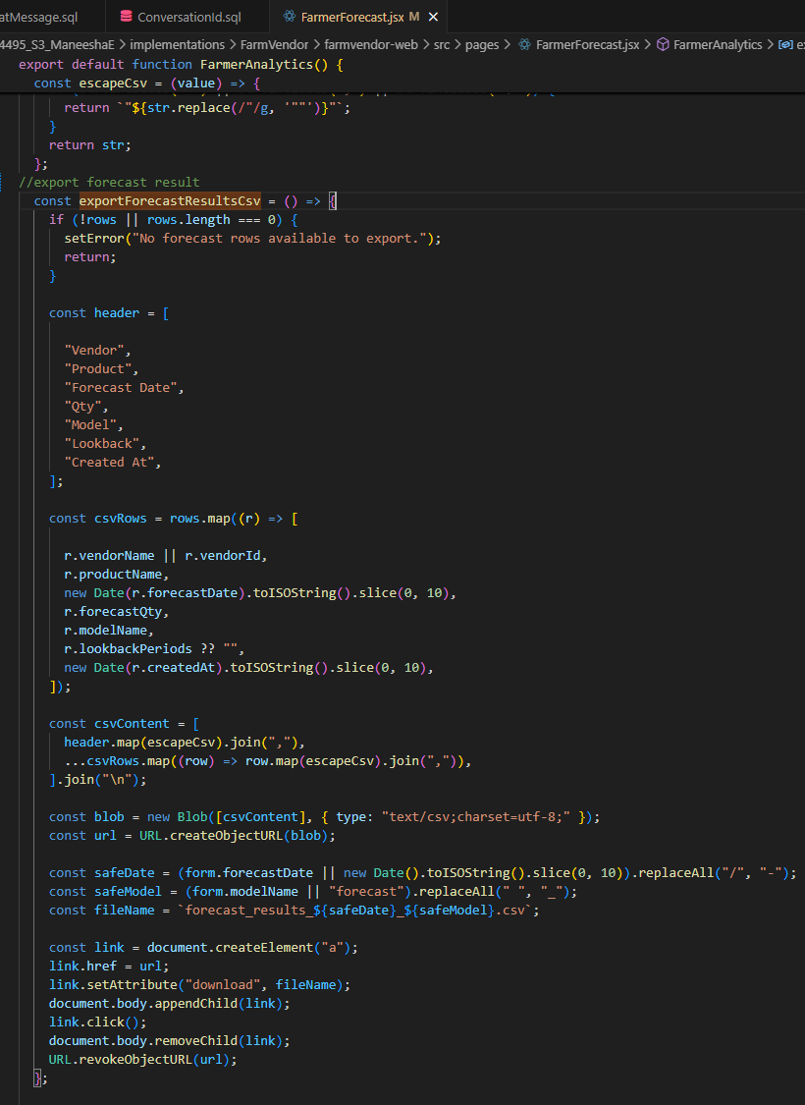
- FarmerForecast.jsx

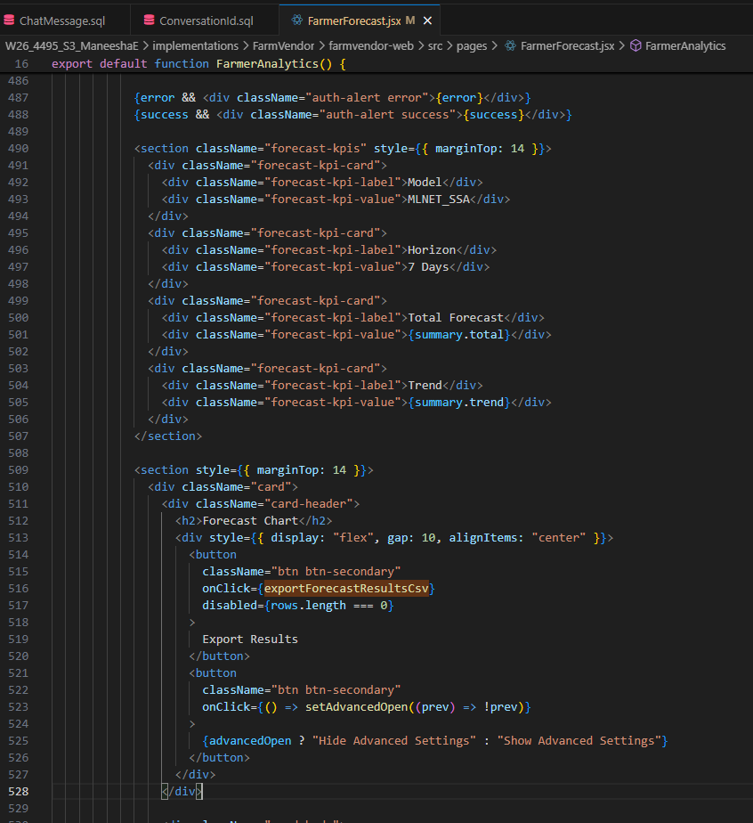

Feature 4: Role-Based Authentication (Registration & Login)

This feature allows users to access the system as either a Farmer or a Vendor. Authentication is implemented using ASP.NET Identity with JWT-based authorization, ensuring secure access, protected API calls, and role-based navigation.
This feature includes:
- User registration with role selection
- Secure login with JWT token generation
- Role-based dashboard access
- Route protection in the frontend
The design consists of:
- Registration page with role selection
- Login page with credential validation
- Backend JWT token generation
- Role-based route protection using React guards
Implementation
Frontend
- Register.jsx – handles registration form, role selection, and API call
- Login.jsx – handles login, stores JWT in localStorage, redirects user dashboard
- RequireAuth.jsx – protects authenticated routes
- RequireRole.jsx – restricts role access based on user type
Backend
- AuthController.cs – login and register endpoints
- ApplicationUser.cs – extended Identity user with custom fields
- Program.cs – JWT authentication and authorization middleware
- JWT token generation logic using issuer, audience, and signing key
Database
- AspNetUsers table stores user accounts
- Identity role tables map users to Farmer / Vendor roles

App

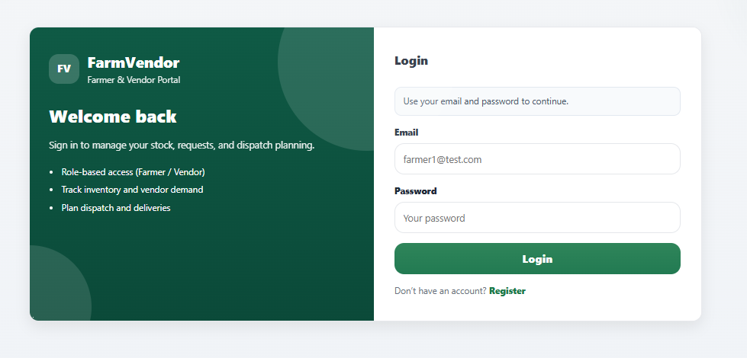

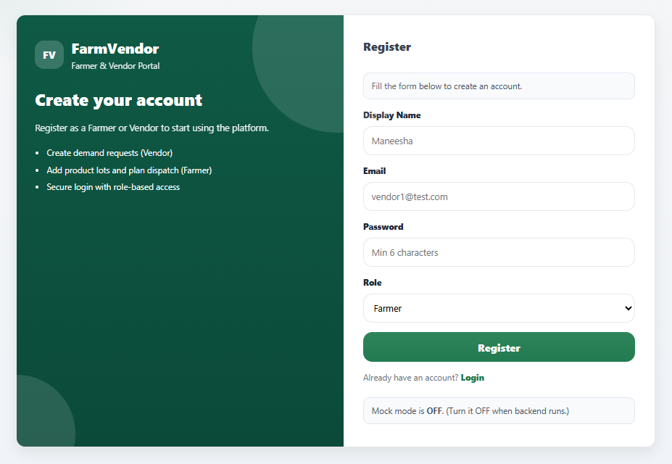

- Register.jsx

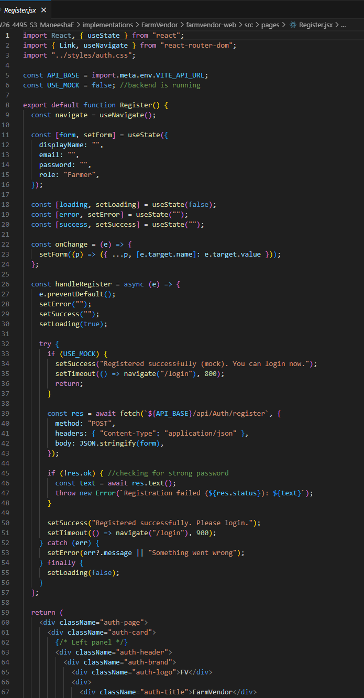

- Login.jsx
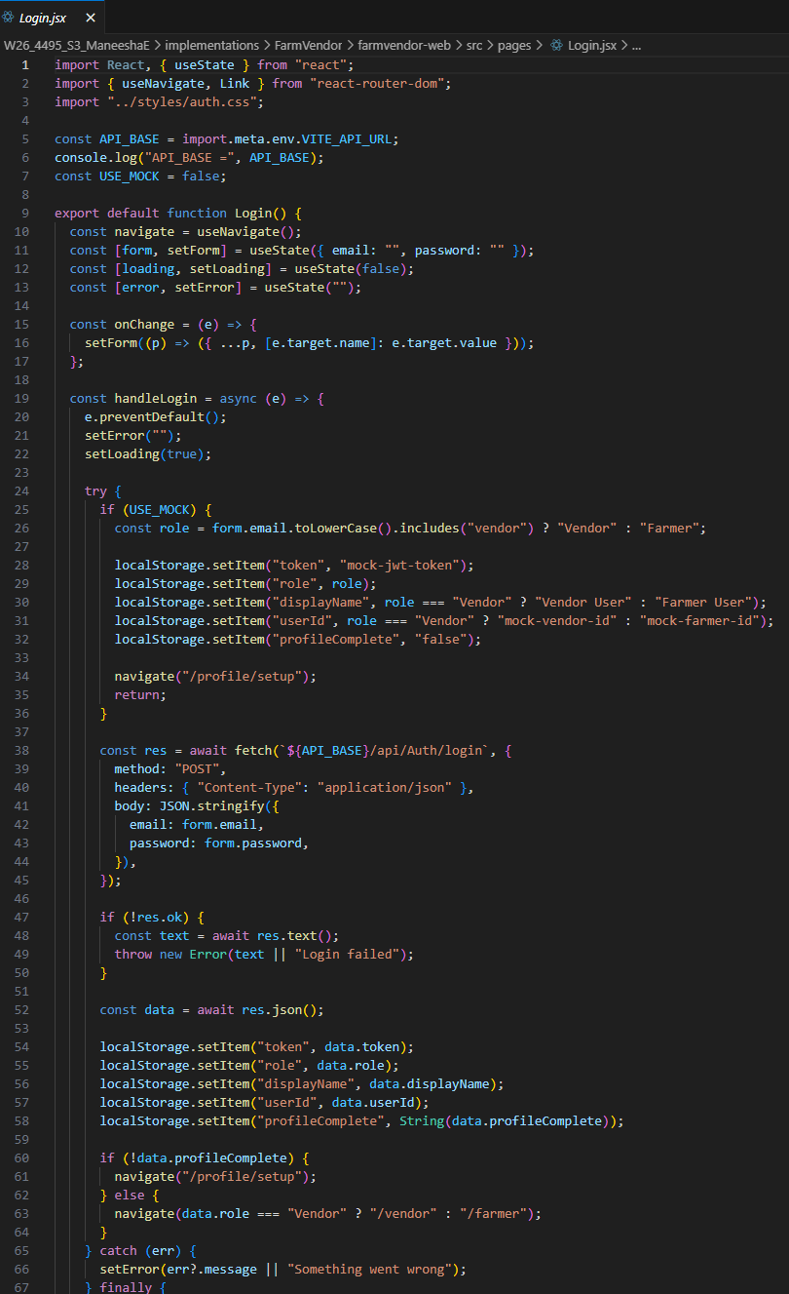

- RequireAuth.jsx
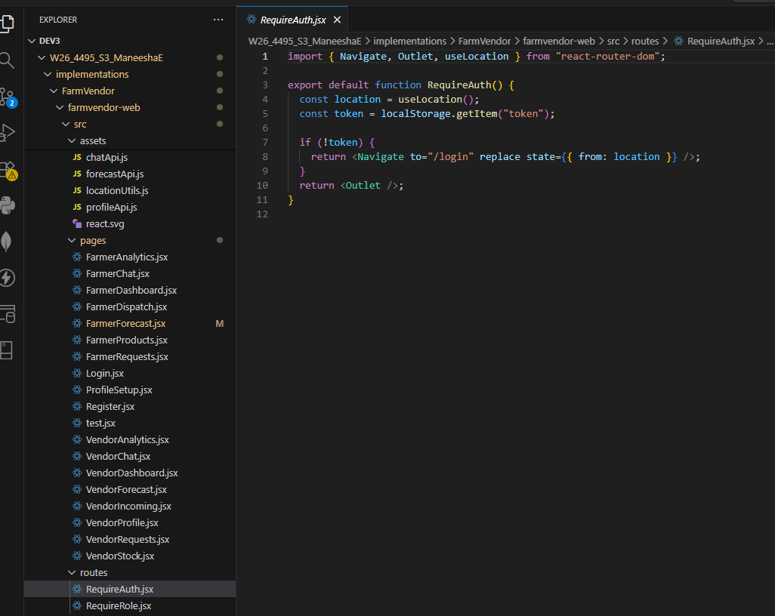

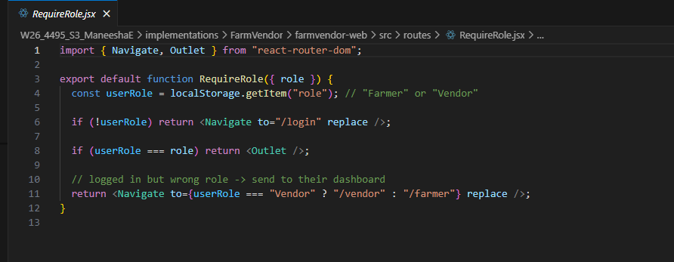
- RequireRole.jsx

Backend

- AuthController.cs
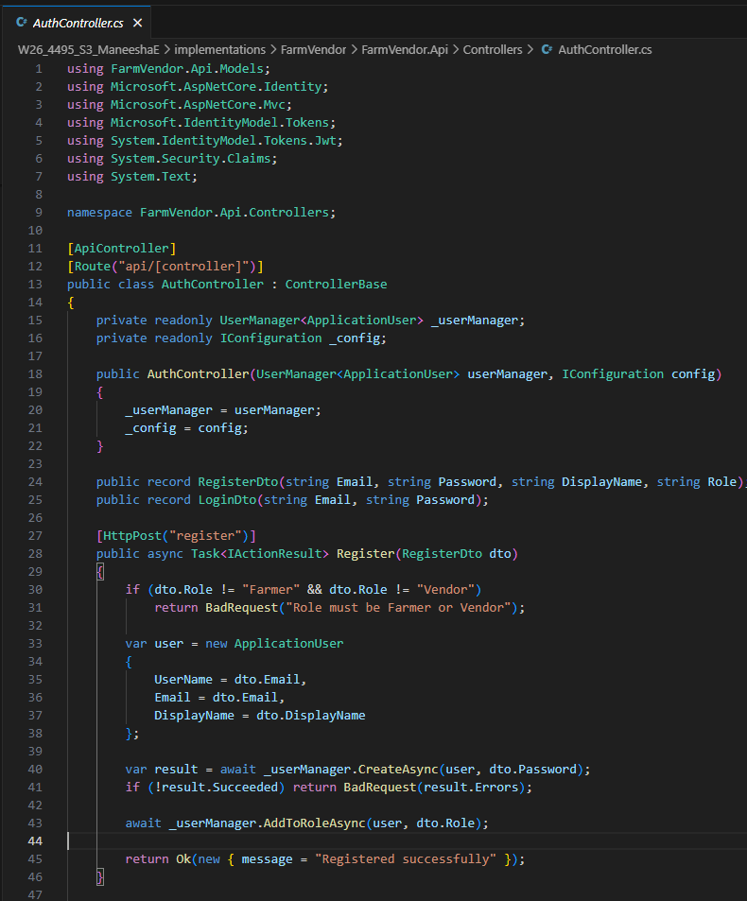

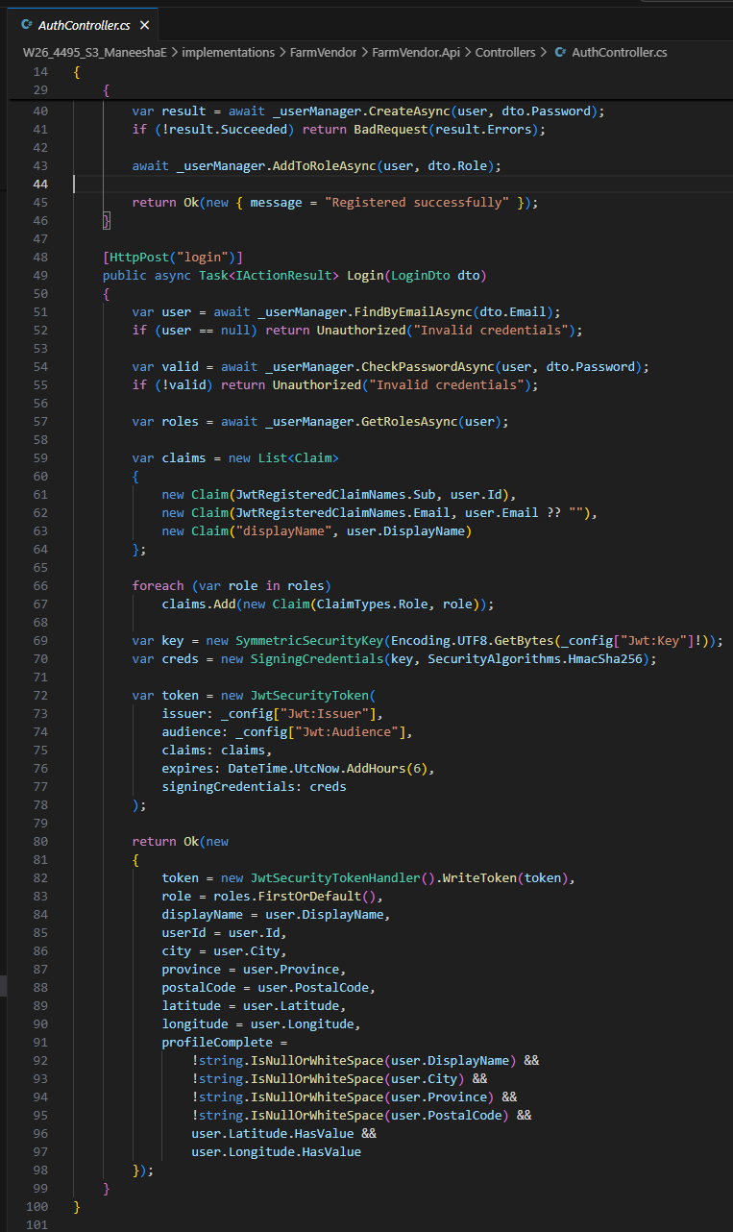

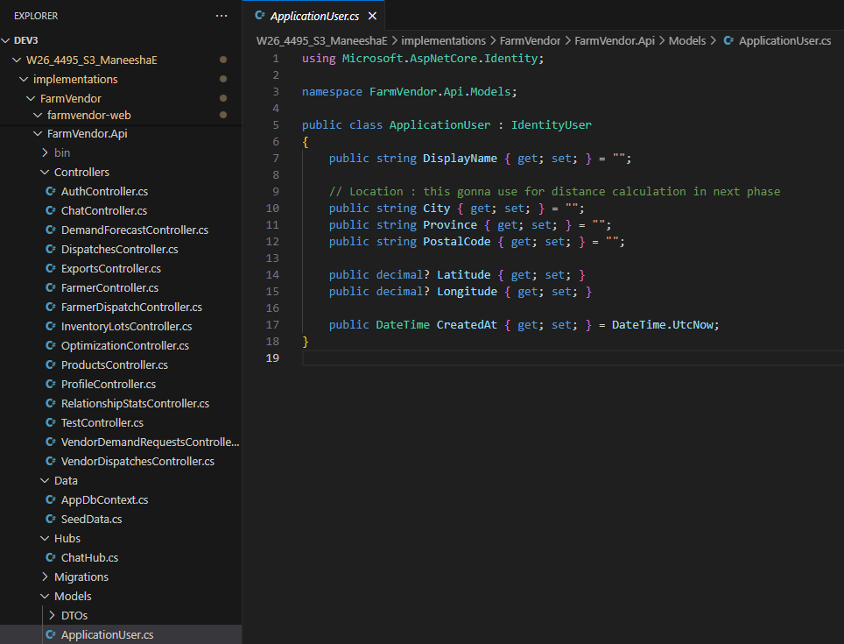

- Program.cs

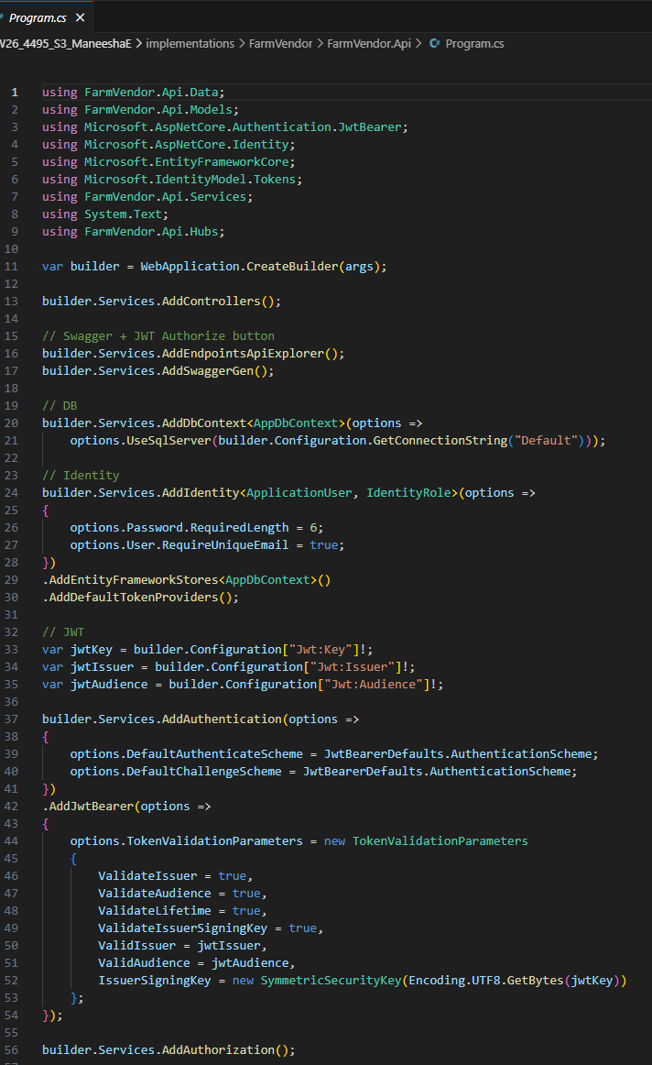

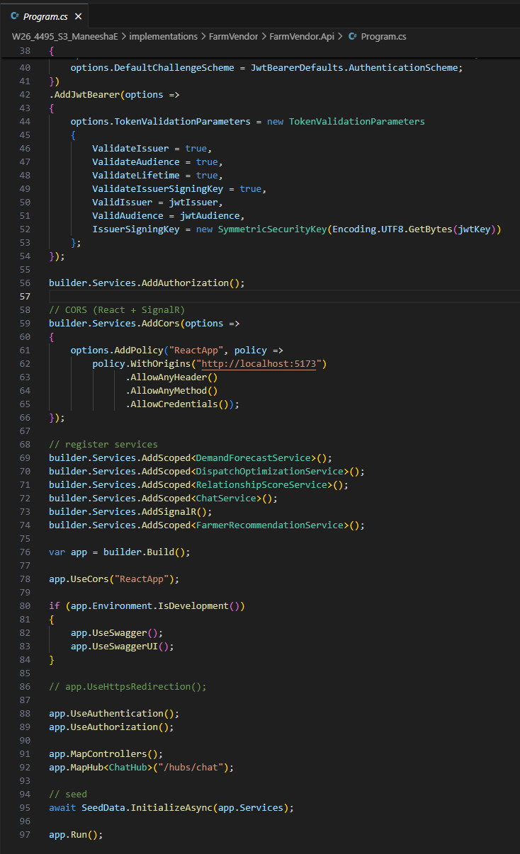

- Postman: JWT token generation logic using issuer, audience, and signing key

POST : http://localhost:5136/api/Auth/login
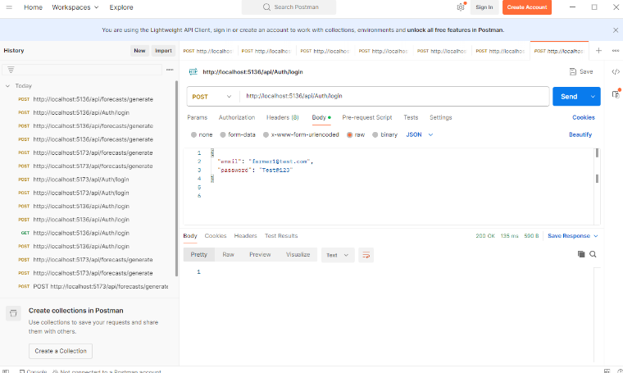

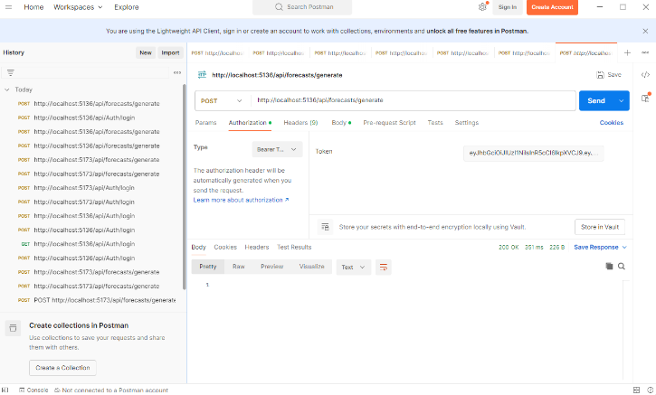
Bearer token

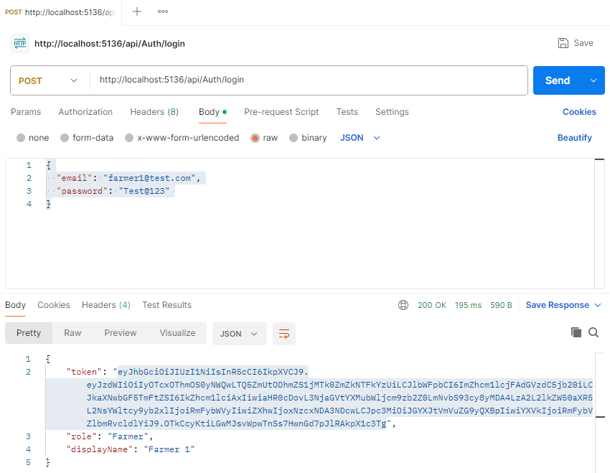

Database

- AspNetUsers Table
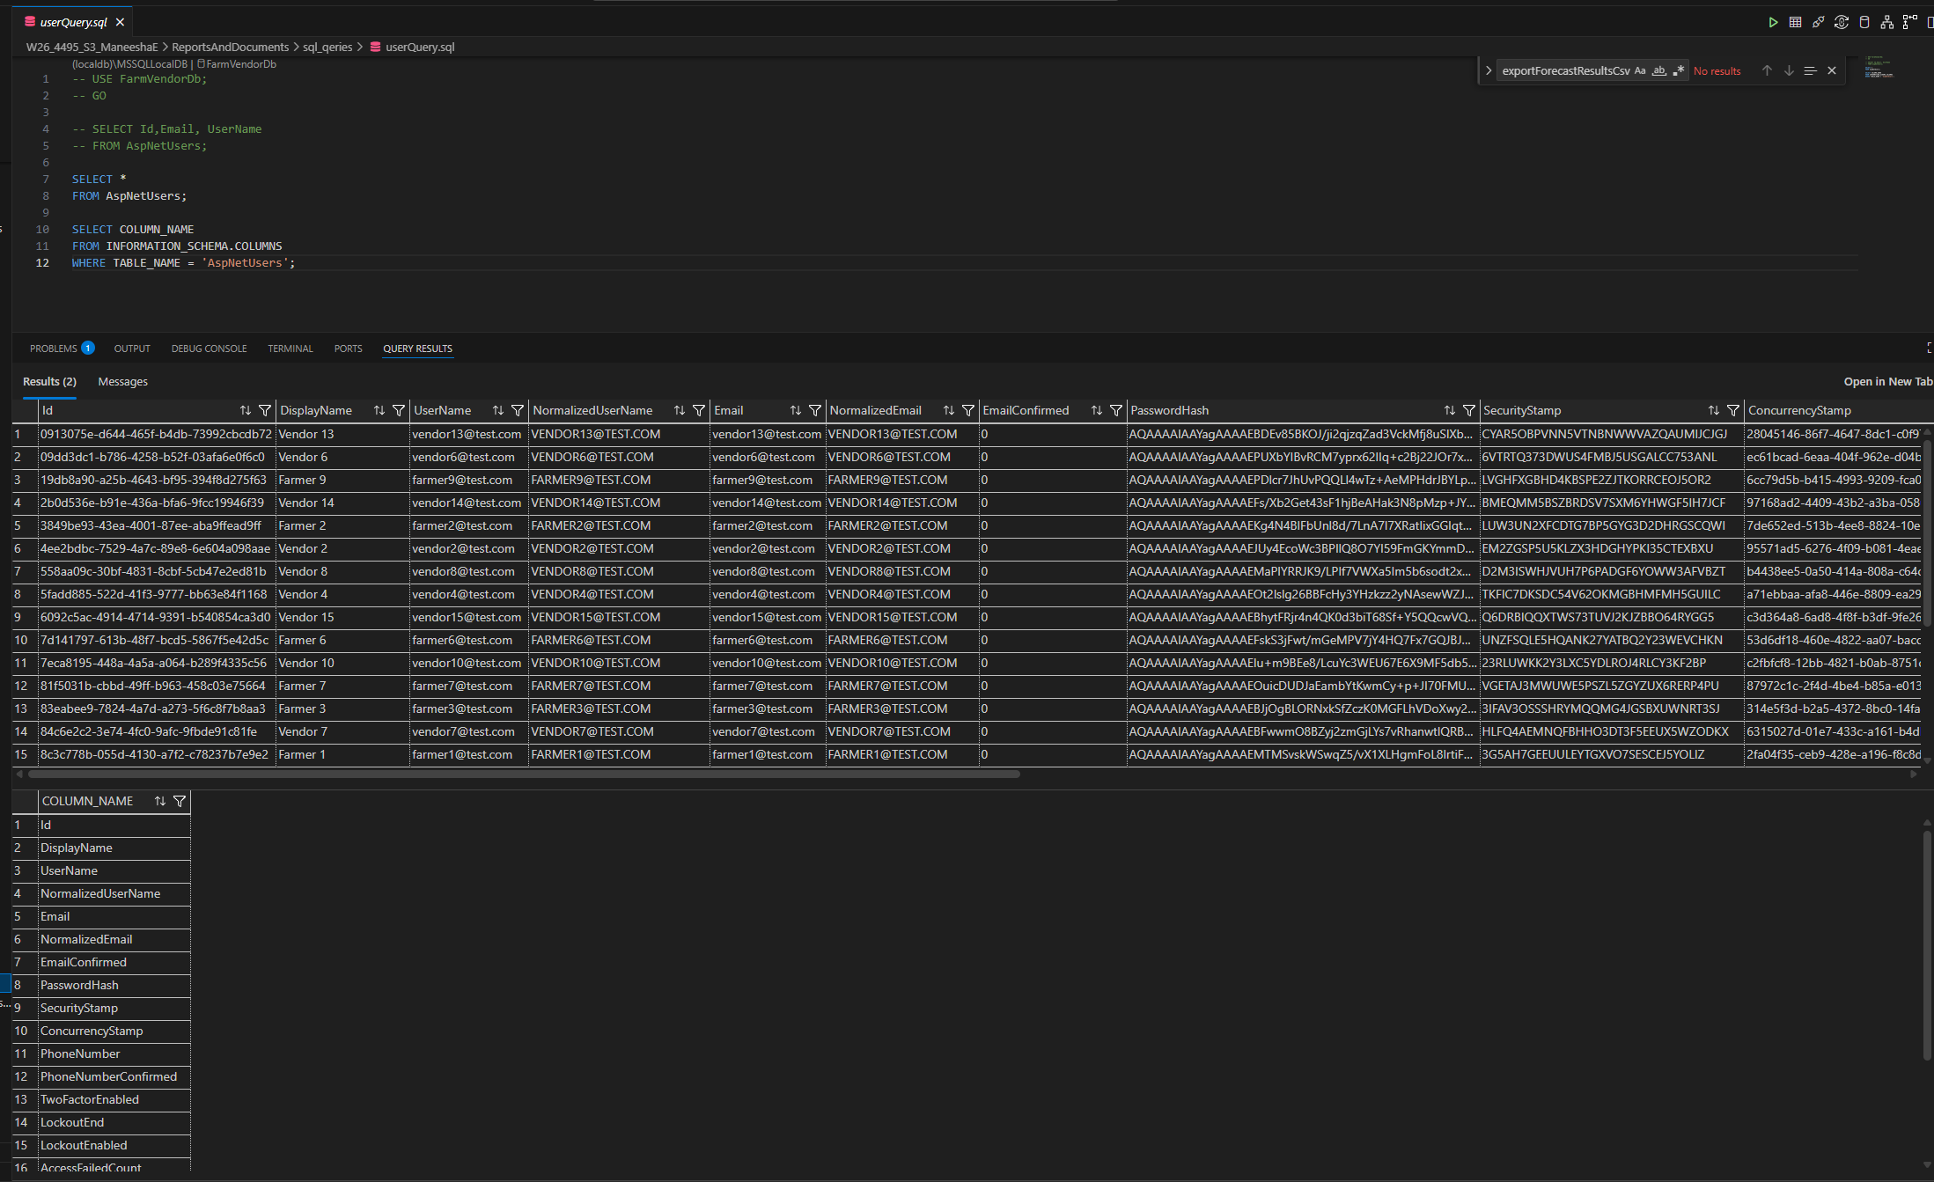

Feature 5: Farmer Inventory Management
This feature enables farmers to add, manage, and monitor product inventory lots with quantity and expiry tracking. It supports operational planning by providing clear visibility into available stock.
In the final implementation, this module was significantly enhanced by integrating product image selection using the Unsplash API, improving usability and visual interaction for non-technical users.

This feature includes:
Add product lot form
Inventory table view
Expiry date tracking
Expiry status badge logic
Product image selection using Unsplash API
Visual product identification instead of text-only selection

The design consists of:
Modal-based inventory lot entry
Real-time table updates after submission
Status labels such as Fresh / Near Expiry / Expired
Image-based product selection modal
Preview of selected product image before saving

Implementation
Frontend
- FarmerDashboard.jsx
- Add Product Lot modal
- Inventory table UI
- Dynamic status badge rendering
- Image selection modal integrated with Unsplash API
- Image preview component for selected product

Backend
- InventoryLotsController.cs
- ProductsController.cs
- CreateInventoryLotDto.cs
- InventoryLot.cs
- Validation for:
  - Quantity
  - Expiry date
  - Product selection
Database
InventoryLot table storing:
- FarmerId
- ProductId
- QuantityAvailable
- Unit
- ExpiryDate
- CreatedAt
Product table enhanced with image fields
- ImageUrl
- ImageThumbUrl
- ImageSource
- PhotographerName
- PhotographerProfile

App
- FarmerDashboard
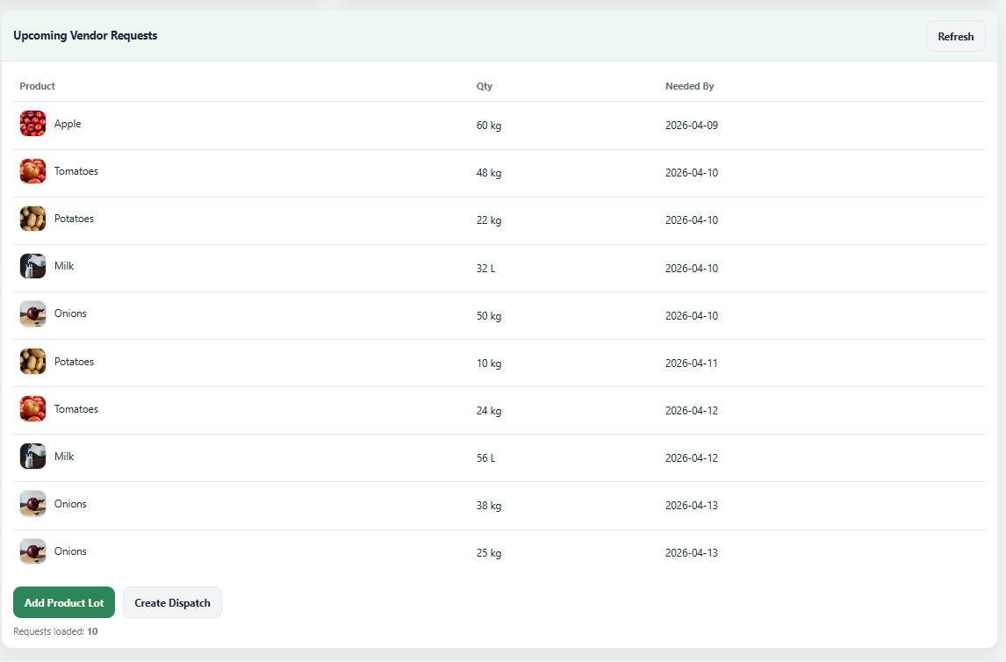

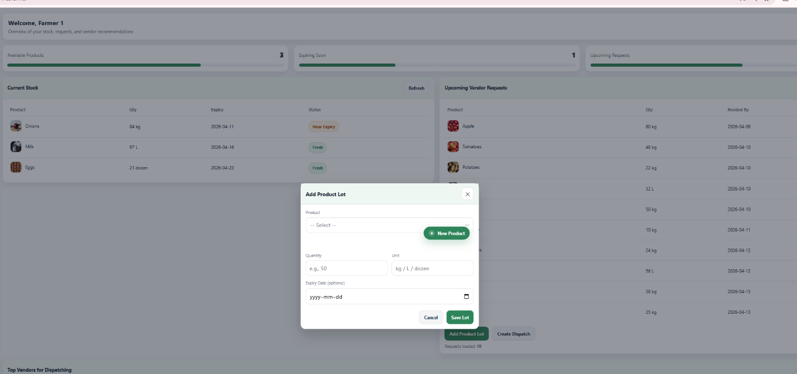

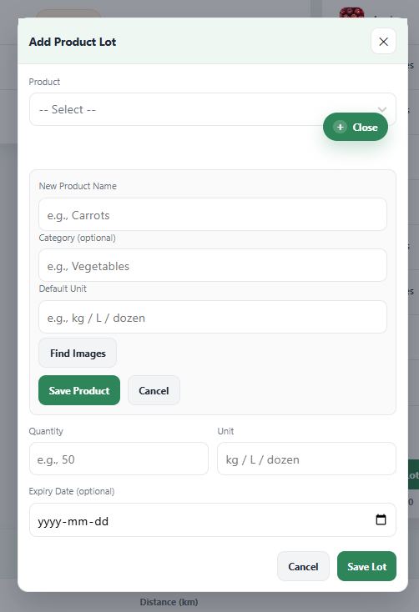

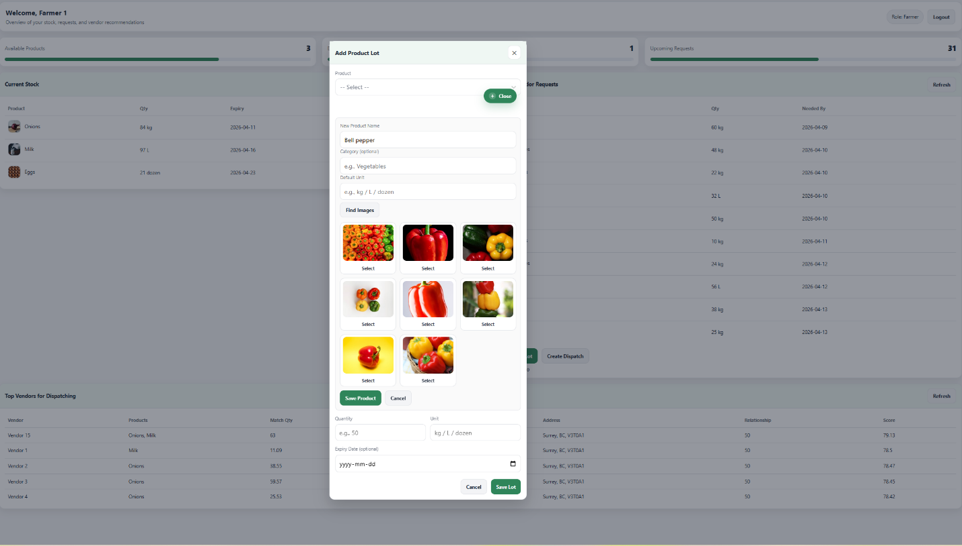

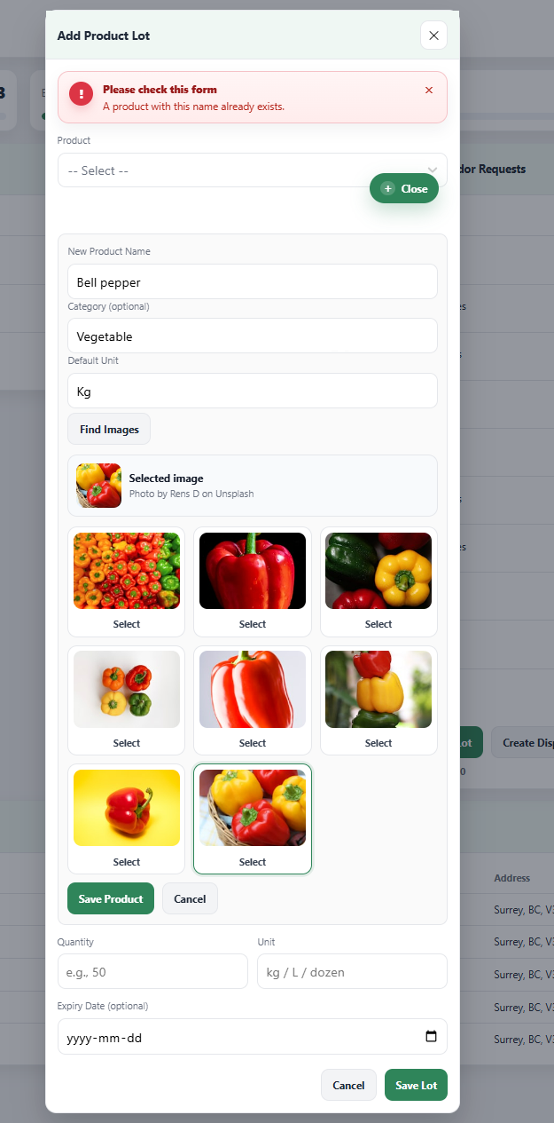

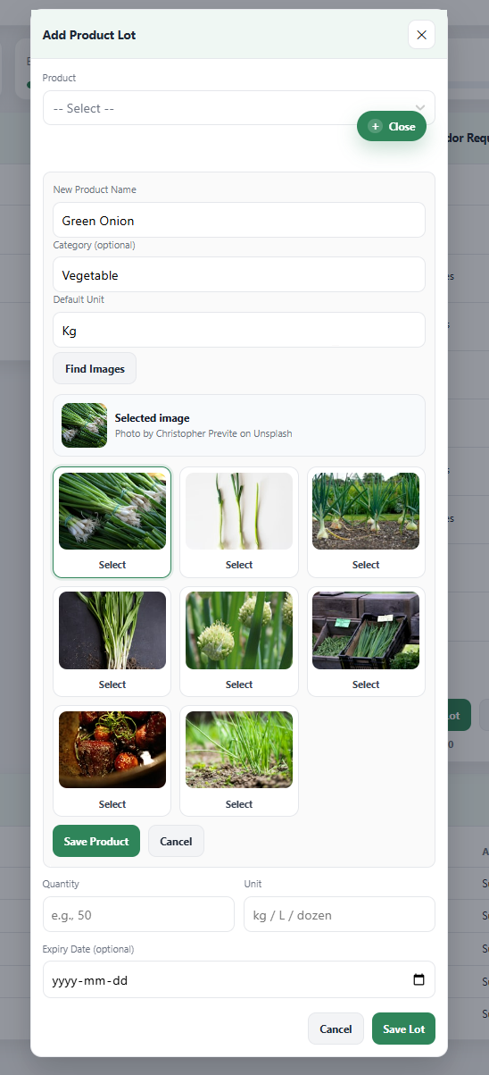

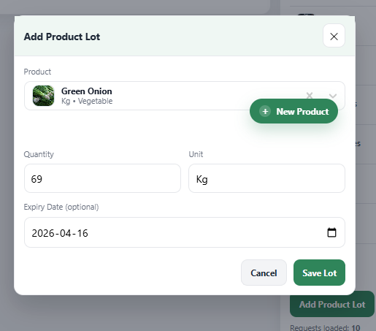

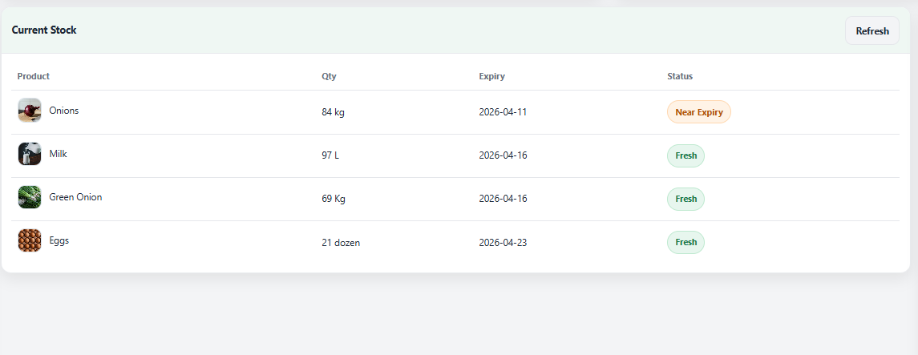

- Product interface

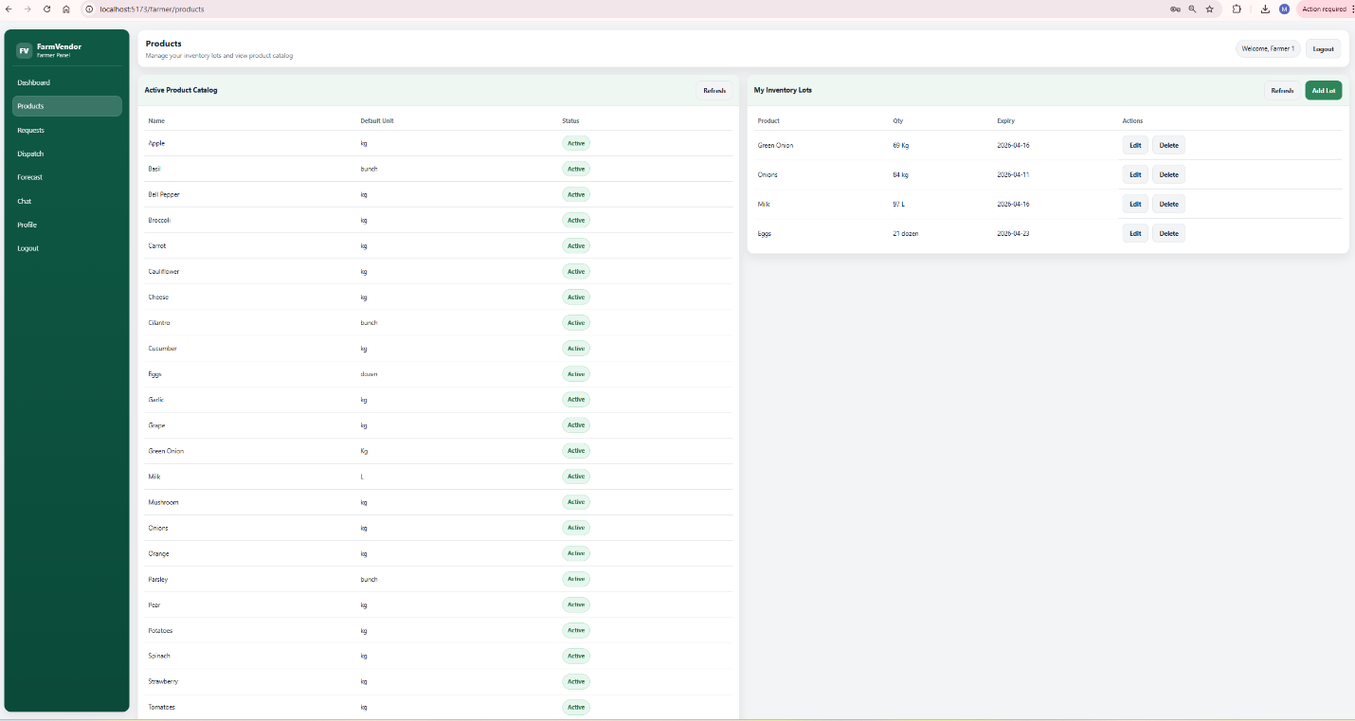

Frontend
- FarmerDashboard.jsx
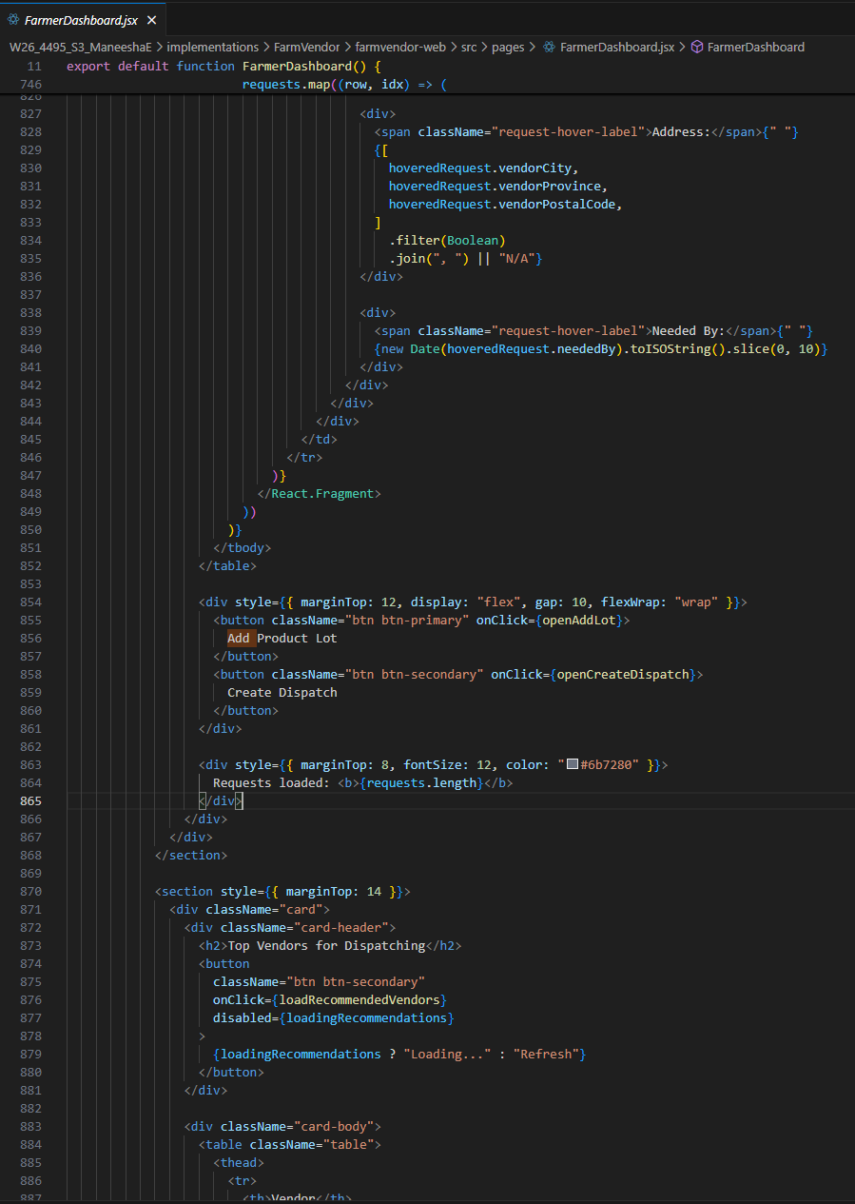

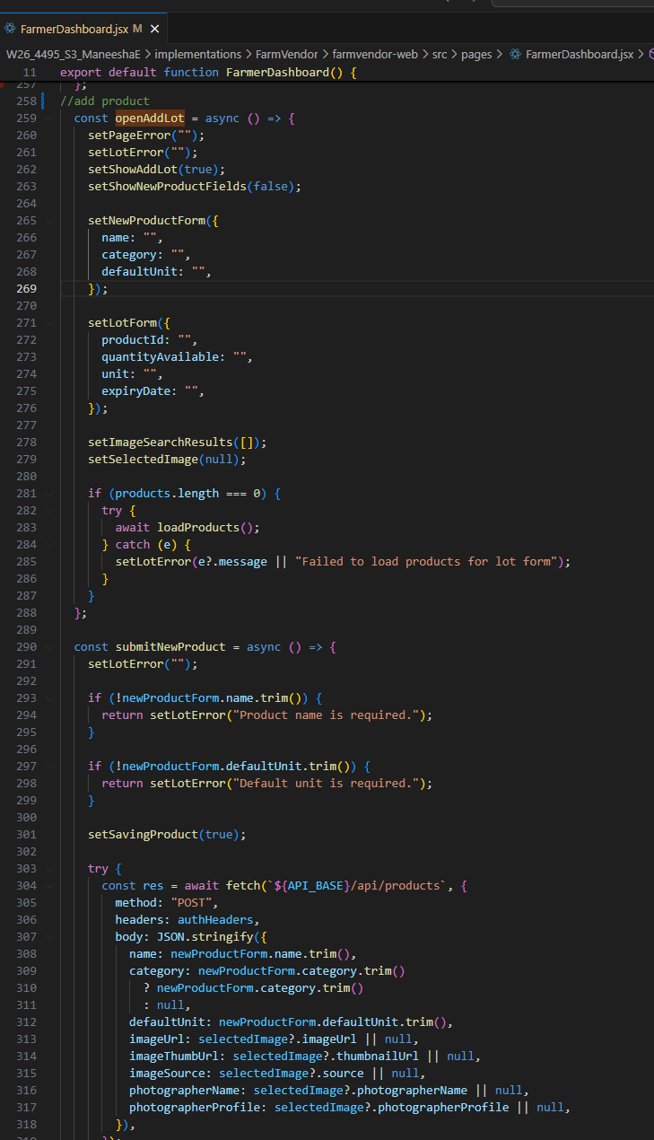

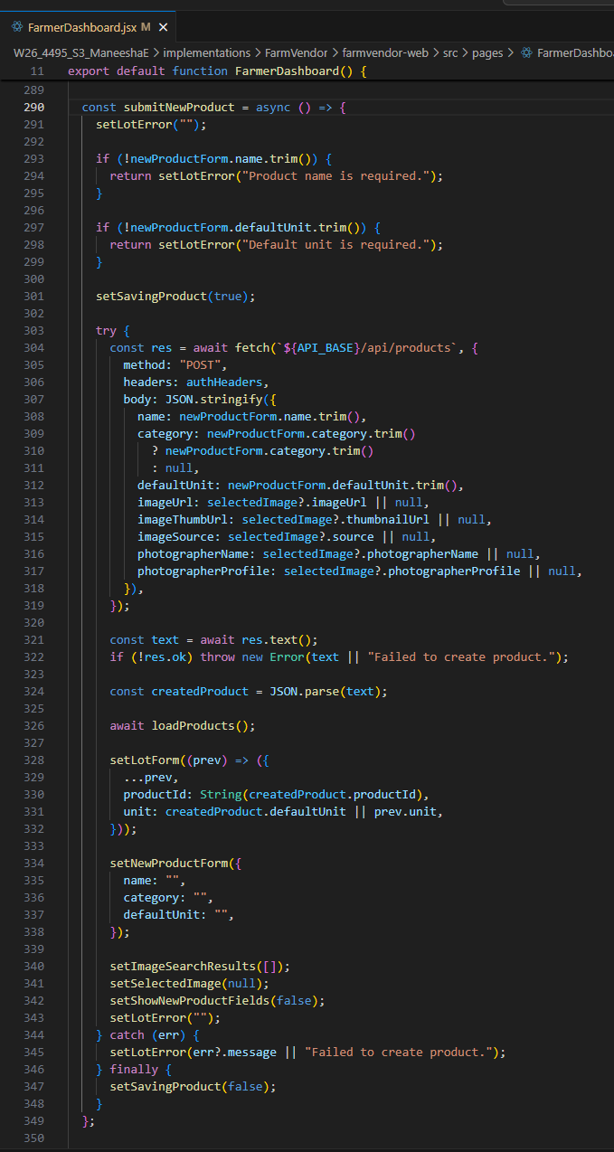

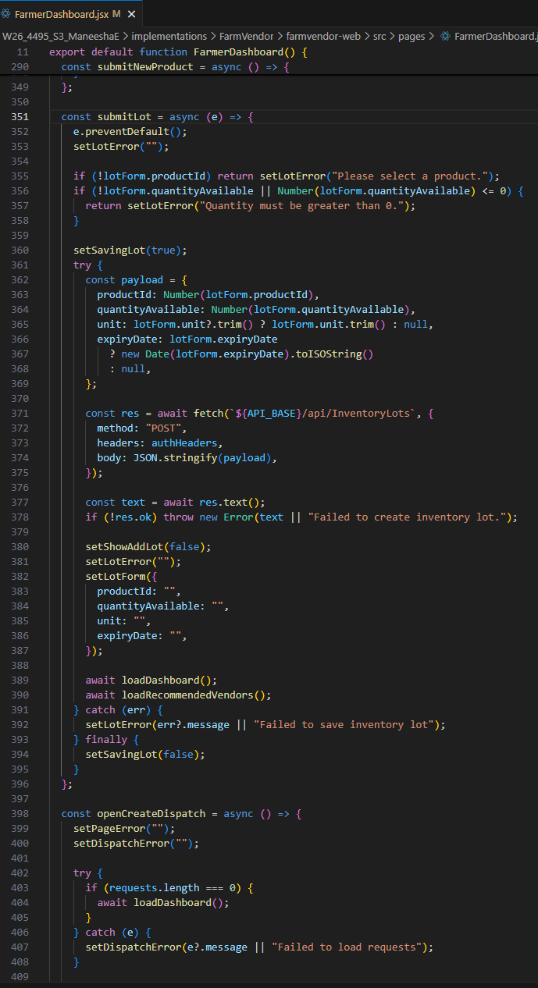

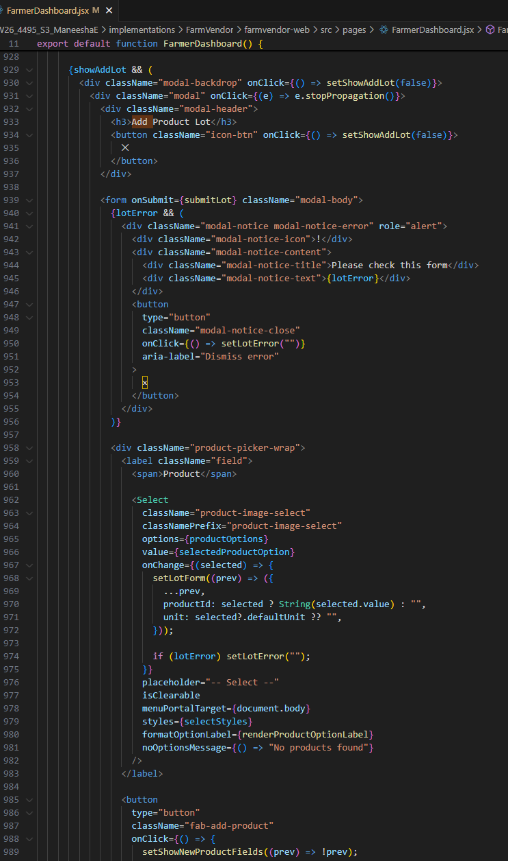

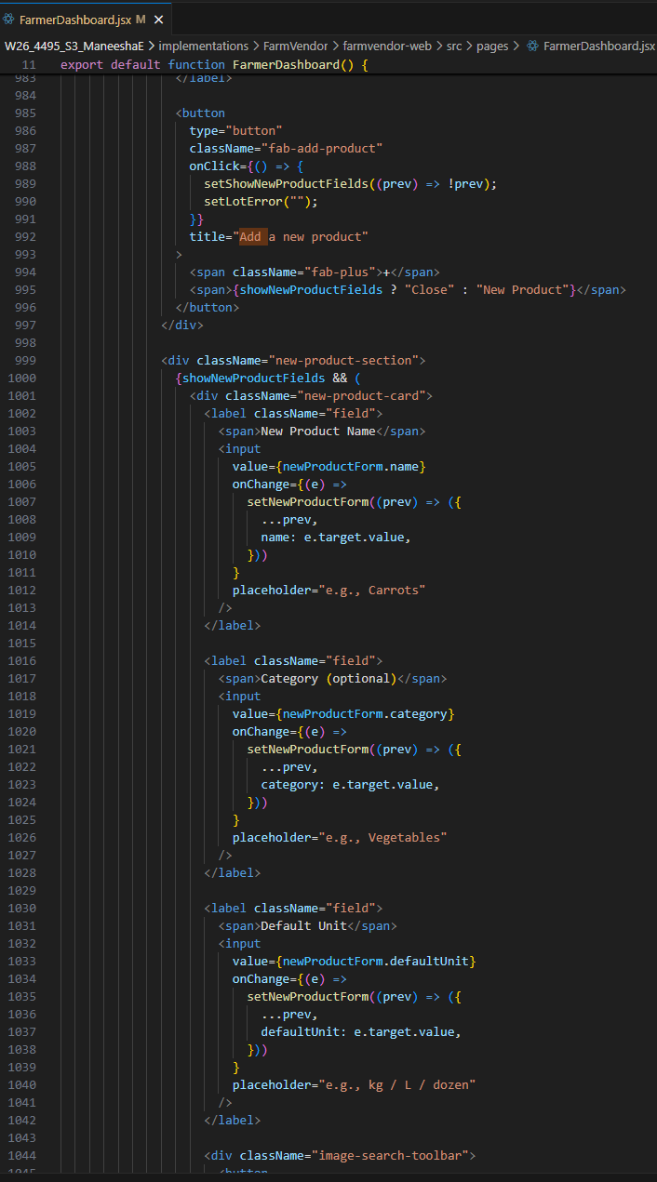

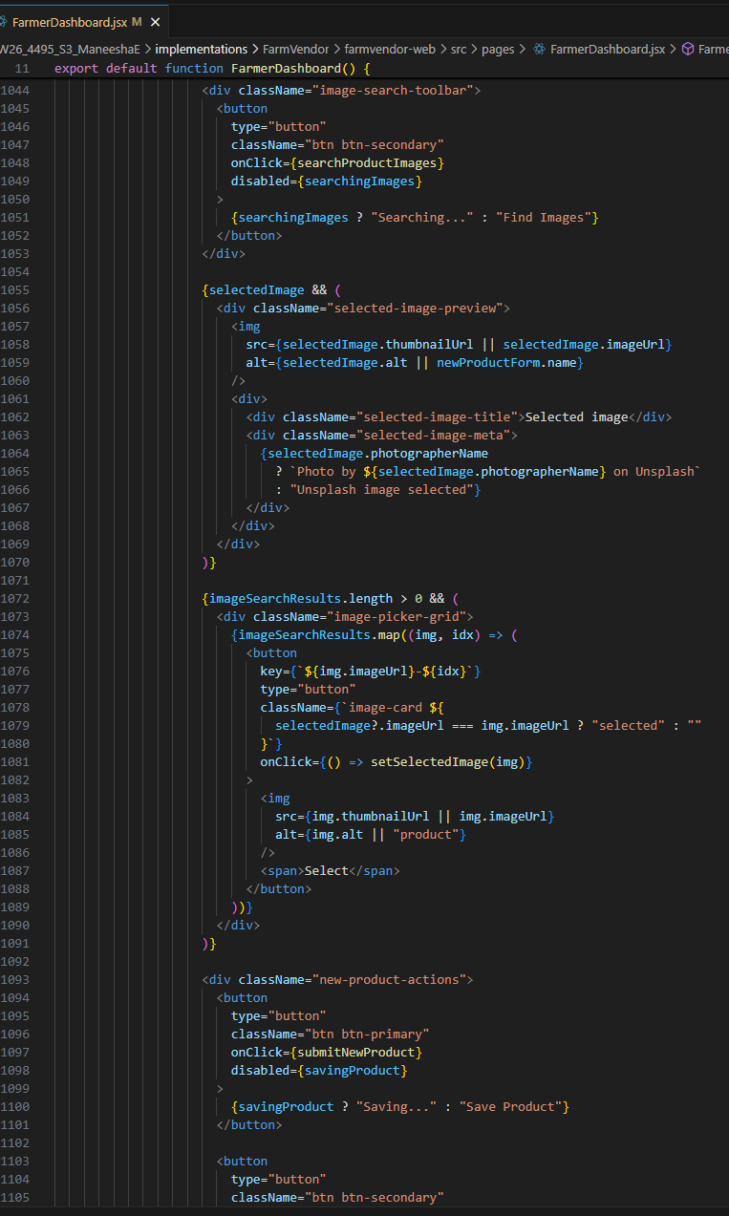

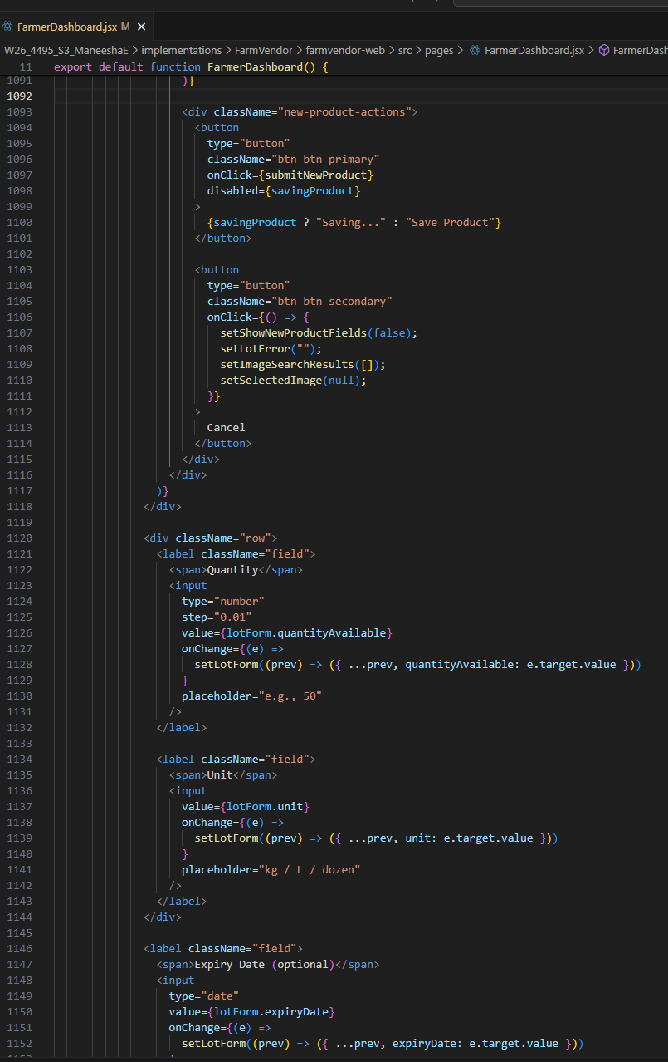

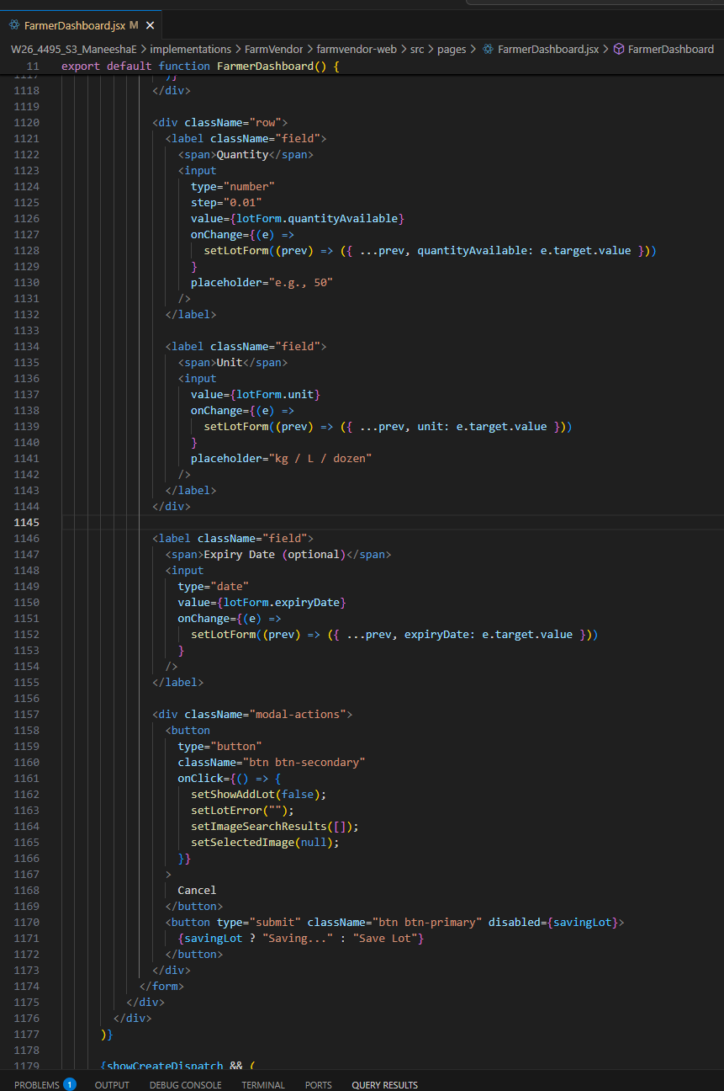

- FarmerProduct.jsx
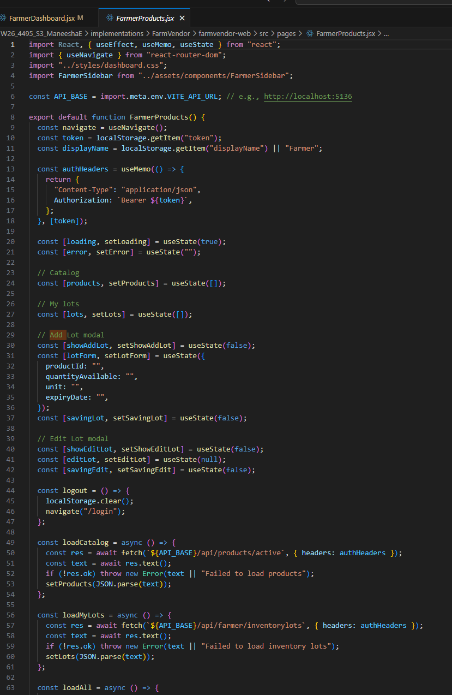

Backend

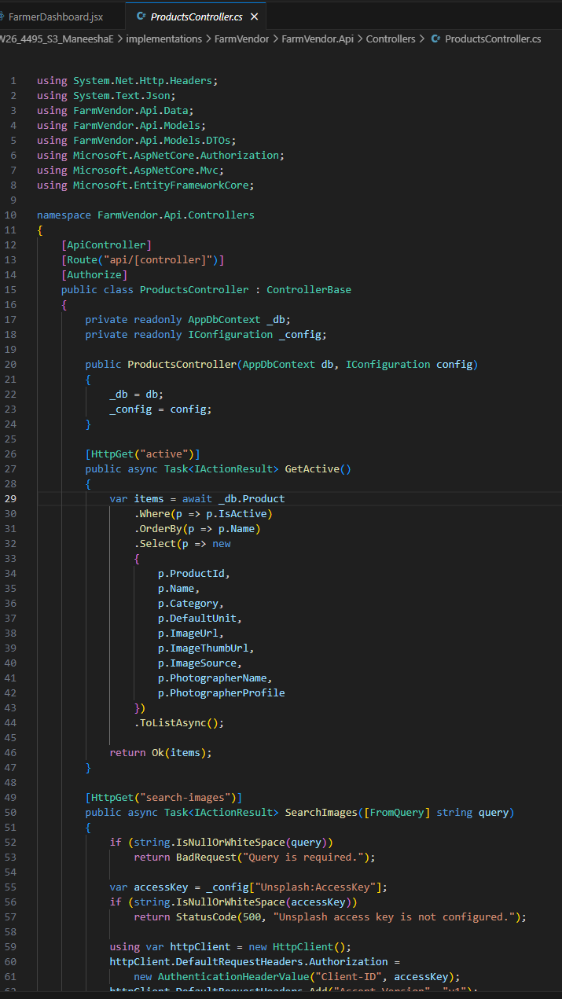
- ProductController.cs

  - CreateProductDTO.cs
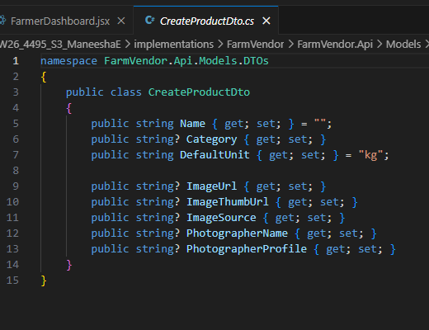

  - InventoryLotDTO.cs
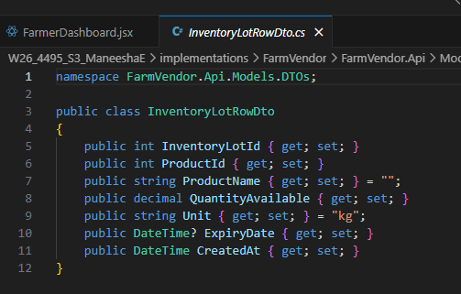

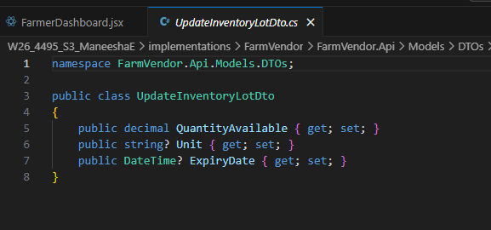
- UpdateInventoryLotDTO.cs

- InventoryLot.cs
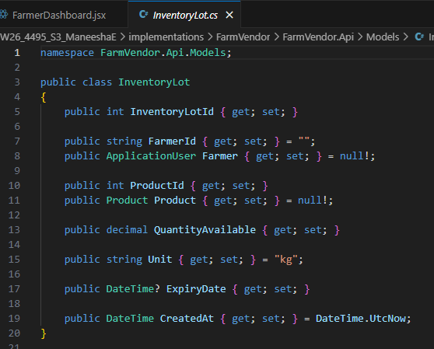

Database

- Product table
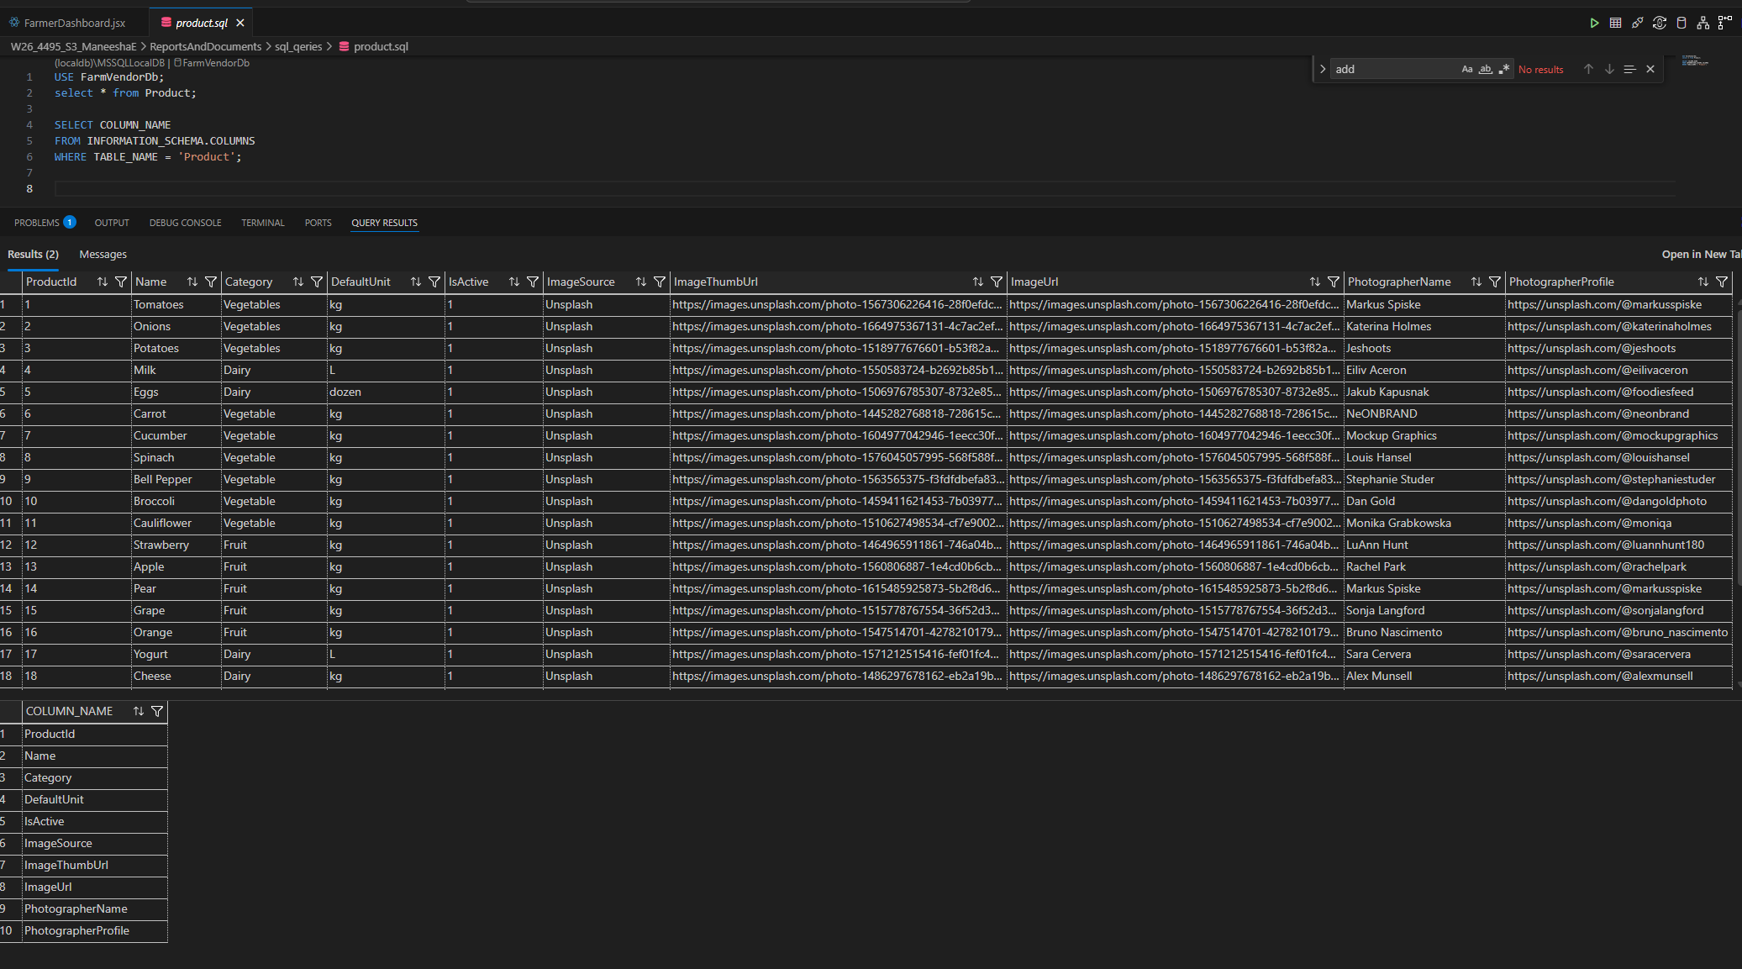

- InventoryLot table
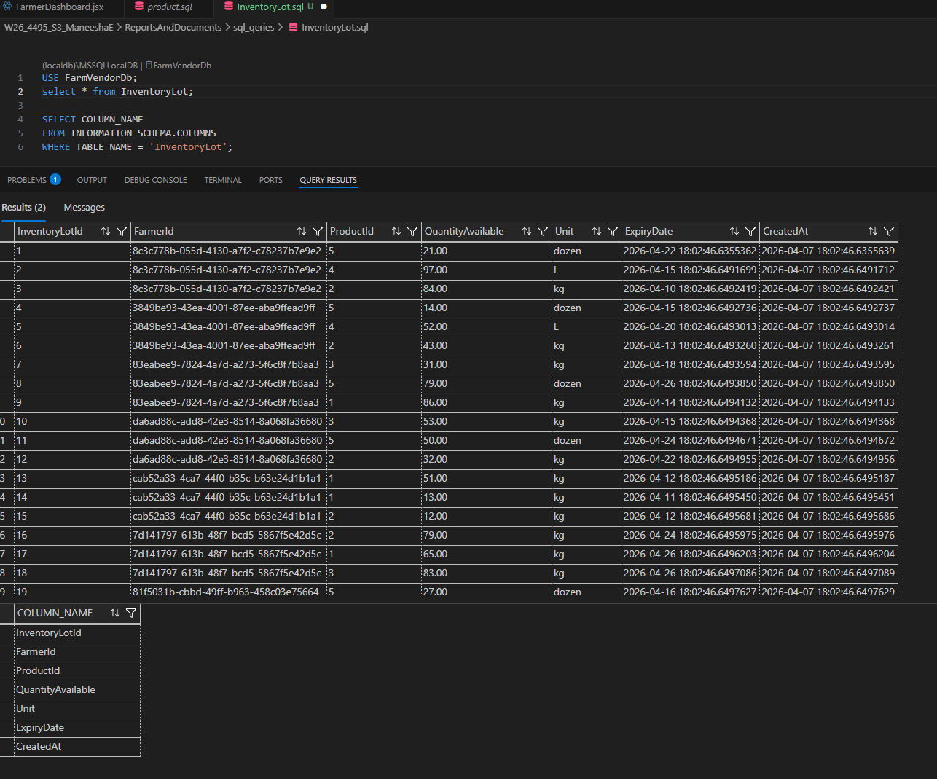

Feature 6: Vendor Demand Request System

This feature allows vendors to create demand requests for products when stock is low. It supports structured communication of vendor needs and acts as a core input to forecasting and dispatch planning.
This feature includes:
- Low stock alert table
- Demand request creation
- Open / Fulfilled / Cancelled lifecycle tracking
- Product-based request creation
The design consists of:
- Low stock visibility
- Demand request creation form
- Request status lifecycle management
Implementation
Frontend
- VendorDashboard.jsx
- Create demand request button
- Low stock alert UI
- Open request list
Backend
- VendorDemandRequestsController.cs
- DemandRequest.cs
- CreateDemandRequestDto.cs
- Request status handling logic
Database
DemandRequest table storing:
- VendorId
- ProductId
- QuantityRequested
- Unit
- NeededBy
- Status
- CreatedAt

App

- VendorDashboard
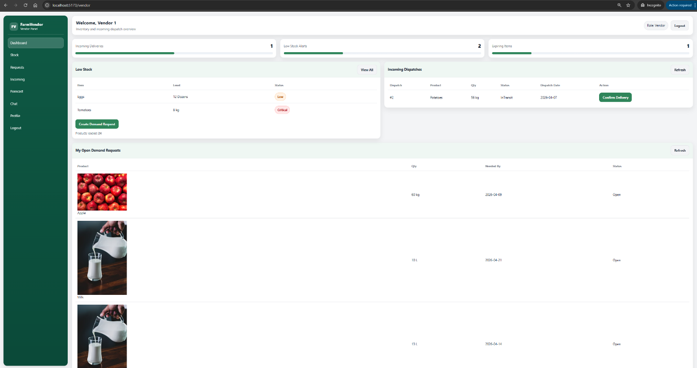

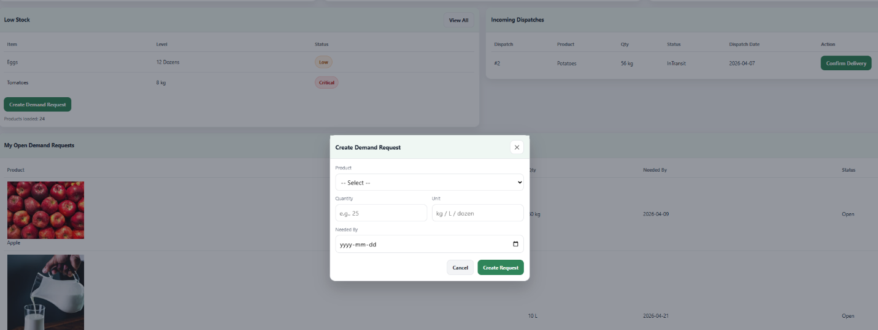

Frontend

- VendorDashboard.jsx
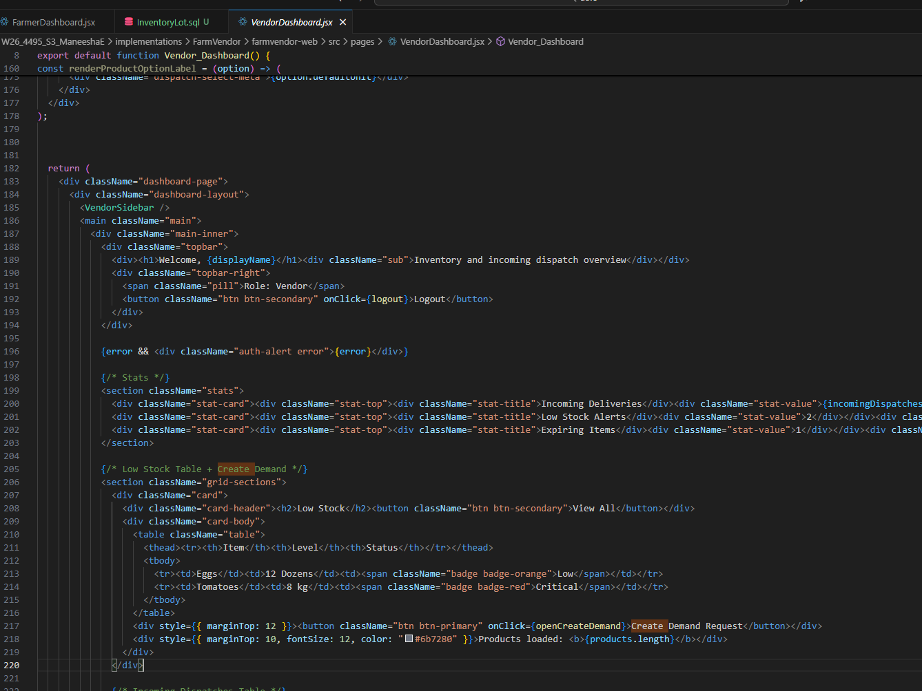

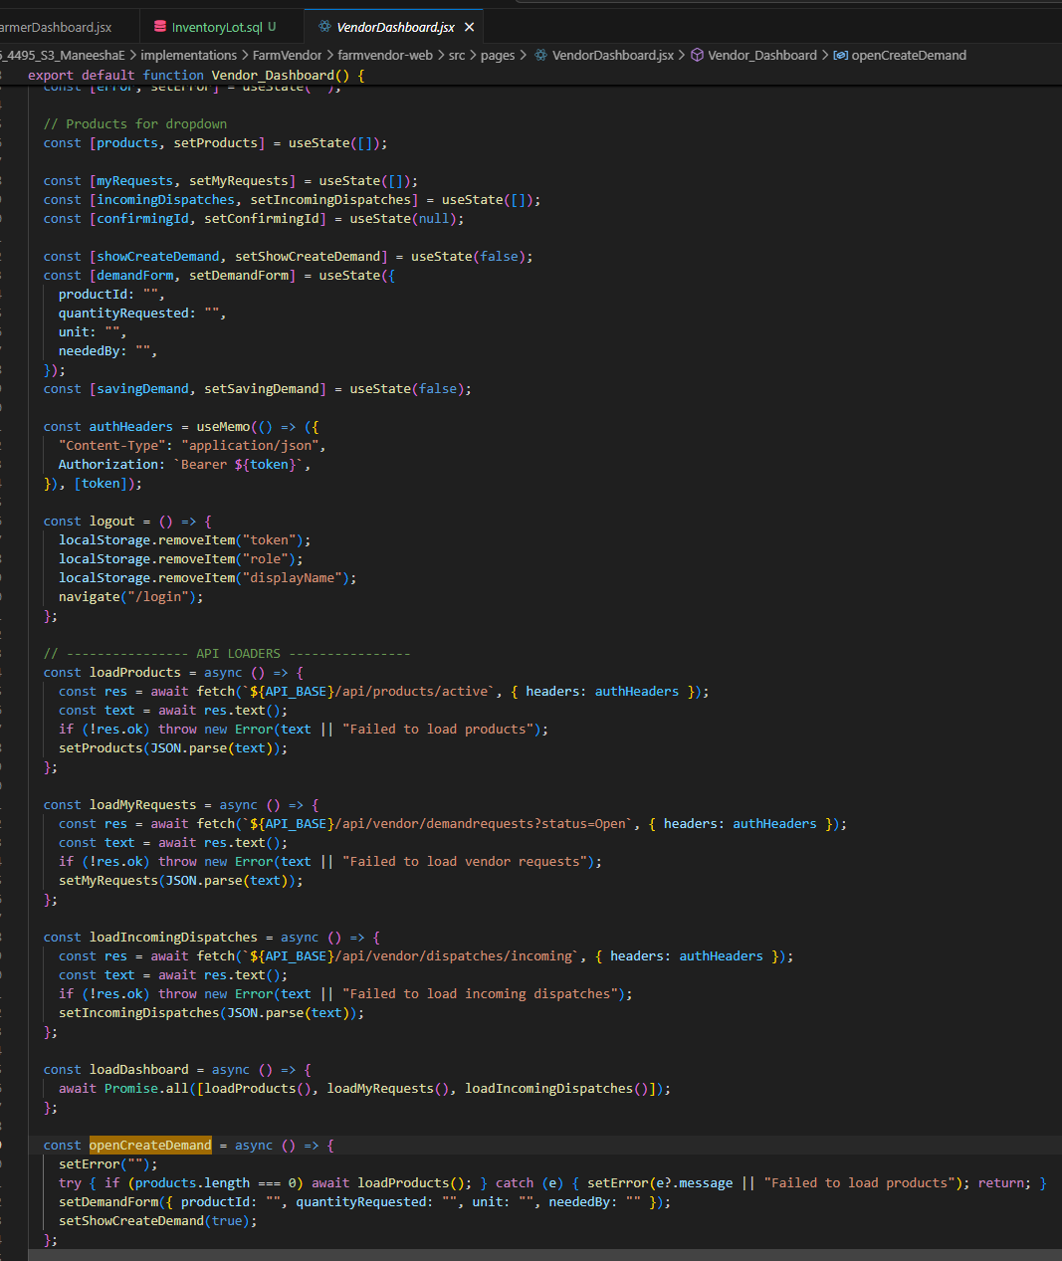

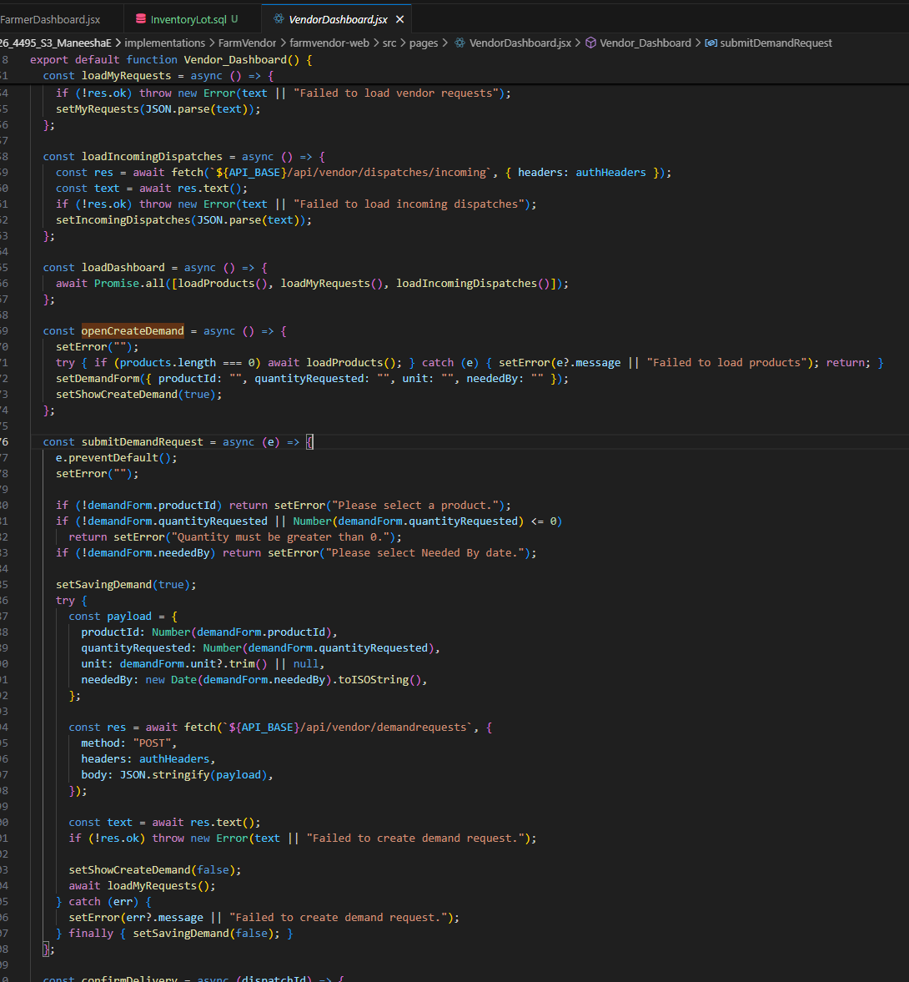

Backend

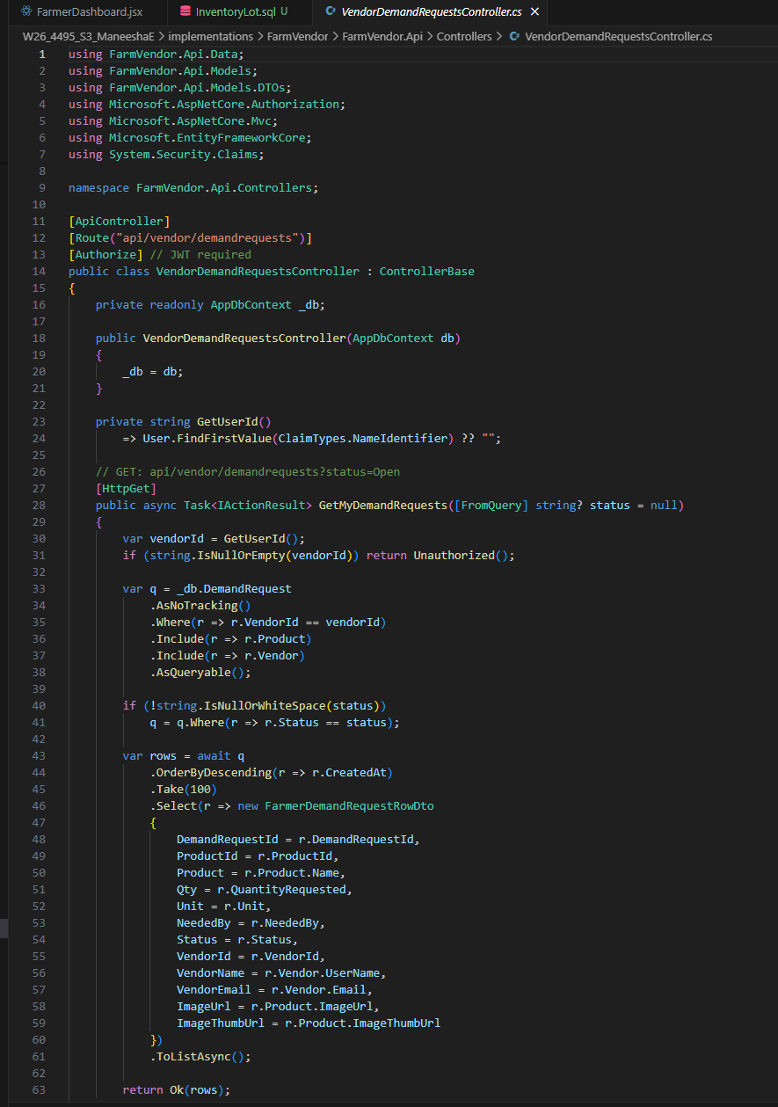
- VendorDemandRequestController.cs

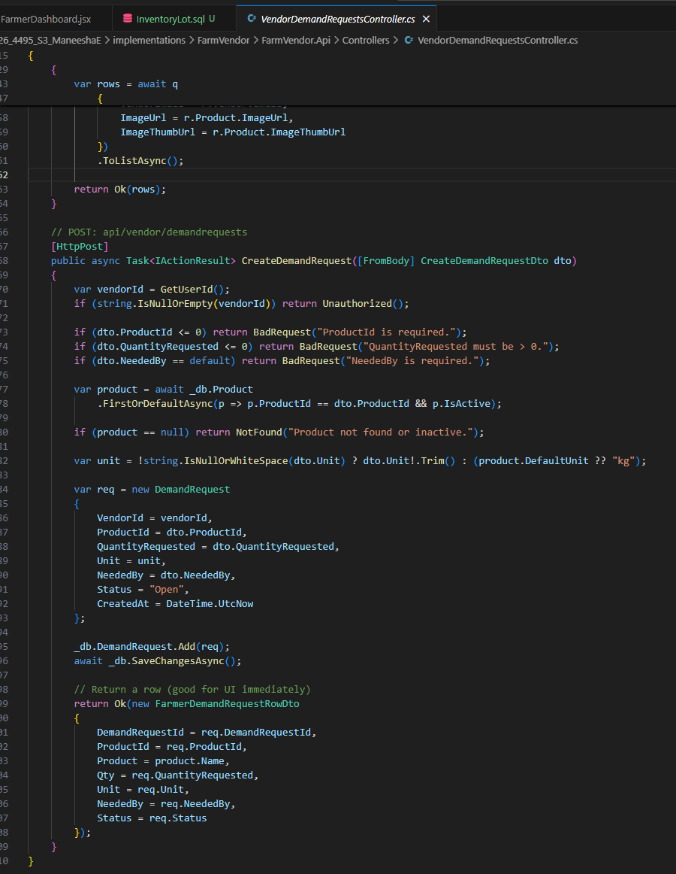

- DemandRequest.cs

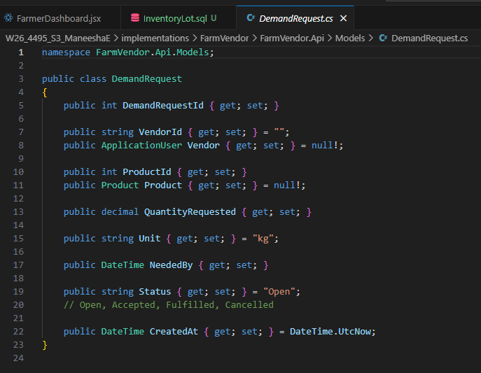

- CreateDemandRequestDTO.cs
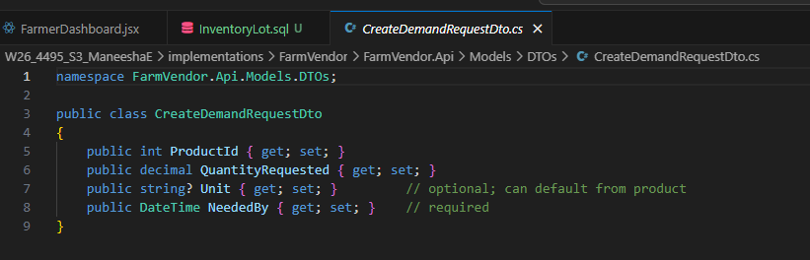

Feature 6: Dispatch Management Module
This feature enables farmers to create dispatches based on vendor demand requests and allows vendors to confirm delivery. It supports operational coordination between both roles.
This feature includes:
- Create Dispatch action from Farmer dashboard
- Request selection for dispatch
- Incoming dispatch list on Vendor dashboard
- Delivery confirmation
- Dispatch status tracking
The design consists of:
- Request-to-dispatch workflow
- Vendor-side delivery confirmation
- Status updates such as Planned / InTransit / Delivered
Implementation
Frontend
- Create Dispatch action in FarmerDashboard.jsx
- Incoming dispatch list in VendorDashboard.jsx
- Confirm Delivery button on vendor side
- Product image shown with requests in dropdown
Backend
- FarmerDispatchController.cs
- VendorDispatchesController.cs
- CreateDispatchDto.cs
- VendorConfirmDeliveryDto.cs
- Delivery status update logic
Database
Dispatch table storing:
- FarmerId
- VendorId
- ProductId
- DemandRequestId
- QuantityDispatched
- Unit
- DispatchDate
- DeliveryStatus
- CreatedAt

App

- FarmerDashboard

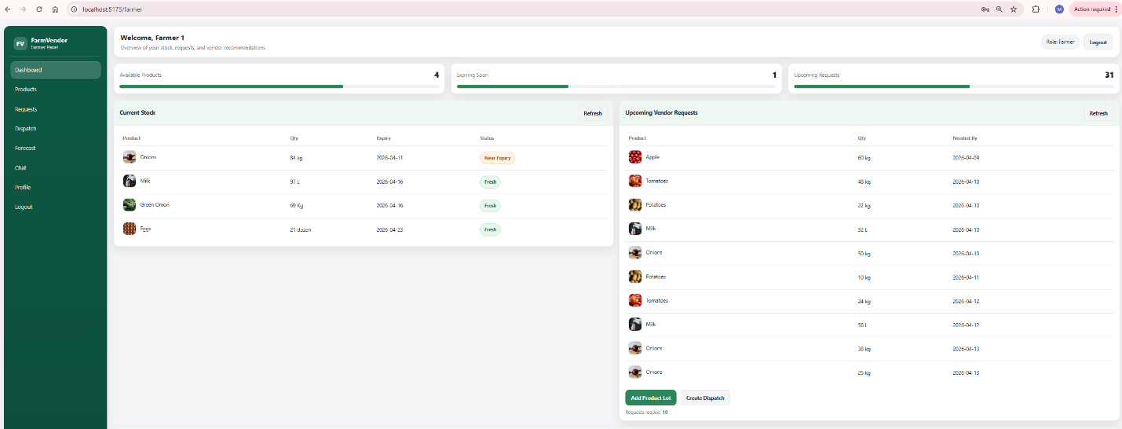

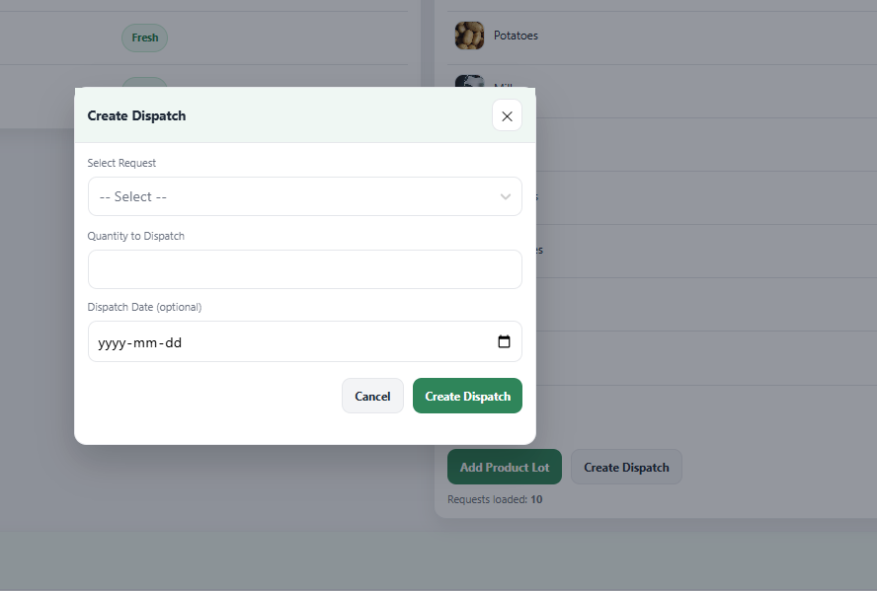

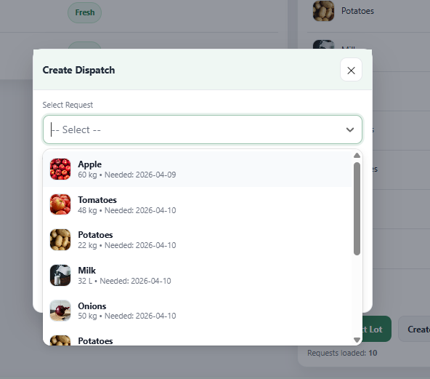

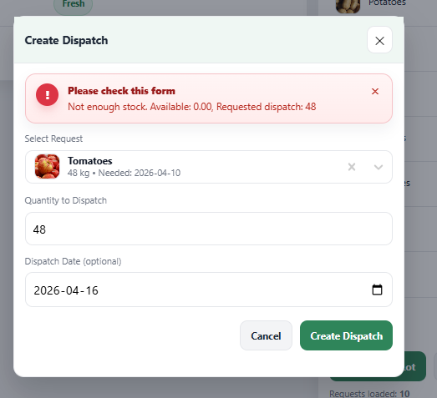

- Dispatch interface
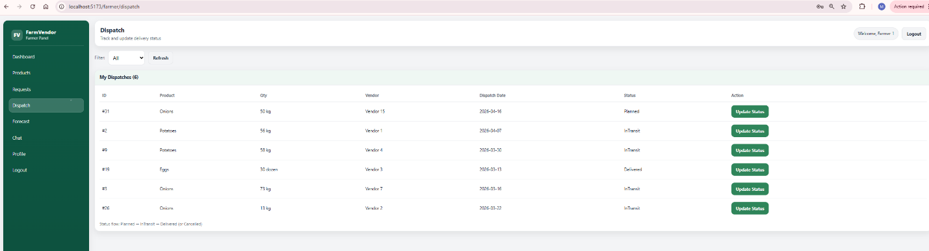

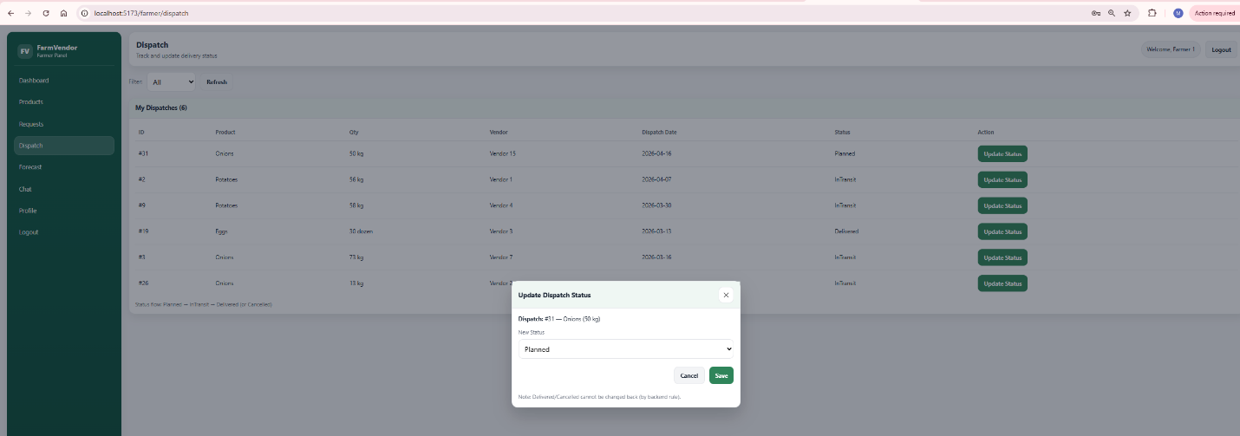

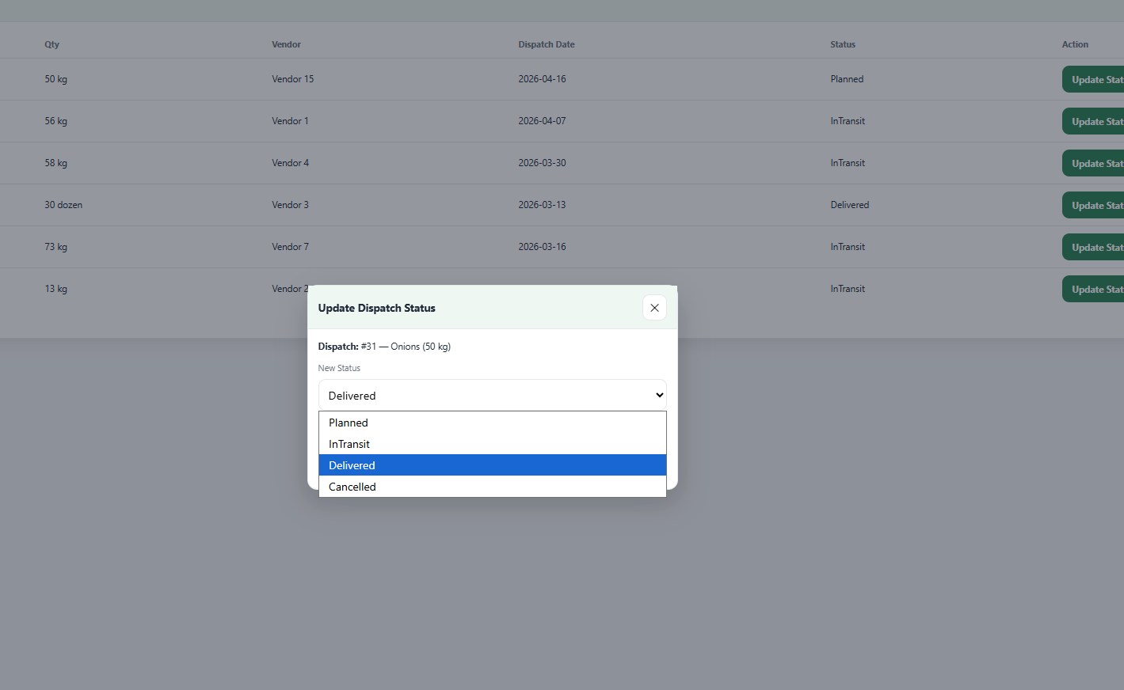

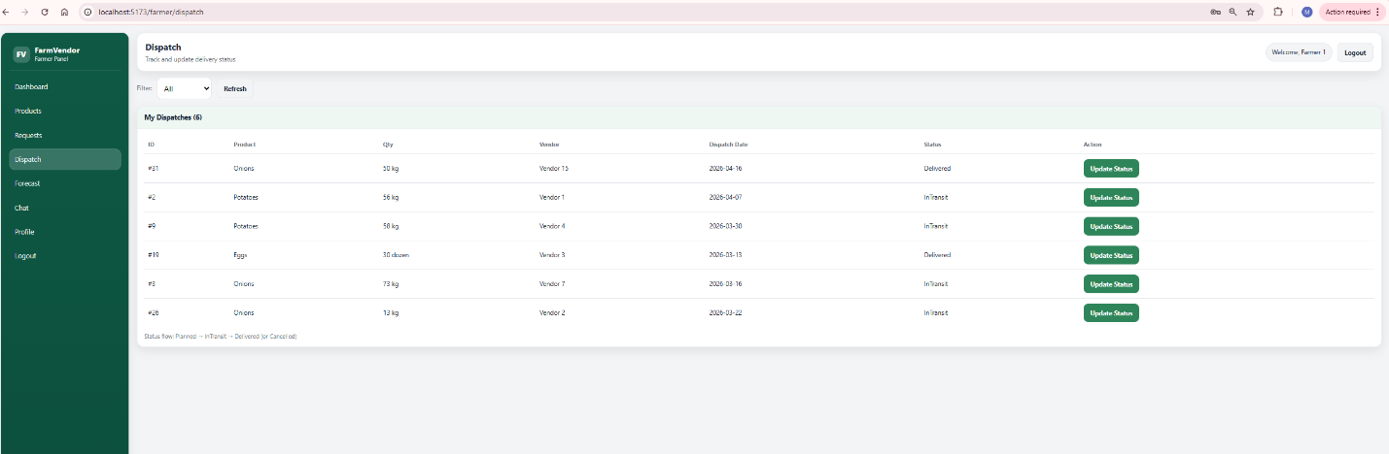

Vendor-dispatch incoming
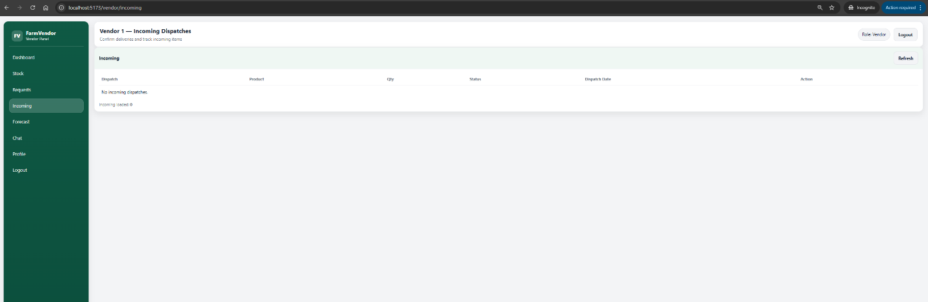

Frontend
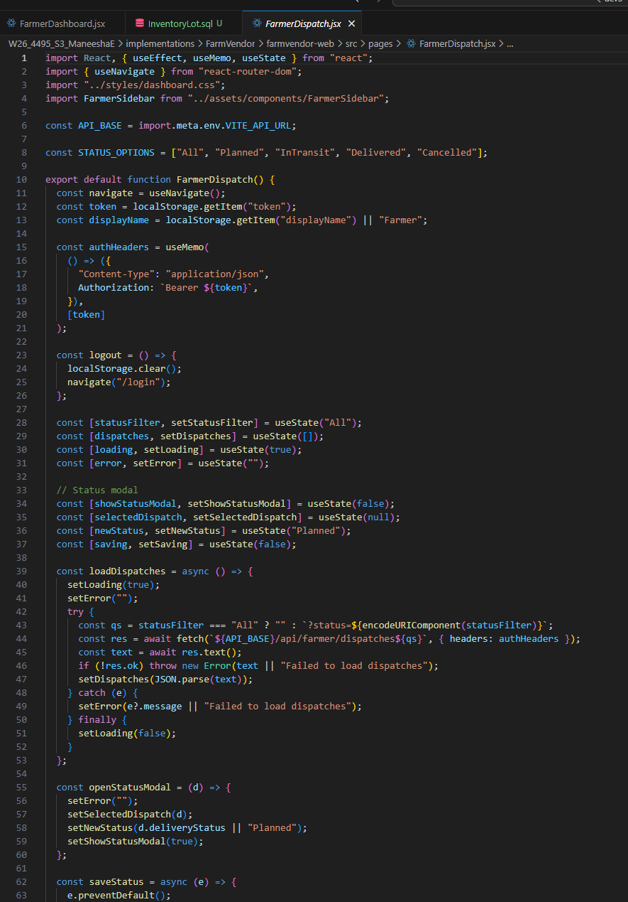

Backend
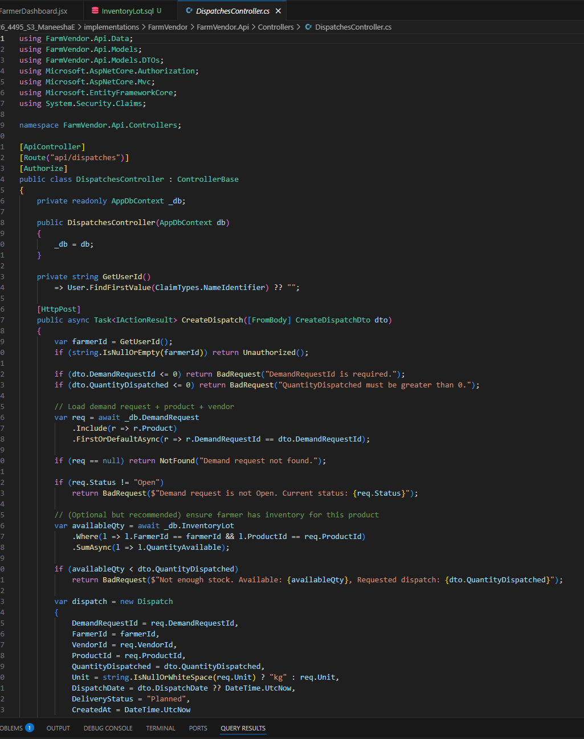

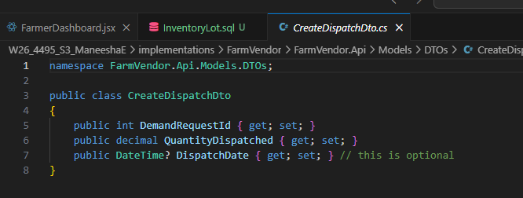

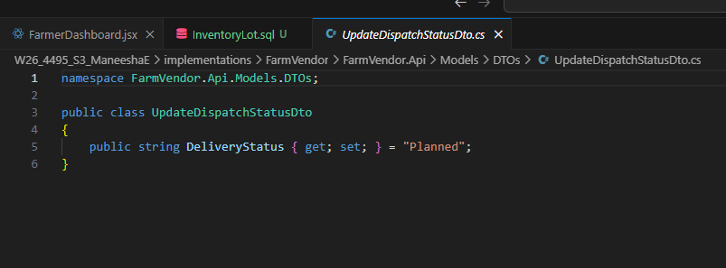

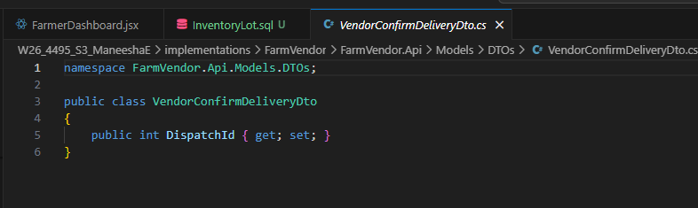

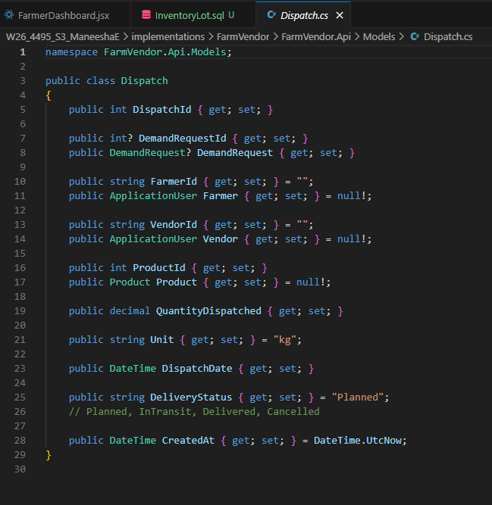

Database
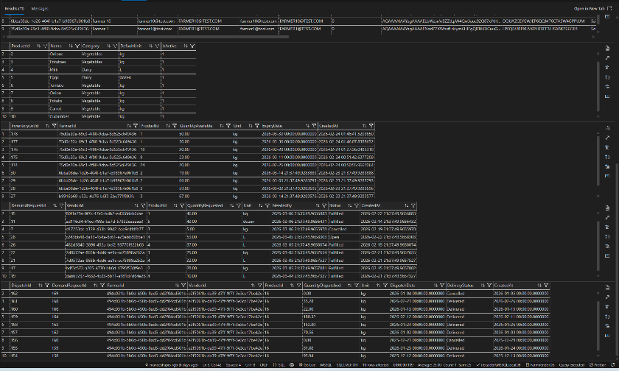

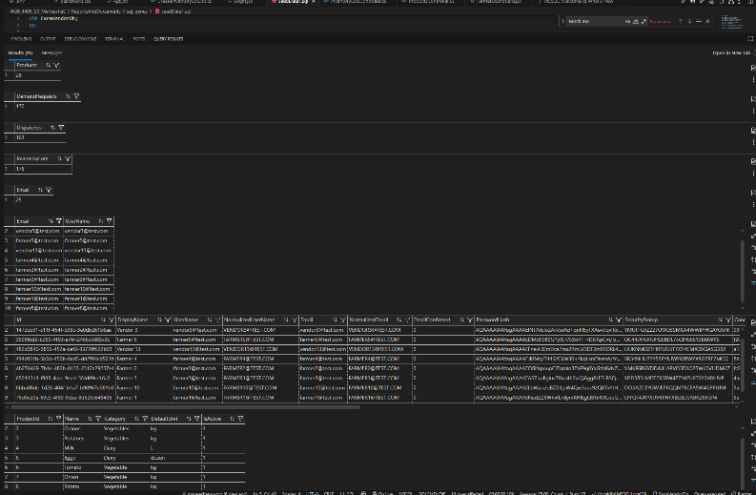

Feature 7: Dashboard Analytics and Status Badge System
This feature improves usability by showing summarized operational insights and visual status indicators for both farmer and vendor dashboards.
Design includes:
- Analytics summary cards
- Expiry status badges
- Low stock alerts
- Dynamic UI rendering based on live API data
Logic implemented using:
- Expiry date difference calculation
- Quantity threshold rules
- React conditional rendering
- API-driven dashboard refresh
Implementation
Frontend
- FarmerDashboard.jsx
- VendorDashboard.jsx
- dashboard.css
- Dynamic summary cards and badges
Backend
- FarmerController.cs
- Vendor dashboard API endpoints
- Aggregation logic for counts and summary metrics
Database
- Data derived from:
  - InventoryLot
  - DemandRequest
  - Dispatch

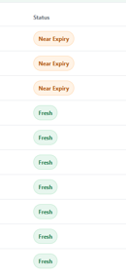
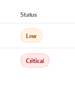

Evaluation Technique

The FarmVendor system was evaluated using a combination of different algorithm comparison, functional and integration testing, scenario-based evaluation, and usability assessment. These evaluation techniques were selected to validate system correctness, decision quality, and practical usability in real-world agricultural supply-chain scenarios. The outcomes of these evaluations directly influenced several design and implementation decisions in the final system.

Forecasting model evaluation

The demand forecasting component was evaluated by comparing multiple approaches before finalizing the forecasting algorithm. Initially, simple logic-based methods, including basic averages and Moving Average techniques, were considered due to their ease of implementation. However, preliminary testing revealed that these approaches were unable to capture temporal trends, seasonal variations, and fluctuations present in historical demand request data.
As an alternative, the ML.NET Singular Spectrum Analysis (SSA) time-series forecasting algorithm was implemented and evaluated using multi-period historical demand data. SSA demonstrated superior performance in identifying trends and generating smoother, forward-looking demand predictions compared to traditional statistical methods.
Design Decision Outcome:
Based on this evaluation, the logic-based forecasting approach was replaced with ML.NET SSA. Forecasting results were fully integrated into the system and used as a core input for vendor recommendation and dispatch planning, enabling proactive and data-driven decision-making.

Comparison between ML.NET SSA model and Moving Average model
To evaluate the effectiveness of the demand forecasting component in the FarmVendor system, two forecasting approaches were implemented and compared: a Moving Average model and a machine-learning-based ML.NET Singular Spectrum Analysis (SSA) model. Both models were applied to the same historical demand dataset across multiple vendors and products, allowing a direct comparison of forecast behavior and suitability for decision support.
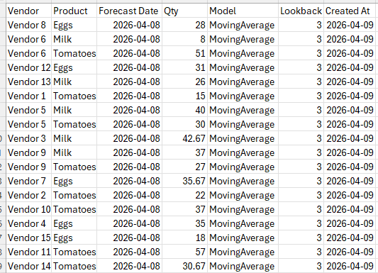
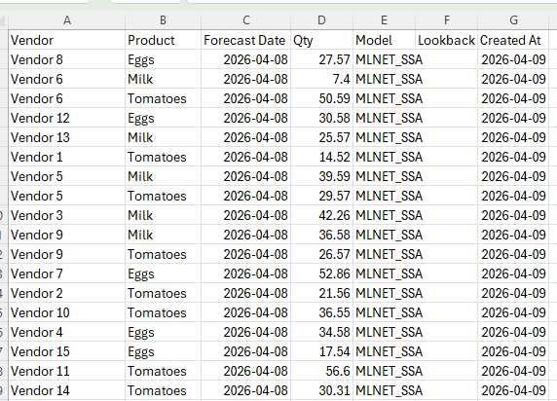

Moving Average Model Evaluation
The Moving Average model was implemented using a fixed lookback window of three periods, producing forecasts based on recent historical demand values. As shown in the dataset, the Moving Average model generated reasonable baseline estimates for short-term demand. For example, Vendor 6’s milk demand was forecast at 8 units, while Vendor 11’s tomato demand was forecast at 57 units.
However, the Moving Average model exhibited several limitations. Because it relies strictly on recent averages, it is highly sensitive to short-term fluctuations and does not capture longer-term trends or demand patterns. In cases where historical demand varied significantly, the model produced abrupt changes or plateau-like forecasts. Additionally, the Moving Average approach treats all past observations equally within the lookback window, limiting its ability to adapt to evolving demand behavior.

ML.NET SSA Model Evaluation
The ML.NET SSA model was implemented to address the limitations of simple statistical forecasting. SSA is a time-series decomposition technique that identifies underlying trends and patterns in historical data. When applied to the same dataset, the SSA model produced forecasts that were smoother and more trend-aware.
For instance, Vendor 6’s milk demand forecast shifted from 8 units (Moving Average) to 7.4 units (SSA), reflecting a slight adjustment based on learned patterns rather than a direct average. Similarly, Vendor 7’s egg demand increased from 35.67 units under the Moving Average model to 52.86 units under the SSA model, indicating that SSA detected an upward demand trend that the Moving Average approach failed to capture.
Across most vendor–product combinations, SSA forecasts differed moderately from Moving Average values rather than drastically, suggesting that SSA refines forecasts by accounting for trend continuity rather than simply smoothing past values.
Quantitative and Behavioral Comparison
Overall, both models produced forecasts within a comparable numerical range; however, their forecasting behavior differed significantly:
- The Moving Average model provided quick, interpretable baseline forecasts but struggled with trend detection and adaptability.
- The ML.NET SSA model produced more stable and forward-looking forecasts by learning from historical patterns, reducing sensitivity to short-term noise.
SSA forecasts also demonstrated greater consistency across similar products and vendors, which is particularly important for downstream processes such as vendor recommendation and dispatch planning.

Based on this evaluation, the Moving Average model was retained as a baseline comparison, while the ML.NET SSA model was selected as the primary forecasting mechanism for the FarmVendor platform. The SSA model’s ability to capture trends and produce smoother predictions made it more suitable for integration into the vendor recommendation system and overall decision-support workflow.
By incorporating SSA-based forecasts, the system shifted from reactive forecasting toward proactive demand planning, enabling farmers to make better-informed inventory and dispatch decisions.

Aspect | Moving Average | ML.NET SSA
Model Type | Statistical | Machine-Learning (Time-Series)
Trend Detection | Limited | Strong
Sensitivity to Noise | High | Lower
Forecast Smoothness | Moderate | High
Interpretability | High | Moderate
Suitability for Decision Support | Limited | High

- Graph generated for ML.NET SSA Model

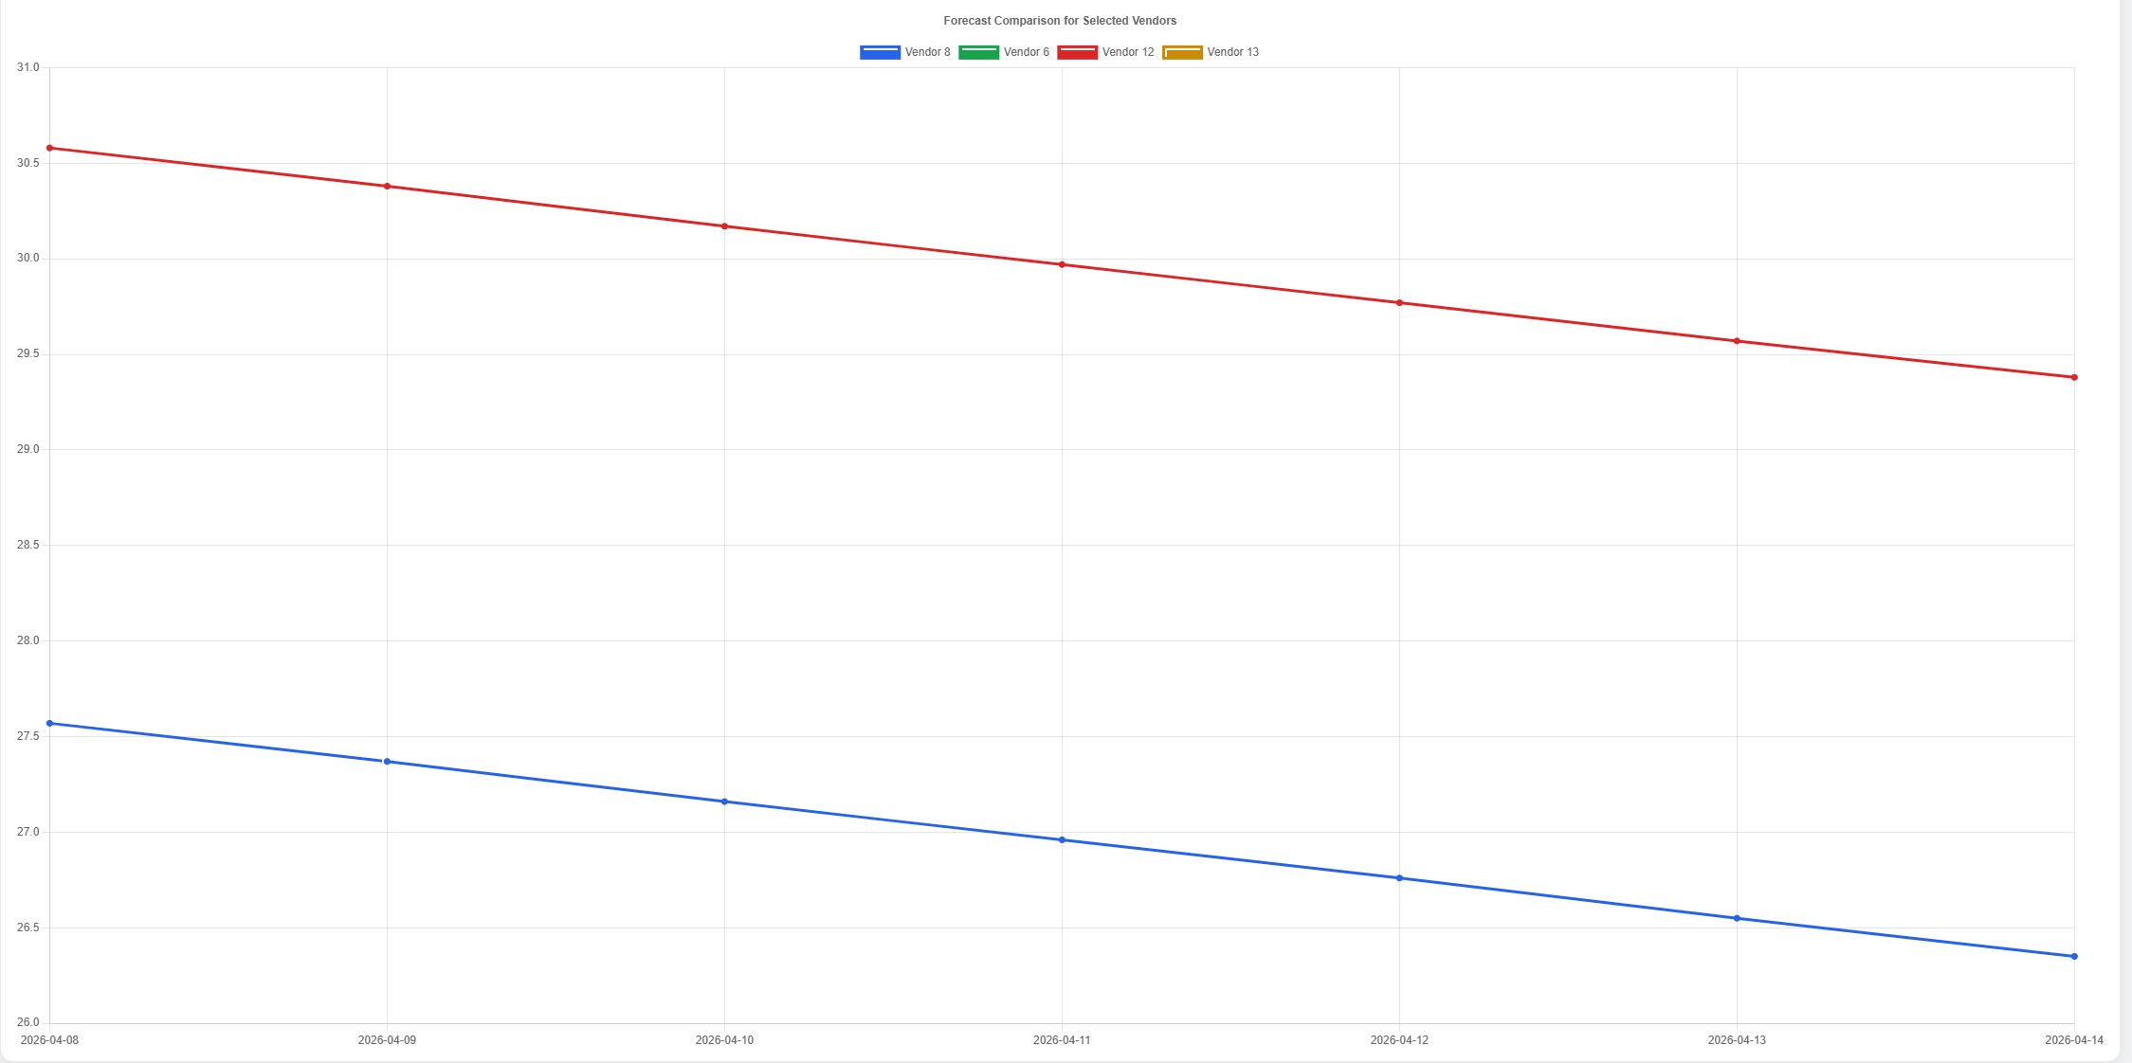

Recommendation Logic Evaluation
The vendor recommendation feature was evaluated by comparing different decision-making strategies. An optimization-based approach was initially explored; however, early experimentation showed that such models were difficult to interpret and explain to non-technical users, limiting their practical usability.
To address this, a weighted scoring-based recommendation system was implemented and evaluated through scenario-based testing. Multiple test scenarios were executed by varying key inputs such as forecasted demand, available inventory, geographic distance (calculated using the Haversine formula), and historical relationship scores. The resulting rankings were reviewed to ensure consistency, transparency, and logical behavior.
Design Decision Outcome:
The optimization-based approach was replaced with a scoring-based model. This change improved interpretability, transparency, and user trust, making the recommendation system more suitable for real-world agricultural users.

Functional and Integration Testing
Functional testing was conducted across all major system modules, including:
- Role-based authentication and authorization
- Farmer inventory management
- Vendor demand request lifecycle
- Dispatch creation and delivery confirmation
- Real-time chat communication
Integration testing focused on validating seamless interaction between the frontend (React) and backend (ASP.NET Core APIs), as well as ensuring proper enforcement of JWT-based security. SignalR-based real-time messaging was tested to confirm message delivery, role isolation, and conversation persistence.
Design Decision Outcome:
Testing results led to improvements in API validation, error handling, and frontend state management, ensuring system stability and secure role-based access.

Usability Evaluation
Usability evaluation was performed through developer testing, instructor testing and informal peer testing, focusing on common user workflows such as adding inventory, submitting demand requests, creating dispatches, and initiating chat conversations, adding products. Observations were made regarding ease of navigation, clarity of information, and error frequency.
Based on this evaluation, several UI/UX enhancements were implemented, including searchable dropdowns, improved input validation, shared sidebar navigation, and clearer status indicators.
Design Decision Outcome:
These changes reduced manual input errors, improved task completion efficiency, and enhanced the overall user experience for both farmers and vendors.

Overall, the evaluation techniques confirmed that the FarmVendor system functions correctly, produces meaningful decision-support outputs, and remains usable for non-technical users. The evaluation process directly informed key design choices, including the adoption of machine-learning-based forecasting, the use of a transparent scoring-based recommendation model, and multiple usability improvements. This iterative evaluation-driven approach ensured alignment between the project’s research objectives and the final implemented solution.

Evaluation Method | What Was Evaluated | Outcome
Model comparison | Moving Average vs ML.NET SSA | SSA selected as primary model
Functional testing | End-to-end workflows | Main features worked correctly
Usability evaluation | Dashboard clarity and ease of use | UI improved through redesign

Reflections/Discussions

The development of FarmVendor provided valuable insights into full-stack application design, machine learning integration, and user-centered system development. The project involved combining ASP.NET Core, React, SQL Server, ML.NET, SignalR, and external APIs into one integrated platform.

Challenges Faced
One of the most significant challenges was implementing machine learning forecasting in a realistic way. The ML.NET SSA model required sufficient historical demand data, which meant that data preparation and simulation became an essential part of the project. Other challenges included synchronizing frontend and backend changes, handling JWT and SignalR authentication issues, and ensuring that dashboard visualizations correctly reflected saved forecast data. Integrating product images and updating the schema without breaking existing workflows was also challenging.

Lessons Learned
This project emphasized the importance of iterative development, testing, and refinement. I learned that the success of a machine learning feature depends not only on the algorithm, but also on the quality and structure of the historical data. I also learned that usability is a major part of system effectiveness; visual improvements such as product images, cleaner dashboards, and better interaction patterns can significantly improve how users understand and use a system.

Most Satisfying Parts
The most satisfying aspect of the project was successfully integrating multiple advanced features into one working system. In particular, generating ML-based forecasts and visualizing them in charts was highly rewarding. It was also satisfying to enhance the dashboard with image-based product identification and real-time chat communication, making the application feel practical and complete.

Future Improvements
Future work could include deploying the system to a cloud platform, collecting real agricultural data for more accurate model training, and performing formal user testing with farmers and vendors. Additional enhancements could include push notifications, mobile access, more advanced recommendation models, and integration with external logistics or weather data sources.

