FarmVendor

A Role- Based Digital Platform for Farmer-Vendor Coordination
And Demand Forecasting and vendor optimization

Student Name : Maneesha Eeshwara
Student ID : 300392759
Course : CSIS 4495 Applied Research Project
Section : 03
GitHub Repository : https://github.com/maneeshaprs- rgb/W26_4495_S3_ManeeshaE.git
Midterm Video Demonstration : https://drive.google.com/file/d/1UjX9kmxRbrBHhqUs3Lwbboizz_h7qboK/view?usp=sharing

Contents
1. Introduction 3
1.1 Background and Domain Context 3
1.2 Problem Definition 3
1.3 Research Questions 3
1.4 Literature Overview and Research Gap 4
1.5 Hypotheses and Expected Benefits 5
2. Summary Of Initially Proposed Project 6
3. Changes to the Proposal 6
4. Project Planning and Timeline 7
5. Implemented Features 8
6. AI Use section 18
7. Work Log 18
8. Closing and References 20

Introduction

Background and Domain Context

Local and small-scale agricultural supply chains continue to struggle with challenges such as demand uncertainty, inventory mismatch, food waste, communication gap between producer and vendor. These challenges are basically visible in British Columbia as many farmers and buyers still depend on informal communication like phone calls, text messages or word of mouth to coordinate with their business partners. This lack of communication may result in overproduction, under-supply, and avoidable waste of perishable goods.
With the increasing adoption of digital platforms in supply chain management, there is an opportunity to develop A Role- Based Digital Platform for Farmer-Vendor Coordination and Demand Forecasting using simulated and User-Generated data. However, most of currently existing systems expensive, complex and most are mobile based applications where unsuitable for small-scale agricultural stakeholders.

Problem Definition
The main issue addressed in this research is the lack of a structured, secure, and data driven platform that enables farmers and vendors with below challenges.
- Track available and dispatched products
- Plan harvest and procurement based on historical patterns
- Communicate future demand clearly
- Support decision-making through optimization recommendations

Research Questions
Following research questions are supposed to addressed by the project:
- How can a role-based digital platform improve coordination between farmers and vendors?
- How can simulated and user generated data be used to support early-stage demand forecasting?
- How system can optimize vendor selection for farmers with the combination of distance, requested quantity and historical relationship?
- Can an optimization-based recommendation model support farmer decision-making while human choice and trust prioritized?

Literature Overview and Research Gap

  - Literature Overview
Research in agriculture supply chain management highlights the importance of demand forecasting, inventory visibility, and coordination between farmers and vendors. Prior studies show that even basic forecasting techniques prioritised with time and structured communication should reduce food waste, improve supply planning and increase efficiency in agricultural operations. Digital platforms are increasingly used to support these goals by enabling data sharing, record keeping and making decisions on data.
There are several farm management tools and other platforms that partially support those challenges. Here is background research and limitations on existing applications.
- AgriWebb : Farm management mobile application that focus on helping farmers manage production records, operational planning and inventory. offer limited direct coordination with vendors such as grocery stores and restaurants
- FarmLogs : largely farmer-centric mobile application with good internal visibility. limited vendor supportive.
- Cropln : web based Agri-intelligence and AI driven platform for enterprises across the agriculture value chain. Designed only for enterprise level Agri businesses
- AgriDigital : Provide cloud based grain supply chain and management platform. Use blockchain technology to secure settlement while digitize grain storage, trading, logistics and financing. Less suitable for small and medium scale farmers where developed models need extensive historical data and long-term adoption.

A key limitation across both academic literature and existing mobile applications and platforms is the high dependability on large historic datasets. While many optimization and forecasting models assume the availability of long-term, real world transactional data newly deployed systems and small – scale agricultural networks face a cold-start problem, where little or no historical data exists.

Most of systems ignore human decision making while fully automated recommendations prioritized where agriculture grow with trust, long-term relationships and farmer experience is vital in decision making and planning.

  - Research Gap
Below gap remains based on existing research and platforms,
- Limited availability of lightweight, role-based platforms designed specifically for local farmers and vendors.
- Insufficient support for incremental data collection, where forecasting improves gradually over time.
- Lack of optimization models that combines distance, requested quantity and historical relationships.
- Minimal focus on human-in-the-loop decision support rather than full automation.
- Overdependence on real-world, large-scale datasets that are impractical for early stage systems.

1.5 Hypotheses and Expected Benefits

Below assumptions are considered on operation of the research:
- Structured demand communication reduces uncertainty for farmers
- Simulated dataset can serve as a valid foundation for early-stage system evaluation.
Expected benefits include reduced food waste, improved planning accuracy and better decision-making support for farmers and vendors.

Summary Of Initially Proposed Project

The proposed research project focuses on designing and implementing a full-stack web-based platform that support role-based interaction between farmers and vendors. The system integrates simulated baseline data and user-generated interactions to support demand forecasting and vendor optimization.
This platform enables farmers to dispatch operations and inventory management while allowing vendors to submit structured demand requests. Historical demand and records of dispatches are used to generate simple forecasting insights based on weekly aggregation and trend comparison.
Additionally, the project introduces an optimization-based recommendation model that ranks potential vendor farmer matches using distance, inventory availability, requested quantity, and historical relationship metrics. The model is designed as a decision-support tool rather than an automated decision engine while ensuring that farmers retain control over final decisions.

Changes to the Proposal
Below modifications were introduced during implementation.
- Dashboard architecture was updated from static UI to API-driven dynamic data retrieval
- Authentication was implemented using ASP.NET Identity with JWT for secure role separation
- Simulated dataset generation strategy was refined to include multi-period demand and dispatch history
- Optimization approach was simplified to a weighted scoring model to improve interpretability
- Relationship tracking entity was introduced to capture historical interactions between farmers and vendors
These changes were aligned with need for transparent and interpretable models suitable for non technical agricultural users while justifying the feasibility considerations and improved research alignment with the cold-start problem.

Project Planning and Timeline

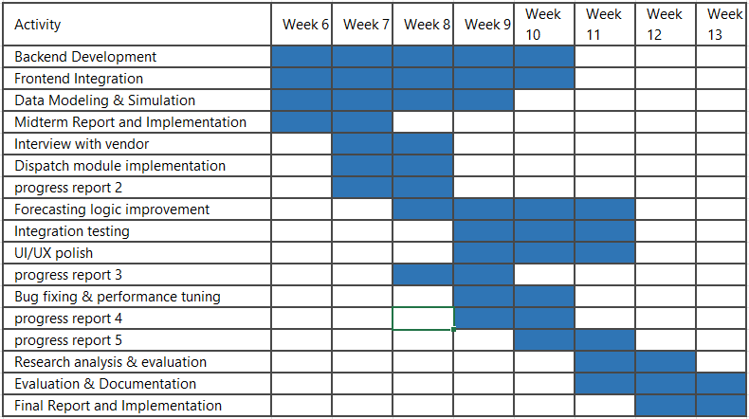

Implemented Features

- Role Based Authentication(registration & Login)
  - This feature allows users to login in roles as either Farmer or Vendor. Authentication is implemented using JWT with ASP.NET Identity, which ensure secure access and role based navigation.
  - Login page


  - Register page
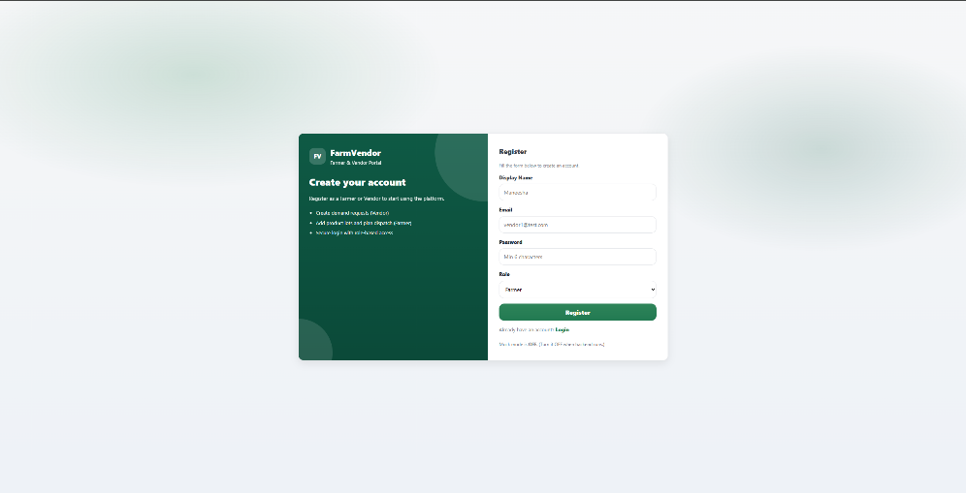

  - The design consist of :
    - Registration page with role selection
    - Login page with credential validation
    - Backend JWT token generation
    - Role-based route protection using React guards

  - Implementation
Frontend
- Register.jsx : handles role selection and API call
- Login.jsx : stores JWT and redirects dashboard
- RequireAuth.jsx : protects routes
- RequireRole.jsx : restricts role access
Backend
- AuthController : login and register endpoints
- ApplicationUser : extended Identity user
- JWT token generation logic
Database
- AspNetUsers table stores user accounts
- Roles mapped using Identity role tables

- Farmer Inventory management
Farmers can add and manage product inventory lots with expiry tracking
This feature includes:
- Add product lot form
- Inventory table view
- Expiry status badge logic
Implementation
Frontend
- FarmerDashboard.jsx
- Add Product Lot modal
- Inventory table UI
Backend
- InventoryLotsController
- CreateInventoryLotDto
- InventoryLot entity
Database
- InventoryLot table storing:
  - FarmerId
  - ProductId
  - Quantity
  - ExpiryDate
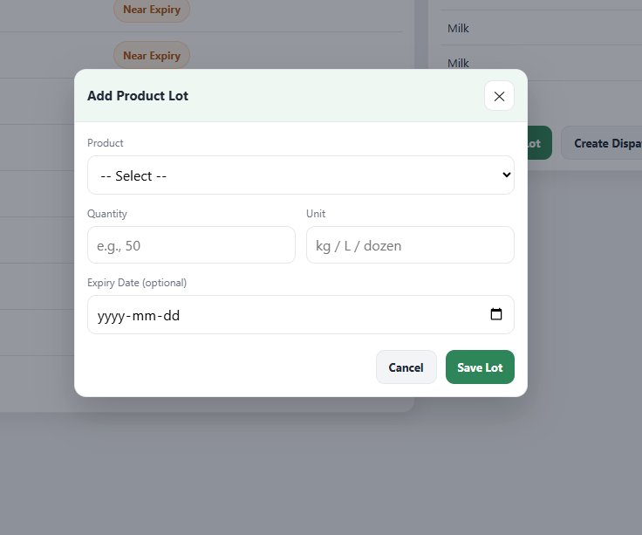

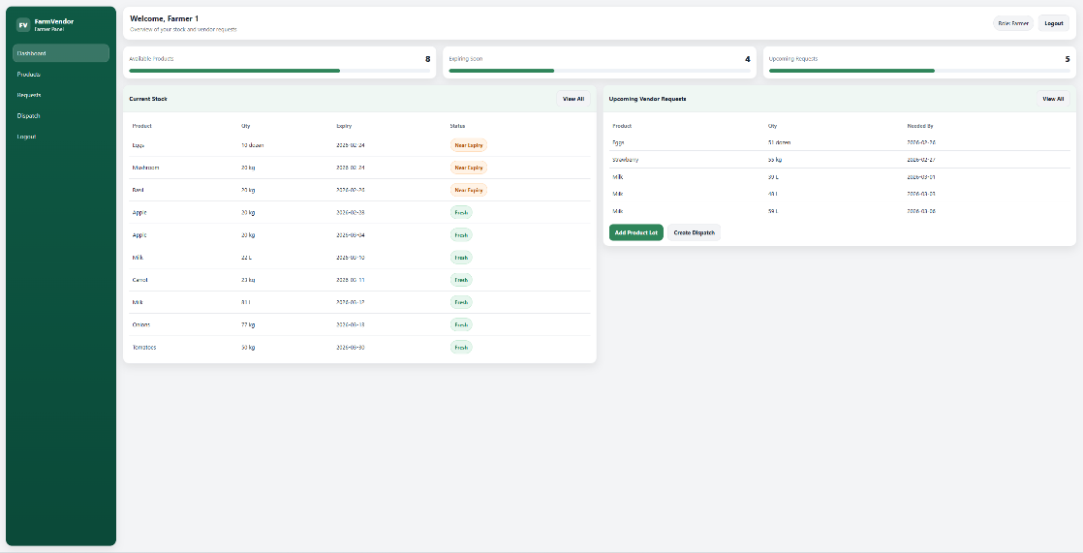

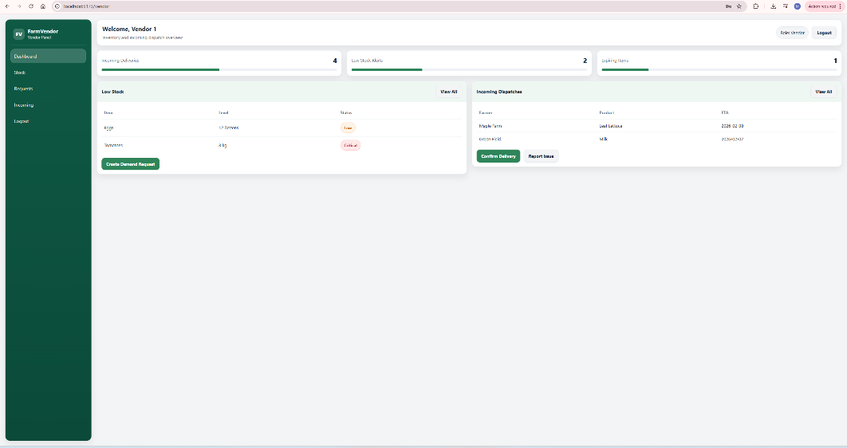

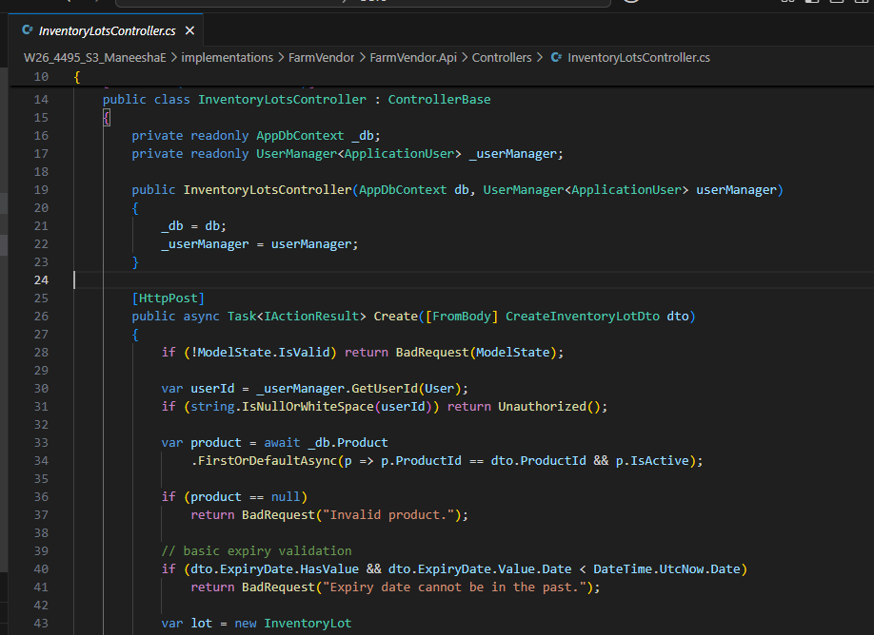

- Vendor Demand Request System
Vendors can create product demand requests when stock is low
This feature includes :
- Low stock alert table
- Demand request creation
- Status lifecycle tracking

Implementation
Frontend
- VendorDashboard.jsx
- Create demand request button
- Low stock alert UI
Backend
- DemandRequest entity
- DemandRequest APIs
- Status management
Database
- DemandRequest table storing:
  - VendorId
  - ProductId
  - QuantityRequested
  - Status

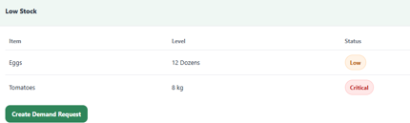
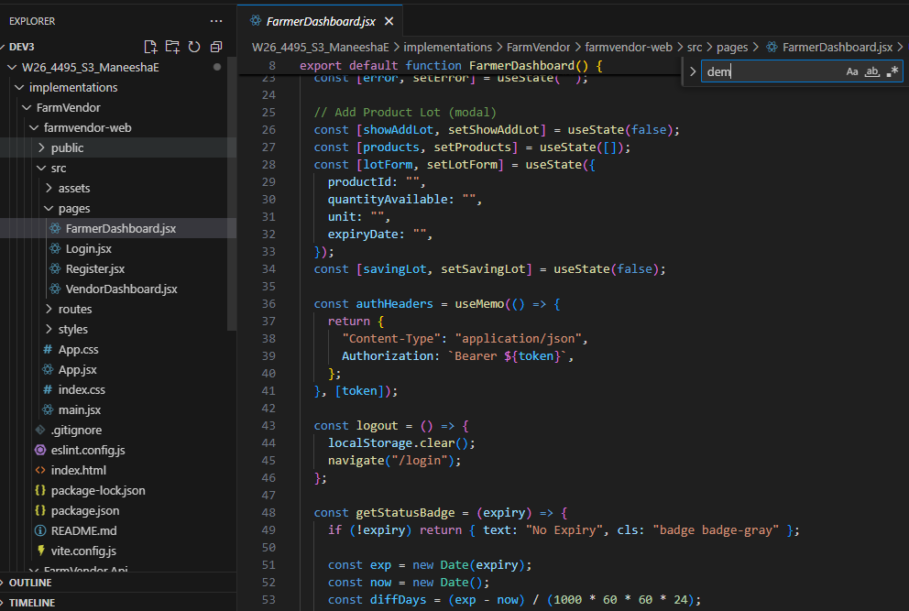

- Dispatch Management Module
This feature enables farmers to create dispatches and vendors to confirm deliveries.
This design includes :
- Create dispatch button
- Incoming dispatch table
- Delivery confirmation
- Dispatch status tracking

Implementation
Frontend
- Create dispatch action in FarmerDashboard
- Incoming dispatch list in VendorDashboard
- Confirm delivery button
Backend
- Dispatch entity
- DispatchController
- Delivery status logic
Database
- Dispatch table storing:
  - FarmerId
  - VendorId
  - ProductId
  - Quantity
  - DispatchDate
  - DeliveryStatus

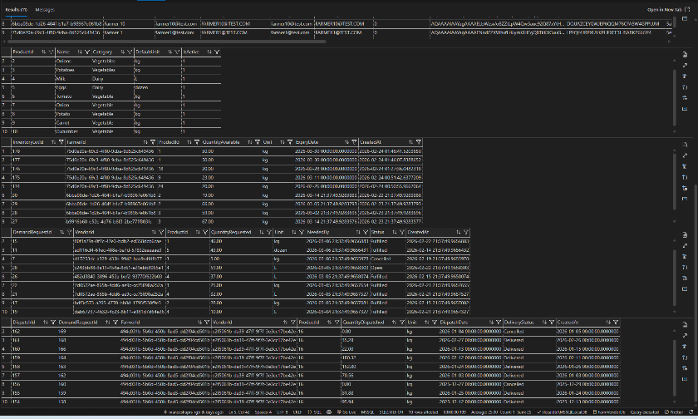

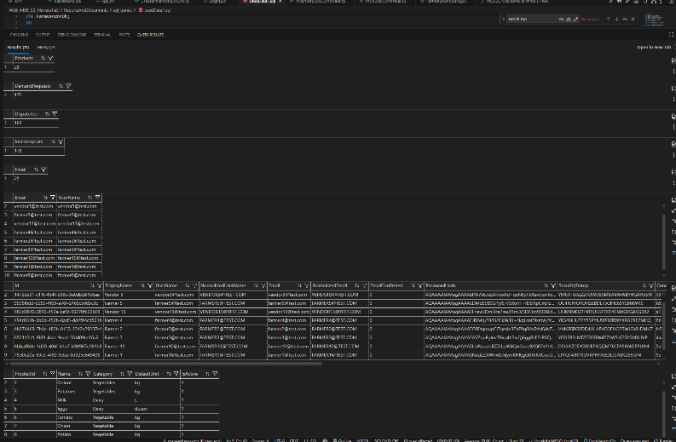

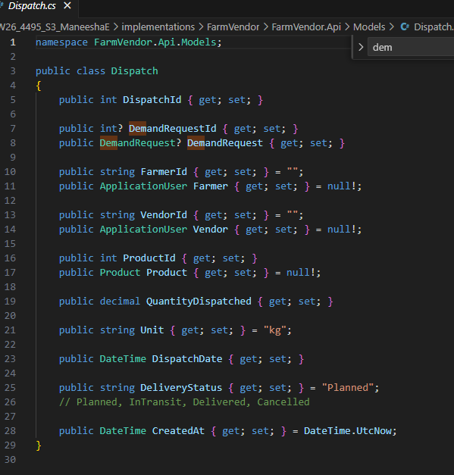

- Dashboard Analytics & Status Badge System
Dashboard Analytics & Status Badge System
Design Includes:
- Analytics summary cards
- Expiry status badges
- Low stock alerts
Logic implemented using:
- Expiry date difference calculation
- Quantity threshold rules
- React dynamic rendering

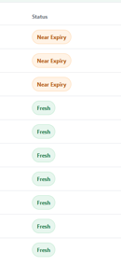
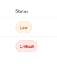

- Backend and front end Architecture

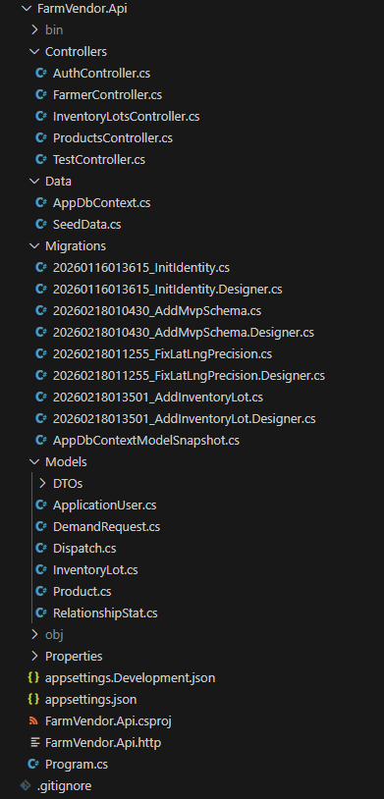

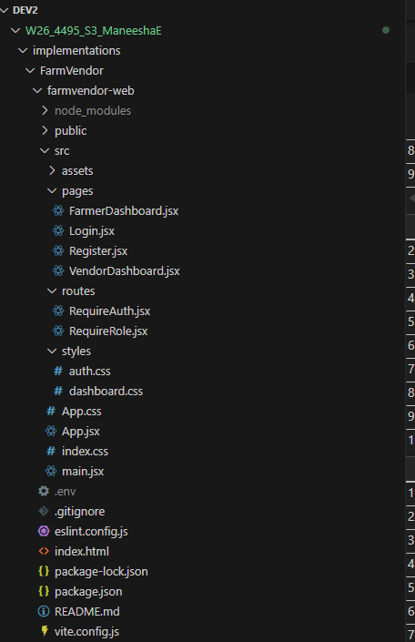

AI Use section

AI Tool Name | Version, Account Type | Specific feature for which the AI tool was used | Value Addition What value did you add over and above what AI did for you?
ChatGPT | Free version | Research on existing tools for farm vendor management | Critical revie while refinement of idea while focusing missing features from existing tools
 |  | System backend design guidance | Developed my own backend activities
 |  |  | Rewrote and refined documentation with personal implementation details and validation
  Worklog, documentation and report structuring
 |  | Rewrote and refined documentation with personal implementation details and validation | Research brainstorming for forecasting and optimization module
 |  | Designed own research novelty including optimization and demand prediction logic | Designed custom dashboards, styling, routing and responsiveness independently

Appendix : Ai prompt history
Prompts and responses used for system design, refinement on ideas will be included in the appendix.
- Provide examples of existing apps for farmer vendor management systems
- Provide steps to develop ASP .NET project backend for role-based website.
- Provide relevant dashboard ui to be included in a supply chain management system

Work Log

Date | No of Hours | Description of work done
13-Jan | 2 | Finalised research idea for FarmVendor application by defining the core problem and scope
 | 1 | Installed development tools: .NET SDK, VS Code, SQL Server LocalDB, Node.js (React)
14-Jan | 4 | Created backend ASP.NET Core Web API and tested in browser by resolving installation dependency issues
15-Jan | 4 | Integrated ASP.NET Core Web API (.NET 8.0)
 |  | Configured SQL Server LocalDB (FarmVendorDb)
 |  | Implemented ASP.NET Identity
 |  | Defined roles: Farmer and Vendor
 |  | Implemented JWT authentication
17-Jan | 2 | Tested working endpoints on Postman (POST /Api/auth/register, POST /Api/auth/login)
20-Jan | 0.5 | Project idea re-evaluation with Professor (Madam Priya) and refined research idea
21-Jan | 2 | Initial research on existing mobile and web-based applications and background research
22-Jan | 2 | Initial research proposal draft development
24-Jan | 2 | Research on React integration with ASP.NET backend
 | 2 | Continued research proposal development
25-Jan | 2 | Continued research proposal development
26-Jan | 1 | Finalised research proposal and submission
27-Jan | 3 | Reviewed proposal with professor and applied modifications to data collection strategy
29-Jan | 4 | Resolved JWT authentication and protected API access issues
 |  | Corrected Postman authorization configuration
2-Feb | 2 | Moved .gitignore to repository root and cleaned tracked artifacts
4-Feb | 3 | Created frontend sketches and planned React component structure
 |  | Installed necessary React dependencies
5-Feb | 2 | Resolved Node.js and npm installation issues
8-Feb | 4 | Implemented Login.jsx, Register.jsx, FarmerDashboard.jsx, App.jsx and dashboard styling
 |  | Modified routing in App.jsx
9-Feb | 5 | Implemented VendorDashboard.jsx and updated routing
 |  | Uploaded modified proposal to GitHub
 |  | Updated worklog for progress report 1
 |  | Verified repository contents
10-Feb | 5 | Fixed UI alignment issues and corrected auth.css padding problems
 |  | Updated login and registration with 2-panel interface
12-Feb | 4 | Connected frontend login with backend authentication
 |  | Created SQL Server LocalDB database using migrations
15-Feb | 5 | Resolved Vite environment loading issues
 |  | Fixed registration and login user errors
17-Feb | 6 | Fixed frontend registration issue caused by mock mode configuration
 |  | Completed role-based authentication, dashboards, DB persistence, JWT and protected routing
 |  | Fixed RelationshipStats FK constraint issue and recreated database
 |  | Created MVP schema: Product, DemandRequest, Dispatch, RelationshipStat
 |  | Implemented InventoryLot table
 |  | Added real DB data to dashboards
 |  | Updated FarmerDashboard with real DB data
18-Feb | 6 | Planned next phase tasks: data generation, forecasting module, optimization model, relationship scoring and evaluation
23-Feb | 8 | Implemented Add Product Lot feature (React form + API POST)
 |  | Created API endpoint POST /api/farmer/inventorylots using CreateInventoryLotDto and InventoryLotsController
 |  | Final Midterm video recording
 |  | Final Midterm report completion and submission

Closing and References

I would like to thank our Professor, Padmapriya Arasanipalai Kandhadai, the institution, Douglas College for the opportunity to design and present this project.

AgriWebb. (2024). AgriWebb farm management software [Mobile application]. https://www.agriwebb.com
FarmLogs. (2024). FarmLogs: Farm management and record keeping [Mobile application]. https://farmlogs.com
CropIn Technology Solutions. (2024). CropIn smart farm management platform [Mobile application]. https://www.cropin.com
AgriDigital. (2024). AgriDigital grain supply chain platform [Web-based platform]. https://www.agridigital.io

This will be updated accordingly as well after the project is done

