Snowflake Assessment
Name: Manisha Yadav

Task 1 Employee Table

1. Create Database and Schema

CREATE DATABASE IF NOT EXISTS bootcamp;
CREATE SCHEMA IF NOT EXISTS bootcamp.snow;

2. Create the Employee Table

CREATE OR REPLACE TABLE bootcamp.snow.employee (
employee_id INT,
name VARCHAR(50),
salary INT,
department_id INT,
joining_date DATE
);

3. Load Data from S3 into the Table

COPY INTO bootcamp.snow.employee
FROM @bootcamp.snow.employee_stage
FILE_FORMAT = (
TYPE = 'CSV'
SKIP_HEADER = 1
FIELD_OPTIONALLY_ENCLOSED_BY = '\''
)
PATTERN = '.*.csv';

4. Copy Data from Snowflake Table to S3 Output Directory

COPY INTO @bootcamp.snow.employee_stage/output/
FROM bootcamp.snow.employee;

Result

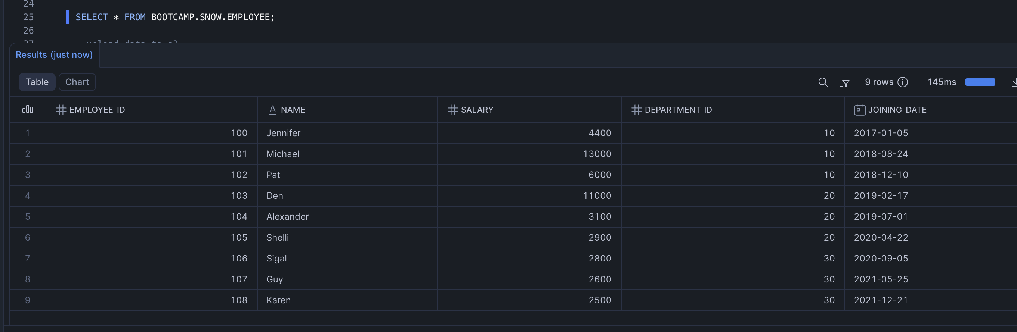

Task 2 Listing Table

1. Unload Listing Table from Redshift to S3 (Parquet)
I

UNLOAD ('SELECT * FROM tickit.listing')
TO 's3://manishatakeo/listing/'
IAM_ROLE 'arn:aws:iam::727699165627:role/admin_redshift'
FORMAT AS PARQUET
ALLOWOVERWRITE;

2. Create the Listing Table in Snowflake

CREATE OR REPLACE TABLE bootcamp.snow.listing (
listid INTEGER,
sellerid INTEGER,
eventid INTEGER,
dateid SMALLINT,
numtickets SMALLINT,
priceperticket DECIMAL(8,2),
totalprice DECIMAL(8,2),
listtime TIMESTAMP
);

3. Load Parquet Data from S3 into the Listing Table

COPY INTO bootcamp.snow.listing
FROM @bootcamp.snow.listing_stage
FILE_FORMAT = (TYPE = 'PARQUET')
MATCH_BY_COLUMN_NAME = CASE_INSENSITIVE;

Result

