**TypeScript Training - Practical Assignments**

**Task-1: Setup the environment for TypeScript**

1. Install node js and vs code
   1. Download and Install the VS CODE
   2. Download and Install the node js. ( <https://nodejs.org/en/> )
   3. Verify the node installation in command prompt

> node -v

> npm -v

1. Install typescript using npm

> npm install -g typescript

**Hint** : “-g” refers global installation.

1. Prepare typescript program as follows in a file using VS Code. (Eg: Demo1.ts)

**let str:string = “Welcome to TypeScript”;**

**console.log(str);**

1. Compile and Execute

> tsc Demo1.ts

> node Demo1.js

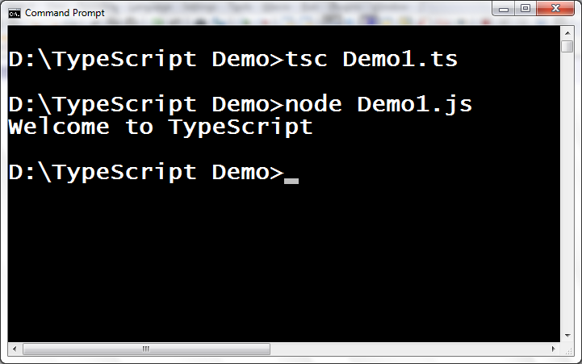

**Task-2:**

**Create a typescript program to display the employee details as follows. Declare the required number of variables by using datatypes available in typescript.**

Expected Output:

**Employee Id : 5464654**

**Employee Name : Scott**

**Employee Job : Manager**

**Is Permanent Employee : true**

**Employee Salary : INR. 45000**

**Employee Deptno : 10**

**3. Question**

**What is purpose of Array map() method in JavaScript? How to use it?**

**What is purpose of Array find() and findIndex() method in JavaScript? How to use it?**