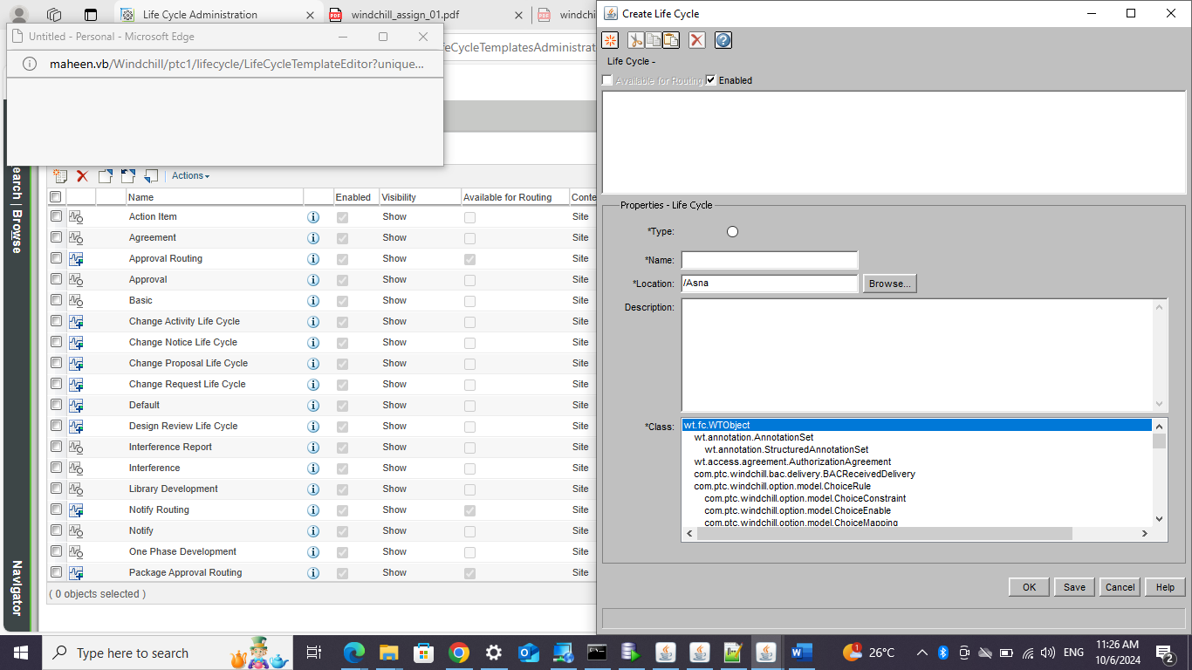

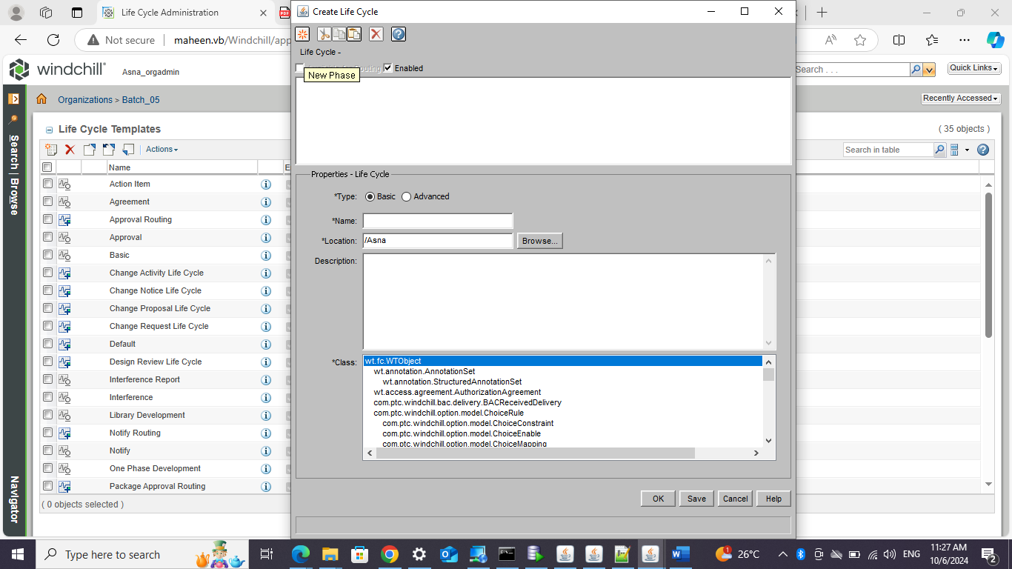

Different tabs are available depending on whether the template type is **Basic** or **Advanced**. For more information, see [Basic and Advanced Life Cycles](https://support.ptc.com/help/windchill/plus/r12.0.2.0/en/Windchill_Help_Center/LCChp_BasicAdvLC.html#wwID0EB2UW).

• [**Transitions**](https://support.ptc.com/help/windchill/plus/r12.0.2.0/en/Windchill_Help_Center/LCStateTransDefine.html#wwID0EECCX) (basic and advanced)

• [**Roles**](https://support.ptc.com/help/windchill/plus/r12.0.2.0/en/Windchill_Help_Center/LCRolesSelect.html#wwID0EZGDX) (advanced)

• [**Access Control**](https://support.ptc.com/help/windchill/plus/r12.0.2.0/en/Windchill_Help_Center/LCAdHocRulesDefine.html#wwID0ESUEX) (advanced)

• [**Workflow**](https://support.ptc.com/help/windchill/plus/r12.0.2.0/en/Windchill_Help_Center/LCWFProcessPhaseGate.html#wwID0ELSFX) (advanced)

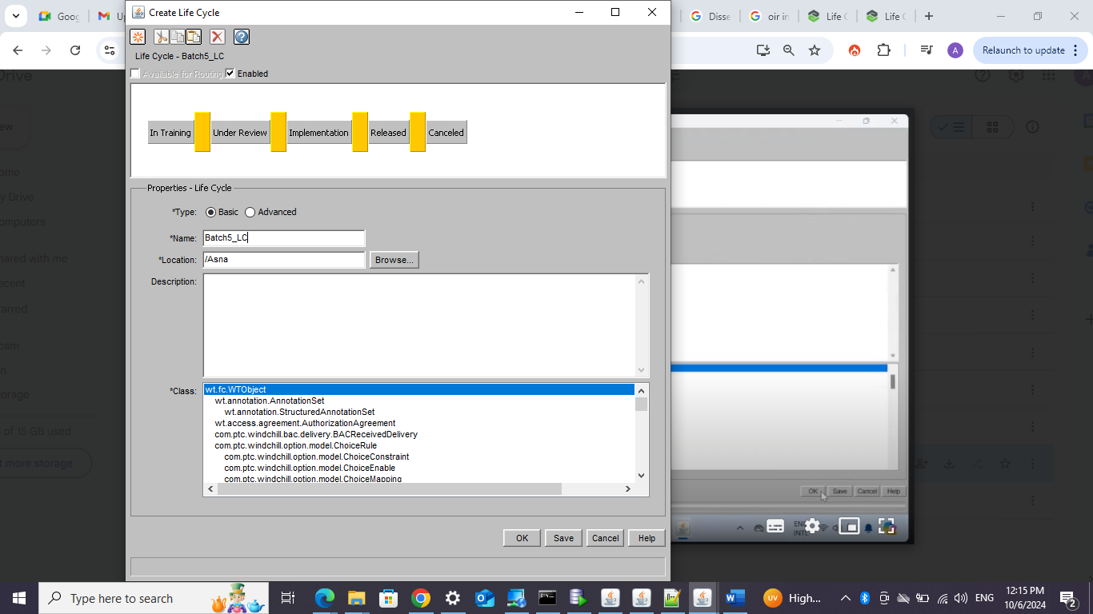

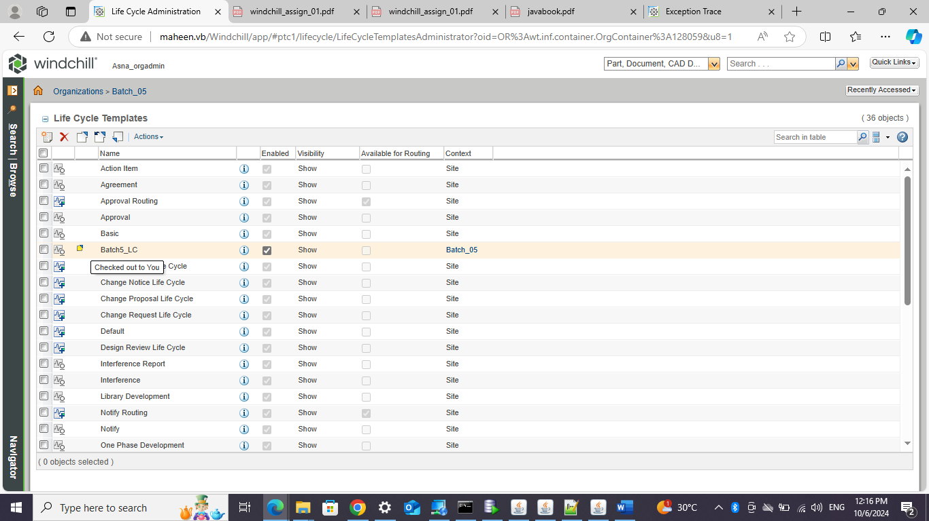

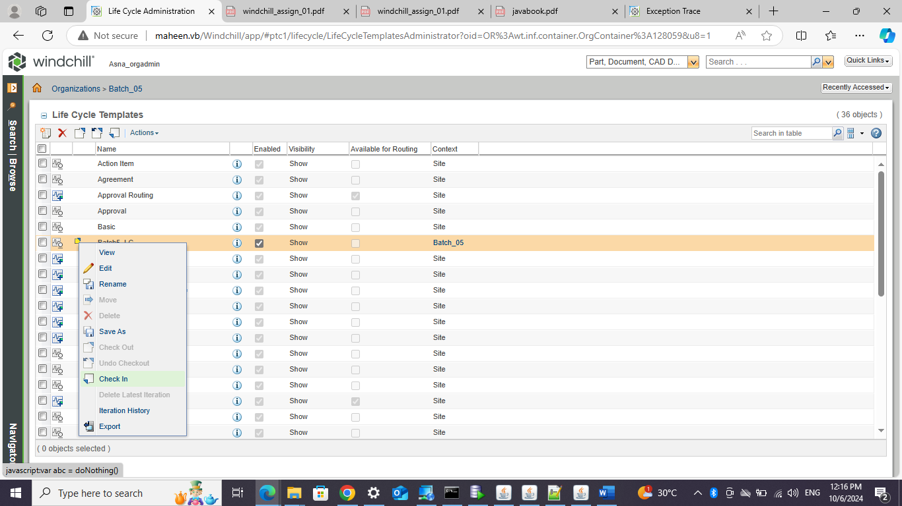

LIFECYCLE CREATION IS COMPLETED

ATTACHING LIFECYCLE TO OIR

ORGANIZATION UTILITY OIR PART (download the file and open )

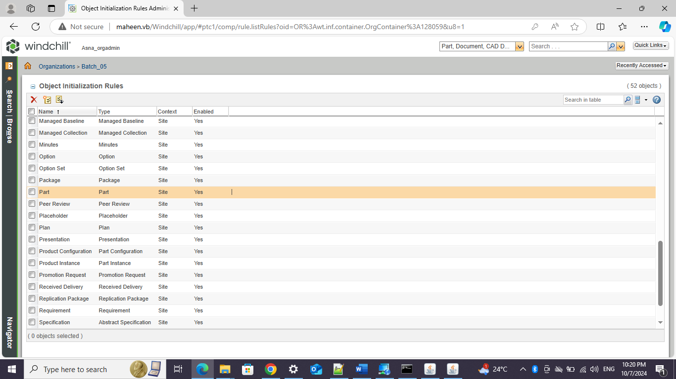

OPEN OIR CHANGE LIFECYCLE NAME AND CREATE NEW OIR.

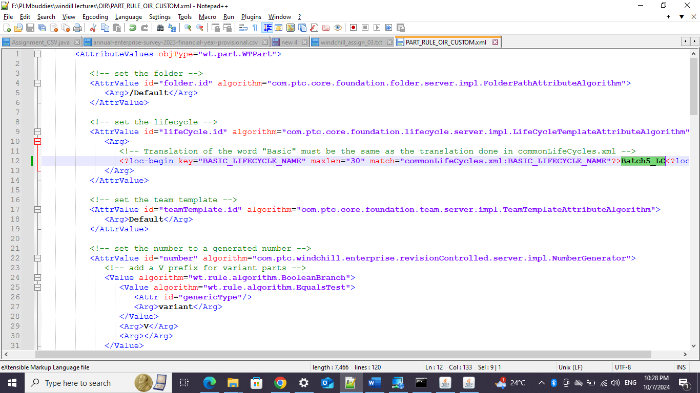

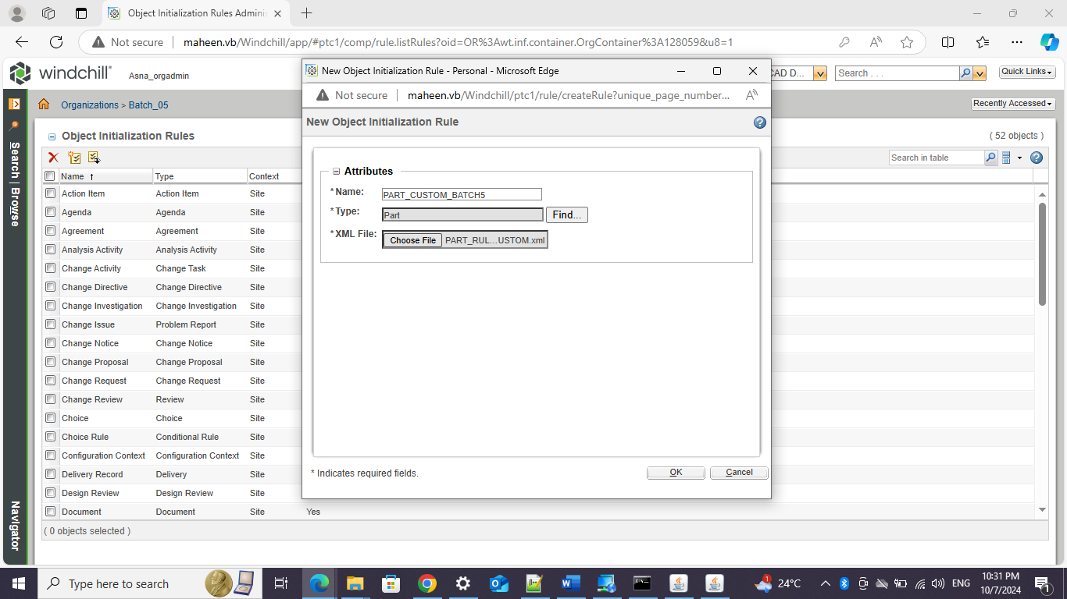

**WORKFLOW**

**Change the lifecycle basic to advanced**

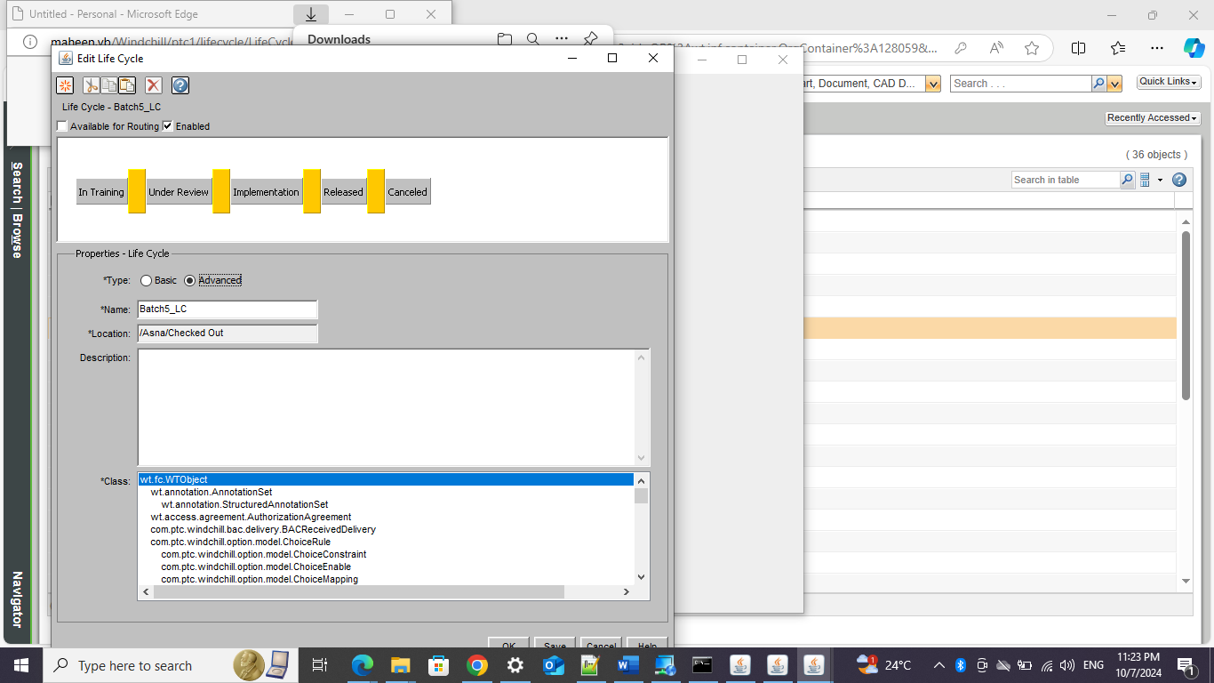

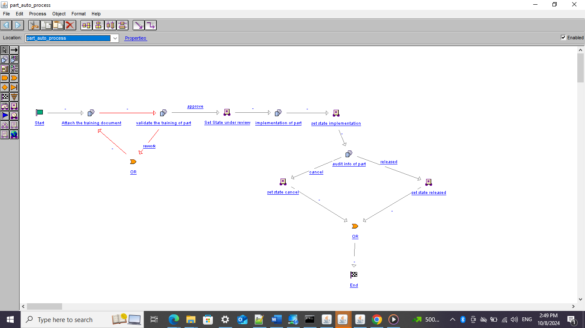

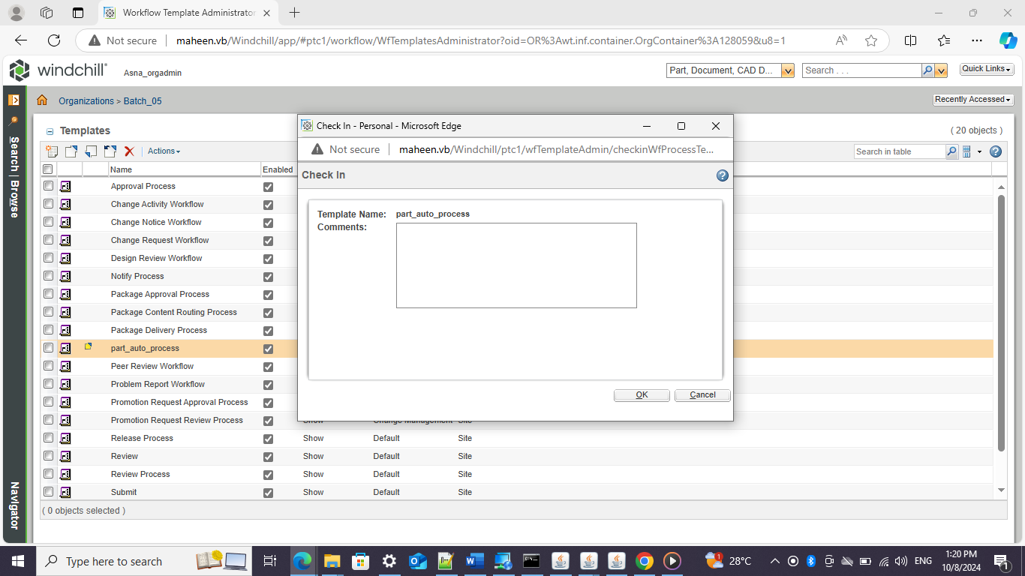

**ATTACH WORKFLOW TO LIFECYCLE:**

