1. **Create a Part subtype: "PLMBPart" and work on the below points.**

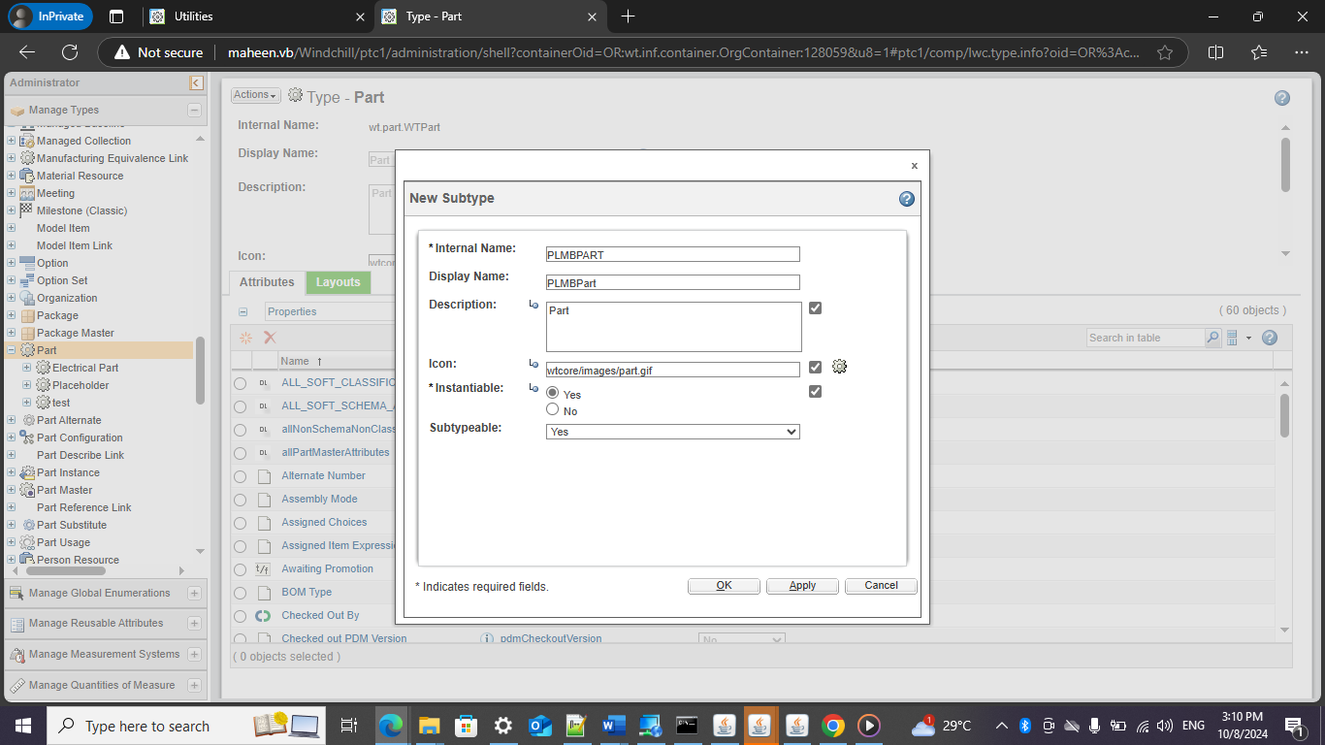

**2. Create a Document subtype: "PLMBDoc" and work on the below points**

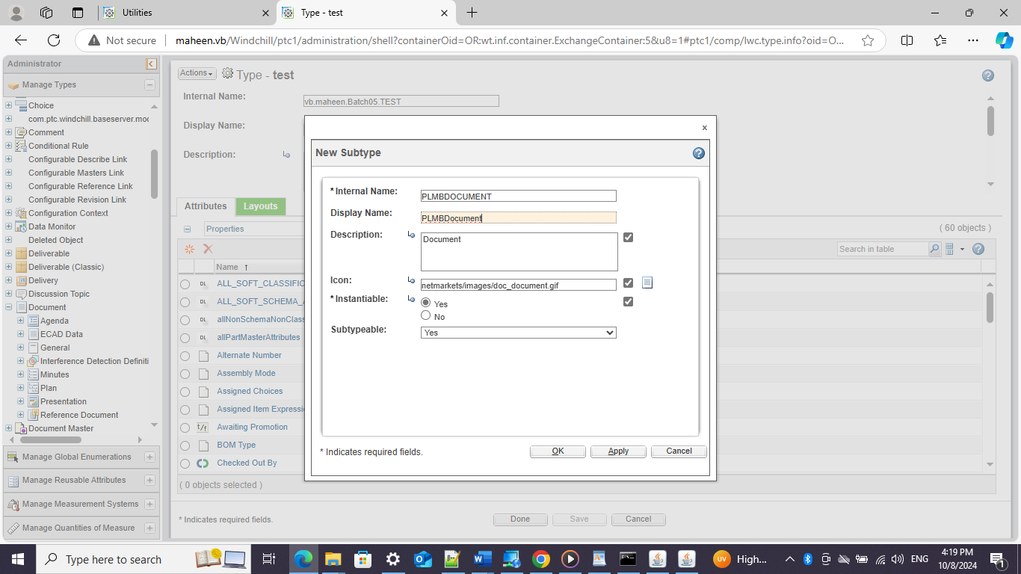

**3.Create below global(reusable)attributes on PLMBPart Subtype**a)Country -----string type    
b)States -----string type    
c)External-----Boolean type    
d)Issue Date------Timestamp/date type  
e)Country of origin---- String type

**Create below global(reusable)attributes on PLMBDoc Subtype**  
  
a)Creation Date----Timestamp/date type  
b)Author---string type  
c)Mandataty---Boolean type  
d)Language----String type

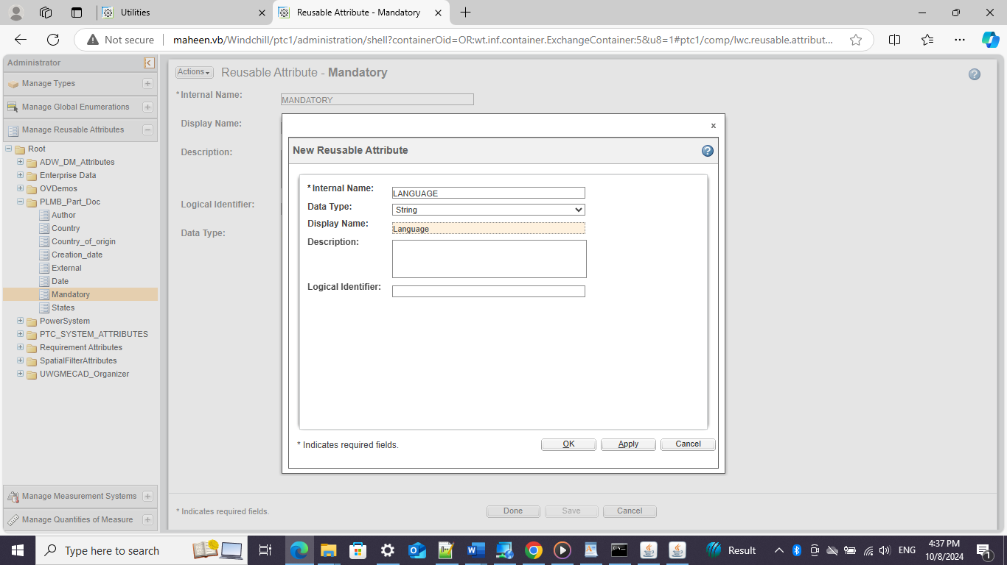

**5. Create one local attribute for PLMBPart Subtype.  
a)Supplier-----String type**

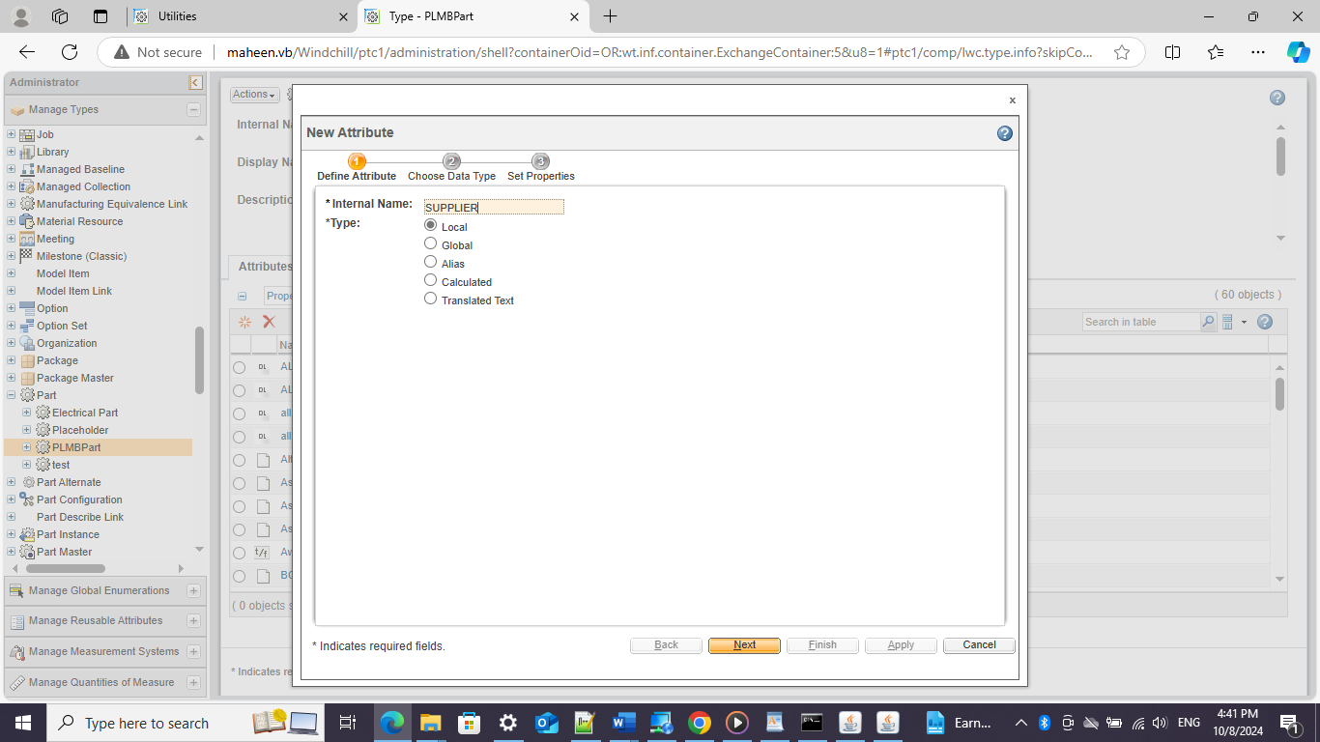

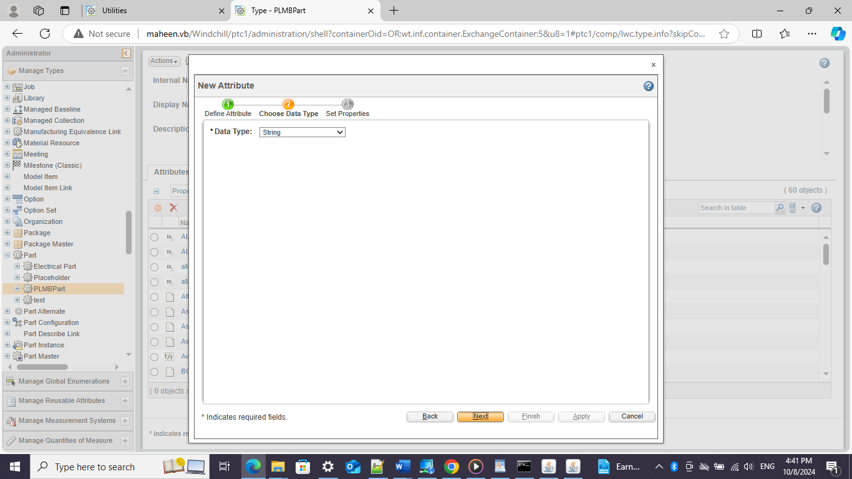

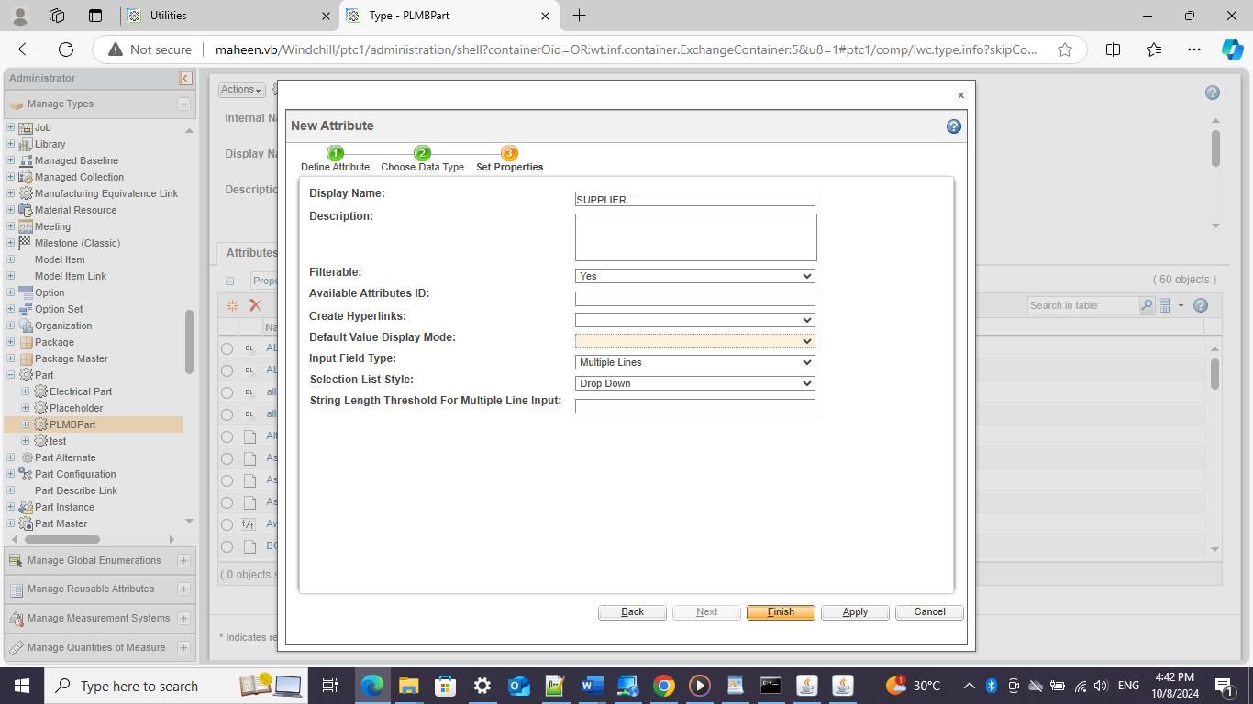

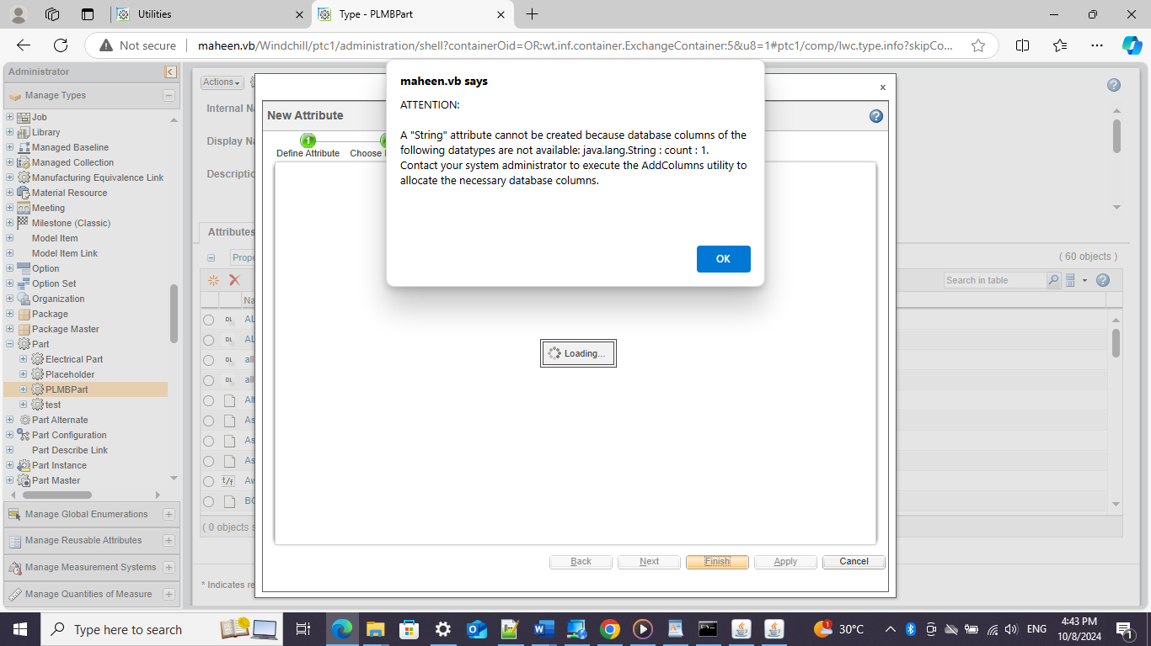

**The user should be able to see Country, States, External, and Issue date in the create page.**

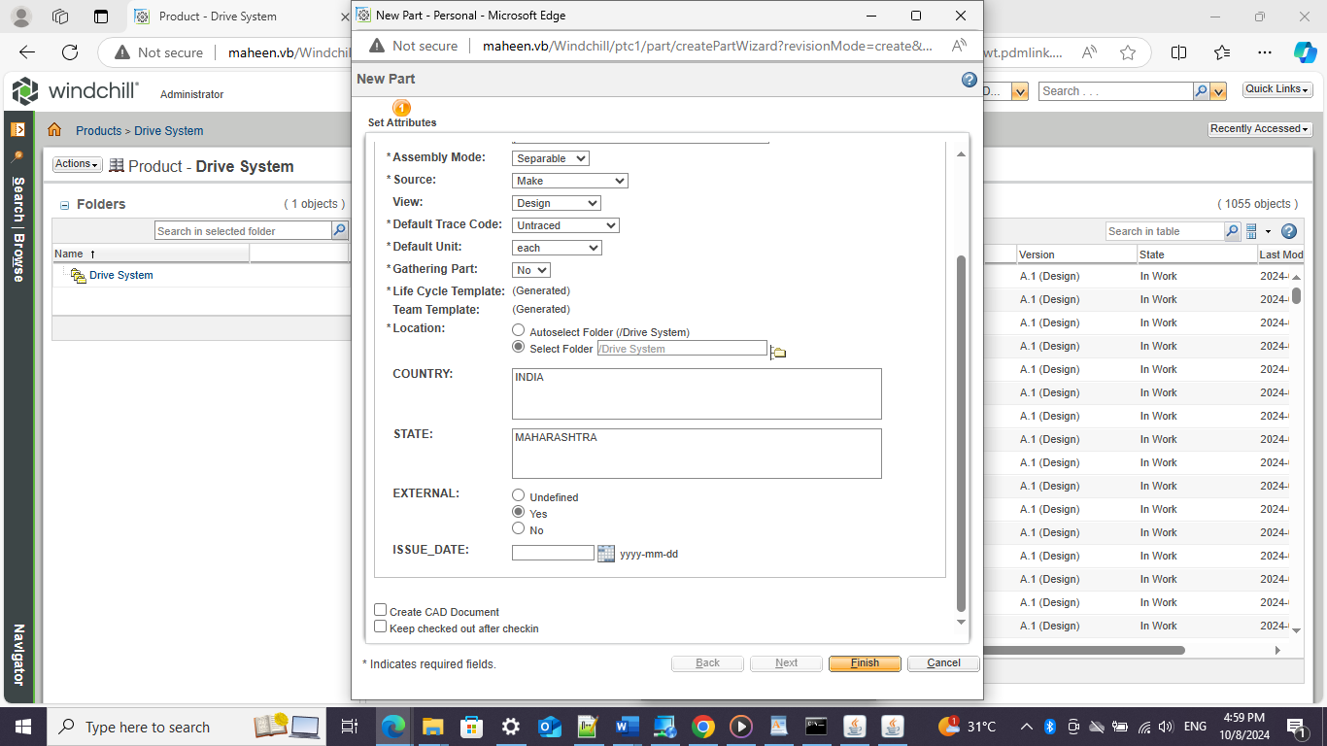

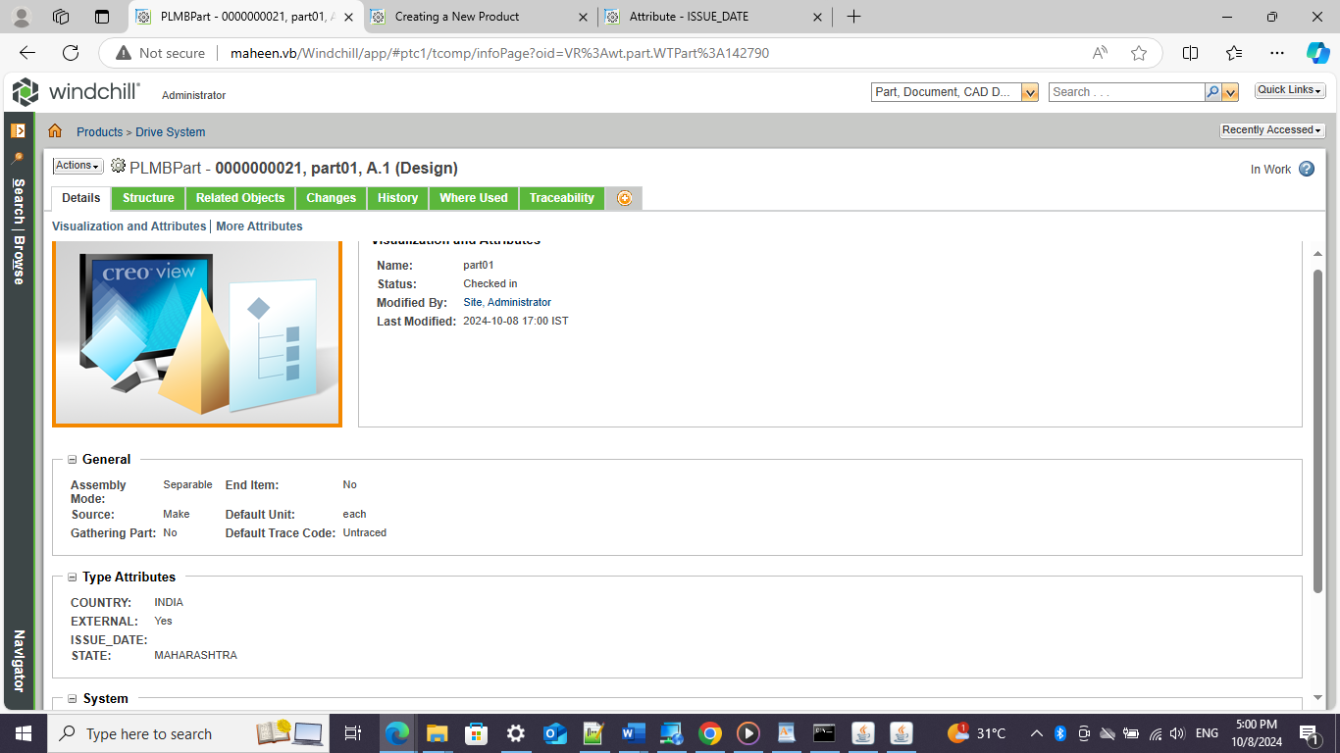

**7. The user should not be able to see Issue date on the edit page but can see Country, States, and External.**

**8. In the View page all 4 attributes should be visible.**

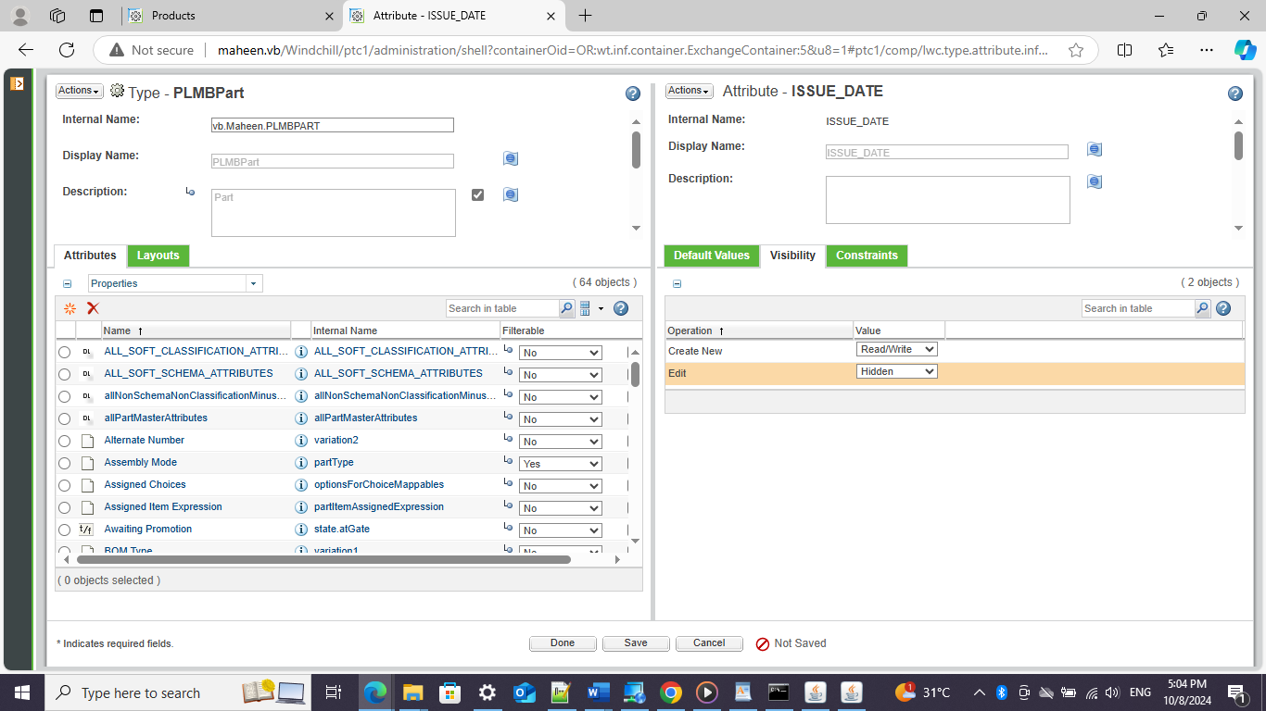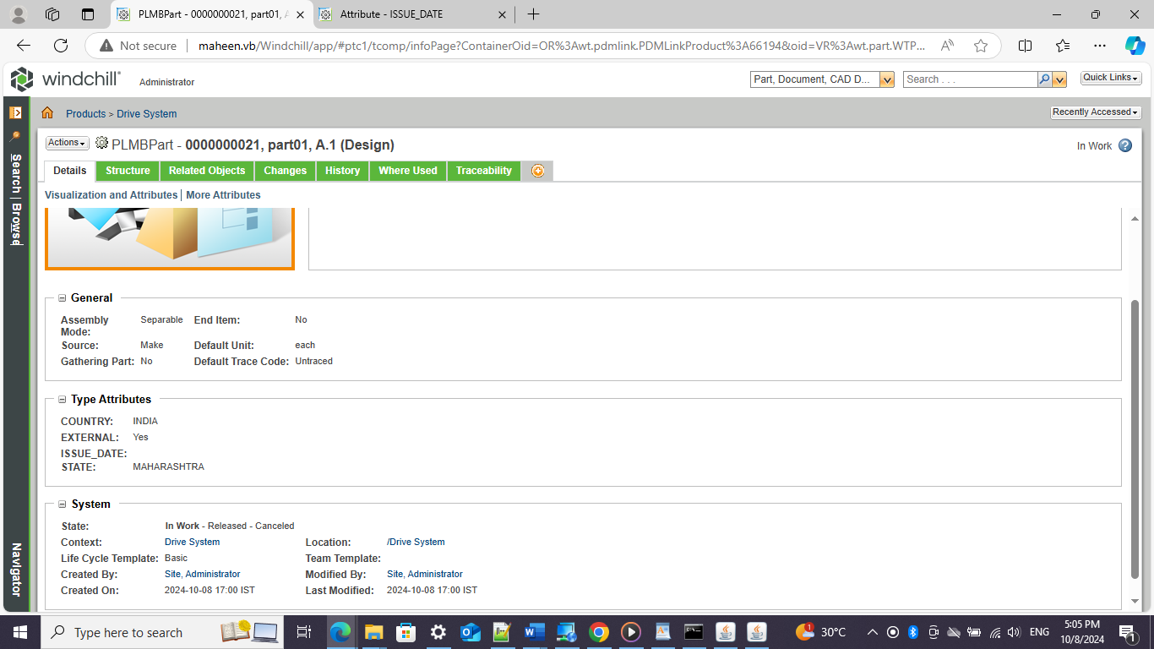

**9. Create a global enumeration where the Country should have values like India, China, and USA, in the dropdown..**

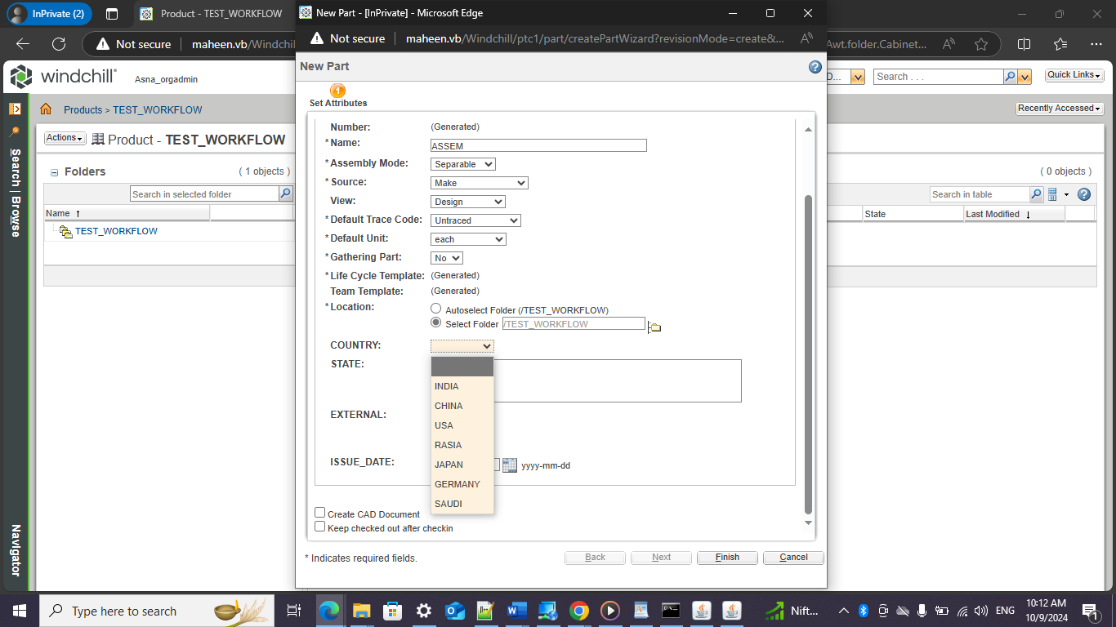

**10. States should have values like Karnataka, Kerala, Madhya Pradesh, Manipur, Maharashtra, Ch1,ch2,us1,us2, in dropdown**