Created an Organization Name : Org_Sonalee

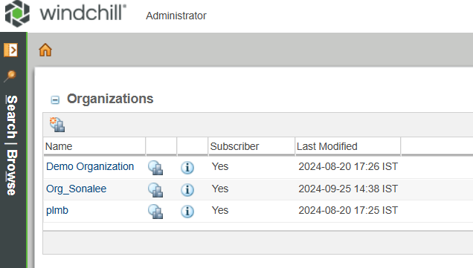

Created a User Name : adhithan_orgadmin

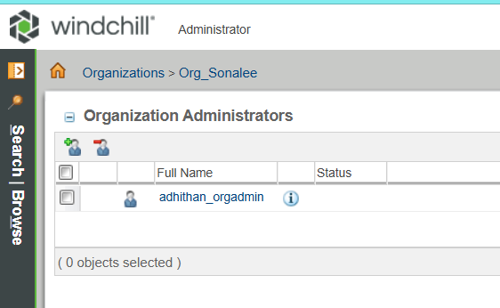

Added product_user001 and allcreator001 as product creator

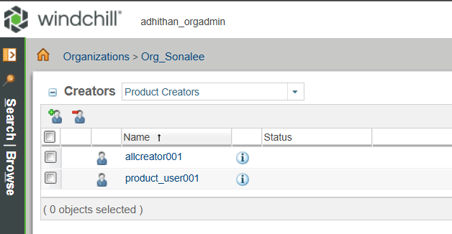

Added library_user001 and allcreator001 as library creator

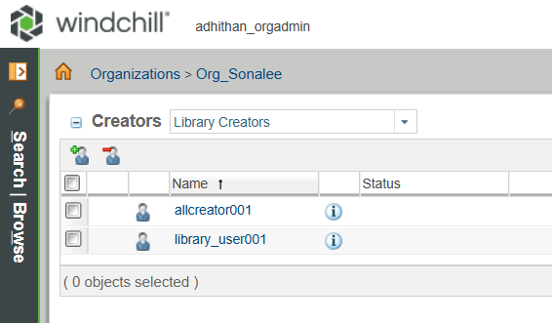

Created product001 in product_user001

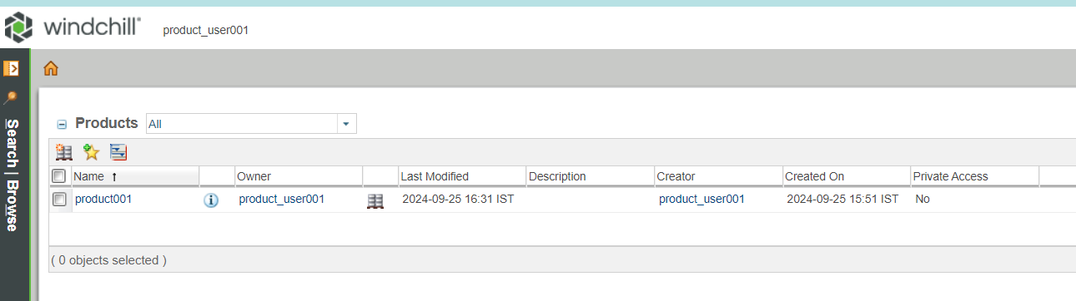

Created library001 in library_user001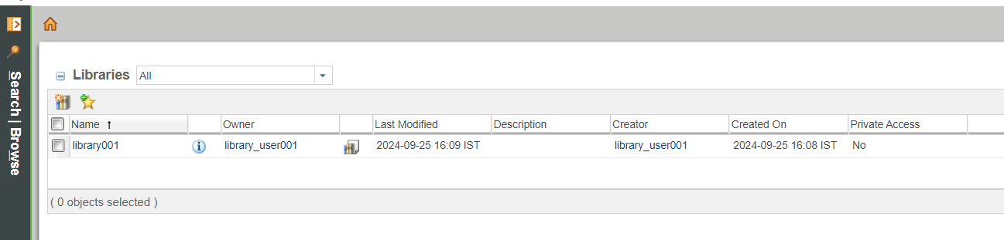

Created 2 users u001 & u002

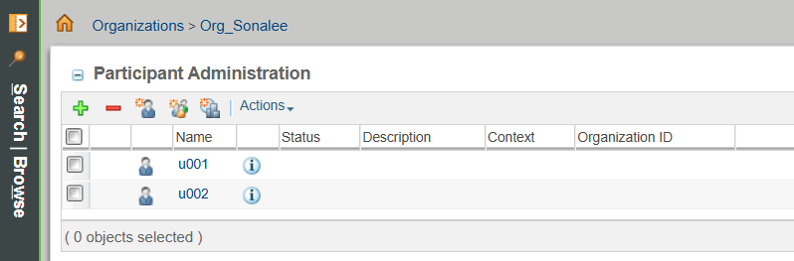

Made u001 as member of product001

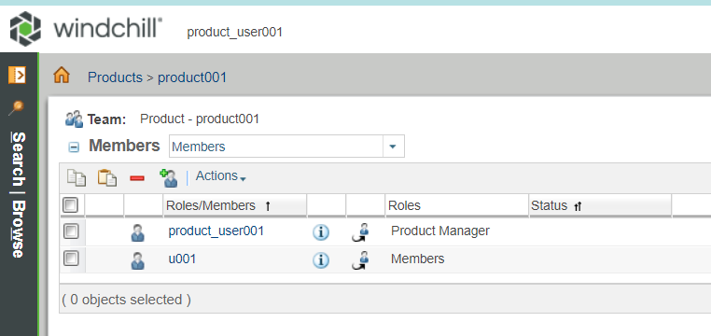

Made u002 as member of library001

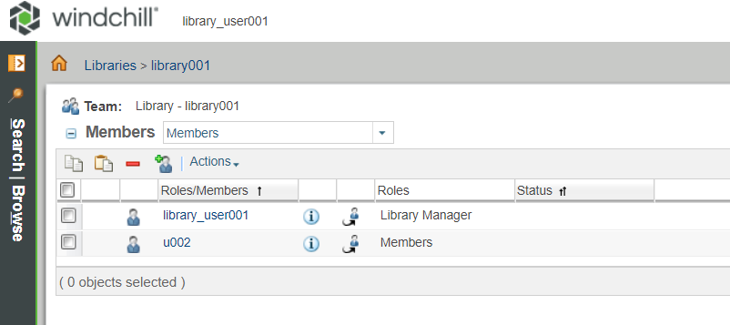

As expected allcreator001 user have both product and library create access

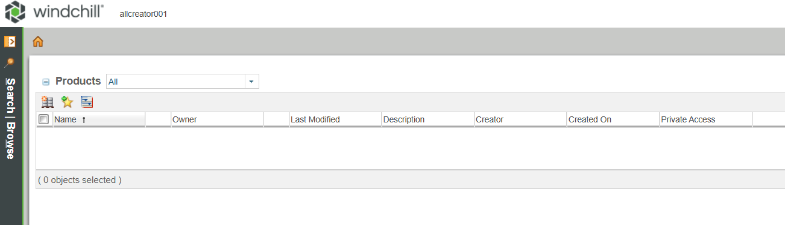

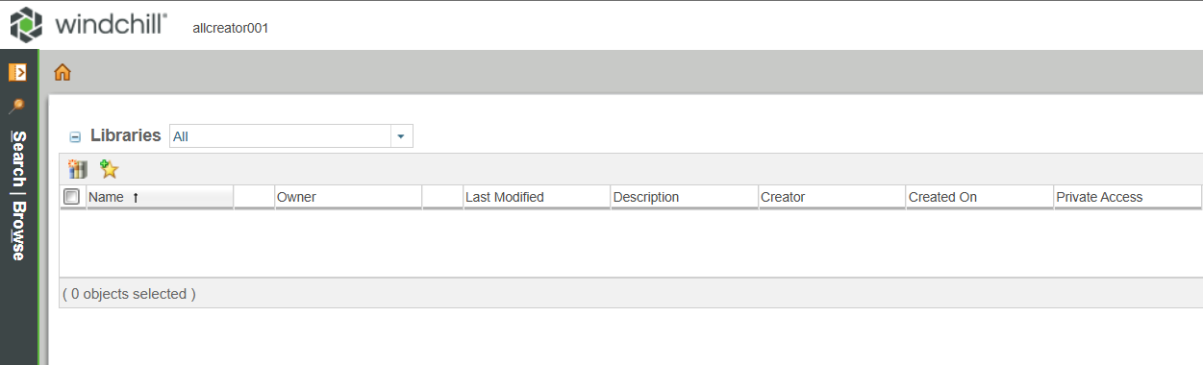

As expected, u001 has read only access for product001



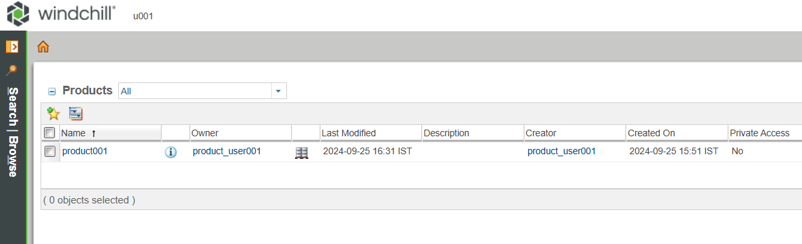

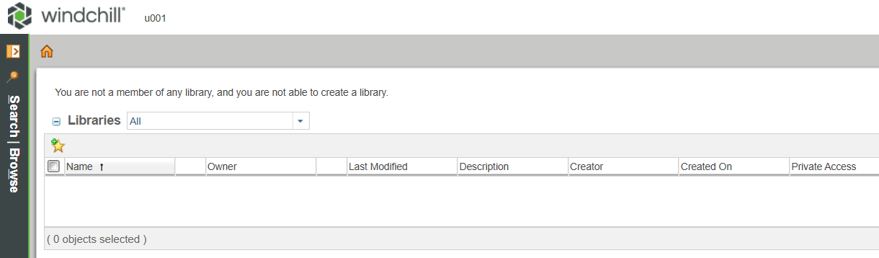

As expected, u002 has read only access for library001



