1. Create document objects.

add primary and secondary content

step:1 A product is created by an Administrator. Under Products🡪select Folders🡪create Document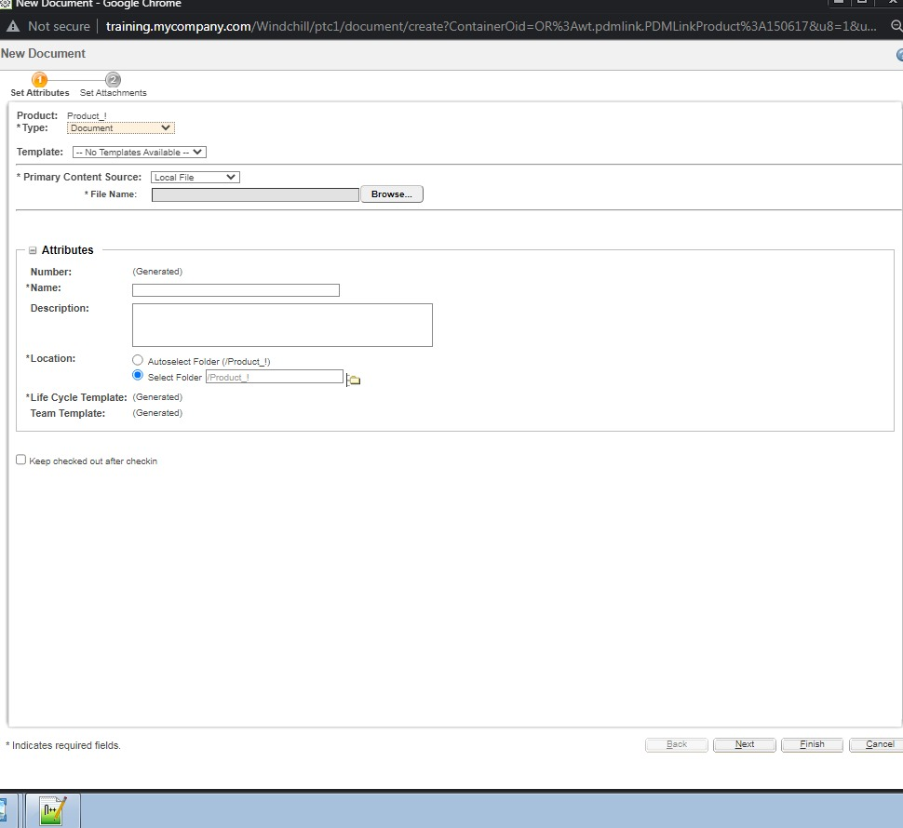

Step:2 Add primary content,only one primary content is given for the Document and n number of Secondary contents can be Attached.

1.Local file.

2.URL link.

3.External sour

Step:3 Both the primary and Secondary contents are added🡪click on finish🡪Document is created

1.21. Checking the document object, change the primary content and checkout the document object.

Step1: check on the document object🡪select content🡪edit

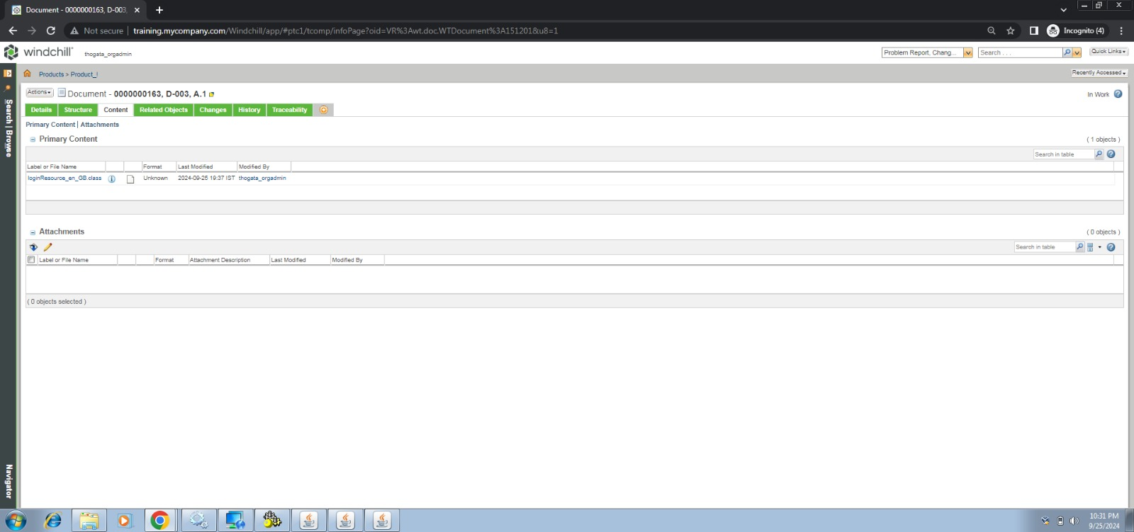

Step:2 now edit the Primary content and attach the new content.thus primary content has been changed

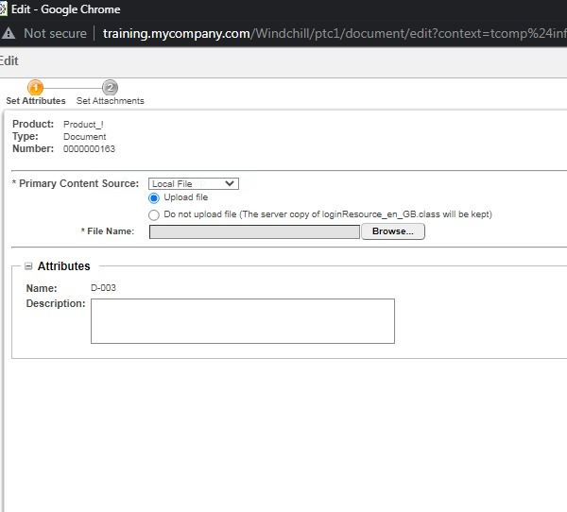

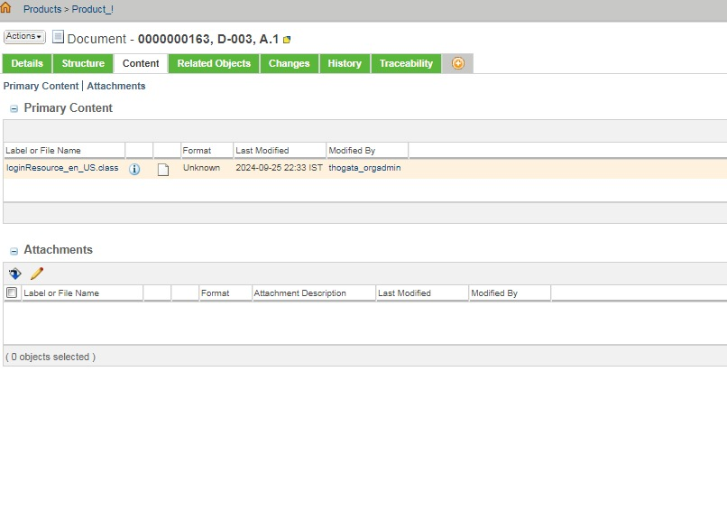

Step4: New Primary content has been Added.

2.1 2. Create Part object

2.1. Create BOM structure, Parent Child relaction in parts.

Step:1 A new part was created

BOM:Billing of Materials,it is nothing but creation of one object to another object and has an parent child Relationships(i.e) first part object becomes the parent to the second part object (child) and n number of parts can be created from part to part

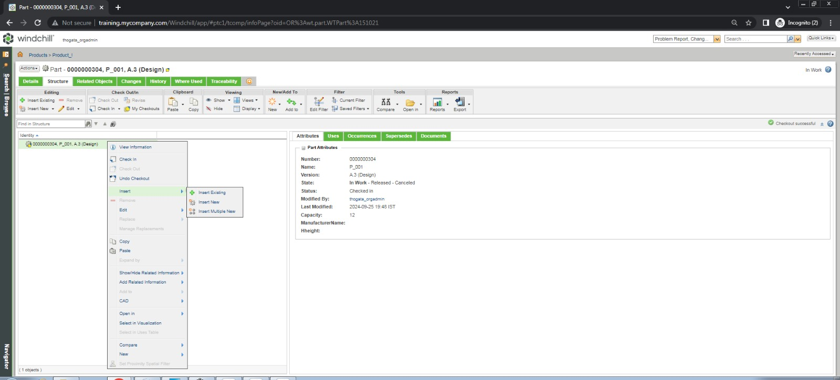

Step:2 Select structure 🡪insert Existing or insert new🡪Add new part🡪 becomes child of that parent Part🡪this criteria is BOM,billing of materials.

