Homework 3
Mane Papoyan
GitHub repo - https://github.com/manehp/CS331-Operating-Systems
Assignment 1: Basic Process Creation with fork()
In this assignment, we want to show how a child process is created using {fork()}. We start by creating the variable ret and then use {ret = fork();}. The fork() creates a new child process, so after this line we have a parent and a child process. If {ret == 0}, we are in the child process, so we print its PID using {getpid()} and then use {exit(0)} to stop the child. Otherwise, we are in the parent process, where we print its PID. Since the parent does not wait for the child, the order of the output can be different each time. The PID numbers are also different because they are assigned by the operating system.
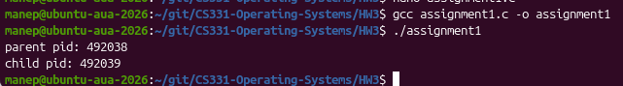
Assignment 2: Using wait() and waitpid()
In this assignment, we create two child processes using {fork()}. The first child prints its PID and exits with {exit(10)}, while the second child prints its PID and exits with {exit(20)}. We then use {waitpid(child2, &status, 0)} so the parent specifically waits for Child 2. With {WEXITSTATUS(status)} we get its exit status, which is 20. After that, {wait(&status)} waits for the remaining child, which is Child 1, and we get its status 10. This shows that waitpid() can be used to wait for a specific child, while wait() waits for any remaining child.
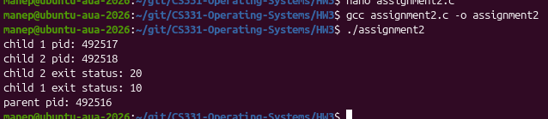

Assignment 3: Understanding atexit()
In this assignment, we use {atexit()} to register functions that run when the program terminates. We create two functions, {cleanup1()} and {cleanup2()}, and register them using {atexit(cleanup1)} and {atexit(cleanup2)}. We then use {exit(0)} to terminate the program. The cleanup functions are called automatically, but in reverse order of registration. So cleanup2 runs first and then cleanup1. This can be useful for performing cleanup tasks before a program finishes.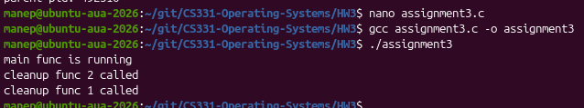
Assignment 4: Fork and Exit Status
In this assignment, we create two child processes using {fork()}. Child 1 prints its PID and exits with {exit(10)}, while Child 2 prints its PID and exits with {exit(20)}. The parent then uses {waitpid()} for each child and stores the result in status. We use {WIFEXITED(status)} to check if the child finished normally and {WEXITSTATUS(status)} to get its exit status. We can observe that Child 1 returns 10 and Child 2 returns 20, showing how the parent can receive the exit status of each child.
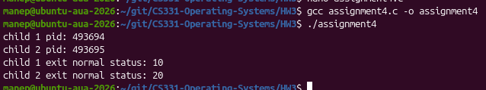

Assignment 5: Zombie Processes
In this assignment, we want to show what happens when a child finishes but the parent does not use {wait()}. The child prints its PID and exits, while the parent sleeps for 20 seconds. During this time, the child becomes a zombie because it has finished but the parent has not collected its exit status. We observed this using {ps -ef | grep assignment5}, where the child appeared as {<defunct>}, and {ps -el | grep Z}, where its state was {Z}. We then added {wait(NULL)} to the parent, which collects the child's status and prevents the child from remaining as a zombie.
