Homework 4
Mane Papoyan
GitHub repo - https://github.com/manehp/CS331-Operating-Systems
Assignment 1: Creating the Source Files
First, we create three files. The main.c file contains the main function. It asks the us as the user to enter an integer and then calls the square function. The math_utils.c file contains the actual square function. It receives an integer and returns the number multiplied by itself. Then we create the math_utils.h file, which contains the declaration of the square function. This allows main.c to know about the function before it is compiled. The files are separated so that the main program and the utility function can be compiled separately.
Assignment 2: Using wait() and waitpid()
We compile the two C files separately using: gcc -c main.c and math_utils.cThis creates main.o and math_utils.o. These are object files, which contain machine code but are not complete executable programs yet. The main.o file contains the code for the main function. It also contains references to functions such as printf, scanf, and square. The square function is not inside main.o because it is defined in math_utils.c. The math_utils.o file contains the code for the square function.
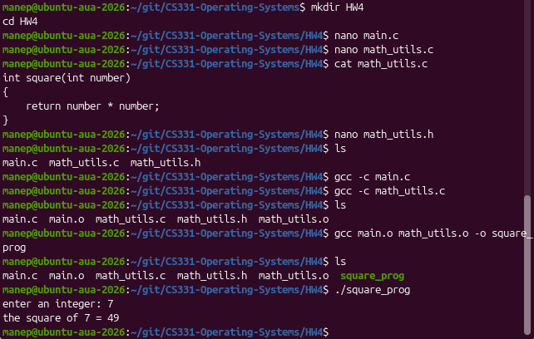
Assignment 3: Linking the Object Files
After creating the object files, we link them using: gcc main.o math_utils.o -o square_prog The linker combines the two object files and resolves the references between them. For example, main.o has a reference to square, while math_utils.o contains the definition of square. After linking, we get the executable square_prog. We also tested the program and confirmed that it asks for an integer and correctly calculates its square.
Assignment 4 Comparing the nm Outputs
We used nm to look at the symbols in the object files and the final executable. In main.o, the symbol main is defined and is shown with T. The symbols square, printf, scanf, and __stack_chk_fail are shown as U, which means they are undefined in this object file and need to be resolved later. In math_utils.o, the symbol square is defined and is shown with T. This is because the actual square function is written in this file.
In square_prog, both main and square are defined. The executable also contains many additional symbols from the C runtime and libraries, such as __libc_start_main, printf, and scanf. This shows how the linker changes the symbols. Before linking, main.o only has a reference to square, but after linking, the final executable contains the actual square function.

Assignment 5: Comparing the objdump Output
We used objdump -d to look at the machine instructions in each file. In main.o, we can see the assembly instructions for the main function. There are also calls to other functions. Since this is still an object file, some of these calls have not been completely resolved yet.
In math_utils.o, we can see the instructions for the square function. The important part is the imul instruction, which multiplies the number by itself. This is the main operation performed by the function. In square_prog, we can see the code from both object files together. The executable also contains additional startup and runtime code. The main function is located at 0x1189, and the square function is located at 0x1217. The call from main to square is now connected to the actual square function in the executable. This shows that the object files contain separate parts of the program, while the final executable contains the combined machine code.

Assignment 6: Comparing the readelf Outputs
We used readelf -h and readelf -S to look at the ELF headers and sections. Both main.o and math_utils.o are REL files, which means they are relocatable object files. They do not have an entry point or program headers because they are not complete executable programs yet.
main.o has 14 sections and math_utils.o has 12 sections. They both contain sections such as .text, .data, .bss, .comment, .eh_frame, .symtab, .strtab, and .shstrtab.
main.o also contains .rodata because it has strings used by the program, such as the messages printed to the user. It also has .rela.text, which contains relocation information for references that still need to be resolved.
The final square_prog is different. It is shown as a DYN (Position-Independent Executable file) and has an entry point at 0x10a0. It has 31 sections, which is more than the object files.
The executable contains additional sections such as .interp, .dynsym, .dynstr, .plt, .plt.sec, .dynamic, and .got. These sections are needed for the final executable to work with the operating system and shared libraries.
Comparison and conclusion
The outputs of the three commands show different parts of the compilation process.
- nm shows the symbols. It helps us see which functions are defined and which functions still need to be resolved.
- objdump shows the machine instructions. It lets us see the actual assembly code in the object files and the final executable.
- readelf shows the structure of the ELF files. It shows that the object files are relocatable files with fewer sections, while the final executable has many additional sections needed to run the program.
Overall, the object files contain separate parts of the program and information that still needs to be resolved. The linker combines these files, resolves references such as the call to square, and creates the final executable with the required runtime and linking information.

