Homework 2
Mane Papoyan
GitHub repo - https://github.com/manehp/CS331-Operating-Systems
Assignment 0: Multiple Fork Calls
In this assignment, we want to show how multiple {fork()} calls create new processes. We start by calling, it which creates one child process. Then it returns 0 for the child and the process ID for the parent. We then call {fork()} two more times, and since all the processes continue to the next fork, the number of processes double each time. And so after 3 forks we get 8 processes. Each process has a parent, and the new processes are the children of that parent process that created them.
Assignment 1: Simple Fork and Exec
In this assignment, we use {fork()} to create a child process. Then inside the child we use {execl()} to run {ls}. The {fork()} returns 0 for the child and the child process ID for the parent. We use {execl("/usr/bin/ls", "ls", NULL)} which replaces the child with the {ls} program and so it prints the files in the directory. The parent uses {wait(NULL)} to wait for the child to finish and then prints "Parent process done".
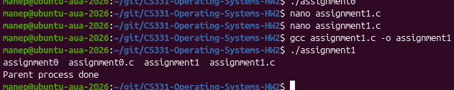
Assignment 2: Multiple Forks and Execs
In this assignment, we create two child processes using {fork()}. For the first child we use {execl()} to run {ls} and for the second child we use {execl()} to run {date}. The parent uses {wait(NULL)} two times to wait for both children to finish. Both children are created by the parent so they are not related as parent and child. The order can also change because the processes can run at different times.
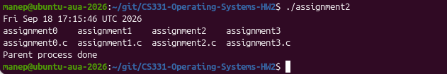
Assignment 3: Fork and Exec with Arguments
In this assignment, we use {fork()} to create a child process and then use {execl()} to run {echo}. We use {execl("/usr/bin/echo", "echo", "Hello from the child process", NULL)} where "Hello from the child process" is the argument we give to {echo}. The child prints the message and the parent uses {wait(NULL)} to wait for the child. After the child finishes the parent prints "Parent process done".
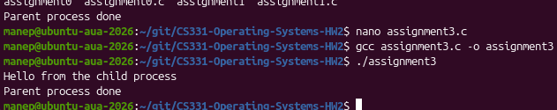
Assignment 4: Fork and Exec with Command-Line Arguments
In this assignment, we use {fork()} to create a child process and then use {execl()} to run {grep}. We use {execl("/usr/bin/grep", "grep", "main", "test.txt", NULL)} where {main} is the word we want to find and {test.txt} is the file we search in. The child then prints the lines where {main} is found. The parent waits for the child using {wait(NULL)} and after that prints "Parent process completed".
