Homework 1
Mane Papoyan
GitHub repo - https://github.com/manehp/CS331-Operating-Systems
Assignment 1: Basics of Pointers
In this assignment, we want to show how the pointer stores the memory address of a variable. For that we start by creating the var = 1. Then we assign the pointer the address of that variable, with {int *ptr = &number;} where the {&number} is the address of that number and {ptr} is the pointer. We then print the variable address with both the address of the number and the pointer, and since we had assigned previously, the pointer directly points to the number we get the same results.
We then change our number from 1 to 2, with {*ptr = 2}. Since ptr contains the address of the number we assign the value located at the address stored in ptr to 2 and so the number gets changed.
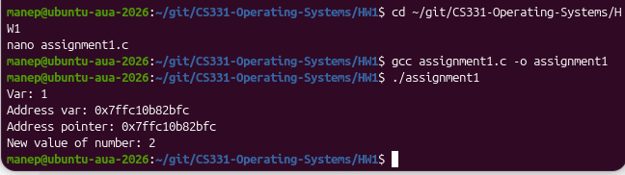
Assignment 2: Pointer Arithmetic
In this assignment, we create the array [1,2,3,4,5]. By {int *ptr = numbers;} we make the ptr to the first element of this array. Using the {*(ptr + i)} arithmetic in a for loop, we move i positions from ptr, then get the value there. Meanwhile {*(ptr + i) = *(ptr + i) * 2} doubles the value through the pointer. And so in both cases the new array becomes [2,4,6,8,10]
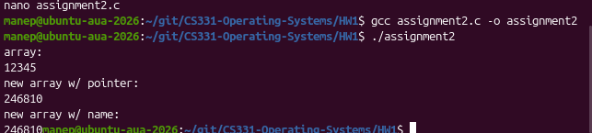
Assignment 3: Pointers and Functions
In this assignment, we use pointers to modify variables inside the {void swap(int *a, int *b)} function. We call {swap(&x, &y)}, where (&x, &y} are the addresses of our two variables, respectively, and so the a points to x, and b points to y. Initially x was 1, and y was 2. When we do {*a = *b}, the 2 is copied into x, and with {*b = temp} the original 1 is copied to y.
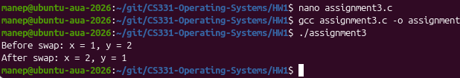
Assignment 4: Pointers to Pointers
In this assignment, we use a pointer to a pointer. We start by creating the number = 10. Then we assign ptr the address of the number with {int *ptr = &number;}. After that, we assign double_ptr the address of ptr with {int **double_ptr = &ptr;}. We then use {*ptr} to get the value of number, and with {**double_ptr} we go through both pointers to get the value of number, so in both cases we get 1.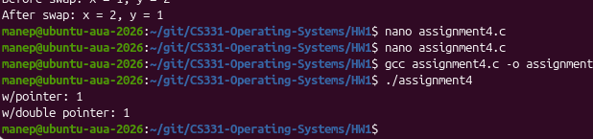
Assignment 5: Strings and Character Pointers
In this assignment, we create the string "Hello" and assign ptr to the first element with {char *ptr = str;}. We then use a while loop to go through the string, where {*ptr} gives us the character at the current position and {ptr++} moves the pointer to the next character. We stop when we reach '\0', which shows the end of the string. We then use another while loop to count the characters, and so we get 5 characters.
