Portable flow multiplexing device for continuous, in situ biodetection of environmental contaminants
J.-Pablo Salvador^{a,b}, M.-Pilar Marco^{a,b}, Giacomo Saviozzi^{c} and Cecilia Laschi^{c}, Fernando Arreza^{d}, Francisco Palacio^{d} and Manel Lopez^{*d}
ª Nanobiotechnology for diagnostics (Nb4D), Department of Chemical and Biomolecular Nanotechnology, Institute for Advanced Chemistry of Catalonia (IQAC) of the Spanish Council for Scientific Research (CSIC), Barcelona, Spain
^{b} CIBER de Bioingeniería, Biomateriales y Nanomedicina (CIBER-BBN), Jordi Girona 18-26, E-08034 Barcelona, Spain
^{c} Marine Robotics, The BioRobotics Institute, Scuola Superiore Sant’Anna (SSSA), 56025 Pontedera, Italy
^{d} Departament d’Enginyeria Electrònica i Biomèdica, Universitat de Barcelona, C/ Martí i Franquès 1, E-08028 Barcelona, Spain
* Corresponding author e-mail: manel.lopez@ub.edu
- Central Unit (CU).
The CU system, powered by 24 VDC, has the following communication peripherals:
- 1 x CAN BUS port to communicate with SU (CAN 2.0A – 500/1000 kbit/s)
- 1 x serial RS232 port for external application communication
- 1 x UART auxiliary port:
- to program the CU microcontroller and test the hardware and firmware (debug mode)
- to handle further devices (operational mode).
The CU system is driving the following peripherals devices:
- Peristaltic µPumps
  - 1 x P625/66.143 with PharMed 3/32” ID tubing
  - 1 x P625/900.143 with PharMed 1/16" ID tubing
- µSolenoid Valves (µVs)
  - 9 x ASCO 2/2 NC - model SC S067A 029 E (one spare)
  - 4 x ASCO 2/2 NC - model SC S067A 039 E – 0.2, 1, 5 and 10 m depths
  - 6 x ASCO 3/2 U - model SC S067A 109 E (one spare)
  - 1 x ASCO 3/2 U - model SC S067A 119 E
- 1 x Equflow PFA0045TNP01XX from Clark Solution
- Sensors:
  - SHT71 for Mote humidity & temperature from Sensirion
  - TMP36 for the S&µFU CPU temperature from Analog Devices
  - INA199 current sensor for the whole S&µFUC power from Texas Instruments
  - home-made for CU virtual case flooding alarm
- Regulators:
  - 12 x drop-voltage controlled series resistances (current sensors for µPs and µVs),
- RTC (+ battery) to furnish DataTime,
- Switches on/off (24V) to control SU power on/off.
- Switch off itself if main battery voltage too low.
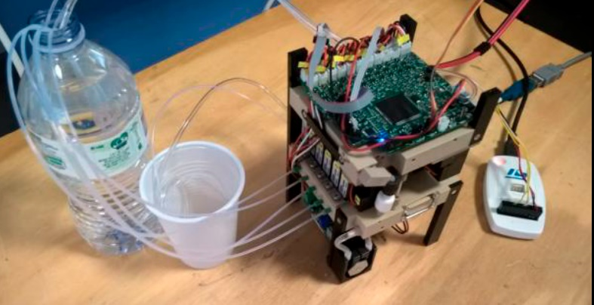
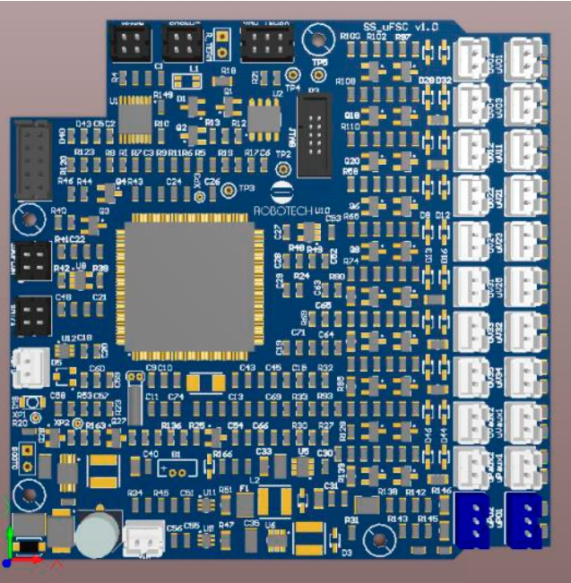
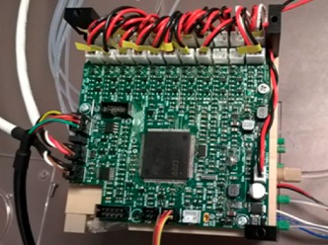
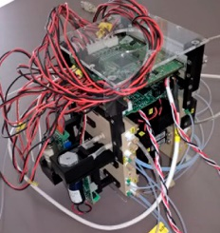
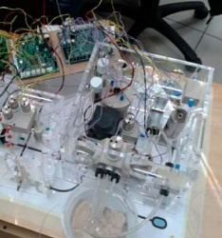
The CU is getting sensor data every 10 ms (10 Hz) to be sent cyclically, together with its state and sampling main events, to the external application via the Serial RS232 line. In order to save energy, in the current implementation CU is sending its Status messages every 10 s and when its state changes.
(b)

(a)
(e)
(d)
(c)

Figure S1. Architecture of the Central Unit. (a) Integrated in the microfluidic platform; (b) PCB pre-print review; (c) Central Unit PCB design; (d) Integration with the other electronic system; (e) Pre-mounting image

- CU electronics schematics.
Figure S2: CU based on the STMicroelectronics STM32F103ZFT6 microcontroller electronics schematic.
Figure S3: CU serial and CAN communications electronics schematic.

- Sensor Unit (SU).
The SU system, powered by 24 VDC, has the following communication peripherals:
- 1 x CAN BUS port to communicate with SU (CAN 2.0A – 500/1000 kbit/s)
- 1 x UART auxiliary port:
- to program the CU microcontroller and test the hardware and firmware (debug mode)
The CU system is driving the following peripherals devices:
- µSolenoid Valves (µVs)
  - 8 x ASCO 2/2 NC - model SC S067A 029 E
- Sensors:
  - Controls and acquire the 8 sensor potentioestats.
  - Acquire the 8 sensor measures.
The SU behavior is as a slave, it has preprogramed the measurement procedure, but only starts to measure when receive the command from the CU.
- SU electronics schematics.
Figure S4: SU based on Microchip PIC32MX795F512L microcontroller electronics schematic.
Figure S5: SU serial and CAN communications electronics schematic.

Figure S6: SU Sallen Key filter and the the 8 minitiaruzed potentiostat stages electronics schematic.
Figure S7: SU the 8 transimpedance operational amplifier (TIA) stages electronics schematic.
Figure S8: SU the 8 microvalves control based on RTR020N05 MOSFET transistor stage electronics schematic.
- Microcontrollers architecture.
Microcontrollers architecture have been implemented with the following functionalities:
- each microcontroller manages its proper system;
- 2. the two microcontrollers are connected to an internal CAN BUS 2.0A network and communicates by using an Application Level 7 proprietary protocol;
- the CU is the logical CAN network master and
  - controls the SU power on/off actions,
  - drives the SU to synchronize the measurement procedure steps;
- CU is also the CAN BUS Front-End microcontroller and communicates with the external application through a RS232 serial connection by using a proprietary protocol:
- sends measurement data, analytical signals, states, alarms, etc. to the external application,
- receives the commands trough the external application and re-directed them to the proper microcontroller on the CAN BUS..
- the external application sends/receives data to/from external End-User stations to achieve a fully operational CU and communicates with CU in the respect of data formats already defined.
The CAN BUS, devoted to the microcontrollers communication, uses CAN 2.0A standard (11 bit Message Identification), OSI Layer 2 “Data Link Layer”, at 1 Mbps speed. It has been implemented proprietary CAN messages formats and protocols between microcontrollers.

- CU flow diagram.
Figure S9: CU flow diagram including the communication protocol.

- SU flow diagram.
Figure S10: SU flow diagram including the communication protocol.

