**Portable flow multiplexing device for continuous, *in situ* biodetection of environmental contaminants**

J.-Pablo Salvadora,b, M.-Pilar Marcoa,b, Giacomo Saviozzic and Cecilia Laschic, Fernando Arrezad, Francisco Palaciod and Manel Lopez*d

a Nanobiotechnology for diagnostics (Nb4D), Department of Chemical and Biomolecular Nanotechnology, Institute for Advanced Chemistry of Catalonia (IQAC) of the Spanish Council for Scientific Research (CSIC), Barcelona, Spain

b CIBER de Bioingeniería, Biomateriales y Nanomedicina (CIBER-BBN), Jordi Girona 18-26, E-08034 Barcelona, Spain

c Marine Robotics, The BioRobotics Institute, Scuola Superiore Sant’Anna (SSSA), 56025 Pontedera, Italy

d Departament d’Enginyeria Electrònica i Biomèdica, Universitat de Barcelona, C/ Martí i Franquès 1, E-08028 Barcelona, Spain

* Corresponding author e-mail: [manel.lopez@ub.edu](mailto:manel.lopez@ub.edu)

**Abstract**

A compact, low-cost and low-powered device was developed and arranged for multiplexed biodetection of sea water contaminants from continuous flow mode. Electronics, mechanics and fluidics were designed to guarantee identical functional liquid flow through eight parallel sensor microchambers during a predetermined time period providing 8 values at the same time. The accuracy and repeatability of the device was tested in-lab, achieving a deviation of less than 10 % when measuring the same analyte in all the chambers. The experimental results obtained with our device were finally compared with those measured in continuous flux by a commercial potentiostat SP150 (Bio-Logic Science Instruments), obtaining identical results, which validated the proposed device.

**1. Introduction**

Maritime regions account for over 40 % of Europe’s gross domestic product (GDP) [1], being between 3 and 5 % of the latter generated directly from marine-based services and industries [2, 3]. Moreover, the direct impact of marine resources on quality of life, public health and business development is of utmost value despite being non-quantifiable. Proof of this impact is that EU aquaculture production reached 1.2 million tons of produce in 2020 and a sale value of € 4.1 billion in turnover in 2018 [2, 4, 5] (These reports estimate that the coronavirus pandemic hit the sector by decreasing income sources and increasing costs). In this context, chemical contamination of estuarine and coastal areas carries perverse consequences for the environment and through the food chain for public health. In addition, coastal industries (e.g. fisheries) are already being severely affected.

According the European Commission (EC) through specific scientific committee on food, farming and fisheries[5] promoted policies to ensure food quality and safety in agriculture/aquaculture products. They have special interest to include severe limitations on the use of chemical products, spills and usage of facilities for food safety. In this context, EC sponsors every year many scientific projects for developing technological solutions to face this issue, and created a permanent project calls, specific for marine and coastal issues. Some of these scientific and technical projects involve developing early warning systems that provide extreme sensitive and selective data for monitoring sea water and eventually triggering an alarm in case the level of contamination reaches a meaningful threshold. This work, carried out within the framework of the **sea-on-a-chip** project, grant agreement No.614168, was aimed to develop a miniaturized, autonomous, remote and flexible immunosensor platform for real-time monitoring of marine waters in multi-stressor conditions by providing a concrete application for aquaculture facilities. The immunosensor platform was based on a fully integrated array of microelectrodes and a microfluidic system in a lab-on-a-chip-like configuration with electrochemical (amperometric) detection.

Current analytical laboratory methodologies for the detection of environmental pollutants are based on chromatographic techniques coupled to mass spectrometric detectors [6]. These methods are characterized with high detectability, specificity, multianalyte analysis and are considered as the golden standard methodology for the validation and confirmatory method of screening techniques. However, they require preconcentration and clean-up strategies, qualified personnel and complex instrumentation that results in a high cost/analysis ratio. In order to reach enough detectability to monitor on-time environmental pollutant, it is required develop rapid, simple and low-cost devices.

Immunosensors make use of the specific binding between an antibody and antigen coupled to physical transducer that converts the biorecognition process into measurable signal [7]. The antigen-antibody interaction is the basis of a wide variety of immunochemical methods enough selective and sensitive to detect organic pollutants. Indeed, immunoassays have been widely used in environmental applications [8] as a high throughput method allowing the simultaneous analysis of a number of samples. These can be adapted to rapid detection formats such as dip-sticks or presented in combination with transducer elements to develop immunosensors [9]. Electrochemical immunosensors have gained attention due to their high detectability, robustness and simplicity in the design of the electrodes, specifically better in amperometric measurements. According to these advantages, the development of an autonomous and automatic device based on this transducing principle was one of the challenges that are facing in this work.

Electrochemical biosensors are commonly assembled for point-of-care applications due to its rapid analytical response, its possibility of miniaturization, that implies a reduction in size and power consumption. Finally, it is important to remark their ability to perform analysis on the field. Some immunosensor platform architectures have been reported in the literature, in both the environmental [10-12] and biomedical[13-18] contexts. Automated, on time and *in situ* environmental chemical sensors and point-of-care systems have led out alternatives to traditional manual sampling (which also involves preservation and transportation to a laboratory for further analysis, at the risk of sample degradation and/or contamination), in all cases the microfluidic technology is the fundamental requirement. In this context, automated sampling and on time, *in situ* analysis not only overcomes the risk of sample damage and cumbersome logistics, but also allows for high measurement frequency or continuous measurement in remote locations (e.g., open seas). Moreover, this microfluidics-based strategy plays an important role in the accuracy achieved in some *in situ* chemical measurements; this is the case of some chemical parameters that contrary to pH, oxygen or nitrate, cannot be measured with solid state sensors [19-26]. In some cases, the sample needs chemical pre-treatment prior to being presented to a chemical sensor (e.g., to measure the concentration of a determined chemical pollutant). The use of microfluidics in such cases helps increase the operational lifetime of *in situ* chemical sensors by carefully managing the reagent stock and pumping energy [27-30].

Energy storage is precisely one of the most challenging issues in the management of automated *in situ* environmental sensing systems and point-of-care technology. Although much progress has been made during the past years in terms of energy management, there is still a long way ahead to achieve highly efficient systems whilst maintaining analytical performances. The pumping action is one of the most critical influences in energy efficiency since it must be supplied with a considerable power level. In this work, a pulsed flow mechanism is presented for the first time to the authors’ knowledge as a suitable method for reducing power consumption in an autonomous and *in situ* sensor network for analysis of sea water pollutants. Here, the complete system is described in several parts, comprising the microfluidics and multiplexing of fluid towards the electrochemical sensor array, the electronics and hardware for micropumps and microvalves control and sample analysis and the software for remote control with a graphical user interface. As a proof of concept, the determination of marine pollutants using antibodies was proposed in this work. Specifically, the demonstration was performed using immunoreagents for the determination of Irgarol 1051® [32].

**2. The measurement system.**

The measurement system designed for detecting marine contaminants is a complex device that allows to perform up to eight different measurements to be carried out simultaneously. To do this, it incorporates an important electromechanical and microfluidic part coupled with an electronic control system that manage the whole system, including the liquids dispensing protocol and the measurement algorithm. To perform the liquids dispensing in the different micro-chamber biosensors a fluidic module was done in an integrated way, using CAD tools for the complete design of the system. The schematic design of the whole system, different pictures that show the electronic system, the electromechanical and microfluidical stage and the power consumption analysis are presented throughout this paper. In particular, the schematic electronic design is available in the supplementary material. This supplementary material includes, among other important information, a video (SM Video_1) that shows the functionality of the whole system.

The different blocks that make up the measurement system are described in detail below.

**2.1. Immunosensor protocol**

This paragraph is focused on the design of an innovative immunoassay flow multiplexing system capable of detecting and quantifying up to eight parallel analytes in an autonomous way. For this purpose, we selected the immunoreagent pair 4e-BSA/As87 (4e-BSA: Bovine serum albumin coupled to a Hapten 4e; Hapten: molecule that mimic the target analyte to be coupled to a carrier protein to induce immune response; As87: antiserum specific for Irgarol 1051®) required for the detection of Irgarol 1051®. This contaminant has been studied widely in our laboratory in different formats such as ELISA [34-36], fluorescent microarray [37], optical [38, 39] and electrochemical immunosensors [32, 33]. Irgarol 1051® is a triazine herbicide that is being used as antifouling paint on recreational and commercial watercraft hulls to prevent algae growth. In our case, the measurement and detection of this contaminant requires the use of a well functionalized electrochemical immunosensor and the implementation of a competitive assay protocol. Such competitive assay protocol is summarized in the Figure 1. Basically, the detection of small molecules such as Irgarol 1051® requires the immobilization of the competitor (4e-BSA) on the chip’s sensor surface and then put in contact the specific antibody and the sample that contains the pollutant. After a period of incubation, the remaining antibody untied to the analyte is removed by a washing step. In order to acquire the binding competitor-antibody, a secondary antibody labelled with anti-IgG Horseradish Peroxidase conjugate (aHRP) is added. HRP would provide the electrochemical signal after additioning the corresponding substrate (H2O2/TMB -Hydrogen Peroxide/Tetramethylbenzidine- based solution). Once the measurements have been performed, the chip can be regenerated after additioning the NaOH 0.3M solution to be ready for the next simultaneous measurements.

According to this protocol a number of tanked reagents linked to the microfluidic system are required. This is depicted in Figure 2, where a scheme of the mixture and measurement flow pathways, including the required peristaltic micropumps and microvalves necessary to perform the process, is shown. Basically, it requires a tank containing Phosphate Buffered Saline buffer with Tween® 20 (PBST) to perform the washes between stages and for the conditioning of the biosensor chambers. The Antibody buffer (ABB) tank supplies the specific antibodies for the recognition of the target analyte. The sample is pushed and addressed to the Dilution tank (DT) by a peristaltic micropump, where it is put in contact with the antibody for the preincubation of analyte-antibody. After a period of time defined in Table 1, the content is flooded to the biosensor chambers. To complete the biosensor protocol defined in Figure 1, the device requires the inclusion of aHRP, DS (detection solution) and RS (regeneration solution) tanks that contain the anti-IgG-HRP conjugate, the detection solution and the regeneration solution, respectively. Those tanks supply their content to flood the biosensor chambers. Finally, a technical issue is important to remark: According to the peristaltic pump used, a minimum flow rate was used and set at 0.027 mL/min in all the steps, in order to favor the analyte-antibody interaction. An immunoassay protocol was designed to perform the device’s automation and the steps required are shown in table 1.

**2.2. Dispensing liquids: The pulsed-flow method**

The transducing principle chosen for the acquisition of the signal was an amperometric measurement. The electrochemical responses are acquired by the detection of the oxidized TMB in the presence of H2O2 and HRP. The fact that the electroactive compound (TMB/H2O2) is in solution creates a significant risk of cross-talk between the Screen-Printed Electrodes (SPEs) that are in the same sensor chamber [40], for this reason is highly recommend to do the measurement in individual biosensors chambers. Multiplexing devices present challenges in device design, fabrication and flexible integration with other microscale techniques [41]. Simultaneous detection of multiple analytes was performed by eight biosensors dipped in their corresponding microchamber (µchamber). For this, a pulsing method was implemented to allow an identical amount of functional liquid to flow through each µchamber during a predetermined interval time, that is the same flow rate. The behind concept is the well-known and well-defined idea of time-division-multiplexing (TDM) used in networks and communications theory. In TDM, you transmit and receive independent code frames from different transmitters to different receivers sharing a common signal path that is synchronized in time, meaning that each transmission frame appears on the common line only a fraction of time in an alternating pattern. Following this concept and adapting it to microfluidics, each biosensor’s µchamber (Figure 3a) is supplied cyclically with equal amount of pulsed functional liquid by a rapid succession of microvalve orifice closure and opening. This succession of flow pulses is schematized in Figure 3b. There, T is the period in which all the µchambers are flooded with the functional liquid, and is the sum of the flow pulsation time τ performed on every µchamber. Therefore, each chamber during an infinitesimal time period τ is supplied with a flow dQ1 that in the steady state will correspond to a continuous flow of A·v, being A the cross-section area and v the velocity. It means that an identical amount of functional liquid can be outfitted, making them work as if they were supplied in continuous flow mode, even at very low flow rates as long as the liquid is effectively entering the biosensor µchamber. Hence, the µchambers flow rate (and its average value) is identical regardless of the steady peristaltic micropump flow rate, pressure and other parameters of the fluid dynamics.

**2.3. Fluidic module**

A commercial SPE array was used as the basis for developing the system sensing part. These screen-printed electrochemical arrays are formed by eight electrochemical sensors specially designed for the development of multiple simultaneous analysis. The biosensor µchamber system, schematically presented in Figure 3a, consisted of eight individual cells that permit the fitting of this SPE array and eight parallel, simultaneous measurements by eight three-electrode biosensors, each with a 2.56 mm-diameter gold-based working electrode (WE), a gold and silver-based counter (CE) and a reference (RE) electrode, respectively. Synthesizing, the eight independent µchamber permit eight independent simultaneous measurements. The physical structure of the sensor chamber was integrated in a 90 mm × 90 mm × 15 mm polyether ether ketone (PEEK) manifold. According to the scheme shown in Fig. 2 two manifolds were designed and constructed to minimize pipes and tubing and reuse common channels, microfluidic pumps and valves. The first one, named Mixing Manifold, contains the Dilution Tank (DT), used to mix the antibodies with the samples. It also included the inlets from the different tanks presented in Figure 2. The second manifold was designed to host the microsensors µchambers. The mixture of the inlet sample plus the antibody flood from the DC to each µchamber to perform the measurement according to the process described in section 2.1. Once the measurement finish, a cleaning process of both manifolds is done, followed by a regeneration stage, necessary to prepare the sensors to new measurements. In the supplementary material, the whole system is presented, and a video demo (SM: Video_2) is included. Figure 4 shows the mechanical design of both manifolds. In can be appreciate the different cavities, pipes and headers done to minimize the whole system. Both manifolds were designed using the well-known SolidWorks software, a solid modeling computer-aided design from SolidWorks Corporation ©. PEEK was chosen for its appropriate chemical and mechanical properties (although it’s pretty hard and somehow difficult to work with, PEEK female threads endure several screwing and unscrewing without early crumbling). The diameter of internal connecting pipes was limited to 1/16’’ due to drill bit availability. Nine ASCO 2/2 Normally Closed – L S067A 030E microvalves, eight for each µchamber’s input and one for whole system cleaning purpose, were connected to the pipes as illustrated in Figure 3a. The volume of all micro-chambers was identical and equal to ~6mm3. An Instech P625/900 peristaltic micropump with a power consumption between 25 and 75 mA at 5 V was employed for regulating the flow rate from 0.0007 to 19 ml/min. All the different parts of the system where interconnected using PharMed 1/16’’ Internal Diameter (ID) tubing that ensure the functionality of the device. Among the different operating conditions offered by the peristaltic micropump, a flow rate of 1.6 ml/min was chosen to completely refill the sensor µchambers, using cyclic pulses of 1 s for each micro-chamber as presented in Figure 3b. Finally, the general protocol to perform the measurement implemented in our module is the well-presented and described in Table 1.

**2.4. The electronic system**

To control a measurement structure as complex as the one proposed in this work, it was necessary to design an electronic system capable of: (i) acting on the different microvalves and micropumps for allowing the introduction, in a controlled manner, of the different chemical compounds into the manifolds to prepare the different solutions in order to detect simultaneously the different analytes; (ii) manage the introduction of the analyte in the µchambers to carry out the measurement and (iii) extract the used up materials from manifolds and µchambers, clean the prototype and regenerate the sensors to be able to carry out the next measurement. Figure 5 shows a block diagram that presents the main characteristics of the two electronic subsystems that make up the complete electronic system: The excitation signal generator and acquisition electronic subsystem and the central unit subsystem.

The excitation signal and the acquisition electronic subsystem, called henceforth sensor unit (SU), is related with the final measurement, includes the management of the eight inputs microvalves that permits to flow independently the eight sensor chambers implementing the pulsed-flow method and perform the measurement. The second one, the central unit (CU), corresponds with the management of the peristaltic pumps and the reservoirs, which also includes the activation of the micropumps to flow the Mixing Manifold, the power supply system, the communication with the SU and the communication with the user.

**2.4.1 The Sensor Unit**

The SU, based in a 32-bit PIC32MX795F512L (Microchip) microcontroller, together with a miniaturized potentiostat for measuring amperometric biosensors has the following tasks: (i) to control the input and output microvalves implementing the pulsed-flow method; (ii) to generate the input voltage signal necessary to excite the sensors; (iii) to acquire the sensing signal using its internal 10 bit analog-to-digital converters (ADC); and (iv) to filter the acquired data before sending them to the CU using a high speed connection based on CAN 2.0. The activation of the microvalves was done using eight microcontroller digital outputs, which excite the gate of eight RTR020N05 NMOSFET transistors (RHOM), one for every microvalve, allowing the fluids pass to the different sensor µchambers. Schematic design of the SU is shown in the supplementary material (Fig. S4 - S8).

The different sensors were excited with a -0.1 volts [42] between the reference and the working electrodes using the potentiostat (OPAMP 1 in Fig. 6) based on an OPA2182 (Texas Instruments) operational amplifier. The -0.1V corresponds to the best signal to be applied to the immobilizer TMB, used as an electron transfer mediator in our amperometric biosensor. Due to the fact that the microcontroller does not have a Digital to Analog Converter (DAC), to generate this -0.1 volts, one of the pulse width modulation (PWM) outputs that this microcontroller has got was used. The signal of the PWM was directly connected to a Sallen-Key low-pass filter, based on another OPA2182, to obtain a clean of noise reference (Fig. S6).

The response of the sensor signal was acquired by very high input impedance LPC662A OPAMP, configured as transimpedance operational amplifier (TIA). The feedback loops were used for measuring three-lead electrochemical biosensors. The output of this TIA was filtered and directly connected to the microcontroller’s Analog to Digital Converter (ADC) (Fig. S7). To perform the in-situ signal processing, we took advantage of its 80 MHz, 1.56 DMIPS and Mk4 core with five stage pipeline Harvard architecture (Fig S4). The complete acquisition electronics is schematized in Figure 6 and the final PCB design can be observed in Figure S9. Finally, Figure S11 shows the embedded firmware flow diagram for the management of the SU, including the communication protocol with the Central Unit.

**2.4.2 The Central Unit**

The digital part of the CU consisted of a 32-bit STM32F103ZFT6 (STMicroelectronics) microcontroller, based on a M3 72 MHz high-performance ARM Cortex M3 processor. The CAN transceiver used in both systems was a Microchip SN65HVD230D. The driver chosen to control the electrovalves and the micro-pumps was the well-known RHOM RTR020N05, the same low resistance n-MOSFET that the used in the SU. The schematic of this system is also shown in the supplementary material (Fig. S2 and S3).

The Central Unit (CU) of Figure 5 is responsible of the microfluidics’ proper functioning, supply management, synchronization requirements, preparation of the mixture for analyte detection and respect for cleanliness issues to avoid inter/intra contamination. Figure S1 shows the PCB design and its integration with the different microfluidic module. The CU also manages two different device communication channels. The first communication occurs between the final user and the platform. The user is connected to the platform via a PC/laptop final application software. This application allows to configure the measurement system, to plan timed measurements and to send data remotely. The communication between user and measurement system is based on the well-known RS232 serial communication protocol. The CU has a DB9 connector connected to a MAX232 transceiver. The communication protocol is embedded in the microcontroller and can be analyzed in Figure S10. The connection with the PC is done using a FTDI TTL-232R-RPI. For more details please see Figures S3, S10 of the supplementary material and Figure 7.

The second communication protocol is implemented between CU and SU. This communication is based on a 1 Mbs-1 CAN 2.0A protocol using a 2 MHz connection. The communication protocol between the CU and the SU is well described in the supplementary material (Fig. S10) and permits to synchronize the measurement process between these two electronic systems. The CU sends a CAN frame to the SU indicating the end of the different states in the measurement process. The SU will response with an ACK frame. Finally, once the mixing between antibodies and samples is finished, the CU sends a request to start the pumping of the analyte and perform the measurement. When the measurement is done, the SU sends a response command to the CU, that will include the results of the measurement. block diagram of, including the two communication transceivers: The MAX232 for the data transmission to the final user and the SN65HVD230D for the CAN communication with the SUFinally, Figure S10 shows the embedded firmware flow diagram for the management of the CU, including the below aforementioned communication protocols and the management of the different microvalves and micropumps.

**2.5 Analysis of the whole system’s power consumption**

The final equipment, with less than 1kg of weight and packed in a volume of 2,175 cm3 is a real portable device that will permit to measure contaminants in situ and in real time. To analyze the supply characteristics that must be taken into account, we have to consider the measurement procedure described in the previous sections, to know the quantities of liquids and interval times summarized in Table 1, and by using the power data found in the products datasheet, it is possible to calculate the energy consumption in a whole measurement procedure (a cycle).

The 24VDC 064 Series ASCO microvalves (2.5W of power consumption) are equipped with a special, optional integrated electronic component that reduces the energy consumption by 40% (Power Reduction Factor or PRF), which represents a final power consumption of 1W. The Instech P625/900.143 micropump has a power consumption of 0.45W (Supply voltage: 18V and current: 25mA). Indeed, due to the fact that the main supply for this system is 24V, it means that there is a dissipation power of 0.15W that must be added when the µPump is used. Anyway, in both cases (µVs and µPump), this consumption will take place during the period in which such devices are required. No quiescent current is considered due to the fact that power is cut by the CU when these devices are not in use. The CU electronic board has a power consumption of 0.288W while the SU electronic board has a consumption of 0.185W. Both board’s power consumptions were estimate in lab.

Table 2 shows the Power dissipation per device, the measurement cycle time, approximately 1 hour and 20 minutes, and the estimated energy consumption of the prototype. As can be observed from Table 2, the energy dispended to perform an automatic measurement will be 3.1234W·h. Analyzing the behavior per group of components we observe that the major consumption corresponds to those µValves associated with the Fluidic Module, approximately the 50% of the total. The Tanks µValves present a consumption of about 25% and the electronic boards around 15%. The peristaltic µPump has a consumption of about the 7.5% of the total energy and finally, the µValves that manage the pulsing fluidic method have a consumption per measurement cycle of about 3%.

**3. Experimental details: Sensor and sensing procedure**

**3.1. Reagents, material and instrumentation.**

Screen-printed Au electrodes (Au/SPEs DRP-8X220AT, Methrom Dropsens, Spain) consisting of a 2.5-mm smooth Au working electrode, an Au counter electrode and an Ag pseudo-reference electrode, were used. UV/Ozone Procleaner™ unit from Bioforce Nanoscience (Ames, IA, USA) was used to ensure the best possible electrodes cleaning. The calibration curves were fitted to a four-parameter logistic equation using the Graph Prism software (GraphPad Software, San Diego, CA, USA).

The immunoreagents used in this study (4e-BSA/As87) have previously been described for the detection of Irgarol 1051® [35, 36]. The antibody As87 and 4e-BSA have been performed with the support of the ICTS “NANBIOSIS”, more specifically by the Custom Antibody Service (CAbS, CIBER-BBN, IQAC-CSIC). The secondary antibody peroxidase conjugate (AntiIgG–HRP) were purchased from Sigma (St. Louis, MI, USA). The O-(2-Carboxyethyl)-O'-(2-mercaptoethyl)-heptaethylene glicol (PEG-thiol-acid) and 2,5,8,11,14,17,20-Heptaoxadocosane-22-thiol (mPEG-thiol) were acquired from Polypure (Oslo, Norway). Stock solutions of Irgarol 1051® (10 mmol L−1) was prepared in dimethyl sulfoxide (Merck) and stored at 4 °C. Phosphate-buffered saline (PBS) is 0.01 M phosphate buffer on a 0.8 % saline solution, and the pH is 7.5. PBST is PBS with 0.05 % Tween 20. For electrochemical measurements, it was used citrate buffer at 0.04 M, pH 5.5, and detection solution (DS) was also prepared containing 0.001 % TMB (3,3’,5,5’-tetramethylbenzidine) and 0.0004 % H2O2 in citrate buffer. The regeneration solution (RS) is 0.3 M sodium hydroxide.

The derivatization and functionalization of the working electrodes as well as the amperometric measurement was done as described [33]. Basically, the derivatization of the gold surface was addressed by the addition of mixed self-assembled monolayer (SAM) with a PEG-thiol-acid and mPEG-thiol. The immobilization of the coating antigen 4e-BSA was performed according to a previous work [32]. The gold SPEs were rinsed with organic solvent, cleaned using an UV/Ozone Procleaner™ and functionalized mixed self-assembled monolayer (m-SAM). Subsequently, the antigen 4e-BSA (100 µg mL-1 in PBS, 25 µL per SPE) were immobilized mixing with 25 µL containing the EDC/NHS (200 mM in PBS) and incubating for 3 h at RT. After this time, the SPEs were rinsed with PBS and capped. Finally, the biofunctionalized SPE chips were washed with water and stored in a desiccator until use.

3.2 Automatic immunosensor protocol

The device must work autonomously by executing analyte sample measurements in air conditions at predefined times. Other fundamental requirement for the device is the execution of:

1. An effective cleaning phase to prevent water intra-sample contamination, defined in steps 6, 8 and 10 Table 1.
2. An exact, well timed, procedure to provide SU, hosting the biosensor, a mixture easily measured with high accuracy and other liquids to preserve its functionalities in the long working time.

The Initial procedure to perform before (steps (a) and (b)) and after (steps (c-e)) the measurement protocol described in Table 1 is the following:

1. Empty DT, fill up DT with PBST 8 ml, keep it inside 2 min,
2. Enter all DT content to SCs at 1.6 ml/min (5 min needed),
3. Add Regeneration Solution 8ml at 1.6ml/min ml/min in SCs (5 min needed),
4. Fill up DT with PBST 8 ml, keep it inside 2 min,
5. Enter all DT content to SCs at 1.6 ml/min, keep SCs flooded (5 min needed).

Prior to analysis, a sample (4 ml) were mixed with the antibody solution at proper concentration (As87 diluted 1/500 in PBST 4 ml). The mixture was flowed to the DT using the A-SW channel. Once all the sample volume is loaded in the DT, the protocol of the assay starts by transferring the content of the DT in the eight µchamber according the pulsed-flow method. After that, empty the biosensor µchambers followed by washing with PBST buffer (5 ml at 1.6 ml/min). Then, anti-IgG-HRP 8 ml were flowed through the biosensor followed by PBST washing. Finally, a substrate solution (DS tank) that contained the mediator for amperometric measurement was flowed through the sensing chamber. The response acquisition starts automatically after the addition of DS 3 ml. The cycle concludes with a new cleaning process consisting of PBST 5 ml. Then, Regeneration Solution (RS) 10 ml is flowed through the system at 1.6 ml/min to prepare the electrodes for the next measurement.

**4. Results and discussion**

In order to demonstrate the feasibility of the device, we have proposed the implementation of the immunoreagents for the determination of Irgarol 1051®, commonly named Cybutryne. Irgarol 1051® is one of the most employed antifouling agents and is one of the most commonly found in the marine environment[43].

4.1 Maximum signal response

Gold screen printed electrodes (Au SPE) were used to test the device performance according to good reproducibility, robustness and the regenerations as described in a previous work [32]. However, in this case, the used chip includes eight Au SPE that would allow the immobilization of up to eight different biomolecules. With the aim to demonstrate the performance and the reproducibility between the eight different Au SPE, the same biomolecule was immobilized.

The first test is to evaluate the behavior of the signal using pulsing method. Following the assay summarized in Figure 1, the assay started by the addition of the specific As87antibody and after a period of time an aHRP solution was added. After that, the substrate solution was pumped in all the chambers and subsequently, the signal was acquired. From Figure 8, the steady state of the signal has been reached after 120 s, approximately. However, a periodic decay signal convoluted with the sensor response were observed in the acquisition of the signal in all the channels. Also note the time shift among the different sensors associated with the channel activation. This behavior is in concordance with the pulsing method implemented in the device. The period observed is 8s and a delay between channels of 1 s, as it was planned (see Figure 8). The signal per channel obtained was from 0.8 and 1.0 with small variation within chamber (CV of 4.8 ± 1.1 %). According to this low CV per channel, the last measurement was chosen to be used as final signal to be plotted. Thus, the mean value obtained in all the channels was 0.85 ± 0.06 r.u. (CV 7.3%).

4.2 Immunosensor determination of Irgarol 1051®

Once it was demonstrated that our immunosensor acquired the immunochemical signal with low variability, it was decided to prove if our immunosensor is able to determine Irgarol 1051® in the same way that in ELISA [36] or using an static amperometric immunosensor [32]. Thus, different concentrations of Irgarol have been measured using the same chip and the last measurement of the whole chronoamperogram was recorded to be plotted in a graph (see Figure 9). These sequential measurements were possible to be done with the same chip due to a regeneration procedure that was applied in the whole immunosensor following the procedure- that was detailly explained in section 2.1, Table 1 and section 3.2.

As it can be observed in the Figure 9, a low degree of variability was found in the different concentrations that were tested (CV 8.7 ± 4.8 %). The four-parameter logistic fitting of each individual channel (see Table 3) gave a mean value of the IC50 of 16.0 ± 1.1 nM (4.1 ± 0.3 µg/l in buffer) with a CV of 7.2%. The limit of detection (LOD) was calculated also for all the channels and a LOD of 0.61 ± 0.13 nM (0.15 ± 0.03 µg/l in buffer) was reached. The detectability found was comparable to the previous work [44] which obtained an LOD of 0.15 ± 0.09 nM. The reproducibility of the maximum signal was evaluated measuring in four consecutive days. Values of 0.85 ± 0.06, 0.94 ± 0.04, 0.69 ± 0.04 and 0.68 ± 0.07 was found with a CV of 7.3, 4.6, 6.0 and 9.7 %, respectively.

Although some variability was found on different measurement days, the measurements continued to be in range. Good agreement between channels and low variability were also found.

5. **Conclusions**

A low-cost, low-power miniaturized electrochemical device was designed, developed and tested for the *in-situ,* simultaneous monitoring of up to eight pollutants. The mechanical and fluidic system was designed to be interconnected with a matrix of eight biosensors in a compact, miniaturized and integrated way with the aim of minimizing the tubing and global encapsulation, integrating the different microvalves and peristaltic micropumps, and allowing the analysis of electrochemical amperometry for the different biosensors without any kind of interference between them. The prototype had a size of 10 × 10 × 20 cm3, with a final weight of 1kg approximately (in empty condition).

The complete system design is flexible enough to leave a door open to fully autonomous operation and the application of various electrochemical techniques, such as amperometry, cyclic voltammetry, and electrochemical impedance spectroscopy, and future steps will consider remote data transmission through the Internet connection at tablets. The amperometry is the applied measurement technique, since currently it is the advanced state-of-the-art regarding precision, reliability and repeatability. We have been able to measure simultaneously up to eight biosensors by in time flow multiplexing according to the pulsing-flow method also described in this work. The implemented system allows an identical amount of functional liquid to flow through each µchamber in identical way during a determined time regardless of the continuous input flow rate from the peristaltic pump. Our device was tested by immobilizing 4e-BSA on a three electrodes SPE array with each biosensor isolated in µchambers where the binding of the specific antibody and the sample containing the chosen contaminant, Irgarol 1051®, happens. In order to detect the binding antigen-antibody interaction, a secondary antibody labeled with HRP was added to provide us the electrochemical signal after adding the corresponding substrate (H2O2 / TMB). Regenerable biosensors allowing multiple, sequential measurements is a main advantage of this measurement type. The detectability of the measurements carried out by our system is similar to that of the reported ELISA and other developed systems, with a precision error of around 5%, as well as a repeatability of the order of 90%.

The system has proven its worth in performing eight simultaneous (parallel) measurements for multiple analyte detection or for single measurement redundancy. The results suggest that the developed device could be useful and easily integrable in POC environments.

**Acknowledgements**

This work has been funded by funding agency EC project SEA-on-a-chip (FP7-OCEAN-2013-614168) and partially supported by the Generalitat de Catalunya thought the TECNIOSpring PLUS program (TECSPR18-1-0042) to Francisco Palacio. The Nb4D group is a consolidated research group (2017 SGR 1441).

**References**

[1] J. Baten, A History of the Global Economy: 1500 to the Present, Cambridge: Cambridge University Press; 2016.

[2] J. Bostock, A. Lane, C. Hough, K. Yamamoto, An assessment of the economic contribution of EU aquaculture production and the influence of policies for its sustainable development, Aquaculture International, 24(2016) 699-733.

[3] EC, Communication from the Commission to the European Parliament, the Council, the European Economic and Social Committee and the Committee of the Regions – Innovation in the Blue Economy: realising the potential of our seas and oceans for jobs and growth COM(2014) 254 final/2, (2014).

[4] J. Guillen, F. Natale, J.M. Fernández Polanco, Estimating the economic performance of the EU aquaculture sector, Aquaculture International, 23(2015) 1387-400.

[5] EC, <https://eceuropaeu/info/food-farming-fisheries_en>, https://ec.europa.eu/jrc/en/news/eu-aquaculture-report-2020 (2020).

[6] M. Farré, L. Kantiani, M. Petrovic, S. Pérez, D. Barceló, Achievements and future trends in the analysis of emerging organic contaminants in environmental samples by mass spectrometry and bioanalytical techniques, Journal of Chromatography A, 1259(2012) 86-99.

[7] J.P. Salvador, J. Adrian, R. Galve, D.G. Pinacho, M. Kreuzer, F. Sánchez-Baeza, et al., Chapter 2.8 Application of bioassays/biosensors for the analysis of pharmaceuticals in environmental samples, in: M. Petrovic, D. Barceló (Eds.), Comprehensive Analytical Chemistry, Elsevier2007, pp. 279-334.

[8] M.-P. Marco, S. Gee, B.D. Hammock, Immunochemical techniques for environmental analysis. I. Antibody production and immunoassay development, Trends Anal Chem, 14(1995) 415-25.

[9] M.-P. Marco, S. Gee, B.D. Hammock, Immunochemical techniques for environmental analysis. I. Immunosensors, Trends Anal Chem, 14(1995) 341-50.

[10] L.S.A. Busa, S. Mohammadi, M. Maeki, A. Ishida, H. Tani, M. Tokeshi, Advances in Microfluidic Paper-Based Analytical Devices for Food and Water Analysis, Micromachines, 7(2016) 86.

[11] M.C. Cole, A.V. Desai, P.J.A. Kenis, Two-layer multiplexed peristaltic pumps for high-density integrated microfluidics, Sensors and Actuators B: Chemical, 151(2011) 384-93.

[12] A.M. Nightingale, A.D. Beaton, M.C. Mowlem, Trends in microfluidic systems for in situ chemical analysis of natural waters, Sensors and Actuators B: Chemical, 221(2015) 1398-405.

[13] C. Dincer, R. Bruch, A. Kling, P.S. Dittrich, G.A. Urban, Multiplexed Point-of-Care Testing – xPOCT, Trends in Biotechnology, 35(2017) 728-42.

[14] R.K. Gupta, R. Pandya, T. Sieffert, M. Meyyappan, J.E. Koehne, Multiplexed electrochemical immunosensor for label-free detection of cardiac markers using a carbon nanofiber array chip, Journal of Electroanalytical Chemistry, 773(2016) 53-62.

[15] G. Lai, F. Yan, H. Ju, Dual Signal Amplification of Glucose Oxidase-Functionalized Nanocomposites as a Trace Label for Ultrasensitive Simultaneous Multiplexed Electrochemical Detection of Tumor Markers, Analytical Chemistry, 81(2009) 9730-6.

[16] N. Radha Shanmugam, S. Muthukumar, S. Chaudhry, J. Anguiano, S. Prasad, Ultrasensitive nanostructure sensor arrays on flexible substrates for multiplexed and simultaneous electrochemical detection of a panel of cardiac biomarkers, Biosensors and Bioelectronics, 89(2017) 764-72.

[17] J.F. Rusling, Multiplexed Electrochemical Protein Detection and Translation to Personalized Cancer Diagnostics, Analytical Chemistry, 85(2013) 5304-10.

[18] C. Zhao, X. Liu, A portable paper-based microfluidic platform for multiplexed electrochemical detection of human immunodeficiency virus and hepatitis C virus antibodies in serum, Biomicrofluidics, 10(2016) 024119.

[19] M.S. Finch, D.J. Hydes, C.H. Clayson, W. Bernhard, J. Dakin, P. Gwilliam, A low power ultra violet spectrophotometer for measurement of nitrate in seawater: introduction, calibration and initial sea trials, Analytica Chimica Acta, 377(1998) 167-77.

[20] K.S. Johnson, L.J. Coletti, In situ ultraviolet spectrophotometry for high resolution and long-term monitoring of nitrate, bromide and bisulfide in the ocean, Deep Sea Research Part I: Oceanographic Research Papers, 49(2002) 1291-305.

[21] K.S. Johnson, L.J. Coletti, F.P. Chavez, Diel nitrate cycles observed with in situ sensors predict monthly and annual new production, Deep Sea Research Part I: Oceanographic Research Papers, 53(2006) 561-73.

[22] K.S. Johnson, S.C. Riser, D.M. Karl, Nitrate supply from deep to near-surface waters of the North Pacific subtropical gyre, Nature, 465(2010) 1062-5.

[23] I. Klimant, V. Meyer, M. Kühl, Fiber-optic oxygen microsensors, a new tool in aquatic biology, Limnology and Oceanography, 40(1995) 1159-65.

[24] T.R. Martz, J.G. Connery, K.S. Johnson, Testing the Honeywell Durafet® for seawater pH applications, Limnology and Oceanography: Methods, 8(2010) 172-84.

[25] N.P. Revsbech, An oxygen microsensor with a guard cathode, Limnology and Oceanography, 34(1989) 474-8.

[26] Y. Takeshita, T.R. Martz, K.S. Johnson, A.G. Dickson, Characterization of an Ion Sensitive Field Effect Transistor and Chloride Ion Selective Electrodes for pH Measurements in Seawater, Analytical Chemistry, 86(2014) 11189-95.

[27] C.D.M. Campos, J.A.F. da Silva, Applications of autonomous microfluidic systems in environmental monitoring, RSC Advances, 3(2013) 18216-27.

[28] A. Jang, Z. Zou, K.K. Lee, C.H. Ahn, P.L. Bishop, State-of-the-art lab chip sensors for environmental water monitoring, Measurement Science and Technology, 22(2011) 032001.

[29] J.C. Jokerst, J.M. Emory, C.S. Henry, Advances in microfluidics for environmental analysis, Analyst, 137(2012) 24-34.

[30] G. Mills, G. Fones, A review of in situ methods and sensors for monitoring the marine environment, Sensor Review, 32(2012) 17-28.

[31] P. Fruhmann, A. Sanchis, L. Mayerhuber, T. Vanka, C. Kleber, J.-P. Salvador, et al., Immunoassay and amperometric biosensor approaches for the detection of deltamethrin in seawater, Analytical and Bioanalytical Chemistry, 410(2018) 5923-30.

[32] J.P. Salvador, M.P. Marco, Amperometric Biosensor for Continuous Monitoring Irgarol 1051 in Sea Water, Electroanalysis, 28(2016) 1833-8.

[33] J.-P. Salvador, K. Kopper, A. Miti, A. Sanchis, M.-P. Marco, Multiplexed Immunosensor Based on the Amperometric Transduction for Monitoring of Marine Pollutants in Sea Water, Sensors, 20(2020) 5532.

[34] B. Ballesteros, D. Barceló, F. Camps, M.-P. Marco, Enzyme-Linked Immunosorbent Assay for the Determination of the Antifouling Agent Irgarol 1051, Anal Chim Acta, 347(1997) 139-47.

[35] B. Ballesteros, D. Barcelo, F. Sanchez-Baeza, F. Camps, M.-P. Marco, Influence of the Hapten Design on the Development of a Competitive ELISA for the Determination of the Antifouling Agent Irgarol 1051 at Trace Levels, Anal Chem, 70(1998) 4004-14.

[36] N. Sanvicens, B. Varela, B. Ballesteros, M.P. Marco, Development of an immunoassay for terbutryn: Study of the influence of the immunization protocol, Talanta, 89(2012) 310-6.

[37] A. Sanchis, J.P. Salvador, K. Campbell, C.T. Elliott, W.L. Shelver, Q.X. Li, et al., Fluorescent microarray for multiplexed quantification of environmental contaminants in seawater samples, Talanta, 184(2018) 499-506.

[38] B. Chocarro-Ruiz, S. Herranz, A. Fernández Gavela, J. Sanchís, M. Farré, M.P. Marco, et al., Interferometric nanoimmunosensor for label-free and real-time monitoring of Irgarol 1051 in seawater, Biosensors and Bioelectronics, 117(2018) 47-52.

[39] M.A. Gonzalez-MartInez, J. Penalva, R. Puchades, A. Maquieira, B. Ballesteros, M.P. Marco, et al., An Immunosensor for the Automatic Determination of the Antifouling Agent Irgarol 1051 in Natural Waters, Environ Sci Technol, 32(1998) 3442-7.

[40] M. Suzuki, H. Akaguma, Chemical cross-talk in flow-type integrated enzyme sensors, Sensors and Actuators B: Chemical, 64(2000) 136-41.

[41] J. Wu, Z. He, Q. Chen, J.-M. Lin, Biochemical analysis on microfluidic chips, TrAC Trends in Analytical Chemistry, 80(2016) 213-31.

[42] B.E.-F. de Ávila, V. Escamilla-Gómez, S. Campuzano, M. Pedrero, J.M. Pingarrón, Disposable Electrochemical Magnetoimmunosensor for the Determination of Troponin T Cardiac Marker, Electroanalysis, 25(2013) 51-8.

[43] I.K. Konstantinou, T.A. Albanis, Worldwide occurrence and effects of antifouling paint booster biocides in the aquatic environment: a review, Environment International, 30(2004) 235-48.

[44] J.- Pablo Salvador, M.-Pilar Marco, Amperometric biosensor for continuous monitoring irgarol 1051 in sea water, Electroanalysis, 28(2016) 1833-1838

FIGURE LEGENDS

Figure 1. Immunosensor procedure for the determination of Irgarol 1051®.

Figure 2. Schematic of the microfluidic network controlled by peristaltic micropumps and microvalves through which the reagents flow to the biosensor µchambers and eventually to waste. Sample Loading pipe is introduced to perform the measurement. Tanks contain PBST, Detection solution (DS), Regeneration Solution (RS) and the anti-IgG-HRP conjugate solution (aHRP)

Figure 3. a) Detailed schematic of the microfluidic system in the biosensors µchambers. The electrodes biosensor (Working (W), Counter or auxiliary (A) and Reference (R) are included in each Sensor Chamber (SC). There is one input electrovalve for every SC input (eight in total) and one common output electrovalve. b) presents the succession of cyclic flow pulses through the eight-parallel sensor µchambers. The total cyclic period T was one second. The ON period τ was 1 seconds.

Figure 4. Mechanical design of the whole system. a) presents the whole system, the two manifolds are at the high and bottom borders of the system. In the middle, between the two manifolds, the different micropumps and microvalves can be appreciated. b) presents the design of the bottom manifold, which includes the dilution tank and the inlets from the different reservoirs. c), the top manifold, shows the sensors µchambers and the interconnection to throw out the mixture.

Figure 5. Block diagram of the whole electronic system.

Figure 6. Configuration schematic of the acquisition electronic system. The configuration of the OpAmp as a transimpedance amplifier (TIA) is shown inside the dotted region. The TIA consists of an OpAmp in inverter configuration, with a resistor converting the current (Icell) into a measurable voltage signal (Vout). A parallel capacitor acts as a low-pass filter to reduce both internal and external noise effects

Figure 7. Block diagram of the Central Unit. The main blocks are: (i) the supply system allowing to supply all system modules; (ii) the power drivers to manage micropumps, microvalves and reservoirs, and (iii) the communication subsystem to transmit commands and receive data with the Sensor Unit and the serial com to connect the whole device with the final user.

Figure 8. (Left) Chronoamperogram corresponding to the acquisition of the maximum signal after the addition of the substrate solution. (Right) Heating map of the signal acquired within the acquisition window of 200-225 s.

Figure 9. Calibration curves obtained for the determination of Irgarol 1051® in the eight individual Au SPE using our measurement prototype

Salvador et al. Figure 1

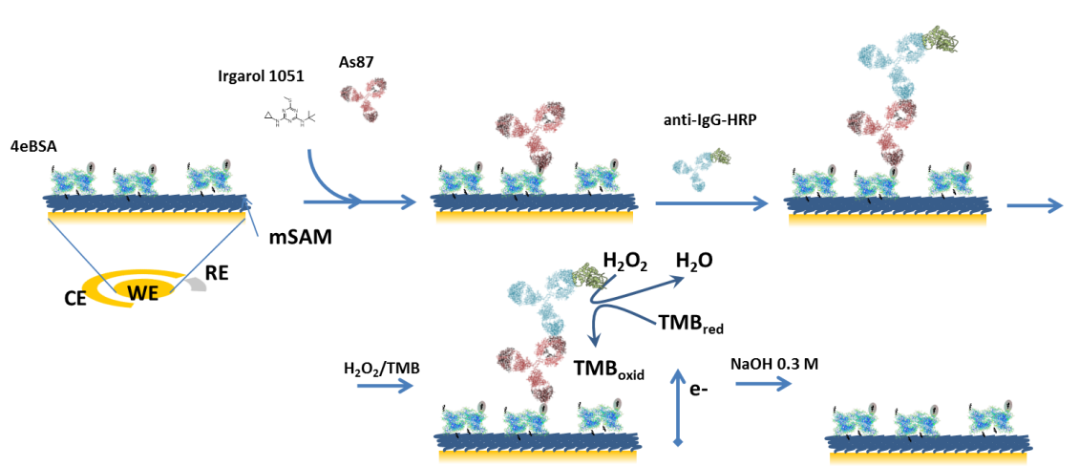

Salvador et al. Figure 2

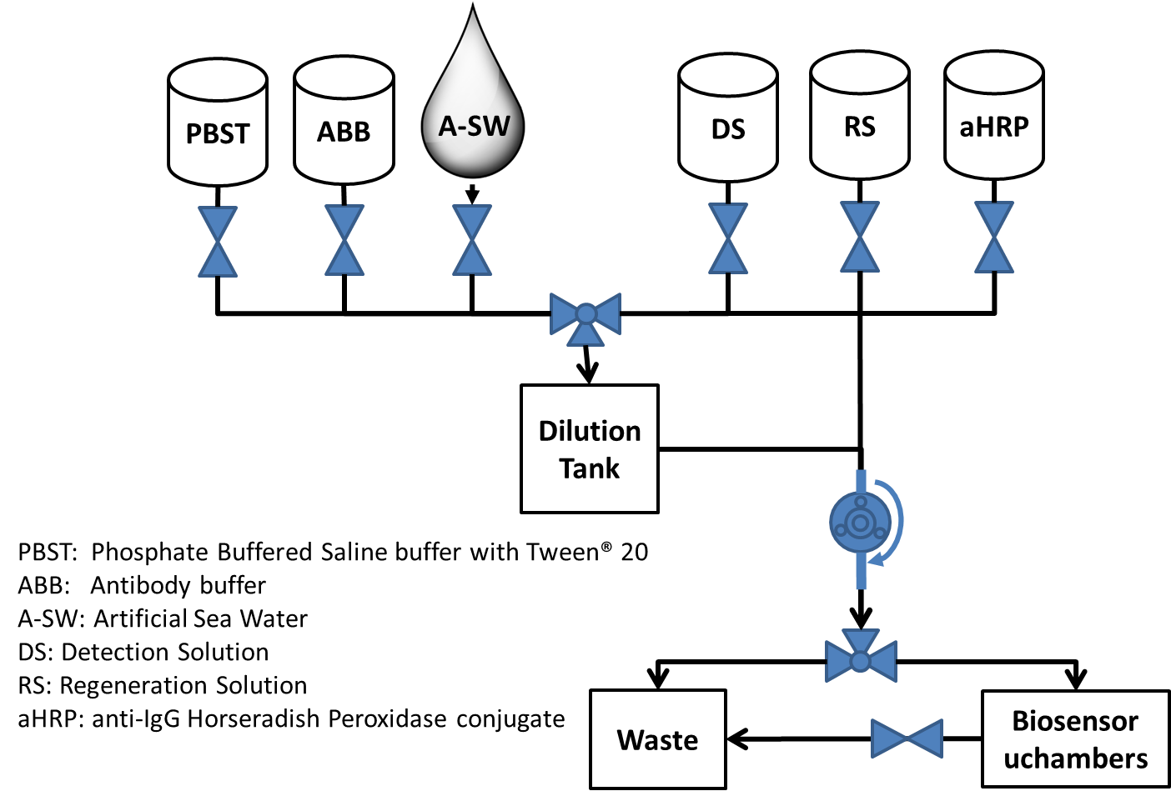

Salvador et al. Figure 3

|  |
| --- |
| (a) |
| (b) |

Salvador et al. Figure 4

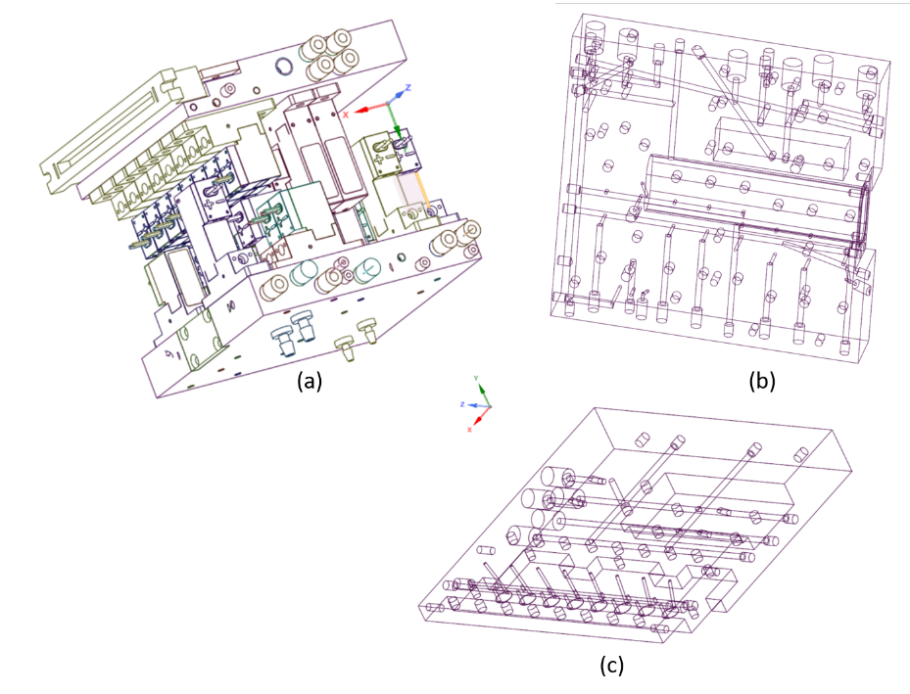

Salvador et al. Figure 5

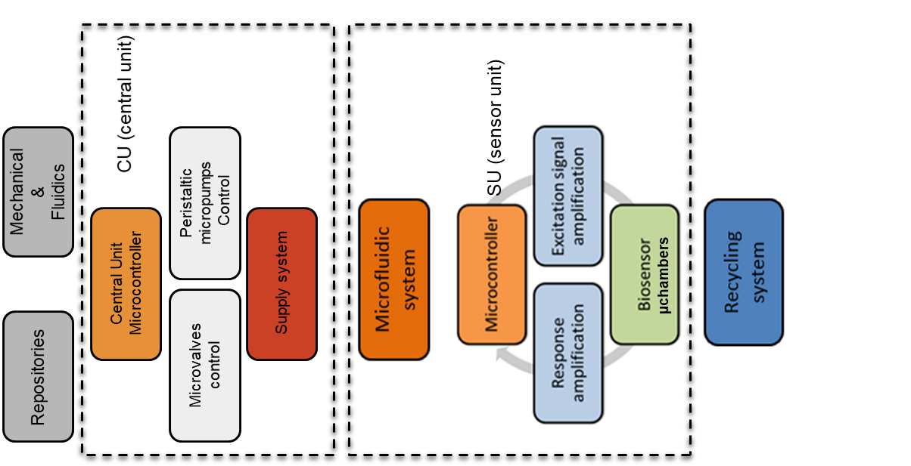

Salvador et al. Figure 6

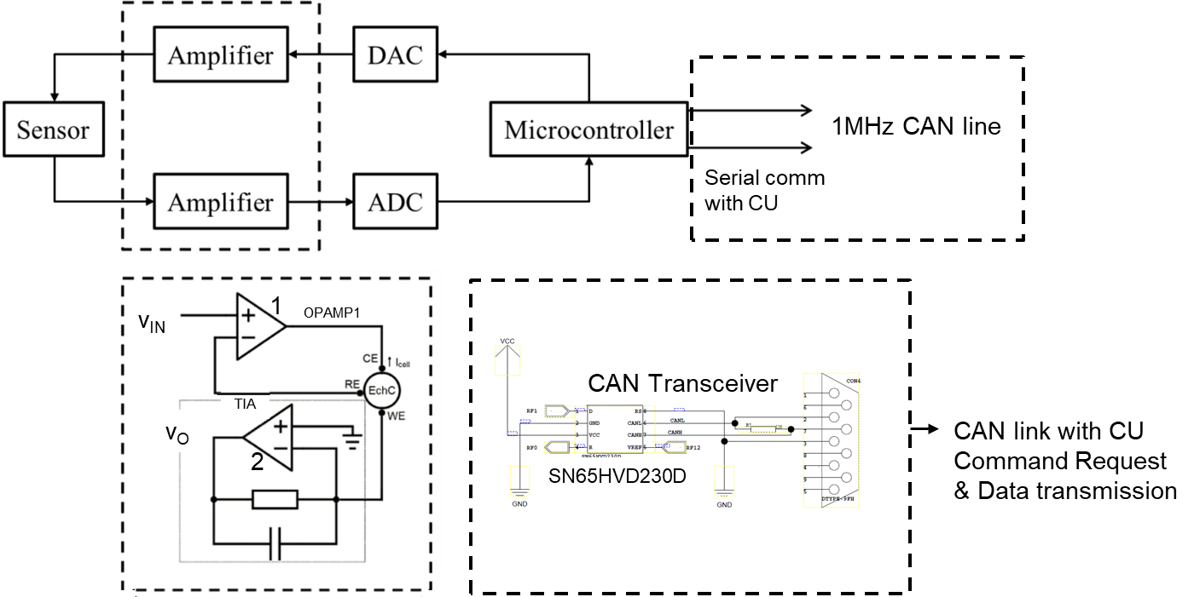

**OPAMP 1**

Salvador et al. Figure 7

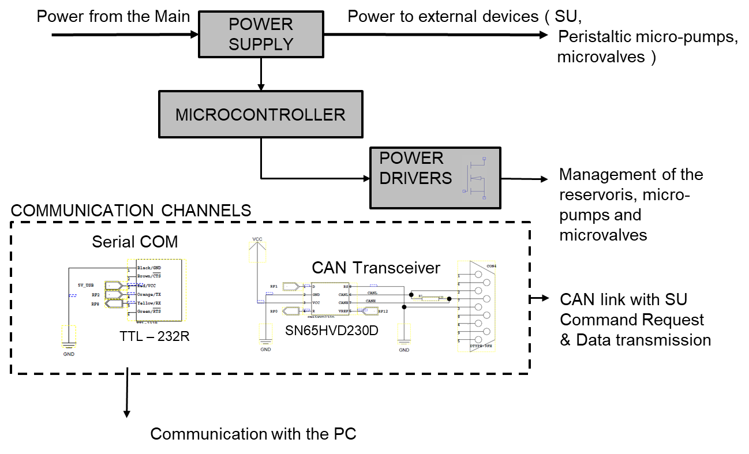

Salvador et al. Figure 8

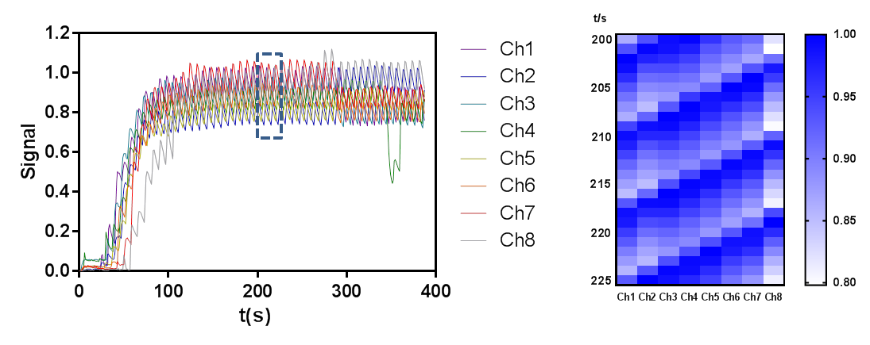

Salvador et al. Figure 9



TABLE CAPTIONS

Table 1: Steps involved for continuous flow in situ multiplexed biodetection of the developed device.

Table 2. Estimated energy consumption of the whole prototype, including the microvalves (6 µVs) of the different reservoir tanks, the 3µVs associated to the filling and emptying of the Fluidic Module (FM), the 9 µVs related with the pulsed flow method (PFM) and the micropump µP.

Table 3. Analytical parameters from the eight calibration curves acquired simultaneously for the detection of Irgarol 1051®. A four-logistic equation was employed for the fitting of the data acquired. The mean value and SD correspond to the eight different SPE. Limit of detection (LOD) was calculated for each calibration curve to the IC90.

Salvador et al. Table 1

|  |  |  |
| --- | --- | --- |
| **Step** | **Description** | **Quantity** |
| 1 | Flood the Mixing with: | 7mL |
| 1.1 | Sample from A-SW | 6.8 mL |
| 1.2 | 0.2 ml of antibody (ABB) | 0.2 mL |
| 2 | Flood the DT content into the Bioensor µchambers | 7mL |
| 3 | Flood the DT with PBST for washing | 7mL |
| 4 | Use the DT content with PBST to wash the Biosensor µchambers | 7mL |
| 5 | Add aHRP content into the biosensor µchamber | 5mL |
| 6 | Wash biosensor chambers and pipes with PBST | 2mL |
| 7 | Add DS to the biosensors µchambers. Start measuring with Sensor unit (SU) | 4mL |
| 8- | Wash biosensor chambers and pipes with PBST | 2mL |
| 9 | Add RS in the biosensor µchamber | 10 mL |
| 10 | Wash biosensor chambers and pipes with PBST | 2mL |

Salvador et al. Table 2

|  |  |  |  |  |  |  |  |
| --- | --- | --- | --- | --- | --- | --- | --- |
| Devices | Biosensor  µP @1.6mL/m | Tanks  µVs | FM  µVs | PFM  µVs | CU  eBoard | SU  eBoard | Total |
| W | 0.45 | 2.5 | 2.5 | 2.5 | 0.288 | 0.185 | 3.1234 Wh |
| PRF | 0.98 | 0.4 | 0.4 | 0.4 | 1 | 1 |
| W·h | 0.2425 | 0.798 | 1.548 | 0.0833 | 0.389 | 0.062 |
| number | 1 | 6 | 3 | 9 | 1 | 1 | 1h:21’ |
| time | 24’:15’’ | -- | -- | 2’:30’’ | 1h:21’ | 20´ |

Salvador et al. Table 3

|  |  |
| --- | --- |
| Analytical parameters | |
| -Imax, µA | 0.974 ± 0.038 |
| -Imin, µA | 0.204 ± 0.027 |
| Slope | -2.10 ± 0.32 |
| IC50, nM (µg/L) | 16.0 ± 1.1 (4.1 ± 0.3) |
| R2 | 0.995 ± 0.005 |
| LOD, nM (µg/L) | 0.61 ± 0.13 (0.15 ± 0.03) |