TNO report

Eclipse model
Date | 12 July 2002
Author(s) | B. van Luipen

Copy no
No. of copies
Number of pages | 176
Number of appendices | 2
Sponsor
Project name | Geomec 3.0
Project number

All rights reserved.
No part of this publication may be reproduced and/or published by print, photoprint, microfilm or any other means without the previous written consent of TNO.

In case this report was drafted on instructions, the rights and obligations of contracting parties are subject to either the Standard Conditions for Research Instructions given to TNO, or the relevant agreement concluded between the contracting parties. Submitting the report for inspection to parties who have a direct interest is permitted.

© 2002 TNO

Summary

Geomec is an application for geo-mechanical analysis. The original plan was that Geomec supports three geo-mechanical models; the eclipse model (incompatible hexahedrons), the horizon model (structured hexahedrons) and the GoCad type model (unstructured tetrahedrons). In this document the Eclipse model is the central point. The Eclipse model is used for flow analysis purposes. With the aid of Geomec Shell will also perform geo-mechanical analysis on the Eclipse model. A grid file imports the Eclipse model in Geomec. The geometrical grid supplied by the Eclipse model is generally not suitable for a finite element analysis by Geomec. Therefore Geomec converts the Eclipse input to a GoCad type model to generate a mesh, which is suited for geo-mechanical analysis purposes. The GoCad type model is analysed in Diana and results of the analysis are mapped back on the Eclipse grid. The original Eclipse grid and the generated tetrahedron mesh will differ dramatically. This causes data loss when input data is mapped on the tetrahedron mesh and results of the analysis are mapped back on the Eclipse mesh. In the current planning the Eclipse model is implemented before the GoCad type model. The planning should be adapted, because the GoCad type model is used by the Eclipse conversion routine. In the new planning the GoCad type model should be implemented and designed before the Eclipse conversion routine.

Contents
1 Introduction 4
1.1 Work flow 4
1.2 Document map 4
2 The Eclipse model 5
2.1 Discontinuities in the Eclipse grid 5
2.1.1 Shifted elements 5
2.1.2 Pinch-outs 6
2.1.3 Bad shaped elements 6
2.1.4 Disabled elements 7
2.1.5 Disconnected pillars 7
2.2 Assigning properties to the mesh 7
3 Conversion to the GoCad type model 8
3.1 Merging grid points 8
3.2 Detect Faults 9
3.3 Detect horizons 9
3.4 Detect grid points 10
3.5 Detect element sets 10
4 The GoCad type model 11
4.1 Depletion stages 11
4.2 Point sets 11
4.3 Surfaces 11
4.4 Horizons 11
4.5 Faults 12
4.6 Bodies 12
4.7 Formation 12
4.8 Materials 12
5 Conclusions 13

Introduction
Geomec is an application for geo-mechanical analysis. Geomec supports multiple geo-mechanical models. In this document the import of an Eclipse model is specified. In the Eclipse file the user specifies the Eclipse model. The file format of the Eclipse file is described in appendix B. The Eclipse model is intended for performing flow analyses in reservoirs. The grid of the Eclipse model is in general not suited for geo-mechanical analyses, because of the possible discontinuities in the Eclipse grid. This document describes the solution for the geo-mechanical analysis of the Eclipse grid model.

Work flow
Actually there is no Eclipse model in Geomec, because the Eclipse model in the Eclipse file is converted to a GoCad type model, which is analysed in Diana. Figure 1 shows that the Eclipse model, stored in the Eclipse file, is converted to a GoCad type model by the Eclipse conversion routine. The user has to define the depletion stages and loads. When the model is meshed and analysed the user can export the results of the analysis by mapping the result back on the original Eclipse grid.
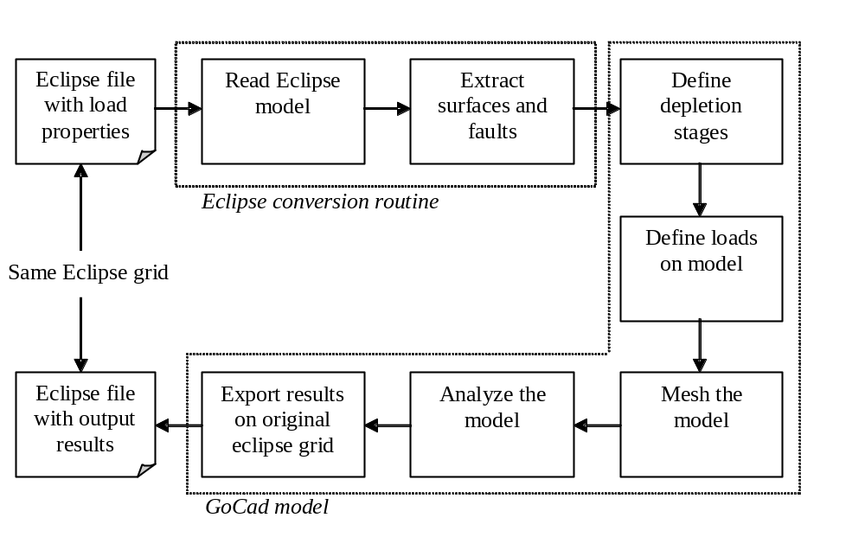
Figure 1 Workflow of the analysis of an Eclipse model

Document map
The first chapter describes the Eclipse model in detail; especially the discontinuities in the Eclipse grid come up for discussion. The second chapter describes the conversion from the Eclipse model to the GoCad model. The next chapter describes briefly the functionality of the GoCad model. The last chapter discusses the conclusions and consequences of the design decisions made in the document.

The Eclipse model
The Eclipse model is defined by an Eclipse file in the GRID format as specified in appendix B. The mesh exists of NUMRES separated reservoirs. Each reservoir has a top- and bottom grid with dimensions NX and NY. The quadrilaterals in the top- and bottom grid don’t necessarily need to connect. The thickness of the model is defined by NZ. The mesh can be represented as NX*NY pillars for each reservoir. The raw GRID mesh supplied by the grid file cannot be directly offered to the Diana kernel, because the mesh may contain discontinuities that the Diana kernel cannot handle. The user can also add distributed properties to the Eclipse grid. This means that the user can assign one or more properties to every Eclipse cell, one value per property per cell. This chapter discusses the discontinuities in the Eclipse grid and the assignment of properties to the Eclipse grid.
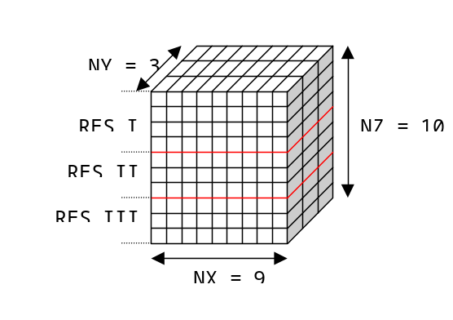
Figure 2 The Eclipse grid

Discontinuities in the Eclipse grid
The mesh delivered by the Eclipse source file can contain five types of discontinuities:
- Shifted elements
- Pinch-outs
- Bad shaped elements
- Disabled elements
- Disconnected pillars

Shifted elements
Figure 3 shows shifted elements in the Eclipse grid. This may indicate the existence of a fault. The shifted elements are grouped and the Eclipse conversion routine defines these elements as a fault in a GoCad type model.
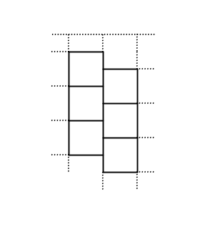
Figure 3 Shifted elements in the Eclipse grid

Pinch-outs
A pinched-out element is an element with no volume. Figure 4 shows a pinch-out element in the Eclipse grid. This element is simply ignored by the Eclipse conversion routine, because it has no additional value in mechanical sense. When the results of the GoCad analysis are mapped back on the original Eclipse grid no results are available for the pinch-outs, because the pinch-outs are not part of a mechanical model.
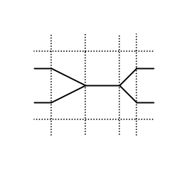
Figure 4 A pinch-out in the Eclipse grid

Bad shaped elements
In general the Eclipse elements can be approached by hexahedrons. In some cases the hexahedrons are bad-shaped i.e. when corners points of a hexahedron coincide with each other. An element, whose corner points nearly coincide, can also be marked as a bad-shaped element. Therefore a distance factor should be defined. Figure 5 shows four examples of bad shaped elements.
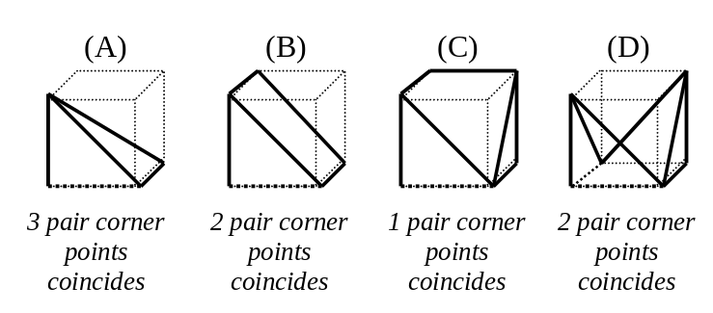
Figure 5 Bad shaped elements
These bad-shaped elements could have a bad influence on the results. This is the main reason why the horizons and faults are exported to a GoCad model. The GoCad model creates a new mesh with tetrahedrons and these bad-shaped elements will not influence the analysis results.

Disabled elements
The Eclipse format can disable elements in the ACTNUM table of the grid file specified in appendix B. These elements are disabled for the flow analysis, thus marked as impermeable. These disabled elements do make sense from a mechanical point of view and cannot be left out of the model because that would create voids in the model. They are still part of the geometrical structure. As a result disabled elements are not ignored during the conversion to a GoCad type model in contrast with Geomec 2.x. Properties like pressures in disabled elements are interpolated from neighbouring voxels using nearest neighbour.

Disconnected pillars
As mentioned in the introduction of this chapter the quadrilaterals of the top- and bottom grid do not necessarily need to connect to each other. When the quadrilaterals in the top- and bottom grid are disconnected, the entire pillars are disconnected. The Diana kernel cannot handle these disconnected elements properly.

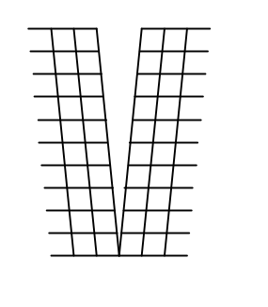
Figure 6 Disconnected pillars

Assigning properties to the mesh
The Eclipse model can also contain properties like pressure and material properties. The properties are assigned to every Eclipse cell in the Eclipse mesh. In the pre-process step before the analysis in the GoCad type model the properties of the Eclipse mesh are mapped to the tetrahedron mesh. The mapping procedure may result in data loss, because of the different mesh topology.

Conversion to the GoCad type model
As discussed in the previous chapter the mesh may contain shifted elements, pinch-outs, bad-shaped elements, holes and disconnected pillars. The Diana kernel does not support the discontinuities in the mesh. On top of that the results of the analysis using such a bad mesh may be very unreliable. A better approach is to deduce the characteristic properties from the Eclipse model in terms of horizons, fault etc. and create a new GoCad type model. The GoCad type model creates a new tetrahedron mesh that is analysed by Diana. The original Eclipse mesh is also exported to the GoCad type model as an element set, so the results of the analysis can be mapped and exported on the original Eclipse mesh. The drawback of this approach is that the input properties mapped on the original Eclipse mesh do not match exactly with the generated tetrahedron mesh. This will result in loss of data. The same will occur by mapping the results back to the original Eclipse grid.
The Eclipse model does not supply all the information needed for an analysis in Geomec. The user must specify at least the following additional information:
- The amount of depletion stages
- The material for each formation
The pressure definition for each formation and each depletion stage

Note that the user can edit the model after it has been converted to a GoCad type model. The user can add and remove horizons, faults, point- and element sets. The mesh can also be refined or coarsened.

Merging grid points
The Eclipse mesh may contain holes and disconnected elements. The first conversion step is to repair the holes and reconnect the elements. This is done by merging the shared points of quadrilateral elements in upper- and lower grid for each formation. Figure 7 illustrates this operation. All the pillars of the eclipseEclipse model are connected now.
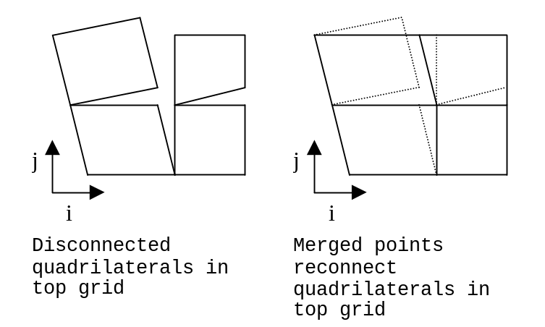
Figure 7 Reconnect quadrilaterals
The pillars themselves may still contain holes in the k direction. These holes disappear when points of disconnected elements in the k direction are merged as illustrated in figure 8.
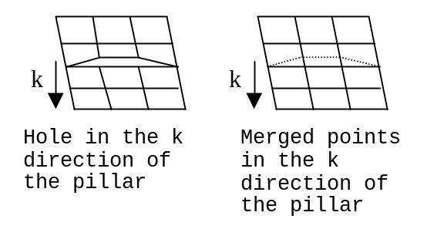
Figure 8 Reconnected pillars

Detect Faults
The shifted elements detected during the conversion routine are modelled as a fault. Figure 9 shows a fault created by shifted elements. The points on the contact surface of the shifted elements are collected and exported as meshed surface to the GoCad type model. In the GoCad type model a cohesion- and a friction angle value are defined for the fault. Faults are modelled with contact elements in Diana.
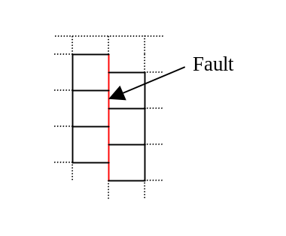
Figure 9 Shifted elements modelled as fault

Detect horizons
As result of merging the points the mesh contains no holes. The model exists of NZ + 1 layers of quadrilaterals. These layers can be seen as potential horizons. During the conversion the user has to select at least two layers of quadrilaterals. Default the top- and bottom layer are selected. The selected layers are exported to the GoCad model as horizons. The horizon consists of at least one surface. When a horizon is crossed by a fault the horizon is split up in multiple surfaces.
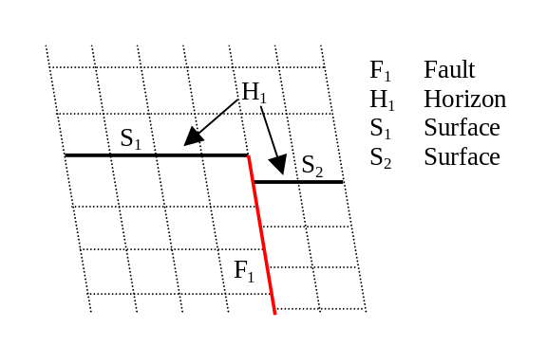
Figure 10 Horizon is split in two surfaces by a fault
The points of the quadrilateral surfaces of the selected horizons are exported to the GoCad type model. The GoCad type model uses these points to mesh triangular surfaces. The surfaces are assigned to created horizon.

Detect grid points
The user has the option to import the original merged grid points from the Eclipse grid into the GoCad type model. The imported points are the points of the Eclipse grid after applying the merging procedure of section 3.1. In the GoCad type model the grid points are used as input for the meshing procedure. As a result the tetrahedron will include the grid points extracted from the Eclipse grid. The benefit of sharing these grid points between the models is that mapping of results and input properties is more accurate.

Detect element sets
The original Eclipse grid is always imported as an element set even if the Eclipse model contains no properties. The element set may contain properties like pressures or material properties as defined in the Eclipse model. The user can assign for example pressure and material properties to formations. After the model is analysed the results of the analysis can be mapped to the original Eclipse grid by simply assigning the results to the element set, and exported as a new Eclipse file.

The GoCad type model
An important feature of the GoCad type model is that it accepts faults. The Eclipse model may contain faults and therefore the horizon type model is not a suitable target for the conversion of the Eclipse model. The GoCad type model has not been designed in detail yet, but an overview is given to give some understanding of the functionality of the GoCad type model. The starting point is that the user interface of the GoCad type model resembles the one of the horizon type model as much as possible.

Depletion stages
The depletion stages represent the time steps in the model. The model always contains an initial depletion stage. Every depletion stage is defined by a year and a name.

Point sets
The GoCad type model supports point sets and element sets, just like the horizon type model. The point set is a collection of points with one or more properties assigned to each point. An example of a property would be pressure or material properties like cohesion or Young’s modulus. The value for a given point, which is not necessarily a member of the point set, is determined by the value of the nearest neighbour of that point. The values for the nodes of an element are calculated by simply taking the value of the nearest neighbour for each element node.
The element set is a collection of elements with a value assigned to every node of every element. The value for a given point, which is not necessarily a member of the element set, is calculated by determining the element containing the given point and using the shape function of the element to interpolate the value for the given point from the values in the nodes of the element.
The original Eclipse grid is always imported as an element set by the Eclipse conversion. Any properties assigned to the Eclipse mesh are assigned to this element set. The user can also import additional point- or element set files in the GoCad type model from (other) Eclipse files, ASCII-formatted files, Excel-files and of course GoCad-files.

Surfaces
The GoCad type model supports triangular surfaces. Surfaces are used to build horizons and faults. Surfaces are created from point- and element sets. This implies that the user can add surfaces to the model after the conversion has taken place.

Horizons
One or more surfaces or a constant depth define a horizon of the GoCad type model. A horizon is split up into multiple surfaces when it is crossed by a fault. Horizons cannot cross each other. The user can define mesh regions on the surfaces of the horizon so the horizon mesh can be refined or coarsened locally.

Faults
A fault is defined by one or more surfaces. The fault can cross horizons and other faults. The user has to supply a friction angle and a cohesion parameter to the fault. The user can also assign distributed values for the cohesion and friction angle from the point- or element sets.

Bodies
When the horizons and faults are defined the model can be meshed. The meshing procedure results in a few bodies, which are enclosed by the surfaces of the horizons, faults and boundary of the model. The bodies consist of tetrahedrons and can be assigned to formations. A body can be assigned to only one formation. The user cannot delete bodies because bodies are deduced from the topology of the horizons and faults.

Formation
A formation consists of bodies. The user can assign pressures and a material to the formation. Like in the horizon type model, the formation has a pressure definition for every depletion stage. The materials and pressure definitions have the same features as in the horizon type model. This means that they can be assigned from the data-storage tree and also distributed properties are supported.

Materials
The user can assign a material to a formation from the material library in the data storage tree. In the material library the user can create, delete and modify materials. The material library supplies only uniform materials. The user can assign distributed material parameters from a point set or element set to the formation. The assignment of materials is exactly the same as in the horizon type model.

Conclusions
Actually there is no Eclipse model in Geomec. The original Eclipse mesh may contain discontinuities that have a negative impact on the results of the geo-mechanical analysis. Therefore the Eclipse model defined in the grid file is converted to a GoCad type model. The conversion routine extracts the horizons, faults, grid points and distributed properties from the Eclipse model and inserts them into a GoCad type model. The GoCad type model creates a mesh using tetrahedrons. As a result the mesh differs from the original Eclipse mesh. The properties assigned to the original Eclipse mesh are mapped to the generated tetrahedron mesh. The procedure may result in a loss of input data. This is also the case when the results of the GoCad analysis are mapped back to the original Eclipse grid.
A benefit of the conversion of the Eclipse grid to a GoCad type model is that the user can edit the model. The user can for example refine and coarsen the mesh, insert extra faults, horizons and import point- and element sets.
In the current planning the Eclipse model is implemented before the GoCad type model. The planning should be adapted, because the GoCad type model is used by the Eclipse conversion routine. In the new planning the GoCad type model should be implemented and designed before the Eclipse conversion routine.

            - Model Overview
Functional model overview |  | Geomec 2.7 | Horizon Model | GoCad Model
Point Sets | XYZ-point set (ASCII & Excel) | X | X | X
Point Sets | GoCad – point set |  | X | X
Point Sets | GoCad surface – point set |  | X | X
Point Sets | GoCad solid - point set |  | X | X
Point Sets | Eclipse – point set |  | X | X
Model | Formation | X | X | X
Model | Horizon | X | X | X
Model | Fault |  |  | X
Model | Surface | X | X | X
Model | Boundary | X | X | X
Model | Well path | X | X | X
Import | Eclipse import | X |  | X
Import | GoCad surface |  | X | X
Material | Distributed material properties |  | X | X
Mesh | Insert horizon | X | X | X
Mesh | Insert faults |  | X | X
Mesh | Coarsen and refine | X | X | X
Analysis | Linear depletion | X | X | X
Analysis | Non-linear depletion | X | X | X
Analysis | Pore pressure inverse |  | X | X
Analysis | Young’s modulus inverse |  | X | X

            - Eclipse format
Geomec supports a sub-set of the GRID-format and the Extensible EGRID format. This means that only the relevant keywords for the Eclipse model are supported. A NX, NY, and NZ coordinate system with NUMRES reservoirs defines the Eclipse model in the file. NX defines the number of elements in the ‘Easting’ direction. NY defines the number of elements in the ‘Northing’ direction.

DIMENS or GRIDSPEC
The keyword DIMENS or GRIDSPEC defines dimensions of the grid with 5 parameters.
- NX defines the number of elements in ‘Easting’ direction
Default: NX = 1
- NY defines the number of elements in ‘Northing’ direction
Default: NY = 1
- NZ defines the number of elements in ‘Depth’ direction
Default: NZ = 1
- NUMRES defines the number of reservoirs.
Default: NUMRES = 1
- F = Cartesian coordinate system
T = Cylindrical coordinate system
Default: F

Geomec supports a Cartesian coordinate system only.

Example:
SPECGRID
5 3 4 2 T /

COORDSYS
The keyword COORDSYS defines the coordinate system layer for each reservoir with 6*NUMRES parameters. The following parameters are specified for each reservoir:
  - Lower bound index for block index in k for grid blocks in this reservoir.
  - Upper bound index for block index in k for grid blocks in this reservoir.
  - Completion of circle, for grid blocks in this reservoir.
‘COMP’ Circle completed in theta (or y) direction.
‘INCOMP’ Circle is not completed
For the circle completed, the coordinate lines to be identified.
Default: ‘INCOMP’
  - Connection to the reservoir below.
‘JOIN’ Transmissibility’s will be calculated to the reservoir below.
‘SEPARATE’ Transmissibility’s will be isolated from the reservoir below
Default: ‘SEPARATE’
  - Lower bound for lateral reservoir connection
Default: Current reservoir number
  - Upper bound for lateral reservoir connection
Default: Current reservoir number
Geomec ignores parameters 3 to 6.

Example:
NX = 5, NY = 3, NZ = 4, NUMRES = 2

COORDSYS
1 2 ‘COMP’ /
3 4 ‘INCOMP’ /

COORD
A coordinate line defines the possible position for grid block corner points, for each (i,j) and for each reservoir in the grid. Given the depth of a particular grid block corner, and the associated coordinate line, the x and y coordinates representing two distinct point on it. If the (x, y) coordinates of the top and bottom points are identical, then the z coordinates of the points are not used in Geomec. The keyword COORD is followed by 2*(NY+1)*(NX+1)*NUMRES X,Y,Z coordinates. These coordinates describe the upper- and lower grid of the reservoirs.

ZCORN
Each grid block has 8 corners. This keyword enables the depths of each corner of each grid block to be separately specified. It is used for specifying depths for corner point geometry. The keyword ZCORN is followed by (2 * NX) * (2 * NY) * (2 * NZ) values, with the two corners in the NX direction of the first grid block being first specified, then two corners for the next block in the I direction, and so on. The last value is followed by a slash (/).

Example
Here NX = 3, NY = 2, NZ = 2
ZCORN
24 * 1000
24 * 1020
24 * 1020
24 * 1040 /

ACTNUM
This keyword is followed by NX*NY*NZ values for each Eclipse element. The value must contain one of the following values:
0 – Inactive
1 – Active (or active matrix for dual porosity runs)
2 – Active fracture (for dual porosity runs)
3 – Active matrix and fracture (for dual porosity runs)
The ACTNUM table is optional and is ignored by Geomec. See chapter “The mesh” for more details.

Properties
Properties like pressures or material properties are specified by a value for each Eclipse element. Every property has its own keyword. Shell and TNO have to make a complete list of these keywords that will be used for ASCII-, GoCad- and Eclipse formats. The keywords are followed by NX*NY*NZ values. The last value is followed by a slash (/).

GEOMEC 2.x could import multiple horizon files using the ‘Join’ function

