TNO report

Functional Design Tetrahedron Model
Date | 19 August 2002
Author(s) | M.H. Tolman  B. van Luipen  A.H.D. Willemse

Copy no
No. of copies
Number of pages | 15
Number of appendices
Sponsor
Project name | Geomec 3 – GoCad
Project number

All rights reserved.
No part of this publication may be reproduced and/or published by print, photoprint, microfilm or any other means without the previous written consent of TNO.

In case this report was drafted on instructions, the rights and obligations of contracting parties are subject to either the Standard Conditions for Research Instructions given to TNO, or the relevant agreement concluded between the contracting parties. Submitting the report for inspection to parties who have a direct interest is permitted.

© 2002 TNO

Summary
Geomec is an application designed to perform finite element compaction analyses. Version 3.2.0 of Geomec is the first version in which it will be possible to import GoCad models. This is also the first 3.x version in which it is possible to import Eclipse models (Eclipse models could be imported in previous 2.x versions of Geomec). After import the GoCad and Eclipse models continue to exist as the sub model in Geomec.
The tetrahedron model will consist of the sub model (in effect the GoCad or Eclipse model) and a super model (that completely encloses the sub model). Adding horizons (and indirectly formations) creates this super model after the sub model was created.
The super model is the tetrahedron type model. The name is derived from the tetrahedrons making up the volume mesh in this model.
It is not possible to edit the sub model after it has been imported. Only the over and side burden that, together with the sub model, make up the super model can be modified after the sub model has been imported. All the horizons (in either sub model or super model) as well as the faults (in sub model only) and the boundary (of either sub model or super model) form enclosing volumes called bodies that Geomec will detect automatically. These bodies are meshed with tetrahedons. Formations are built up from bodies and the user can assign the detected bodies to the formations. Assignment of material parameters as well as pressures to the formations takes place in exactly the same way as in the hexahedron type model.
After the analysis has taken place the results can be visualised in the same way as is possible in the horizon type model. If desired, it is possible to export the results as a point set or an element set.

Contents
;56 GoCad import — 6
2.1.1 Faults — 7
2.2 Eclipse import — 7
2.2.1 Eclipse overview — 8
2.2.2 Conversion to the sub model — 8
3 The tetrahedron type model — 11
3.1 Refinement of the mesh — 11
3.1.1 Refinement of a surface — 11
3.2 Bodies — 12
3.3 Formations — 12
3.3.1 Assigning material — 12
3.3.2 Assigning pore pressures — 12
3.4 Boundary — 12
3.4.1 Super model is equal to sub model — 13
3.4.2 Super model is not equal to sub model — 13
3.5 Invalidating the mesh — 13
3.6 Invalidating the results — 14
3.7 Analysis — 14

Appendices
;

Introduction
Geomec is an application designed for performing finite element compaction analyses. Geomec supports different types of geo-mechanical models. This document specifies the functional requirements for the tetrahedron type model. The tetrahedron type model will be available in Geomec version 3.2.0 for the first time. The functional requirements need to be accepted by TNO and Shell before TNO will start with the technical design.
The aim of the tetrahedron type model is to be able to analyse GoCad type models and Eclipse type models in Geomec. The tetrahedron type model is divided into two separate model spaces, the sub model and the super model. The sub model contains the imported Eclipse type or imported GoCad type model. The super model incorporates the sub model, the overburden and the side burden of the geological model. This division is created since the sub model and super model have different properties and validation criteria. The tetrahedron type model generates a tetrahedron volume mesh for the Diana analysis.
The second chapter describes the import of a GoCad model in Geomec and the import of an Eclipse model. The third and final chapter will discuss the resulting tetrahedron type model in Geomec.

Import of GoCad and Eclipse
The function of the tetrahedron type model is to be able to do a compaction analysis on GoCad and Eclipse models. In case of the GoCad type model this basically means import of a GoCad file or import of different files describing the surfaces in the GoCad type model, from which the sub model is constructed. After importing these surfaces, however, a closed model will have to be the result. In the case of an Eclipse file the user will have to select which surfaces and faults will have to be extracted in order to construct the sub model. After the sub model is created, the user can opt to add geometry ‘around’ the sub model resulting in the super model, see chapter 3.

GoCad import
The workflow describing the export and import of GoCad files as well as the following processing steps in Geomec is illustrated in figure 2.1.

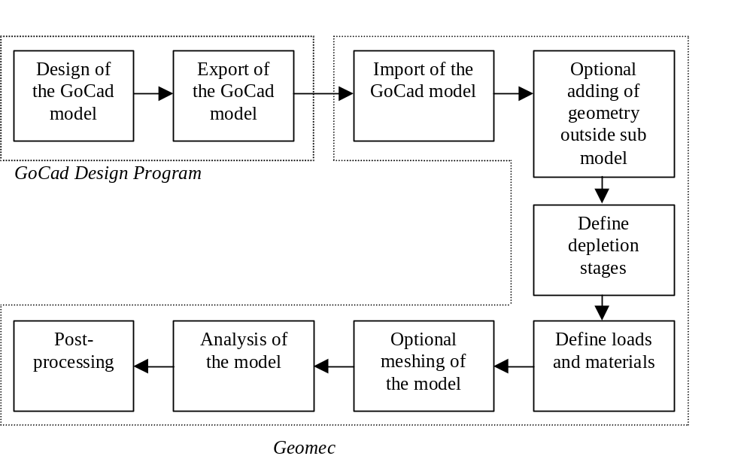
Figure 2.1 Workflow from GoCad design to post-processing in Geomec
The user designs the geometry of the model in the geo-mechanical program GoCad, which is then exported to a GoCad file. Geomec is able to import the GoCad file including the 3D mesh (this is the sub model, see chapter 3) and the user can adapt the geometry outside the sub model by adding for example a constant depth horizon. Alternatively the user can read in different surfaces that make up the GoCad file. The user will have to make sure that all the surfaces that are read in construct a closed sub model. Surfaces are not allowed to cross each other.
After the surfaces are read in (either one by one or via the GoCad file) the user will have to specify which surfaces make up the boundary, specifically which surfaces make up the top of the boundary, which the bottom and which the side of the boundary. Optionally, surfaces can have a tag for either ‘top’, ‘bottom’ or ‘side’. If the user decides to construct a super model, the surfaces making up the top and bottom of the boundary will be treated like they are part of a horizon which will be extended to the boundary of the super model (see 3.4 for more information on the boundary of the sub and super model).
Models containing borderless surfaces or surfaces that have more than one Z co-ordinate at one N, E co-ordinate (e.g. mushroom shaped salt dome) can only be read in via a GoCad file containing the 3D mesh.
Next the user has to define the depletion stages, loads and materials in the model. If the imported GoCad file only contains horizons and/or faults or the sub model was created by reading in different surfaces the model has to be meshed. If, on the other hand, a GoCad file was read in that already contained a 3D mesh this is not necessary. The user can analyse the model and use the post-processor to view the results of the analysis. The final model, whether it is only the imported (and meshed) GoCad model or the GoCad model with added horizons (and meshed) is the super model as described in chapter 3. For an example of the definition of a GoCad file see appendix C.

Faults
Faults in a GoCad type model can consist of one or two surfaces. If a fault consists of two surfaces, they are flagged as back and front (ASCII document for details), both being one side of the fault. In that case the two surfaces can enclose an empty volume. The inner sides of the surfaces of the fault are modelled using contact elements.

Eclipse import
The workflow describing the import of an Eclipse file, the conversion to a sub model and the final export to an Eclipse file (with calculated results) is shown in figure 2.2.

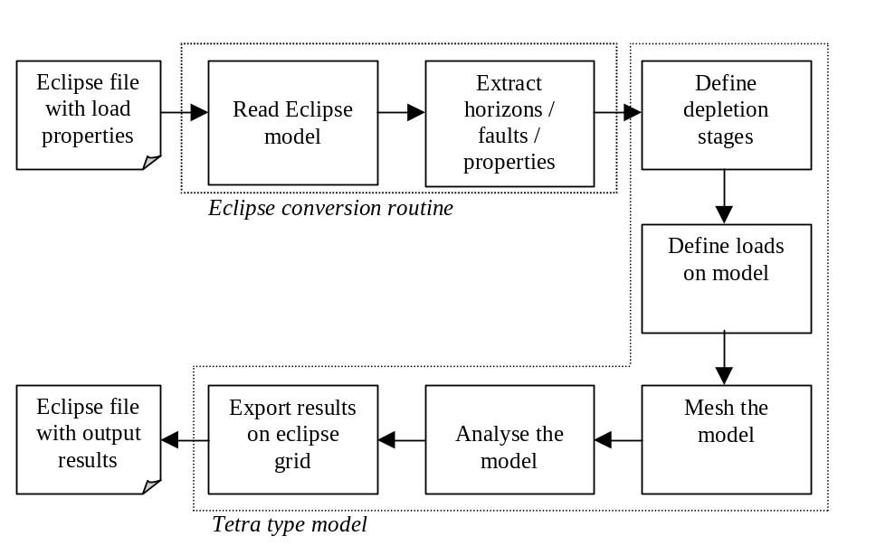
Figure 2.3 From Eclipse file to Eclipse file with calculated results
The Eclipse file is read in and the appropriate surfaces and faults are extracted. If the file contains material properties and / or initial stresses and / or initial pressures and / or depletion stage pressures, these will also be read in. The surfaces and faults are used to construct a sub model, see paragraph 2.2. The analysis can be performed on the sub model and visualised in Geomec. After the analysis has taken place the results can be exported onto the original Eclipse grid.

Eclipse overview
The Eclipse model is defined by an Eclipse file in the GRID format as specified in appendix B. The mesh exists of NUMRES separated reservoirs. Each reservoir has a top- and bottom grid with dimensions NX and NY. The quadrilaterals in the top- and bottom grid don’t necessarily need to connect. The thickness of the model is defined by NZ. The mesh can be represented as NX*NY pillars for each reservoir. The raw GRID mesh supplied by the grid file cannot be directly offered to the Diana kernel, because the mesh may contain discontinuities that the Diana kernel cannot handle, therefore horizons and faults are extracted. The user can define properties in the Eclipse file by defining tags in the same way as was possible in the 2.x versions. This means that the user can assign one or more properties to every Eclipse cell, one value per property per cell. Mapping of properties and results from Eclipse grid to tetrahedron mesh and vice versa will be done using element to element mapping.
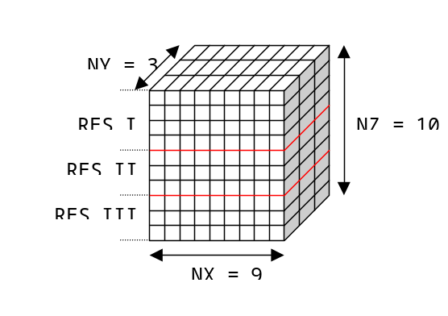
Figure 2.4 The Eclipse grid

Conversion to the sub model
The Eclipse mesh may contain shifted elements, pinch-outs, bad-shaped elements, holes and disconnected pillars. The Diana kernel does not support the discontinuities in the mesh. On top of that the results of the analysis using such a bad mesh may be very unreliable. A better approach is to deduce the characteristic properties from the Eclipse model in terms of horizons, faults etc. and create the sub model. The sub model creates a new tetrahedron mesh that is analysed by Diana. The original Eclipse mesh is also exported to the tetrahedron type model as an element set, so the results of the analysis can be mapped and exported on the original Eclipse mesh. The drawback of this approach is that the input properties mapped on the original Eclipse mesh do not match exactly with the generated tetrahedron mesh. This will result in loss of data. The same will occur by mapping the results back to the original Eclipse grid.
The Eclipse model does not supply all the information needed for an analysis in Geomec. The user must specify at least the following additional information if they were not present in the file:
- The amount of depletion stages
- The material for each formation
- The pressure definition for each formation and each depletion stage
- The initial stresses

Merging grid points
The Eclipse mesh may contain holes and disconnected elements. The first conversion step is to repair the holes and reconnect the elements. This is done by merging the shared points of quadrilateral elements in upper and lower grid for each formation. Figure 2.5 illustrates this operation. All the pillars of the Eclipse model are connected now.

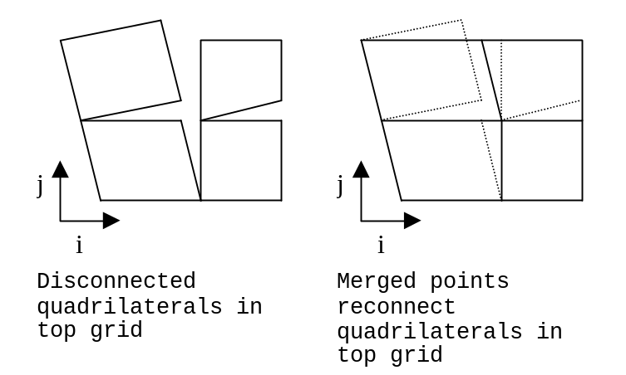
Figure 2.5 Reconnect quadrilaterals
The pillars themselves may still contain holes in the k direction. These holes disappear when points of disconnected elements in the k direction are merged as illustrated in figure 2.6.
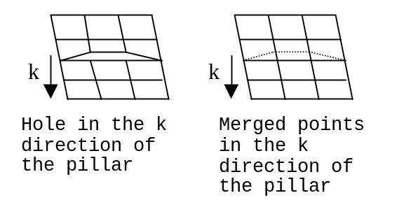
Figure 2.6 Reconnected pillars

Detect faults
In the tetrahedron model a cohesion- and a friction angle value are defined for the fault. Faults are modelled with contact elements in the tetrahedron model. Geomec will identify the faults through fault keyword in the Eclipse file. Details about the fault identification through keywords will be provided by Shell.

Detect horizons
As a result of merging the points the mesh contains no holes. The model exists of NZ + 1 layers of quadrilaterals. These layers can be seen as potential horizons. During the conversion the user has to select at least two layers of quadrilaterals. Default the top- and bottom layers are selected. The selected layers are exported to the tetrahedron model as horizons. The horizon consists of at least one surface. When a horizon (this includes the top and bottom horizon) is crossed by a fault the horizon is split up in multiple surfaces, see figure 2.8.
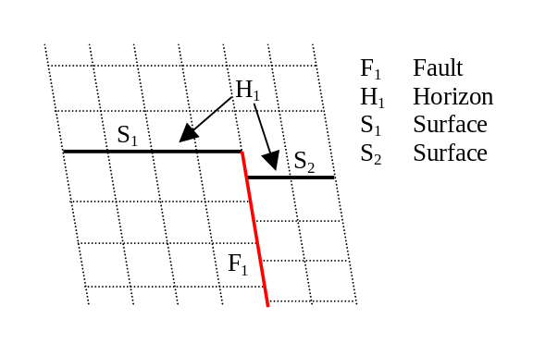
Figure 2.7 Horizon is split in two surfaces by a fault
The points of the quadrilateral surfaces of the selected horizons are exported to the tetrahedron model. The tetrahedron model uses these points to mesh triangular surfaces. The surfaces are assigned to a previously created horizon.

Detect grid points
The user has the option to import the original merged grid points from the Eclipse grid into the tetrahedron model. The imported points are the points of the Eclipse grid before applying the merging procedure of paragraph 2.2.2.1. In the tetrahedron model the merged grid points are used as input for the meshing procedure. As a result the tetrahedron mesh will include the grid points extracted from the merged Eclipse grid. Mapping the results from the merged grid onto the original grid can result in loss of accuracy of the results. Of course it is always possible to export the merged Eclipse grid with the results.

Detect element sets
The original Eclipse grid is always imported as an element set even if the Eclipse model contains no properties. The element set may contain properties like pressures or material properties as defined in the Eclipse model. The user can assign for example pressure and material properties to formations. After the model is analysed the results of the analysis can be mapped to the original Eclipse grid by simply assigning the results to the element set, and exported as a new Eclipse file.

The tetrahedron type model
After importing a GoCad type or an Eclipse type model and completing the model by inserting more horizons (if desired) a tetrahedron type model is the result. The tetrahedron model consists of the sub model (in effect the imported GoCad or Eclipse model) and the super model (the complete model including the sub model). Figure 3.8 shows the tetrahedron model with the sub- and super model. The super model incorporates the sub model and allows the definition of a side-burden and overburden. In the super model the horizons from the sub model are extended horizontally, connecting the horizons of the sub model to the boundary of the super model. Faults are never extended outside the sub model. The super model is very similar to the horizon type model.
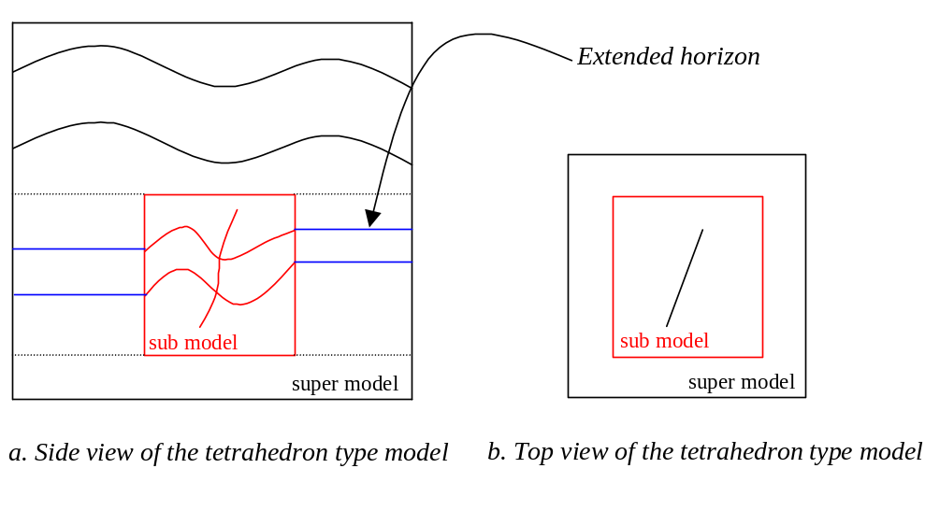
Figure 3.1 The tetrahedron model with sub and super model
The tetrahedron meshing routine generates bodies defined as volumes containing tetrahedrons enclosed by the surfaces of the horizons, faults and the boundary of the sub- and super model. If possible, formations are detected automatically and are named after the top horizon. Geomec will try to assign the bodies to formations, if this is not possible the user will have to assign the bodies to a formation manually. The user can never delete the bodies. When all the bodies are assigned to a formation the analysis can be performed.

Refinement of the mesh
The mesh density of the volumetric mesh depends on the density of the mesh of the different surfaces in the sub and super model. By changing the density of the meshes of the different surfaces the density of the volumetric mesh is changed. The user will not be able to control the 3D mesh directly or define parameters for the element quality. The tetrahedron mesher will always try to make a mesh with optimum quality elements.

Refinement of a surface
The tetrahedron model supports triangulated surfaces. Each surface can be refined or coarsened totally or locally inside defined mesh regions. These mesh regions can be defined either from a top view perspective, after which the region is projected on all the surfaces below, or the mesh region can be defined for a single surface. If a mesh region is defined for a single surface the view will be parallel to the average normal of the surface. For a mesh region the user can define a meshing criterion in the form of the maximum length a side of a triangle can become inside the region. Whenever mesh regions overlap, either from local or global definitions, the criterion with the shortest length is taken in the intersecting part of the mesh regions.
The sub model supports the import of borderless surfaces (Whether it will be possible to generate 3D meshes with borderless surfaces is not clear at the moment, TNO will answer this question shortly) in order to be able to model erosional surfaces and salt layers. Not only will it not be possible to refine or coarsen these borderless surfaces, if one of these surfaces is present in the sub model it will be impossible to refine or coarsen any surface in the sub model. This is a result of the fact that the surfaces are all connected and refinement or coarsening of one surface can result in remeshing of other surfaces.

Bodies
The generation of the volumetric mesh results in a number of bodies. A body is defined by tetrahedrons in a volume enclosed by the surfaces of the horizons, faults and boundary of sub model and super model. Each body can be assigned to a formation and one formation only. A formation can contain multiple bodies. Bodies can have any geometrical shape.

Formations
Material properties and a pore pressure distribution have to be assigned to each formation and in that way indirectly to the bodies of the formation. When the mesh is invalidated (see paragraph 3.5) the bodies are deleted but the formations remain present in the model. If the mesh is regenerated due to a model change the bodies are regenerated and assigned in an intelligent way to prevent unnecessary loss of body assignment. The formations in the tetrahedron model have no formation planes like in the hexahedron model, because the formation is split up in multiple bodies and are not modelled as layers with a top and bottom.

Assigning material
The materials in the tetrahedron type model are assigned in exactly the same way as they are assigned in the horizon model.

Assigning pore pressures
The pore pressures in the tetrahedron type model are assigned in exactly the same way as they are assigned in the horizon model.

Assigning initial stresses
The initial stresses in the tetrahedron model are assigned in exactly the same way as they are assigned in the horizon model.

Boundary
In effect there are two boundaries in the tetrahedron model. One boundary enclosing the sub model and one boundary enclosing the super model. The boundary enclosing the sub model is used (boundary conditions are prescribed for it) only when the sub and super model coincide. The side surfaces of the boundary can be refined and coarsened in exactly the same way as any regular surface, including the insertion of mesh regions.
Surfaces of either boundary may never be removed, not even the surfaces of the boundary of the sub model inside a super model.

Super model is equal to sub model
If the user does not want to add any horizons after construction and the sub model is constructed via a GoCad model, the user will have to define the boundary manually if the boundary information was not provided in the files. The user will have to assign which surfaces of the model are considered to be the top of the boundary, which surfaces are considered to be the side of the boundary and which surfaces are considered to be the bottom of the boundary. All these surfaces together will have to describe a closed volume containing all the horizons and faults. As a result the model can have any geometrical shape (potato shape).
If the model is constructed via an Eclipse file the boundary is constructed automatically. Although the GUI will ask the user whether the imported Eclipse file is defined having the Z-axis upward or downward. Which k-index if the top and which is the bottom of the grid will then be determined based on the co-ordinates.

Super model is not equal to sub model
Before the user starts to construct a super model by adding horizons outside the sub model, the sub model will have to be created. The surfaces defining the top and bottom of the sub model (as described in 3.4.1) will be considered to be part of a horizon and these horizons will be stretched horizontally to the boundary of the super model.

The boundary consists of four surfaces when the sub model is not equal to the super model. None of the horizons or faults can cross the boundary. For the tetrahedron type model the boundary can have the following states:
- Best-fit
The best-fit definition resizes the boundary to the smallest bounding box containing all the horizons and faults. The boundary generates four side surfaces enclosing the model on the front, back, left and right side of the model. The top and bottom of the model is enclosed by the top and bottom horizon.
- User defined
The user can manually set the boundary by either defining the rectangle of the boundary in the north-east plane or by completing the northing and easting co-ordinates of the minimum and maximum corner points of the boundary in a dialog box. The rectangle must contain all horizons and faults defined at that moment.
The top and bottom of the boundary are equal to the top and bottom horizons of the model.

Invalidating the mesh
Invalidating the mesh means that the tetrahedron volumetric mesh between surfaces of the horizons, faults and boundary of the sub- and super model is deleted. This happens whenever there is a change in the model’s geometry and / or in the mesh parameters. As a result all the bodies generated by the mesh procedure are deleted automatically from the model. For example the following actions result in invalidation of the mesh:
- Inserting a horizon
- Deleting a horizon
- Refining or coarsening surfaces of a horizon, a fault or the boundary
- Changing the state of the boundary
Invalidating the mesh automatically results in invalidation of any results.

Invalidating the results
The results are invalidated whenever there is a change in input parameters and / or in the mesh.
For example the results are invalidated when
- The mesh invalidates
- The global parameters for stress or initial pressure changes
- The pressure for a formation changes
- The material for a formation changes
- The cohesion and / or friction angle parameter for a fault changes.

Analysis
The tetrahedron model supports the following analysis types:
- Linear depletion analysis
- Non-linear depletion analysis
Other types will be added to the Geomec program later.

Geomec first validates the model before the analysis is started. The program saves the model before the analysis is performed.

            - Model Overview
Functional model overview |  | Geomec 2.7 | Horizon Model | Tetrahedron Model
Point Sets | XYZ-point set (ASCII & Excel) | X | X | X
Point Sets | GoCad – point set |  | X | X
Point Sets | GoCad surface – point set |  | X | X
Point Sets | GoCad solid - point set |  | X | X
Point Sets | Eclipse – point set |  | X | X
Model | Formation | X | X | X
Model | Horizon | X | X | X
Model | Fault |  |  | X
Model | Surface | X | X | X
Model | Boundary | X | X | X
Model | Well path | X | X | X
Import | Eclipse import | X |  | X
Import | GoCad surface |  | X | X
Material | Distributed material properties |  | X | X
Mesh | Insert horizon | X | X | X
Mesh | Insert faults |  |  | X
Mesh | Coarsen and refine | X | X | X
Analysis | Linear depletion | X | X | X
Analysis | Non-linear depletion | X | X | X
Analysis | Pore pressure inverse |  | X | X
Analysis | Young’s modulus inverse |  | X | X
Analysis | Initial stress pre-processing |  | X | X

GEOMEC 2.x could import multiple horizon files using the ‘Join’ function

