Geomec OIV implementation

Introduction
The Open Inventor (OIV) visualization module for Geomec uses the MeshViz XLM library to display meshes and surfaces. MeshViz XLM has numerous options for extracting and visualizing volume meshes (tetrahedral, hexahedral, etc.), such as skin, isosurface, slice and vector field rendering.
MeshViz XLM provides interfaces that users need to implement, in order to give MeshViz access to their data. Instead of copying data into an intermediate format the MeshViz understand, users tell MeshViz how to retrieve their data through these interfaces. This eliminates the need to copy data, which has its benefits when working with large data sets.
Extensive online documentation on Open Inventor is available at http://oivdoc93.vsg3d.com/. Volume 2 of the Open Inventor Mentor goes into more detail on MeshViz XLM at http://oivdoc93.vsg3d.com/content/chapter-2-meshviz-xlm.

MeshViz XLM interface
MeshViz provides several interfaces that can be implemented in order to visualize different mesh types, but all of them define at least the following
- A geometry interface that provides access to the coordinates of the mesh vertices
- A topology interface that provides access to indivual cells. The main topology categories are structured (e.g. IJK) and unstructured (e.g. tetrahedral, hexahedral).
Property data can be provided by implementing a suitable MiDataSet-based interface.
These interfaces are only used to specify the data needed for rendering; in order to actually render something, one or more render nodes need to be added to the scenegraph, such as
- MoMeshSkin – renders the skin of the mesh, i.e. all polygons that belong to only a single cell
- MoMeshPlaneSlice – renders a planar cross section through the mesh
- MoMeshIsosurface – renders an isosurface based on the property values on the mesh

Mapping Geomec data to OIV
The geometry of a mesh is provided by an instance of OIDIGeometryI, which implements the MeshViz interface MiGeometryI. It wraps a geo::IElementSet from which it gets the coordinates of the mesh vertices.
OIDIMeshTemplate is the generic class that is used to represent all possible meshes. It is templated on the mesh type, cell type and topology type. OIDIMeshVU and OIDIMeshSU are specific implementations for volume and surface meshes, respectively.
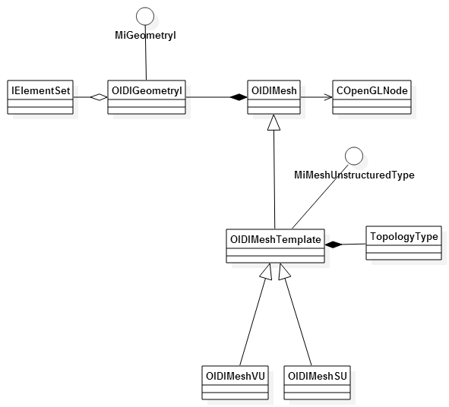
Figure 1 Classes involved in storing mesh data
OIDISet maintains a mapping from Geomec COpenGLNodes to the corresponding OIDIMesh instances. Whenever a new COpenGLNode is added, it instances an appropriate OIDIMesh subclass for it using a visitor pattern.

OIDIMeshNodeManager
OIDIMeshNodeManager is the central component in the OIV visualization. As the name implies, it manages all volume and surface meshes, the OIV representations of cross sections and well paths, and property data sets. It is also the endpoint for most UI events, such as enabling or disabling clipping, contour lines or formation outlines, setting the vector scale, switching between per-element and per-node properties, etc.
OIDIMeshNodeManager is derived from the Open Inventor class SoSeparator, and is basically a scenegraph with functions to manage the internal nodes.
OIDIMeshNodeManager also manages the data sets used for scalar, vector and tensor properties, and keeps track of where they are used. To select a data set, mesh nodes use an integer id which is equal to the index of the desired data set in the current traversal state.
Most of the work in creating and assigning data sets takes place in the function OnValueComponentChanged(). This is a large and complicated function that is called when an IValueComponentBase – derived graphnode is connected to the scene. Depending on the type of the values (scalars, vectors or tensors), and the desired mapping (per-cell or per-node), it constructs the appropriate data sets, adds them to the scene graph, and sets the corresponding ids in the mesh nodes and cross sections.
In order to keep track of which data sets are used with which meshes, OIDIMeshNodeManager use the MeshInfo structure.
- MeshInfo
  - colorScalarSetId – scalar set for mesh coloring
  - isoScalarSetId – scalar set for generating isolines on the mesh (MoMeshAnnotatedIsoline)
  - vectorSetId –vector set for MoMeshVector
  - tensorSetId – tensor set for MoMeshTensor
  - tensorVectorSetId – data set for MoMeshTensorVector
  - eigenValueSignSetId – data set for coloring MoMeshTensorVector
  - beachballScalarSetId1 – first scalar set for beachball coloring
  - beachballScalarSetId2 – second scalar set for beachball coloring
OIDIMeshNodeManager keeps a MeshInfo object for every OIDIMesh, since a lot of this information is shared between formation nodes and cross section nodes.

Formations & horizons
Formations and horizons are represented by the OIDIVolumeMeshNode and OIDISurfaceMeshNode, respectively. Common functionality is provided by the base class OIDIMeshNode, which takes care of the properties that are shared by both, such as
- The cell filter for vector, tensors and tensor vectors (to show a subset of these properties, controlled by the ‘decimate’slider in the UI)
- Vectors (MoMeshVector)
- Tensors (MoMeshTensor, also known as ‘beachballs’)
- Tensorvectors (MoMeshTensorVector, double-sided vectors that show compressive or tensile stresses in a certain direction)
The mesh data for every OIDMeshNode is provided by an instance of OIDIMesh, all of which are managed by an OIDISet.
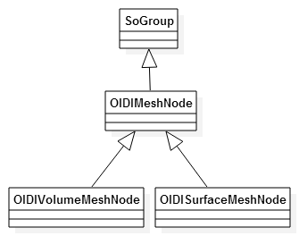
Figure 2 Class diagram for mesh nodes

Formation
OIDIVolumeMeshNode is used to display formations. It uses the OIV MoMeshSkin class to render only the outer skin of the formation mesh, i.e. it renders all polygons that belong to only a single cell.
A MoMeshAnnotatedIsoline instance is used in case the user wants to display the isolines for a certain property on the mesh. This can be the same property that is used for the coloring, or it can be a separate one.

Horizon
Horizons are represented by OIDISurfaceMeshNode instances. A MoMeshSurface takes care of the actual rendering. Otherwise its characteristics are very similar to those of OIDIVolumeMeshNode.
Like OIDIVolumeMeshNode, OIDISurfaceMeshNode also contains a MoMeshAnnotatedIsoline node to enable isoline rendering on the surface.

Cross sections
Cross sections are built using multiple OIV MoMeshPlaneSlice primitives, one for each formation in the mesh. Using the same plane equation for all subsections, the illusion of a single cross section object is created. The composite cross section object is called MeshCrossSection, and it’s made up of several FormationCrossSection objects.
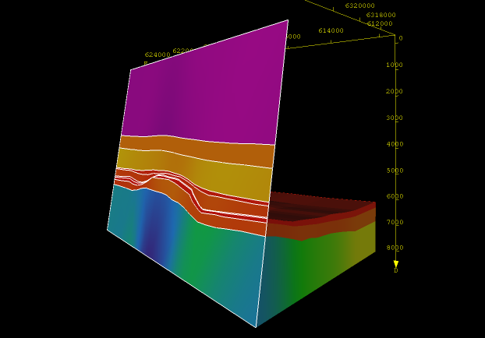
Figure 3 A cross section with formation outlines, and clipping enabled

Structure
Tree structure with a single FormationCrossSection:
- MeshCrossSection
  - SoGroup
    - FormationCrossSection
      - SoSeparator
        - MoMesh
        - MoMaterial
        - MoDrawStyle
        - MoMeshPlaneSlice
      - SoSeparator
        - MoMesh
        - SoSeparator
          - SoSwitch
            - MoCellFilter
          - SoSwitch
            - MoMeshVector
          - SoSwitch
            - MoLevelColorMapping
            - MoMeshTensorVector
        - MoMaterial
        - MoDrawStyle
        - SoSwitch
          - MoMeshIsoline
        - SoSwitch
          - SoDrawStyle
          - MoMeshOutline
  - SoClipPlane
Cross sections can display scalar properties using a color mapping, and a separate scalar property can be set for the display of isolines (MoMeshIsoline). A MoMeshOutline node is used for showing formation outlines on the mesh.
The first MoMesh node in the tree provides the basic mesh data from which the cross section mesh is extracted. This is the same mesh as used for the corresponding formation node.
The second MoMesh node in the tree represents the actual cross section mesh, which is retrieved using the MoMesh::connectFrom() function with the MoMeshPlaneSlice instance as the argument. This new MoMesh is then used as the base mesh on which vectors, tensor vectors, isolines and formation outlines are rendered.

Clipping
Cross sections also have the ability to clip away everything on one side of the plane. A SoClipPlane node is added to the subgraph to achieve this. This node is the last one in the cross section graph, to prevent it from clipping the cross section itself.
Since a cross section with clipping enabled needs to clip all other geometry in the scene, it is important that that particular cross section is traversed before the nodes it needs to clip. For this reason the cross section group is placed in the scenegraph before the mesh group, but within the cross section group the clipping node will also need to be the first one. This requires rearranging some of the nodes in that group when another cross section has its clip plane enabled.

Well paths
Well paths are visualized using the SoExtrusion class. A circular cross section is extruded along the well path, creating a tubular shape. Each well section is also annotated with its name and a set of arrows showing the section bounds. The implementation is done using only the regular OIV classes, no MeshViz XLM components are used in the construction of well visualizations.
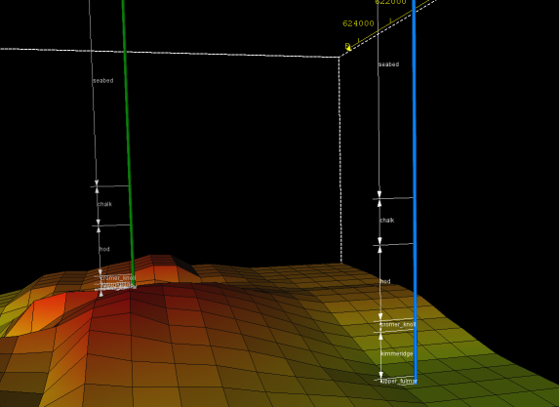
Figure 4 Well paths showing formation sections

Property data sets
Various types of properties can be visualized on a mesh:
- Scalar properties can be used together with a colormap to assign colors to individual cells or nodes.
- Vector properties can be rendered using arrows to represent the vectors.
- Tensor properties can be rendered using a beachball representation, or as vectors when stresses or strains at a point on a surface are to be visualized.
All data set implementations ultimately derive from the generic OIV interface MiDataSetI<T>. OIDIDataSetI<T> does most of the heavy lifting for OIDIScalarSetI, OIDITensorSetI and OIDIVectorSetI. OIDITensorVectorSignSetI and OIDITensorVectorSetI are special cases: both use a OIDITensorSetI and a normal vector to generate their values.
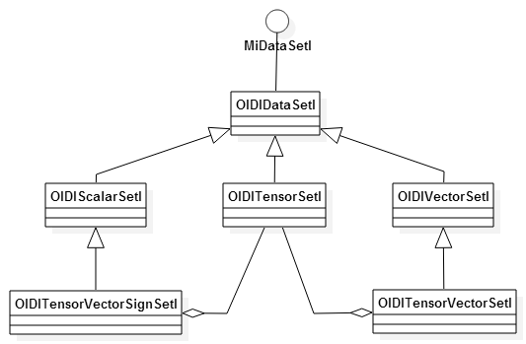
Figure 5 Class diagram for property data sets
Data sets are inserted in the scenegraph to become part of the render state. Rendering primitives like MoMeshSkin are then able to reference specific data sets by means of an index, such as colorScalarSetId for scalar data sets.

Scalar properties
OIDIScalarSetI is used to store scalar properties such as temperature, porosity, etc. One way of visualizing scalar properties is to color the mesh according to their values, using color maps. Open Inventor provides several color mapping classes, but the most common one is MoLinearColorMapping. This class creates a color mapping defined by a set of scalar values and their corresponding colors, linearly interpolating colors for values between the given ones.
Another way to display scalar properties is by mapping isolines onto the mesh. MoMeshIsoline and MoMeshAnnotatedIsoline are the OIV classes that take a scalar set id and render isolines on a surface mesh. Since formations are represented by volume meshes, adding isolines to a formation requires adding a second MoMesh node to the scenegraph, and setting it to represent the surface mesh extracted by MoMeshSkin, by using the MoMesh::connectFrom() method.

Vector properties
Properties such as displacements are stored as vectors. They can be visualized using MoMeshVector, using OIDIVectorSetI as the data set type. The size of the vectors can be controlled via the scaleFactor field on MoMeshVector.
When working with large, dense meshes, showing a vector on every cell or node quickly becomes impractical. In cases like this, a MoCellFilter can be used to show only a subset of the vectors. The cell filter uses an instance of DecimatingCellFilterI, which takes as a parameter the fraction of vectors that should be visible.
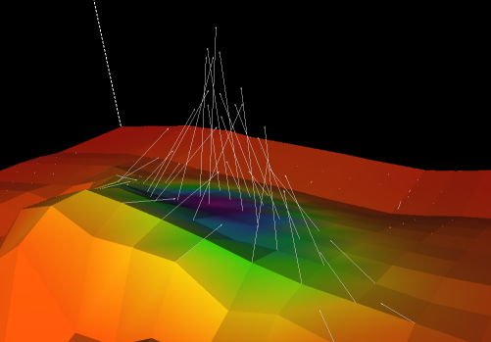
Figure 6 Rendering displacement vectors

Tensor properties
Stresses and strains are represented with tensors, stored in an OIDITensorSetI. Since Open Inventor has no built-in way of visualizing tensors, 2 custom solutions have been developed.
The first, called “tensor vectors”, can be used to display various tensor attributes as vectors, such as the principal directions of a tensor, or the stress vector on a planar cross section through the formation. Different colors can be assigned to indicate compressive and tensile stresses. When displaying stress vectors on a cross section, OIDITensorVectorSetI and OIDITensorVectorSignSetI are used to generate vectors and scalars from the tensor set using the normal vector of the cross section plane.
The second way of visualizing tensors involves the rendering of “beach balls”, small colored spheres oriented in such a way that they show the principal directions of the tensors.

Tensor vectors
MoMeshTensorVector is a custom OpenInventor render node that is used to display a “double-sided” vector showing the magnitude in one of the principal directions of the tensor, or in the case of a planar cross section,
It uses 2 data sets:
- A scalar data set (using colorScalarSetId) to select the values used for coloring the vectors. In most cases this will be used to differentiate between tensile (red) and compressive (green) stresses, by using the signs of the tensor eigenvalues and an instance of MoLevelColorMapping.
- A vector data set (using vectorSetId) for the actual vector data. This will usually be a OIDIVectorSetI containing vectors for one of the principal directions of the tensors, or in the case of a cross section, an OIDITensorVectorSetI, which generates vectors based on a OIDITensorVectorSetI and a surface normal vector.
The MoMeshTensorVector class itself is a subclass of SoGroup, and just builds a small scenegraph composed of 2 MoMeshVector instances, a forward and a reverse vector. Both vector nodes refer to the same data set, with the reverse vector using a negative scale factor to point it in the opposite direction.

Beachballs
The ‘beachball’ visualization of tensor properties is a custom OIV extension that uses OpenGL for rendering. The integration with MeshViz is done using a set of classes that are designed to work in a similar way as the existing interfaces for displaying vector properties. The following features are supported:
- PER_CELL and PER_NODE rendering
- Works on unstructured volume and surface meshes
- Takes the current cell filter into account
- Supports clipping with a single clip plane
- Can use 2 scalar sets and a color map for coloring
- Allows scaling of the beachballs without rebuilding the mesh
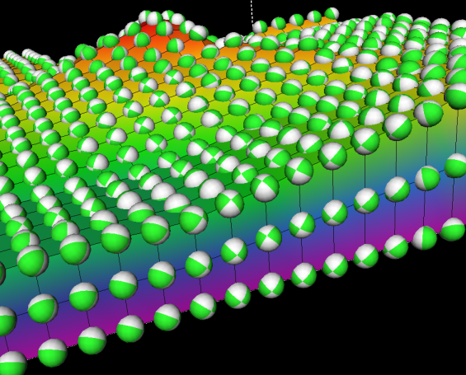
Figure 7 Rendering tensors as beachballs

OpenGL
In order to allow efficient rendering of potentially large numbers of beach balls, an OpenGL technique called instancing is used. Using this technique, a single beachball mesh is drawn multiple times with different parameters (position, orientation) using only a single drawcall.
The resulting code creates 2 vertex buffer objects (VBOs): one for the geometry of a single beachball, and one with the parameters for each individual instance. A texture is created for the colormap, if any.
Instanced rendering requires the use of shaders; a vertex shader to handle vertex transformation and clipping, and a fragment shader that assigns the final color to each rendered pixel (fragment). Since much of Open Inventor is still built on the old fixed pipeline functionality of OpenGL, some render state needs to be retrieved using the glGetXXX functions, and passed to the shader, such as the current modelview and projection matrices, current lighting direction, etc.

MeshViz extensions
The integration with MeshViz is done through the following classes:
- MoMeshTensor – the render node, works with the currently active MoTensorSet
- MoTensorSet – node containing a tensor data set, which is a MiDataSetI<CTensor>
- MoTensorSetElement – used to store / retrieve a tensor set in / from the scenegraph state
These are modelled after the corresponding classes for displaying vector properties. Adding beachballs to the scene is done by inserting one or more MoTensorSet nodes containing the tensor data, and a MoMeshTensor node for the actual rendering. This works similar to rendering of vector properties, where one or more vector data sets are added, using a MoMeshVector for display. The MoTensorSetElement class is only used internally.

Issues
Mixing Open Inventor rendering with straight OpenGL is quite tricky. The major issue is leaking of render state; when custom OpenGL code fails to reset certain render states which throw off subsequent Open Inventor rendering, or vice versa. Examples are certain buffers that are still enabled, or the transparency mode that was set.
Another issue encountered during the development of this feature was that instanced rendering apparently does not work with display lists. This would normally not be a problem, but it turns out that Open Inventor still uses display lists when a SoSeparator node has its renderCaching variable set to true. Unfortunately, this is the default setting, so when using the beachball visualization, every SoSeparator ancestor node of MoMeshTensor needs to have renderCaching disabled.

IvTune
When working with Open Inventor, it is occasionally very convenient to look at IvTune. This is an external tool that allows you to inspect the current scenegraph, and modify parameters that are exposed as fields in OIV classes.
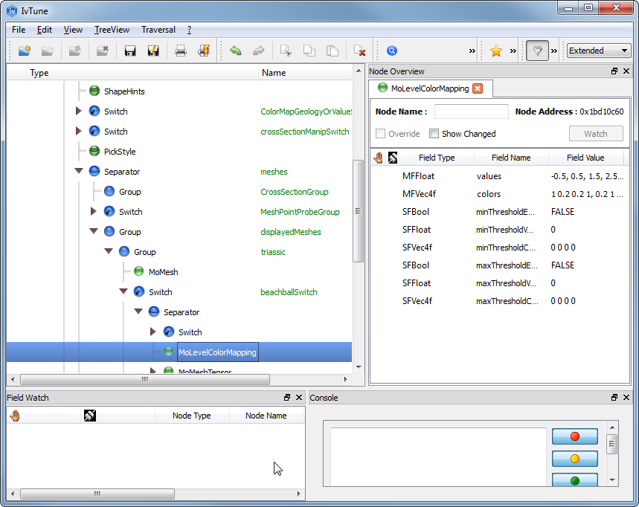
Figure 8 The IvTune window
Enabling the use of IvTune is done by uncommenting a #define in the code, so regular users are prevented from messing with the scenegraph. In OpenInventorEventsHandler.cpp, make sure that the line
#define USE_IVTUNE
is uncommented, then recompile, and when opening an Open Inventor scene IvTune should be automatically displayed.

