TNO report

2001-NM-R016
Geomec Phase III Interface Design
Date | October 2001
Author(s) | ir. M.H. Tolman  ir. A.H.D. Willemse  dr. ir. G. Schreppers

Copy no
No. of copies
Number of pages | 64
Number of appendices | 1
Sponsor | Shell International Exploration & Production
Project name | Shell-Geomec
Project number | 006.03592/01

All rights reserved.
No part of this publication may be reproduced and/or published by print, photoprint, microfilm or any other means without the previous written consent of TNO.

In case this report was drafted on instructions, the rights and obligations of contracting parties are subject to either the Standard Conditions for Research Instructions given to TNO, or the relevant agreement concluded between the contracting parties. Submitting the report for inspection to parties who have a direct interest is permitted.

© 2001 TNO

Contents
1 Introduction — 6
2 Models in Geomec — 8
2.1 Horizon model — 8
2.2 GoCAD model — 8
2.3 Eclipse model — 8
3 The Trees — 10
4 The Data Storage Tree — 12
4.1 Data Storage / Surfaces — 12
4.1.1 Add Surface — 12
4.1.2 Remove All — 12
4.1.3 Attributes — 12
4.2 Data Storage / Point Sets — 13
4.2.1 Add Point Sets — 13
4.2.2 Remove All — 13
4.2.3 Attributes — 13
4.3 Data Storage / Point Sets / File containing point sets — 13
4.3.1 Attributes — 13
4.3.2 Remove All — 14
4.4 Data Storage / Point Sets / File containing point sets / Point Set — 14
4.4.1 Add to Formation — 14
4.4.2 Add to Fault — 14
4.4.3 Remove — 14
4.4.4 Attributes — 14
4.5 Data Storage / Surfaces / Surface — 14
4.5.1 Add to Horizon — 15
4.5.2 Add to Fault — 15
4.5.3 Remove — 15
4.5.4 Attributes — 16
5 The Model Tree — 18
5.1 Model branch — 18
5.2 Model / Horizons — 18
5.2.1 New Horizon — 19
5.2.2 Remove All — 20
5.2.3 Attributes — 20
5.3 Model / Horizons / Horizon — 20
5.3.1 Add Surface — 21
5.3.2 Act as slip layer — 21
5.3.3 Remove All Surfaces — 21
5.3.4 Remove — 21
5.3.5 Move Up — 21
5.3.6 Move Down — 21
5.3.7 Attributes — 21
5.4 Model / Horizons / Horizon / Surface — 21
5.4.1 Remove — 22
5.4.2 Attributes — 22
5.5 Model / Faults — 22
5.5.1 New Fault — 22
5.5.2 Remove All — 23
5.5.3 Attributes — 23
5.6 Model / Faults / Fault — 23
5.6.1 Add Surface — 24
5.6.2 Convert to Horizon — 24
5.6.3 Remove All Surfaces — 24
5.6.4 Attributes — 24
5.7 Model / Faults / Fault / Surface — 24
5.7.1 Remove — 24
5.7.2 Attributes — 24
5.8 Model / Formations — 24
5.8.1 Detect — 25
5.8.2 Add — 25
5.8.3 Attributes — 25
5.9 Model / Formations / Formation — 25
5.9.1 Remove — 26
5.9.2 Attributes — 27
5.10 Model / Formations / Formation / (Bodies / Horizons) — 27
5.11 Model / Formations / Formation / Material — 27
5.11.1 Assign Material — 28
5.11.2 Remove Material — 28
5.11.3 Assign Distributed Property — 28
5.11.4 Export — 28
5.11.5 Remove All — 29
5.11.6 Homogenisation — 29
5.11.7 Properties — 29
5.12 Model / Formations / Formation / Pressures — 29
5.13 Model / Formations / Formation / Stresses — 30
5.14 Model / Boundary — 30
5.14.1 Initial Stress Pre-processing attributes — 32
5.14.2 Modify/Define — 32
5.14.3 Best Fit — 32
5.14.4 Attributes — 32
6 Mesh — 34
6.1 Concepts — 34
6.2 Mesh / All Horizons — 35
6.2.1 Mesh — 35
6.2.2 Add Region — 35
6.2.3 Remove all Regions — 35
6.2.4 Attributes — 35
6.3 Two-dimensional meshing (horizon/fault meshes) — 35
6.3.1 Mesh — 36
6.3.2 Add Region — 36
6.3.3 Remove all Regions — 36
6.3.4 Refine — 36
6.3.5 Coarsen — 37
6.3.6 Attributes — 37
6.4 Mesh / (All Horizons, Horizons, Faults) / Region — 37
6.4.1 Mesh — 37
6.4.2 Remove — 37
6.4.3 Refine — 37
6.4.4 Coarsen — 37
6.4.5 Attributes — 37
6.5 Three-dimensional meshing (Volumetric Meshes) — 38
7 Views — 40
7.1 General — 40
7.2 Views / Bird Eye View — 40
7.2.1 Attributes — 41
7.2.2 Change to Default — 41
7.3 Views / Planar View — 41
7.4 Views / Well Path View — 42
7.4.1 Add Well Path — 42
7.4.2 Remove all — 42
7.5 Views / Well Path View / Well Path — 42
7.5.1 Run DStabor — 43
7.5.2 Remove — 43
7.5.3 Attributes — 43
7.6 Views / Cross Section View — 43
7.6.1 Add Cross Section — 43
7.6.2 Remove all — 43
7.7 Views / Cross Section View / Cross Section — 43
7.7.1 Run Geomec 2D — 44
7.7.2 Attributes — 44
8 Results — 46
8.1 Results / Result type — 46
8.2 Results / Depletion Stage — 48
8.3 Results / (Linear / Non Linear) — 48
8.4 Results / Colour Gradient — 48
8.5 Results / Colour Gradient / Global — 48
8.5.1 Attributes — 48
8.6 Results / Colour Gradient / Local — 49
8.6.1 Attributes — 49
8.7 Results / Colour Gradient / Hot Spot — 50
8.7.1 Attributes — 50
9 Reports — 52
9.1 Sectioned Reports — 52
9.2 Free Form Reports — 52
10 Menu — 54
10.1 File — 54
10.2 Edit — 54
10.3 View — 54
10.4 Analysis — 54
10.5 Action — 54
10.6 Tools — 54
10.7 Help — 54
11 Analysis Types / Modes — 56
11.1 Inverse — Error! Bookmark not defined.
11.2 Initial stress pre-processing — 56
11.3 Depletion — Error! Bookmark not defined.
12 Approval — 58

Appendices
A List of Definitions 1
B Header File Definition 1

Introduction
In 1998-1999 the Geomec development has started with a basic module for standard three-dimensional linear analyses. In this module the finite element mesh is directly derived from electronic seismic interpretation input. Only linear elastic analyses and user friendly interfaces for pre- and post-processing have been made available in this phase.

The second phase development has resulted in three additional modules. First is a module for automatic calibration of material parameters from experimental tests. A range of elasto-plastic and viscous material models has been made available including models that can cope with pore-collapse. Non-linear material behaviour can be taken into account in the field compaction analysis. Secondly, a module has been made that allows modifications such as mesh-refinement and sliding faults in a two-dimensional cross section of the field. Third, the automatic import of and analysis of Eclipse models has been made available in this phase.

This document deals with the phase 3 development of Geomec and includes the following functions in the three-dimensional model:

- Inverse analysis module for calculating pore-pressure changes and Young's modulus distributions using surface subsidence measurement data as input.

- More advanced three-dimensional model definitions imported from the GoCAD modeller, as well as features for the manipulation of these models has been planned.

- The module will be extended to allow ‘Initial Stress Pre-processing’ for calculating the heterogeneous initial stress resulting from movements of formations on a geological time-scale. These detailed initial stresses will be used as input for the following subsidence analyses.

Detailed functional specifications of the phase 3 development have been described in the quotation with reference 2000.23.104\SSGA\J10 with date 5th September 2000.

Geomec shall be a user-friendly program that allows both researchers and engineers from operating units to perform finite element analyses in order to establish stress-development in the reservoir and overburden as well as compaction and subsidence. Due to the complex nature of the new features and especially because user-friendly manipulation of three-dimensional models requires direct graphical interactivity with the model and results, the development of a completely new program for three-dimensional analyses is proposed. One of the important changes with respect to previous versions is that model and results will be visualised using OpenGL features directly, instead of using FemView for the visualisation of for instance three-dimensional bird-eye views and cross-sections of model and results. Another important change is that the in the main window (see Figure 1.1) the input tab-forms are replaced by tree-structures. The user has to define information in the respective branches of these trees. These tree-structures will provide the user a better overview of what is defined and is more suitable for the complex new features to be incorporated in the phase 3 of the Geomec development. Further integration of the several databases (Access, Filos and FemView) in phase 1 and 2 is considered in order to get a better performance.

The main window of the graphical user interface is shown in Figure 1.1 and has the look and feel of a Windows application. At the top a bar with menus is shown and the contents of these menus are described in chapter 10 of this document. In the bar underneath, a number of icons for frequently used operations is located. At the bottom a status-bar is located. In between, two panels are placed next to each other. The left-hand panel comprises of two tree-structures. The trees and their underlying functions are described in chapter 3 and the following. The right-hand panel comprises the model and result visualisation. As OpenGL is used the visualisation in this window can be dynamically rotated, translated and zoomed in/out.

In this document the graphical user interface is defined and describes only additional functionality to phase 2. Original phase 2 functionality will be maintained.
This document concerns the description of the renewed graphical user interface. Not all the new functionality is described in this document; the rest will be described in a next document. There will also be a document describing the wizards.

For a list of definitions see Appendix A.

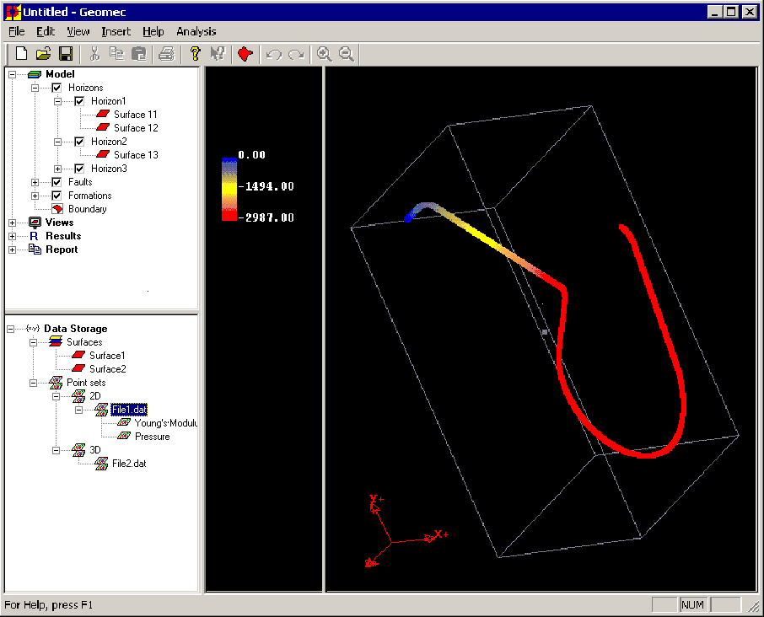
Figure 1.1 – Main lay out of graphical user interface in Geomec phase III.

Models in Geomec

Horizon model
The horizon model is built from old version 2.* GM3 databases or x, y, z horizon files. The horizon model does not support faults. The horizons in the model extend to all boundaries. Unconformities are not allowed. When horizons are created that intersect, the lower horizon is moved down a bit under the upper horizon and the user is able to adapt the model. When this takes place the user will be notified. Each horizon can be exported to x, y, z in ASCII or Excel or to a GoCAD format with connectivity information. The horizon model only supports a hexahedron mesh. The horizon model can be compared with the old Geomec 2.6 models. In extension to version 2.6 horizons can now act as slip layers. The horizon model is saved in a Geomec 3.0-model database, which can not be read by older versions of Geomec.
The geology data (horizons, formations) of a horizon model can be converted to:

- GoCAD model

- Eclipse model

GoCAD model
Geomec will be able to read all model items from GoCAD if GoCAD supports it. The GoCAD model accepts GoCAD and x, y, z files to build the horizons and faults. The horizons can be separated by faults. In that case the horizon consists of multiple surfaces. The horizons and faults in the model must have exact interconnections. Unconformities are allowed. The GoCAD model only supports a tetrahedron mesh. The GoCAD model is also saved to a Geomec 3.0 model database.
The geology data of a GoCAD model can be converted to:

- Eclipse model

A GoCAD database can be read in regardless of its situation. If information is missing this has to be completed in Geomec before the analysis can be run. A 3D GoCAD mesh can be read in and will default be used for analyses. Remeshing will remain possible, although not for intrusive bodies.

Eclipse model
The eclipse model is constructed from eclipse files with properties as defined in Geomec 2.6. Pressures, Young’s moduli etc. can be assigned to the formations. The eclipse model uses the mesh as defined in the eclipse file. The mesh can not be modified in the eclipse model.
The eclipse model can be converted to:

- Horizon model

This allows the user to modify the mesh. The geology data of an eclipse model and the results of the calculation can be saved to an eclipse file.

The Trees
The tree-structures in the left-hand panel show the hierarchical organisation of data. General information is located at the top of the tree-structures and more specific information can be found at lower branches of the trees. Each branch ends in a leaf. In Geomec the trees represent all data items that can be displayed or manipulated by the user. As a consequence, each branch/leaf in the trees comprises an action menu with command operations. These menus can be reached by right clicking on a leaf. A context sensitive pop-up menu will appear at the cursor location detailing the menu options available for this leaf. This menu will also be placed on the menu bar under the item Action menu.

The two trees are the Model tree and the Data Storage tree. Each tree has a number of branches that are described in the following chapters of this document.

The main branches of the Model tree are:

- Model

- Mesh

- Views

- Results

- Reports

The sub-branches of the Data Storage tree are:

- Surfaces

- Point Sets

Each action menu for a leaf has at least the following items:

- Copy

- Paste

- Add to Report

- Attributes

The applicability of the above mentioned actions will always be checked. If the action is not possible, the action menu item will be greyed out. Wherever applicable items can be dragged from the data storage tree onto an item in the model tree. Items within the model tree can be dragged within the tree.

The Data Storage Tree
First the data storage tree will be discussed. This tree represents the imported items from files used to define the model. A model is composed from Surfaces (for horizons and/or faults) and Point Sets (for distribution of e.g. material properties or stresses), both are sub-branches in the tree.

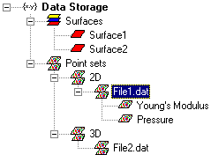
Figure 4.2 –Expanded Data Storage tree.

Data Storage / Surfaces
The branch Surfaces may contain a list of surfaces. Each surface in the list represents a surface imported by the wizard or the user. An example of an expanded view of the sub-branch Surfaces is given in Figure 4.1.

This branch has the following action items:

- Add Surface

- Remove All

- Attributes

Add Surface
This action item allows the user to add a surface to the list. Importing a surface file can do this as well.

Remove All
This action item allows the user to remove all the surfaces from the list that are not in use in the model.

Attributes
This action item opens a dialog showing the attributes of the Surfaces branch, e.g. number of surfaces etc.

Data Storage / Point Sets
A file can be read in containing multiple point sets. In the header of the file the contents of the file can be explained (see Appendix B). If not everything is specified, the user can specify this in the attributes of the file containing the point sets at a later point. The only thing that needs to be defined when reading in the file is the dimension. Geomec needs to know if the point sets that are contained in the file are two-dimensional or three-dimensional point sets. If the first two columns in the file contain x and y co-ordinates and the third column does not contain z co-ordinates, the file is considered two-dimensional. If the third column does contain z co-ordinates the file is considered three-dimensional. In general each property (e.g. material property or stress tensor) combined with the co-ordinates (2D or 3D) is considered a point set. When a file containing point sets is read in, the name of the file appears under either the 2D or the 3D sub-branch of the Point Sets branch, depending on its dimension. The accompanying point sets are displayed under the file.
Apart from using point sets for distributed properties, they can also be used to define horizons that can then be used in a horizon model.

The Point Sets branch only expands when there are point sets in the list. The branch has the following action items:

- Add Point Sets

- Remove all

- Attributes

Add Point Sets
This action item allows the user to select a file containing point sets to import. The file is placed in either the 2D or 3D sub-branch. If from the header of the file the definition of (a) point set(s) can be distilled, they are put below the file. See Figure 4.1

Remove All
This action item allows the user to remove all the point sets from the list that are not yet used in the model.

Attributes
This action item opens a dialog showing the attributes of the Point Set branch, e.g. number of point sets etc.

Data Storage / Point Sets / File containing point sets
The file containing the point sets has the following action item:

- Attributes

- Remove all

Attributes
This action item opens into a window in which it is possible to specify point sets from the contents of the file. If a new point set is defined it is placed beneath the file. It is also possible to override the point sets as they were defined in the header of the file. The type a point set can get (e.g. Pressure or Young’s modulus) is listed. This means that the user has to select a property, be it a physical one like Pressure or a material property like Young’s modulus, and then assign the appropriate columns from the file to this property. If the type chosen by the user is a surface (the point set has to be 3D) the columns containing the x, y and z information are chosen and a new surface will be added in the surfaces branch.

Remove All
This action item removes all the previously defined point sets from the sub-branch that are not yet in use in the model. The point sets will have to be defined again using the attributes action item.

Data Storage / Point Sets / File containing point sets / Point Set
Each point set has the following action items:

- Add to Formation

- Add to Fault

- Remove

- Attributes

Add to Formation
This action item opens into a dynamic menu that allows the user to add the point set to a formation.

Add to Fault
If the point set contains fault information like friction angle or cohesion, the point set can be assigned to a fault.

Remove
This action item removes the point set from the branch if the point set is not yet in use in the model. Pressing the ‘delete’ key will also remove the selected point set.

Attributes
This action item opens a dialog showing the attributes of the Point Set leaf, such as the number of points etc.

Data Storage / Surfaces / Surface
This leaf appears under the Surfaces sub-branch. A surface can be viewed as points or as an open triangulated wire frame or as a filled triangulated surface. Figure 4.2 displays an example of an open triangulated wire frame of a surface.

The leaf surface has the following action items:

- Add to Horizon

- Add to Fault

- Remove

- Attributes

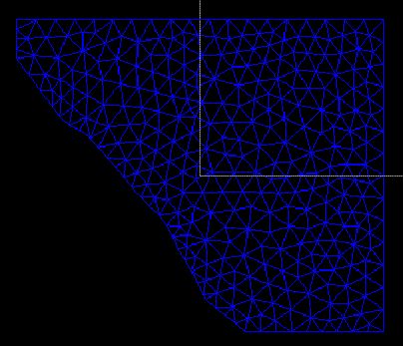
Figure 4.3 –Example of a triangulated surface.

Add to Horizon
This action item opens into a dynamic menu that contains all previously defined horizons in the model. When one of the existing horizons is chosen the surface will be added to this horizon.
More than one surface can be added to a horizon. The surfaces in one horizon do not have to connect in order to make up the horizon. It is also possible to create a new horizon from the surface in this action item.

Add to Fault
This action item opens into a dynamic menu that contains all previously defined faults in the model (if the model is a GoCAD model.) When one of the existing faults is chosen the surface will be added to this fault. More than one surface can be added to a fault. The surfaces in one fault have to connect in order to make up the fault. It is also possible to create a new fault from the surface in this action item.

Remove
This action item removes the selected surface from the list. A surface can only be removed if it is not used in the model. Pressing the ‘delete’ key will also remove the selected surface.

Attributes
This action item opens a dialog showing the attributes of the Surface leaf such as the file it was imported from, number of triangles, area, number of points etc.

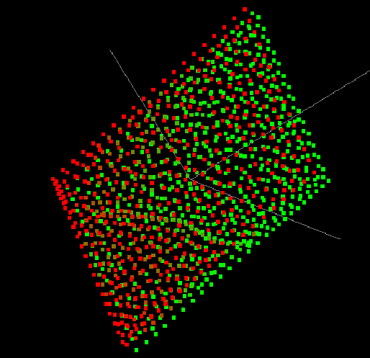
Figure 4.4 –An example of a point set.

The Model Tree
This tree has the following main branches:

- Model

- Mesh

- Views

- Results

- Reports

In case the model is an eclipse model, mesh branch is inactive.

Model branch
This branch contains all geological and model data. The sub-branches are:

- Horizons

- Faults

- Formations

- Boundary

Each sub-branch has one or more attributes. The contents of the sub-branches are built using data from the Data Storage tree. The model objects are displayed in a bird eye view when they are created. Checking and unchecking objects can alter the contents of the view.

Model / Horizons
This sub-branch contains a list of the horizons that are defined from surfaces in the Data Storage tree or from a constant depth. Each horizon contains a list of surfaces that belong to it. Figure 5.1 gives an example of the tree in the branch Horizons. An example of a horizon is shown in Figure 5.2.
The sub-branch Horizons has the following action items:

- New Horizon

- Remove All

- Attributes
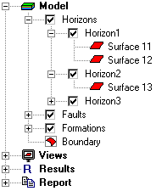
Figure 5.5 –Expanded view of Hhorizons.
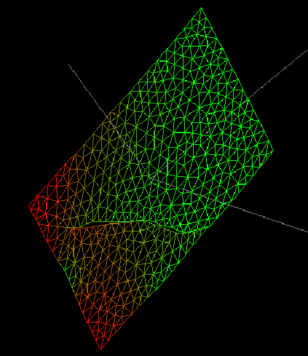
Figure 5.6 –A triangulated rotated horizon.

New Horizon
This action item will open a file browser where either surface files can be selected or a constant depth for the new horizon can be specified. From this information a new horizon will be created in the model. If a surface file was read in, it will now also be present in the Data Storage tree. If the model is a GoCAD model, it is the responsibility of the user to make sure that the newly created horizon does not intersect with any existing horizons in the model. Surfaces defined in the Data Storage tree can be ‘dragged’ onto the Horizons branch. A new horizon will then be created from the surface. It is also possible to define a new horizon above 0 m. In the model attributes (under ‘File’ menu) it is then possible to switch off the water column influence.

Remove All
This action item allows the user to remove all currently defined horizons. This does not remove the surfaces from the surfaces sub-branch of the Data Storage tree.

Attributes
This action item opens a dialog showing the attributes of the Horizons sub-branch such as number of horizons etc.

Model / Horizons / Horizon
A Horizon sub-branch represents the separation of layers in the geological model. Geomec supports two types of horizons. Horizons are created from one or more surfaces from the Data Storage tree or are defined by a constant depth. Both types are supported by horizon-file models as well as by GoCAD models. The two types are:

- Single/Multi Surface

- Constant Depth

Single/Multi Surface horizons have a list of surfaces that belong to it. It is created from surfaces defined in the Data Storage tree or from surfaces selected when a new horizon was created by the ‘New Horizon’ action.

Constant Depth horizons are not created from a surface, but have a constant depth attribute that the user specifies.

The Horizon sub-branch has the following action items:

- Add Surface

- Act as slip layer

- Remove All Surfaces

- Remove

- Move Up

- Move Down

- Attributes

Add Surface
This action item will open a file browser where surfaces can be selected and is disabled for a Constant Depth horizon. All selected surfaces will be added to the horizon. If a surface file is read in, it will now also be present in the Data Storage tree. Surfaces defined in the Data Storage tree can be ‘dragged’ onto the Horizon. The surfaces will then be added to the horizon.

Act as slip layer
This action item allows the user to enter a sliding function for the horizon. The fault/slip layer parameters (cohesion, friction angle) can also be distributed (point set.) The horizon will not be removed from the horizons branch, and can always be converted back to a ‘normal’ horizon.

Remove All Surfaces
This action item applies only to single/multi surface horizons. This action item allows the user to remove all surfaces from the horizon. This does not remove the surfaces from the Surfaces branch in the Data Storage tree.

Remove
This action item allows the user to remove the horizon from the model. All attributes of the horizon are lost. For a single/multi surface horizon the surfaces are not removed from the Surfaces branch in the Data Storage tree. The selected horizon can also be removed by pressing the ‘delete’ key.

Move Up
Horizons are automatically ordered by depth. This action item moves the horizon up in the order by depth of the horizons.

Move Down
Horizons are automatically ordered by depth. This action item moves the horizon down in the order by depth of the horizons.

Attributes
This action item opens a dialog showing the attributes for the horizon, e.g. colour, number of surfaces etc.

For the horizon-files models this dialog allows the user to switch the horizon type from single surface to constant depth and vice-versa. Changing the type from a single surface to constant depth removes all the surfaces in the horizon.

Model / Horizons / Horizon / Surface
Each surface leaf in the horizon sub-branch has the following action items:

- Remove

- Attributes

Remove
This action item allows the user to remove the surface from the horizon sub-branch. The surface is not removed from the Surfaces sub-branch in the Data Storage tree. Pressing the ‘delete’ key will also remove the selected surface.

Attributes
This action item opens a dialog showing the attributes of the surface leaf in the horizon sub-branch.

Model / Faults
This sub-branch is only valid for GoCAD models, and will only be represented in the tree if the model is of the GoCAD type. This sub-branch contains a list of faults that are defined by surfaces from the Surfaces sub-branch in the Data Storage tree. Each fault contains a list of surfaces that belong to it. Figure 5.3 gives an example of the tree in the branch Faults.

An example of a fault is shown in Figure 5.4.

The sub-branch Faults has the following action items:

- New Fault

- Remove All

- Attributes
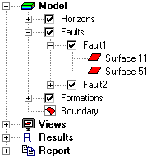
Figure 5.7 –Expanded view of faults.

New Fault
This action item will open a file browser where surface files can be selected. From this information a new fault will be created in the model. The surface file that was read in will now also be present in the Data Storage tree. Surfaces defined in the Data Storage tree can be ‘dragged’ onto the Faults branch. A new fault will then be created from the surface.

Remove All
This action item allows the user to remove all currently defined faults from the Faults sub-branch. This does not remove the surfaces from the surfaces sub-branch in the Data Storage tree. Removing faults may invalidate the model.

Attributes
This action item opens a dialog showing the attributes of the sub-branch faults such as number of faults etc.

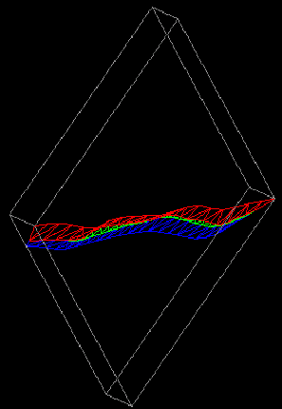
Figure 5.8 –A triangulated rotated fault.

Model / Faults / Fault
A fault sub-branch represents geological fault lines along which displacement may have occurred in geological time. There is only one type of fault, and that is a Single/Multi surface type.

Each fault sub-branch has a list of surfaces that represent it. A fault may consist of one or more surfaces. The surfaces in a fault must touch along at least one edge. The surfaces in a fault may not enclose a volume.

The Fault sub-branch has the following action items:

- Add Surface

- Convert to Horizon

- Remove All Surfaces

- Remove

- Attributes

Add Surface
This action item will open a file browser where surfaces can be selected. All selected surfaces will be added to the fault. If a surface file is read in, it will now also be present in the Data Storage tree. Surfaces defined in the Data Storage tree can be ‘dragged’ onto the fault. The surfaces will then be added to the fault.

Convert to Horizon
This will convert the fault to a horizon. The fault will be removed from the faults branch and a new horizon will be added in the horizons branch.

Remove All Surfaces
This action item allows the user to remove all the surfaces from the fault. This does not remove the surfaces from the surface sub-branch of the Data Storage tree.

Attributes
This action item opens a dialog showing the attributes of the fault. Apart from assigning constant properties it will also be possible to read in distributed properties (point set) for a fault.

Model / Faults / Fault / Surface
Each surface leaf in the fault sub-branch has the following action items:

- Remove

- Attributes

Remove
This action item allows the user to remove the surface from the fault sub-branch. The surface is not removed from the Surface sub-branch in the Data Storage tree. Pressing the ‘delete’ key on the keyboard will also remove the surface.

Attributes
This action item opens a dialog showing the attributes of the surface leaf in the fault.

Model / Formations
For a horizon type model the volume between two horizons defines a formation. For GoCAD models a formation is identified by the upper horizon. Bodies define the formation in a GoCAD model. Geomec can detect bodies and assigns these bodies to formations depending on the horizon at the top of the body.

This sub-branch contains a bodies sub-branch if the model is a GoCAD model and a horizons sub-branch if the model is a horizon type model. Figure 5.5 gives an example of the tree in Formations, if the model is a GoCAD model. An example of a formation is shown in Figure 5.6

The sub-branch Formations has the following action menu:

- Detect

- Add

- Attributes

Geomec always creates the most likely formations for the detected bodies (for GoCAD) or for the available horizons (for horizon type model).

Detect
- GoCAD
This action item is used to detect bodies in the model. A body is an enclosed volume. Each detected body will be added to an existing or to a newly created formation. The formation that the body is added to is determined by the horizon directly above it. It is possible to move bodies between formations. It is not possible to remove bodies.

- Horizon type
This action item is not available for a horizon type model.

Add
- GoCAD
This action item allows the user to add a formation to the formations sub-branch. This is only possible if there is at least one formation containing more than one body. One or more of the bodies from the formation containing multiple bodies can be selected by the user and is then converted into a new formation. The number of formations may not exceed the number of bodies.

- Horizon type
This action item is not available in a horizon type model.

Attributes
This action item opens a dialog showing the attributes of the formations. For instance the name of the formation can be changed here.

Model / Formations / Formation
A formation represents a volume between two horizons. If the model is a GoCAD model, each formation has a sub-branch bodies that contains a list of one or more bodies that define the formation. If the model is a horizon type model, each formation has a horizons sub-branch that contains the upper and lower horizon defining the formation. Formations may never intersect.

A formation has the following action items:

- Remove

- Attributes

Each formation has the following sub-branches:

- Bodies/Horizons (depending on model type)

- Material

- Pressures

- Stresses

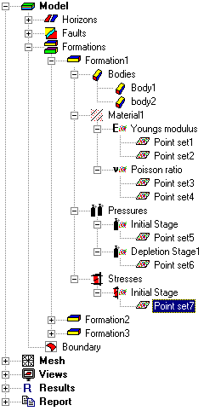
Figure 5.9 –Expanded view of formation for a GoCAD model.

Remove
This action item allows the user to remove the formation from the Formations sub-branch in the Model branch. A formation must be empty (contain no bodies) before it can be removed (in case of GoCAD). If the formation is not empty this action item is disabled (grey.) Pressing the ‘delete’ key on the keyboard will also remove the formation if this is possible.
In a horizon type model it is not possible to remove a formation.

Attributes
This action item opens a dialog showing the attributes of a formation.

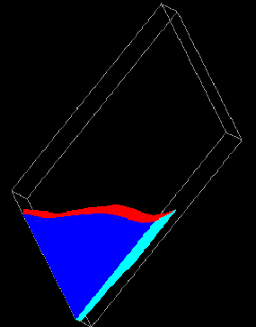
Figure 5.10 –A solid filled rotated formation.

Model / Formations / Formation / (Bodies / Horizons)
- GoCAD
This sub-branch contains a list of the bodies that define the formation. When this list is empty the formation may be removed from the Model branch.

- Horizon type
This sub-branch contains the upper and lower horizon defining the formation.

Model / Formations / Formation / Material
This sub-branch represents the material in a formation.

All formations have a material name as a property. This name is assigned from the Material Library. Material properties can also be distributed based on a point set with a material property (see chapter 4 for a discussion of point sets). For instance, the user has assigned a distributed Poisson ratio for one of the formations' material properties. The Poisson ratio is assigned to elements based on a nearest neighbour or an averaging algorithm with respect to the point set, while the other material properties are taken from the material library.

Material has the following action items:

- Assign Material

- Remove Material

- Assign Distributed Property

- Export

- Remove All

- Homogenisation

- Properties

Assign Material
This action item allows the user to choose a material from the Material Library. Each formation needs to have a material assigned to it before an analysis can be performed.

Remove Material
This action item allows the user to remove the material assigned to the formation's material name. This does not affect the material in the Material Library. Pressing the ‘delete’ key on the keyboard will also remove the assigned material.

Assign Distributed Property
This action item allows the user to assign a point set to one of the material properties. The user can select a point set that was previously defined in the data storage tree or read in another point set file from which he then has to select a point set. After assignment an extra sub-branch is created (e.g. Poisson ratio) that has the accompanying point set(s) as children. After making a material property distributed the material property (e.g. Poisson ratio) in the material (from the library) is ignored. It is possible to apply multiple point sets (of the same type) to a material property.

Distribution of material properties default apply within as well as outside the convex hull described by the point set and inside the formation. If points are present inside an element the average of the values in these points are taken as the value for the element. If no points are present in an element a nearest neighbour algorithm is used to assign material properties to the element. In the ‘attributes’ dialog of the point set the user can specify that the distribution of the material properties only applies within the convex hull. The default supplied by the assigned material from the material library applies outside this hull, in that case.

Export
If the user has altered the material and wants to save it as another material in a material library, this action item allows the user to export the current material to a Material Library.

Remove All
This action item allows the user to remove all assigned distributed properties.

Homogenisation
A homogenisation analysis is useful only when a Young’s modulus or poisson ratio is divided inhomogeneously over a formation. This analysis can be performed before the complete finite element model is finished. The user defines an area within the formation. This area is used to construct a small block. The sides of the block are the size of the area defined by the user. A finite element mesh is constructed inside this block of, for instance, 5 by 5 by 5 solid brick elements. Next the points from the point-set, defining the Young’s modulus and poisson ration, in each element have to be found. These points are then used to calculate the average value for the Young’s modulus and the poisson ratio for each element. These parameters are passed to the DIANA core. The DIANA core returns an accompanying set of material parameters. These material parameters are shown to the user who can then choose to save the parameters to a material library. The material parameters are related to an anisotropic elastic material model.

Properties
This action item opens a dialog showing the properties of the material. Again the material library is not touched. Use ‘export material’ to make this material available outside the current model.

Model / Formations / Formation / Pressures
This sub-branch represents the pressures in the formation.

All formations have pressures. If no user-defined pressures are applied then the global pressure gradient (defined in the model attributes dialog, ‘File’ menu) is applied to calculate an initial pressure for the formation.

The user can decide to apply an initial pressure distribution to the formation. This can be seen in the tree as a point set attached to the initial depletion stage. The initial depletion stage is not a Diana calculated value, it is the initial situation in the formation. The user may choose to apply a single pressure value to the formation for the initial situation.

To calculate depletion stages, the user must assign a pressure to all subsequent depletion stages after initial. This can be done either by a pressure distribution or a GWC/OWC. The choice of pressure assignment for each stage after the first must be the same. For example, if the user has decided to apply a GWC/OWC to depletion stage one, then he must apply a GWC/OWC for every stage. Conversely if he chooses a pressure distribution for depletion stage one then he must assign a pressure distribution for every stage. This is not order dependent, the user may choose to fill in one of the later stages first, he does however, lock his choice (pressure distribution or GWC/OWC.) A GWC/OWC is defined by a contact depth, the pressure at the given depth and a pressure gradient above and below the contact.

As with material property distributions, a union of multiple point sets is allowed as a pressure distribution. Contrary to the material property distribution, the distribution default applies within the convex hull. The pressure value for each element is calculated by taking the average of the points inside the element. If no points are inside the element a nearest neighbour algorithm is performed. Outside the hull and inside the formation the default pore-pressure gradient applies, this is the initial state pore-pressure. In the ‘attributes’ dialog of the point set the user can specify that the distribution of the pressures apply within as well as outside the convex hull.

Model / Formations / Formation / Stresses
This sub-branch represents the initial stresses in the formation.

All formations have initial stresses. If no user defined initial stresses are applied, then the global stress gradient is applied to calculate the initial stresses in the formation.

The user can decide to apply an initial stress distribution for the formation. This only applies to the initial situation, and stresses cannot be applied to subsequent depletion stages.

Model / Boundary
This leaf represents the boundary of the model. The boundary is a hexahedral shape defined in the x/y plane. It is displayed as a dotted grey wire frame box that is never triangulated. The top and bottom horizons determine the top and bottom of the boundary.

Figure 5.7 gives an example of a boundary.

Every model must have a boundary. The default boundary is defined by a box that is three times the width as the depleting area as defined by the depletion stages in the formations. If no depleting area has been assigned, the boundary is the smallest enclosing box that contains all points in the model. The user is allowed to define its own boundary. This is done by drawing a box in the x/y plane or by the input of co-ordinates of the box in the attributes of the boundary box. Rotation of the box is allowed (See Figure 5.8 for an example of this view, without rotated box, however).

A box is shown for the boundary, but the top and bottom horizons actually define the top and bottom of the model/boundary.

The Boundary leaf has the following action items:

- Initial Stress Pre-processing attributes

- Modify/Define

- Best Fit

- Attributes

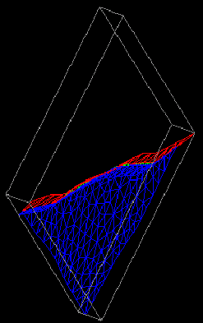
Figure 5.11 –Example of a boundary, Fault and Horizon provided as reference.

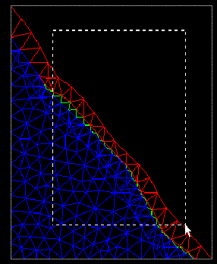
Figure 5.12 –Top view of boundary, smaller box is an example of a new boundary by dragging a rectangle (rectangle can also be rotated).

Initial Stress Pre-processing attributes
Here the initial stress pre-processing attributes can be defined. See chapter 11.

Modify/Define
This menu option allows the user to modify the current boundary or define a new boundary. The view changes to a top down view, and the user can manipulate the rectangle displayed, or draw an entirely different one. It is not necessary to include all the points in the model, as the boundaries will automatically crop/extend the horizons in the x/y plane to fit the drawn rectangle (see Figure 5.8). Cropping means that not all information is used, it is not lost.

Best Fit
This menu option automatically opens a dynamic menu containing all point sets defined in the depletion stages of the formations. If no formations are defined, and no pressures are applied to the depletion stages, then this menu option is disabled.
This menu option uses the point set the user has chosen to create a boundary that is three times as high/wide as the point set is high/wide. If necessary the boundary box will also be rotated to fit the point set even better.

Attributes
This menu option allows the user to view/edit the attributes of the boundary. Here the co-ordinates of the boundary box can also be defined.

Mesh

Concepts
The user is only allowed to modify meshing attributes for horizons or faults. As such only horizons and faults are represented in the tree. Figure 6.1 shows the tree in branch mesh for a GoCAD model without faults.

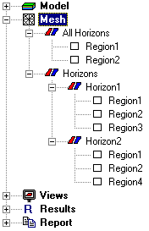
Figure 6.13 – Expanded view of Mesh.
- GoCAD
The user can have a normal view to any horizon or fault that he selects. This horizon or fault may then be refined or coarsened based on rectangular regions that the user defines within the normal view. The rectangular regions may overlap. The overlapping region will be meshed as fine as the finest mesh.

It will be possible to get a top view of the total model in which the defined regions affect all the horizons and faults in the model underneath the regions.

Modifying the two-dimensional mesh does not affect the imported surfaces in Files or the Data Storage tree. The relationship between these two exists by the requirement that the two-dimensional mesh follows the surface mesh as closely as possible within the constraints provided by the user defined regions and their respective coarseness or fineness.

- Horizon type
For horizon type models it will only be possible to define regions for all the horizons at once. No overlap is possible. (Phase 2 functionality).

The sub-branches in the mesh branch are:

- All Horizons

- Horizons

- Faults

The Mesh branch is not available for eclipse models.

Mesh / All Horizons
In this sub-branch a top view of the model will be shown. All the regions that will be defined here affect all the horizons in the model. The regions are displayed in a list.

This sub-branch has the following action items:

- Mesh

- Add Region

- Remove all Regions

- Attributes

Mesh
This menu option allows the user to create the mesh for all horizons to the boundary extents. This is the minimal mesh that fits the constraints applied by the user in attributes. If no boundaries are defined the ‘Best Fit’ boundary is automatically assigned to the model before the mesh procedure is started.

Add Region
This allows the user to add a new region to the region list. The user can now drag a rectangular region in the mesh. The region will also appear in the list of regions for each separate horizon, in case of a GoCAD model. However, the region can only be modified in the All Horizons branch (e.g. removed.)

Remove all Regions
This menu option allows the user to remove all the regions in the region list. The regions are also removed from the list of regions for each separate horizon, in case of a GoCAD model.

Attributes
This action item shows the attributes for the All Horizons sub-branch.

Two-dimensional meshing (horizon/fault meshes)
Each horizon/fault sub-branch in the Mesh branch has the following action menu:

- Mesh

- Add Region

- Remove all Regions

- Refine

- Coarsen

- Attributes

For an example of a horizon mesh with regions see Figure 6.2.

Mesh
This menu option allows the user to create the surface mesh to the boundary extents. This is the minimal mesh that fits the constraints applied by the user in attributes. If no boundaries are defined the ‘Best Fit’ boundary is automatically assigned to the model before the mesh procedure is started.

Add Region
This allows the user to add a new region to the region list. The user can now drag a rectangular region in the mesh. The user will also be able to rotate the region.

Remove all Regions
This menu option allows the user to remove all the regions in the region list except for the regions defined in the All Horizons branch.

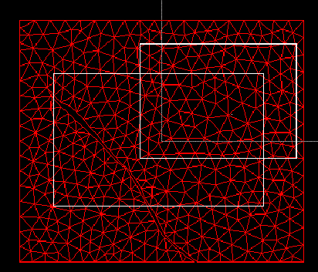
Figure 6.14 –Horizon mesh with two regions (not refined or coarsened).

Refine
This menu option allows the user to refine the mesh based on the regions defined. Each region is refined separately. Where regions overlap the mesh will be as fine as the region with the finest mesh. Where the mesh has lost horizon or fault data due to coarsening, refinement will simply reintroduce the topology.

Coarsen
This menu option allows the user to coarsen the mesh. Each region is coarsened separately. Where regions overlap the mesh will be as fine as the region with the finest mesh. Coarsening can result in loss of horizon or fault resolution. When the user again refines the mesh, the details of the horizon or fault are reintroduced.

Attributes
This menu option shows the attributes of the selected horizon or fault.

Mesh / (All Horizons, Horizons, Faults) / Region
Regions define areas to be refined or coarsened. They are situated in a list in either the All Horizons sub-branch or in the horizon/fault sub-branch.

Each region has the following action menu and is the same regardless of which sub-branch it is situated in:

- Mesh

- Remove

- Refine

- Coarsen

- Attributes

Mesh
This menu option meshes a region according to the current constraints in the properties of the region. The region can have different constraints applied to it than the horizon.

Remove
This menu option allows the user to remove the region from the region list. Pressing the ‘delete’ key will also remove the region from the list.

Refine
This menu option allows the user to refine the region. Only the region is refined. Where the region has lost horizon or fault data due to coarsening, the horizon or fault data is reintroduced.

Coarsen
This menu option allows the user to coarsen the region. Only the region is coarsened. Coarsening can result in loss of horizon or fault data. Subsequent refinement of the region will reintroduce the lost horizon or fault data.

Attributes
This menu option allows the user to adjust the attributes of the two dimensional mesh. In particular angle and area constraints can be applied.

Three-dimensional meshing (Volumetric Meshes)
In case of a horizon type model the three-dimensional mesh will be generated using hexahedral elements, similar as in the previous versions of Geomec.

The three-dimensional mesh generated by this version of Geomec is based on tetrahedra in case of a GoCAD model. The meshing algorithm used is a Delaunay constrained mesh. Each tetrahedron in the mesh represents an element for the DIANA core.

The user can influence the volumetric mesh by manipulating the surface mesh in two dimensions. Basically a fine two-dimensional surface mesh creates a fine three-dimensional mesh.

Views
Views are a new concept in Geomec. They attempt to unify the viewing of Geology/Model objects and Results in a single idiom.

A View can be one of four types:

- Bird eye

- Planar

- Well Path

- Cross-section

General
Only one instance of each of the four view types is present. A view type can contain one or more Geology/Model objects that can be switched on/off in the Model branch. Each view can have a single result assigned to it. Clearly it only makes sense to assign multiple Geology/Model objects to bird eye views. In some views it is possible to show other views (e.g. cross-section in a bird eye) these can be switched on/off in the view branch itself.

Selecting a view manipulates the OpenGL view to show the contents of that view. Only one view can be selected/activated at one time. Previously defined views are remembered when switching between views.

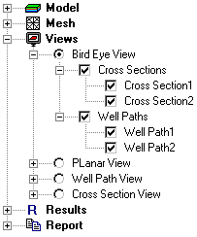
Figure 7.15 –Expanded Bire Eye view tree.

Views / Bird Eye View
Bird Eye views represent a three-dimensional point of view and distance from the model. Compare this to a camera on a tripod taking a picture of a scene.

For an example of the tree of a Bird Eye see Figure 7.1.

In the Bird Eye view branch all the possible items which can be shown in the Bird Eye view (e.g. horizons) can be switched on and off using check boxes in the Model branch. If the user has defined cross-sections and/or well paths, they can also be switched on and shown in the view. It is also possible to switch on or of a complete category of items (e.g. all horizons).

The result attribute is mapped onto the Geology/Model object, cross section or well path according to a colour scale. This object can be viewed either solid filled or wire frame. For example, the user has selected the Bird Eye view thereby activating it. The contents of the Bird Eye are displayed. The user now switches on Horizon1. The OpenGL view will show the Bird Eye contents and Horizon 1 in its triangulated form.

A Bird Eye has the following action menu:

- Attributes

- Change to Default

Attributes
This menu option allows the user to view the attributes of the Bird Eye. Here it will be possible to set the vertical magnification factor.

Change to Default
This menu option allows the user to set the view to a default view direction in a dialog box.

Views / Planar View
Planar View represent a two dimensional view of either a horizon or fault. A well path, if defined, can also be visualised in the Planar View.

In the Model branch all the possible items (horizons, faults) can be switched on and off using radio buttons. If the user has defined well paths, they can also be switched on and shown in the view. It is also possible to switch on or off all the defined well paths.

The result attribute is mapped onto the horizon or fault according to a colour scale. This scale can be solid fill or wire frame. Figure 7.2 shows the expanded tree for the Planar View.

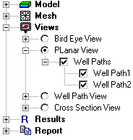
Figure 7.16 –Expanded tree for the Planar View.

Views / Well Path View
The Well Path View represents a one-dimensional view of a well path defined by the user. The user can switch between well paths by the use of radio buttons.

The result attribute is mapped as a graph along the well path. The user can zoom in by dragging a box across the graph. Figure 7.3 shows the expanded tree for the Well Path View.

This sub-branch has the following action items:

- Add Well Path

- Remove all

Add Well Path
This action item allows the user to add a well path to view.

Remove all
This action item allows the user to remove all previously defined well paths.

Views / Well Path View / Well Path
Each well path has the following action menu:

- Run DStabor

- Remove

- Attributes

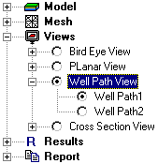
Figure 7.17 –Expanded tree for the Well Path View.

Run DStabor
This menu option allows the user to start a DStabor analysis for the defined well path. It is also possible to start DStabor from the Analysis menu. It will be possible to automatically detect DFE for mudweights from a .mwr file.

Remove
This action item allows the user to remove a well path from the tree. Pressing the ‘delete’ key will also remove the well path.

Attributes
This menu option allows the user to view the attributes of the well path. The derrick floor elevation can be changed here for instance.

Views / Cross Section View
The Cross Section View represents a two dimensional view of a cross section defined by the user. This can be done either graphically or numerically. The user can switch between cross sections by the use of radio buttons.

The result attribute is mapped onto the cross-section according to a colour scale. This scale can be solid fill or wire frame. Figure 7.4 shows the expanded tree for the Cross Section View.

This sub-branch has the following action items:

- Add Cross Section

- Remove all

Add Cross Section
This action item allows the user to define a new cross section to view.

Remove all
This action item allows the user to remove all previously defined cross sections.

Views / Cross Section View / Cross Section

Each cross section has the following action menu:

- Run Geomec 2D

- Attributes

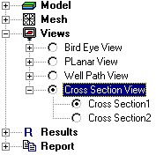
Figure 7.18 –Expanded tree for the Cross Section View.

Run Geomec 2D
This menu option allows the user to start the 2D version of Geomec with the defined cross section, if the cross section is a vertical cross section. It is also possible to start Geomec 2D from the analysis menu.

Attributes
This menu option allows the user to view the attributes of the cross section. Here it will be possible to set the vertical magnification factor.

Results
Results can be assigned to the active view. The result sub-branches are:

- Result type

- Depletion stage

- Linear/Non Linear

- Colour Gradient (Global/Local)/Hot Spot

If a result is not yet available, the plain model is shown. If the result is available the result is displayed using the Colour Gradient or Hot Spot. In Figure 8.1 the Result branch is shown. In the menu bar under item ‘File’, option ‘Export’, it will be possible to export results to a point set file. (see Chapter 10.)

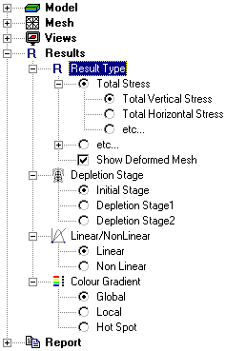
Figure 8.19 –Expanded tree for the Results branch.

Results / Result type
All the result types are presented in a list in this sub-branch. A result type can be switched on here by the use of radio buttons. If a result type can not be shown in a view the result type will be greyed out. One result type can be switched on using a checkbox, this is the ability to switch on and off the deformed mesh in the view. If the ‘Show Deformed Mesh’ checkbox is checked, the results are shown in the deformed model.

The following result types will be available in Geomec:

(note: The bold names represent a sub-branch in the Results branch)

Plain model
Total Stress
Total vertical stress, Sv
Total max. horizontal stress, SH
Total min. horizontal stress, Sh
Change in total vertical stress, dSv
Change in total max. horizontal stress, dSH
Change in total min. horizontal stress, dSh
Effective Stress
Effective vertical stress, Sev
Effective max. horizontal stress, SeH
Effective min. horizontal stress, She
Change in effective vertical stress, dSev
Change in effective max. horizontal stress, dSeH
Change in effective min. horizontal stress, dSeh
Shear Stress
Shear stresses, Svh
Shear stresses, ShH
Shear stresses, SvH
Change in shear stresses, dSvh
Change in shear stresses, dShH
Change in shear stresses, dSvH
Shear capacity
Total Principal Stress
Total max. principal stress
Total interm. principal stress
Total min. principal stress
Change in total max. principal stress
Change in total interm. principal stress
Change in total min. principal stress
Effective Principal Stress
Effective max. principal stress
Effective interm. principal stress
Effective min. principal stress
Change in effective max. principal stress
Change in effective interm. principal stress
Change in effective min. principal stress
Pore Pressure
Stress in Fault
Shear stress in fault
Normal stress in fault
Change in shear stress in fault
Change in normal stress in fault
Shear capacity in fault
Slip in Fault
Gamma
Gamma v
Gamma h
Gamma H
Gamma max. principal stress
Gamma interm. principal stress
Gamma min. principal stress
Compaction Strain
Vertical compaction strain
Max. horizontal compaction strain
Min. horizontal compaction strain
Max. principal compaction strain
Interm. principal compaction strain
Min. principal compaction strain
Volumetric compaction strain
Plastic Strain Invariants
Plastic strain invariant 1
Plastic strain invariant 2
Subsidence
Horizontal displacements
Depth

Results / Depletion Stage
All the depletion stages are presented in a list in this sub-branch. Depletion stages are numbered, with the exception of the initial stage, which is called Initial. The appropriate depletion stage can be switched on by the use of radio buttons.

Results / (Linear / Non Linear)
In this branch the appropriate analysis type can be switched on by the use of radio buttons.

Results / Colour Gradient
In this branch the appropriate colour gradient to use in the result can be switched on by the use of radio buttons. The user can choose between a Global colour scale, a Local colour scale or a Hot Spot.

Results / Colour Gradient / Global
This option allows the user to select the global colour gradient for the result type. The global colour gradient has one action item:

- Attributes

Attributes
This action item opens a dialog box showing the attributes for the global colour gradient (Figure 8.2).

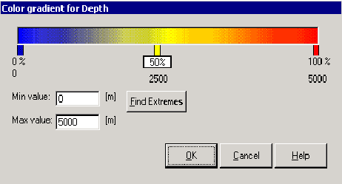
Figure 8.20 –Global Colour Gradient for depth.
The global colour gradient within a result is global for that result and is never relative to the maximum and minimum of the result. The user must define representative values for each colour gradient.

By default a gradient from 0 to 100 percent is available with a single value at 50%. The maximum and minimum valued can be modified by the user, or looked up within the result using the Find Extremes button. Result values outside the maximum and minimum are mapped to their respective maximum and minimum colours. The extremes can not be removed, so at least two colours are defined. The scaling of colours along the gradient is linear within an interval.

Results / Colour Gradient / Local
This option allows the user to select the local Colour Gradient for the result type. The local colour gradient has one action item:

- Attributes

Attributes
This action item opens a dialog box showing the attributes for the local colour gradient (Figure 8.3).
Local colour gradients represent generic colour gradients and are always linked to the maximum and minimum values of the result type to which they are attached in a view. Local colour gradients are meaningless outside a view and without a result. No maximum and minimum values can be assigned to them. As with global colour gradients two or more colours can be assigned.

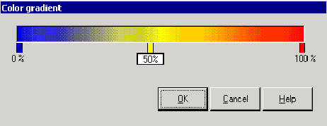
Figure 8.21 –Local Colour Gradient.

Results / Colour Gradient / Hot Spot
This menu option allows the user to select the Hot Spot colour gradient for the result type. The Hot Spot has one action item:

- Attributes

Attributes
This action item opens a dialog box showing the attributes for the Hot Spot (Figure 8.4).
The hot spot within a result is global for that result and is never relative to the maximum and minimum of the result. Hot Spots are partially transparent. Either the range within the values or the range left of the minimum value is transparent. This can not be modified. The colours assigned to the values can be changed.

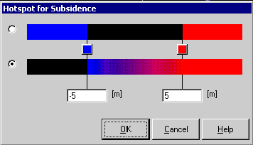
Figure 8.22 –Hot Spot for subsidence.

Reports
This main branch can contain one or more reports. Each report contains text, views and model objects (see Figure 9.1.) Views and model objects can be dragged to the reports branch and dropped there. Modifying the views or the items at their respective branches or sub-branches in the tree modifies the report. Reports are exported as MS-WORD files. There are two types of reports.

Sectioned Reports
Sectioned reports group each item placed in the report by category. For example, all horizons that the user adds to the reports are grouped together in a section. The user can change the order of sections. The order of items within a section can also be moved. Items in a section can not be moved to other sections.

When exported to MS-WORD, Sectioned reports receive a ‘Heading 1’ style for each section in the report and each item receives a ‘Heading 2’ style for its name.

Free Form Reports
Free Form Reports have no section structure at all. The user is free to move the report items within the report.

When exported to MS-WORD free form reports get the ‘Heading 1’ style for the name of each item.

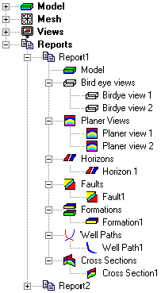
Figure 9.23 –Expanded tree for Reports.

Menu

File
This menu will contain an ‘Import’ option that will make it possible to import a complete GoCAD model, an Eclipse model, DIANA files and old Geomec 2.* models. (Alternatively it will be possible to ‘drag’ the model file(s) onto the ‘Model’ branch in the model tree).
An ‘Export’ option will also be available. It will be possible to export a horizon model to a GoCAD model and an eclipse model, a GoCAD to an eclipse model and an eclipse to a horizon model.
The ‘Export’ option can also be used to export results to a point set file. The user will have to select the results that have to be exported and a point set file.

The ‘File’ menu also holds the model attributes. In these attributes various variables can set that influence the whole model. For instance the possibility to switch off the water column influence if horizons above 0 m are present.

Edit
Standard edit options like Copy, Paste, Delete etc.

View
Standard view options like Toolbars, Statusbar etc. Other view options include Model tree, Data Storage tree, legend etc.

Analysis
This menu allows the user to set the analysis mode (linear/non linear) and to choose the analysis he wants to perform. It will be possible to start a DStabor or Geomec 2D analysis from this menu.

In addition this menu contains an option that allows the user to check which analyses he can run, and reports on missing information or data for each of the three types of analyses.

Action
This menu option contains the action menu of the current selected leaf/branch in the tree. For action menus see the chapters referring to the tree.

Tools
Standard Tool options like Options.

Help

Analysis Types / Modes
An analysis is a calculation performed on the model based on specific model information and expected results.

The following analyses can be performed:

- Depletion

- Initial Stress Pre-processing

- Inverse

There are two analysis modes, linear and non-linear. The analysis mode is set in the Analysis Menu.

Depletion
To perform a depletion analysis, pressure changes at multiple time steps are prescribed and displacements, stresses and strains are calculated for the whole model for these time steps. Assigning a pore pressure distribution for the initial situation and all subsequent time steps for the given formation specifies the pressure changes. The pore pressure change is determined by calculating the difference between the pore pressure distribution of two subsequent time steps. Either a linear calculation or a non-linear calculation can perform a depletion analysis. If a non-linear calculation is performed the pressure change is applied in small steps and for each step the non-linear solution is found in an iterative way.
The boundary conditions for a depletion analysis are always such that for the bottom and four sides of the model only in-plane displacements are allowed. The top of the model is left free.

Initial stress pre-processing
The finite element mesh for an initial stress pre-processing analysis is constructed in the same manner as for a depletion analysis. The loads and boundary conditions, however, are not necessarily the same. The initial pore pressures can be defined like in a depletion analysis but this is not necessary. For instance, the pore pressures can remain the same for all time steps. The boundary conditions for the sides of the model can be described for each time step. The boundary conditions that can be described are either displacements or stresses. If the described boundary condition for a certain plane in the side of the model is a stress, the plane is free to move in any direction. For each time step the stresses for the whole model are calculated. (the applied loads and boundary conditions still need some more discussion before a good design can be made)
This analysis type simulates the resulting displacements and stresses in the earth’s crust as a result from the movements in the crust on a geological time scale. The stresses calculated in an initial stress pre-processing analysis are used as input for initial stresses in a depletion analysis. The finite element model used in an initial stress pre-processing analysis will in general cover a larger area than the model used in the depletion analysis.
Like in a depletion analysis the initial pre-processing analysis can be performed either linear or non-linear.

Inverse
An inverse analysis has the same boundary conditions as a depletion analysis; the bottom and four sides of the model only allow in-plane movement, the top of the model is left free. When performing an inverse analysis only linear material models are taken into account; non-linear material models are not taken into account. An inverse analysis needs a measured displacement field describing the subsidence for the top surface as input. There are two types of inverse analysis:

- Pore pressure inverse analysis

- Young’s modulus inverse analysis

Both analysis types need one formation that contains a reservoir.

Pore pressure inverse analysis
For the pore pressure inverse analysis the Young’s modulus has to be defined for all formations and the distribution of the pore pressure change is calculated. The horizontal domain of the depleting formation is divided into zones. For each zone the calculated change in pore pressure has to be constant. A linear calculation is performed with as many load vectors as there are zones. For each load vector the pore pressure change equals one in one zone and zero in all the other zones. The subsidence at the top surface is calculated for each load vector. In an optimisation routine calculating the best linear combination of all the separate subsidence profile composes the measured subsidence profile. When the factors of the linear combination are applied onto the corresponding unit pore pressure changes in the zone, the best fitting pore pressure change is acquired. This pore pressure change can subsequently be used in a depletion analysis.

Young’s modulus inverse analysis
For the Young’s modulus inverse analysis the pore pressure change is defined for the formation with the reservoir and the Young’s modulus distribution is calculated. The horizontal domain of the depleting formation is divided into zones. For each zone the calculated Young’s modulus has to be constant. A linear calculation is performed with as many load vectors as there are zones. (specification follows)

Approval
Ir. M.H. Tolman (author)

Ir. A.H.D. Willemse (author)

Dr. ir. G. Schreppers (author)

Ir. B. van Luipen (approval)

S. Rijkers (approval)

Ing. G.M. van Hilst (approval)

            - List of Definitions
Body
An enclosed volume, used to construct formations. Only a formation in a GoCAD model can consist of multiple bodies.

Boundary
Describes the edges of the model. Default the size of the boundary is such that that the boundary is the smallest enclosing box that contains all points in the model.

Check buttons
A white square that can be clicked by the user, thereby selecting an item. If multiple check buttons are grouped, checking one button does not influence the state of the other check buttons (checked or unchecked.) Check buttons are used when the items that can be selected, can be selected at the same time.

Depletion analysis
This is a finite element analysis using pore pressure changes as driving force and giving displacements, strains and stresses as results.

Formation
An enclosed volume, built up from one or more bodies. This is the virtual version of a real geological formation.

Global material library
A default material library.

Global pressure gradient
Gradient used to calculate the pore pressure when no other definition for the pore pressure (e.g. a point set) is available.

Global stress gradient
Gradient used to calculate the in situ stress situation when no other definition for the stress situation (e.g. a pointset) is available.

Homogenisation
Averaging of parameters (e.g. material parameters) in order to create continuous values for those parameters.

Horizon
A surface defining the boundary between two different formations.

Horizons
More than one horizon. A multiple of horizons define the formations in a model.

Hot spot
A colour gradient that can be selected for result type. It is used to give results above (or below) a certain value one colour.

Initial pressure
The pore pressure before any depletion from the reservoir has taken place.

Initial stress preprocessing
This is a finite element analysis using stresses and strains at the outer edges of the model as input and giving displacements and stresses as output. Calculated stresses are used as input for a following depletion analysis.

Initial stresses
The in situ stress situation before any depletion from the reservoir has taken place.

Inverse analysis
This is a finite element analysis using the subsidence at ground-surface as input and giving either a pore pressure distribution in the reservoir or a stiffness-distribution in the reservoir as result.

Linear analysis
In this analysis a linear relation is assumed between input and output. Material failure such as pore-collapse, fault-slipping and creep are nonlinear aspects and are not considered in a linear analysis.

Local material library
Material library defined by the user.

Nonlinear analysis
In this analysis nonlinear aspects such as pore-collapse, fault-slipping and creep are taken into account. Usally in a nonlinear analysis the load is applied in several load-increments and in every load increment an iterative search is performed to find the equilibrium situation.

Point set
A set of values describing a property (e.g. material property or stress tensor), each value is assigned to a co-ordinate (either 2D or 3D). A point set is used to describe distributed properties if these are known.

Point sets
More than one point set.

Radio buttons
A white circle that can be checked by the user, thereby selecting an item. If multiple radio buttons are grouped, checking one radio button will uncheck a possible previously checked radio button. Radio buttons are used when the items that can be selected can never be selected at the same time.

Region
A small area in which it is possible to refine or coarsen the mesh.

Regions
More than one region. Where regions overlap the mesh will be refined as fine as the region with the finest mesh.

Reservoir
The formation in which the pore pressure is depleted during a depletion stage.

Surface
Used to construct horizons and/or faults.

Surfaces
More than one surface. In a GoCAD model horizons can be constructed from more than one surface.

            - Header File Definition

Geomec will at least accept the following definition.

COMMON AGREEMENT

“Quantities are optionally expressed per scenario <n> (e.g. load steps, time steps)”
n is an integer: n >= 0

Conventions:
- Left-handed Cartesian co-ordinates.
- Compression is negative, contraction is negative for rocks.

Initial co-ordinates
X<_n>
Y<_n>
Z<_n>

Total displacement relative to initial state
Displacementx<_n>
Displacementy<_n>
Displacementz<_n>

Total stress tensor expressed in Cartesian co-ordinates
Stressxx<_n>
Stressyy<_n>
Stresszz<_n>
Stressxy<_n>
Stressyz<_n>
Stressxz<_n>

Total stress tensor expressed in local co-ordinates
Stressh<_n>
StressH<_n>
Stressv<_n>
AzimuthStressH<_n>

Pore pressure
Pressure<_n>

Total strain tensor expressed in Cartesian co-ordinates
Strainxx<_n>
Strainyy<_n>
Strainzz<_n>
Strainxy<_n>
Strainyz<_n>
Strainxz<_n>

Principle stresses expressed in order of smallest first
Pstress1<_n>
Pstress2<_n>
Pstress3<_n>

Principle strains expressed in order of smallest first
Pstrain1<_n>
Pstrain2<_n>
Pstrain3<_n>

For faults

FrictionCoefficient<_n>
Cohesion<_n>

Material Properties
YoungsModulus<_n>
PoissonsRatio<_n>
Cohesion<_n>
FrictionAngle<_n>
Porosity<_n>
BulkDensity<_n>
CompressionalVelocity<_n>
ShearVelocity<_n>
VerticalPermeability<_n>
HorizontalPermeability<_n>

All properties have unit dimension.

For a discussion of elements and how they relate to volumetric meshes see chapter 6.4.

