Geomec results from DIANA primary output - Theory

Author: O. Gastebled
Date: 05/06/02

Project: Geomec 3
Recipients: B. Luipen
D. Willemse
DIANA results on filos:

Path | Notation
/RESULTS/LINSTA/STEP(1)/ELEMEN()/POINT()/SIG(1) | 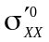
/RESULTS/LINSTA/STEP(1)/ELEMEN()/POINT()/SIG(2) | 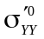
/RESULTS/LINSTA/STEP(1)/ELEMEN()/POINT()/SIG(3) | 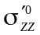
/RESULTS/LINSTA/STEP(1)/ELEMEN()/POINT()/SIG(4) | 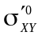
/RESULTS/LINSTA/STEP(1)/ELEMEN()/POINT()/SIG(5) | 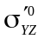
/RESULTS/LINSTA/STEP(1)/ELEMEN()/POINT()/SIG(6) | 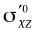
/RESULTS/LINSTA/STEP(1)/ELEMEN()/POINT()/PRESSU | 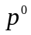
/RESULTS/LINSTA/STEP(i)/ELEMEN()/POINT()/SIG(1) | 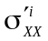
/RESULTS/LINSTA/STEP(i)/ELEMEN()/POINT()/SIG(2) | 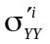
/RESULTS/LINSTA/STEP(i)/ELEMEN()/POINT()/SIG(3) | 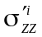
/RESULTS/LINSTA/STEP(i)/ELEMEN()/POINT()/SIG(4) | 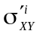
/RESULTS/LINSTA/STEP(i)/ELEMEN()/POINT()/SIG(5) | 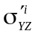
/RESULTS/LINSTA/STEP(i)/ELEMEN()/POINT()/SIG(6) | 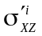
/RESULTS/LINSTA/STEP(i)/ELEMEN()/POINT()/PRESSU | 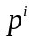
/RESULTS/LINSTA/STEP(i)/ELEMEN()/POINT()/EPS(1) | 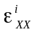
/RESULTS/LINSTA/STEP(i)/ELEMEN()/POINT()/EPS(2) | 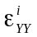
/RESULTS/LINSTA/STEP(i)/ELEMEN()/POINT()/EPS(3) | 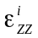
/RESULTS/LINSTA/STEP(i)/ELEMEN()/POINT()/EPS(4) | 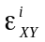
/RESULTS/LINSTA/STEP(i)/ELEMEN()/POINT()/EPS(5) | 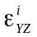
/RESULTS/LINSTA/STEP(i)/ELEMEN()/POINT()/EPS(6) | 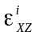
/RESULTS/LINSTA/STEP(i)/ELEMEN()/POINT()/EPSP(1) | 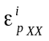
/RESULTS/LINSTA/STEP(i)/ELEMEN()/POINT()/EPSP(2) | 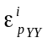
/RESULTS/LINSTA/STEP(i)/ELEMEN()/POINT()/EPSP(3) | 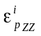
/RESULTS/LINSTA/STEP(i)/ELEMEN()/POINT()/EPSP(4) | 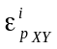
/RESULTS/LINSTA/STEP(i)/ELEMEN()/POINT()/EPSP(5) | 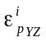
/RESULTS/LINSTA/STEP(i)/ELEMEN()/POINT()/EPSP(6) | 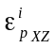
cohesion
friction angle

Geomec results:

Name | initial  situation | depletion  stage | Notation
Total vertical stress | X | X | 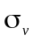
Total max. horizontal stress | X | X | 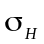
Total min. horizontal stress | X | X | 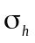
Change in total vertical stress |  | X | 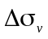
Change in total max. horizontal stress |  | X | 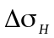
Change in total min. horizontal stress |  | X | 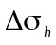
Effective vertical stress | X | X | 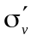
Effective max. horizontal stress | X | X | 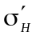
Effective min. horizontal stress | X | X | 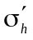
Change in effective vertical stress |  | X | 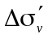
Change in effective max. horizontal stress |  | X | 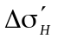
Change in effective min. horizontal stress |  | X | 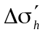
Shear stress Hv | X | X | 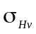
Shear stress hv | X | X | 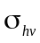
Change in shear stress Hv |  | X | 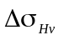
Change in shear stress hv |  | X | 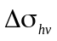
Shear capacity | X | X | 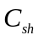
Total max. principal stress | X | X | 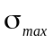
Total interm. principal stress | X | X | 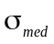
Total min. principal stress | X | X | 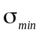
Change in total max. principal stress |  | X | 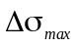
Change in total interm. principal stress |  | X | 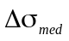
Change in total min. principal stress |  | X | 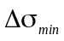
Effective max. principal stress | X | X | 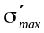
Effective interm. principal stress | X | X | 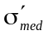
Effective min. principal stress | X | X | 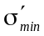
Change in effective max. principal stress |  | X | 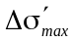
Change in effective interm. principal stress |  | X | 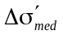
Change in effective min. principal stress |  | X | 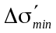
Pore pressure | X | X | 

Name | initial  situation | depletion  stage | Notation
Gamma vertical |  | X | 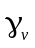
Gamma max. horizontal |  | X | 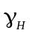
Gamma min horizontal |  | X | 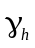
Gamma max. principal stress |  | X | 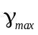
Gamma interm. principal stress |  | X | 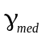
Gamma min. principal stress |  | X | 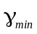
Vertical compaction strain |  | X | 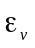
Max. horizontal compaction strain |  | X | 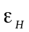
Min. horizontal compaction strain |  | X | 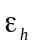
Max. principal compaction strain |  | X | 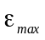
Interm. principal compaction strain |  | X | 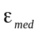
Min. principal compaction strain |  | X | 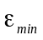
Volumetric compaction strain |  | X | 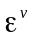
Plastic strain invariant 1 |  | X | 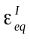
Plastic strain invariant 2 |  | X | 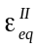
Subsidience |  | X | 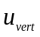
Horizontal displacement |  | X | 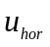

Relationships

For initial situation and depletion stages (then replace superscript 0 by i):

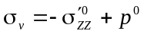
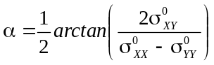
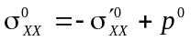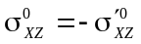
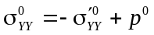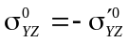
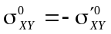

ordering:
(H, h) permutation if σ_{H} < σ_{h}

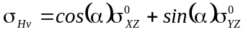

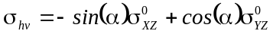

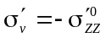

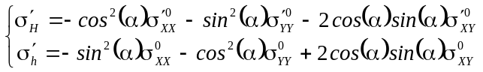 or from total stresses: 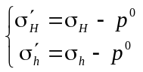

Using function GetEigenValues() on tensor 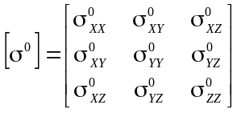 results in:
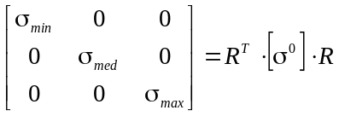 or from effect. stresses: 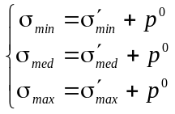
Using function GetEigenValues() on tensor 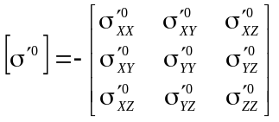 results in:
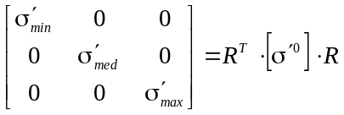 or from total stresses: 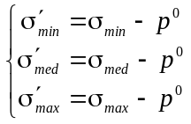

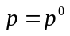
invariants of effective stresses:
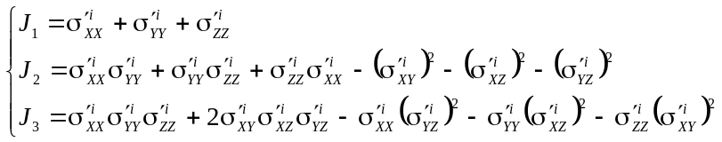

invariants of effective deviatoric stresses:
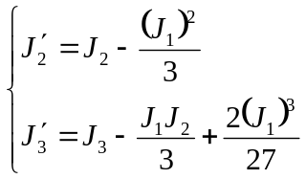

mean stress, equivalent shear stress and Lode angle:
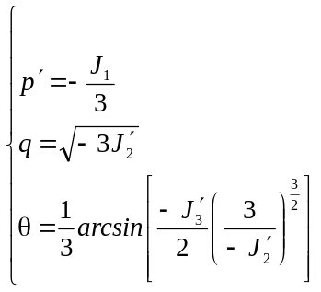

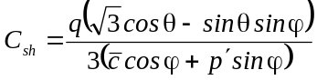

For depletion stages:

For all stress changes: 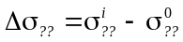

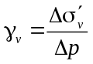

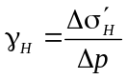

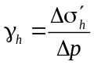

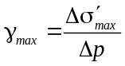

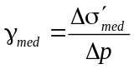

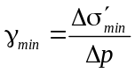

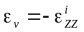

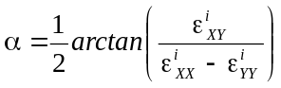

ordering:
(H, h) permutation if ε_{H} < ε_{h}

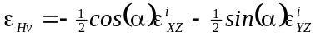

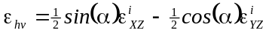

Using function GetEigenValues() on tensor 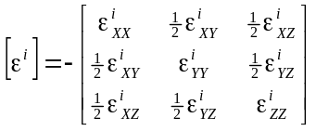 results in:
