Restricted to Shell Personnel Only
This document is classified as Restricted to Shell Personnel Only. 'Shell Personnel' includes all staff with a personal contract with the Shell Group of Companies, designated Associate Companies and Contractors working on Shell projects who have signed a confidentiality agreement with a Shell Group Company. Issuance of this document is restricted to staff employed by the Shell Group of Companies. Neither the whole nor any part of this document may be disclosed to Non-Shell Personnel without the prior written consent of the copyright owners.
Copyright 2001 SIEP B.V.
SHELL TECHNOLOGY EP, RIJSWIJK
Further copies can be obtained from the Global EP Library, Rijswijk

Table of contents
1. Introduction 3
1.1. Terminology and notation 3
2. Well path construction 4
2.1. Introduction 4
2.2. Basis vectors 4
2.3. Along-hole-depth, inclination and azimuth 5
2.4. Well bore direction vector 5
2.5. Minimum curvature method 6
2.6. Curvature vector 8
2.7. Interpolation of well path properties 9
2.7.1. Direction vector 10
2.7.2. Azimuth and inclination 11
2.7.3. Position vector 11
2.7.4. North, east and true vertical co-ordinates 11
2.8. Co-rotational triad 11
2.9. Interconnecting geological targets with arc segments 12
APPENDIX A. List of symbols 14
A.1. Latin symbols 14
A.2. Greek symbols 14
A.3. Vector operators 15
APPENDIX B. Alternative expressions for minimum curvature method 16
B.1. Introduction 16
B.2. Auxiliary variables and vectors 17
B.3 Arc segment end point calculation 19
B.4 Interpolation on survey interval 20
APPENDIX C. Taylor series expansions of minimum curvature relations for small dog-leg severities 21
APPENDIX D. Linearisations of minimum curvature relations 22
APPENDIX E. Finite rotation transformations of vectors 24
E.1. Introduction 24
E.2. Rotation of vectors 24
E.3. Rotation vector calculation 25
E.4. Rotation of triads of vectors 25

Introduction

Terminology and notation
In this report the following terminology will be used:
Well trajectory : The (calculated) 3D-path of a well through the subsurface.
Survey station : A point along the well trajectory at, which the along-hole depth Ahd, inclination I and azimuth A are known (either inputted, calculated or measured).
Survey section : The 3-D path between two subsequent survey stations.
Directional data set : The series of measured or planned values for the along-hole depth, inclination and azimuth of the subsequent survey stations along the well.
Vector : A physical quantity, which has both a magnitude and a direction (see Section 2.2).
Direction vector : The local tangent vector to the 3-D well trajectory, which has a unit length. Specifying the direction vector depends is equivalent to specifying the values for the local inclination and azimuth (see Section 2.4).
Curvature vector : A vector that specifies the local change of the direction vector per unit of along-hole length (see section 2.6).
Minimum curvature method : Method for constructing the 3D-well trajectory, whereby the survey sections are represented by circular arcs, while the tangent vector to the 3D-well trajectory is continuous over the survey stations (see Section 2.5).
In this report the following notation will be used:
scalars : lower or upper case, normal face, e.g. Ahd, I, γ,
vectors : lower case, bold face, e.g. a,
2nd order tensors : upper case, bold face. E.g. B.
Physical quantities, that represent angles, rotations or rotation vectors are represented by Greek symbols. Note that for these properties the physical unit / dimension of radians is used rather than degrees.
Subscripts like i, i+1 to physical quantities e.g. A_{i}, I_{i+1} are used to refer to the survey station numbers. The subscripts i are therefore not used to denote vector or tensor components, unless explicitly stated in the accompanying text. So called dyadic or Gibbs notation is used for describing vector and tensor operations. The reader is referred to the standard text book Error: Reference source not found] and a summary is given in APPENDIX A.
Curly brackets { } are used to refer to equation numbers, whereas straight brackets [ ] are used to refer to literature references.

Well path construction

Introduction
In well engineering the 3-D well path is constructed from directional data and/or by connecting geological targets. In this chapter a surveying framework is given that uses abstract vector notation. For convenience, in APPENDIX B the minimum curvature relations are also expressed in a more conventional way, which relies less on the abstract notation of vector and tensors. The current framework is sufficient for the development for a tortuosity simulation functionality. It is not intended to cover a complete set of possible surveying/directional needs, nor to supersede Shell’s standards in well engineering and bore hole surveying Error: Reference source not found]. Furthermore, the current framework allows for a future extension with of a tortuosity analysis tool dependent on project demand.

Basis vectors
In Figure 2.1 the set of natural Cartesian basis vectors e_{x}, e_{y}, e_{z} is shown, which is fixed to the earth. The drilling community generally uses North, East, Vertical co-ordinate system which uses the orthonormal vectors n, e, v for an earth fixed basis. The driller’s basis vectors are expressed in terms of the Cartesian basis vectors as:
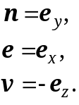 {2.1}
The derivation of expressions and equations will be as much as possible in terms of abstract vectors and tensors, which are independent of the choice for a vector basis.
Note: A vector represents a physical quantity having both a magnitude and a direction. A vector is independent of the particular choice for the basis vectors. For example, earth gravitation may be represented by a vector g with an absolute magnitude of 9.81 m/s² and which points (approximately) to the mass center of the earth. Only when evaluating the components of vectors, a dependency on the particular choice for the basis vectors occurs. When expressing g with respect to the e_{x} e_{y}, e_{z}-vector basis, then the third components becomes g.e_{z} = –9.81 m/s², meaning that g is directed in opposite direction to e_{z}. When expressing g with respect to the n, e, v–vector basis, then the third components becomes g.v = +9.81 m/s², meaning that g is directed in same direction as v. It is noted, that in the code of the computer implementation all vector components are expressed with respect to the Cartesian basis vectors.

Along-hole-depth, inclination and azimuth
The directional data consist of sets of Along-Hole Depth (AHD), Inclination (I) and Azimuth (A) values along the well. These quantities have been illustrated in Figure 2.1. The along-hole depth, which is also often called the Measured Depth (MD), corresponds to the distance measured along the well path from the surface reference point to the survey point under consideration. For drilling operations generally, the derrick floor is used as the reference for the AHD. The inclination and azimuth angles define the unit direction vector u of the 3-D well path at a certain along-hole position. The inclination I is defined as the angle between the Vertical Depth direction (negative z-axis) and the local direction u. The azimuth A is defined as the angle between the North direction and the local direction u, while rotating about the v-axis towards the East direction. The shaded plane in Figure 2.1 denotes the vertical plane in the azimuthal direction A.
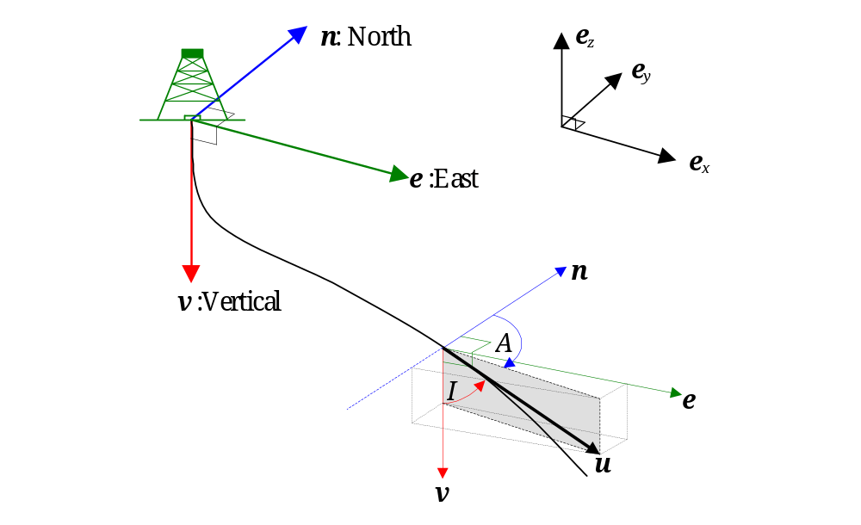
Figure 2.1: The direction vector u at a certain along-hole-depth of the well path. The inclination is defined as the angle between u and the vertical direction. The azimuth is defined as the angle between u and the north direction while rotating towards the east.

Well bore direction vector
The azimuth A and inclination I at an along-hole position determine the local direction/tangent vector u to the well path as shown in Figure 2.1. The physical meaning of the direction vector u is absolute and is independent of the choice for a vector basis. However, the components of u do depend on which set of basis vectors is used.
With respect to the driller’s n, e, v basis vectors, as defined in Figure 2.1, the local direction vector u to the well path is given by:
{2.2}
With respect to the general Cartesian basis vectors e_{x}, e_{y}, e_{z}, as defined in Figure 2.1, the local direction vector u of the well path is given by:
{2.3}

Minimum curvature method
The minimum curvature method is the standard/prescribed method within the Shell Group to determine the 3-D well path from a directional data set Error: Reference source not found]. The method interconnects the survey stations using arc segments as shown in Figure 2.2. Each of the consecutive arc segments is embedded in it’s own plane. Such a plane may be tilted relative to the plane of a previous arc segment.
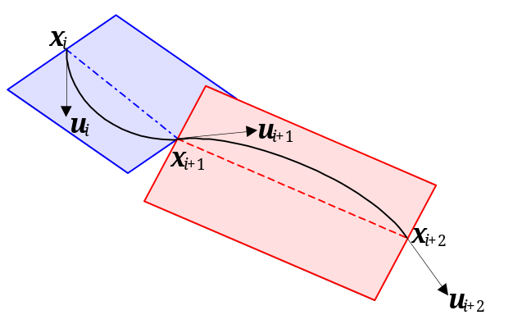
Figure 2.2: In the minimum curvature method the well bore path is constructed from consecutive arc segments between the survey stations that have unit direction vectors u_{i} and spational poisitiond x_{i}. The arcs may have different curvatures and may be embedded in different planes.
The interpolated well trajectory consists of consecutive are segments. The interpolated spatial position vector x(Ahd), the unit direction vector u(Ahd) and the curvature vector c(Ahd) as a function of the along-hole depth value Ahd have the has three convenient features:
- The interpolated direction vector u(AHD) at the begin and end points of the consecutive arc segments are consistent with the inclination and azimuth values at the survey stations.
- The interpolated direction vector u(AHD) is continuous over a survey station.
- The total calculated arc length along the interpolated well path is consistent with the along-hole depth values of the survey stations. This last characteristic cannot be achieved with e.g. spline or polynomial interpolations.
The minimum curvature method has a drawback as well. The second order derivative of the 3-D well path with respect to the along-hole co-ordinate, which represents the curvature vector c, is not continuous over a survey station. The consecutive arc segments may have different curvature magnitudes (DLS) and/or may be embedded in different planes, as shown in Figure 2.2.
An analytical procedure is used to calculate the spatial positions of the subsequent survey stations for a given directional data set. Assume, that x_{i} and u_{i} denote the 3-D position and direction vector respectively at survey station i. The spatial position x_{i+1} of the next survey station is calculated with the following algorithm Error: Reference source not found]:
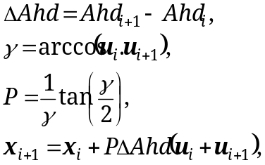 {2.4}
with P a dimensionless factor (see below). The direction vectors u_{i} and u_{i+1} are calculated from the local inclination and azimuth in the survey stations using {2.2} or {2.3}. The above algorithm is used repeatedly, while initializing the first survey station to the position of the slot/derrick floor and proceeding to the last survey station. The various vectors, distances and angles are shown in Figure 2.3.
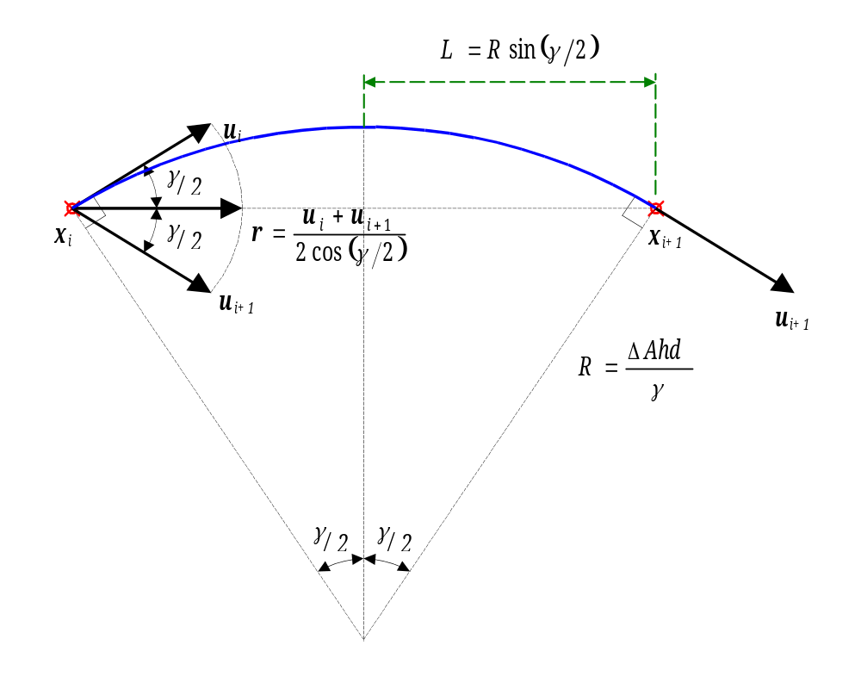
Figure 2.3: Quantities involved in well path evaluation when using the minimum curvature method.
In order to clarify the factor P in equation {2.4} some additional variables and vectors are shown in Figure 2.3. The (unit) direction vector r along which x_{i+1} is located is given by:
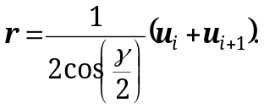 {2.5}
The distance L along this direction vector r is given by:
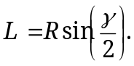 {2.6}
The dog-leg severity DLS and the radius of curvature R of the arc segment are defined by:
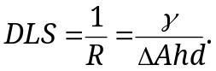 {2.7}

Curvature vector
The local curvature vector c(AHD) of the well path is defined as the derivative of the direction vector, with respect to the along-hole length AHD:
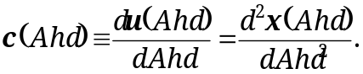 {2.8}
The direction of the curvature vector c is per definition perpendicular to u. This follows simply from the fact that u is a unit vector and therefore:
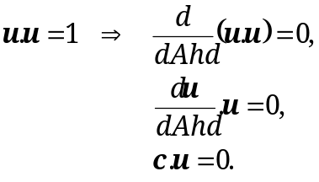 {2.9}
The dog-leg severity (DLS) and the radius of curvature (R) are determined from the curvature vector by:
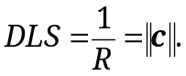 {2.10}
When using the minimum curvature method, the magnitude of the curvature vector along an arc segment of the well path is constant and is equal to the dog-leg severity. The direction of the curvature vector along an arc segment of the well path continuously varies, such that it always points to the spatial center-of-curvature point corresponding to the radius of curvature of the arc segment.
For the minimum curvature method, the curvature vector c_{i} at a survey station i is calculated using the direction vectors u_{i} and u_{i+1} in the same and in the next survey station respectively using:
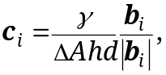 {2.11}
with:
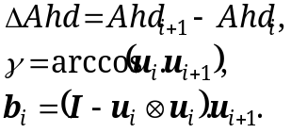 {2.12}
Figure 2.4 shows the vectors involved in the calculation of the curvature vector.
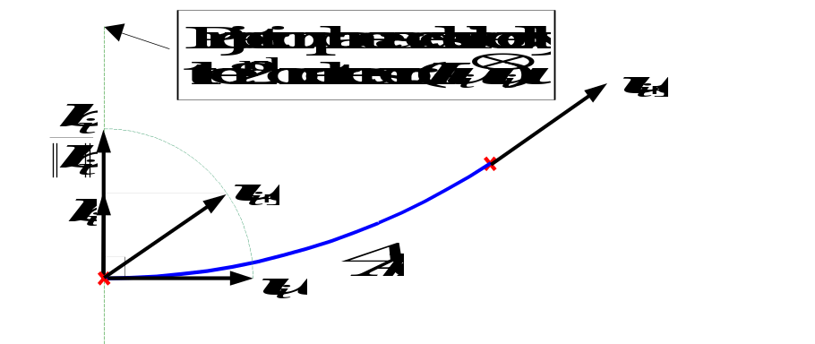
Figure 2.4: Vectors involved in the calculation of the curvature vector at a survey station. In survey station i the non-unit vector b_{i} points in the direction of the center of curvature of the arc segment.
The second order tensor (I - u_{i}⊗u_{i}) physically describes the vectorial projection onto the plane with u_{i} as the normal vector. Therefore, the projection of the vector u_{i+1} results in the vector b_{i} which is perpendicular to u_{i}. As a consequence the vector c_{i} is also perpendicular to the direction vector to u_{i} and has a magnitude equal to the dog-leg severity. It is noted, that the normalized vector b_{i}/||b_{i}|| corresponds to the vector s used in Appendix B.
An alternative expression for the curvature vector c_{i} in survey station i is:
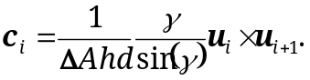 {2.13}

Interpolation of well path properties
When interpolating well path properties in between survey stations for the minimum curvature method one may utilize the fact, that the changes of the direction vector are described by finite rotations. Further details on finite rotation transformations are given in APPENDIX E. Furthermore also alternative (i.e. more conventional) expressions for the interpolation of properties along an arc segment are given in APPENDIX B.
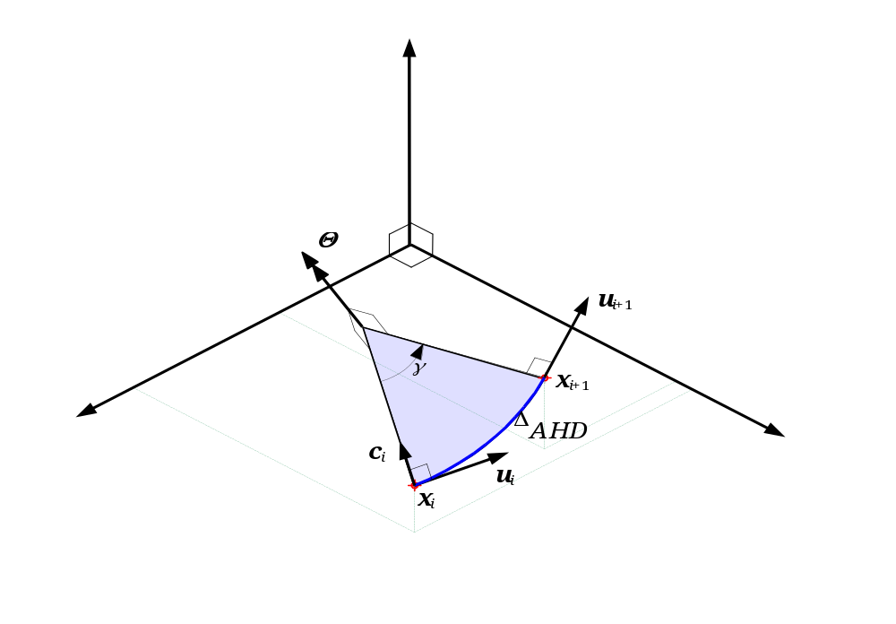
Figure 2.5: Finite rotation vector Θ associated with a survey section with direction vectors u_{i} and u_{i+1} at the begin and end positions x_{i} and x_{i+1}, respectively.
In this section it is assumed that well path properties need to be evaluated at an along-hole depth value Ahd, which is located in between the survey stations with numbers i and i+1. Figure 2.5 shows the finite rotation vector Θ associated with a survey section, which is determined by:
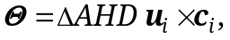 {2.14}
with u_{i} and c_{i} the direction and curvature vectors in survey station i.

Direction vector
The interpolated well path direction vector u(Ahd) at an along-hole depth Ahd is described by the finite rotation vector Φ:
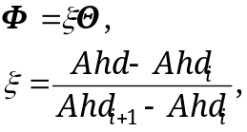 {2.15}
where the finite rotation vector Θ describes the finite rotation of the survey station direction vector u_{i} into u_{i+1}, as given by equation {2.14}. The direction vector u(Ahd) is determined subsequently by rotating u_{i} over 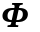 by using equation {E.10.

Azimuth and inclination
The interpolated azimuth A(Ahd) and inclination I(Ahd) at an along-hole depth Ahd are determined from the direction vector u(Ahd) which is interpolated as described in Section 2.7.1. The interpolated azimuth and inclination are determined by the projections:
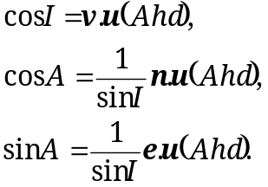 {2.16}
The driller’s co-ordinate directions n, e, v are defined in Section 2.2. When evaluating the azimuth value from the projections special arrangements have to be taken for (near) vertical hole and to guarantee, that the returned value is on the domain: 0 ≤ A ≤ 2π.

Position vector
The interpolated well path position vector x(Ahd) at an along-hole depth Ahd is determined in two steps:
- The direction vector u(Ahd) at that position is interpolated, as described in Section 2.7.1.
- The end point x(Ahd) of the arc segment that starts at position x_{i} is calculated using equation {2.4}, while substituting u(Ahd) for u_{i+1} and substituting Ahd for Ahd_{i+1}.

North, east and true vertical co-ordinates
The north N, east E and true vertical TVD co-ordinates of an interpolated point along the well path are obtained by interpolating the spatial position x(Ahd) as described in Section 2.7.3 and subsequently taking the projections:
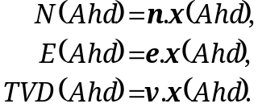 {2.17}
The driller’s co-ordinate directions n, e, v are defined in Section 2.2.

Co-rotational triad
In each survey station i an orthogonal triad u_{i}, v_{i}, w_{i} of vectors can be calculated. The triads in the subsequent survey stations will be used in the tortuosity simulation for calculating small changes of the direction vector. The triad vector u_{i} is consistent with the azimuth and inclination according to equation {2.2} or {2.3}. Figure 2.6 below gives an example of the triads in the subsequent stations. The rotation transformations between the triads in the subsequent survey stations uses a special description which is discussed in Section E.4.
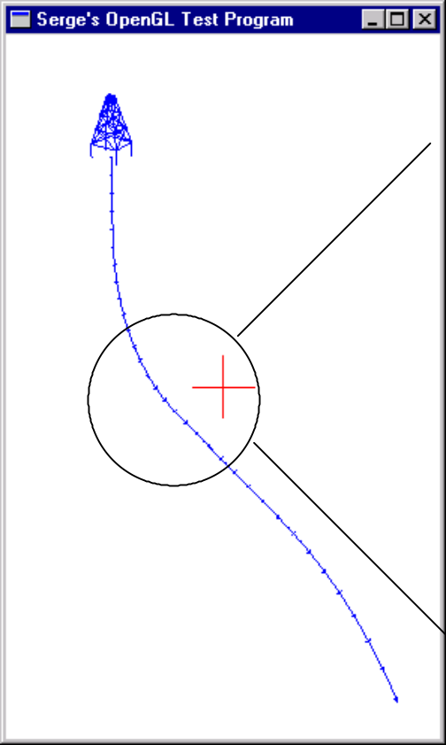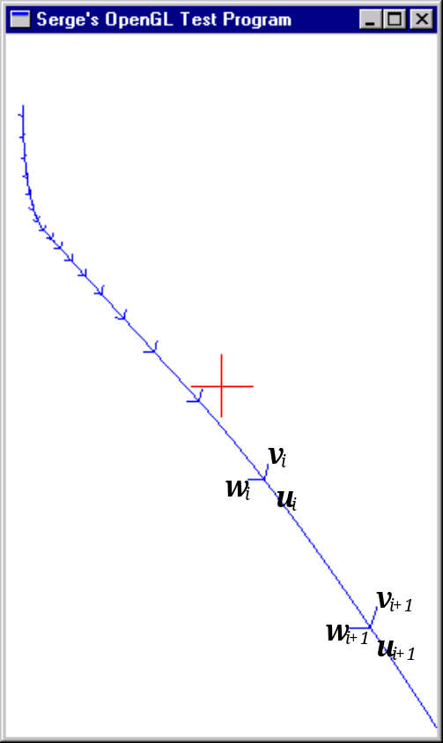
Figure 2.6: In each survey station a triad u, v, w of orthonormal vectors is calculated. The triads in the subsequent survey stations are calculated by finite rotation transformations.
At the surface station the triad vectors u₁, v₁, w₁ are initialized as follows:
- A triad of vectors u₀, v₀, w₀ is initialized to the driller’s coordinate directions (see Section 2.2) as: u₀ = v, v₀ = e, w₀ = -n.
- A finite rotation transformation u₀, v₀, w₀ → u₁, v₁, w₁ is applied to this triad such that the surface vector u₁ becomes consistent with the azimuth and direction at surface.
This second rotation is relevant for the case of a non-vertical top-hole. It is noted, that these co-rotational triad are different from toolface triad. The latter always have the additional requirement that one of the vectors is aligned with the high-side direction.

Interconnecting geological targets with arc segments
The minimum curvature procedure {2.4} can be quite straightforward when used for calculating the spatial well path from an inputted directional data set. The inverse calculation of interconnecting given set of geological targets with consecutive arc segments is slightly different. It can be reduced to the solution of an along-hole depth increment ΔAhd and a tangent vector u_{i+1} at the end of an arc segment. This situation is illustrated in the Figure 2.7. The position of a geological target with “driller’s” northern co-ordinate N, eastern co-ordinate E and true vertical depth TVD is given by:
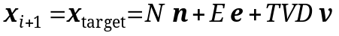 {2.18}
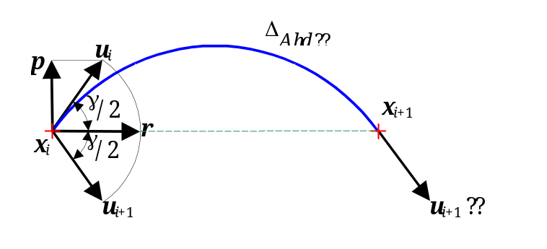
Figure 2.7: When interconnecting subsequent geological targets via the minimum curvature method the along-hole depth increments ΔAhd and the direction vector u_{i+1} at the ends of the consecutive arc segments have to be solved for.
The arc segment departs at a geological position x_{i} at a direction vector u_{i} and terminates at the end position x_{i+1}. The unknown variables in the current problem are ΔAhd and u_{i+1}. The unit vector r that points from x_{i} to x_{i+1} is determined by:
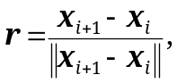 {2.19}
where ║ ║ denotes the length operator on a vector (See Appendix A). Now, the vector p, which is the component of u_{i} that is perpendicular to r, is determined by:
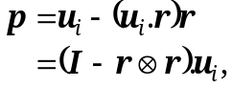 {2.20}
with I the second order unit tensor. The symbol “⊗” denotes the dyadic product operator of the vectors, which yields a second order tensor (See Appendix A). The end-point direction vector u_{i+1} of the arc segment is now given by:
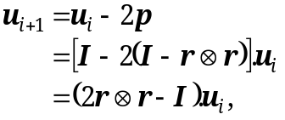 {2.21}
from which the corresponding inclination and azimuth values can be determined via the projections {2.16}. The half of the angle γ enclosed by the arc segment is determined by:
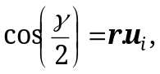 {2.22}
which is used for the calculation of the along-hole depth increment ΔAhd via:
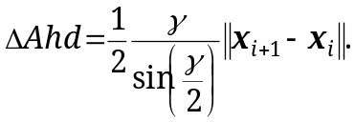 {2.23}

- List of symbols
  - Latin symbols
Symbol Description [unit]
a tortuosity magnitude / amplitude [rad/m]
A Azimuth angle [rad]
Ahd Along-hole depth (or alternatively called Measured Depth) [m]
DLS Dog-Leg Severity [rad/m]
c Curvature vector [rad/m]
e Unit direction vector in Eastern direction [-]
e_{x} Cartesian basis vector (x-axis) [-]
e_{y} Cartesian basis vector (y-axis) [-]
e_{z} Cartesian basis vector (z-axis) [-]
E Eastern co-ordinate of point with respect to driller’s e-basis vector [-]
i Index for referencing survey stations or survey points [-]
I Inclination angle [rad]
I Unit or metric tensor [-]
MD Measured depth (or alternatively called Along-Hole Depth) [m]
n Unit direction vector in Northern direction [-]
N Northern co-ordinate of point with respect to driller’s n-basis vector [-]
P Trigonometric term (Equation {D.7}) [-]
Q Trigonometric term (Equation {D.7}) [-]
R Radius of curvature [m]
Ran( ) Random number, which is uniformly distributed between 0 and 1 [-]
r, s, t Auxiliary unit vectors (used in various contexts) [-]
u Unit direction vector [-]
v Unit direction vector in True Vertical direction [-]
u_{i}, v_{i}, w_{i} Survey station co-rotational triad vectors [-]
TVD True vertical co-ordinate of point with respect to driller’s v-basis vector [-]
x Position vector [m]
  - Greek symbols
Symbol Description [unit]
Δ Finite change of a physical quantity [-]
δ Infinitesimal small change or variation of a physical quantity [-]
γ Enclosed angle between two (unit) direction vectors [rad]
φ₁, φ₂ Angles describing survey station directional variations [rad]
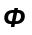 Rotation pseudo-vector [rad]
θ Rotation angle [rad]
Rotation pseudo-vector [rad]
ξ Dimensionless relative distance [-]
  - Vector operators
Operator Description
a.b Inner or dot product of vectors a and b given by: 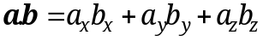 The inner product be physically interpreted as the length of the common component (or of the projection) of vector a onto vector b.
║a║ Length of a vector a given by: 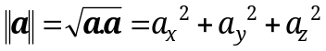.
a×b Cross product of vector a and vector b given by: . The vector c = a×b is perpendicular to both a and b.
a⊗b Dyadic product of vector a and vector b , which yields a second order tensor M = a⊗b. The tensor M describes the linear operations: M.x = a⊗b.x = (b.x) a and: x.M = x.a⊗b = (a.x) b for an arbitrary vector x Error: Reference source not found]. The matrix of tensor components is given by: 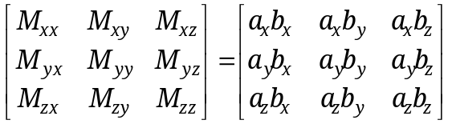
Further reference is made to the textbook Error: Reference source not found] for the used notation of vectors and tensors and the definition of vector operators.
- Alternative expressions for minimum curvature method
  - Introduction
In this appendix the minimum curvature relations will be expressed using a more conventional notation, which relies less on the abstract notation of vectors. Expressions are given more directly in terms of the along-hole depth values: AHD₁, AHD₂, the inclination values I₁, I₂ and azimuth values: A₁, A₂ of two subsequent survey stations.
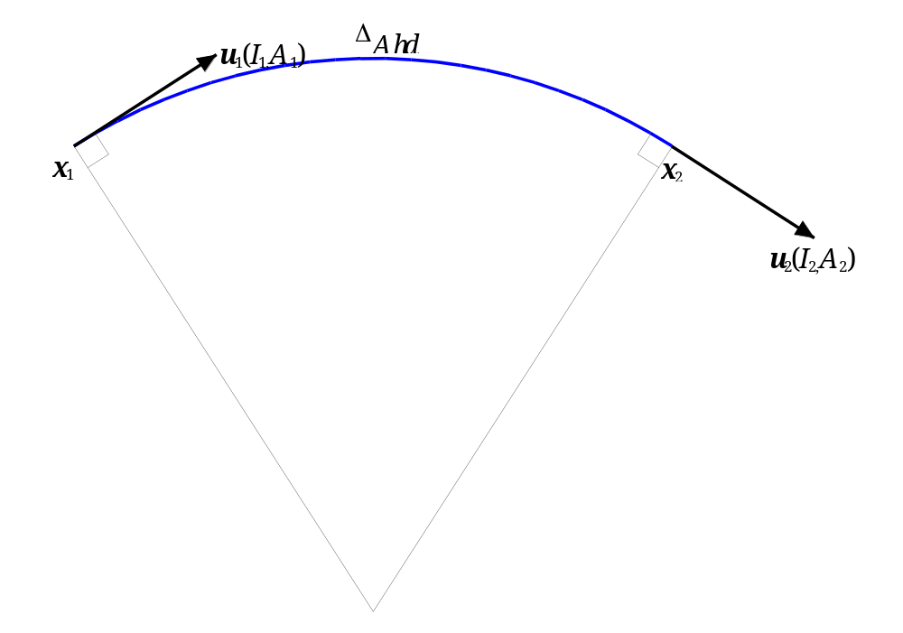
Figure B.1: Arc segment between two subsequent survey stations with numbers 1 and 2 at relative along hole distance ΔAhd. The tangent vectors u₁ and u₂ in the survey points are determined by the local inclination I and azimuth A values.
Figure B.1 shows the situation of two survey points 1 and 2, that are interconnected by a circular arc. The following properties are assumed as given, either form a survey file or from a well plan:
Ahd₁ : Along hole depth at survey point 1,
I₁ : Inclination at survey point 1,
A₁ : Azimuth at survey point 1,
u₁ : Direction vector in survey point 1 as determined by I₁ and A₁,
Ahd₂ : Along hole depth at survey point 2,
I₂ : Inclination at survey point 2,
A₂ : Azimuth at survey point 2,
u₂ : Direction vector in survey point 2 as determined by I₂ and A₂.
Firstly, Section B.2 introduces some auxiliary variables and vectors, which will be used extensively in the subsequent sections. Section B.3, gives the procedure for the calculation of the spatial position x₂ of survey point 2 as a function of the spatial position x₁ of survey point 1 and abovementioned data. Section B.4, gives the calculation procedures for interpolating the inclination, azimuth, direction vector or position vector for intermediate along hole positions in between the two survey points.
  - Auxiliary variables and vectors
In Figure B.1 a number of auxiliary angles, distances and vectors are shown, that will be used in the subsequent sections.
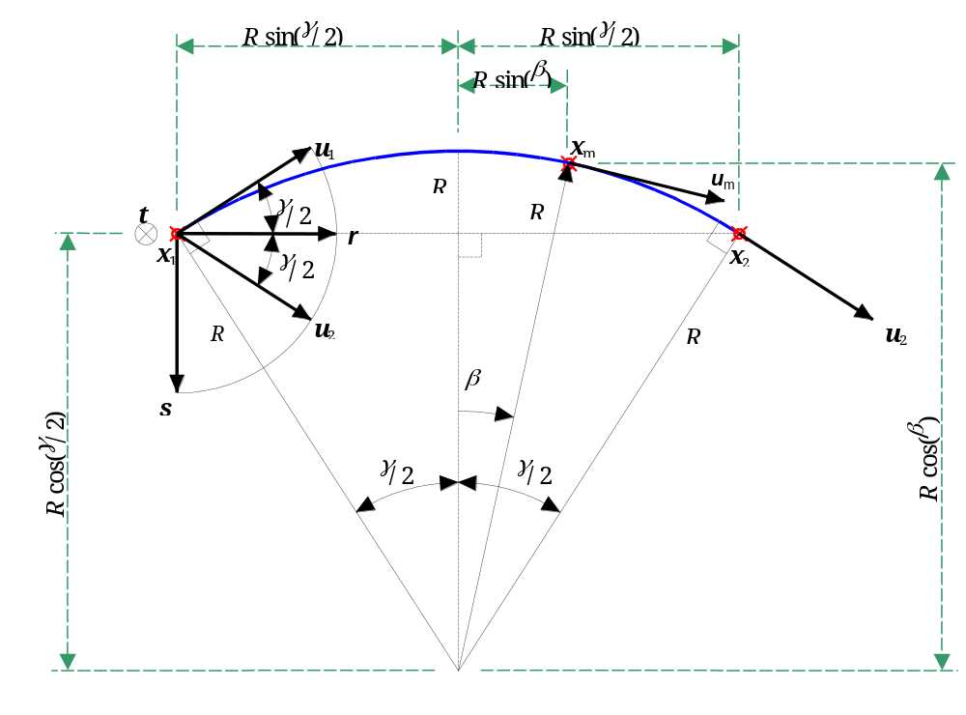
Figure B.2: Auxiliary variables and vectors associated to a circular arc between two survey station 1 and 2. The angle between the two survey station directions is γ. The angle β will be used for interpolating on the survey interval.
The arc length of the circular arc between the survey stations is given by:
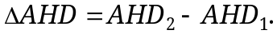 {B1}
The angle enclosed in the arc segment is determined by from the survey point direction vectors by:
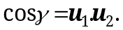 {B2}
With the survey vector given by:
{2.2}
the expression for the angle γ is re-written as:
{B3}
With the relation:
{B4}
the angle γ is finally determined by:
{B5}
The radius of curvature R and the dog-leg severity DLS of the arc segment are given by:
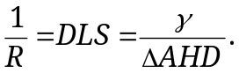 {B6}
The local r, s, t -triad of orthonormal vectors is defined for the arc segment, as shown in Figure B.2. The first unit vector r of the triad points along the line through the two survey stations and is given by:
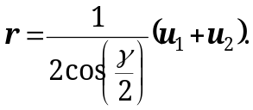 {B7}
The second unit vector s of the triad is embedded in the plane of curvature and is perpendicular to r. It is given by:
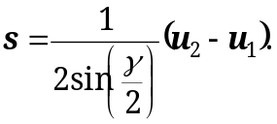 {B8}
The third unit vector t of the triad is perpendicular to the plane of curvature and is given by:
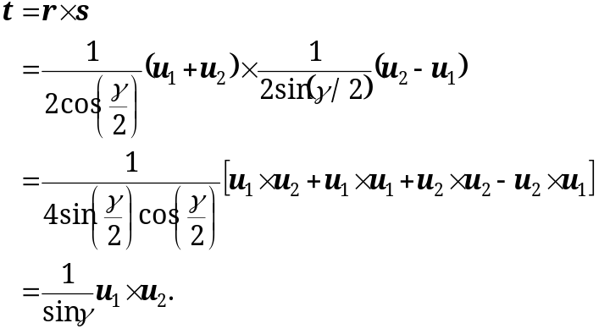 {B9}
In the above the properties: sin(2α) = 2sin(α)cos(α), b×a = -a×b and a×a = 0 have been used, which hold for arbitrary non-zero vectors a and b.
The rotation vector Θ (see also Figure 2.5) about which u₁ is rotated into u₂ is given by:
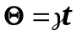 {B10}
Note, that alternative expressions have to be used when γ is zero or numerically close to zero.
B.3 Arc segment end point calculation
Assume, that the position x₂ of survey point 2 has to be calculated for a given position x₁ and direction vectors u₁ and u₂. In Figure B.2 it is shown, that the relative of position x₂ with respect to x₁ h as to be in the direction along the unit vector r, and at a distance of 2Rsin(γ/2). Therefore the increment Δx in spatial position is given by:
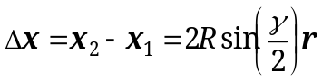 {B11}
Now with {B7}for the vector r and {B6} for the radius of curvature R, the position increment Δx is given by:
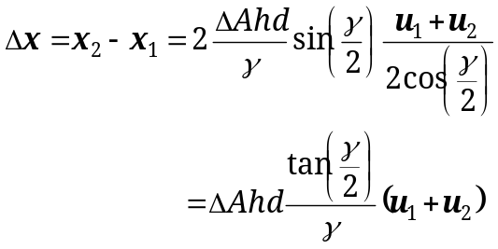 {B12}
When defining a ratio-factor RF by:
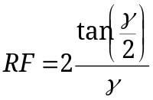 {B13}
then the position increment Δx may also be written as:
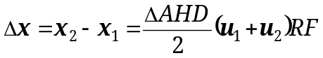 {B14}
By expressing the direction vectors u₁ and u₁ directly in terms of the corresponding azimuth and inclination values, then the increments ΔN, ΔE, ΔTVD in the driller’s coordinate directions can be calculated in a straightforward manner.
The increment ΔN in the Northern co-ordinate direction is given by:
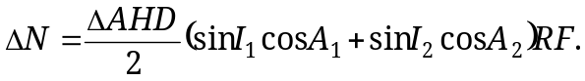 {B15}
The increment ΔE in the Eastern co-ordinate direction is given by:
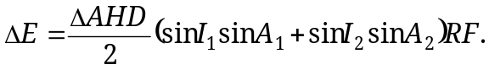 {B16}
The increment ΔTVD in the Vertical co-ordinate direction is given by:
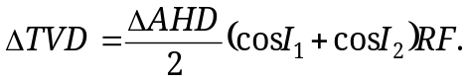} {B17}
B.4 Interpolation on survey interval
The angle β is defined for interpolating a property at an along-hole depth value Ahd_{m} on the arc segment by:
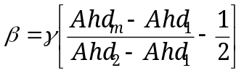 {B18}
This angle is shown in Figure B.2. Note, that β = 0 for the position half way along the arc segment.
The spatial position x_{m} at the point with along-hole depth value Ahd_{m} is firstly expressed as in terms of the auxiliary r and s vectors:
{B19}
in which the scalar factors are the designated horizontal resp. vertical distances in Figure B.2. Now secondly, with {B7} for the vector r, {B8} for the vector s and {B6}for the radius of curvature R, the interpolated position x_{m} is determined by:
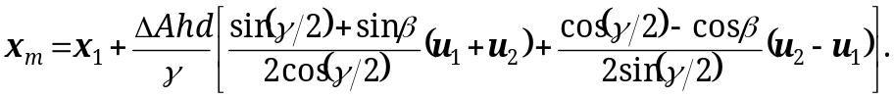 {B20}
The direction vector u_{m} at the point with along-hole depth value Ahd_{m} is interpolated by:
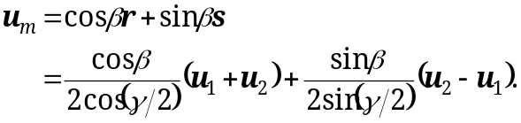 {B21}
The azimuth and inclination values at the point with along-hole depth value Ahd_{m} may be determined by from the projections of u_{m} on the n, e, v-coordinate directions, as given by {2.16}.
- Taylor series expansions of minimum curvature relations for small dog-leg severities
In a computer implementation, the minimum curvature relations equations {2.4} and {D7} suffer from floating point rounding-off inaccuracies and a potential division by zero for small dog-leg severities. In particular the trigonometric terms give problems for a zero or numerically very small value of the angle γ enclosed between the direction vectors u_{i} and u_{i+1} at two subsequent survey stations as shown in Figure 2.3. In order to overcome this problem, Taylor expansion series expansions about γ = 0 can be used. The following expansion series for trigonometric terms are relevant Error: Reference source not found]:
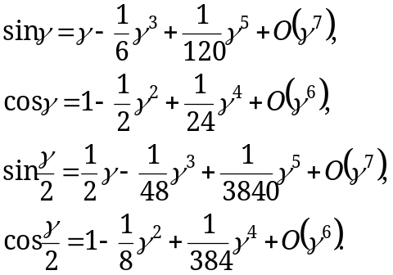
With the above expansions the factors P and Q given in equations {2.4} and {D7} can be approximated for small angles γ by:
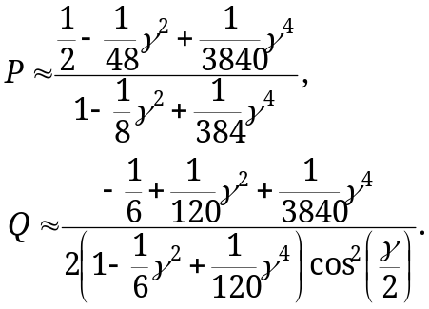 {C1}
When using a double precision implementation (16 significant digits on PC) the above series approximations may even be used up to γ ≈ O(10⁻⁴).
- Linearisations of minimum curvature relations
In certain algorithms, e.g. iterative procedures for solving directional data from given geological targets, the liberalizations of the minimum curvature relations {2.4}given in Section 2.5 are required. The linearization of the arc end point position x_{i+1} with respect to the along-hole-depth increment ΔAhd and the direction u_{i+1} in the end point is given by:
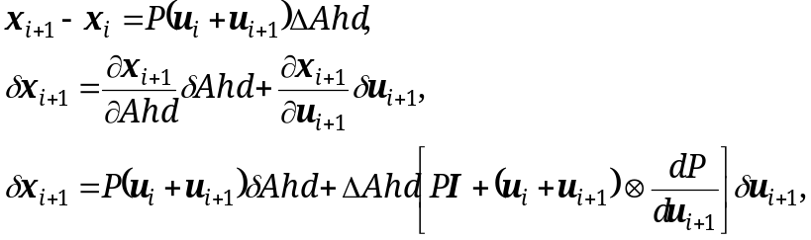 {D1}
where I denotes the unit tensor and the symbol “⊗” denotes the so called dyadic product. See footnote Error: Reference source not found on page 13 for more a definition. The calculation of the derivative of P with respect to u_{i+1} is split-up into the product of two terms:
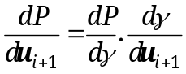 {D2}
The first term, which represents the derivative P with respect to angle γ enclosed by the direction vectors, is given by:
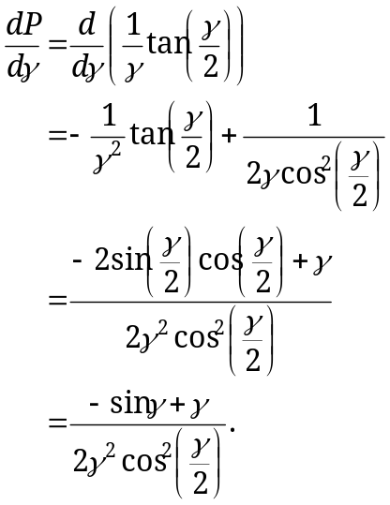 {D3}
The second term, which represents the derivative of the enclosed angle γ with respect to the direction u_{i+1} in the end point, is given by:
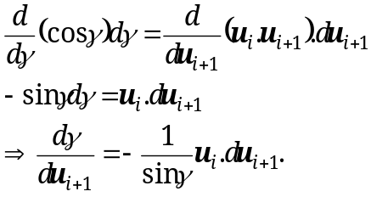 {D4}
Therefore by combination we get:
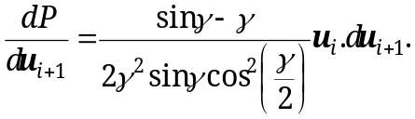 {D5}
In summary therefore: The minimum curvature method expression for the end point position x_{i+1} of an arc segment and the partial derivatives with respect to the along-hole-depth increment ΔAhd and the end point direction vector u_{i+1} are given by:
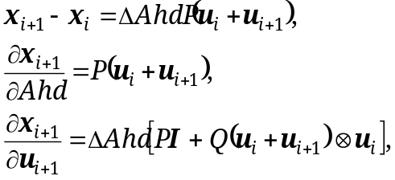 {D6}
with:
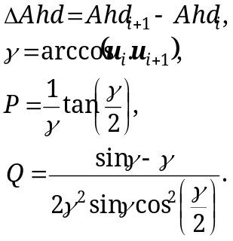 {D7}
For a zero or numerically small value of γ the evaluation of the above mentioned relations suffers from divisions by zero or from floating point inaccuracies. This situation physically corresponds to (near) straight hole and is therefore very important. In Appendix C Taylor series expansions are applied in order to overcome these problems. This approach is to be preferred over just to assume straight hole below a certain cut-off limit for γ.

- Finite rotation transformations of vectors
  - Introduction
For the minimum curvature method the well path consists of arc-segments. The direction vectors u_{i} in the subsequent survey stations are related by finite rotation transformations. In this appendix three aspects of finite rotations will be presented, which are used by the minimum curvature method:
1. Determine the finite rotation transformations of vectors for a given rotation vector in order to interpolate or extrapolate on the survey stations.
2. Determine the rotation vector associated to change in well path direction vector in two subsequent survey stations.
3. Determine the transformations between the orthonormal triads of vectors in the subsequent survey stations.
These aspects will be covered in the following sections. The finite rotation descriptions are given using the vectorial notation that is used throughout this report
  - Rotation of vectors
The finite rotations of vectors for a given “pseudo” rotation vector Θ are commonly used, e.g. for interpolations between survey stations. Suppose, that the vector a is rotated into the vector a’ by the (finite) rotation vector Θ, which is determined by a rotation angle θ as shown in Figure E.3.
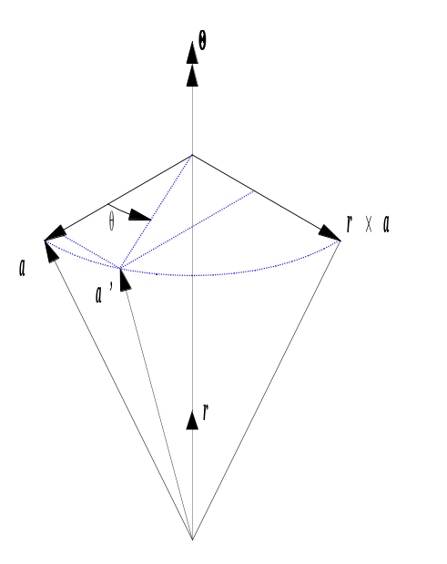
Figure E.3: A vector a is rotated by a rotation vector Θ having an angle/magnitude θ.
The rotation θ angle is given by:
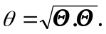 {E1}
The unit rotation axis is given by:
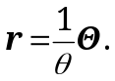 {E2}
The solution for the rotated vector a’ is given by:
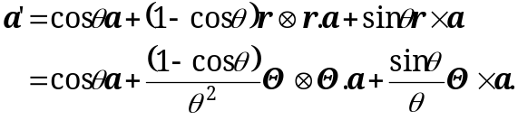 {E3}
The symbol ⊗ denotes the dyadic product operator (See footnote Error: Reference source not found on page 13). For θ << 1 numerical errors may occur due to floating point accuracies and potential divisions by zero. Using Taylor series expansions, the rotated vector is for small rotation angles approximated by:
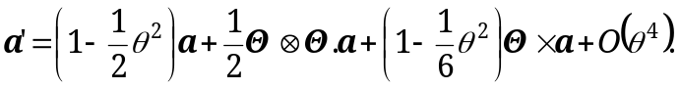 {E4}
  - Rotation vector calculation
The solution for the “pseudo” rotation vector Θ, that describes the rotation of unit vector u_{i} into the unit vector u_{i+1} is given by:
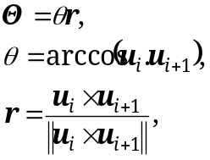 {E5}
where θ denotes the rotation angle (magnitude) and r denotes the unit rotation axis.
  - Rotation of triads of vectors
The transitions between the triad vectors in the subsequent survey stations are described by finite rotations. For this case a convenient description may be used, although the generic relations given in Section E.2 could also be used. Two sets of orthonormal (unit length and mutually perpendicular) vectors u, v, w are depicted in Figure E.4. In order to illustrate the finite rotations both triads are drawn at the same position. However, the actual triads in two subsequent survey stations will be at different positions. The unit vector u_{i} survey station i is rotated into the direction vector u_{i+1}(= u_{i}+Δu) in the next survey station i+1. It is assumed, that the finite rotation is completely determined by the prescribed finite change Δu of the well bore direction vector. The triad vectors v_{i} and w_{i} undergo the same rotational transformation as u_{i} and are rotated into the vectors v_{i+1} and w_{i+1}, respectively.
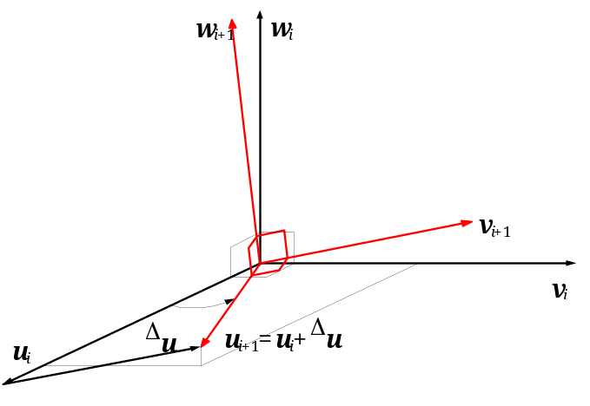
Figure E.4: The set of orthonormal vectors u_{i}, v_{i}, w_{i} constitutes the reference triangle of orthonormal vectors. The set of orthonormal vectors u_{i+1}, v_{i+1}, w_{i+1} is obtained by a finite rotation of the reference triangle, by prescribing a finite change Δu with respect to the reference vector u_{i}. The vectors v_{i} and w_{i} are rotated into the vectors v_{i+1} and w_{i+1}, respectively.
The rotated vectors are given by:
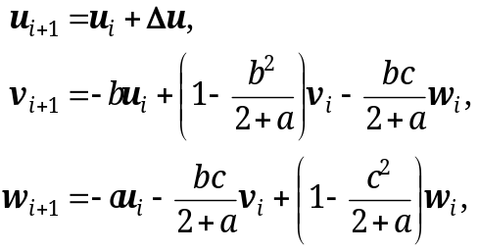 {E7}
with
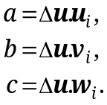 {E8}

The copyright of this document is vested in Shell International Exploration and Production B.V., The Hague, The Netherlands. All rights reserved.
Neither the whole nor any part of this document may be reproduced, stored in any retrieval system or transmitted in any form or by any means (electronic, mechanical, reprographic, recording or otherwise) without the prior written consent of the copyright owner.

In certain disciplines in the oil and gas industry (e.g. well engineering community) the z-axis is defined to be equal to the v-axis as defined herein. In well engineering this definition is convenient and has been made to obtain positive true vertical co-ordinate values for positions that are in the subsurface. However, in this work the “normal” e_{x}, e_{y}, e_{z} Cartesian basis vectors are used in order to be consistent with the general definition in science, the subsurface disciplines and the 3D-graphics discipline.
Orthonormal basis vectors have a unit length and are mutually perpendicular.
The dyadic product B = a⊗b of non-zero vectors a and b yields the second order tensor B, that describes the linear operations: B.x = a⊗b.x = (b.x) a and: x.B = x.a⊗b = (a.x) b for an arbitrary vector x Error: Reference source not found].
Note that the “conventional” Ratio Factor RF is twice as large as the factor P defined in {2.4}
The designation “pseudo” vector is used, because a finite rotation is a non-linear operation (non-associative); The rotation about the designated rotation vector Θ is different from the sum of three rotations corresponding to the three components of Θ.

