**Code Fellas**

**‘Hackathon’**

**Project on I.O.T.**

**____________________________________**

**Presented by Team Akatsuki**

**-Manendra Thakur**

**Problem statement**

**Develop a security system for student dorm rooms to prevent theft of valued possessions using camera and motion sensing technology.**

**Requirements**

* **ESP32 cam module**
* **PIR sensor**
* **DC male and female jacks**
* **Wires**
* **Stable internet and electric supply**
* **Perf board**
* **5v dc adapter**

**Project Description**

Our security system works on the motion sense with photo capture technology and ‘Telegram’ Application notifications using ESP 32-CAM.

Communication with security system is done using a Telegram ‘BOT’.

We named our bot as ‘Campro’ which can only be accessed by the special authorization.

It will only respond to messages coming from user’s Telegram account ID.

* To start receiving notifications **/motion_on** message is sent to bot.
* Whenever motion is detected you will receive a notification with the photo
* To stop receiving notifications **/motion_off**

Message is to be sent

* **/motion_state** command will respond with current state of motion notifications(enabled or disabled)
* **/photo** to get instant photo
* **/flash** switches on the flash of the camera
* **/start** sends a welcome message with the commands to control the system

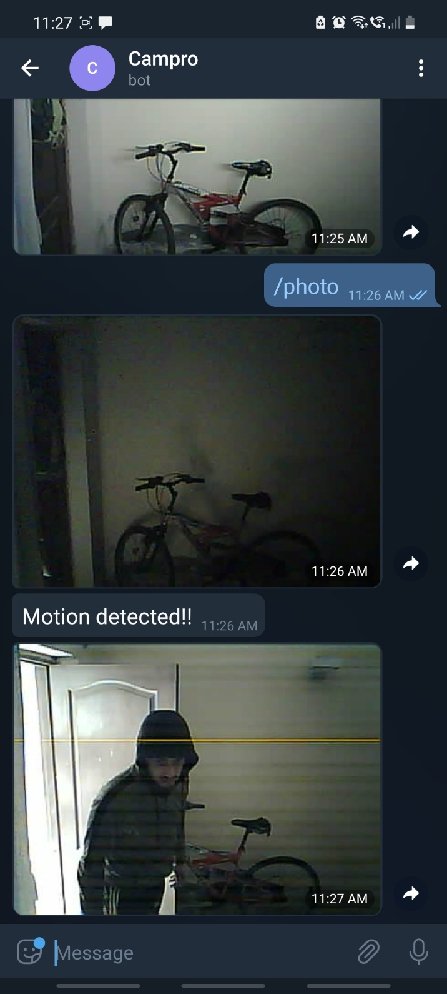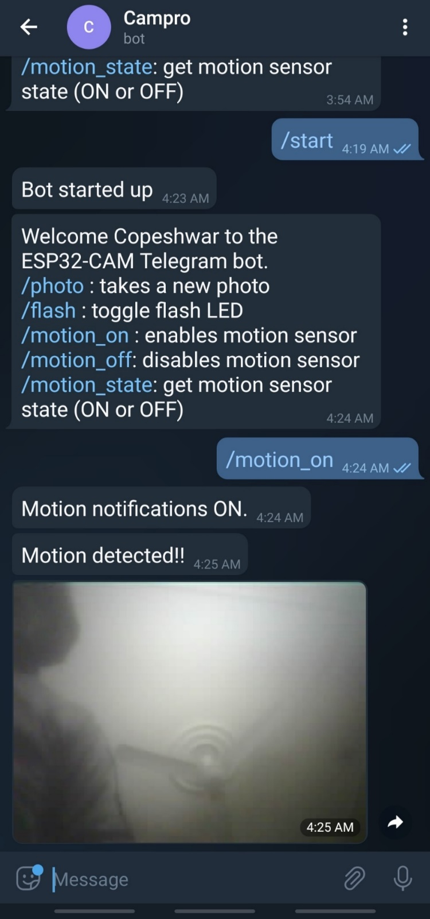

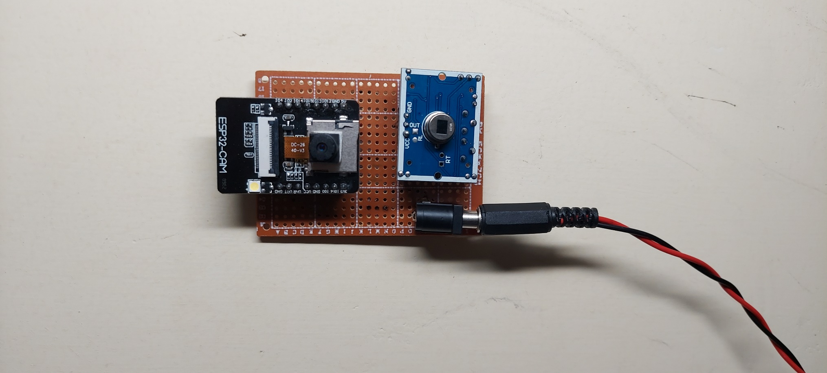

**Scope**

* Ability to take live photos of room sitting anywhere in the world.
* Ability to take photos in dim light (flash light provided in the system).
* Real time system (instant alerts on user’s mobile/laptop/tablet about any kind of motion induced intrusion in private property).

**Challenges Faced**

* Tight spot: user needs to find a spot near power source while masking wire where view is adequate and security system is hidden from unsuspecting eyes
* Stable power supply of 5v: to reduce the overall cost of system, power supply adaptor of 5v could have been replaced by a IC 7850 voltage regulator of TO-220 package with use to capacitors of 0.22uf between input and ground but it usually heats up and affects the camera sensor functionality of ESP32-CAM, so it had to be avoided and a 5v DC adapter was used.

**Conclusion**

* This ESP32 CAM based security system solves the problem of detection of unwanted intrusion in dorm rooms through instant alerting and capturing pics of the culprit.
* While some cons which definitely needed to be acknowledged are power issues and internet connectivity issues, if power goes out, user’s dorm room will be vulnerable for few minutes and if internet is slow user won’t get instant notifications.
* **Looking forward** few above addressed issues could be tackled in the next update of this project in which power issue could be tackled with a “18650” lithium ion cells powered battery pack which could power this system voluntarily when the power goes out. While the internet issue could be taken care of by installing a memory card module in system to save real time pics when required, which can be later accessed by the user when the device again comes back online

**____________________________________**

**Presented by Team Akatsuki**

**-Manendra Thakur**