# Introduction

# Related work

## Causality introduction

1. 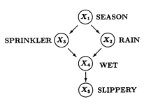DAG

Figure1

Form1: $P\left(x_{j}∣pa_{j}\right)=P\left(x_{j}∣x_{1},…,x_{j-1}\right)$

Form2: $\begin{aligned}&P\left(x_{1},…,x_{n}\right)=\prod_{i}{ }P\left(x_{i}∣pa_{i}\right) \\ & \\ &P\left(x_{1},x_{2},x_{3},x_{4},x_{5}\right)=P\left(x_{1}\right)P\left(x_{2}∣x_{1}\right)P\left(x_{3}∣x_{1}\right)P\left(x_{4}∣x_{2},x_{3}\right)P\left(x_{5}∣x_{4}\right)\end{aligned}$

1. SEM…

Form3: $x_{i}=f_{i}\left(pa_{i},u_{i}\right),i=1,…,n$

Form4: $x_{i}=\sum_{k≠i}{α_{ik}x_{k}+u_{i}},i=1,…,n$

Form5： $X_{j}=w_{j}^{T}X+u_{j}$

Form6: $E\left(X_{j}∣X_{pa\left(X_{j}\right)}\right)=f\left(w_{j}^{T}X\right)$

## Student performance prediction

1. Feature selection-relevance

[ref2]

1. Causality based approaches

# Students' performance prediction based on causal inference and multi-head self-attention mechanism

## Factor-association discovery using causal analysis

1. Notears algorithm to reveal linear SEM\

Form7:

$$\begin{aligned}&\min_{W∈R^{d×d}} &&F(W) \\ &\text{ subject to } &&G(W)∈DAGs\end{aligned}$$

Form8:

$F(W)=l(W;X)+λ‖W‖_{1}=\frac{1}{2n}‖X-XW‖_{F}^{2}+λ‖W‖_{1}$

$$l(W;X)=\frac{1}{2n}‖X-XW‖_{F}^{2}$$

Form9:

$$\begin{matrix}\min_{G} & Q(G) \\ \text{subject to} & G∈D\end{matrix}$$

$$Q:D→R$$

$$DAGsD$$

Form10:

$$G(W)∈D$$

Form11:

$$h(W)=0$$

Form12:

$$h:R^{d×d}→R$$

Form13:

(a) $h(W)=0$ if and only if $W$ is acyclic (i.e. $G(W)∈D$);  
(b) The values of $h$ quantify the "DAG-ness" of the graph;  
(c) $h$ is smooth;  
(d) $h$ and its derivatives are easy to compute.

Form14:

$$W∈R^{d×d}$$

$$\begin{aligned}h(W)=tr\left(e^{W∘W}\right)-d=0\end{aligned}$$

$e^{A}$, $A$. $h(W)$

$$\begin{aligned}∇h(W)={\left(e^{W∘W}\right)}^{T}∘2W\end{aligned}$$

Form15:

$$B∈\{0,1\}^{d×d}$$

${\left(B^{k}\right)}_{ii}=0$ for all $k≥1$ and all $i$

$${\sum_{k=1}^{∞}{\sum_{i=1}^{d}{ \frac{{\left(B^{k}\right)}_{ii}}{k!}}}}_{}^{} =tre^{B}-d=0$$

Form16:

$$tr\left(B+B^{2}+⋯\right)$$

form17:

$$\begin{matrix}\min_{W∈R^{d×d}} & F(W) \\ \text{subject to} & h(W)=0\end{matrix}$$

Form18:

$$\{W:h(W)=0\}$$

Form19:

$$\begin{matrix}\min_{W∈R^{d×d}} & F(W)+\frac{ρ}{2}|h(W)|^{2} \\ \text{subject to} & h\left(W\right)=0\end{matrix}$$

$$ρ>0$$

Form20:

$$\begin{aligned}D(α) =\min_{W∈R^{d×d}} L^{ρ}(W,α) \\ where L^{ρ}(W,α) =F(W)+\frac{ρ}{2}|h(W)|^{2}+αh(W)\end{aligned}$$

Form21:

$$\max_{α∈R} D(α)$$

Form22:

$$W_{α}^{⋆}$$

$$D(α)=L^{ρ}\left(W_{α}^{⋆},α\right)$$

$$∇D(α)=h\left(W_{α}^{⋆}\right)$$

Form23:

$$α←α+ρh\left(W_{α}^{⋆}\right)$$

$$Algorithm:No tears$$

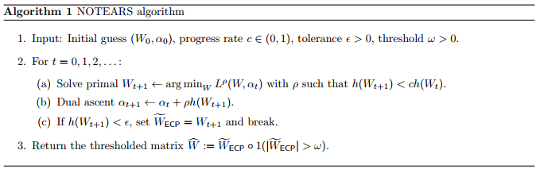

$$\left(W_{0},α_{0}\right)\text{, }c∈(0,1)\text{, }ϵ>0\text{, }ω>0\text{.}$$

$$t=0,1,2,…:$$

$$W_{t+1}←arg\min_{W} L^{ρ}\left(W,α_{t}\right)\text{ with }ρ\text{ such that }h\left(W_{t+1}\right)<ch\left(W_{t}\right)\text{.}$$

$$α_{t+1}←α_{t}+ρh\left(W_{t+1}\right)$$

$$\text{If }h\left(W_{t+1}\right)<ϵ\text{, set }{\tilde{W}}_{ECP}=W_{t+1}\text{ and break.}$$

$$\hat{W}:={\tilde{W}}_{ECP}∘1\left(\left|{\tilde{W}}_{ECP}\right|>ω\right)$$

Form24:

$$\begin{aligned}\min_{w∈R^{p}} f(w)+λ∥w∥_{1} \\ \text{ where }f(w)=l(W;X)+\frac{ρ}{2}|h(W)|^{2}+αh(W)\end{aligned}$$

**Here, $w=vec⁡(W)∈R^{p}, p=d^{2}$**

**Form25:**

$$\begin{aligned}d_{k}=\underset{d∈R^{p}}{arg⁡min}g_{k}^{T}d+\frac{1}{2}d^{T}B_{k}d+λ{\left\|w_{k}+d\right\|}_{1}\#(17)\end{aligned}$$

$$d←d+z^{⋆}e_{j}$$

Form26:

$$z^{⋆}=\underset{z}{arg⁡min}\frac{1}{2}\underset{a}{\underbrace{B_{jj}}}z^{2}+(\underset{b}{\underbrace{g_{j}+(Bd)_{j}}})z+λ|\underset{c}{\underbrace{w_{j}+d_{j}}}+z|=-c+S\left(c-\frac{b}{a},\frac{λ}{a}\right)$$

## Transformer

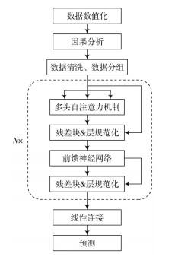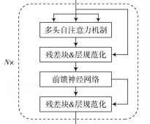

# Result

## Dataset

## Assessment metrics

Form27:

$$\begin{aligned}\text{ Accuracy }=\frac{TP+TN}{TP+TN+FP+FN} \\ \text{ Precision }=\frac{TP}{TP+FP} \\ \text{ Recall }=\frac{TP}{TP+FN} \\ F_{1}-\text{ Measure }=\frac{2×\text{ Precision }×\text{ Recall }}{\text{ Precision }+\text{ Recall }}\end{aligned}$$

## Parameters

## result

## prediction performance

|  |  |  |  |  |
| --- | --- | --- | --- | --- |
| 方法 | Accuracy | Precision | Recall | $F_{1}$-Measure |
| Ours | 93.06 | 93.90 | 93.06 | 93.01 |
| LR | 91.67 | 92.38 | 91.67 | 91.65 |
| RF | 91.67 | 92.17 | 91.67 | 91.63 |
| XGB | 90.28 | 91.10 | 90.28 | 90.17 |
| KNN | 84.72 | 89.34 | 84.72 | 85.03 |
| MNB | 52.78 | 58.60 | 52.78 | 49.11 |

|  |  |  |  |  |
| --- | --- | --- | --- | --- |
| 方法 | Accuracy | Precision | Recall | $F_{1}$-Measure |
| Ours | 93.06 | 93.90 | 93.06 | 93.01 |
| No-T | 91.67 | 91.92 | 91.67 | 91.71 |
| No-C | 87.50 | 87.87 | 87.50 | 87.57 |
| No-C-T | 84.72 | 85.38 | 84.72 | 84.57 |

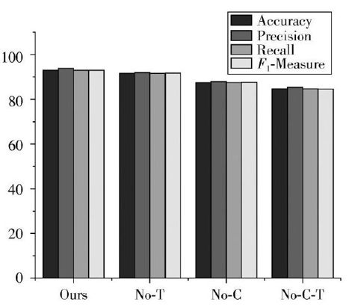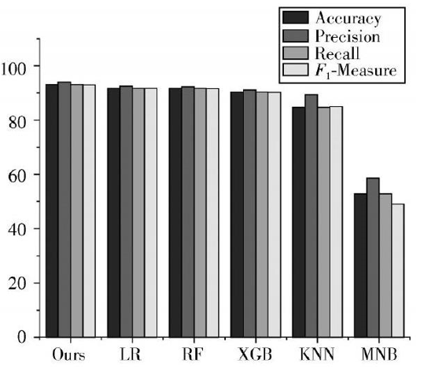

# Ref

[1]Judea Pearl, causality-models, reasoning and inference, 2009, Cambridge

[2]Kimcholmyong

[3] POLYZOU A, KARYPIS G. Feature extraction for next-term prediction of poor student performance [J]. IEEE transactions on learning technologies, 2019, 12(2): 237-248.  
[4] HUANG S, FANG N. Predicting student academic performance in an engineering dynamics course: A comparison of four types of predictive mathematical models [J]. Computers & education, 2013, 61: 133-145.

[5] PANDEY M, SHARMA V K. A decision tree algorithm pertaining to the student performance analysis and prediction [J]. International journal of computer applications, 2013, 61(13): 1-5.

[6] 谢娟英, 张宜, 陈恩红. 学生成绩关键因素挖掘与成绩预测[J].南京信息工程大学学报(自然科学版), 2022,11(3):316-325.

[7] MA Y, CUI C, NIE X, et al. Pre-course student performance prediction with multi-instance multi-label learning [J]. Science China information sciences, 2019, 62(2): 1-3.

[8] 李梦莹, 王晓东,院书岚, 等.基于双路注意力机制的学生成绩预测模型[J].计算机研究与发展, 2022, 57(8):1729-1740.

[9]Rijisong

[10] A. Nemirovski. Optimization II: Standard Numerical Methods for Nonlinear Continuous Optimization. 1999

[11] K. Zhong, I. E.-H. Yen, I. S. Dhillon, and P. K. Ravikumar. Proximal quasi-newton for computationally

intensive l1-regularized m-estimators. In *Advances in Neural Information Processing Systems*, pages

2375{2383,2014

# Summary