PROJECT REPORT
SERVICE NOW
Incident Management – Incident Lifecycle and Resolution
Submitted By
Name | Manepalli Samhitha
Course | B.Tech – Data Science
College | ISTS Women’s Engineering College
Academic Year | 2026–2027
Project Platform | ServiceNow
Project Area | IT Service Management – Incident Management

Project focus: End-to-end handling of a corporate VPN connectivity incident
Project Report Format
1. INTRODUCTION
1.1 Project Overview
1.2 Purpose
2. IDEATION PHASE
2.1 Problem Statement
2.2 Empathy Map Canvas
2.3 Brainstorming
3. REQUIREMENT ANALYSIS
3.1 Customer Journey map
3.2 Solution Requirement
3.3 Data Flow Diagram
3.4 Technology Stack
4. PROJECT DESIGN
4.1 Problem Solution Fit
4.2 Proposed Solution
4.3 Solution Architecture
5. PROJECT PLANNING & SCHEDULING
5.1 Project Planning
6. FUNCTIONAL AND PERFORMANCE TESTING
6.1 Performance Testing
7. RESULTS
7.1 Output Screenshots
8. ADVANTAGES AND DISADVANTAGES
9. CONCLUSION
10. FUTURE SCOPE
11. APPENDIX
Source Code (if any)
Dataset Link
GitHub & Project Demo Link
1. INTRODUCTION
1.1 Project Overview
ServiceNow is a cloud-based platform widely used for IT Service Management (ITSM), where organizations can record, track, assign, investigate, and resolve service-related issues in a controlled workflow. This project demonstrates the Incident Management process using a realistic corporate VPN connectivity issue. The practical record shown in the ServiceNow workspace is incident number INC0010001, with the short description “Unable to connect to Corporate VPN from home office.” The incident is used to demonstrate the complete movement of an issue from identification to resolution.
The incident record contains the information required by a support team to understand and manage the issue. The caller is Michael Hoefer, the location is SHS quadra 5, Bloco E, and the contact channel is Phone. The issue is classified under Category = Network and Subcategory = VPN. The incident has Impact = 3 - Low, Urgency = 2 - Medium, and Priority = 4 - Low. These fields help the support organization decide how quickly the issue should be handled and which technical group should own it.
The screenshots also show the Service Operations Workspace, Activity stream, Work notes, Agent Assist, SLA information, Assignment section, Related Records, Cause section, and Resolution section. The incident moves through practical service-management activities rather than being treated as a simple text entry. Assignment is made to the Network group and later to David Loo. At one stage the incident is placed On Hold with the reason “Awaiting Change,” showing how ServiceNow can represent a dependency on another operational action. The probable cause is documented as “PowerEdge service was suspended and required restart.” Finally, the resolution is captured with the code “Workaround provided” and the note “Restarted VPN-SRV-02 service as per emergency change request.”
This project therefore focuses not only on creating an incident but also on maintaining traceability. Every important change can be observed in the Activity stream. SLA information gives visibility into response and resolution targets. Agent Assist presents relevant knowledge content such as “How to configure VPN for Apple Devices,” which demonstrates how knowledge support can help an agent investigate common service issues. The project is useful for understanding how an enterprise support process can be organized in a single platform.
1.2 Purpose
The main purpose of this project is to understand and document the end-to-end Incident Management lifecycle in ServiceNow. The work demonstrates how a service issue is received from a user, converted into a structured incident, categorized, prioritized, assigned to the correct support group, investigated, placed on hold when an operational dependency exists, and finally resolved with clear resolution information. The project also provides practical exposure to the Service Operations Workspace interface and the fields that are important for incident handling.
A second purpose is to understand the relationship between business information and technical information. The caller, location, channel, and short description represent the user's side of the issue. Category, subcategory, impact, urgency, priority, assignment group, probable cause, work notes, and resolution details represent the service team's operational side. Keeping both sides together allows the support team to communicate clearly, preserve an audit trail, and use the record for future analysis.
The project also aims to demonstrate disciplined documentation. A good incident record should contain enough information for another support engineer to understand what happened without depending entirely on a verbal explanation. In this example, the activity history, assignment details, probable cause, SLA information, and resolution notes collectively create a useful record of the troubleshooting journey. This makes the incident suitable for learning, reporting, trend analysis, and future knowledge improvement.
Incident Details Used in the Project
Incident Number | INC0010001
Short Description | Unable to connect to Corporate VPN from home office
Caller | Michael Hoefer
Location | SHS quadra 5, Bloco E
Channel | Phone
Category / Subcategory | Network / VPN
Impact / Urgency / Priority | 3 - Low / 2 - Medium / 4 - Low
Assignment | Network group / David Loo
On Hold Reason | Awaiting Change
Probable Cause | PowerEdge service was suspended and required restart
Resolution Code | Workaround provided
Resolution Notes | Restarted VPN-SRV-02 service as per emergency change request

2. IDEATION PHASE
2.1 Problem Statement
The problem identified for the project is a corporate VPN connectivity failure experienced by a user working from a home office. The caller reported that the VPN connection had worked on the previous evening, but on the following morning an authentication error appeared while attempting to connect. The Internet connection itself was working correctly. This distinction is important because it indicates that the problem is not a general loss of Internet connectivity and should be investigated as a corporate VPN or authentication/service issue.
From an IT support perspective, the problem needs to be converted into a structured incident. The support team must capture who is affected, where the user is working, how the issue was reported, which service is affected, and how urgent the issue is. In the ServiceNow record, the issue is classified as Network with VPN as the subcategory. The selected impact, urgency, and priority values provide a consistent way to manage the issue instead of relying only on subjective descriptions.
The problem statement also considers the operational dependency that appears during troubleshooting. The incident eventually reaches an On Hold state with the reason “Awaiting Change.” This means the resolution is dependent on a controlled technical action rather than an immediate field-level change. The later cause information shows that the PowerEdge service was suspended and required a restart. The final workaround records that VPN-SRV-02 was restarted under an emergency change request. Thus, the ideation stage identifies both the user-facing symptom and the likely service-management path needed to restore service.
2.2 Empathy Map Canvas
The empathy map is used to understand the incident from the caller's point of view before defining the technical response. In this scenario, the caller wants to work from home and needs access to corporate resources. The user can connect to the Internet but cannot authenticate to the corporate VPN. This creates frustration because the basic network connection appears healthy while the business service remains inaccessible.
What the user says: The user reports that the corporate VPN cannot be connected from the home office and that an authentication error is received. The user also indicates that the VPN worked previously, which suggests that the condition may have changed after the last successful connection.
What the user thinks: The user may expect the VPN to work because the Internet is functioning normally. The user may also expect the support team to restore access quickly because corporate applications and resources depend on the VPN connection.
What the user does: The user attempts to connect again, observes the authentication error, and contacts support by phone. The support agent records the issue in ServiceNow so the problem can be investigated and tracked.
What the user feels: The user is likely concerned about losing access to work resources and may be uncertain whether the problem is related to the laptop, Internet connection, credentials, or the corporate VPN service.
Support-team need: The support team needs a clear symptom, classification, priority, ownership, troubleshooting history, and final resolution. The incident record provides a common place for this information.
2.3 Brainstorming
During brainstorming, several possible causes and actions can be considered before selecting the most suitable path. First, the agent can confirm that Internet access is working. Second, the VPN configuration and authentication details can be checked. Third, the support team can search the knowledge base for VPN-related troubleshooting guidance. Fourth, the incident can be assigned to the Network team because the service belongs to the network/VPN area. Fifth, the technical team can check whether the relevant VPN service is running normally. Finally, if a service restart or infrastructure change is required, the incident can be linked to the appropriate change process and placed on hold while the action is performed.
The ServiceNow Agent Assist panel visible in the screenshots provides an example of how knowledge can support brainstorming. One of the suggested articles is “How to configure VPN for Apple Devices.” Although the final cause in this incident is related to a suspended service, knowledge suggestions can help an agent quickly eliminate configuration-related possibilities and choose the correct troubleshooting direction. The brainstorming outcome is therefore a structured investigation rather than an immediate assumption about the cause.
The key idea generated from the brainstorming activity is to maintain a complete incident lifecycle: identify the symptom, classify the issue, assign ownership, investigate using available knowledge, record work notes, coordinate any required change, verify restoration, and document the final resolution. This approach reduces repeated troubleshooting and makes the support process easier to audit and improve.
Empathy Map Summary
Says | VPN cannot connect; authentication error appears; Internet works.
Thinks | VPN should work because the Internet connection is available.
Does | Attempts connection and contacts support by phone.
Feels | Concerned about loss of access to corporate resources.
Needs | Fast restoration, clear communication, and a reliable workaround.
Support Response | Create, classify, assign, investigate, coordinate change, validate, resolve.

3. REQUIREMENT ANALYSIS
3.1 Customer Journey map
The customer journey begins when the user notices that the corporate VPN no longer connects from the home office. The first important step is reporting the problem through a support channel. In the project, the channel is Phone. The service desk or agent then creates the incident and captures the short description, caller, location, category, subcategory, impact, urgency, and priority. This stage converts an informal complaint into a structured service-management record.
The second stage is classification and ownership. The issue is classified under Network and VPN, and the assignment group is Network. Assigning an appropriate group is important because it directs the issue to people with the relevant technical knowledge. The record later shows David Loo as the assigned technician. The activity stream provides visibility into changes made during this stage and preserves the history of the incident.
The third stage is investigation. The support team checks the available information, reviews the knowledge recommendations in Agent Assist, and records relevant actions in the incident. If the issue requires a technical change, the incident may be moved to On Hold with the reason Awaiting Change. This prevents the record from appearing abandoned; instead, it communicates that progress is dependent on a defined external or operational action.
The fourth stage is restoration and validation. The documented probable cause states that the PowerEdge service was suspended and required a restart. The resolution notes indicate that the VPN-SRV-02 service was restarted under an emergency change request. After the service is restored, the incident can be resolved using a resolution code and resolution notes. This closes the customer journey with evidence of what was done and why the incident can be considered complete.
3.2 Solution Requirement
The solution requirements for this project are grouped into functional, information, workflow, and monitoring requirements.
- The system must create a unique incident number so the issue can be tracked throughout its lifecycle.
- The incident must capture caller, location, contact channel, short description, and detailed description.
- The issue must be classified using Category and Subcategory so that the correct support area can be identified.
- Impact, urgency, and priority must be available for consistent incident prioritization.
- The record must support Assignment Group and Assigned To fields to establish ownership.
- The Activity stream and Work notes must provide a history of troubleshooting actions and field changes.
- The incident must support an On Hold state and a reason such as Awaiting Change when resolution depends on another action.
- The record must provide a place to document the probable cause so that troubleshooting conclusions are preserved.
- The solution must capture a resolution code and resolution notes before the incident is finally closed.
- SLA information should provide visibility into response and resolution targets.
- Related Records should support relationships such as a Parent Incident when the incident is part of a broader issue.
- Knowledge or Agent Assist content should be available to help the agent identify useful troubleshooting information.
3.3 Data Flow Diagram
The data flow for the project can be represented as: Caller → ServiceNow Incident → Classification → Prioritization → Network Assignment → Investigation → Change/Workaround → Validation → Resolution → Closure. At each stage, information is added to the same incident record. The Activity stream provides an audit trail of important field changes and comments. SLA information is associated with the incident so that response and resolution performance can be monitored.
Caller | Incident | Classification | Assignment | Investigation | Resolution
Reports VPN issue | INC0010001 created | Network / VPN | Network / David Loo | Cause + change | Workaround + notes
3.4 Technology Stack
The primary technology used for the project is ServiceNow, specifically the Service Operations Workspace and Incident Management functionality. The practical implementation uses a web browser to access the ServiceNow instance and interact with incident records. The important platform components observed in the project include Incident Management, Service Operations Workspace, Activity stream, Work notes, Agent Assist, Knowledge content, Assignment management, Related Records, SLA information, and the incident resolution workflow.
- Platform: ServiceNow cloud platform.
- Application area: IT Service Management (ITSM) – Incident Management.
- Workspace: Service Operations Workspace.
- Knowledge support: Agent Assist and knowledge articles.
- Process elements: incident classification, assignment, state management, SLA tracking, and resolution.
- Interface: Web-based ServiceNow user interface accessed through a browser.

4. PROJECT DESIGN
4.1 Problem Solution Fit
The selected ServiceNow incident workflow is a strong fit for the VPN problem because the issue requires more than a one-time technical instruction. It requires ownership, tracking, escalation, dependency management, and documented closure. A user who cannot connect to a corporate VPN may need assistance from a network or infrastructure team, and the support organization needs a reliable way to record every stage of that interaction.
ServiceNow fits the problem by keeping business context and technical context together. The caller and location identify the affected user. Network/VPN classification identifies the service area. Impact, urgency, and priority describe business importance. Assignment identifies the responsible team and technician. Work notes and the Activity stream document actions. The On Hold state represents a dependency. Cause and Resolution sections capture the final technical understanding and outcome. This makes the incident useful both during troubleshooting and after closure.
4.2 Proposed Solution
The proposed solution begins by creating or opening the incident for the VPN problem. The agent confirms the caller, location, short description, and detailed description. The issue is classified as Network with VPN as the subcategory. Impact and urgency are recorded and the resulting priority is Low. The incident is assigned to the Network group and to the responsible technician. The support team then investigates the authentication failure and uses the available knowledge recommendations as supporting information.
When investigation shows that an operational change is required, the incident is moved to On Hold and the reason is set to Awaiting Change. The change is performed through the appropriate operational process. In the documented example, the probable cause is that the PowerEdge service was suspended and needed a restart. The resolution action is recorded as restarting VPN-SRV-02 under an emergency change request. Once service restoration is verified, the agent opens the Resolve action and provides the required resolution code and resolution notes.
This design ensures that the incident record is not simply marked closed without evidence. The final record explains what was wrong, what action was taken, and what workaround or resolution was provided. The design also supports future reporting because the same structured fields can be analyzed across many incidents.
4.3 Solution Architecture
The solution architecture can be understood as a set of connected layers. At the first layer is the Caller, who reports the service issue. The second layer is the ServiceNow Incident record, which stores the problem statement and operational metadata. The third layer is Classification and Prioritization, where Network/VPN, impact, urgency, and priority are defined. The fourth layer is Assignment, where the incident is routed to the Network group and a technician such as David Loo.
The next layer is Investigation and Knowledge Support. The agent can use the Activity stream, Work notes, Agent Assist, and related information to investigate the issue. The Change Coordination layer handles cases where service restoration requires a controlled technical change. The SLA layer provides response and resolution timing information. The final layer is Resolution and Closure, where the cause, resolution code, and resolution notes are documented. This architecture supports accountability and repeatable service operations.
- Caller Layer – receives the symptom and business context.
- Incident Layer – creates the unique incident and stores all information.
- Classification Layer – identifies Network/VPN and determines priority.
- Assignment Layer – routes the incident to Network and the assigned technician.
- Investigation Layer – records troubleshooting, knowledge use, and activity.
- Change Layer – coordin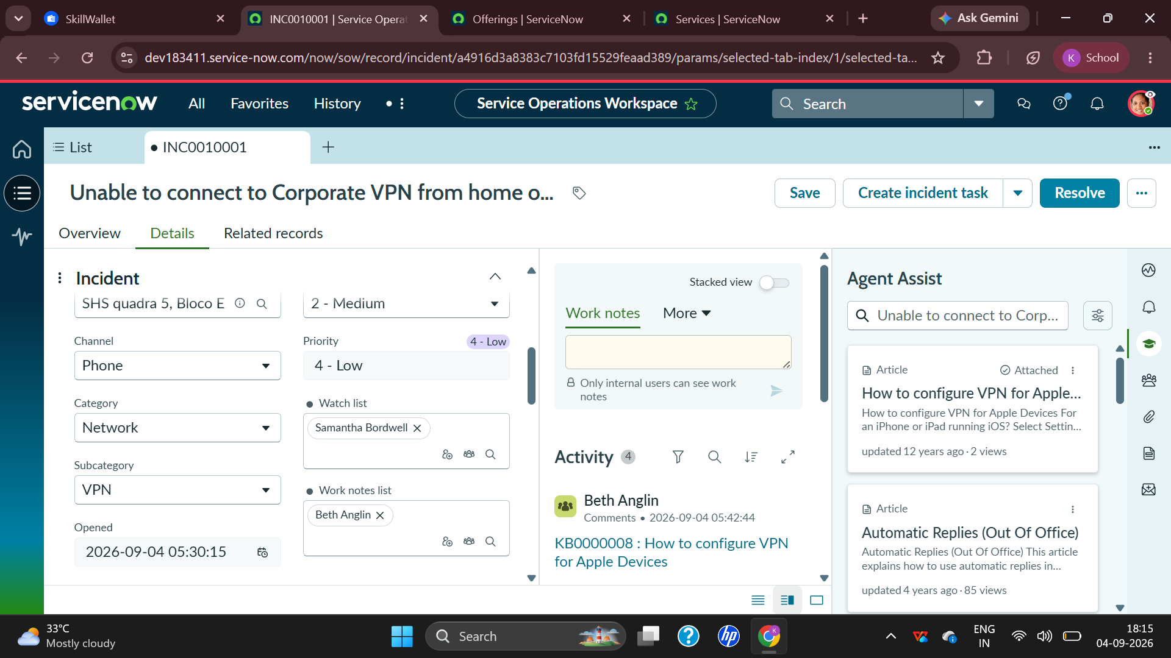ates

- required changes and supports On Hold status.
- SLA Layer – monitors response and resolution commitments.
- Resolution Layer – documents the cause, action taken, resolution code, and notes.

Figure 1: Service Operations Workspace showing the incident, classification, priority, work notes, activity, and Agent Assist areas.

5. PROJECT PLANNING & SCHEDULING
5.1 Project Planning
The project was planned as a practical ServiceNow Incident Management exercise in which the complete lifecycle of one incident is documented. Planning begins with understanding the project-report format and identifying the exact evidence required from the ServiceNow workspace. The selected incident, INC0010001, provides enough information to demonstrate classification, assignment, related records, cause analysis, SLA tracking, activity history, and resolution.
The first planning activity is requirement identification. The project requires an incident record, user and location details, classification, priority, assignment, investigation notes, state changes, cause, resolution, and screenshots. The second activity is workflow mapping. The incident is followed from its initial state through assignment and investigation, including the On Hold condition and later resolution. The third activity is evidence collection, where screenshots are captured from the workspace at each meaningful stage. The final activity is documentation, where screenshots are placed near the relevant explanation so that the report is easy to understand.
Planned Activities
- Understand the Incident Management workflow and the fields required for an enterprise incident.
- Select the corporate VPN incident as the practical project scenario.
- Capture initial incident information such as caller, location, channel, category, subcategory, impact, urgency, and priority.
- Record assignment details for the Network group and assigned technician.
- Review Related Records and document the Parent Incident relationship where applicable.
- Observe the On Hold state and the Awaiting Change reason.
- Document the probable cause identified during investigation.
- Review SLA information and Activity stream entries.
- Complete the resolution process using a resolution code and resolution notes.
- Organize screenshots and explanations according to the prescribed project-report format.
Scheduling and Sequence
The work follows a logical sequence rather than treating each screen as an independent task. Identification is completed first, followed by analysis and design. Planning then defines the testing and evidence requirements. Functional testing checks whether the incident fields and state transitions support the intended workflow. Finally, the results section presents the screenshots and the final resolution evidence. This sequence reduces duplication and ensures that every important ServiceNow activity is represented in the final report.
Stage 1 | Problem identification and incident creation
Stage 2 | Classification, prioritization, and assignment
Stage 3 | Investigation, knowledge support, and activity tracking
Stage 4 | Change dependency and On Hold management
Stage 5 | Cause identification and service restoration
Stage 6 | Resolution code, resolution notes, and closure
Stage 7 | Testing, screenshot collection, and final documentation
Project Planning Considerations
The planning approach emphasizes accuracy of the incident record. Field values should not be changed casually because they affect routing, priority, SLA interpretation, and reporting. The screenshots are treated as evidence of the practical workflow. The report also avoids assuming that every VPN issue has the same root cause; the documented cause belongs specifically to the incident shown in the practical screenshots. This distinction is important in a professional ITSM environment because incidents should be resolved using evidence rather than assumptions.
Another planning consideration is traceability. The report links the visible screens to the lifecycle stages they represent. For example, the Assignment screen demonstrates ownership, the Related Records screen demonstrates incident relationships, the Cause screen demonstrates technical analysis, and the Resolve dialog demonstrates formal closure. Together these records create a consistent project narrative from problem identification to resolution.

6. FUNCTIONAL AND PERFORMANCE TESTING
6.1 Performance Testing
Testing is performed to confirm that the incident workflow behaves as expected and that the important information remains visible and traceable throughout the lifecycle. Functional testing checks the correctness of individual fields and actions. Performance-oriented observation checks whether the workspace provides the required incident information, activity history, Agent Assist suggestions, and SLA indicators without preventing the agent from completing the workflow.
Functional Test Cases
Test ID | Area | Expected Result | Status
TC01 | Incident number | Verify that INC0010001 is displayed as the unique incident identifier. | Pass
TC02 | Caller | Verify that Michael Hoefer is recorded as the caller. | Pass
TC03 | Classification | Verify Category = Network and Subcategory = VPN. | Pass
TC04 | Priority | Verify Impact = 3 - Low, Urgency = 2 - Medium, and Priority = 4 - Low. | Pass
TC05 | Assignment | Verify Assignment group = Network and Assigned to = David Loo. | Pass
TC06 | State | Verify that the incident can be placed On Hold with Awaiting Change. | Pass
TC07 | Activity | Verify that field changes and activity entries are visible in the Activity stream. | Pass
TC08 | Related Records | Verify that the Parent Incident relationship can be recorded as shown. | Pass
TC09 | Cause | Verify that the probable cause can be entered and retained. | Pass
TC10 | Resolution | Verify that a resolution code and resolution notes can be provided during Resolve. | Pass
Performance Testing
Performance testing in this practical project is primarily observational because the project is focused on ITSM workflow rather than benchmarking server response time. The Service Operations Workspace is checked for the availability of the incident details, Activity stream, Work notes, Agent Assist content, and Record Information panel. The screenshots show that these components are available within the workspace and provide the information required for incident handling.
SLA visibility is also considered part of the operational performance of the workflow. The screenshots show response and resolution information in the Record Information panel. In one stage, the Response SLA is shown as completed while the Resolution SLA remains active. In another view, the response status is shown as “No matching SLA.” These values illustrate why agents should review the SLA panel instead of assuming that all incidents have identical timing conditions.
The testing results indicate that the project workflow supports the intended lifecycle: capture, classify, assign, investigate, hold for change, document cause, and resolve. The activity history provides traceability, while the resolution dialog enforces the completion of the final resolution information. This demonstrates that the ServiceNow incident record can act as the central operational record for the support process.
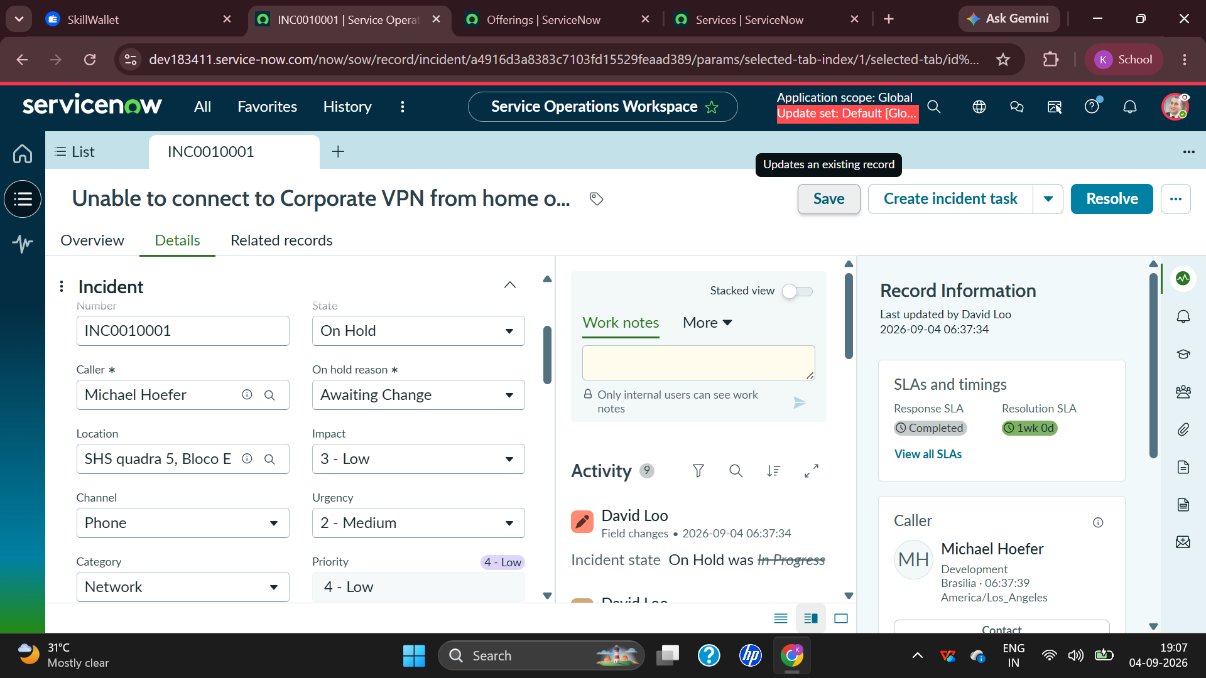
Figure 2: Incident fields showing On Hold state, Awaiting Change reason, impact, urgency, priority, and Activity history.

7. RESULTS
7.1 Output Screenshots
The practical result of the project is a documented ServiceNow incident lifecycle for the corporate VPN issue. The screenshots below are arranged in a logical sequence so that the reader can follow the incident from its visible details through assignment, related records, cause analysis, and final resolution. The screenshots are the same practical evidence collected from the ServiceNow workspace and are accompanied by explanations of the information visible in each screen.
Figure 3: Initial incident details and Agent Assist
This screen shows the Service Operations Workspace for the VPN incident. The incident is classified as Network and the priority is Low. The Work notes area is available for internal troubleshooting comments. The Activity area displays incident history, while Agent Assist provides knowledge suggestions. The screen demonstrates how the workspace brings operational information and support guidance together.
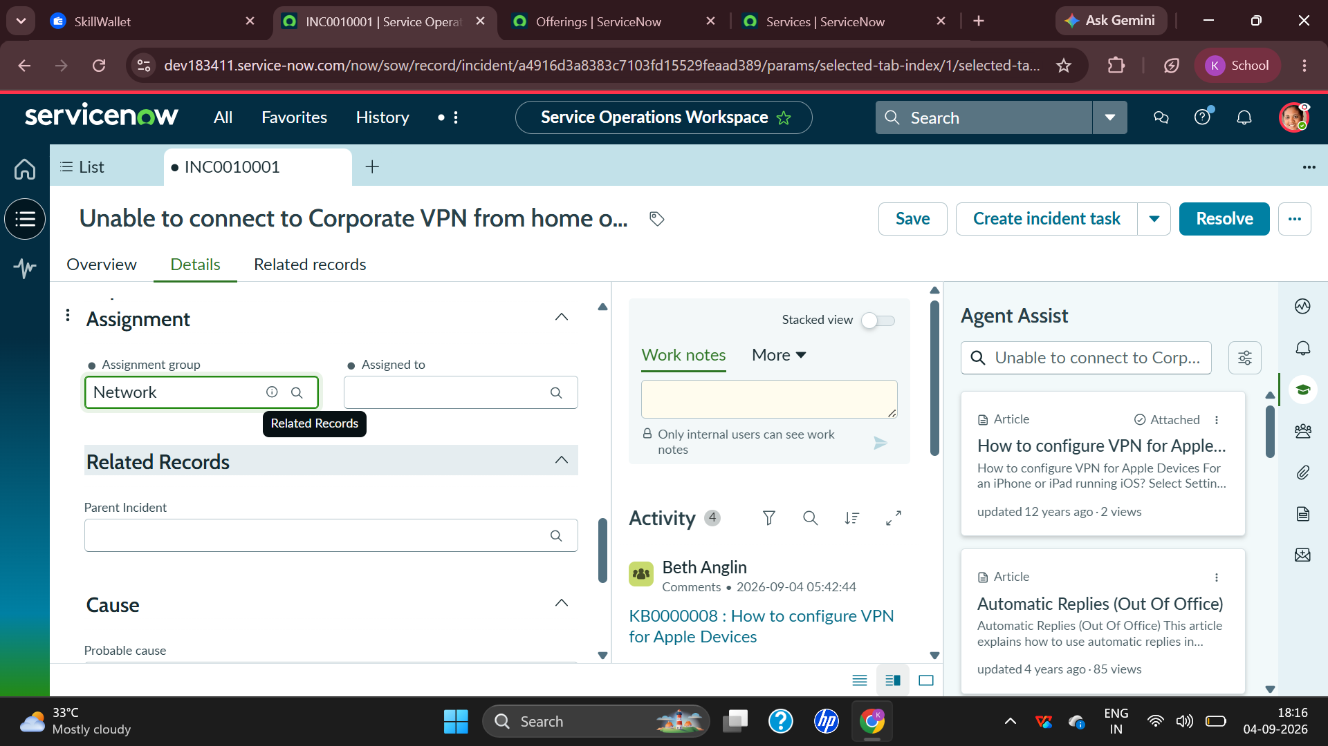
Figure 4: Assignment and Related Records
The Assignment section shows the Network assignment group. The Related Records area is visible below it, providing a place for relationships such as Parent Incident. This screen demonstrates ownership and relationship management, both of which are important when an incident is connected to a wider service issue.

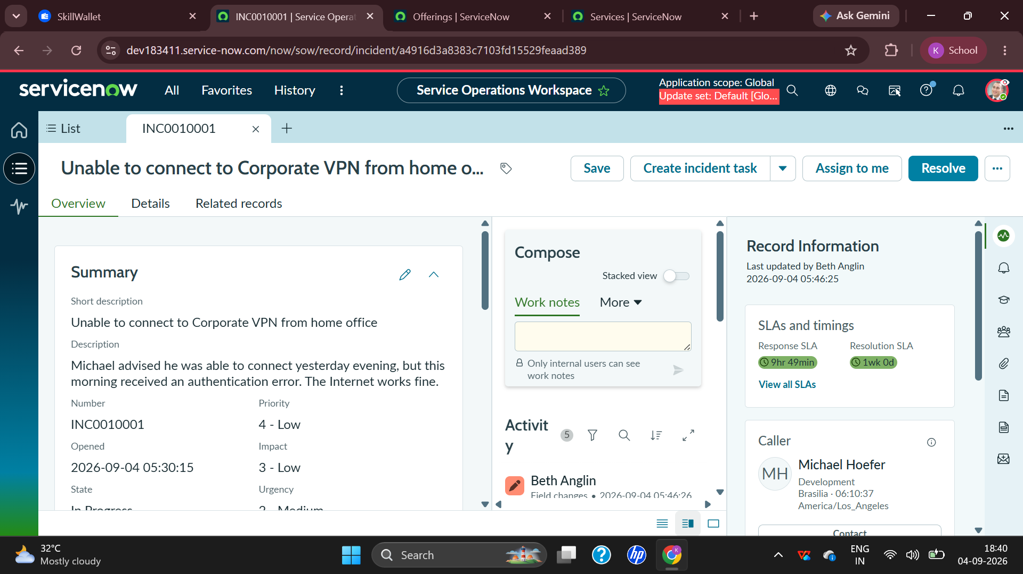
Figure 5: Incident overview
The Overview screen provides a concise summary of the incident. It shows the short description, detailed description, incident number, priority, opened time, impact, urgency, state, and caller information. The description explains that the VPN worked the previous evening but an authentication error appeared in the morning while Internet access continued to work.

Figure 6: Incident state and operational fields
This screen shows the incident details with caller, state, location, channel, category, impact, urgency, and priority. The incident is On Hold with the reason Awaiting Change. The Activity stream records the state change, showing how the platform preserves an audit trail.

Figure 7: On Hold state with Awaiting Change
The On Hold state is clearly visible along with the Awaiting Change reason. The Network category, impact, urgency, and priority are also visible. This represents a stage where the support team is waiting for a required operational change before the incident can continue toward resolution.
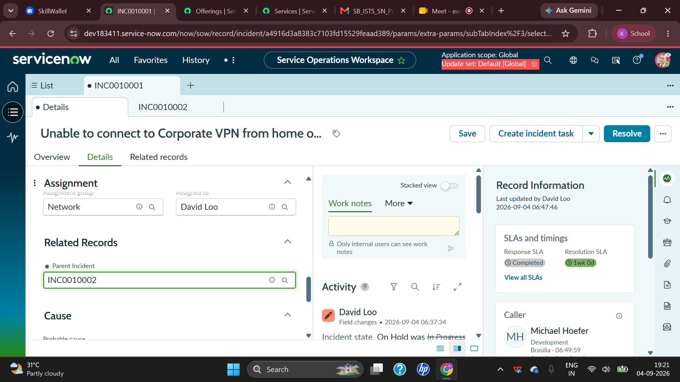
Figure 8: Assignment and Parent Incident relationship
The Assignment section shows Network as the assignment group and David Loo as the assigned technician. The Related Records area shows Parent Incident INC0010002. This demonstrates how ServiceNow can connect incidents and maintain ownership at the same time.
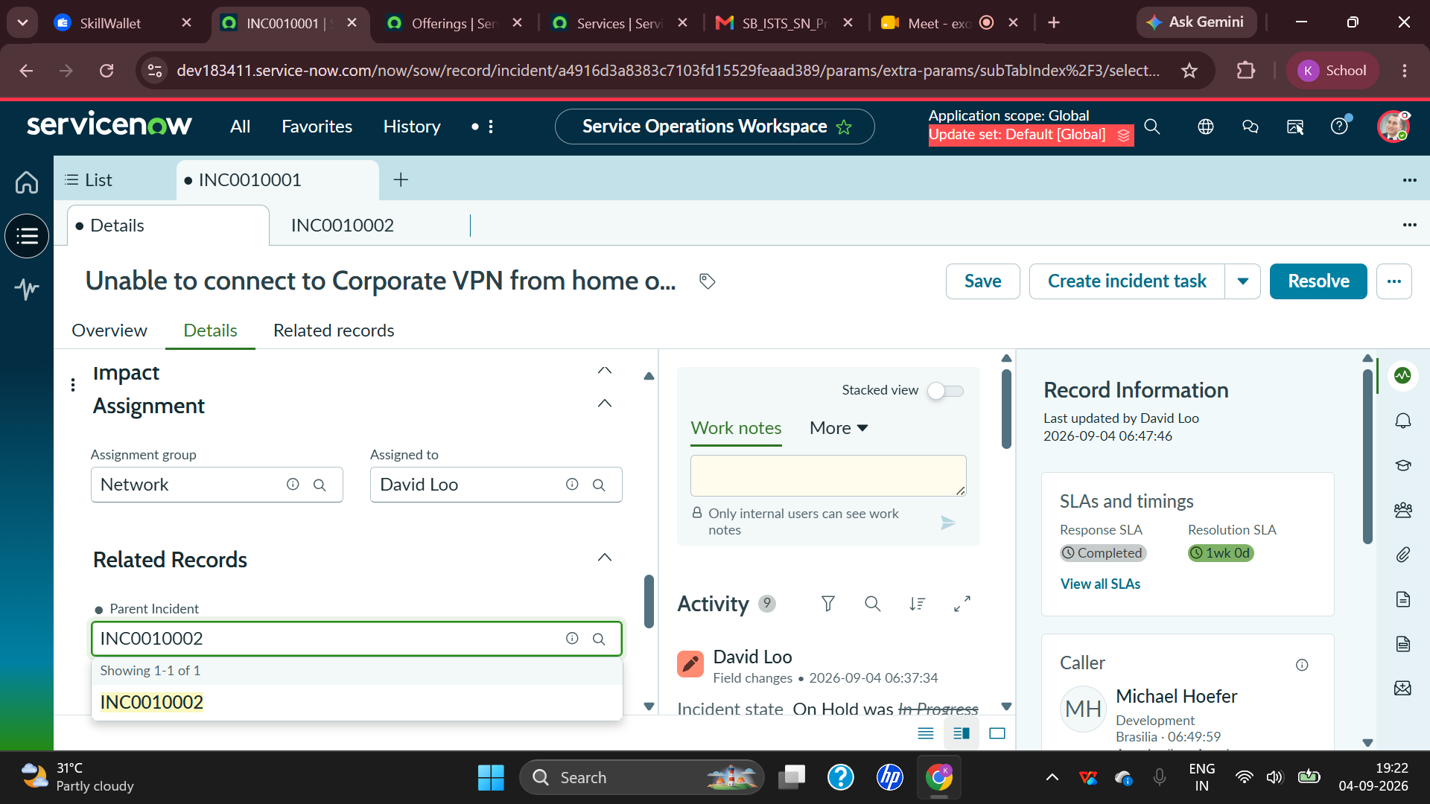
Figure 9: Related Records and activity
The Related Records section contains the Parent Incident reference, while the right side continues to show Record Information and activity. This screen provides evidence that the incident relationship was stored in the record and that the activity history remains available during investigation.
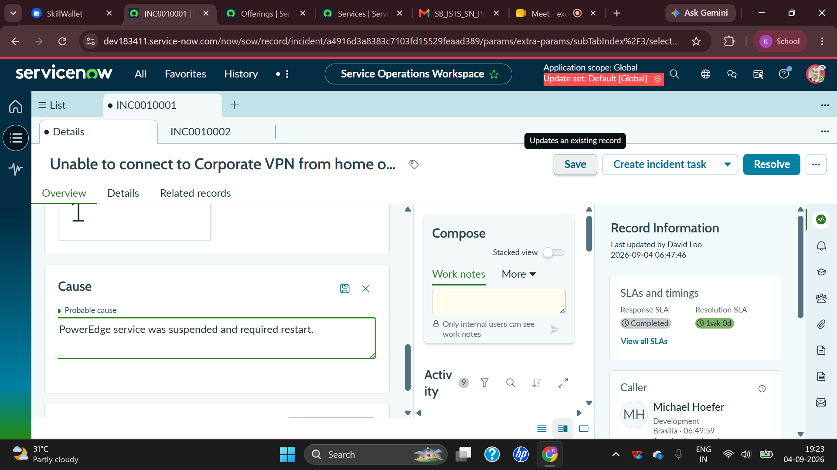
Figure 10: Probable cause
The Cause section contains the probable cause: “PowerEdge service was suspended and required restart.” This is an important result because it converts the investigation into a documented technical conclusion rather than leaving the incident with only the original symptom.
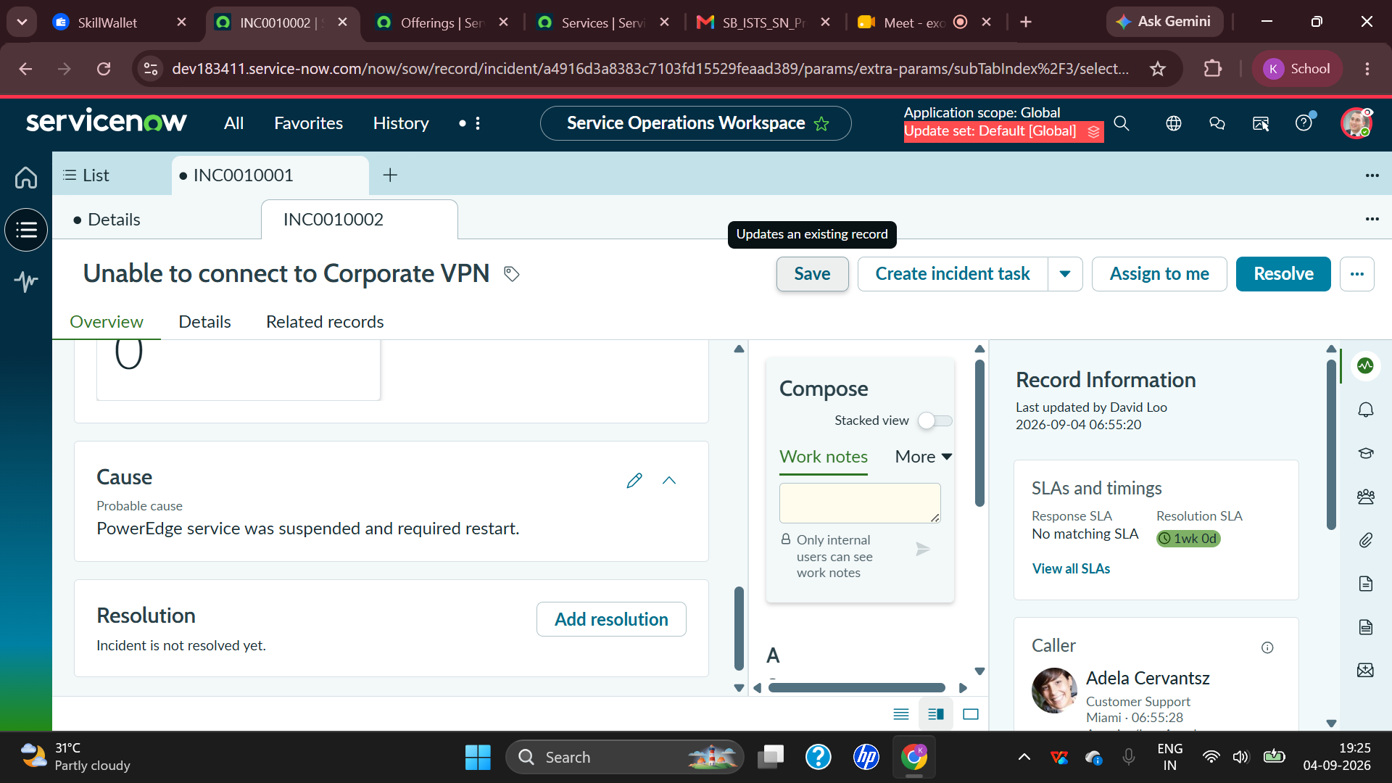
Figure 11: Cause and Resolution sections
The screen shows the Cause section together with the Resolution area. The resolution area indicates that the incident is not resolved yet at that stage. This demonstrates the distinction between identifying a probable cause and formally completing the resolution process.
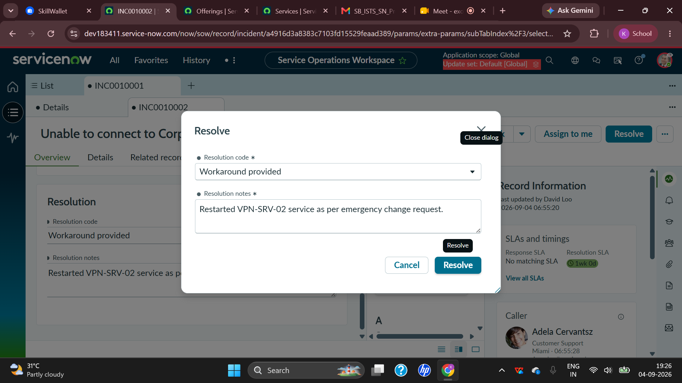
Figure 12: Resolve dialog
The Resolve dialog requires a Resolution code and Resolution notes. The selected code is “Workaround provided.” The notes state that the VPN-SRV-02 service was restarted as per an emergency change request. This is the final evidence of the technical action used to restore service.
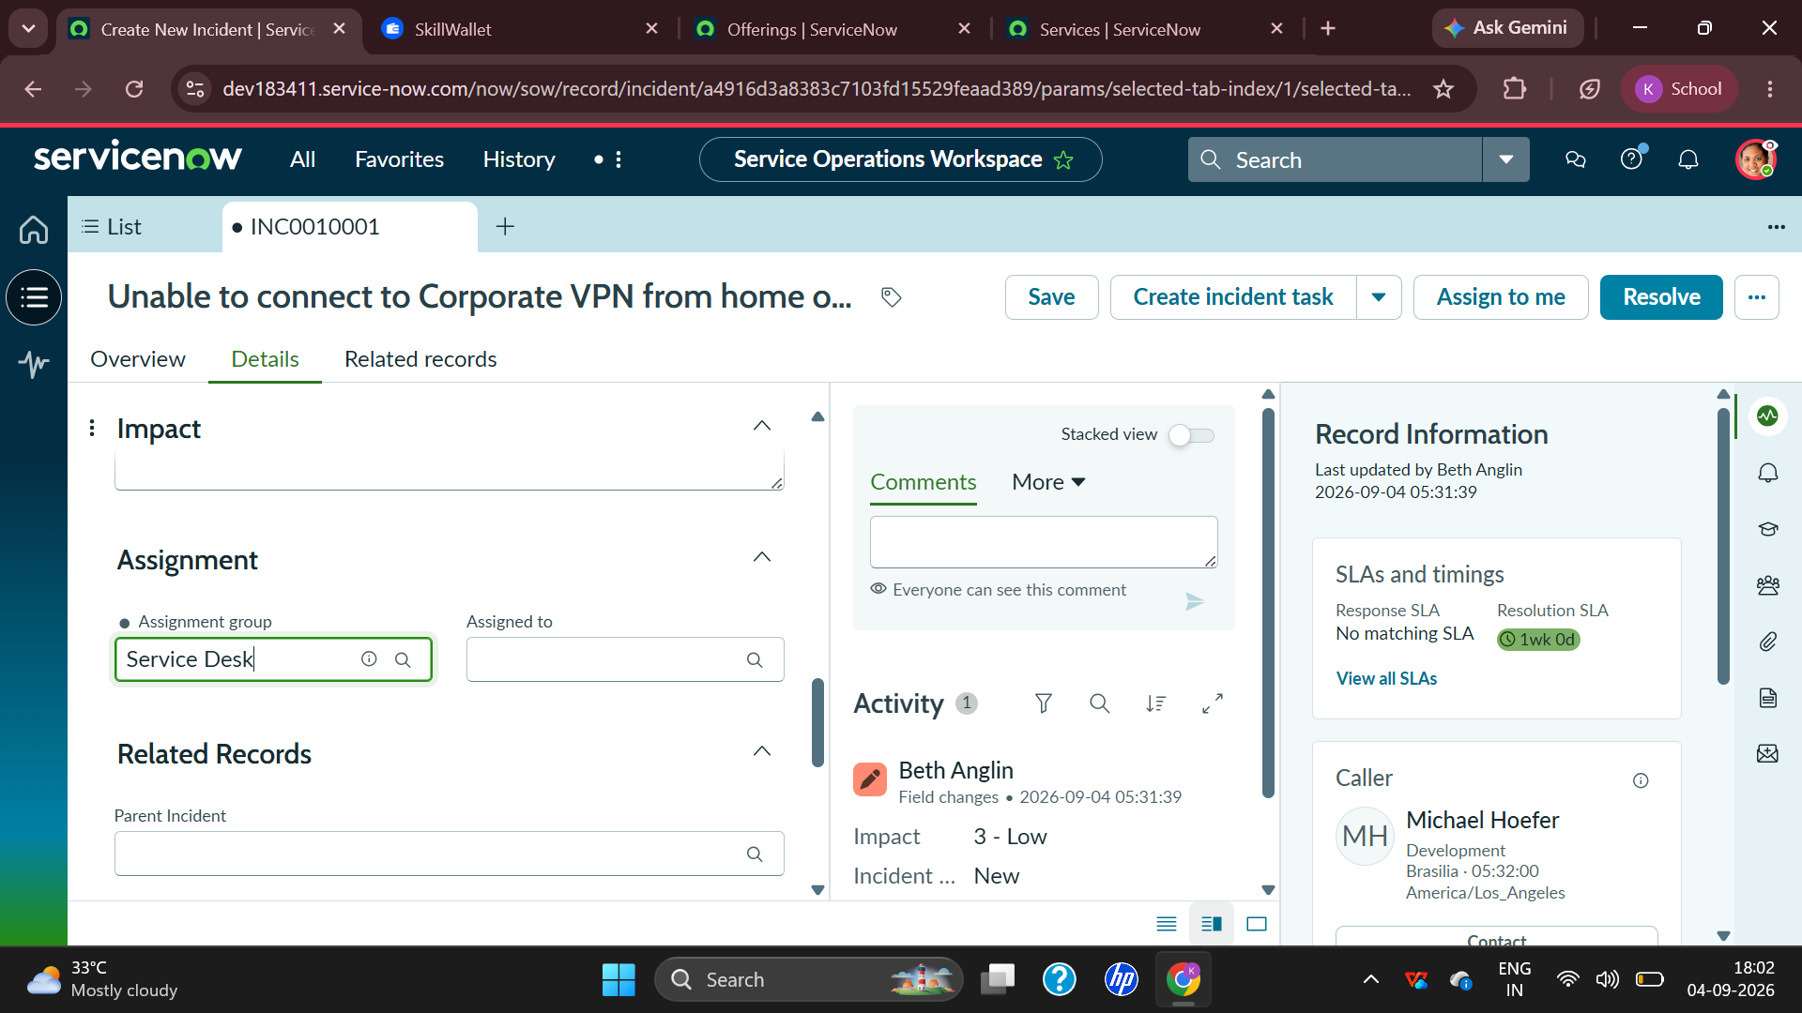
Figure 13: Assignment and incident activity
This workspace view provides additional evidence of the assignment and incident activity. It shows the incident being managed by the Network team and provides the Activity stream for tracking changes and operational updates.

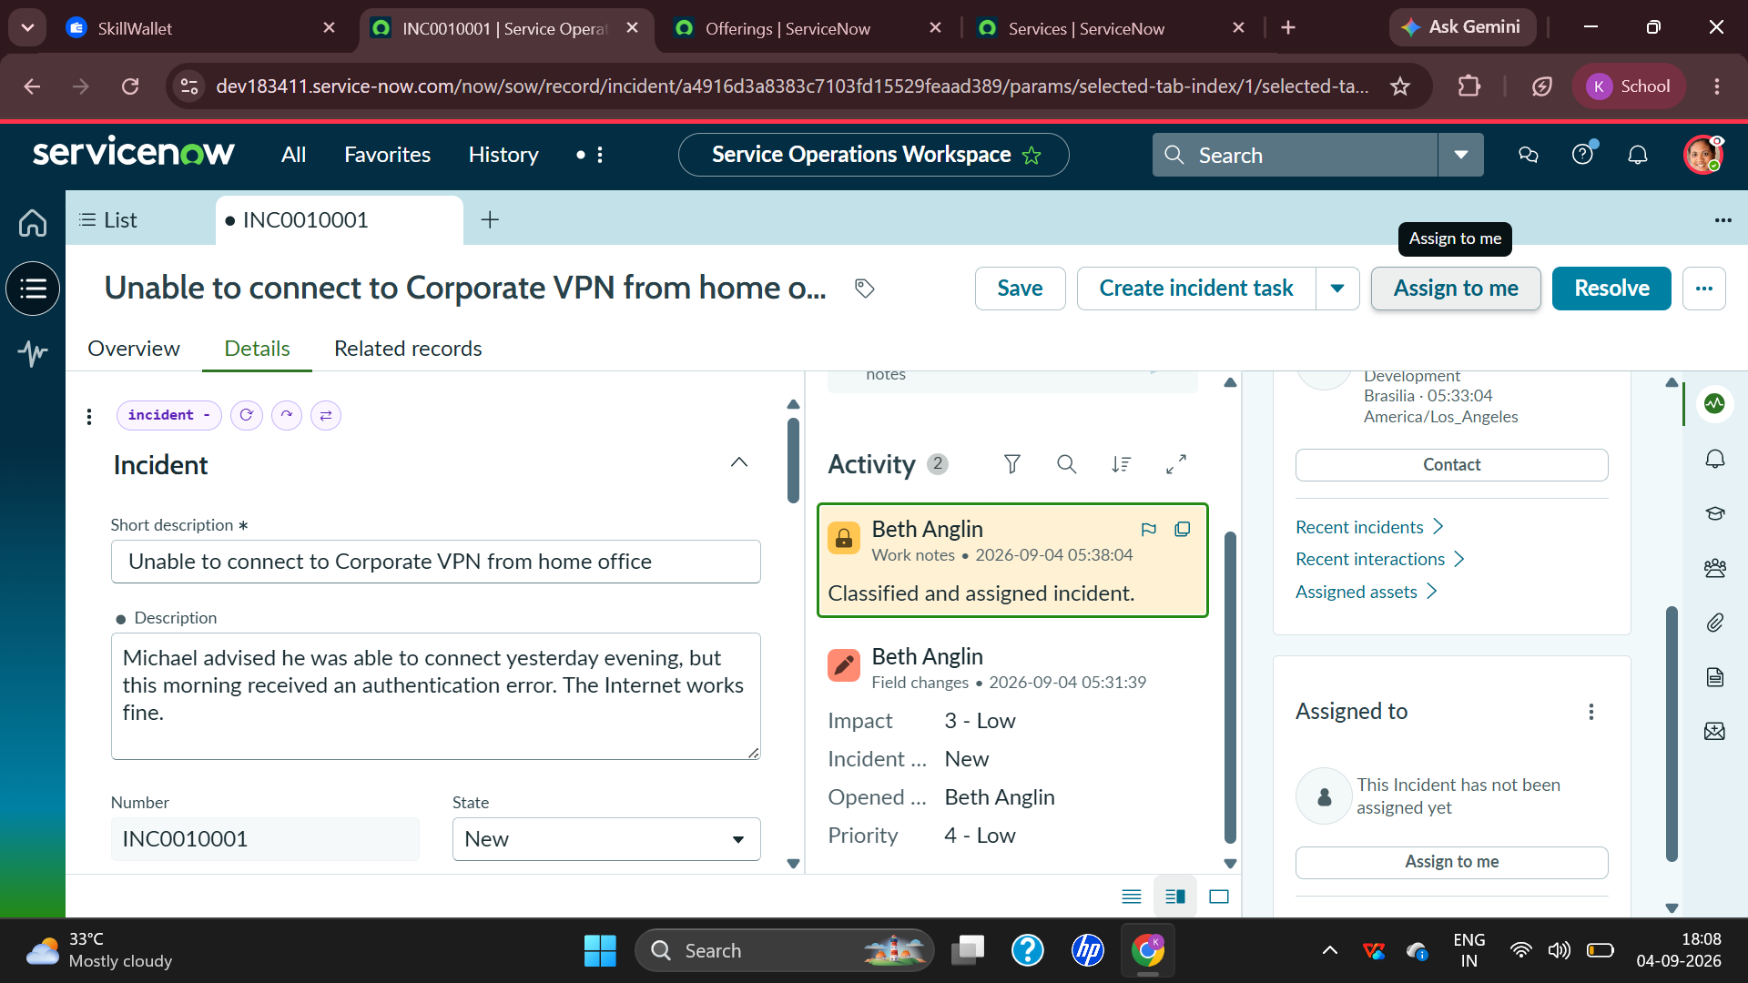
Figure 14: Incident activity and summary
This screen provides another view of the incident workspace and activity information. It supports the overall result by showing that the incident record contains both structured fields and a chronological activity history.
Overall, the results demonstrate a complete and traceable incident-management workflow. The user-facing problem is converted into structured service information, routed to the correct support team, investigated, associated with a change dependency, documented with a probable cause, and completed using formal resolution details. The screenshots also show how ServiceNow provides a consistent interface for operational teams to work on the same record from different stages of the lifecycle.

8. ADVANTAGES AND DISADVANTAGES
8.1 Advantages
- Centralized incident tracking: All important information about the VPN issue is stored in one incident record.
- Clear ownership: Assignment group and Assigned To fields make responsibility visible to the support team.
- Structured classification: Network and VPN classification helps route similar incidents consistently.
- Priority management: Impact, urgency, and priority provide a standard approach to determining attention level.
- Audit trail: The Activity stream records field changes and important operational events.
- Knowledge support: Agent Assist can surface relevant knowledge articles while the agent is investigating.
- SLA visibility: Response and resolution information helps the support organization monitor service commitments.
- Dependency management: On Hold and Awaiting Change make it clear when progress depends on another operational action.
- Cause documentation: The Cause section captures the technical understanding reached during investigation.
- Formal closure: Resolution code and resolution notes provide a structured end point for the incident.
- Related records: Parent Incident and other relationships can connect individual issues to broader operational problems.
- Reporting potential: Structured incident data can later be used for dashboards, trends, recurring-issue analysis, and service improvement.
8.2 Disadvantages
- Configuration complexity: A large ServiceNow environment may require administrators to configure workflows, fields, roles, and policies.
- Training requirement: Agents need practice to classify incidents correctly and use the workflow consistently.
- Data quality dependency: Incorrect categories, priorities, or assignment information can reduce the value of reports and routing.
- Process dependency: Resolution can be delayed when an incident depends on another team or an approved change.
- Knowledge maintenance: Agent Assist and knowledge suggestions are only useful when knowledge content is accurate and up to date.
- User-interface complexity: A workspace with many panels and fields may appear complex to a new agent.
- Cost and administration: Enterprise platforms require governance, maintenance, access management, and ongoing configuration.
- Not every issue has the same cause: A VPN incident can have many possible technical causes, so the workflow cannot replace proper diagnosis.
Comparison of Advantages and Disadvantages
Advantage | Operational benefit | Related limitation
Centralized record | Improves traceability | Requires accurate data entry
Assignment | Creates clear ownership | Incorrect routing can delay resolution
SLA tracking | Improves service visibility | Depends on correct SLA configuration
Agent Assist | Provides knowledge quickly | Knowledge must remain current
On Hold workflow | Represents dependencies clearly | Waiting for change may extend resolution time
Resolution fields | Creates a clear closure record | Agents must provide meaningful notes

9. CONCLUSION
This project successfully demonstrates the Incident Management lifecycle in ServiceNow using a corporate VPN connectivity issue as the practical scenario. The incident begins with a user reporting that the corporate VPN cannot be accessed from the home office even though the Internet connection is working. The problem is converted into incident INC0010001 and captured using structured fields such as caller, location, channel, category, subcategory, impact, urgency, and priority.
The project then demonstrates ownership and investigation. The incident is assigned to the Network group and later to David Loo. The Activity stream provides a history of field changes and operational activity. Agent Assist provides knowledge support, showing how an agent can use relevant articles while troubleshooting. The Related Records area demonstrates how an incident can be connected to a Parent Incident when required.
A key part of the project is the On Hold state. The incident is placed On Hold with the reason Awaiting Change, representing a dependency on an operational change. The probable cause is documented as a suspended PowerEdge service requiring a restart. The final resolution information records that VPN-SRV-02 was restarted under an emergency change request. The Resolve dialog captures the resolution code “Workaround provided” and the corresponding resolution notes.
The screenshots collected during the practical work provide visual evidence of each stage. They show that ServiceNow can keep the user's problem, technical investigation, assignment information, SLA status, activity history, cause, and resolution within a single managed record. This makes the platform suitable for structured incident handling in enterprise environments.
From the learning perspective, the project provides practical understanding of ITSM concepts such as incident identification, classification, prioritization, assignment, state management, change dependency, knowledge support, SLA monitoring, root-cause documentation, and formal resolution. The workflow also demonstrates why clear documentation is important: another technician can review the record and understand what happened without depending entirely on informal communication.
In conclusion, the project meets its objective of documenting a complete ServiceNow Incident Management process in a clear and evidence-based manner. The same approach can be extended to other incidents such as application failures, hardware issues, access problems, email problems, or network outages. The structured lifecycle provides a strong foundation for improving support quality, reporting, and service reliability.

10. FUTURE SCOPE
The current project demonstrates a manually managed incident lifecycle. The future scope is to extend the same workflow with automation, analytics, artificial intelligence, and deeper integration with other ITSM processes. These improvements can reduce repetitive work for agents and help organizations identify and prevent recurring incidents.
AI-based incident classification: Use natural-language understanding to identify the likely category, subcategory, assignment group, and priority from the incident description.
Automated incident assignment: Route Network/VPN incidents automatically to the correct support group based on service, location, and issue type.
AI-assisted troubleshooting: Recommend troubleshooting steps, relevant knowledge articles, and similar resolved incidents based on the current incident.
Automatic incident summarization: Generate concise summaries of the incident history, actions taken, current state, and next steps.
Predictive incident management: Analyze historical incidents to identify patterns and predict recurring VPN or infrastructure failures.
Monitoring integration: Create incidents automatically when monitoring systems detect VPN service failures, server issues, or network anomalies.
Change and incident integration: Automatically associate incidents with the change request responsible for service restoration and preserve the full dependency chain.
Problem Management integration: Create problem records for repeated VPN incidents and use root-cause analysis to eliminate recurring failures.
SLA prediction and alerts: Provide proactive warnings when an incident is likely to miss its response or resolution target.
Dashboards and analytics: Build dashboards showing incident volume, priority distribution, resolution time, recurring categories, SLA compliance, and assignment-team performance.
Self-service support: Allow users to search knowledge articles and follow guided troubleshooting steps before raising an incident.
Mobile support: Provide support agents with mobile access to incidents, approvals, notifications, and resolution activities.
The most valuable future improvement for this project would be the combination of AI-based classification, knowledge recommendation, and automated assignment. When a user reports a VPN problem, the system could identify the service and likely category, recommend the correct knowledge articles, compare the issue with previous incidents, and route it to the Network team automatically. The agent could then spend more time on diagnosis and communication rather than repetitive record preparation.
Another important extension is proactive service management. If VPN-SRV-02 or the underlying infrastructure is monitored continuously, an automated event could detect a service interruption before many users report it. ServiceNow could create an incident, correlate it with other incidents, associate a problem record when a recurring pattern is detected, and trigger the appropriate change workflow. This would move the organization from reactive incident handling toward proactive service reliability.
11. APPENDIX
Source Code (if any)
This project is a ServiceNow platform-based practical implementation. No standalone application source code is required for the demonstrated Incident Management workflow. The project primarily uses ServiceNow configuration, incident records, workspace functionality, assignment, state management, knowledge support, SLA information, and resolution features. If custom scripts, business rules, client scripts, or flows are added in a future version, they can be attached to this section as supporting source code.
Dataset Link
Not applicable. The project does not depend on a conventional external dataset. The evidence is generated from ServiceNow incident records and the practical configuration/workflow used in the training instance. The incident data shown in this report is the project record used to demonstrate the lifecycle.
GitHub & Project Demo Link
GitHub link: Not provided for this platform-based project. Project demo: The practical demonstration is available through the ServiceNow training/developer instance used for the project. A repository or public demo URL can be added here if one is created later.
Additional Incident Information
Incident | INC0010001
Issue | Unable to connect to Corporate VPN from home office
Caller | Michael Hoefer
Category | Network
Subcategory | VPN
State shown during workflow | On Hold
On Hold reason | Awaiting Change
Assignment group | Network
Assigned to | David Loo
Parent Incident shown | INC0010002
Probable cause | PowerEdge service was suspended and required restart.
Resolution code | Workaround provided
Resolution notes | Restarted VPN-SRV-02 service as per emergency change request.

Screenshot Evidence
The following screenshots are included as practical evidence of the ServiceNow workflow:
Figure 3: Initial incident details and Agent Assist
Figure 4: Assignment and Related Records
Figure 5: Incident overview
Figure 6: Incident state and operational fields
Figure 7: On Hold state with Awaiting Change
Figure 8: Assignment and Parent Incident relationship
Figure 9: Related Records and activity
Figure 10: Probable cause
Figure 11: Cause and Resolution sections
Figure 12: Resolve dialog
Figure 13: Assignment and incident activity
Figure 14: Incident activity and summary

END OF PROJECT REPORT

