Incident Response Plan Development for Digital Services

Executive Summary
This Incident Response Plan (IRP) provides a structured approach for identifying, managing, containing, eradicating, and recovering from cybersecurity incidents affecting a hypothetical Citizen Service Portal (CSP).

1. Introduction
Purpose: The purpose of this Incident Response Plan is to establish a comprehensive framework for responding to cybersecurity incidents within an e-governance digital service environment. The plan ensures that incidents are detected promptly, managed effectively, and resolved with minimal impact on government operations and citizen services.
Scope: This plan applies to all components of the Citizen Service Portal, including:
- Web applications
- Application servers
- Databases
- Cloud infrastructure
- Government employee accounts
- Network infrastructure
- Citizen-facing services
Objectives: The primary objectives of this Incident Response Plan are:
- Protect sensitive citizen information.
- Minimize operational disruption.
- Ensure rapid incident detection and response.
- Restore affected systems efficiently.
- Improve organizational resilience against future attacks

2. Overview of the Citizen Service Portal
The Citizen Service Portal (CSP) is a hypothetical e-governance platform that provides citizens with access to various public services, including:
- Tax payments
- Certificate applications
- Welfare scheme registrations
- Identity verification services
- Public grievance management
The portal stores and processes sensitive personal information, making it a high-value target for cybercriminals and other threat actors.

3. Common Cyber Incidents
Government digital platforms face numerous cybersecurity threats that can impact service availability, data security, and public trust.
Incident Type | Description | Potential Impact
Data Breach | Unauthorized access to sensitive citizen data | Privacy violations and identity theft
Phishing Attack | Fraudulent attempts to steal credentials | Unauthorized system access
DDoS Attack | Flooding systems with excessive traffic | Service disruption
Ransomware | Malicious encryption of data and systems | Operational shutdown
Insider Threat | Unauthorized actions by employees | Data leakage and misuse
Malware Infection | Installation of malicious software | System compromise
SQL Injection | Exploitation of application vulnerabilities | Database manipulation

4. Incident Response Lifecycle
An effective incident response process follows a structured lifecycle to ensure consistency and efficiency.
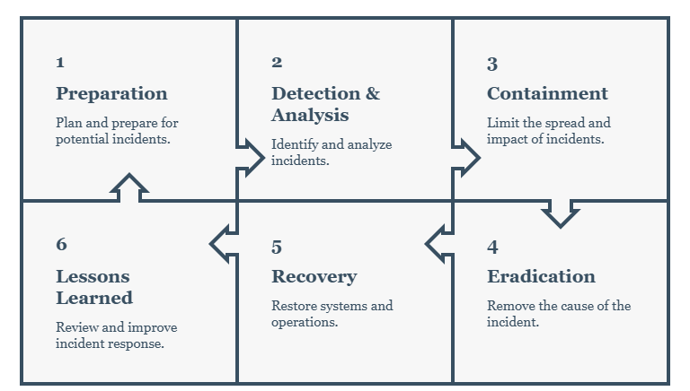
Phase 1: Preparation
Preparation involves establishing security policies, incident response procedures, communication protocols, backup mechanisms, and employee awareness programs. Regular training and simulation exercises help ensure organizational readiness.
Phase 2: Detection and Analysis
Cybersecurity incidents are identified through security monitoring tools, intrusion detection systems, log analysis, threat intelligence feeds, and user reports. Security analysts verify alerts to determine whether a genuine incident has occurred.
Phase 3: Containment
Once an incident is confirmed, immediate containment measures are implemented to prevent further damage. Examples include isolating affected systems, disabling compromised accounts, and blocking malicious network traffic.
Phase 4: Eradication
The root cause of the incident is identified and removed. Malware is eliminated, vulnerabilities are patched, and compromised credentials are reset.
Phase 5: Recovery
Systems are restored from secure backups, security controls are validated, and normal operations resume under enhanced monitoring.
Phase 6: Lessons Learned
A post-incident review is conducted to analyze the effectiveness of the response process and identify opportunities for improvement.

5. Incident Identification Process
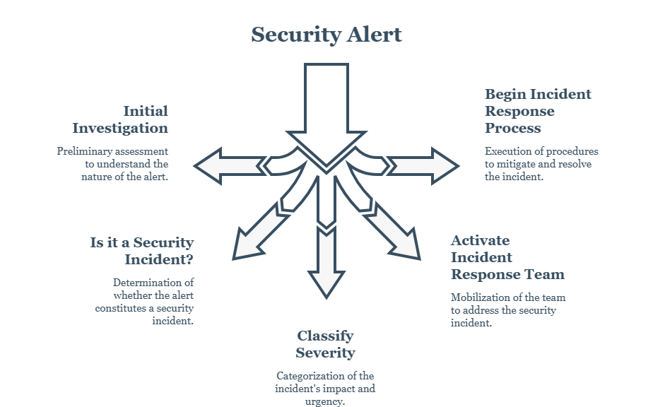
Security Alert:
A potential security event is detected through monitoring tools, SIEM systems, IDS/IPS alerts, firewall logs, antivirus software, threat intelligence feeds, or user reports.
Initial Investigation:
The security team performs a preliminary analysis to determine whether the alert represents a genuine cybersecurity incident or a false positive.
Incident Verification:
The event is evaluated to confirm whether it poses a threat to system confidentiality, integrity, or availability.
Incident Response Team Activation:
Depending on the severity level, the Incident Response Team (IRT) is notified and assigned responsibilities.
Begin Response Process:
The organization proceeds with containment, eradication, recovery, and post-incident activities according to the Incident Response Plan.
Severity Level | Description:
Critical | Significant impact on operations or data
High | Serious threat requiring immediate action
Medium | Limited impact with manageable risk
Low | Minor security event with minimal impact

6. Response Procedures
Data Breach Response:
Immediate Actions
- Identify affected systems.
- Disable compromised user accounts.
- Isolate affected servers.
- Preserve evidence for investigation.
Short-Term Actions
- Conduct forensic analysis.
- Notify management and relevant authorities.
- Assess the extent of data exposure.
Long-Term Actions
- Strengthen access controls.
- Implement Multi-Factor Authentication (MFA).
- Conduct regular security audits.
Phishing Attack Response
Immediate Actions
- Block malicious domains and email addresses.
- Disable compromised accounts.
- Alert affected users.
Short-Term Actions
- Reset passwords.
- Scan affected systems.
- Review email security configurations.
Long-Term Actions
- Conduct awareness training.
- Implement advanced email filtering solutions.
- Perform regular phishing simulations.
DDoS Attack Response
Immediate Actions
- Activate DDoS mitigation services.
- Filter malicious traffic.
- Notify network administrators.
Short-Term Actions
- Increase infrastructure capacity.
- Monitor network performance.
Long-Term Actions
- Implement rate limiting.
- Deploy Content Delivery Networks (CDNs).
- Improve traffic analysis capabilities.
Ransomware Response
Immediate Actions
- Disconnect infected systems.
- Isolate affected network segments.
- Prevent further spread.
Short-Term Actions
- Identify affected assets.
- Assess backup availability.
- Conduct malware analysis.
Long-Term Actions
- Strengthen endpoint security.
- Improve backup procedures.
- Conduct employee awareness programs.

7. Communication Flow
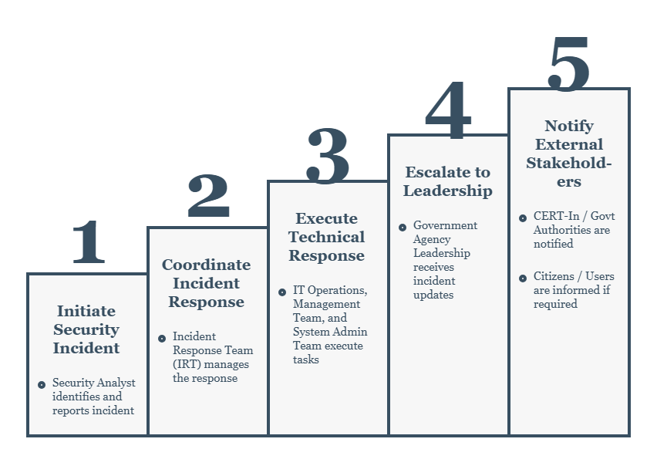
Security Analyst: The Security Analyst is responsible for detecting, investigating, and validating security incidents. Once an incident is confirmed, it is immediately reported to the Incident Response Team.
Incident Response Team (IRT): The Incident Response Team coordinates all response activities, assigns responsibilities, and ensures that containment and recovery actions are executed effectively.
IT Operations Team: The IT Operations Team assists in maintaining service availability, implementing temporary fixes, and restoring affected systems.
System Administration Team: System administrators perform technical actions such as disabling compromised accounts, applying security patches, and restoring system configurations.
Management Team: Senior management evaluates the business impact of the incident, approves major decisions, and coordinates organizational resources.
Government Agency Leadership: Leadership receives status updates regarding the incident and ensures compliance with organizational policies and regulatory requirements.
CERT-In and Government Authorities: For major cybersecurity incidents, appropriate authorities such as CERT-In may be notified according to government regulations and reporting requirements.
Citizens and Service Users: If the incident affects public services or citizen data, transparent communication may be provided regarding service disruptions, security measures, and recommended actions.

8. Recovery Procedures
Recovery activities focus on restoring services while ensuring security.
System Restoration
- Restore systems from verified backups.
- Rebuild compromised systems if required.
- Verify integrity of restored data.
Validation
- Conduct vulnerability assessments.
- Perform security testing.
- Confirm operational functionality.
Monitoring
- Implement enhanced monitoring.
- Review security logs.
- Conduct threat hunting activities.

9. Post-Incident Analysis
Root Cause Analysis
The investigation should determine:
- How the incident occurred.
- Which vulnerabilities were exploited.
- Which systems were affected.
- The overall impact on operations.
Lessons Learned
The organization should document:
- Successful response activities.
- Areas requiring improvement.
- Security gaps discovered.
- Updated recommendations for future prevention.

10. Security Best Practices
To strengthen cybersecurity resilience, the following best practices are recommended:
Authentication and Access Control
- Enforce strong password policies.
- Implement Multi-Factor Authentication (MFA).
- Apply Role-Based Access Control (RBAC).
- Follow the Principle of Least Privilege.
Data Protection
- Encrypt sensitive data at rest and in transit.
- Perform regular data backups.
- Implement secure communication protocols.
System Security
- Apply security patches promptly.
- Conduct vulnerability assessments.
- Deploy endpoint protection solutions.
Monitoring and Logging
- Maintain detailed audit logs.
- Monitor network traffic continuously.
- Deploy SIEM solutions.
User Awareness
- Conduct cybersecurity training programs.
- Educate employees about phishing attacks.
- Promote secure digital practices.

11. Key Recommendations
Based on this assessment, the following recommendations are proposed:
- Establish a dedicated Security Operations Center (SOC).
- Conduct periodic penetration testing.
- Implement Zero Trust security principles.
- Integrate threat intelligence services.
- Strengthen cloud security controls.
- Perform regular incident response exercises.
- Enhance employee cybersecurity awareness programs.

12. Incident Response Team Roles and Responsibilities
Role | Responsibility
Incident Manager | Coordinates response activities
Security Analyst | Investigates incidents
System Administrator | Restores systems
Network Administrator | Contains network threats
Communications Officer | Handles stakeholder communication

13. Conclusion
Cybersecurity incidents can significantly impact the availability, integrity, and confidentiality of e-governance services. A well-defined Incident Response Plan enables organizations to respond effectively to security incidents while minimizing operational disruption and protecting citizen information. By implementing structured response procedures, maintaining clear communication channels, and continuously improving security controls, government organizations can enhance resilience and maintain public trust in digital services.

References
1. NIST Incident Response Framework (SP 800-61)
2. NIST Cybersecurity Framework (CSF)
3. OWASP Top 10 Security Risks
4. Microsoft Security Response Guidance
5. CERT-In Cybersecurity Guidelines
6. ISO/IEC 27001 Information Security Management Standard

