SLE-3: Architectural Design (Full C4 Model)
Course: 02AML204 – Introduction to Artificial Intelligence

PRN: 25UAM096
Name: Pranjal Vijay Mane
Division: B
Date: 04-10-2026
GitHub Link (optional): https://github.com/manepranjal07-design/SLE-AI.git

--------------------------------------------------
1. System Title & Short Description
System Title: 8-Puzzle Solver System (Empirical Search Engine)
This system is an intelligent search-based application designed to solve the classic 8Puzzle problem using both uninformed (BFS) and informed (A*) search strategies. It takes a 3x3 initial board configuration, evaluates state transitions, applies heuristic metrics (Manhattan Distance), and generates the optimal sequence of moves to achieve the goal state (1, 2, 3, 4, 5, 6, 7, 8, 0).

- Context Diagram (Level 1)
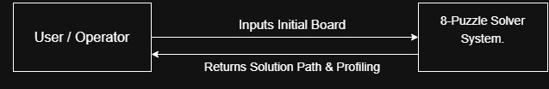
Short explanation (3–5 lines) : The Context diagram shows the system boundary at a high level. The user (student/operator) interacts directly with the 8-Puzzle Solver System by providing an initial scrambled board state. The system processes the request using internal search routines and outputs the optimal solution path along with profiling metrics (execution time and nodes expanded).

- Container Diagram (Level 2)
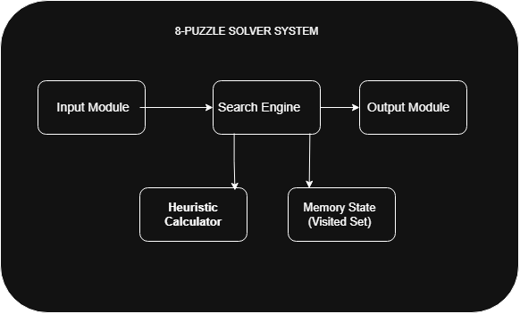

Explanation of each container :
- Input Module: Parses, validates, and initializes the starting state and goal state tuples.
- Search Engine: Executes the chosen search algorithm (BFS or A*) to explore valid board moves.
-Heuristic Calculator: Computes Manhattan Distance values for candidate states during A* execution.
-Memory State (Visited Set): Tracks explored states and best path costs (𝑔-scores) to prevent loops and redundant evaluation.
-Output Module: Formats the final solution path, node expansion counts, and execution timings for display.

- Component Diagram (Level 3)
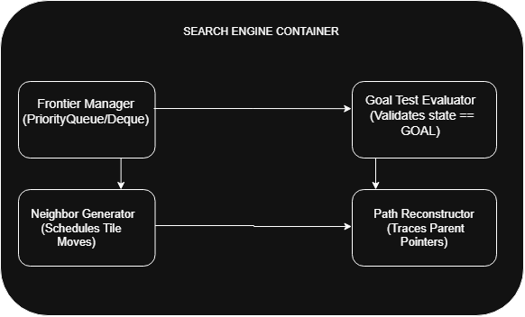
Short explanation of components (3–5 lines):
  - Frontier Manager: Maintains candidate states in queue structures (deque for BFS, heapq priority queue for A*).
  - Goal Test Evaluator: Compares popped board configurations against the target state (1, 2, 3, 4, 5, 6, 7, 8, 0).
  - Neighbor Generator: Calculates valid blank tile (0) movements (Up, Down, Left, Right) to yield child configurations.
  - Path Reconstructor: Backtracks through recorded parent pointers upon goal detection to assemble the complete move order.

- Code Level Overview (Level 4)

Main classes / functions:

- class Node: Represents a state in the search tree containing the board tuple, parent node pointer, step cost (𝑔), and total evaluation cost (𝑓).
- def get_neighbors(state): Generates valid adjacent board configurations by moving the blank tile (0) up, down, left, or right.
- def manhattan_distance(state): Heuristic function that calculates the sum of vertical and horizontal distances of tiles from their goal positions.
- def bfs(start, goal): Implements Breadth-First Search using a FIFO queue (deque) to explore states level-by-level.
- def astar(start, goal): Implements A* Search using a priority queue (heapq) sorted by 𝑓(𝑛) = 𝑔(𝑛)+ℎ(𝑛).
- def reconstruct_path(parent, state): Traverses parent pointers backward from the goal state to assemble the step-by-step solution path.

- Design Decisions (2–4 lines) :
-Decoupled Search Logic & Heuristics: Separated search algorithms from heuristic functions so alternative heuristics can be swapped without modifying core traversal code.
-Immutable Tuples for State Tracking: Used 1D tuples for board states to enable 𝑂(1) set lookups for rapid duplicate state pruning.
-Modular I/O Separation: Isolated user input and profiling output to keep the search algorithms pure and easily testable.

- AI Contribution Note :
- AI tools used (if any): Claude , Gemini.
- What AI helped with: Structuring the C4 architecture levels, refining component descriptions, and formatting text layouts.
- What I did myself: Designed the component boundaries, mapped Python classes/functions to C4 abstractions, created diagram layouts on draw.io, and wrote design rationale
8. Conclusion (3–5 lines) :
This assignment provided practical experience structuring a software project using the 4 levels of the C4 model. I learned how high-level user context translates cleanly through container dependencies down to low-level algorithm components. Documenting systems with C4 diagrams ensures clear communication of architectural choices without clogging reports with raw source code.

