DUAL-USE ENERGY-SYSTEM MODELLING FOR CRITICAL-INFRASTRUCTURE RESILIENCE: OPEN-SOURCE STRESS-TEST ORCHESTRATION AS A LEVER FOR TECHNICAL INTEROPERABILITY
Bogdan-Andrei MĂNESCU*
*University, Faculty, City, Country
E-mail: manescu.bogdan.andrei@gmail.com
Abstract: European energy systems are simultaneously a foundation for civilian welfare and a high-value target for hybrid disruption. This paper argues that open-source energy-system modelling stacks – exemplified by PyPSA-Eur with the Romania-specific Vizualizer dashboard – qualify as dual-use technologies whose maturation supports both Industry 5.0 resilience objectives and contemporary security funding agendas. We describe a six-layer web platform that turns multi-shock stress-tests into a deterministic, reproducible workflow accessible to non-coding analysts. A worked Romania winter case study quantifies the country's exposure under a hybrid disruption: a 30 % demand surge combined with a complete cross-border import cap and partial gas / hydro derating produces approximately 45 GWh of energy not served and a 31 % system-cost increase over a single winter week. We map these capabilities onto the four-layer European Interoperability Framework, identify EU funding instruments – Horizon Europe, the European Defence Fund, the Connecting Europe Facility and rescEU – whose objectives align with the platform's outputs, and discuss governance constraints under EU Regulation 2021/821 and the Critical Entities Resilience Directive. The paper concludes that civilian-by-design open modelling platforms are the most defensible substrate for cross-pillar interoperability in critical-infrastructure security.
Keywords: dual-use technology, critical infrastructure resilience, energy-system modelling, technical interoperability, EU security funding
1. Introduction
The 31st KBO conference invites contributions on augmenting technical interoperability of complex systems, with explicit framing toward Industry 5.0 risk analysis and dual-use security funding. Energy systems sit at the intersection of these two themes: they are the prototypical complex socio-technical system whose disruption cascades through every other sector, and their digital control surfaces have become a contested domain in hybrid conflict [1], [2]. Romania's exposure is illustrative: as a south-eastern frontier of the European synchronous area with active interconnection to Bulgaria, Hungary and Serbia, it operates in a region where physical, market and informational disruptions are no longer hypothetical.
This paper advances three claims. First, that an open-source modelling stack can satisfy the European Interoperability Framework's four layers – legal, organisational, semantic, and technical – when its result schema, configuration grammar and orchestration are explicitly designed as contracts rather than as artefacts [3]. Second, that such a stack qualifies as a dual-use technology in the sense of EU Regulation 2021/821: usable for civilian decarbonisation studies and equally for defence-relevant resilience assessments, while remaining within the public-domain carve-out of the regulation [4]. Third, that contemporary EU funding instruments – Horizon Europe Cluster 5, the European Defence Fund (EDF), the Connecting Europe Facility (CEF) and rescEU – already foresee this dual orientation, and that platforms that internalise the four-layer interoperability obligation can be co-funded across instruments without architectural duplication.
The contribution is grounded in an instantiated platform. PyPSA-Eur is the de-facto open European power-system optimisation model, built on the PyPSA library, with a Snakemake workflow orchestrating data preparation, network assembly and optimisation [5]. To this generic substrate we have added a Romania-specific extension that consumes the same data pipeline but exposes a stress-test API designed for security-relevant simulation: synthetic load multipliers, hydro and gas capacity reductions, ramp-rate constraints proxying SCADA limits, and directional caps on cross-border interconnections. A Next.js / React web dashboard ("Vizualizer") provides a three-tab control room – scenario builder, run queue, results viewer – that allows non-coding analysts to assemble paired baseline / scenario runs, monitor execution, and inspect results that satisfy a deterministic seven-CSV contract.
The remainder of the paper is structured as follows. Section 2 reviews Industry 5.0, the EU regulatory frame for critical infrastructure and dual-use export controls. Section 3 details the platform architecture (Figure 1) and lifecycle (Figure 2). Section 4 presents a Romania winter cross-border-isolation case study. Section 5 discusses dual-use applicability (Figure 4). Section 6 surveys the funding mechanisms relevant to such a platform. Section 7 maps the platform onto the EIF layers (Figure 5). Section 8 closes with limitations and future work.
2. Background
2.1. Industry 5.0 and critical-infrastructure resilience
Industry 5.0, in the European Commission's reformulation, augments the productivity-centric Industry 4.0 narrative with three explicit pillars: human-centricity, sustainability and resilience [6]. Energy systems are the canonical embodiment of all three. They are human-centric in the sense that supply continuity is a precondition for every other public service. They are sustainable in the sense that their decarbonisation is the largest single lever for European emissions reductions. And they are resilient – or fail to be – under the cascading dynamics that affect every linked sector. Figure 3 organises the typical risk surface that an Industry 5.0 lens applies to European energy systems.
2.2. The EU regulatory frame
Three legal instruments converge on the platform discussed here. The Network and Information Systems (NIS2) Directive (Directive (EU) 2022/2555) sets cybersecurity obligations on operators of essential services, including transmission and distribution system operators [7]. The Critical Entities Resilience Directive (Directive (EU) 2022/2557) extends those obligations to physical and hybrid threats and requires national risk assessments that identify dependencies, vulnerabilities and stress scenarios [8]. The Recast Dual-Use Regulation (Regulation (EU) 2021/821) governs the export and intra-Union transfer of dual-use items, with a public-domain carve-out for openly published software and data [4]. The interplay of the three is significant: NIS2 imposes a defensive posture, the CER Directive demands quantitative resilience evidence, and the dual-use regulation determines whether modelling platforms can circulate freely across borders.
2.3. Why open modelling stacks matter
Closed, proprietary models force national authorities into vendor lock-in and impede cross-border peer review. Open models invert that dynamic: they are inspectable, reproducible, and naturally compatible with the open-data obligations attached to Horizon Europe and other EU R&I instruments [9], [10]. They also satisfy the dual-use public-domain carve-out by construction. The corollary is that the marginal cost of producing additional dual-use capability – for example, a national stress-test playbook – is bounded by the cost of integration work rather than by relicensing or re-engineering of the modelling core.
3. Platform architecture
3.1. Layered system overview
Figure 1 presents the six-layer architecture of the platform. The Presentation Layer (a React 19 client served by Next.js 16) is bilingual (English / Romanian) and exposes three control-room tabs. The API & Service Layer consists of typed Next.js route handlers under /api/scenario/, /api/runs/ and /api/results/, structured as REST resources for portability. The Domain Logic Layer (TypeScript modules) encapsulates the scenario builder, the sequential job runner, the results handler and the runtime resolver, each with a single responsibility. The Workflow & Optimisation Layer is Python: a Snakemake DAG orchestrates data retrieval, network assembly and solver invocation, with a dedicated stress-test module that injects shocks and adds linear constraints before optimisation. The Persistence Layer holds generated YAML configurations, persistent job state and per-job logs, with results materialised under results/<name>/. The External Data Layer ingests open data: ECMWF ERA5 atmospheric reanalysis, Zenodo-hosted datasets, ENTSO-E TYNDP outputs, and GADM / NUTS administrative boundaries.
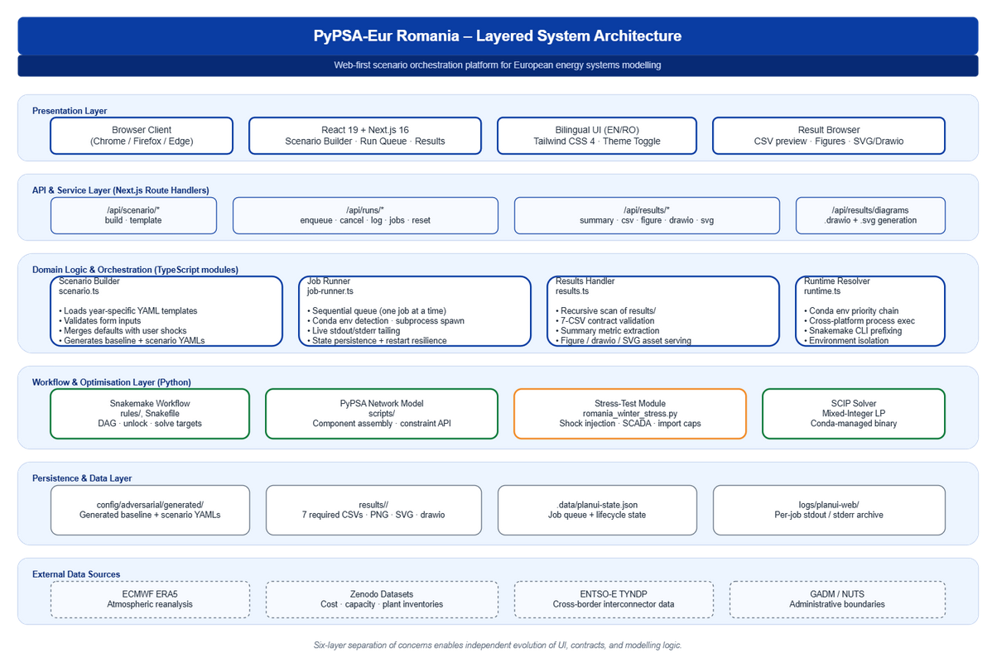
Figure 1: Six-layer architecture of the PyPSA-Eur Romania platform. Source: authors, derived from the project codebase.
3.2. The seven-CSV result contract
The platform's interoperability claim hinges on a deterministic result contract. Every comparison between a baseline and a stressed scenario must produce exactly seven CSVs: system_cost_comparison, generation_mix_mwh, lmp_summary_ro, ens_summary, curtailment_mwh, daily_net_imports_mwh and interconnector_flow_congestion. The dashboard hides any folder lacking one of these files; downstream tools therefore never confront partial outputs. Optional artefacts – a markdown assumptions file, PNG figures, drawio editable diagrams and SVG vector exports – are surfaced when present but never required for validity.
3.3. Scenario lifecycle
Figure 2 traces a scenario's lifecycle. The user configures the run through either form controls or direct YAML editing; both surfaces are kept in sync within the dashboard. On enqueue, two YAML configurations are written: a baseline (stress disabled) and a scenario (stress enabled with shock parameters populated). The job is persisted and added to a sequential runner. Snakemake then unlocks the workflow, solves the baseline, solves the shocked scenario, and runs a comparison report. A baseline solve typically completes in seven to fifteen minutes; a paired run with comparison report typically completes in twenty to twenty-five minutes on a developer laptop with twenty clusters and hourly resolution.
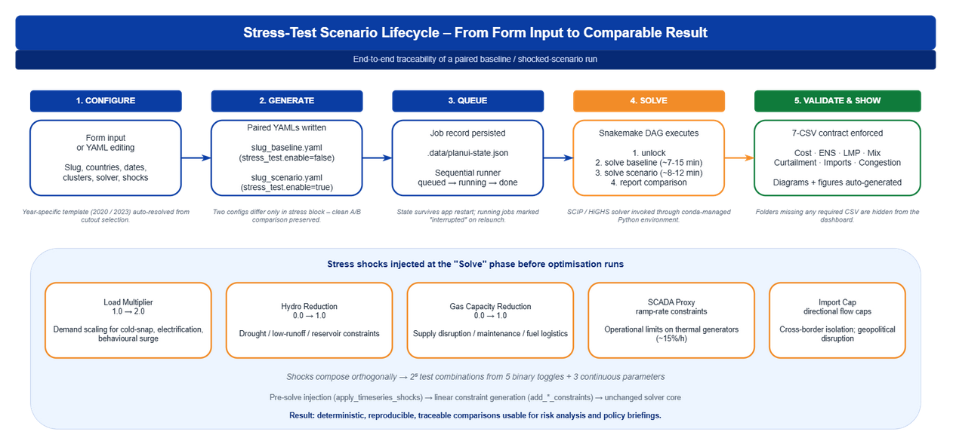
Figure 2: Stress-test scenario lifecycle from form input to comparable result, with the five shock channels exposed by the dashboard. Source: authors.
3.4. Stress-test taxonomy
The shock toolkit is intentionally compact and orthogonal so that combinations are interpretable. Five shock channels are exposed: a load multiplier on demand, a hydro reduction coefficient on hydropower availability, a gas capacity reduction on the maximum installed power of natural-gas units, a SCADA proxy enabling ramp-rate constraints on controllable generators, and an import cap with directional limits on cross-border interconnector flows. Each shock is applied either before optimisation (load and capacity scaling) or as additional linear constraints, leaving the solver core unchanged.
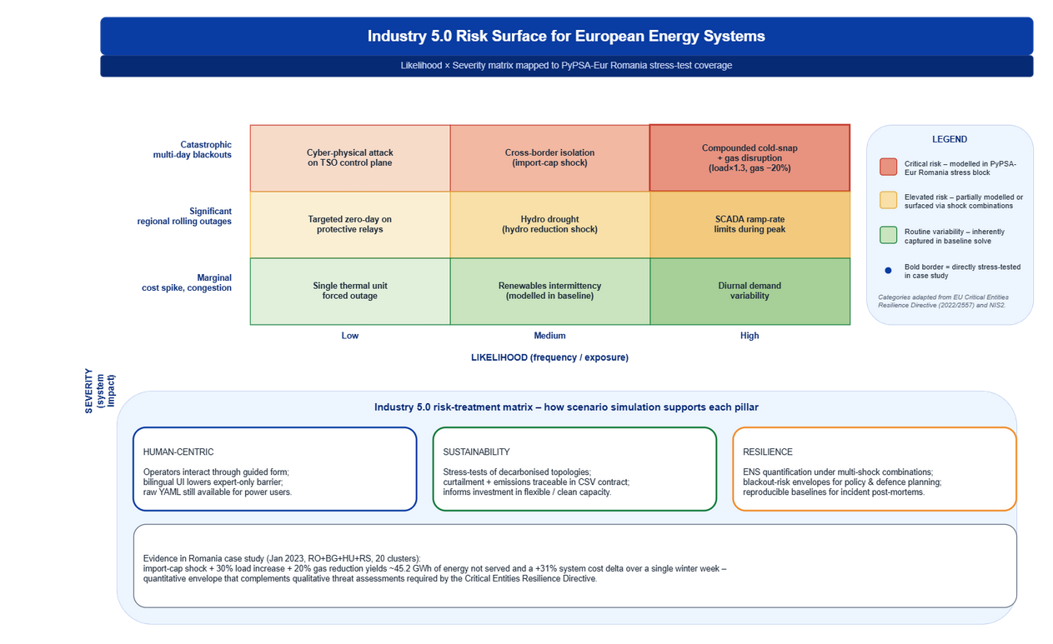
Figure 3: Likelihood-severity risk matrix for European energy systems under an Industry 5.0 lens, mapped to the platform's stress-test coverage. Source: authors, categories adapted from Directive (EU) 2022/2557.
4. Romania winter case study
4.1. Scenario set-up
To illustrate the platform we instantiate a stress-test configured to mirror the type of question posed by the CER Directive's national risk assessment process. The simulated week is 15-22 January 2023 – a real winter week with cold-snap conditions reflected in ERA5 – modelled at 20 spatial clusters covering Romania (RO) plus its three principal interconnection partners Bulgaria (BG), Hungary (HU) and Serbia (RS). Shocks apply only to Romania. The baseline runs the same network without stress. The stressed scenario applies: load multiplier 1.30 (30 % demand surge), hydro reduction 0.10 (10 % unavailable for low-flow conditions), gas capacity reduction 0.20 (20 % derating for supply-chain or maintenance constraints), SCADA proxy enabled (ramp-rate limits on thermal units of approximately 15 % of nominal capacity per hour), and an import cap of 0 MWh on every cross-border interconnector – complete electrical isolation of Romania.
4.2. Quantitative results
The stressed scenario produces a cost delta of approximately +570 million EUR over the eight-day window – a 31 % increase – driven by displacement of imports by costly domestic generation. Energy not served reaches roughly 45.2 GWh in Romania, concentrated in evening-peak hours and northern regions; neighbour countries are unaffected since the shock is unilateral. Mean locational marginal prices for Romania more than double, with peaks rising from 180 EUR/MWh to 380 EUR/MWh. Generation mix shifts as expected: nuclear and renewables remain saturated at the baseline level (weather is fixed); gas attempts to compensate but is bounded by capacity reduction and ramp constraints; coal increases but does not cover the gap. Daily net imports collapse to zero by construction; congestion hours on inbound interconnectors fall to zero.
4.3. Interpretation
The case study is not predictive of any specific event; it is an envelope indicating order of magnitude. Three conclusions follow. First, even mild simultaneous derating combined with a 30 % demand spike is enough to trigger blackouts under cross-border isolation, despite Romania's domestic baseload. Second, the problem is concentrated in evening-peak hours and northern regions, so demand-flexibility programmes and targeted storage have asymmetric leverage. Third, the cost of cross-border isolation per GWh of forgone imports – on the order of 12 to 15 million EUR per GWh – provides a quantitative input to the value-of-interconnection discussion that the TYNDP cycle and the PCI process require.
5. Dual-use applicability
Figure 4 maps the same platform across a civilian column, a shared engineering core and a defence/security column. The core is unchanged: identical optimisation engine, identical data pipeline, identical YAML grammar, identical result schema. The differentiation is only at the consumption side. Civilian uses include net-zero pathway studies for ministries, renewables-siting and grid-expansion analysis, wholesale-market design and climate-adaptation assessments. Defence and security uses include CER-Directive-compliant resilience evidence, hybrid-threat scenario libraries, energy-supply contingency planning, strategic reserve sizing under ENS envelopes and joint table-top exercises with Allied partners. The shared core is the interoperability surface: anything consumed in one column can be reproduced in the other from the same artefacts.
This is precisely what the Recast Dual-Use Regulation contemplates [4]. A platform whose codebase is openly published is exempt under the public-domain carve-out, but a deployed instance that integrates national-confidential data may fall back under control. The architectural response is to separate the orchestration layer (open) from the data layer (operator-controlled), so the same codebase serves both purposes without licensing collision.
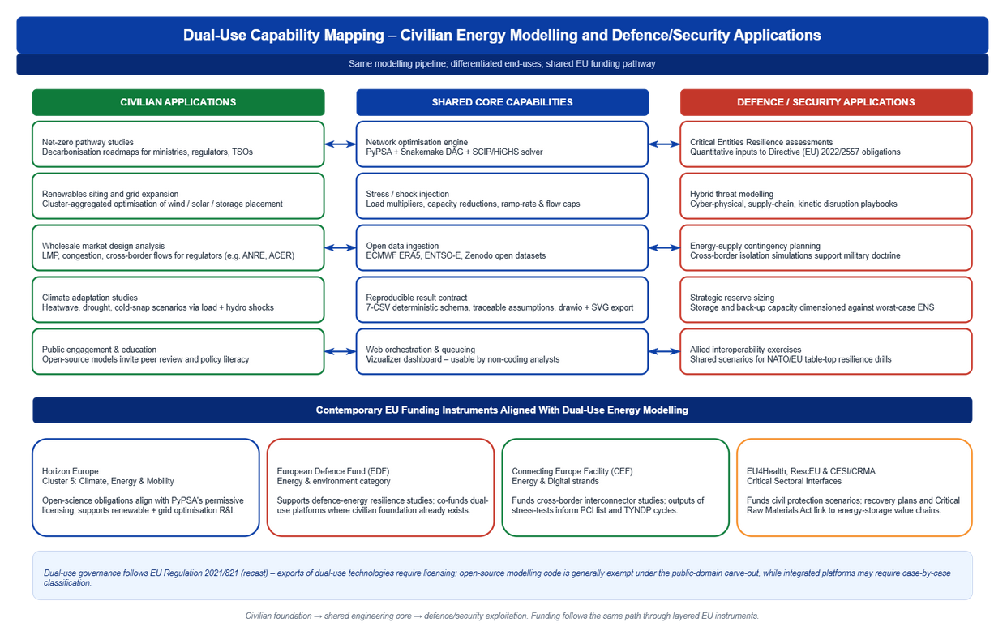
Figure 4: Dual-use capability mapping – civilian, shared core and defence/security columns – with aligned EU funding instruments. Source: authors, instruments compiled from official EU work programmes.
6. Contemporary funding mechanisms
The lower band of Figure 4 lists four EU instruments whose objectives align with the platform's outputs.
Horizon Europe – Cluster 5 (Climate, Energy & Mobility). Cluster 5 is the principal R&I instrument funding open energy modelling. Its 2023-2024 work programme already cites "open and interoperable energy system models" as eligible activity [9]. The platform's permissive licensing satisfies the open-science obligations attached to Horizon Europe grants without further negotiation.
European Defence Fund. Within the EDF's research strand, energy-and-environment categories explicitly support resilience-related work and explicitly contemplate dual-use leverage where civilian foundations exist [11]. Stress-test envelopes generated by the platform are admissible inputs to EDF resilience proposals; the open-source carve-out keeps the underlying code outside the controlled-items list while the deployment artefacts can be classified independently.
Connecting Europe Facility – Energy. CEF Energy funds cross-border interconnector projects through the Projects of Common Interest list. Platform outputs – interconnector-flow congestion and net-import deltas under stress – feed directly into the cost-benefit analyses required by CEF and TYNDP [12]. CEF Digital adds a complementary track for the data infrastructure underpinning interoperable modelling.
rescEU and the Critical Raw Materials Act. Civil-protection funding under the Union Civil Protection Mechanism (rescEU) backs preparedness exercises, including energy-supply contingencies; the Critical Raw Materials Act of 2024 connects energy storage and grid hardware supply chains to the critical-resilience agenda [13].
The funding architecture is therefore multi-instrument by design. A platform that internalises EIF interoperability obligations can claim eligibility across all four without architectural duplication, because its outputs are interpretable in each instrument's terms.
7. Mapping to the European Interoperability Framework
Figure 5 maps the platform onto the four EIF layers, with an additional governance layer that the present authors propose as a fifth, cross-cutting concern.
The legal layer is anchored in MIT/Apache-style licensing on PyPSA, the dashboard's own permissive licence, and the open data licences attached to ECMWF and Zenodo upstream sources. The organisational layer is reflected in the three-tab UI, which maps directly to RACI roles, and in the persistent job state that documents who initiated which run. The semantic layer enforces SI units, ISO-3166-1 country codes, ENTSO-E component identifiers and a result schema whose column names align with TYNDP output expectations. The technical layer relies on YAML for configuration, netCDF (CF conventions) for climate inputs, CSV for results, REST/HTTP for the dashboard API, and drawio + SVG for figure portability. The governance layer – our proposed addition – bundles persistent state, immutable templates and per-run logs into a verifiable audit envelope, with each result inheriting an assumptions-and-limitations file so policy briefings carry their epistemic provenance forward.
The novelty is not in the layers themselves – they are EIF doctrine – but in the demonstration that each is enforced by a concrete artefact in the codebase. Interoperability becomes a verifiable property rather than an aspirational claim.
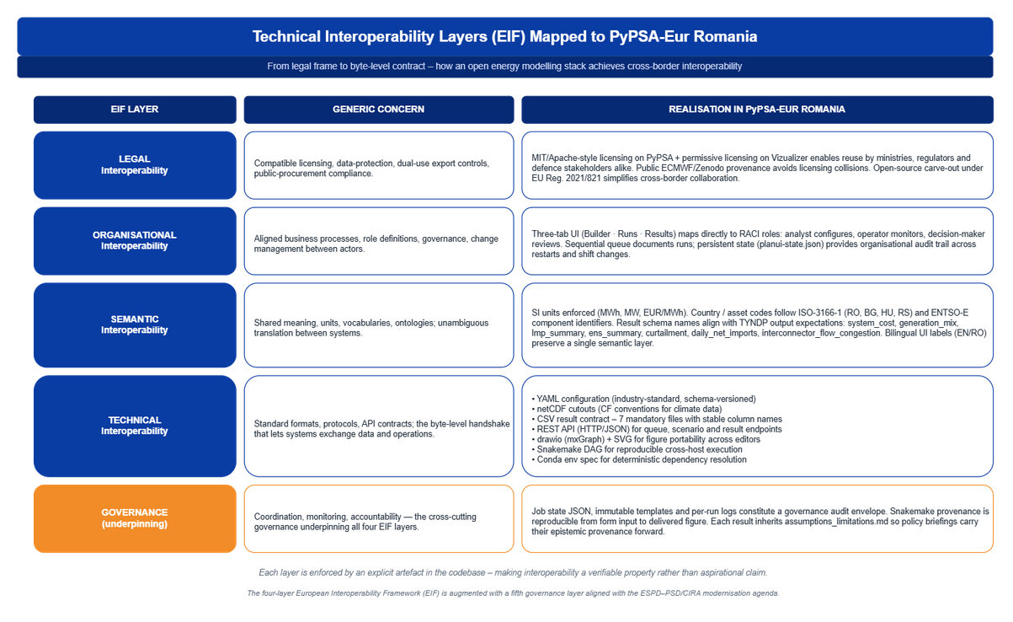
Figure 5: Mapping of the platform onto the four-layer European Interoperability Framework, augmented with a governance layer. Source: authors.
8. Discussion, limitations and future work
Several limitations warrant explicit treatment. First, the stress-test taxonomy is intentionally compact; real hybrid threats include attacker-adaptive components that an optimisation-based model cannot represent without a game-theoretic extension. Second, the seven-CSV contract is sufficient for a single-country case study but will require extension for multi-country assessments. Third, the dashboard's sequential runner is appropriate for analyst-driven exploration but not for automated parameter sweeps; a parallel runner is on the roadmap. Fourth, the dual-use carve-out is currently invoked at the codebase level; a deployment that ingests classified network parameters would have to be assessed under the controlled-list framework, even though the codebase itself is exempt.
Future work has three vectors. The modelling vector will integrate adversarial scenarios with explicit attacker models (cyber-physical co-simulation). The interoperability vector will harmonise the result schema with EU-funded ontology projects and propose a public RDF/JSON-LD wrapper around the seven CSVs. The governance vector will formalise the assumptions-limitations file as a machine-readable provenance object aligned with W3C PROV [14].
9. Conclusions
We have argued that civilian-by-design, open-source energy-system modelling stacks are the most defensible substrate for cross-pillar interoperability in critical-infrastructure security. The paper makes three contributions: a six-layer architecture for a paired-scenario stress-test platform built on PyPSA-Eur and a Next.js dashboard; a worked Romania winter case study that demonstrates the platform's quantitative envelope under cross-border isolation; and a mapping of the platform's artefacts to the European Interoperability Framework, augmented with a governance layer. Contemporary EU funding instruments – Horizon Europe Cluster 5, the EDF, CEF Energy and rescEU – already foresee the dual orientation; platforms that internalise the EIF obligations can be co-funded across instruments without architectural duplication. The route from civilian decarbonisation studies to defence-relevant resilience evidence runs through the same codebase; the differentiation is at the data and exploitation layer, not at the modelling core.
Acknowledgements
The author thanks the PyPSA-Eur open-source community for an exceptionally well-structured modelling substrate, and the Romanian academic community for ongoing exchanges on national grid resilience. Computational work was carried out on locally-managed resources; no institutional funding is reported.
References
[1] European Union Agency for Cybersecurity (ENISA). Threat Landscape for the Energy Sector. Athens: ENISA; 2023.
[2] International Energy Agency. Power Systems in Transition: Challenges and Opportunities Ahead for Electricity Security. Paris: OECD/IEA; 2020.
[3] European Commission. European Interoperability Framework – Implementation Strategy. COM(2017) 134 final. Brussels: European Commission; 2017.
[4] European Parliament and Council. Regulation (EU) 2021/821 of 20 May 2021 setting up a Union regime for the control of exports, brokering, technical assistance, transit and transfer of dual-use items (recast). Official Journal of the European Union L 206; 11 June 2021.
[5] Hörsch J., Hofmann F., Schlachtberger D., Brown T. PyPSA-Eur: An open optimisation model of the European transmission system. Energy Strategy Reviews. 2018; 22: 207-215.
[6] Breque M., De Nul L., Petridis A. Industry 5.0 – Towards a sustainable, human-centric and resilient European industry. Luxembourg: Publications Office of the European Union; 2021.
[7] European Parliament and Council. Directive (EU) 2022/2555 of 14 December 2022 on measures for a high common level of cybersecurity across the Union (NIS2). Official Journal of the European Union L 333; 27 December 2022.
[8] European Parliament and Council. Directive (EU) 2022/2557 of 14 December 2022 on the resilience of critical entities. Official Journal of the European Union L 333; 27 December 2022.
[9] European Commission. Horizon Europe Work Programme 2023-2024 – Cluster 5: Climate, Energy and Mobility. Brussels: European Commission; 2023.
[10] Pfenninger S., Hawkes A., Keirstead J. Energy systems modeling for twenty-first century energy challenges. Renewable and Sustainable Energy Reviews. 2014; 33: 74-86.
[11] European Commission. European Defence Fund Annual Work Programme 2024. Brussels: European Commission; 2024.
[12] European Network of Transmission System Operators for Electricity (ENTSO-E). Ten-Year Network Development Plan 2024 – Methodology. Brussels: ENTSO-E; 2024.
[13] European Parliament and Council. Regulation (EU) 2024/1252 of 11 April 2024 establishing a framework for ensuring a secure and sustainable supply of critical raw materials. Official Journal of the European Union L 173; 22 April 2024.
[14] World Wide Web Consortium. PROV-O: The PROV Ontology, W3C Recommendation 30 April 2013. Cambridge MA: W3C; 2013.

