DUAL-USE ENERGY-SYSTEM MODELLING FOR CRITICAL-INFRASTRUCTURE RESILIENCE: OPEN-SOURCE STRESS-TEST ORCHESTRATION AS A LEVER FOR TECHNICAL INTEROPERABILITY
First AUTHOR*, Second AUTHOR**, Third AUTHOR***
*University, Faculty, City, Country
E-mail: manescu.bogdan.andrei@gmail.com
Abstract: European energy systems are simultaneously a foundation for civilian welfare and a high-value target for hybrid disruption. This paper argues that open-source energy-system modelling stacks exemplified by PyPSA-Eur with the Romania-specific Vizualizer dashboard qualify as dual-use technologies whose maturation supports both Industry 5.0 resilience objectives and contemporary security funding agendas. We describe a six-layer web platform that turns multi-shock stress-tests into a deterministic, reproducible workflow accessible to non-coding analysts. A worked Romania winter case study quantifies the country's exposure under a hybrid disruption: a 30 % demand surge combined with a complete cross-border import cap and partial gas / hydro derating produces approximately 45 GWh of energy not served and a 31 % system-cost increase over a single winter week. We map these capabilities onto the four-layer European Interoperability Framework, identify EU funding instruments Horizon Europe, the European Defence Fund, the Connecting Europe Facility and rescEU whose objectives align with the platform's outputs, and discuss governance constraints under EU Regulation 2021/821 and the Critical Entities Resilience Directive. The paper concludes that civilian-by-design open modelling platforms are the most defensible substrate for cross-pillar interoperability in critical-infrastructure security.
Keywords: dual-use technology, critical infrastructure resilience, energy-system modelling, technical interoperability, EU security funding

1. Introduction
Energy systems sit at the intersection of two contemporary policy concerns: they are the prototypical complex socio-technical systems whose disruption cascades through every other sector, and their digital control surfaces have become a contested domain in hybrid conflict [1], [2]. Romania, as a south-eastern frontier of the European synchronous area with active interconnection to Bulgaria, Hungary and Serbia, operates in a region where physical, market and informational disruptions are no longer hypothetical. The 2022–2024 European energy-security crisis exposed the cost of modelling deficits — emergency analyses had no shared interoperability surface for cross-checking results between ministries, transmission operators, regulators and defence agencies.
This paper investigates whether an open-source energy-system modelling stack — instantiated by PyPSA-Eur and a Romania-specific orchestration dashboard — can serve as a verifiable substrate for technical interoperability in critical-infrastructure security. PyPSA-Eur is an open European power-system optimisation model built on the PyPSA library, with a Snakemake workflow orchestrating data preparation, network assembly and optimisation [5]. We add a Romania-specific extension exposing a stress-test interface designed for security-relevant simulation: synthetic load multipliers, hydro and gas capacity reductions, ramp-rate constraints proxying SCADA limits, and directional caps on cross-border interconnections. A web dashboard ("Vizualizer") provides a three-tab control room — scenario builder, run queue, results viewer — that allows non-coding analysts to assemble paired baseline/stressed runs and inspect results satisfying a deterministic seven-CSV contract.
Three research questions structure the work that follows.
RQ1 — Interoperability. Can an open-source modelling stack satisfy the four layers of the European Interoperability Framework — legal, organisational, semantic and technical — when its result schema, configuration grammar and orchestration are deliberately designed as contracts rather than as artefacts [3]?
RQ2 — Dual-use qualification. Does such a stack qualify as a dual-use technology in the sense of EU Regulation 2021/821, that is, usable for civilian decarbonisation studies and equally for defence-relevant resilience assessments while remaining within the public-domain carve-out of the regulation [4]?
RQ3 — Funding alignment. Do contemporary EU funding instruments — Horizon Europe Cluster 5, the European Defence Fund, the Connecting Europe Facility and rescEU — already foresee this dual orientation in a way that lets a platform internalise the four-layer interoperability obligation be co-funded across instruments without architectural duplication?
The paper follows an IMRAD structure: Section 2 details the platform's architecture, result contract and stress-test taxonomy; Section 3 presents a Romania winter cross-border-isolation case study; Section 4 discusses dual-use applicability, EU funding alignment, mapping to the European Interoperability Framework, and limitations; Section 5 returns to the three research questions in concluding form.
1.1. Background
1.1.1. Industry 5.0 and resilience
Industry 5.0 augments the productivity-centric Industry 4.0 narrative with three explicit pillars: human-centricity, sustainability and resilience [6]. Energy systems embody all three — supply continuity is a precondition for every other public service, decarbonisation is the largest single lever for European emissions reductions, and cascading disruption dynamics affect every linked sector.
1.1.2. EU regulatory frame
Three legal instruments converge here. NIS2 (Directive (EU) 2022/2555) sets cybersecurity obligations on operators of essential services [7]. The Critical Entities Resilience Directive (Directive (EU) 2022/2557) extends those obligations to physical and hybrid threats and requires national risk assessments [8]. The Recast Dual-Use Regulation (Regulation (EU) 2021/821) governs cross-border transfer of dual-use items with a public-domain carve-out for openly published software [4]. The interplay matters: NIS2 imposes a defensive posture, the CER Directive demands quantitative resilience evidence, and the dual-use regulation determines whether modelling platforms can circulate freely.
1.1.3. Open modelling stacks
Closed proprietary models force national authorities into vendor lock-in and impede cross-border peer review. Open models invert that dynamic: they are inspectable, reproducible and compatible with the open-data obligations attached to Horizon Europe [9], [10], and satisfy the dual-use public-domain carve-out by construction. The marginal cost of additional dual-use capability is bounded by integration work rather than relicensing of the modelling core.
2. Methods
2.1. Layered system overview
Figure 1 shows the six-layer architecture. The Presentation Layer (React 19 / Next.js 16, bilingual EN/RO) exposes three control-room tabs. The API & Service Layer comprises typed Next.js route handlers under /api/scenario/, /api/runs/ and /api/results/, structured as REST resources. The Domain Logic Layer (TypeScript modules) encapsulates the scenario builder, sequential job runner, results handler and runtime resolver. The Workflow & Optimisation Layer is Python: a Snakemake DAG orchestrates data retrieval, network assembly and solver invocation, with a dedicated stress-test module injecting shocks and linear constraints before optimisation. The Persistence Layer holds generated YAML configurations, job state and logs, with results materialised under results/{name}/. The External Data Layer ingests ECMWF ERA5 reanalysis, Zenodo datasets, ENTSO-E TYNDP outputs and GADM/NUTS administrative boundaries.

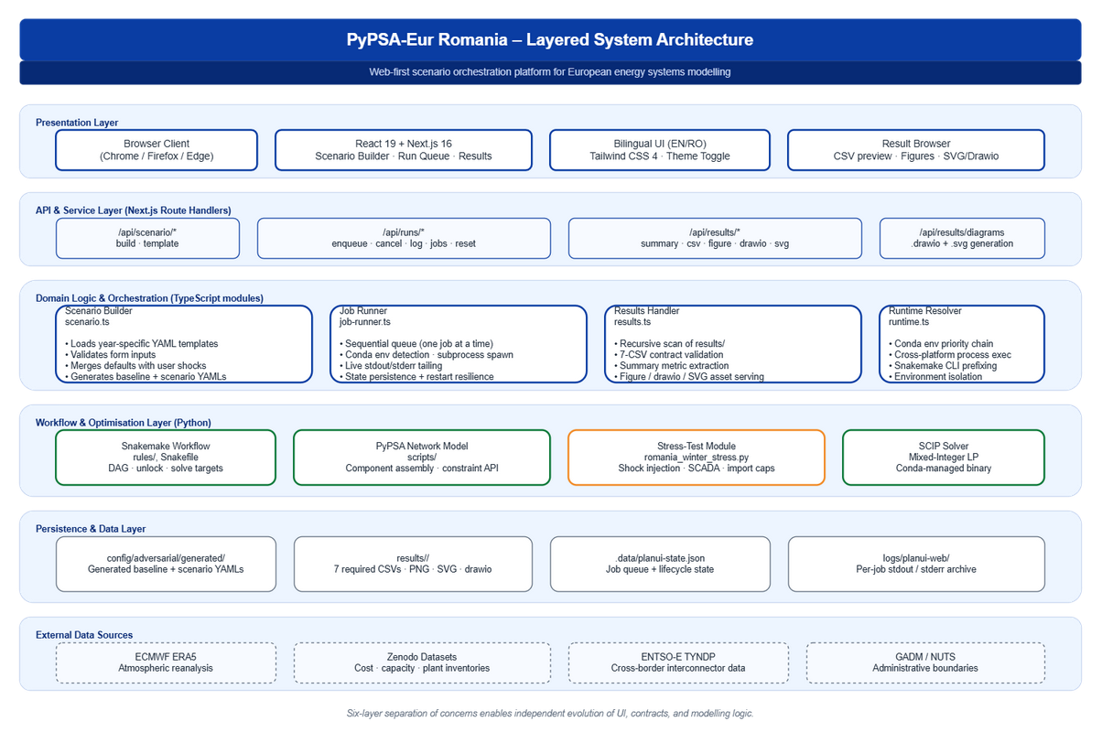
Figure 1: Six-layer architecture of the PyPSA-Eur Romania platform. Source: authors, derived from the project codebase.

2.2. The seven-CSV result contract
The interoperability claim hinges on a deterministic result contract. Every paired comparison must produce exactly seven CSVs: system_cost_comparison, generation_mix_mwh, lmp_summary_ro, ens_summary, curtailment_mwh, daily_net_imports_mwh and interconnector_flow_congestion. The dashboard hides any folder lacking one of these files, so downstream tools never confront partial outputs. Optional artefacts (markdown assumptions, PNG figures, drawio diagrams, SVG exports) are surfaced when present but not required for validity.
2.3. Scenario lifecycle
Figure 2 traces the scenario lifecycle. The user configures runs through form controls or YAML editing (kept in sync). On enqueue, two YAML configurations are written — a baseline (stress disabled) and a scenario (stress enabled) — persisted and added to a sequential runner. Snakemake then solves baseline and shocked scenario, and runs a comparison report. Baseline solves typically complete in 7-15 minutes; paired runs with comparison in 20-25 minutes on a developer laptop at 20 clusters, hourly resolution.

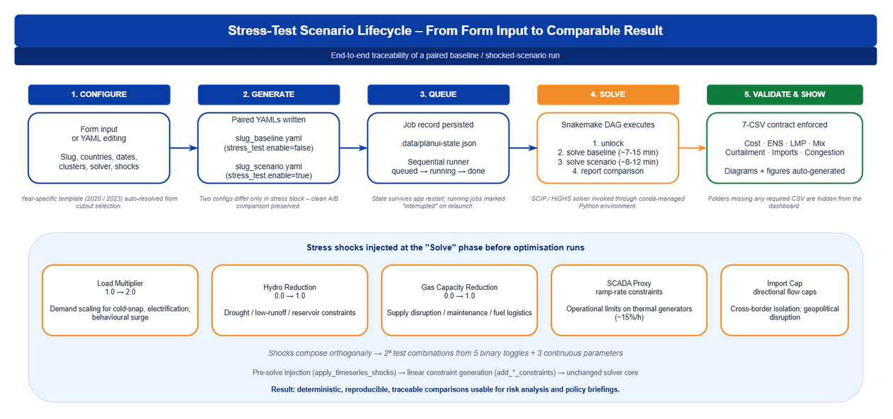
Figure 2: Stress-test scenario lifecycle from form input to comparable result, with the five shock channels exposed by the dashboard. Source: authors.

2.4. Stress-test taxonomy
The shock toolkit is compact and orthogonal so that combinations are interpretable. Five channels are exposed: a load multiplier on demand, a hydro reduction coefficient, a gas capacity reduction, a SCADA proxy enabling ramp-rate constraints on controllable generators, and a directional import cap on cross-border interconnectors. Each shock is applied either before optimisation (load and capacity scaling) or as linear constraints, leaving the solver core unchanged.

3. Results
3.1. Romania winter case study set-up
We instantiate a stress-test mirroring the CER Directive's national risk assessment process. The simulated week is 15-22 January 2023 — a real winter cold-snap week reflected in ERA5 — modelled at 20 spatial clusters covering Romania (RO) plus interconnection partners Bulgaria (BG), Hungary (HU) and Serbia (RS). Shocks apply only to Romania. The stressed scenario applies: load multiplier 1.30 (30% demand surge), hydro reduction 0.10, gas capacity reduction 0.20, SCADA proxy enabled (ramp-rate ≈15% of nominal capacity per hour), and a 0 MWh import cap on every cross-border interconnector — complete electrical isolation of Romania.
3.2. Quantitative results
The stressed scenario produces a cost delta of approximately +570 M EUR over the eight-day window — a 31% increase driven by displacement of imports with costly domestic generation. Energy not served reaches roughly 45.2 GWh in Romania, concentrated in evening-peak hours and northern regions; neighbour countries are unaffected since the shock is unilateral. Mean locational marginal prices more than double, with peaks rising from 180 EUR/MWh to 380 EUR/MWh. Generation mix shifts as expected: nuclear and renewables remain saturated at baseline (weather is fixed); gas attempts to compensate but is bounded by capacity reduction and ramp constraints; coal increases but does not cover the gap. Daily net imports collapse to zero by construction.
3.3. Interpretation
The case study is an order-of-magnitude envelope, not a prediction. Three conclusions follow. First, even mild simultaneous derating combined with a 30% demand spike triggers blackouts under cross-border isolation despite Romania's domestic baseload. Second, the problem concentrates in evening-peak hours and northern regions, so demand-flexibility programmes and targeted storage have asymmetric leverage. Third, the cost of cross-border isolation — on the order of 12-15 M EUR per GWh of forgone imports — provides a quantitative input to the value-of-interconnection discussion required by the TYNDP cycle and the PCI process.
4. Discussion
4.1. Dual-use applicability
Figure 3 maps the platform across a civilian column, a shared engineering core and a defence/security column. The core is unchanged — identical optimisation engine, data pipeline, YAML grammar and result schema — and differentiation occurs only at the consumption side: civilian uses include net-zero pathway studies, renewables-siting analysis and market design, while defence and security uses include CER-Directive-compliant resilience evidence, hybrid-threat scenario libraries and strategic reserve sizing under ENS envelopes. The shared core is the interoperability surface: anything consumed in one column is reproducible in the other from the same artefacts.
This is what the Recast Dual-Use Regulation contemplates [4]: an openly published codebase is exempt under the public-domain carve-out, while a deployed instance integrating national-confidential data may fall back under control. The architectural response is to separate the orchestration layer (open) from the data layer (operator-controlled), so one codebase serves both purposes.

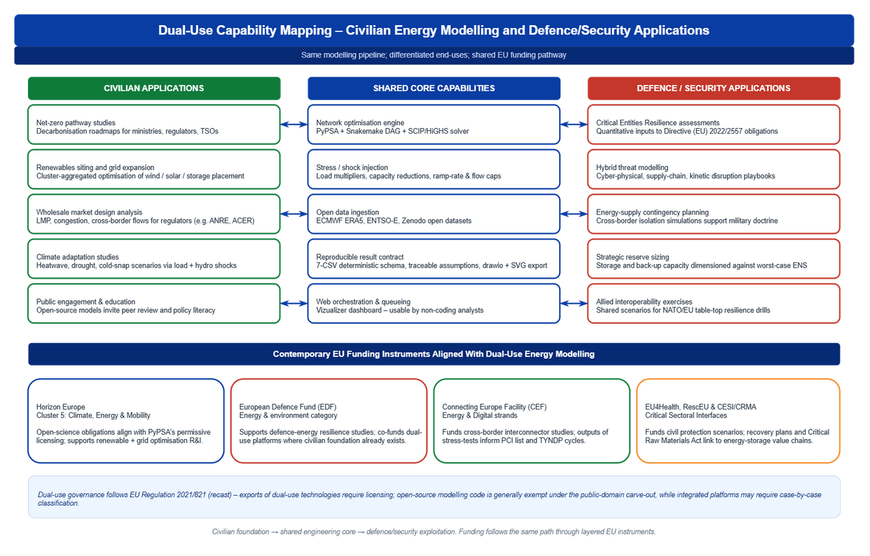

Figure 3: Dual-use capability mapping – civilian, shared core and defence/security columns – with aligned EU funding instruments. Source: authors, instruments compiled from official EU work programmes.

4.2.
EU funding alignment

Four EU instruments align with platform outputs. Horizon Europe Cluster 5 (Climate, Energy & Mobility) is the principal R&I instrument funding open energy modelling and explicitly lists "open and interoperable energy system models" as eligible activity [9]; the platform's permissive licensing satisfies its open-science obligations by construction. The European Defence Fund's research strand supports resilience-related work and contemplates dual-use leverage where civilian foundations exist [11], making stress-test envelopes admissible inputs to EDF resilience proposals. The Connecting Europe Facility – Energy funds cross-border interconnectors through the PCI list, and platform outputs on interconnector congestion and net-import deltas feed directly into the CEF/TYNDP cost-benefit framework [12]. Finally, rescEU under the Union Civil Protection Mechanism backs preparedness exercises including energy-supply contingencies, and the 2024 Critical Raw Materials Act connects storage and grid hardware supply chains to the same resilience agenda [13].
A platform that internalises EIF interoperability obligations can therefore claim eligibility across all four instruments without architectural duplication.
4.3. EIF mapping
The platform satisfies all four EIF layers, and we propose a fifth, cross-cutting governance layer.
The legal layer is anchored in permissive licensing on PyPSA, the dashboard and upstream ECMWF/Zenodo data. The organisational layer is reflected in the three-tab UI mapping to RACI roles and in persistent job state documenting who initiated each run. The semantic layer enforces SI units, ISO-3166-1 country codes, ENTSO-E component identifiers and a result schema aligned with TYNDP output expectations. The technical layer relies on YAML for configuration, netCDF (CF conventions) for climate inputs, CSV for results and REST/HTTP for the dashboard API. The proposed governance layer bundles persistent state, immutable templates and per-run logs into a verifiable audit envelope, with each result inheriting an assumptions-and-limitations file so policy briefings carry their epistemic provenance forward.

4.4. Limitations and future work
Four limitations warrant treatment. The stress-test taxonomy is compact and cannot represent attacker-adaptive components without a game-theoretic extension. The seven-CSV contract is sufficient for single-country studies but will need extension for multi-country assessments. The sequential runner is appropriate for analyst-driven exploration but not for automated parameter sweeps. Finally, the dual-use carve-out is invoked at the codebase level; deployments ingesting classified network parameters must still be assessed under the controlled-list framework.
Future work will integrate adversarial scenarios via cyber-physical co-simulation, harmonise the result schema with EU-funded ontology projects through an RDF/JSON-LD wrapper, and formalise the assumptions-limitations file as a machine-readable provenance object aligned with W3C PROV [14].
5. Conclusions
Returning to the three research questions: (RQ1) the platform demonstrates that an open-source modelling stack can satisfy all four EIF layers when its result schema, configuration grammar and orchestration are designed as contracts rather than artefacts. (RQ2) The codebase qualifies as dual-use under the public-domain carve-out of Regulation (EU) 2021/821 because the same engine serves civilian decarbonisation studies and defence-relevant resilience evidence, with differentiation only at the data and exploitation layer. (RQ3) Horizon Europe Cluster 5, the European Defence Fund, the Connecting Europe Facility and rescEU each foresee complementary deliverables of this single architecture, so a platform that internalises EIF interoperability obligations is co-fundable across instruments without duplication. We propose that a fifth, cross-cutting governance layer — bundling persistent state, immutable templates and per-run logs into a verifiable audit envelope — be added to the EIF for critical-infrastructure modelling, and that civilian-by-design open platforms be made an explicit eligibility criterion in the next work-programme cycle of each instrument.

References
[1] European Union Agency for Cybersecurity (ENISA). Threat Landscape for the Energy Sector. Athens: ENISA; 2023.
[2] International Energy Agency. Power Systems in Transition: Challenges and Opportunities Ahead for Electricity Security. Paris: OECD/IEA; 2020.
[3] European Commission. European Interoperability Framework – Implementation Strategy. COM(2017) 134 final. Brussels: European Commission; 2017.
[4] European Parliament and Council. Regulation (EU) 2021/821 of 20 May 2021 setting up a Union regime for the control of exports, brokering, technical assistance, transit and transfer of dual-use items (recast). Official Journal of the European Union L 206; 11 June 2021.
[5] Hörsch J., Hofmann F., Schlachtberger D., Brown T. PyPSA-Eur: An open optimisation model of the European transmission system. Energy Strategy Reviews. 2018; 22: 207-215.
[6] Breque M., De Nul L., Petridis A. Industry 5.0 – Towards a sustainable, human-centric and resilient European industry. Luxembourg: Publications Office of the European Union; 2021.
[7] European Parliament and Council. Directive (EU) 2022/2555 of 14 December 2022 on measures for a high common level of cybersecurity across the Union (NIS2). Official Journal of the European Union L 333; 27 December 2022.
[8] European Parliament and Council. Directive (EU) 2022/2557 of 14 December 2022 on the resilience of critical entities. Official Journal of the European Union L 333; 27 December 2022.
[9] European Commission. Horizon Europe Work Programme 2023-2024 – Cluster 5: Climate, Energy and Mobility. Brussels: European Commission; 2023.
[10] Pfenninger S., Hawkes A., Keirstead J. Energy systems modeling for twenty-first century energy challenges. Renewable and Sustainable Energy Reviews. 2014; 33: 74-86.
[11] European Commission. European Defence Fund Annual Work Programme 2024. Brussels: European Commission; 2024.
[12] European Network of Transmission System Operators for Electricity (ENTSO-E). Ten-Year Network Development Plan 2024 – Methodology. Brussels: ENTSO-E; 2024.
[13] European Parliament and Council. Regulation (EU) 2024/1252 of 11 April 2024 establishing a framework for ensuring a secure and sustainable supply of critical raw materials. Official Journal of the European Union L 173; 22 April 2024.
[14] World Wide Web Consortium. PROV-O: The PROV Ontology, W3C Recommendation 30 April 2013. Cambridge MA: W3C; 2013.

