Sub-task 1 – Create AWS Account
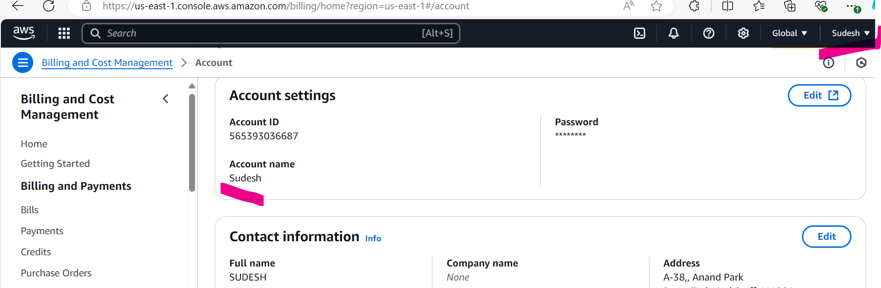

Sub-task 2 – Secure account
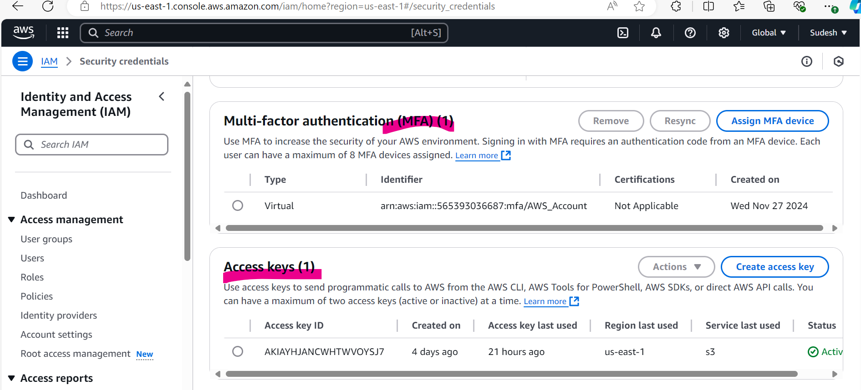

Sub-task 3 – Set Budgets/Alerts
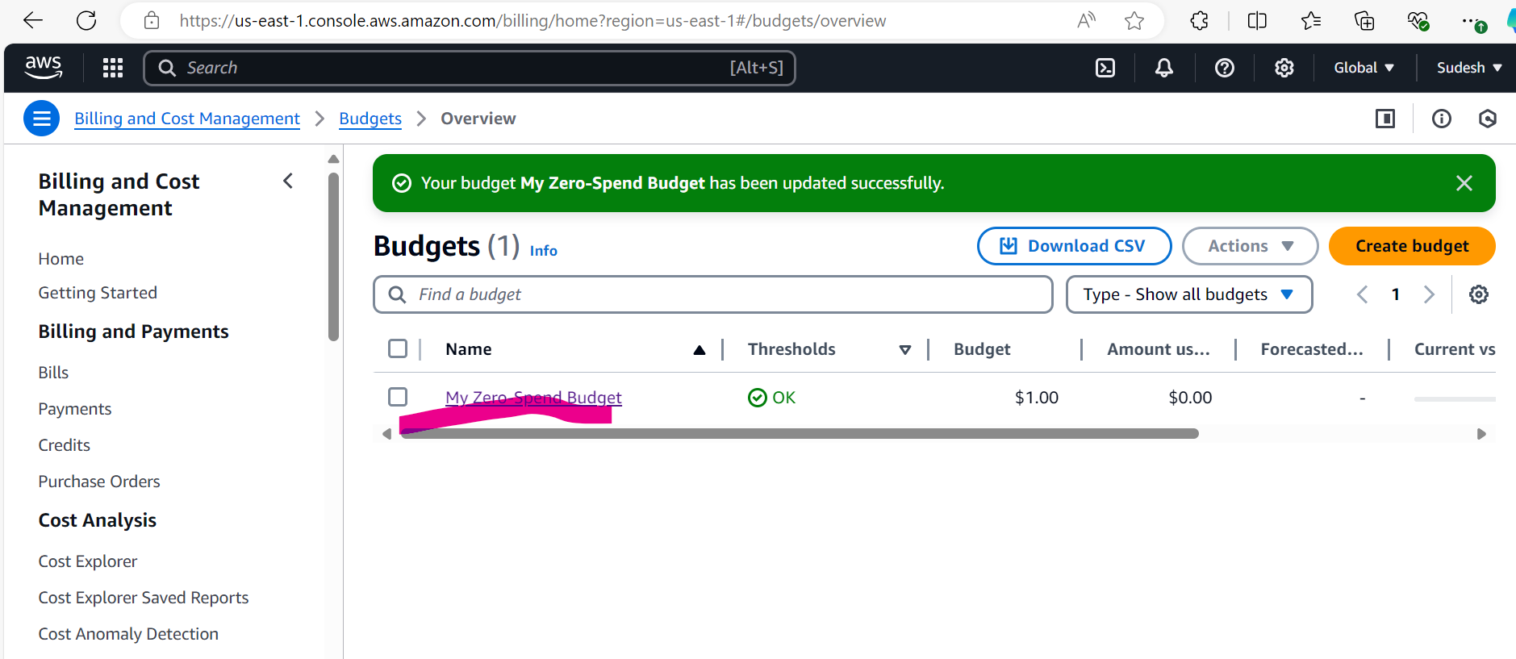

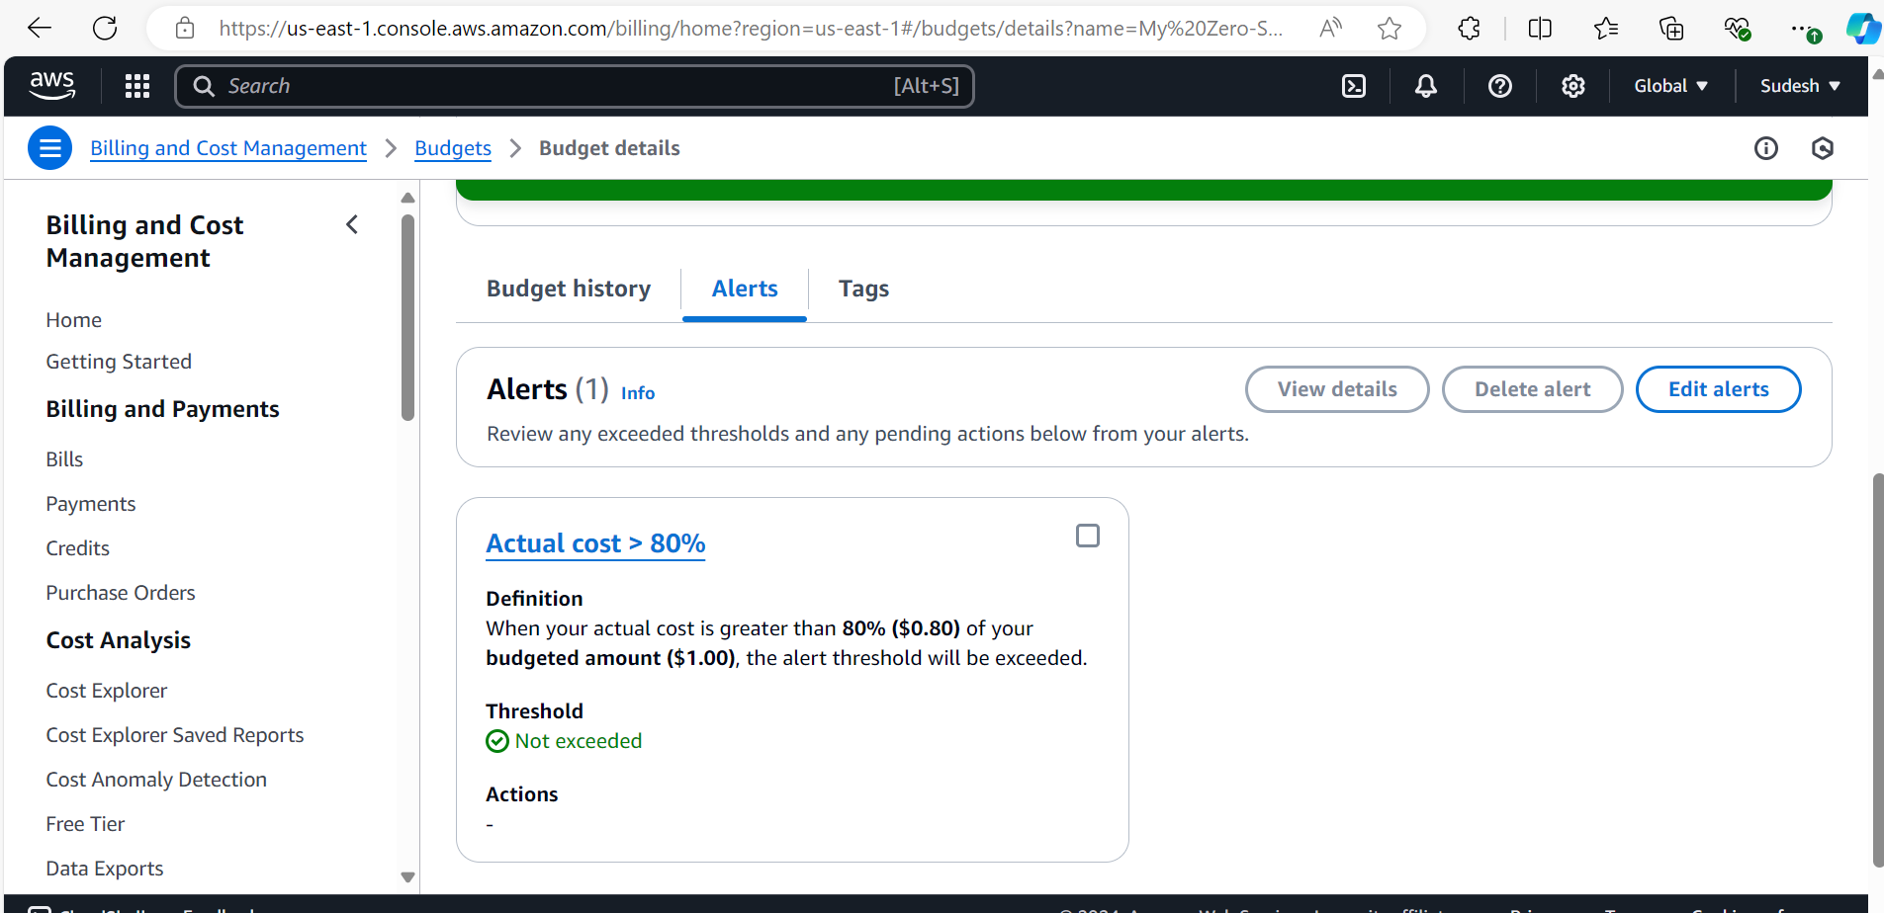

Sub-task 4 – Optional Task - Setup SCP
