Contract Clause Analyzer
INF1103 Phase 2: Object-Oriented Refactoring and Extension
Engineering Report
Item | Details
Team ID | [fill in]
Team name | [fill in]
Date of submission | [fill in]
Repository | github.com/manfredlumjunann/SIT-INF1103-Project-1

Team members
Name | Student ID | Email
[fill in] | [fill in] | [fill in]
[fill in] | [fill in] | [fill in]
[fill in] | [fill in] | [fill in]
[fill in] | [fill in] | [fill in]

The main report starts on page 2 and is within six pages. The appendix holds supporting material only.

1. Introduction
The Contract Clause Analyzer is a web application for a business team that signs many contracts. A staff member signs in, uploads a contract (PDF, Word or TXT) and can add a question. Every upload passes through an AI model that flags risky clauses with a risk level (high, medium or low), the reason and a suggested workaround, and a web search adds supporting case law. Results are saved per user, so a repeated upload is answered from the database and two analyses can be compared. Engineers are alerted on Telegram when a contract has many flagged clauses (7 to 8 to one chat, 9 or more to another) or when every AI model fails and a person must press Fix or Stop.
Additions since Part 1
- Object-oriented refactor. The procedural code is now small classes, one class per file, in four layers (IO, AI, Logic, Data) that keep the four mandatory manager responsibilities.
- New feature: administrator review. The boss sees every user's submitted files, expands or minimises each user, opens a file and writes one comment on each flagged clause. The customer can read the comment but cannot edit it.
- Advanced feature: updated database system. Records moved from JSON files to PostgreSQL, with keys, constraints, transactions and cascading deletes.
- Automated tests. One Docker image runs 41 end-to-end test cases against the running system with a fake AI and a fake Telegram.
2. Data structure and storage design
All records are stored as relational tables in PostgreSQL 17, reached through SQLAlchemy; the data layer is the only code that touches the database. No data files are kept: an upload is read through a temporary file that is deleted at once, and JSON is used only for HTTP messages and AI answers, which are validated before use. Tables are created from the entity classes at start-up and live in a Docker volume. Ids are readable (us_001, an_001, cm_001) and come from PostgreSQL sequences.
Table | Stored record and rules
users | id, username (unique, lower case, 3 to 30 characters), password_hash, role (customer or admin), created_at.
analyses | id, owner_id (to users), status (processing, done, failed), filename, context, contract_text, contract_hash (SHA-256 of text plus context, used to reuse a saved result), created_at.
clauses | analysis_id (to analyses, cascade), position (unique per analysis), clause_type, risk_level (HIGH, MEDIUM, LOW), clause_text, location_*, issue_description, workaround.
clause_comments | id, clause_id (to clauses, cascade, unique: one comment per clause), author_id (to users), text (1 to 2000 characters), created_at, updated_at.
legal_references | id (hash of the URL), url (unique), title, domain, verification. Shared by clauses and kept when an analysis is deleted.
clause_references | Key (clause_id, reference_id), position, snippet: links a clause to its sources.

3. Diagrams
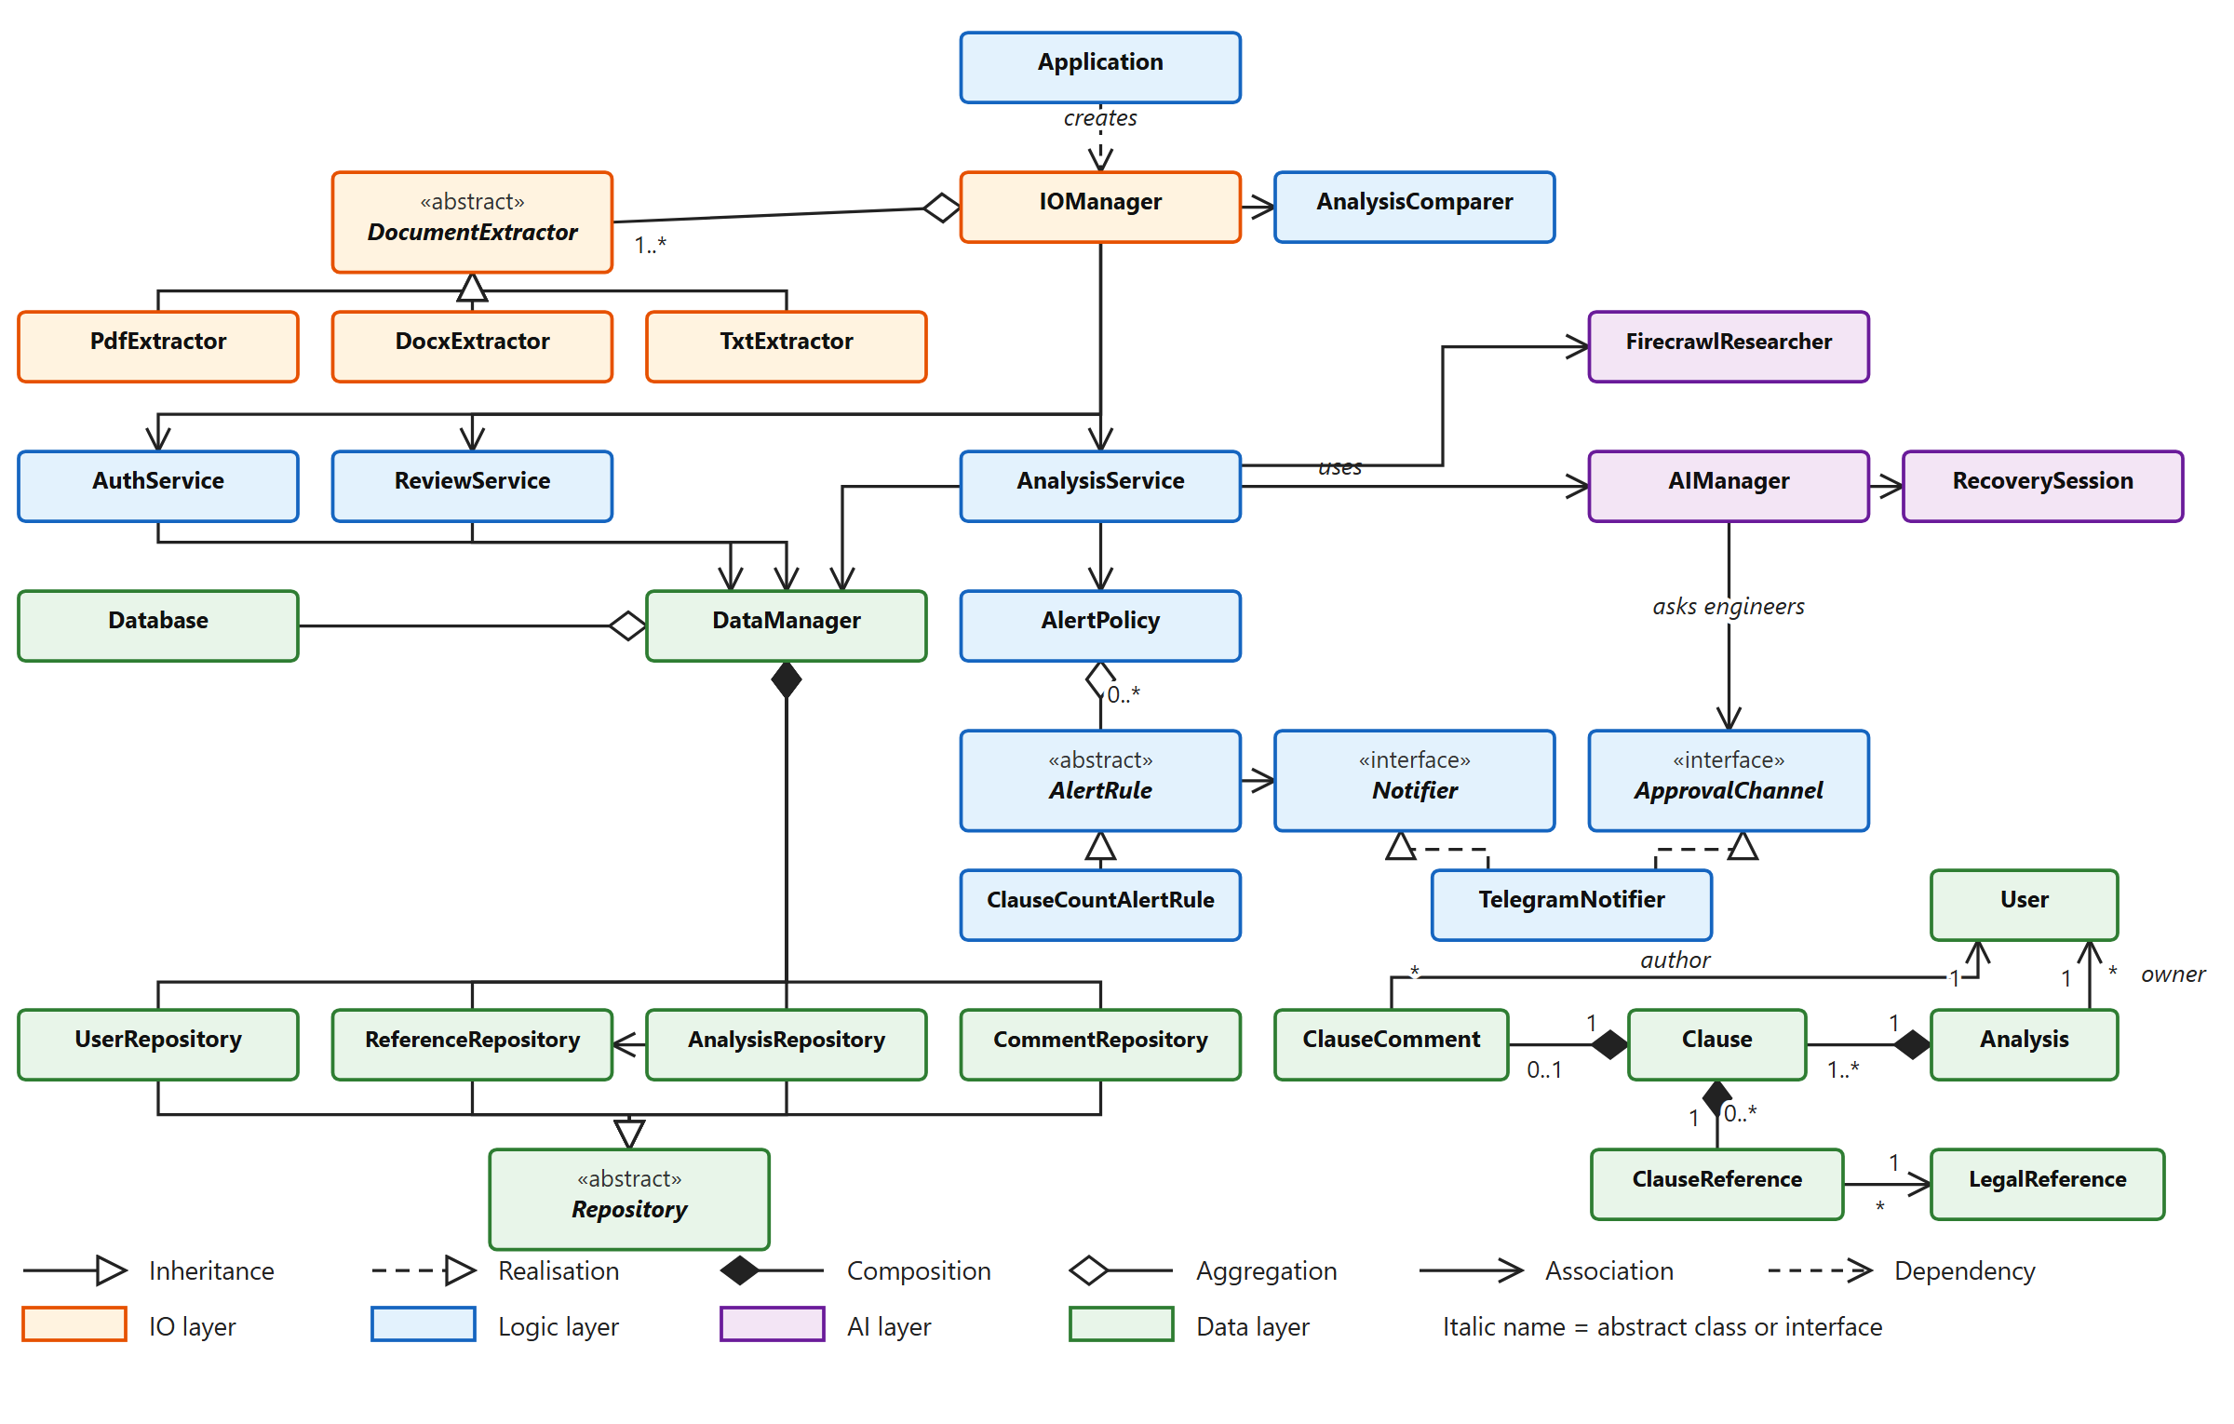
Figure 1. Class diagram: every class and its relationships (report-01-class-diagram.svg).
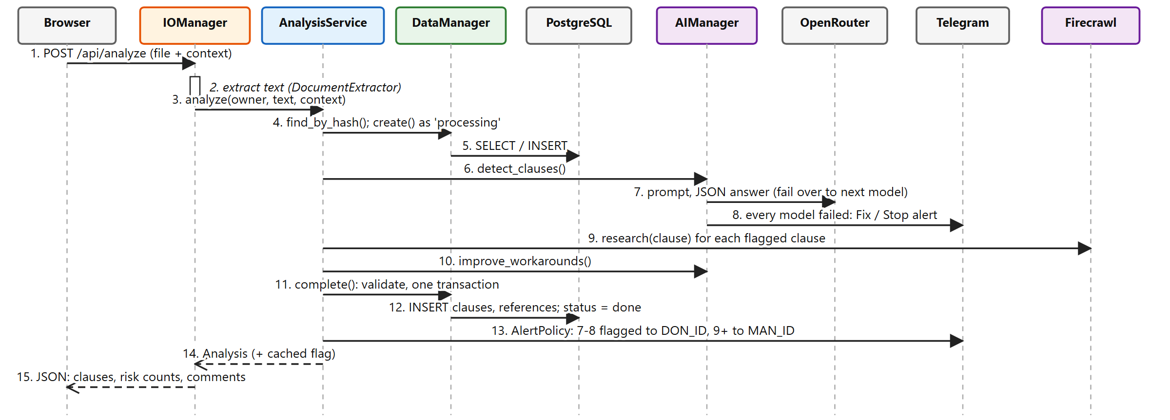
Figure 2. Data flow diagram: analysing a contract (report-02-dataflow-analysis.svg).
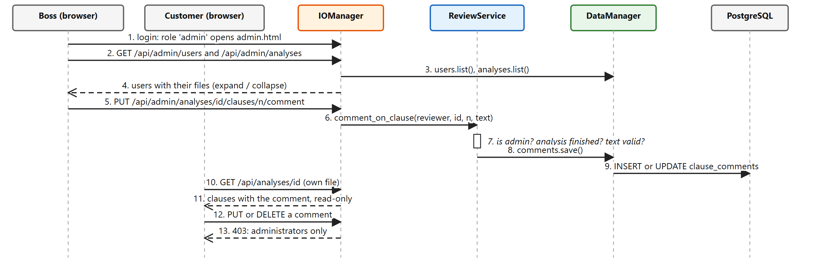
Figure 3. Data flow diagram: administrator review (report-03-dataflow-review.svg).

4. Exception handling matrix
Exception scenario | Possible cause | Detection method | Handling strategy | User outcome
Invalid sign-up or login | Bad username, short password, wrong password, name already taken | AuthService checks the input and raises AuthError; a unique index settles two sign-ups at once | Refuse; nothing is stored; the wrong-password message is generic | Clear message (400, 409 or 401)
Not signed in, or not an admin | Expired session; a customer calls an admin route | _login_required and _admin_required check on the server | Refuse the request | Sent to the login page (401) or told it is for administrators (403)
Invalid review request | Blank or over-long comment, unknown analysis or clause, analysis not finished | ClauseComment.text setter and ReviewService raise ReviewError | Refuse; no comment is saved | Clear message (400, 404 or 409)
Unreadable upload | Unsupported type, scanned PDF with no text, file over 50 MB | No extractor accepts it; empty text; Flask size limit | Stop before any AI call | Message that the file cannot be analysed (400 or 413)
AI model unavailable | Model down, rate limit, timeout | Exception from the API call, sorted by _classify_error | Skip the model or retry it, then fail over to the next model | None, apart from a slower answer
Every AI model fails | Provider outage, bad key | All models raised | Alert the engineers on Telegram (Fix or Stop) through ApprovalChannel; Fix uses the backup model | Fix: result arrives. Stop: "AI service unavailable" (503)
Malformed AI answer | Text that is not JSON, wrong fields, unknown risk level | JSON parsing and Clause.from_ai validation | Drop invalid items; one invalid risk level rejects the batch and saves nothing | Result without clauses, or a retry message
Search, workaround step or Telegram send fails | Network error, bad token | Exception caught where the call is made | Log it and carry on | Analysis still completes (no references, or alert only logged)
Unexpected error in the pipeline | Any bug or failure | Broad catch in AnalysisService and IOManager | Mark the analysis failed, log details, re-raise | Generic message with a reference code; file shows as Failed
Database unreachable, or restart mid-analysis | Database not ready; app stopped while analysing | ping() at start-up; analyses still "processing" at start | Stop with a clear message that hides the password; mark leftovers failed | App does not start until the database is healthy

5. OOP concepts, SOLID and new and advanced features
Mandatory OOP concepts
Concept | How it is demonstrated
Encapsulation | Values with rules are private (_status, _role, _risk_level, _text, _verification) and change only through methods or validating property setters (User.role, LegalReference.verification, ClauseComment.text, RecoverySession.manual_model).
Abstract classes | Repository, AlertRule and DocumentExtractor hold shared behaviour plus abstract methods and cannot be created.
Inheritance, overriding | Four repositories extend Repository; ClauseCountAlertRule extends AlertRule; three extractors extend DocumentExtractor. Children override the abstract methods and call super().__init__().
Interfaces | Notifier and ApprovalChannel are ABCs with no state; TelegramNotifier implements both.
Polymorphism | AlertPolicy loops over AlertRules and IOManager over DocumentExtractors, calling one method with no type checks.
Association | Repositories use Database; services use DataManager; Analysis refers to its owner User, ClauseComment to its author.
Aggregation | AlertPolicy holds rules, IOManager extractors, DataManager the Database; Application builds them and passes them in.
Composition | DataManager creates its repositories; Analysis owns its Clauses, which own their references and ClauseComment; deleting an analysis deletes them, shared LegalReferences stay.

SOLID, with evidence
- SRP: IOManager shapes HTTP, AnalysisService runs the pipeline, ReviewService applies review rules, repositories save, entities validate themselves.
- OCP: a new alert is a new AlertRule subclass and AlertPolicy is unchanged; a new file type is a new DocumentExtractor. The review feature added ReviewService, CommentRepository and ClauseComment without editing AnalysisService, AIManager or the other repositories.
- LSP: any Repository, AlertRule, DocumentExtractor or Notifier can replace its base type; none raises NotImplementedError, so AlertPolicy mixes ClauseCountAlertRule(7, 8) and (9).
- ISP and DIP: two small interfaces; Application injects every collaborator, so AIManager depends on ApprovalChannel, not on Telegram.
New feature: administrator review. Problem: nobody could check the AI's flagged clauses or advise the customer. Access: the boss account is created at start-up from ADMIN_USERNAME and ADMIN_PASSWORD (registering only ever makes customers). Logging in opens a page of all users; a click expands or minimises a user's files, and opening a file shows a comment box under each flagged clause. The customer sees the comment read-only; trying to change it returns 403. Classes: ReviewService, ReviewError, ClauseComment, CommentRepository, IOManager (_admin_required and the comment routes), User.role. Tests: end-to-end cases 28 to 41 (Appendix A).
Advanced feature: updated database system. Problem: JSON files could not enforce rules, share legal references or serve several users. Access: docker compose up starts PostgreSQL and the app together; data stays in a volume. Classes: Database, DataManager, four repositories, six entities. Tests: end-to-end cases show a repeated upload answered from the database, saved analyses surviving a new login, comments surviving a new boss session, deleting an analysis, and users unable to see each other's files. Run them with docker load -i inf1103test/inf1103-e2e-combined.tar then docker run --rm inf1103-e2e (41 cases, all pass, no API keys needed).

Appendix A. Supporting material
Not needed to understand the main report. All diagrams are SVG files in report/uml/ and can be zoomed.
SVG file | What it shows
uml-02-complete-class-diagram | Every class, including exceptions, Comparison and ClauseMatch (Figure A1)
uml-03-logic-ai-io-detail | Attributes and methods of the logic, AI and IO classes
uml-04-data-services | DataManager, Database and the repositories with their methods
uml-05-data-entities | Entities and enumerations with attributes and methods
uml-06-review-feature | Classes behind the review feature
uml-07-database-schema | Tables, keys and constraints
uml-01-system-overview, dataflow-08, dataflow-09 | Larger versions of the overview and both data flows

End-to-end cases for the review feature (cases 28 to 41 of 41)
28. The boss logs in with the administrator account created at start-up
29. The boss sees every user and how many files each submitted
30. The boss sees alice's files, newest first, so the page can list them under her name
31. The boss opens alice's file: both flagged clauses, no comments yet
32. A customer cannot write a comment, not even on her own file
33. The boss writes a comment on each flagged clause and saves them (text is trimmed)
34. Alice sees the boss's comments next to the right clauses
35. Alice cannot edit or delete the comments
36. A blank comment is refused
37. A comment on a clause that does not exist is refused
38. The boss edits a comment: it is replaced (one comment per clause) and alice sees the new text
39. The comments are saved in PostgreSQL: a new boss session still sees them, with the progress count
40. Comments are not public: a visitor who is not signed in gets nothing
41. The boss removes a comment; removing it twice says there is none, and alice no longer sees it

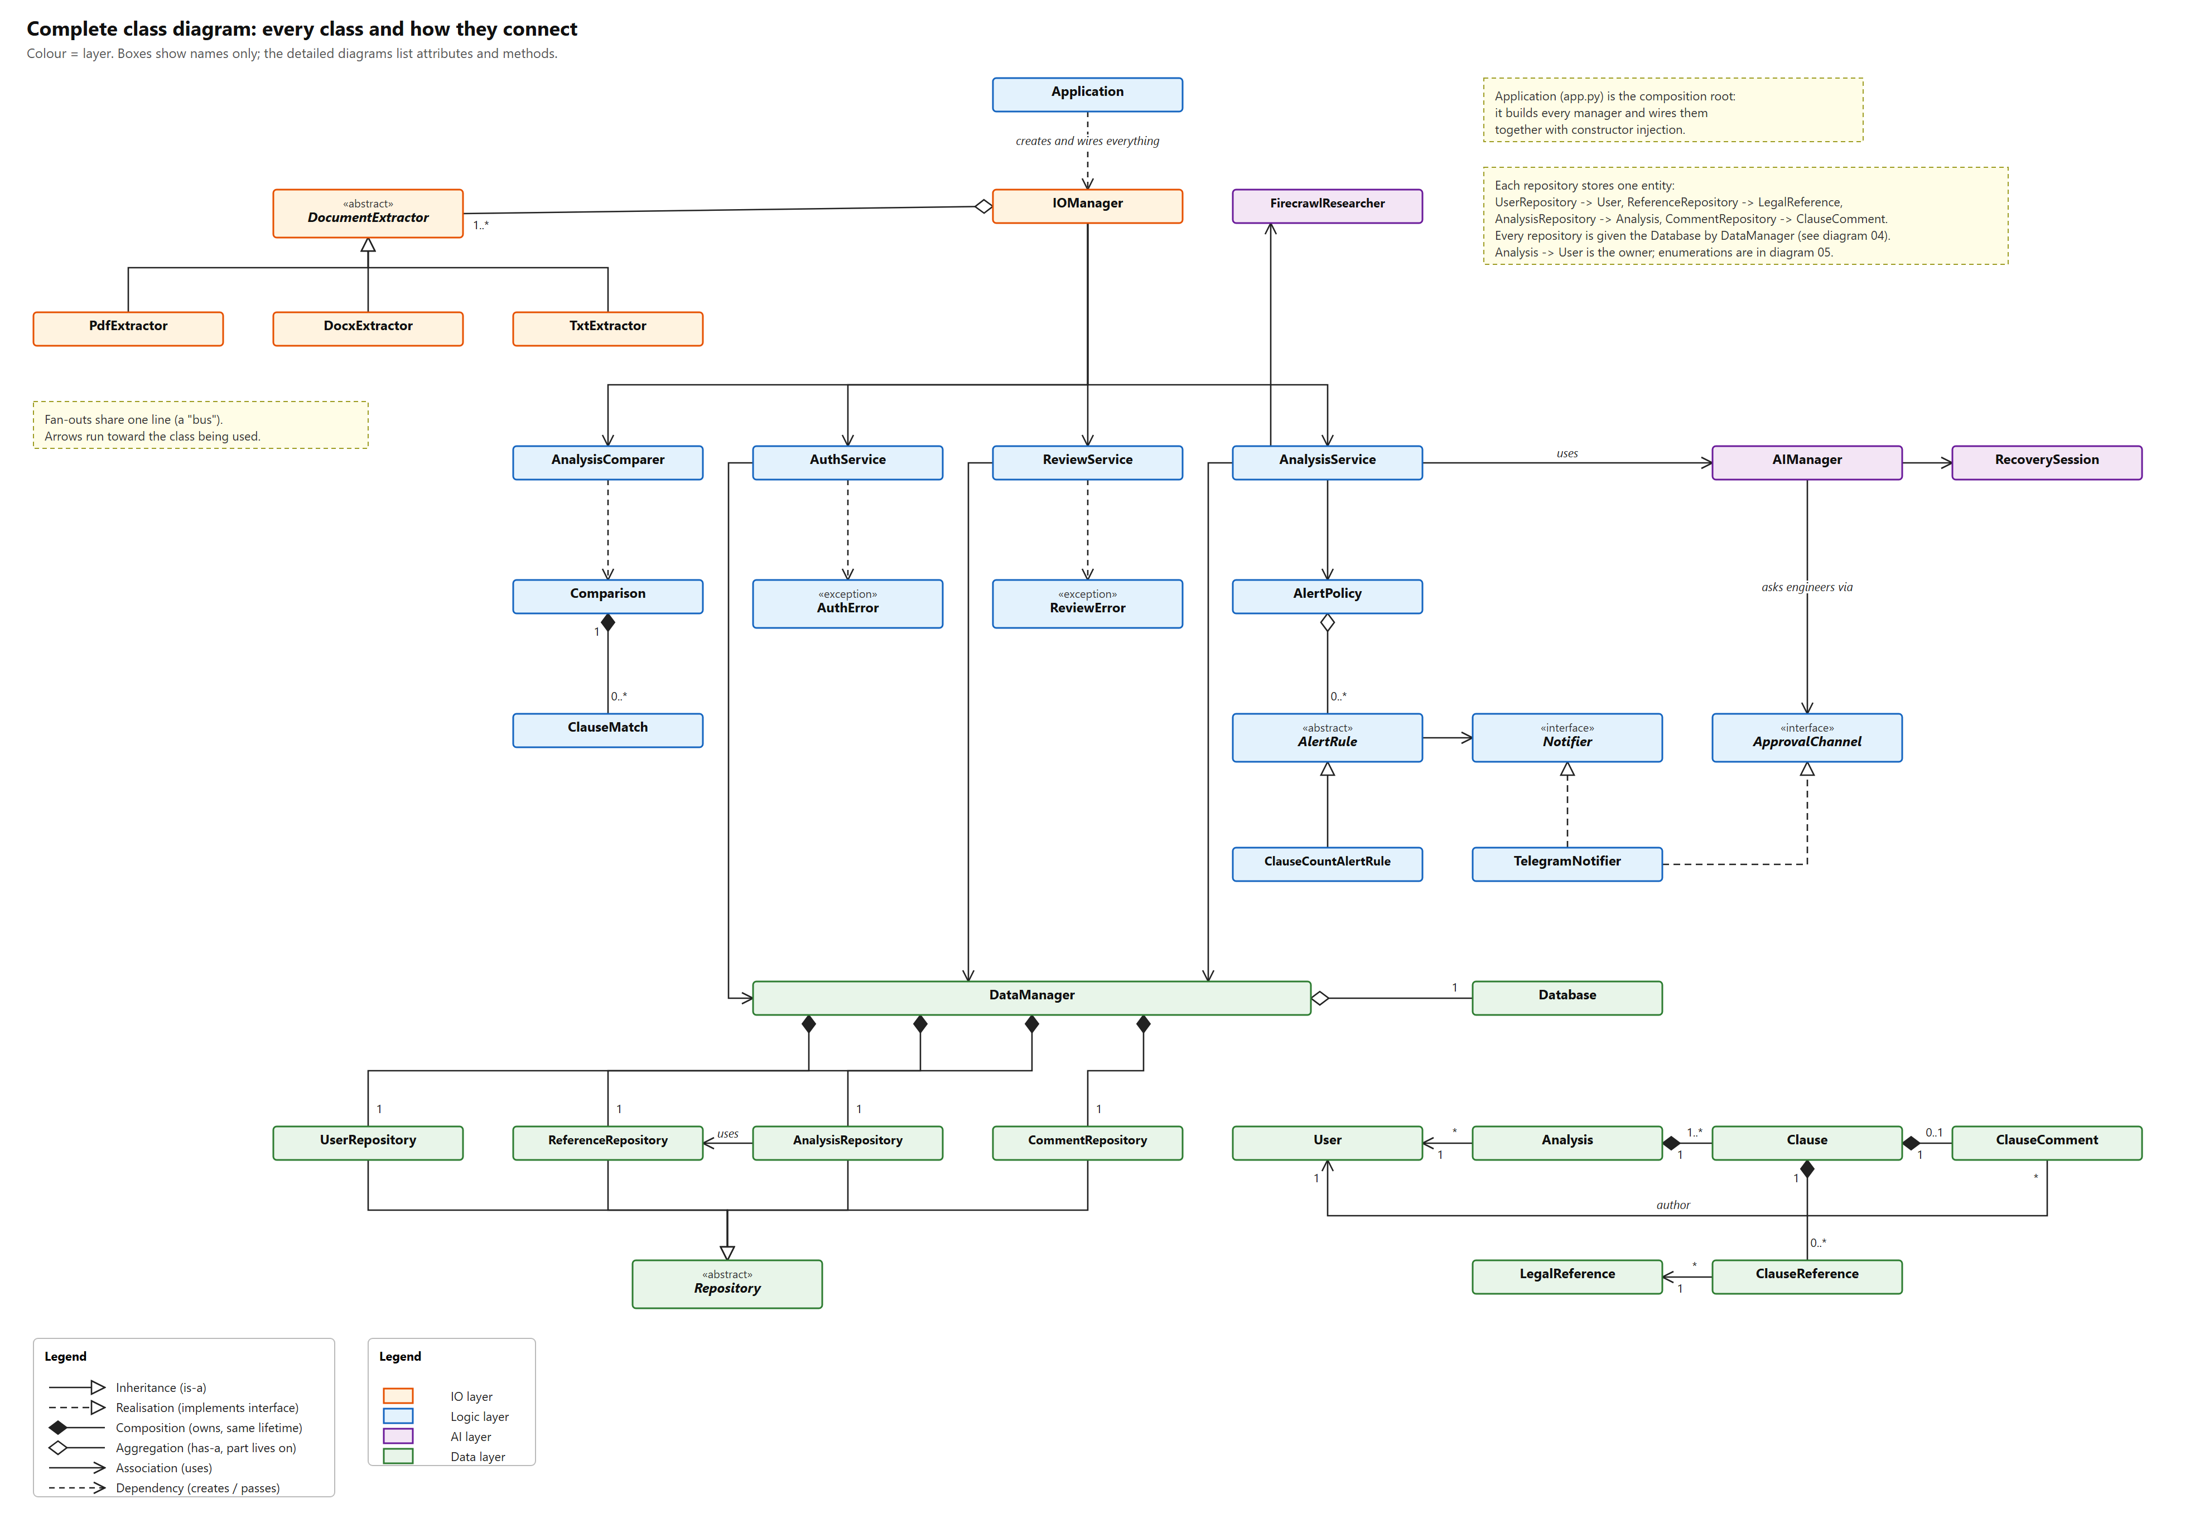
Figure A1. Complete class diagram (uml-02-complete-class-diagram.svg).

