PROJECT DOCUMENTATION
VPC Nexus
AWS Multi-VPC Network Architecture and Connectivity Management System
Connect two VPCs. Prove private connectivity.
Student name SWETHA SRI MANAGALAGIRI
Batch 1
Course AWS
AWS Region ap-southeast-2
Completion date 28-10-26
Instructor / Guide BHANU PRAKASH

Table of Contents
1. Project Overview 1
1.1 Objective 1
1.2 Scope 1
1.3 Learning Outcomes 1
1.4 Tools and Technologies 1
2. Architecture 1
3. IP Plan and Resource Inventory 1
4. Implementation 1
4.1 Create VPC 1 1
4.2 Create VPC 2 1
4.3 Security Groups 1
4.4 Launch EC2 Instances 1
4.5 SSH Access through the Bastion 1
4.6 Baseline Test (Before Peering) 1
4.7 VPC Peering 1
4.8 Route Tables 1
5. Testing and Validation 1
5.1 Controlled Failure 1
6. Concept Explanations 1
6.1 Forward Path and Return Path 1
6.2 Viva Questions 1
7. Troubleshooting Guide 1
8. Cleanup 1
9. Conclusion and Learnings 1
10. Submission Checklist 1

1. Project Overview

1.1 Objective
Build a working private network connection between two Amazon VPCs using VPC peering, keep both application servers private, and use a single public bastion host in VPC 1 for administration. Every route and security rule is explained and backed by test evidence.

1.2 Scope
- 2 VPCs, 3 EC2 instances, 1 VPC peering connection, 1 internet gateway (VPC 1 only).
- Private-IP communication between VPC1-Private-EC2-B and VPC2-Private-EC2-C.
- Administration through the bastion using SSH ProxyJump, with no private key stored on any instance.
- No NAT gateway; private instances have no internet access.

1.3 Learning Outcomes
- Plan non-overlapping VPC and subnet CIDR ranges.
- Create public and private subnets with explicit route table associations.
- Activate peering, add return routes and allow only the required inbound traffic.
- Show a failed test before peering, successful tests after peering, and a controlled failure.

1.4 Tools and Technologies
Item | Details
Cloud platform | AWS (VPC, EC2, Security Groups, Route Tables, VPC Peering)
Operating system | Amazon Linux 2023
Instance type | t3.micro (or instructor-approved small x86 type)
Client tools | OpenSSH (WSL / macOS / Linux terminal)
Key pair | vpc-nexus-lab (RSA, aws.pem stored on local laptop only)

2. Architecture
The design has one internet entry point (the internet gateway on VPC 1), two private workloads, and a direct peering link between the VPCs. Administration flows laptop > bastion > private host. Project traffic flows between VPC1-Private-EC2-B and VPC2-Private-EC2-C over private IPs and the peering connection.
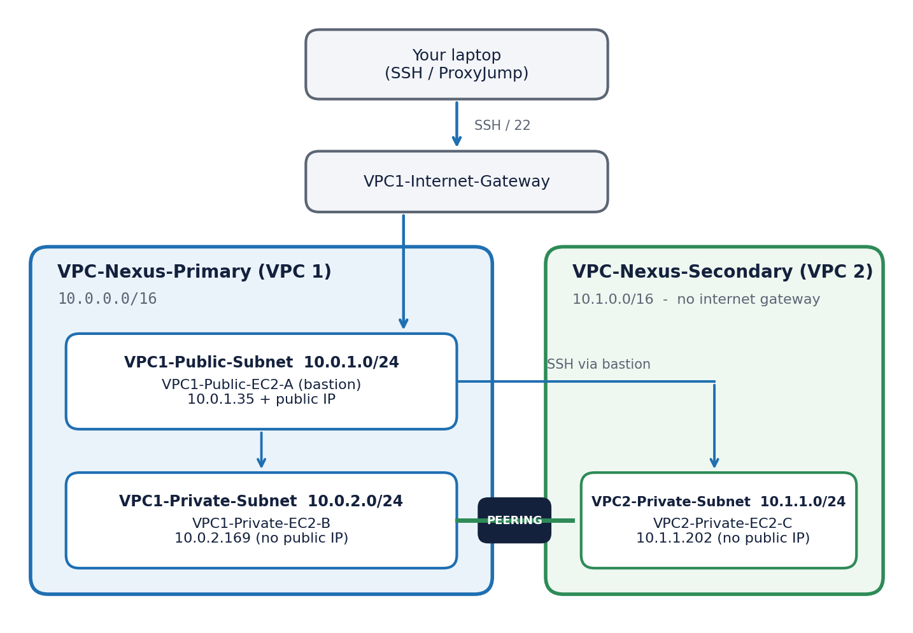
Figure 1: VPC Nexus conceptual architecture
Design notes
The diagram is conceptual: the bastion opens a separate SSH connection to the destination. Peering does not give VPC 2 internet access through VPC 1.

3. IP Plan and Resource Inventory
Replace the placeholders with your actual resource IDs after creating each resource. Keep names consistent so screenshots, routes and terminal output can be matched.
Resource | Name tag | CIDR / IP | Actual ID
VPC 1 | VPC-Nexus-Primary | 10.0.0.0/16 | Vpc-079abb86532f28868
Public subnet | VPC1-Public-Subnet | 10.0.1.0/24 | Subnet-0d7f3b711df82a6c8
Private subnet | VPC1-Private-Subnet | 10.0.2.0/24 | Subnet-05c59184972d315cc
VPC 2 | VPC-Nexus-Secondary | 10.1.0.0/16 | Vpc-0b9d91a537de992cf
Private subnet | VPC2-Private-Subnet | 10.1.1.0/24 | Subnet-01a698367eb50c574
Internet gateway | VPC1-Internet-Gateway | Attached to VPC 1 | Igw-0db8e47e042dede80
Route table | VPC1-Public-RT | Public subnet | Rtb-080c2dbd06b39ed9b
Route table | VPC1-Private-RT | Private subnet | Rtb-023b680f7505cfbd3
Route table | VPC2-Private-RT | VPC 2 subnet | Rtb-0cbbf66f96147a38d
Peering | VPC1-VPC2-Peering | VPC 1 <> VPC 2 | Pcx-of9eb046f5ed58283
EC2 (bastion) | VPC1-Public-EC2-A | 10.0.1.35 + public IP | i-0b0008831d1ba3e41
EC2 (private) | VPC1-Private-EC2-B | 10.0.2.169 | i-033a7d86c1cfc6072
EC2 (private) | VPC2-Private-EC2-C | 10.1.1.202 | i-0fc802d227e79b912

Why these CIDRs? 10.0.0.0/16 and 10.1.0.0/16 do not overlap, and each /24 subnet sits inside its own VPC range. Overlapping VPC CIDRs cannot be peered, and changing subnet ranges alone does not fix that.

4. Implementation

4.1 Create VPC 1
- VPC console > Create VPC > VPC only. Name VPC-Nexus-Primary, CIDR 10.0.0.0/16, no IPv6, default tenancy.
- Create VPC1-Public-Subnet (10.0.1.0/24) and VPC1-Private-Subnet (10.0.2.0/24) in the same Availability Zone.
- Create VPC1-Internet-Gateway and attach it to VPC-Nexus-Primary.
- Create VPC1-Public-RT, associate the public subnet, and add 0.0.0.0/0 to the internet gateway.
- Create VPC1-Private-RT, associate the private subnet, and keep only the local route. Leave auto-assign public IPv4 disabled.
- 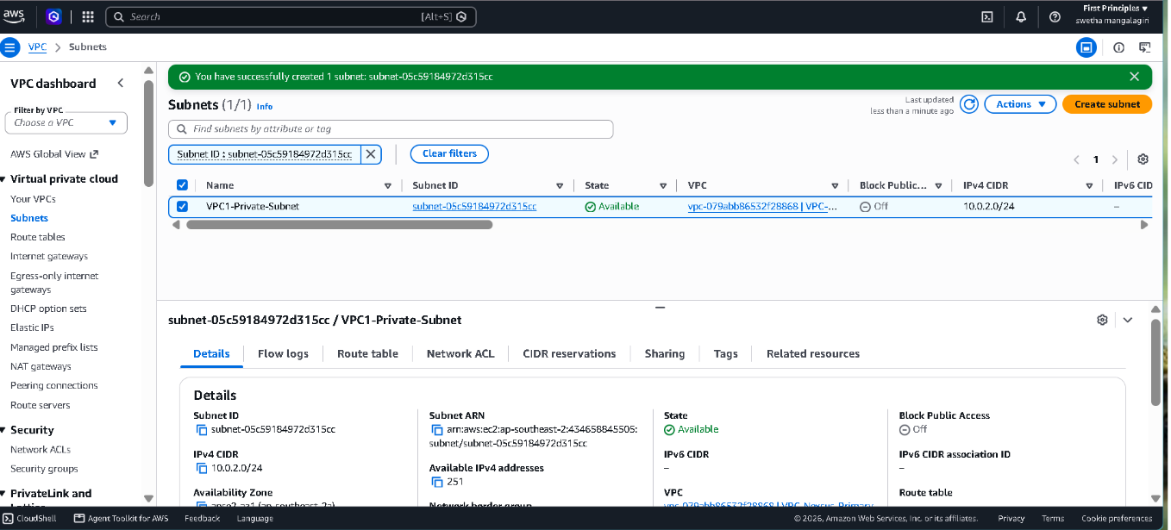

4.2 Create VPC 2
- Create VPC-Nexus-Secondary (10.1.0.0/16) and VPC2-Private-Subnet (10.1.1.0/24).
- Create VPC2-Private-RT, associate the subnet and keep the local route. No internet gateway is needed.
- 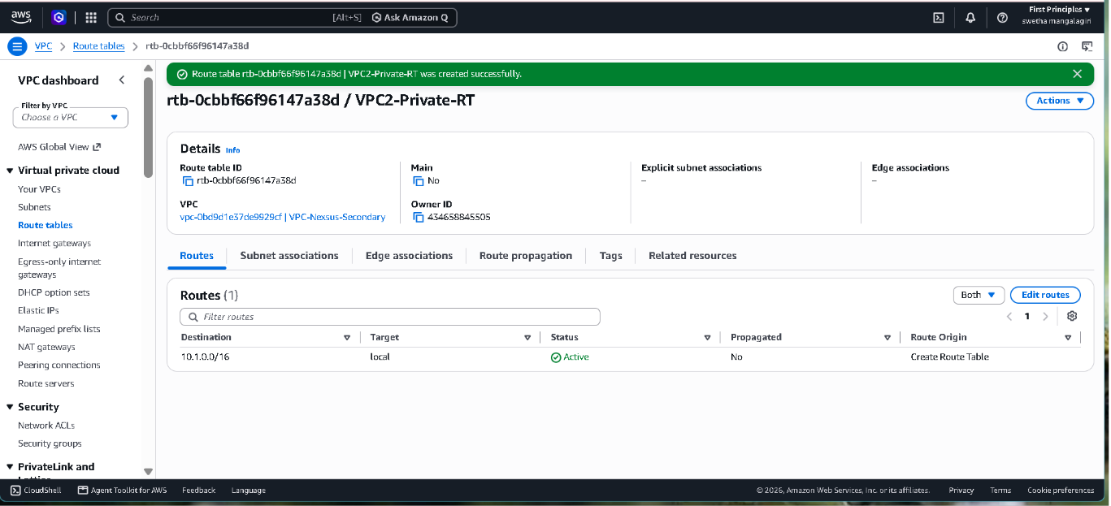

4.3 Security Groups
Create the inbound rules below. Keep default outbound allow-all. Security groups are stateful, so replies to permitted traffic are allowed automatically. Use default allow-all network ACLs.
Security group | Type / port | Source | Purpose
VPC1-Public-SG | SSH / TCP 22 | Your public IPv4 /32 | Laptop to bastion only
VPC1-Private-SG | SSH / TCP 22 | 10.0.1.35/32 | Bastion to VPC1-Private-EC2-B
VPC1-Private-SG | ICMP Echo request | 10.1.1.202/32 | Reverse ping from VPC2-Private-EC2-C
VPC2-Private-SG | SSH / TCP 22 | 10.0.1.35/32 | Bastion to VPC2-Private-EC2-C
VPC2-Private-SG | ICMP Echo request | 10.0.2.169/32 | Forward ping from VPC1-Private-EC2-B

Port and source are different fields
SSH uses port 22. The private IP or CIDR goes in Source, never in Port. Do not expose SSH or ICMP to 0.0.0.0/0.

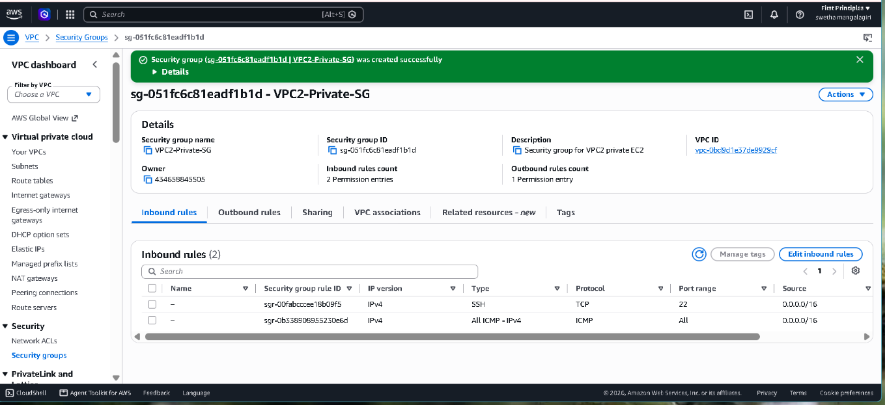
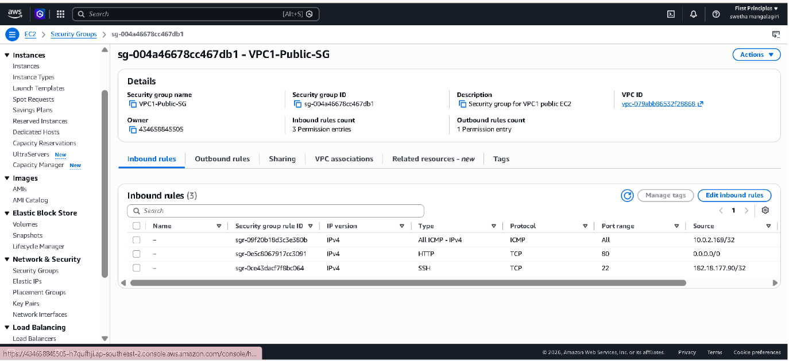
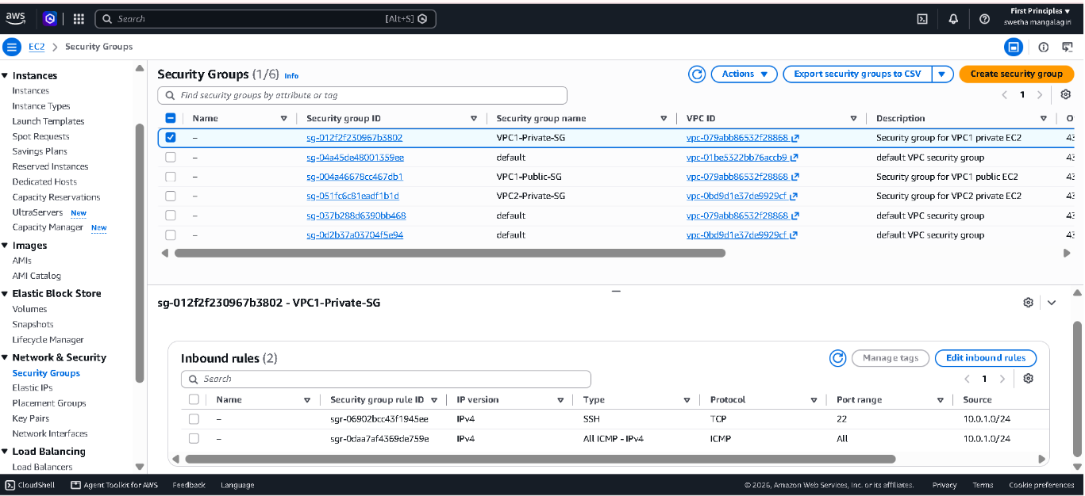

4.4 Launch EC2 Instances
Create the RSA key pair vpc-nexus-lab on your laptop and use it for all three instances. Never paste or upload the private key onto an instance. Use Amazon Linux 2023, enable delete-on-termination for the root volume, and set the primary private IPv4 during launch.
Instance | Network | Public IP | Security group
VPC1-Public-EC2-A | VPC 1 / public subnet / 10.0.1.35 | Enable | VPC1-Public-SG
VPC1-Private-EC2-B | VPC 1 / private subnet / 10.0.2.169 | Disable | VPC1-Private-SG
VPC2-Private-EC2-C | VPC 2 / private subnet / 10.1.1.202 | Disable | VPC2-Private-SG

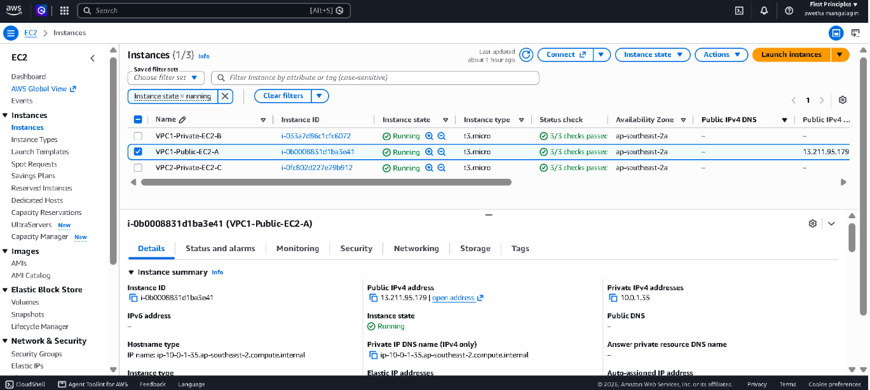
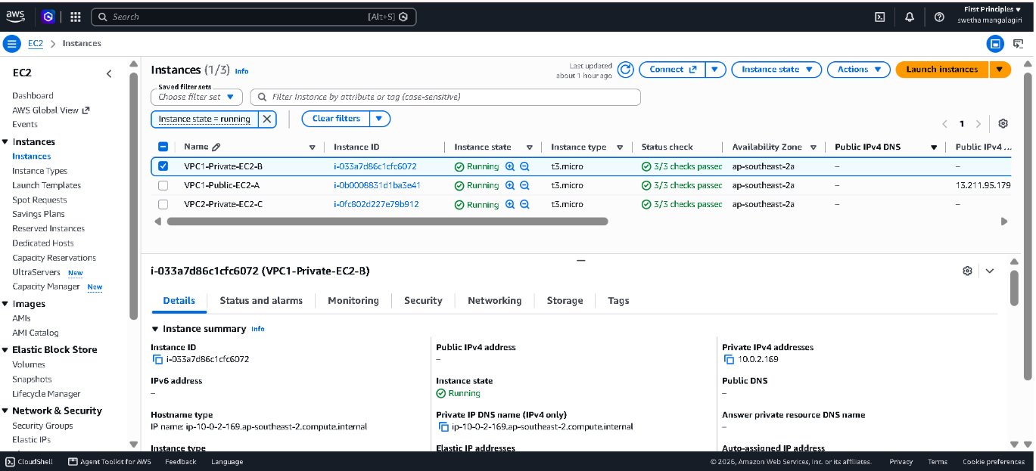
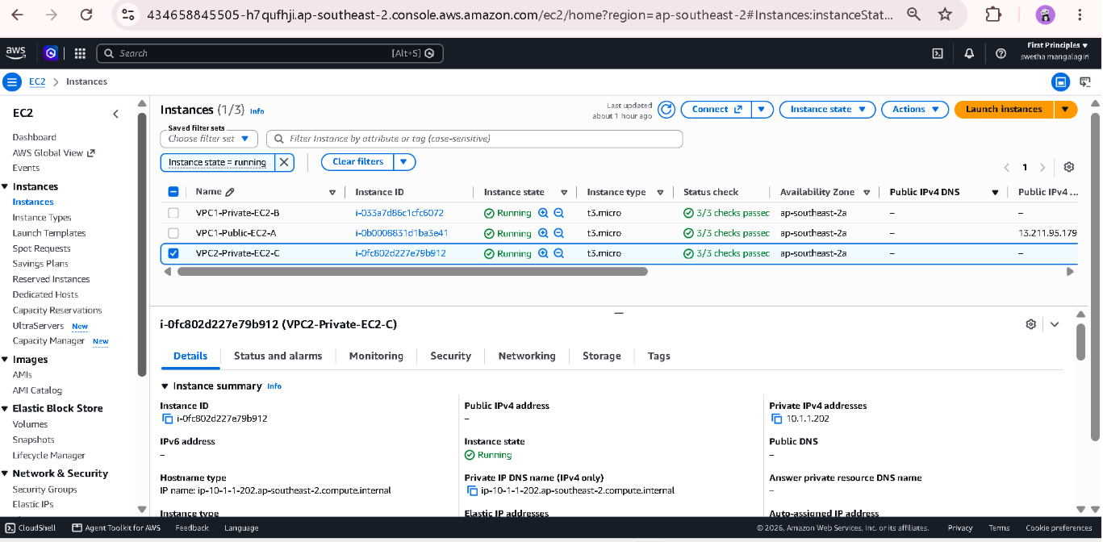

4.5 SSH Access through the Bastion
Run all SSH commands on your laptop. Set key permissions with chmod 400 ~/.ssh/vpc-nexus-lab.pem, then add the following to ~/.ssh/config (replace BASTION_PUBLIC_IP).
Host VPC1-Public-EC2-A
HostName BASTION_PUBLIC_IP
User ec2-user
IdentityFile ~/.ssh/vpc-nexus-lab.pem
IdentitiesOnly yes

Host VPC1-Private-EC2-B
HostName 10.0.2.169
User ec2-user
IdentityFile ~/.ssh/vpc-nexus-lab.pem
IdentitiesOnly yes
ProxyJump VPC1-Public-EC2-A

Host VPC2-Private-EC2-C
HostName 10.1.1.202
User ec2-user
IdentityFile ~/.ssh/vpc-nexus-lab.pem
IdentitiesOnly yes
ProxyJump VPC1-Public-EC2-A

Test ssh VPC1-Public-EC2-A, then ssh VPC1-Private-EC2-B. Both work before peering because of VPC 1's local route. Access to VPC2-Private-EC2-C works only after peering and routes are complete.
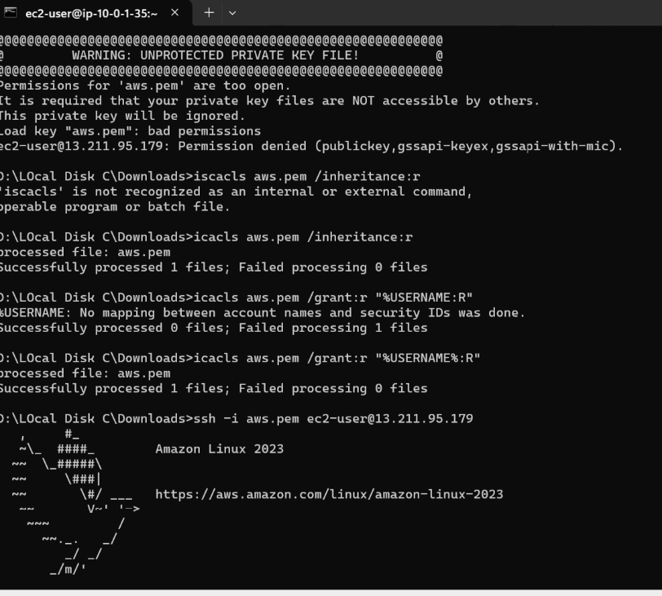
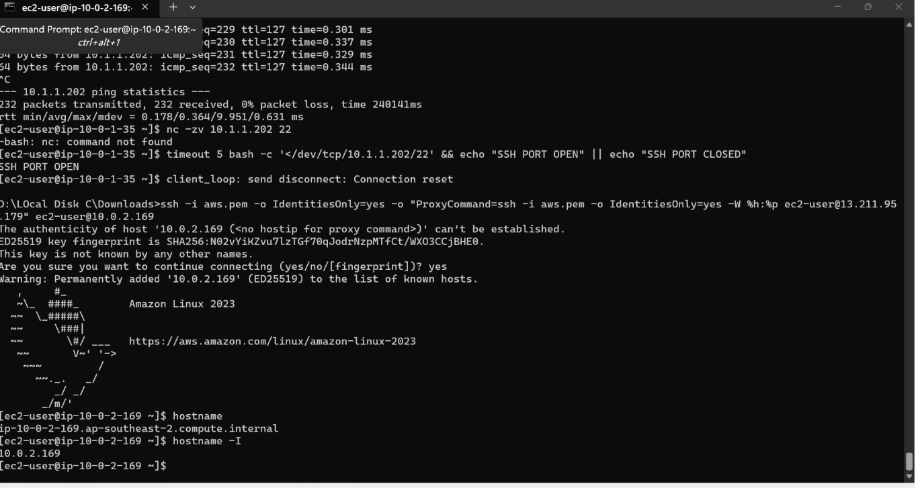

4.6 Baseline Test (Before Peering)
From VPC1-Private-EC2-B run ping -c 4 10.1.1.202. It should receive no replies. Save this output as the baseline failure.
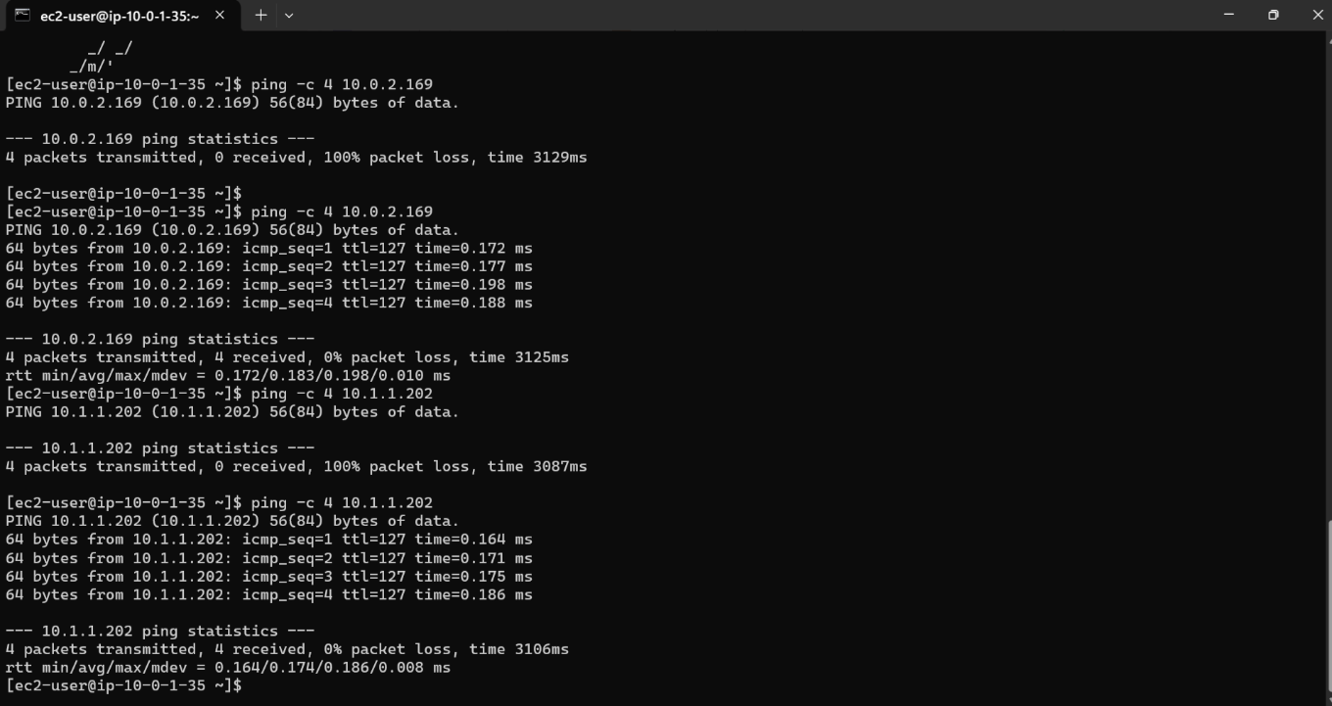

4.7 VPC Peering
Field | Value
Name | VPC1-VPC2-Peering
Requester VPC | VPC-Nexus-Primary
Account / Region | My account / This Region
Accepter VPC | VPC-Nexus-Secondary

Create the request, then choose Actions > Accept request (acceptance is required even within one account). Wait for status Active and record the pcx ID.
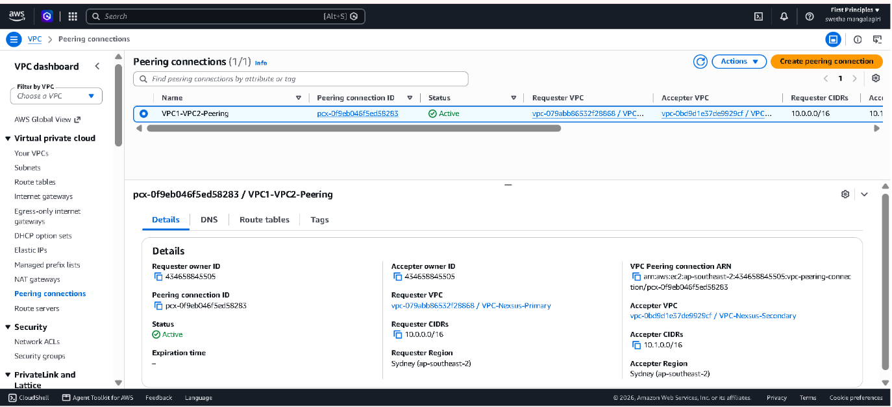

4.8 Route Tables
Add routes on both sides. A one-way route is not enough because replies also need the route back. Replace pcx-ID with your actual peering ID.
VPC1-Private-RT
Destination | Target | Purpose
10.0.0.0/16 | local | Existing VPC 1 route
10.1.0.0/16 | pcx-ID | VPC1-Private-EC2-B to VPC 2
VPC2-Private-RT
Destination | Target | Purpose
10.1.0.0/16 | local | Existing VPC 2 route
10.0.0.0/16 | pcx-ID | Return path to VPC 1
VPC1-Public-RT
Destination | Target | Purpose
10.0.0.0/16 | local | Bastion to VPC1-Private-EC2-B
0.0.0.0/0 | igw-ID | Bastion internet access
10.1.0.0/16 | pcx-ID | Bastion SSH to VPC2-Private-EC2-C

Why does the public subnet need a peering route?
ProxyJump makes the bastion open a connection to VPC2-Private-EC2-C, so its subnet must know how to reach VPC 2. The more specific 10.1.0.0/16 route wins over the internet default route.

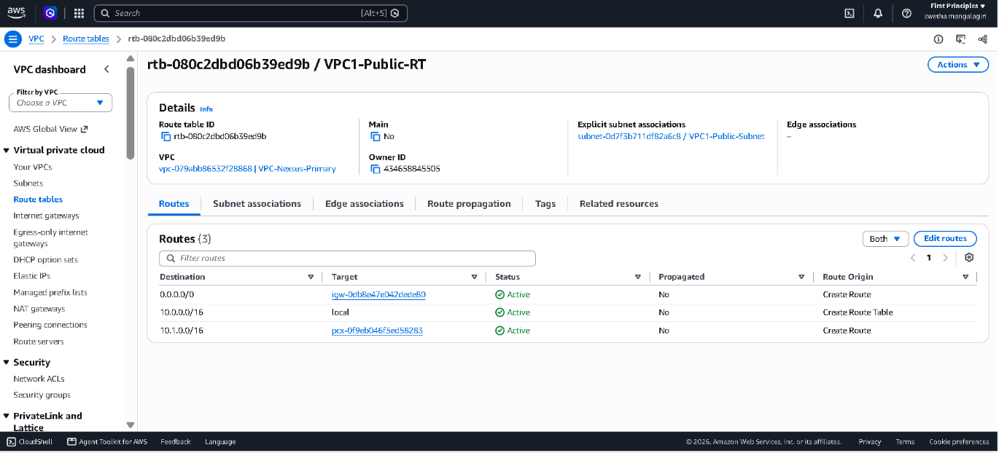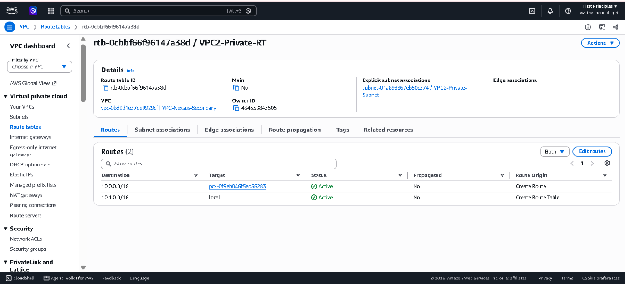
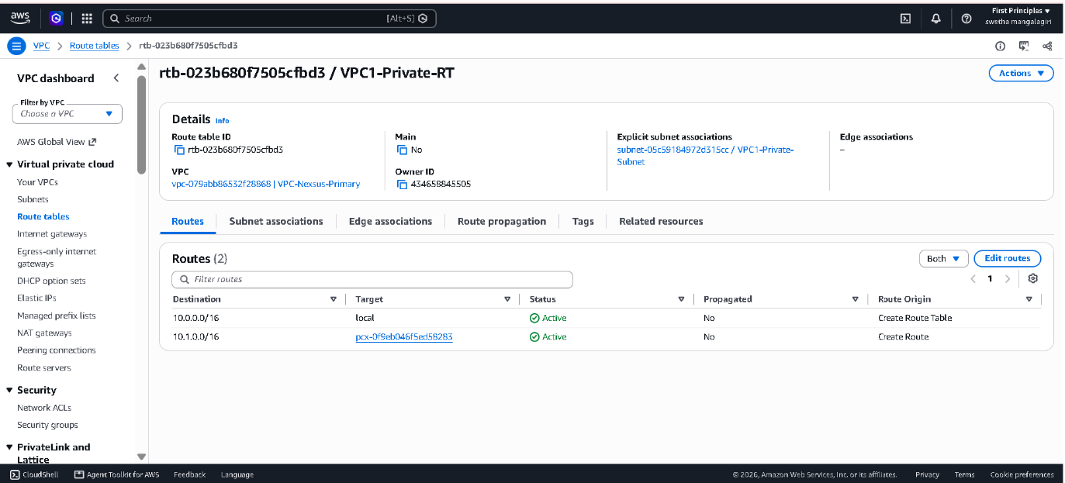

5. Testing and Validation
Record real terminal output in the Actual result column. The expected results are acceptance criteria.
Test | Where / command | Expected | Actual result | Status
01 Baseline | VPC1-Private-EC2-B, before peering: ping -c 4 10.1.1.202 | No replies | Not captured in our recorded testing | N/A
02 Forward | VPC1-Private-EC2-B: ping -c 4 10.1.1.202 | 4 replies, 0% loss | 4 packets transmitted, 4 received,0% packet loss | pass
03 Reverse | VPC2-Private-EC2-C: ping -c 4 10.0.2.169 | 4 replies, 0% loss | 4 packets transmitted, 4 received,0% packet loss | Pass
04 Private SSH | Laptop: ssh VPC2-Private-EC2-C | Shell via bastion | SSH connection to EC2-C through EC2-A bastion successfully established | Pass
05 Isolation | EC2 details of B and C | No public IPv4 | EC2-B and EC2-C have no public IPv4 addresses | Pass

5.1 Controlled Failure
Temporarily remove only the ICMP Echo request rule (source 10.0.2.169/32) from VPC2-Private-SG. Repeat the forward ping: replies should stop. Restore the exact rule and rerun: replies should resume. Keep the SSH rule in place.
hostname
hostname -I
ping -c 4 PEER_PRIVATE_IP

Step | Expected | Actual result
Rule removed, ping from B | Replies stop | 4 packets transmitted, 4 received,100% packet loss
Rule restored, ping from B | Replies resume | 4 packets transmitted, 4 received,0% packet loss

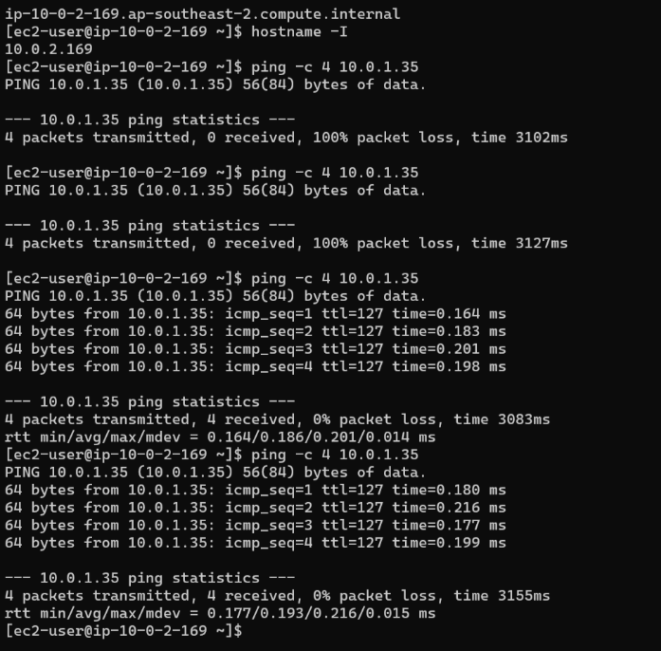

Short explanation: Removing the ICMP rule stopped replies because VPC peering and routing only provide the network path; the Security Group controls whether ICMP traffic is allowed. With the ICMP rule removed, the packets reached the destination but the security group blocked the ICMP echo traffic. The peering and routes remained unchanged.

6.1 Forward Path and Return Path
Forward path: VPC1-Private-EC2-B (10.0.2.169) sends traffic to 10.1.1.202. VPC1-Private-RT matches 10.1.0.0/16 and sends it to the peering connection. VPC2-Private-SG allows the ICMP Echo request from 10.0.2.169/32, so VPC2-Private-EC2-C receives it.
Return path: the reply goes to 10.0.2.169. VPC2-Private-RT matches 10.0.0.0/16 and sends it back through the peering connection. Security groups are stateful, so the reply is allowed automatically.

6.2 Viva Questions
Question | Answer
Why is the return route needed? | Peering only creates the link. Each subnet needs its own route to the other VPC's CIDR, otherwise replies have no path back and the ping or SSH session fails.
Why is the SSH source for VPC2-Private-EC2-C the bastion private IP? | With ProxyJump the bastion opens a new connection to the target, so the target sees the bastion's private IP (10.0.1.35), not your laptop's address.
Why does Active peering not guarantee a successful ping? | Active only means the link exists. Route tables, security group rules and network ACLs on both sides must also allow the traffic.
Can VPC 2 use VPC 1's internet gateway over peering? | No. Peering is one-to-one and non-transitive, and it does not extend an internet gateway to the peer VPC. VPC 2 stays without internet access.

7. Troubleshooting Guide
Check the instance state, the destination IP, the subnet route table and the security rule, in that order.
Symptom | What to inspect
Bastion SSH times out | Bastion public IP; your current public IP /32 in VPC1-Public-SG; public subnet association; 0.0.0.0/0 route to the attached IGW.
VPC1-Private-EC2-B SSH fails | Private IP; TCP 22 allowed from 10.0.1.35/32; correct key, ec2-user and running instance.
VPC2-Private-EC2-C SSH fails | Public subnet route 10.1.0.0/16 to pcx-ID; VPC 2 return route; SSH source is the bastion private IP.
Ping fails after acceptance | Both private route tables; correct pcx-ID and Active state; Echo request rule on the destination; actual host IPs.
Peering creation fails | Check every CIDR on both VPCs for overlap, including secondary CIDRs.
Permission denied (publickey) | Correct key pair, local IdentityFile and ec2-user. Routing is working if you reached SSH authentication.
Failure with custom ACLs | Check both directions, ICMP rules and SSH return ephemeral ports. This lab assumes default allow-all ACLs.

8. Cleanup
Save your evidence first. Remove only the resources you created for this project.
Step | Action | Done
1 | Terminate the three EC2 instances; confirm lab EBS volumes are deleted; release any Elastic IP; remove the unused lab key pair and local key. | No
2 | Delete peer routes and VPC1-VPC2-Peering; delete security groups; remove subnet associations; delete subnets and custom route tables; detach and delete the internet gateway; delete both VPCs. | No
3 | Filter by the project tag and confirm EC2, volumes, public IPv4 allocations and VPC resources are gone. Check Billing for remaining charges. | No

9. Conclusion and Learnings

I built VPC Nexus, an AWS multi-VPC networking project consisting of two VPCs connected through VPC Peering. VPC1 contains a public EC2 instance acting as the access/bastion host and a private EC2 instance, while VPC2 contains another private EC2 instance. Private communication between the VPCs was established using route tables and VPC peering.

What Went Wrong and How It Was Fixed: During implementation, some connectivity issues occurred due to incorrect route table associations, security group rules, and ICMP source CIDRs. Connectivity between the private instances initially failed. I verified the routes, peering status, subnet associations, and security group rules and corrected the configurations.

I also performed a controlled failure test by removing an ICMP rule. The ping stopped even though the peering connection and routes remained active. Restoring the ICMP rule immediately restored connectivity, proving that security groups control whether the traffic is permitted.

What I Learned:

- VPC: Learned how to create isolated AWS networks with different CIDR ranges and organize resources using public and private subnets.

- Routing: Learned that route tables determine where network traffic is sent. Both sides of a peering connection require appropriate routes for communication.

- Security Groups: Learned that routing alone does not guarantee connectivity; security groups must explicitly allow the required traffic such as SSH and ICMP.

- VPC Peering: Learned how two separate VPCs can communicate privately using their private IP addresses without exposing the private EC2 instances to the public Internet.

- Troubleshooting: Learned to troubleshoot connectivity systematically by checking the instance IP, subnet, route table, peering status, security groups, and connectivity tests.

- Practical AWS Networking: Successfully verified forward and reverse ping connectivity and accessed a private EC2 instance through the public/bastion EC2 instance.

10. Submission Checklist
☐ Cover page: name, batch, project title, Region, completion date.
☐ Architecture diagram and inventory with actual resource IDs and private IPs.
☐ Subnet CIDRs and all three route tables with subnet associations.
☐ Active peering connection and inbound rules for each security group.
☐ Baseline failure, forward and reverse ping success, and SSH proof for VPC2-Private-EC2-C.
☐ Controlled ICMP failure and recovery with a short explanation.
☐ Cleanup evidence and a short note on what you learned.
☐ No private keys, passwords or access tokens in the report. File named YourName_VPC_Nexus.pdf.

