Project-4
Touchless full home automatic system
Working:
The working of the Touchless Full Home Automatic System begins by initializing the laptop camera and establishing serial communication with the ESP32 microcontroller. The laptop camera continuously captures the user's hand movements in real time.
The captured video frames are processed using OpenCV, while MediaPipe detects the hand and identifies 21 hand landmarks. The system then calculates the distance between the thumb and index finger to recognize the user's gesture.
In this project, the right hand is used to control the DC fan speed, and the left hand is used to control the LED bulb brightness. According to the detected gesture, the Python program generates the appropriate control command.
These commands are transmitted to the ESP32 through serial communication. The ESP32 processes the received commands and generates PWM (Pulse Width Modulation) signals.
The PWM signals are sent to the L298N2A motor driver modules. One L298N2A module controls the DC fan by increasing or decreasing its speed, while the other L298N2A module controls the LED bulb by adjusting its brightness smoothly.
At the same time, the ESP32 uploads the current fan speed and bulb brightness values to the ThingSpeak cloud platform through Wi-Fi. ThingSpeak displays these values as real-time graphs, allowing the system to be monitored remotely.
This entire process runs continuously, enabling touchless, real-time, and smooth control of both the DC fan and LED bulb using simple hand gestures without the need for physical switches.

HARDWARE SETUP:

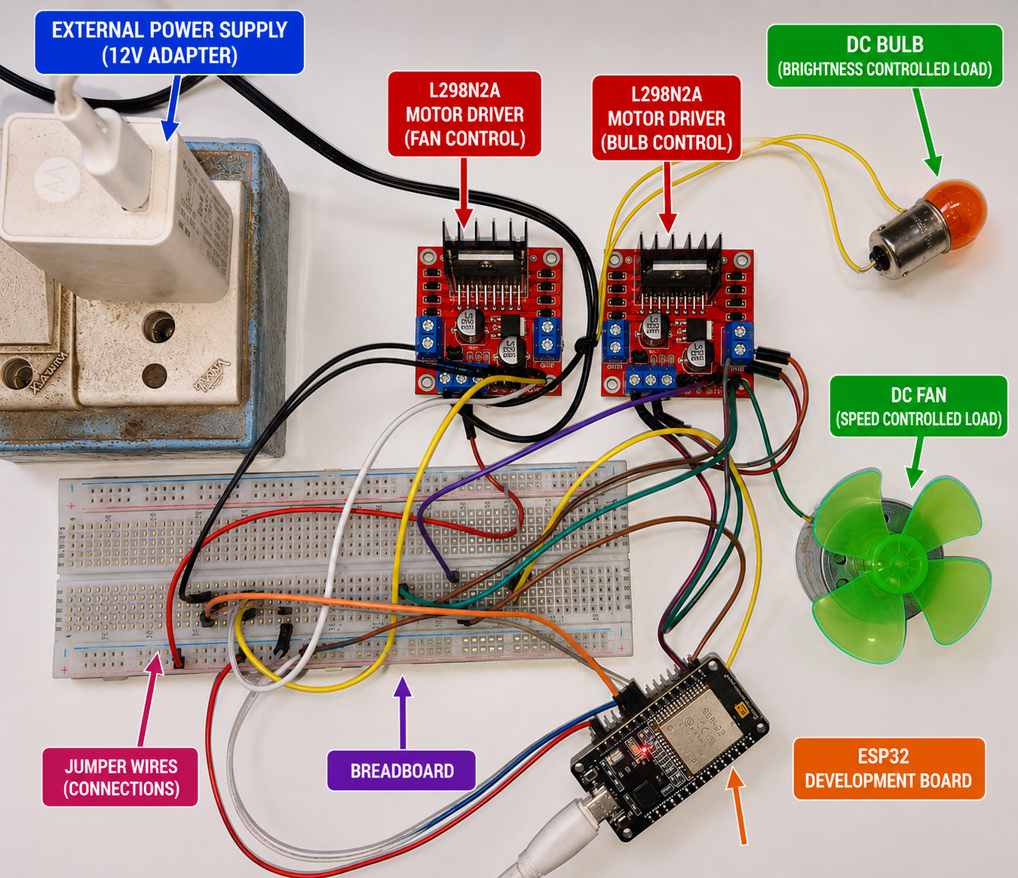
Python program:

import cv2
import serial
import time
import mediapipe as mp
import math
import requests
esp32 = serial.Serial('COM12', 115200)
time.sleep(2)
WRITE_API_KEY = "GAXKITFKCSC8P92E"
last_update = time.time()
mp_hands = mp.solutions.hands
hands = mp_hands.Hands(
static_image_mode=False,
max_num_hands=2,
min_detection_confidence=0.7,
min_tracking_confidence=0.7
mp_draw = mp.solutions.drawing_utils
cap = cv2.VideoCapture(0)
fan_value = 0
bulb_value = 0
while True:
success, img = cap.read()
if not success:
continue
img = cv2.flip(img, 1)
rgb_img = cv2.cvtColor(img, cv2.COLOR_BGR2RGB)
results = hands.process(rgb_img)
if results.multi_hand_landmarks and results.multi_handedness:
for handLms, handType in zip(
results.multi_hand_landmarks,
results.multi_handedness):
label = handType.classification[0].label
mp_draw.draw_landmarks(
img,
handLms,
mp_hands.HAND_CONNECTIONS
)
h, w, c = img.shape
lm_list = []
for lm in handLms.landmark:
cx = int(lm.x * w)
cy = int(lm.y * h)
lm_list.append((cx, cy))
if len(lm_list) > 8:
# Thumb tip
x1, y1 = lm_list[4]
# Index finger tip
x2, y2 = lm_list[8]
cv2.circle(img, (x1, y1), 10, (0, 255, 0), -1)
cv2.circle(img, (x2, y2), 10, (0, 255, 0), -1)
cv2.line(img, (x1, y1), (x2, y2), (255, 0, 255), 3)
distance = math.hypot(x2 - x1, y2 - y1)
value = int((distance / 200) * 255)
if value > 255:
value = 255
if value < 0:
value = 0
# RIGHT HAND -> FAN
if label == "Right":
fan_value = value
esp32.write(f"F{value}\n".encode())
# LEFT HAND -> BULB
elif label == "Left":
bulb_value = value
esp32.write(f"B{value}\n".encode())
# ==========================
# ThingSpeak Update Every 10 Seconds
# ==========================
if time.time() - last_update >= 10:
try:
response = requests.post(
"https://api.thingspeak.com/update",
data={
"api_key": WRITE_API_KEY,
"field1": fan_value,
"field2": bulb_value
}
)

print("ThingSpeak Updated")
print("Fan Speed:", fan_value)
print("Bulb Brightness:", bulb_value)
except Exception as e:
print("ThingSpeak Error:", e)
last_update = time.time()
# ==========================
# Display Values
# ==========================
cv2.putText(
img,
f"RIGHT HAND FAN SPEED : {fan_value}",
(20, 50),
cv2.FONT_HERSHEY_SIMPLEX,
0.8,
(0, 0, 255),
2
)

cv2.putText(
img,
f"LEFT HAND BULB BRIGHTNESS : {bulb_value}",
(20, 100),
cv2.FONT_HERSHEY_SIMPLEX,
0.8,
(255, 0, 0),
2
)
cv2.imshow("ESP32 Fan & Bulb Control + ThingSpeak", img)
if cv2.waitKey(1) & 0xFF == ord('q'):
break
cap.release()
cv2.destroyAllWindows()
esp32.close()

